

**Brunella Isabella Burlando Rios**

Age: 26 years

Birth Date: 03/25/1990 Nacionality: Peruvian

Adress: Guillem Tell Street, N°14 1B – Barcelona, 08006

Movil: +34 657 88 27 22

NIE: Y4538935Z Passport: 4923332

E-mail: burlando.brunella@gmail.com

Available

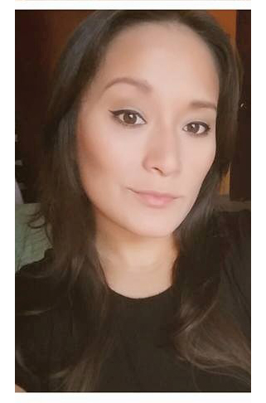

**WORK TOOLS**

**Microsoft:** Excel, PowerPoint y Word.

**Adobe:** Illustrator y Photoshop Avanzado

**SKILLS**

* Teamplayer
* Leadership
* Perfectionist
* Respect the work hour
* Good enviroment to work
* Work under pressure.
* Organized
* Flexible Attitud.

**Notion**

-Visual Merchandising

-Decoración Vitrina y Tienda

-Organigrama funciones dentro de Área de trabajo

**Languages**

**Español:** Natal

**Inglés:** Avanzado (Leído-hablado-escrito)

**Francés:** Básico (Leído-hablado)

**STUDIES**

**2016-2017** Management of Fashion Companies

**Barcelona**

**Mar 16-Jun 16** Retail & Visual Merchandising Management / Fashion Production Management

**Barcelona**

**2011-2012**  Fashion & Advertising Photography

**Lima - Perú** *Instituto Peruano de Publicidad IPP*

**2010**  Thesis in Textile Design & Fashion (Titulación)

**Lima- Perú** *Centro de Alton Estudios de la Moda –CEAM*

**2007-2010**  Fashion Design (Carrer)

**Lima- Perú** *Centro de Altos Estudios de la Moda –CEAM*

**WORK EXPERIENCE**

**November 2013-**

**Dicember 2015**

Surquillo- Lima

**TWB COMPANY SAC**

Textile Industry / Manufacturer and Traders / Work Licenses (Disney-Marvel y Star Wars)

**Chief Designer:**

Responsabilities:

* Making Collection per season for Disney/Marvel & Star Wars
* Graphic Design for clothing.
* Flats for Clothing (Adobe Illustrator)
* Head of Design
* Developing Techfiles and Artfiles.
* Trend research.
* Product Approval.
* Follow-up the producction with the suppliers.
* Visual Merchandising to the stores Company.

**Diseño Trendy Perú**

Textile Industry / Manufacturer and Traders / Womans & Kids

**Senior Designer**

Work:

* Follow-up the producction .
* Coordination with Suppliers..
* New Fabric Sourcing
* TechFiles
* Rapport y Patterns Design

**March 2012- June 2013**

Surco-Lima

**Applauzi Perú**

Textile Industry / Manufacturer and Traders / Swimwear and Lingerie

**Fashion Intern**

Work:

* Fabric Sourcing.
* Styling & Art Direction for Design Summer Issue.
* Swimwear Collection Kids & Toddlers Summer 2009-2010
* Summer Collection 2009-2010
* Techfiles and Artfiles.

**2009- 2010**

Miraflores-Lima

**REFERENCES**

**Carla Morán Peñafiel**

TWB COMPANY SAC

Commercial Manager

Phone: +51 982508972 E-mail cmoran@twbc.pe

**Centro Colich**

Art Gllery

Jr. Colina 110 Barranco-Lima Perú

Phone: +51 247 1538 [**http://www.centrocolich.com**](http://www.centrocolich.com/)

**Alfredo Mondragon**

Diseño Trendy Perú

General Manager

Phone: +51 9983 34072

**Nelly Gil**

Applauzi Perú

Production Manager

Phone: +51 717 7200

**- June 2008:** Back Stage “Viva México” Runway

**- Febrero 2009:**  Image Consultant “Sweet Pea” Store

**- 2010-2014:** My own Fashion Line “Paralelo”

**- Summer 2013:** Personal Styling -

- **November 2013:** Spring-Summer Collection 2014 *Prêt-à-porter* Exhibition in Art Gallery “Centro Colich” Barranco-Lima Perú.

**PROJECTS**