Kadeejah Beswick
May 9, 2017
EVM400
Ann Dow

Assignment 2: Tours
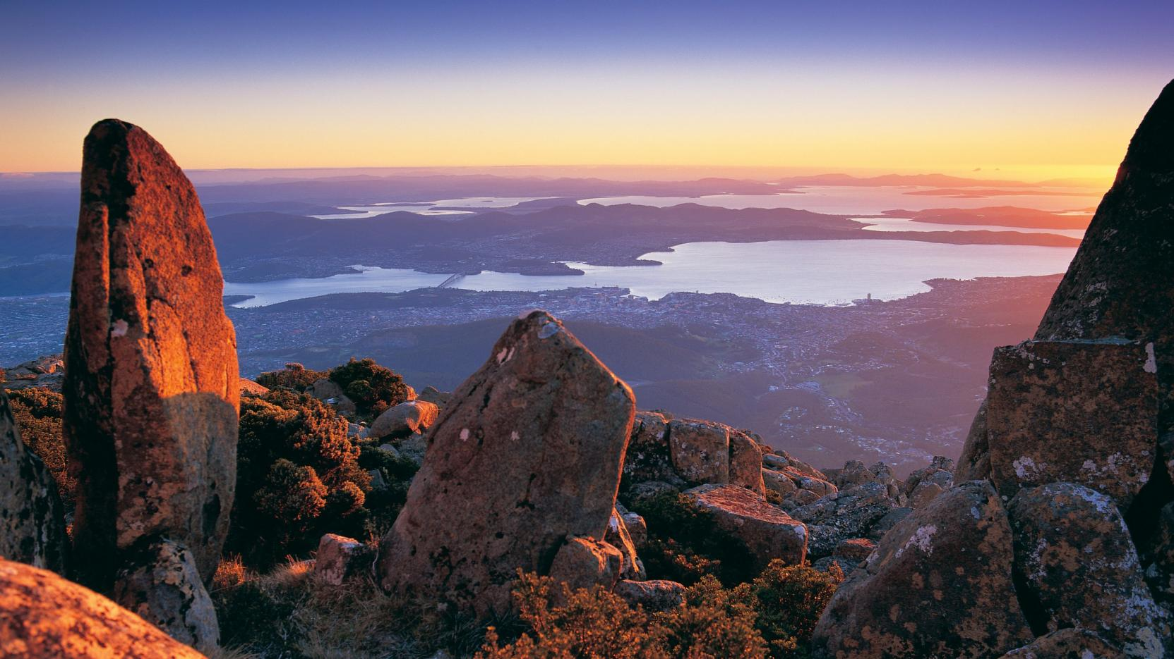
AUSTRALIA

Nicole Wiggins’ Perfect Tour

About Nicole:
- Age: 19
- Animal lover
- Adventurous

Questions
- Do you prefer beaches and sun or a little cabin up north?
Beaches and sun
- Where in the world have you always wanted to visit?
Australia
- What activities do you enjoy doing?
Outdoor activities/adventures/experiences
Activities that have something to do with sight seeing
- What activities have you always wanted to do?
Snorkeling and helicopter rides
- How many people do you want to include in your tour?
1, not including herself. She wants to include her boyfriend.
- Do you prefer longer tours or shorter tours? Why?
She prefers tours that last at least a day because then you can really experience the tour, and not feel rushed.
- Your perfect tour contains?
  - Lots of sitting
  - Lots of moving (always on your feet)
  - The perfect mixture of both sitting and moving
- What are you afraid of?
Birds and snakes. Heights.
- What activities would you never want to do?
Sky diving, cliff jumping
Australia

Travel dates: July 26 – August 2, 2017

Transportation to Australia
On July 26th, 2017, Nicole and her boyfriend will be picked up at her house at 8:30pm by a limo and brought to the Vancouver International Airport for 9:30pm so they can check in, and have plenty of time to get through security. Once they get through security, they will board their plane, and the plane will leave the airport at 11:50 pm. They will be flying for 15-hours non-stop in business class and arrive in the Sydney Airport in Australia on July 28th, 2017 at 8:15am.
From the airport, there will be another limo waiting for Nicole and her boyfriend. They will take a 20-30-minute limo ride, and be dropped off at the Four Seasons in Sydney.
This limo will be Nicole and her boyfriend’s private ride for the duration of their trip.
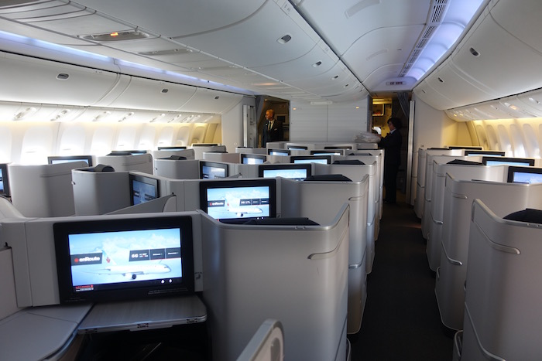

Accommodations
Nicole and her boyfriend will be staying at the Four Seasons hotel, in their Club Premier Full Harbour Room. The room has a beautiful view of Sydney Harbour, Sydney Harbour Bridge and the Sydney Opera house. It contains one king sized bed and an extra rollaway bed. The room comes with its own espresso machine and private bar. It also has a beautiful, spacious marble bathroom with a deep bathtub.
Once they settle in and unpack, they will have the rest of July 28th to do whatever they want because the tour doesn’t start until July 29th

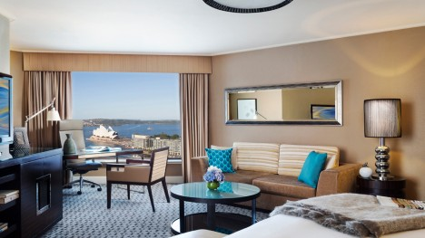

Tour Details

Day 1: July 29th
Sight Seeing Tour and Surf Lesson: 3.5 hours
- 7:00am: Wake up, enjoy some breakfast and get ready for the tour.
- 9:00am: Limo driver takes you to the Bondi Hotel for 9:30am
- 10:00am: Meet your professional Life guard and surf instructor who will be your guide. The surf instructor will then take you on a drive through the city to Bondi Beach, with some stops along the way. You get to learn about the importance of Bondi in Sydney’s beach lifestyle, as well as visit the Bondi Lifeguard Headquarters. Learn about the history of Bondi, and the surf lifeguarding roots.
- 10:15am: Photo op on the beach with a Bondi Lifeguard.
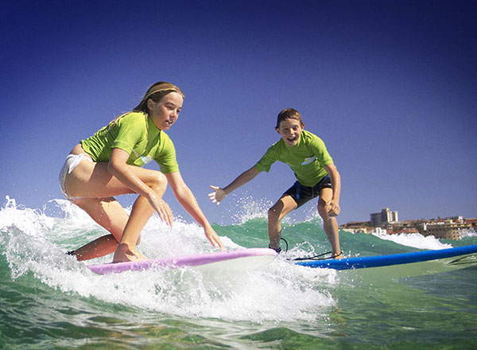
- 10:30am: Surf lesson. Your guide will teach you the surfing basics, cover safety rules and teach you how to warm up. The guide will also teach you how to paddle out, catch waves and stand on the surfboard. You will be given a surfboard, wetsuit, rash vest and sunscreen.
- 11:00am – 12:00pm: Surf Practice.
- 12:00pm – 12:30pm: Relax on the beach and dry off
- 12:30pm – 1:30pm: Enjoy lunch at a local beachside eatery with a fantastic view.
- 1:45pm: Limo driver will pick you up and bring you to your second tour.

Underwater Scooter Experience: 2 hours
- 2:30pm: Arrive at the Clovelly Surf Club. You will meet your instructors and put on the provided wet suits.
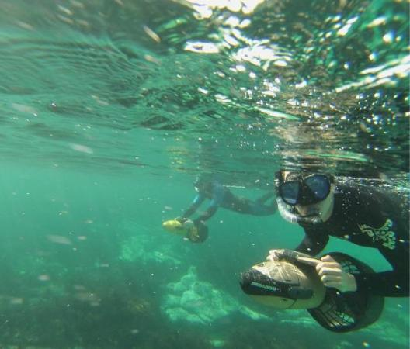
- 3:00pm: head to the water’s edge and learn the safety briefing and orientation. You will follow your instructor into the water and learn about Buoyancy and underwater maneuvers.
- 4:00pm – 5:00pm: Allow the water scooter to pull you along underwater or on the seas surface. Have fun diving, snorkeling and getting to get a closer look at the areas marine life.
- 5:00pm: Return the equipment provided to you and hop back into your limo. The limo will take them back to their hotel.
- 5:35pm: Arrive back at your hotel, and enjoy the rest of your free day doing whatever your heart desires.

Day 2: July 30th
Private Tour of Blue Mountains and Jenolan Caves: 11 hours
- 7:00am: Wake up, enjoy breakfast and get ready for the tour
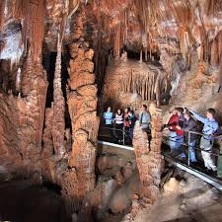
- 8:30am: No need to use your limo driver today, he can have the day off! Your private driver and guide will pick you up at your hotel and your tour starts off at Featherdale Wildlife Park.
- 9:30am – 11:00am: Arrive at one of the best wildlife parks in Sydney. At Featherdale Park, get to know koalas, crocodiles, Tasmanian devils, wombats, and fairy penguins. Enjoy hand feeding kangaroos and more than 2,000 other animals!
- 11:00am – 12:00pm: Continue your tour to see the Great Blue Mountains Canyon. Travel across the Nepean River, and through the sleepy towns of Blaxland, Leura and Wentworth.
- 12:00pm – 1:00pm: Enjoy the scenery and take pictures
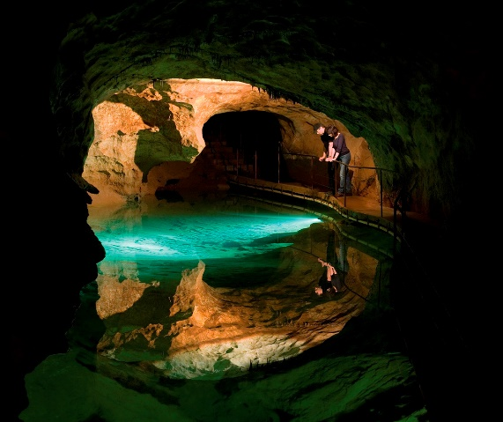
- 1:00pm – 2:00pm: Stop for lunch
- 2:00pm – 3:00pm: Head to the Jenolan Caves. On the way, you will get to drive through the scenic eucalyptus forests.
- 3:00pm – 5:00pm: Explore the hiding place of sparkling limestone and embrace the natural beauty of your new location. You will get to see the mysterious blue lake, and go on a guided cave tour through the Lucas, Imperial, or Chifley caves.
- 5:00pm – 6:00pm: On your way back to Sydney and your hotel, you will get to stop at Katoomba and see the Three Sisters, the three sisters is a rock formation in the Blue Mountains, and one of the Blue Mountains best known sites. Their names are Meehni, Wimlah, and Gunnedoo. Learn about the legend behind how the rocks were formed.
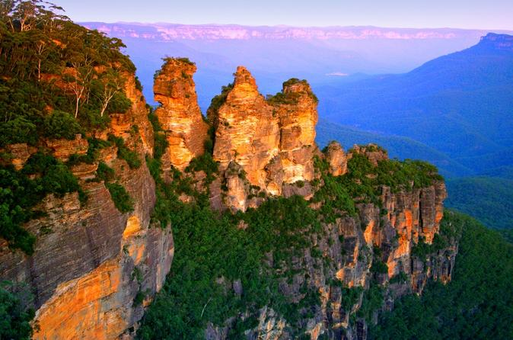
- 7:00pm: Arrive back at your hotel and relax.

Day 3: July 31st
Blue Mountains Helicopter Tour: 5 hours
- 8:30am: Wake up, enjoy breakfast and get ready for your final tour.
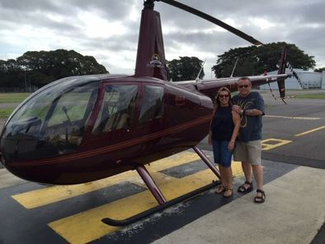
- 10:45am: Your limo driver can have this day off as well, because someone will be picking Nicole and her boyfriend up from their hotel and bringing them to the Sydney Airport Helipad.
- 11:15am: Arrive at the Helipad. You will be welcomed by your private helicopter pilot, who will brief you on the safety guidelines before taking off.
- 11:30am: Get strapped into the helicopter, put on the headsets for two-way communications and lift off.
- 11:30am – 1:00pm: Have fun flying over Sydney Harbour, Sydney Harbour Bridge, Sydney Opera House and year 2000 Sydney Olympic site. You will be heading towards Katoomba. They will get to fly over The Three sisters before landing at Scenic World.
- 1:00pm – 2:00pm: They get to choose between riding the cableway to the valley floor, riding the skyway across the valley, or riding the railway (the steepest inclined railway in the world).
- 2:30pm – 3:00pm: The descent will take you through a cliff side tunnel down into the rainforest. Here you have choices on several short walks. On the walks, explore elements of the site’s coal mining history. They will get to see a replica miners’ hut and scale bronze sculpture of a miner and his pit pony. They will get to learn about the local flora and taste the pure Blue Mountains water straight from the Marrangaroo Spring. During the walk, they can relax a little the open-air Rainforest Room, or on the benches that are located along the route.
- 3:00pm – 4:00pm: Relax and have lunch at the Scenic World Center, overlooking the Jamison Valley.
- 4:00pm – 4:30pm: Return to your hotel, and enjoy the rest of your day doing whatever your heart desires.

Day 4: August 1st
Free day. Enjoy doing whatever you would like to do.

Day 5: August 2nd
The day they travel back to Vancouver.
- 7:00am: Wake up, enjoy breakfast and get ready to head back home.
- 8:30am: Hop in your limo, and drive to the Sydney Airport.
- 9:00am: Check into the Airport, get through security.
- 10:10am: Depart from the Sydney Airport, and head towards Vancouver BC.

Transportation back to Vancouver
Nicole and her boyfriend will be flying a 14-hour business class non-stop flight back to Vancouver BC. They will arrive in Vancouver at the Vancouver International Airport on August 3rd at 7:30am. From the airport, there will be another limo driver waiting for them to drive them back to her house. They will leave the airport around 8:00am, and arrive back home at 8:30am, where they are free to share the stories of their great experiences.
https://www.viator.com/tours/Sydney/Bondi-Local/d357-2458P6
https://www.viator.com/tours/Sydney/Underwater-Scooter-Tours/d357-15755P1
https://www.viator.com/tours/Sydney/Blue-Mountains-Full-Day-Tour/d357-10784P9

