A La Carte

Sturgeon and risotto

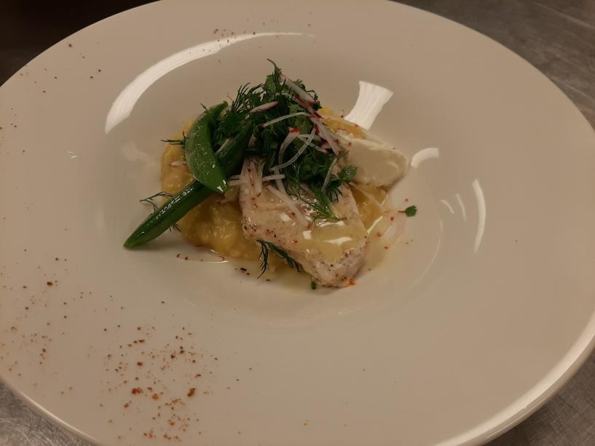

Green salad with walnut
- Walnuts should be roasted
- Dressing should cover all the greens
- All plates should have the same amount
- Cut the brie cheese at serving time

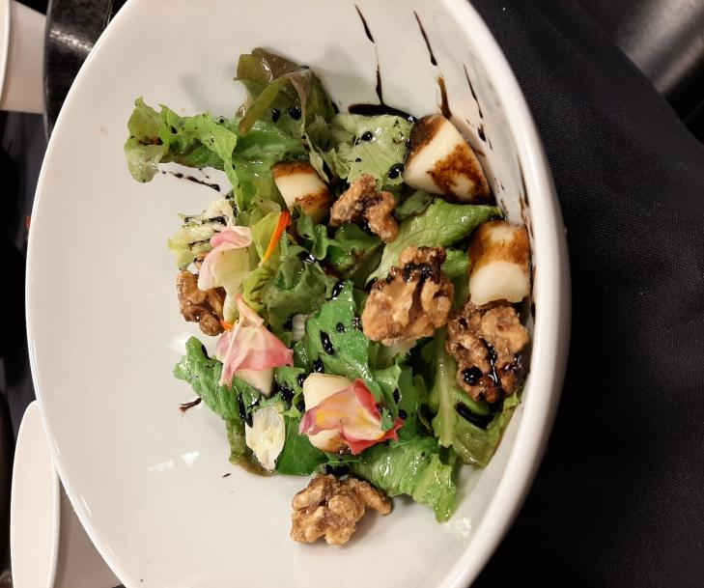

Turkey dinner plate

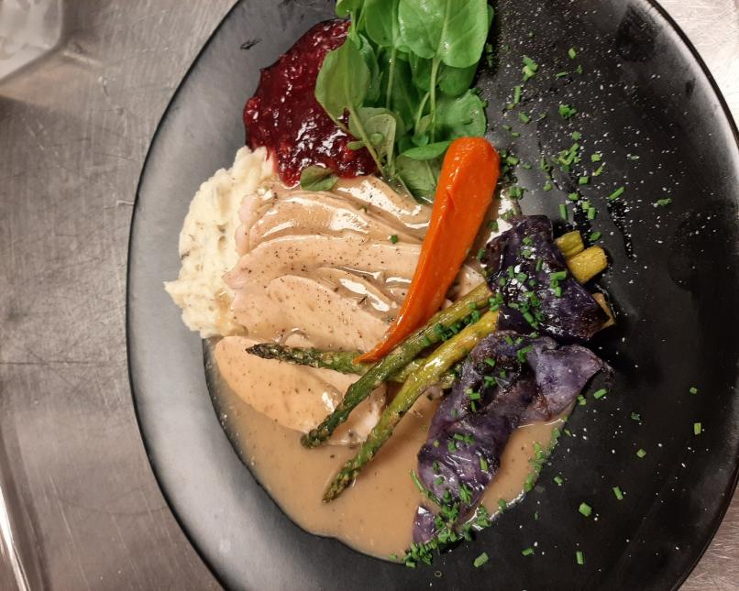

Cholate Flan
- Mix Milk, salt, sugar, cinnamon stick, vanilla bean, orange zest heat it up.
- Mix with melted chocolate. Temper eggs and mix it into the mixture.
- Make the caramel and divide into molds, roll the molds to cover the bottom
- Strain flan and divide into molds, have boiling water ready for water bath
- 375F 30 mins check every 10 min

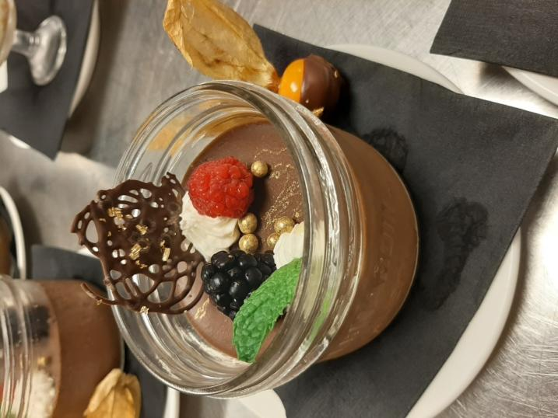

Caesar salad

Used fresh lettuce leaf with Caesar salad dressing for garnish crouton fresh grape and on top parmesan cheese

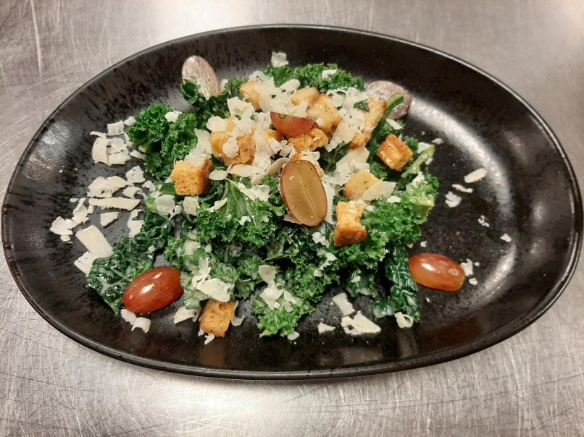

World cuisine
Akoho sy voanio (chicken in coconut milk)
- Fabric style cutting chicken
- Using peanut oil for browning the chicken after add stock bring boil and simmered with correct ingredient’s until meat tender
- Taste is a rich curry flavored with coconut milk Serve with grill lemon with large sauté pan

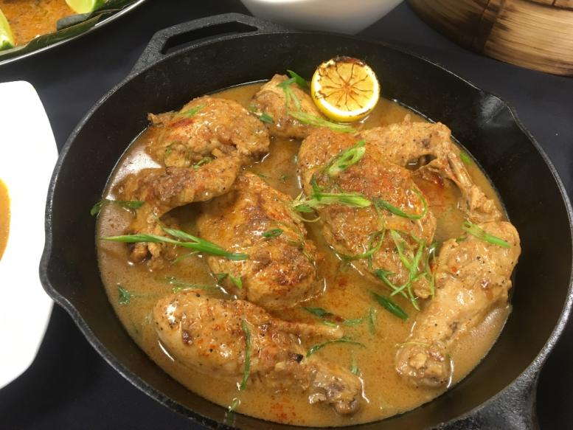

Akara (black-eyed pea fritters)

- Akara as bean cakes or beans balls
- clean the beans skins crush it make peas paste
- shape the beans paste small balls and deep fry until crispy golden
- akara is popular in west Africa this dish cooking for the breakfast meal
traditionally deep fried in dende wich means is deep fried in palm oil.
- Served in large bamboo bowl with sliced lemon and African hot sauce

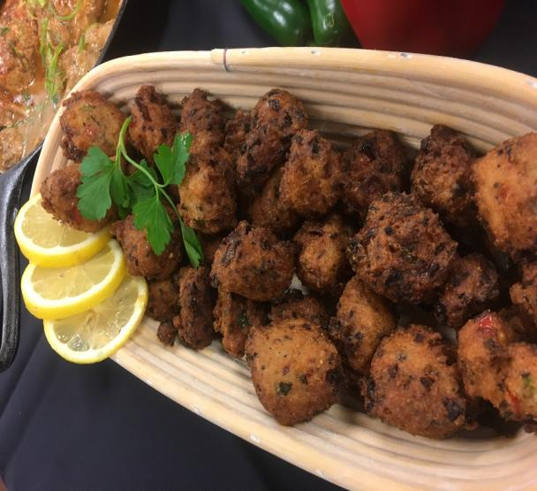

Samaki wa kupaka (grilled fish)
- Clean the fish skiing take out the bones cut the fillet
- Prepare the paste for fillet fish for paste ingredients grind ginger garlic crush and green Chile
- We used banana leaf, roll up the fish with banana leaf and cooked on grill until fish is cook juice
- Prepared sauce with coconut milk, tamarind, garam masala and seasoning
- Tamarind is from leguminous tree grown tropical Africa
- Served large square plate with banana leaf with coconut sauce

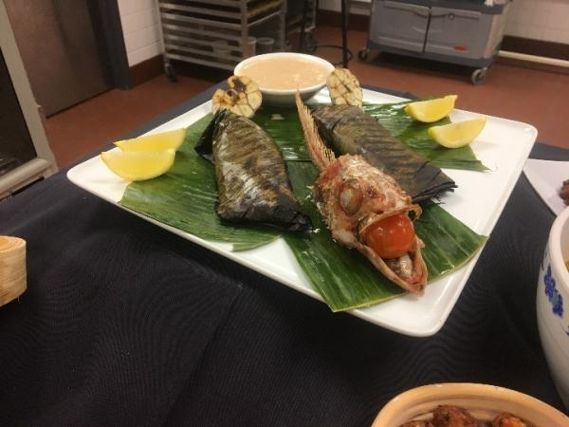

Kaklo (banana and Chile fritters)
Kaklo can be served cold and warm plate. cold serve more snack warm is more lunch dishes
We served for snack cut the plantain to length and thine
Toss the spices into the sliced banana mix well and depp fry until crispy brown
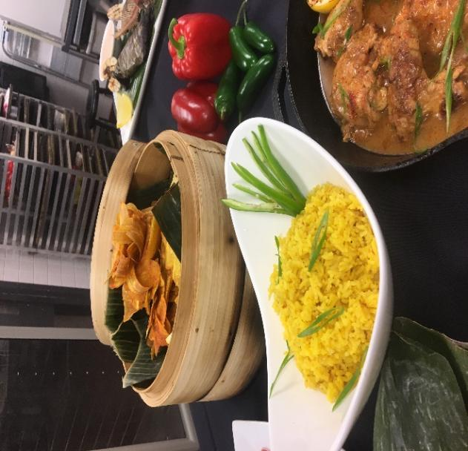

Mescouta (Date Cookies)

For the mescouta cooking method is baking 350F
Mix the all ingredients well and bake about 30 min
Main ingredients is nuts
Served with strawberry and fresh mint leaf on the top powder sugar
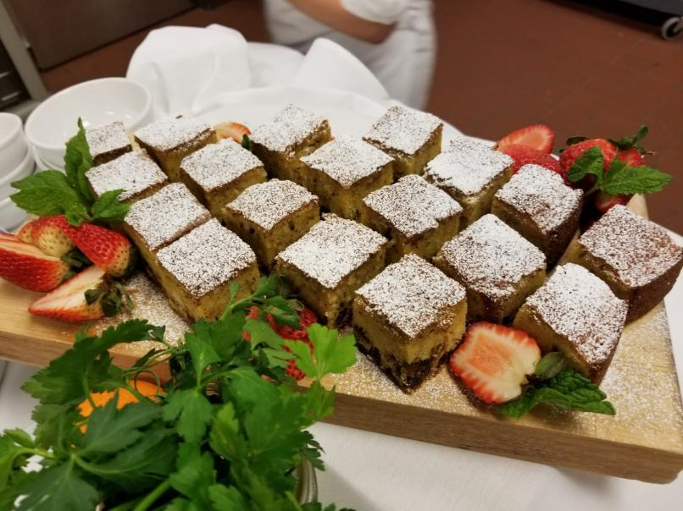

Carrots with Black Currants
Cut the carrot julienne and peeled
Soak in the hot water and covered about 30 min
After mix all ingredients and simmering until reduce the liquid and carrot until tender
Serve on plate with chop parsley for garnish
Black currants is family of the berries.
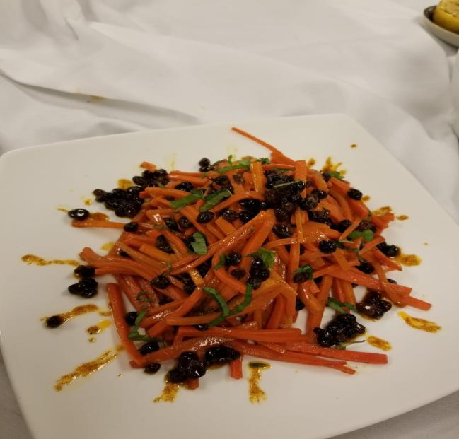

Fava Bean Salad
For beans cooking method is boiling
Beans should be very tender but not cook until mushy after boiled drain it(boil with onion after discard the onion
Fava beans has another name as well, this are broad bean or fava bean
Fava beans is a species of flowering plant in the pea and bean family Fabaceae.
Serve with olive for the garnish

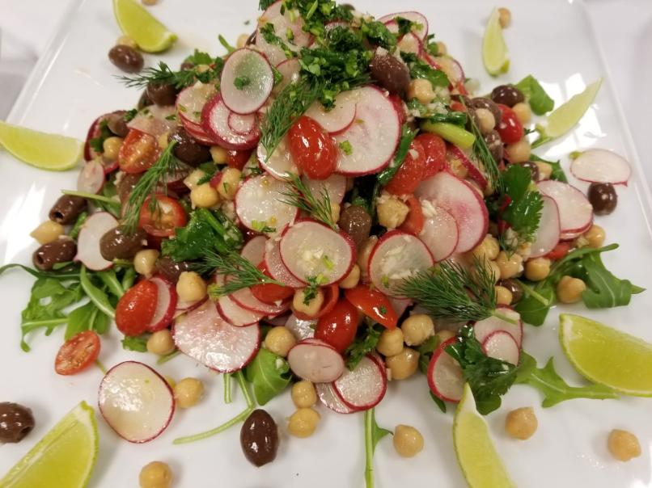

Squid with Caramelized Onions
- Caramelize the onions on a low heat until onions caramelized about 20 min.
- Make the squid cut flat and, on the squid make it small cut this is help the squid shape
- you can cook the squid in batches to ensure you don’t overfill the pan.
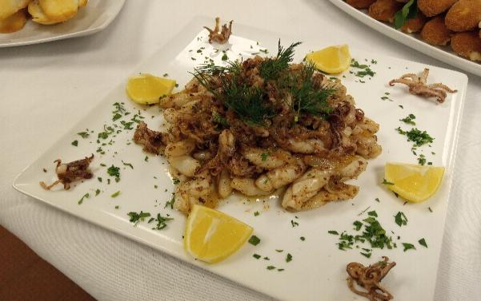

Serrano Ham Fritters
- Important is same shape and size
- Color should be golden brown

- Make sure your mixture is not sticky when you try to roll it out.

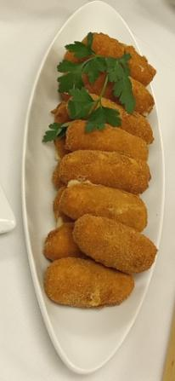

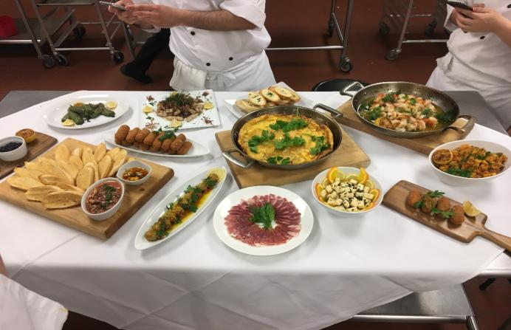

Tomato Toast

- Before the toast the bread makes a garlic with olive oil and chili powder use on the slice bread.
- Do not Scrub the tomatoes on the bread because bread needs to be crispy tomato sauce just for dipping sauce.

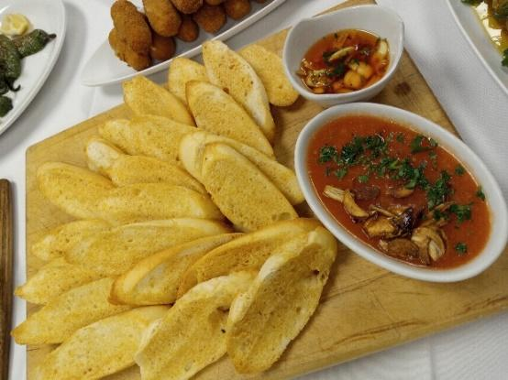

North cuisine

Roast Duck breast w/ Parsnip Puree and Blueberry Sauce
- Seasoning the roast duck breast
- Cook the roast duck breast in sauté pan
- First cook skinny side until crispy golden brown about 15 min medium heat
Parsnip Puree
- Cube cute Knife skill
- Parsnip into the large sauce pan add cream and butter simmered
- Make it puree with food mill
- Puree should be smooth
Blueberry sauce
- Boiled the blueberry with sugar and other ingredients
- Use the duck juice to make sauce, juice giving the more flavor
- Sauce should be thick
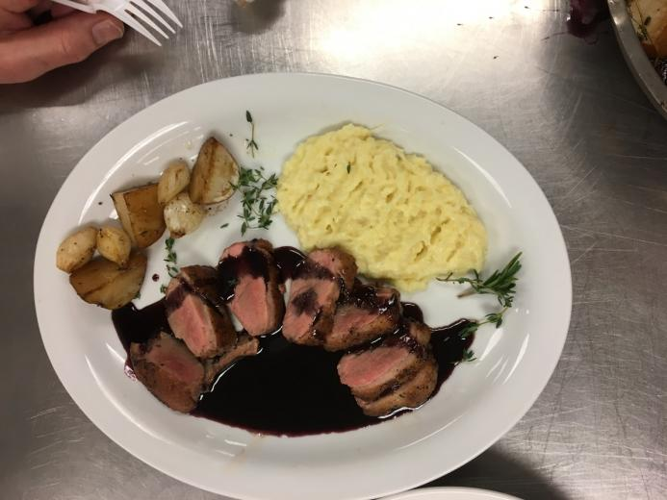

Chery muffin
Menu products;
Vegetable oil
eggs
Granted sugar
All dry ingredients all together stir;
Bread flour, Baking powder, Baking soda
Chery
Method;

Mixing the all ingredients and creaming. cooking 375 F about 30 minutes until muffins get golden brown.
Before the cooking, muffins pan should be put oil after tossing little bit flour for stickiness.
Muffins taste was good but looks are not well. because my group mate when his drop the muffin cream in a pan he presses the cream into the pan.
Timeline of my production
Chery muffin baked takes about 30 minute, calculate and prepped the all ingredients 20 min. in the total takes 50 minute.

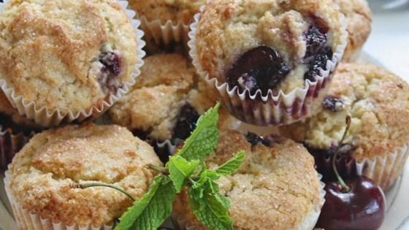

Soft yeast dinner rolls
Menu products;
Yeast into the small amount water active the yeast
Bread flour
Salt
Sugar
Milk
Unsalted butter
Eggs
Egg wash
Method;
Add the yeast in warm water wait for yeast active after that make dough. Knead the dough until dough get soft and smooth.
Wait for the ferment until doubled about 1 hour. after that divide the dough and shape it like (8) after shape wait for proofing. Each bread calculated 30g dough .
Bake 400F until bread get brown about 12 to 15 minutes.
Timeline of my production
1 hour fermented ,20 min prepared 12 min baked total 1hour 35 min.
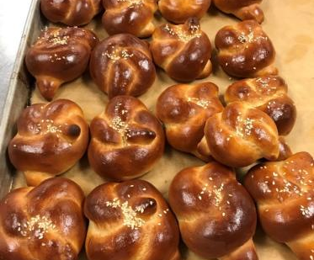

sandwich bread
Menu products;
Warm water with yeast
Dry milk powder
Sugar
Salt
Lour bread flour and whole flour
Eggs
Egg wash
Method

- straight dough method
- Combine the eater, milk powder, sugar, salt, yeast. Then stir in remaining flour and knead until the dough get mixture well.
- Place the dough to ferment at room temperature until double around 1-2 hours.
Divide the dough into 4 pieces, roll and shape into greased loaf pan and proof until double size. Then brush with egg was

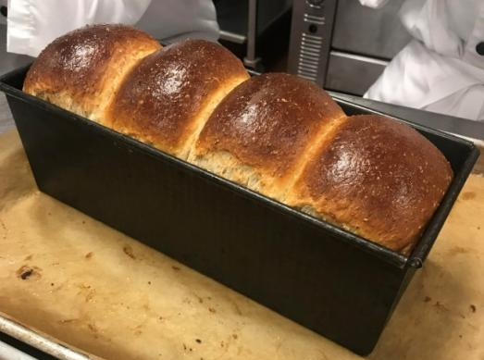

Baguette
Menu products;
Bread flour 720 g
Old dough 255g
Active fresh yeast 18 g or active dry yeast 25g
Water 457 ml -15.25 oz

Method;
Straight dough method. After making a paper towel, spread it long enough to form a shape, then bake it again. At this time, place the modified dough on a French cloth and insert the cloth between the loaves on the bread that does not stick together when it is baked
When modifying an accompaniment, the dough is not well prepared due to its elasticity. At that time, the dough is modified with time for the writing routine to increase
Timeline of my production
1 hour fermented ,20 min prepared 12 min baked total 1hour 35 min.
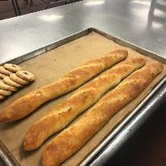

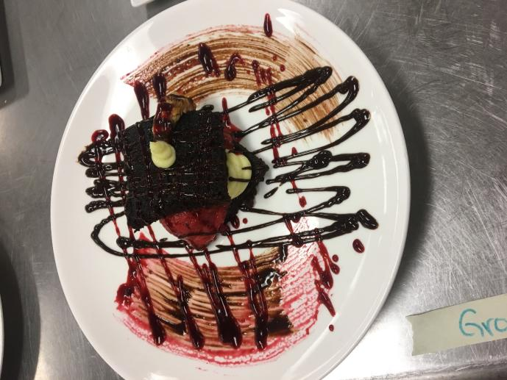

Ice Cream Base
Combine the milk cream and vanilla bean in the pan bring boil and another bowl whisk egg yolks and sugar. Temper the egg mixture into the milk (do not cook egg) cook until 185F until thickened. before the ice cream machine cool it ice cream base.
Pastry Cream
bring the milk, sugar and vanilla beans a saucepan after add corn starch, at the same time whisk egg yolks in another mixing bowl and combine.

Chocolate Cake

First whisking egg sugar in mixer bowl until eggs are turn creamed. Take out portion of the genoise batter mix with malted butter. after mixed cake flour and cocoa powder together and sift it on piercement paper folding pour in a mixed whipped egg and keep mix until mixture get thick about 12 to 15 minutes. After that prepared cake mold. before the drop the cake mixture in a cake mold pour the butter mixture in a cocoa mixture after that drop the cake mixture in a cake mold. bake 420F until light brown. after baked take out cake mold.
Melted chocolate sauce: melt the chocolate with butter mix and ready to use.

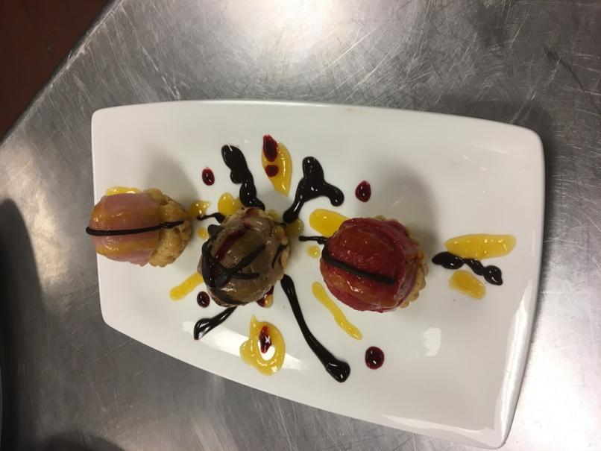

Sorbet
Combine sugar with zest salt and water in a saucepan and set over high. stirring until dissolved. pour cold sorbet mixture into the ice cream maker after chill freezer.
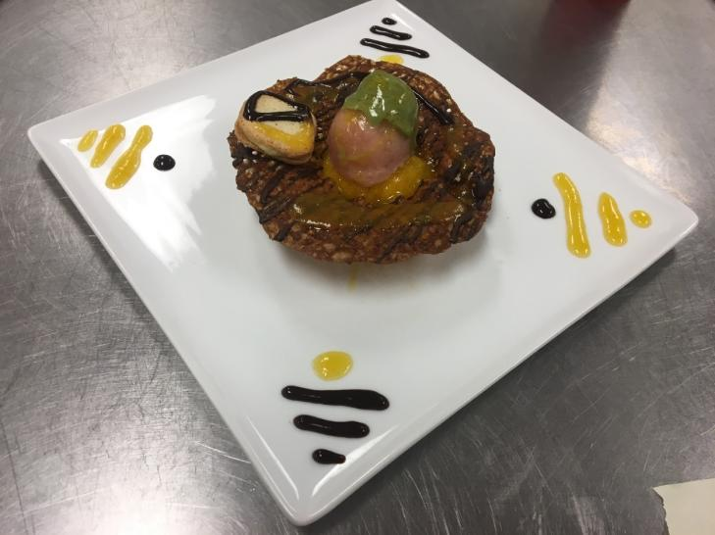

Tuiles
Mix 4 ingredients use creaming method, making spooning onto the baking sheets. only use small amount of cookie dough because they’ll spread.

