



**The Final Term Project**

**SUSTAINABLE PURCHASING & CONTROLLING COSTS**

CUL136 sect. 10001

***Chef Corbin Venida***

**ShunziSanyi(Betty)** Student ID **1920064**

**Feddy Halabi Troisi** Student ID **1840036**

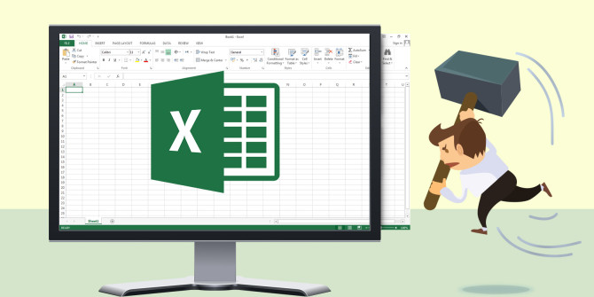

13 of December 2019

**RECIPE CARDS**

**Recipe # 1**

**GNOCCHI WITH BOLOGNESE SAUCE AND PEAS STEWED WITH BACON**

* 1. 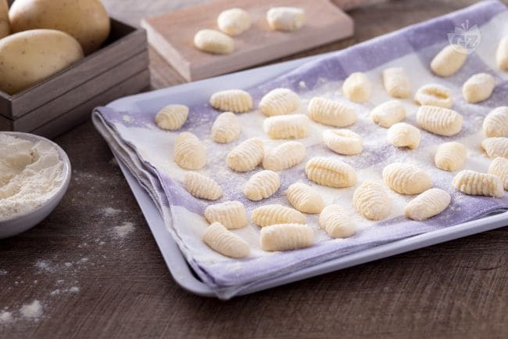**GNOCCHI**
  2. **BOLOGNESE SAUCE**
  3. **PEAS STEWED WITH BACON**

**Components:**

* CARBOHYDRATES
* PROTEIN
* VEGETABLES

***1.1GNOCCHI***

|  |
| --- |
| Image result for simboli in cucina attrezzi***Preparation: 20 min***Image result for simboli in cucina attrezzi***Cooking: 40 min***Image result for simboli in cucina attrezzi***Yield: 60 PORTIONS*** |
|  |
| |  |  | | --- | --- | | **LIST OF PRODUCTS** | ***YIELD: 60 PORTIONS*** | | Potatoes | 15 Kg | | All Purpose Flour | 4.5 Kg | | Eggs | 15 unit | | Salt | 300 g | |

* ***LIST OF EQUIPMENT:***
* 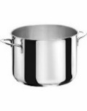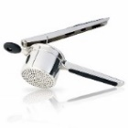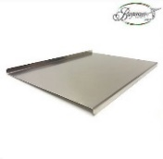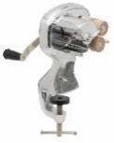*POT*
* *MASHER*
* *STEEL PASTRY BOARD*
* *GNOCCHI MACHINE*
* ***METHODOLOGY:***

Boil the potatoes in large pots, where the potatoes are placed covered with plenty of cold water **(FIGURE 1)**.

From the boiling of the water, count about 30-40 minutes (the fork test and if the tines enter without difficulty in the middle of the potatoes they are ready). Peel the potatoes while they are still hot, and crush them on the flour that will already be on the steel pastry board **(FIGURE 2)**.

Add the lightly beaten eggs together with a pinch of salt **(FIGURE 3)**.

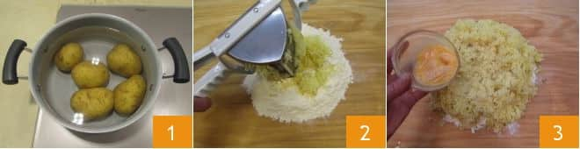

To mix everything **(FIGURE 4)** until you get a soft but compact mixture **(FIGURE 5)**. To remember that when to work them too much, the dumplings will become hard during cooking, so just to mix the necessary. To take a part of the dough and to spread it, to obtain strands, 2 cm thick **(FIGURE 6)**; always cover the remaining dough with a cloth to prevent it from drying out.

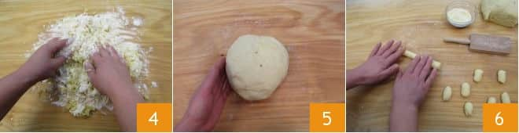

As the potato gnocchi come out of the machine, place them on a tray with a lightly floured cloth, well spaced from one another, when is full, to put it in the freezer for about 20 minutes, after which it will be possible to prepare the portions, placing the potato dumplings in a food bag and to continue until you have frozen them all. To cook them, just throw them in boiling salted water without thawing them first.

***1.2 BOLOGNESE SAUCE***

***Preparation: 20 min******Cooking: 210 min******Yield: 60 PORTIONS***

|  |  |  |  |  |  |  |  |  |  |  |  |  |  |  |  |  |  |  |  |  |  |  |  |  |  |  |
| --- | --- | --- | --- | --- | --- | --- | --- | --- | --- | --- | --- | --- | --- | --- | --- | --- | --- | --- | --- | --- | --- | --- | --- | --- | --- | --- |
| |  |  | | --- | --- | | **LIST OF PRODUCTS** | ***YIELD: 60 PORTIONS*** | | Beef Ground | 7.5 Kg | | Pork Ground | 3.75 Kg | | Tomato sauce | 3.75 Kg | | Celery | 750 g | | Onions | 750 g | | Carrots | 750 g | | White wine | 3.75 Lt | | Olive Oil | 230 ml | | Water | 45 Lt | | Milk | 600 ml | | Salt | 300 g | | Black Pepper | 300 g | |

* 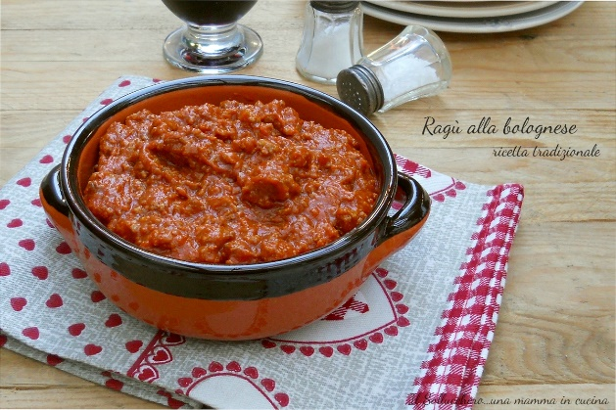***LIST OF EQUIPMENT:***
* *KNIFE*
* *COOKING PAN*

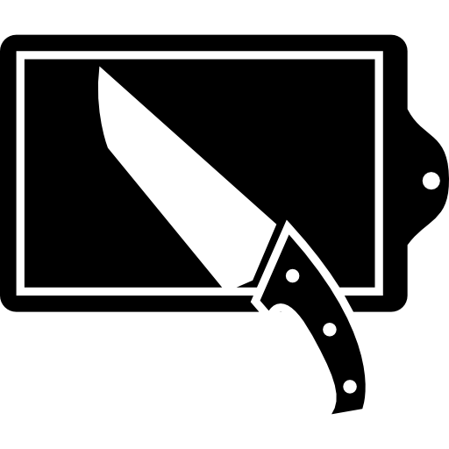

* ***METHODOLOGY:***

Finely chop the celery **(FIGURE 1)**, peeled and blunted carrot **(FIGURE 2)** and peeled onion **(FIGURE 3)**.

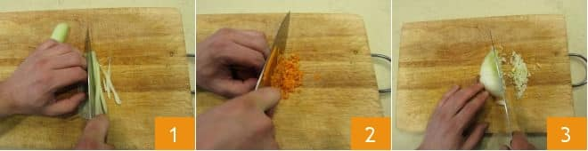

Pour the oil into a saucepan and add the mince, cook 10 minutes over low heat, stirring from time to time **(FIGURE 4)**. After this time, the fried must have withered and the bottom of the pan is dry. Add the coarsely minced meat **(FIGURE 5)** and the ground pork **(FIGURE 6)**.

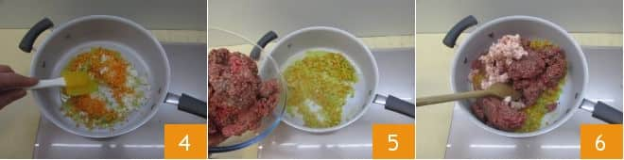

Brown slowly for about 10 minutes, stirring occasionally. Initially all the juices will come out, but once dry it is possible to blend with white wine **(FIGURE 7)**. As soon as the alcohol has evaporated and the bottom is back and is dry, add

the tomato puree **(FIGURE 8)**. Pour only ½ of the total water liters **(FIGURE 9)**

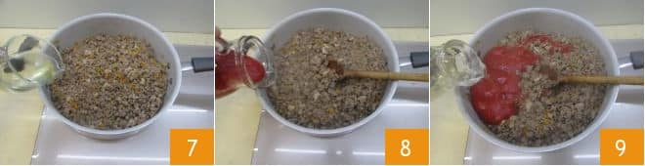

Add necessary salt, stir and cook over medium-low heat for one hour. After the first hour, add ½ of the remaining water, stir and cook for another hour. At the end of the second hour of cooking, pour the remaining water, and continue to cook over low heat for another hour. In this way the sauce will cook for at least 3 hours **(FIGURE 10)**. At the end of cooking the result will be very dry, season with salt and pepper, turn off the heat and add the milk **(FIGURE 11)**; mix again **(FIGURE 12)**!

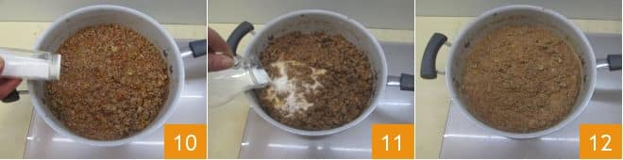

***1.3 PEAS STEWED WITH BACON***

***Preparation: 5 min******Cooking: 30 min******Yield: 60 PORTIONS***

|  |  |
| --- | --- |
| **LIST OF PRODUCTS** | ***YIELD: 60 PORTIONS*** |
| Frozen peas | 9 Kg |
| Salt | 200 g |
| Black pepper | 200 g |
| Fresh spring onion | 30 unit |
| Smoked bacon | 1.5 Kg |
| Nutmeg | 60 g |
| Olive oil | 750 ml |

* ***LIST OF EQUIPMENT:***
* 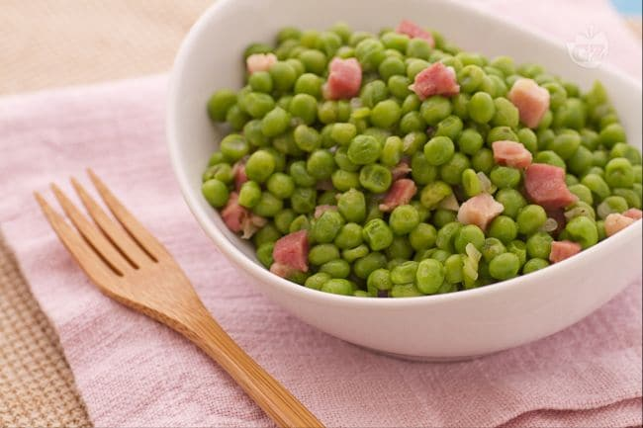*POT*
* *KNIFE*
* *COOKING PAN*

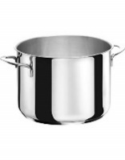

* ***METHODOLOGY:***

To put a pot of water on the fire and keep it always warm, so that it can be added to the peas once cooked. Clean and finely chop the onion **(FIGURE 1)** and cut the smoked pancetta into small pieces. To put a pan on the stove with oil and toss the chopped onion **(FIGURE 2)** and the bacon to brown it **(FIGURE 3)**,

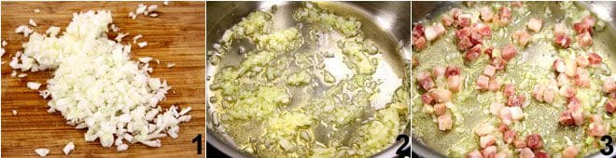

add the peas **(FIGURE 4)**, and on a low heat, stir for a few minutes. Salt the peas and add a ladle of hot water **(FIGURE 5)** and continue cooking, covering the pot with a lid but leaving a small vent; add hot water as the peas dry, until cooked, then season with salt, pepper and add a nice grated nutmeg **(FIGURE 6)**.

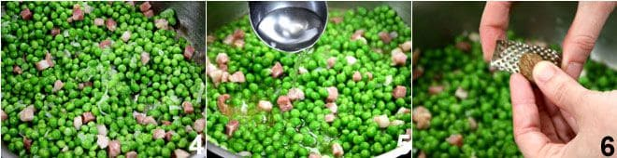

**Recipe #2**

**BAKED CANNELLONI & ZUCCHINI SALAD MINT and BASIL**

* 1. 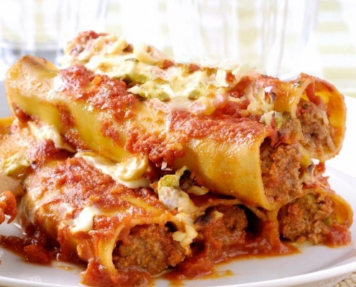***CANNELLONI***
  2. ***FILLING***
  3. ***ZUCCHINI SALAD***

**Components:**

* CARBOHYDRATES
* PROTEIN
* VEGETABLES

**2.1 BAKED CANNELLONI 2.2 FILLING**

***Preparation: 90 min******Cooking: 50 min******Yield: 60 PORTIONS***

***(240 units)***

|  |  |
| --- | --- |
| **LIST OF PRODUCTS** | ***YIELD: 60 PORTIONS*** |
| All Purpose Flour | 4.5 Kg |
| Eggs | 45 un |
| Tomato Sauce | 3.75 Kg |
| Olive Oil | 825 ml |
| Garlic | 15 unit |
| Milk | 3.75 Lt |
| Butter | 375 g |
| Graund Pork | 3 Kg |
| Graund Beef | 4.5 Kg |
| Onions | 1.2 Kg |
| Celery | 900 g |
| Carrots | 1.2 Kg |
| Red Wine | 300 ml |
| Parmesan Cheese | 1.75 Kg |
| Salt | 200 g |
| Black Pepper | 150 g |
| Nutmeg | 80 g |

* ***LIST OF EQUIPMENT:***
* *SIEVE FOR FLOUR*

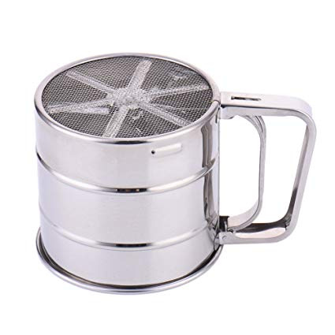 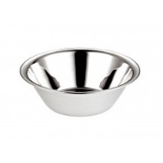 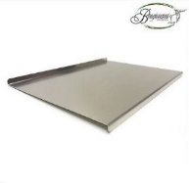 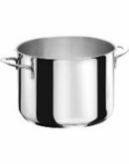

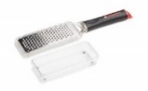  

* *BOWL*
* *STEEL PASTRY BOARD*
* *POT*
* *GRATER*
* *KNIFE*
* *COOKING PAN*
* *PASTA MAKER MACHINE*

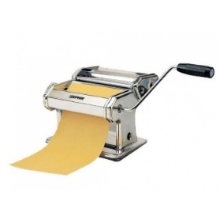 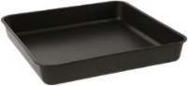 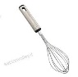

* *BAKING SHEET*
* *WHISK*
* ***METHODOLOGY:***

Make the egg pasta. To place the flour in a large bowl **(FIGURE 1)** and the eggs previously beaten **(FIGURE 2)**. To knead **(FIGURE 3)** until a uniform mixture is obtained.

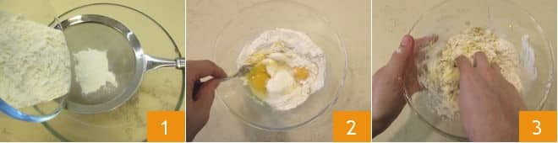

Transfer the dough onto a work surface **(FIGURE 4)** and work it until a smooth dough is obtained, giving the shape of a sphere **(FIGURE 5)**. Wrap the dough in plastic wrap **(FIGURE 6)** and let it rest for about 1 hour.

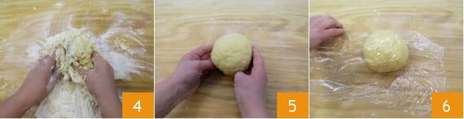

Prepare the sauce by pouring the necessary oil into a pan, add the garlic, let it brown and pour the tomato puree **(FIGURE 7)**. Season with salt and pepper **(FIGURE 8)**, cover with a lid and cook over moderate heat for about 30 minutes **(FIGURE 9)**, to stir occasionally.

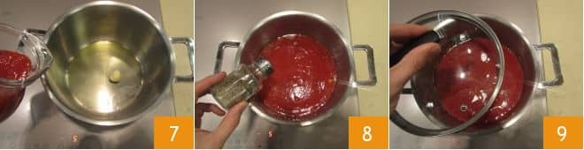

During this time, make the béchamel by pouring the butter into a pan **(FIGURE 10)** and let it melt. Add the sifted flour **(FIGURE 11)** and mix quickly with a whisk. Once you have obtained a slightly brown roux, pour the hot milk **(FIGURE 12)** and continue stirring.

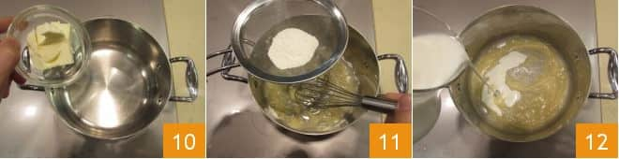

Add salt, pepper **(FIGURE 13)** and to add nutmeg **(FIGURE 14)**. Let the béchamel thicken, stir constantly, pour it into a bowl and cover it with the plastic film **(FIGURE 15)**.

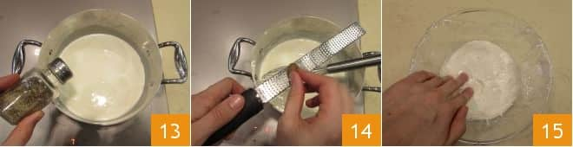

To prepare the filling, first prepare the sauté by finely chopping carrot, celery and onion **(FIGURE 16)**. Then transfer to a pan with a little oil and add the minced meat **(FIGURE 17)**. Remove the sausage from its casing **(FIGURE 18)** and crumble it with your hands.

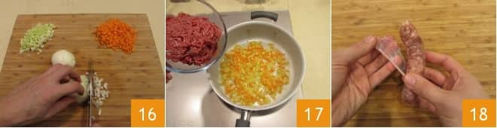

To combine the sausage in the pan **(FIGURE 19)** and let it all brown, stirring often. Season with salt and pepper and deglaze with red wine only when the meat has changed color **(FIGURE 20)**. Cook for another ten minutes, then pour into a bowl. Once the meat has cooled, to add the eggs **(FIGURE 21)**,

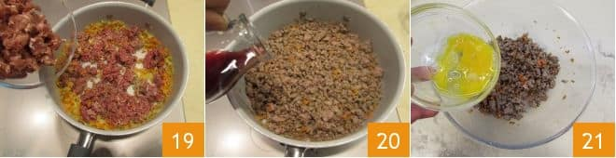

the grated Parmesan **(FIGURE 22)** and mix everything **(FIGURE 23)**. Take the egg pasta and to divide the dough in half **(FIGURE 24)**.

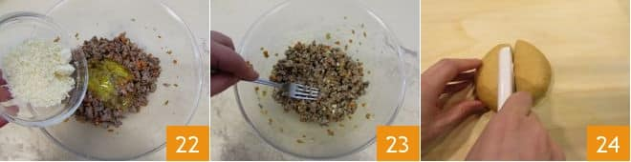

Spread the two halves with a sheeter **(FIGURE 25)** up to the thickness 8 **(FIGURE 26)**, so as to obtain a thickness of about 1-2 mm and from each sheet obtain rectangles with the dimensions of 14 X 9 cm **(FIGURE 27)**.

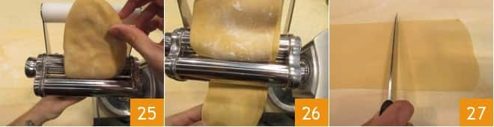

Blanch for 1 minute a rectangle of dough at a time in plenty of lightly salted boiling water **(FIGURE 28)** and place the pasta in a tray **(FIGURE 29)**; spread the various rectangles perfectly, without overlapping them. To fill the cannelloni by placing some stuffing on the shorter part of the rectangle and roll them up **(FIGURE 30)**.

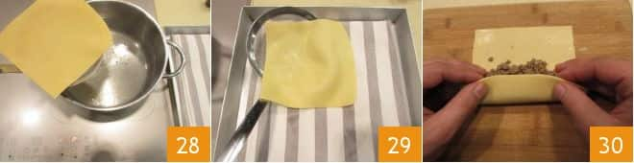

Roll up the cannelloni **(FIGURE 31)**, spread a little béchamel, a few tablespoons of sauce **(FIGURE 32)** in a pan and lay the cannelloni side by side. Cover the surface of the cannelloni with the remaining béchamel and sauce **(FIGURE 33)**

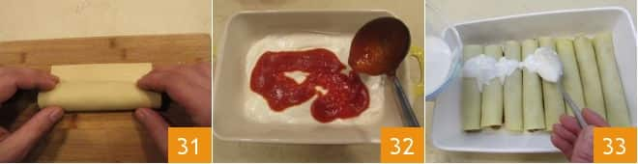

and dust the surface with grated Parmesan **(FIGURE 34)**. Cook for 15 minutes in a preheated static oven at 180 ° for 15 minutes and then for 3 minutes by operating the grill function **(FIGURE 35)**, serve the cannelloni while still hot **(FIGURE 36)**!

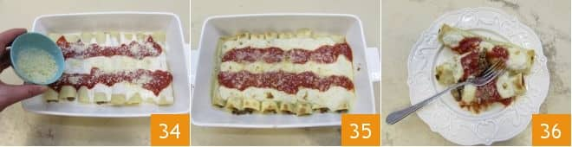

**2.3 ZUCCHINI SALAD WITH MINT & BASIL**

***Preparation: 20 min******Cooking: 10 min******Yield: 60 PORTIONS***

|  |  |
| --- | --- |
| **LIST OF PRODUCTS** | ***YIELD: 60 PORTIONS*** |
| Zucchini | 12 kg |
| Basil | 60 leaves |
| Mint | 60 leaves |
| Coarse salt | 150 g |
| Extra virgin olive oil | 200 ml |
| Salt | 150 g |
| Black pepper | 150 g |
| Garlic cloves | 15 unit |

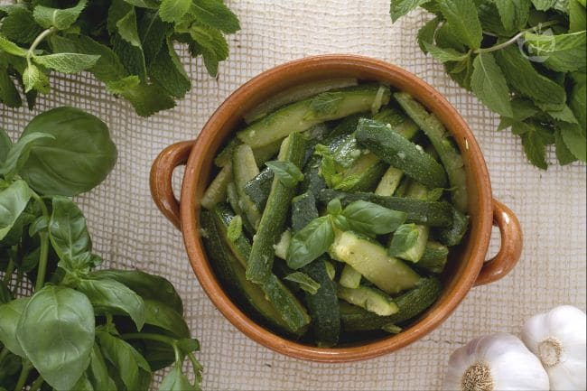

* ***LIST OF EQUIPMENT:***
* *KNIFE*
* *POT*
* *COLANDER*

 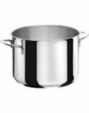 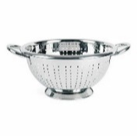

* ***METHODOLOGY:***

Carefully wash the zucchini under running water **(FIGURE 1)**. Dry with a cloth and place them on a cutting board, then clean them, removing the two ends **(FIGURE 2)**. To divide the zucchini in half **(FIGURE 3)**.

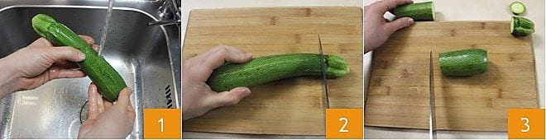

To cut it again in half lengthwise **(FIGURE 4)** and begin to make slices about 1, 5 cm wide **(FIGURE 5)**. To take a large pot, to fill it with water and bring to a boil. Pour the sliced zucchini in boiling water **(FIGURE 6)**.

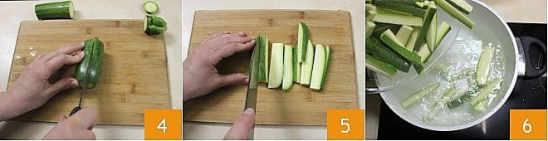

Add a tablespoon of coarse salt **(FIGURE 7)** and cook for 10 minutes. After 10 minutes, drain the zucchini with a colander and let them cool **(FIGURE 8)**. Transfer them to a baking dish and season them with a drizzle of Olive Oil **(FIGURE 9)**.

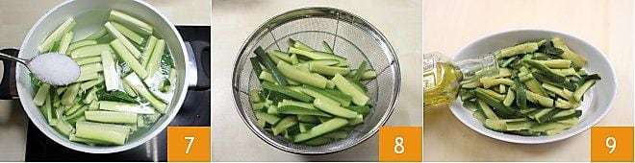

Season the zucchini with salt and pepper to taste **(FIGURES 10-11)** and add a clove of garlic **(FIGURE 12)**.

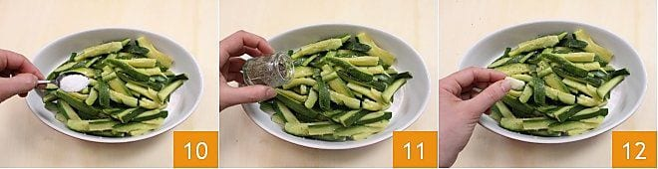

Then add the chopped mint leaves **(FIGURE 13)** and the basil leaves **(FIGURE 14)**. To mix everything with a fork **(FIGURE 15)**.

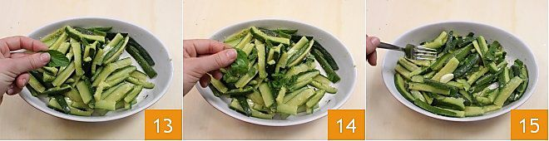

**Recipe #3**

**SCALOPPINE WITH POTATO PUREE & GRILLED VEGETABLES**

* 1. ***SCALOPPINE***

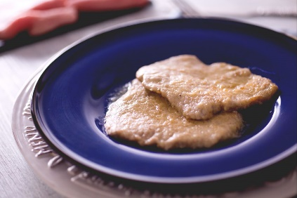***3.2 POTATO PUREE***

***3.3 GRILLED VEGETABLES***

**Components:**

* PROTEIN
* CARBOHYDRATES
* VEGETABLES

**3.1 SCALOPPINE**

***Preparation: 10 min******Cooking: 10 min******Yield: 50 PORTIONS***

|  |  |  |  |  |  |  |  |  |  |  |  |  |  |  |
| --- | --- | --- | --- | --- | --- | --- | --- | --- | --- | --- | --- | --- | --- | --- |
| |  |  | | --- | --- | | **LIST OF PRODUCTS** | ***YIELD: 50 PORTIONS*** | | Beef slices | 10 kg | | Lemon juice | 1.25 ml | | Butter | 1 Kg | | Salt | 200 g | | Black pepper | 200 g | | Flour | 2.5 Kg | |
|  |

* ***LIST OF EQUIPMENT:***
* *CITRUS-FRUIT SQUEEZER*
* *MEAT MALLET*
* *CUTTING BOARD*
* *FRYING PAN*

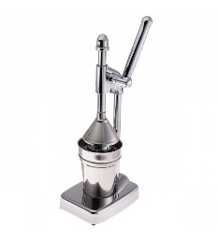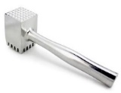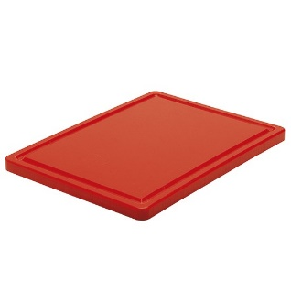

* ***METHODOLOGY:***

To prepare the lemon scalloppine, to start by squeezing the latter to make the juice **(FIGURE 1)**. Beat the slices of beef with the help of a meat tenderizer, covering them with baking paper so as not to break the fibers **(FIGURE 2)**. Striking with a firm hand but without too much violence, in this way the tissues will soften without tearing the pulp **(FIGURE 3)**.

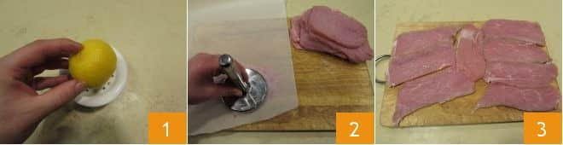

Flour the beef slices **(FIGURE 4)** and remove the excess flour; in a large pan, to melt the butter over low heat, then to add the slices, to raise the heat and brown for a couple of minutes first on one side **(FIGURE 5)** and then on the other **(FIGURE 6)**.

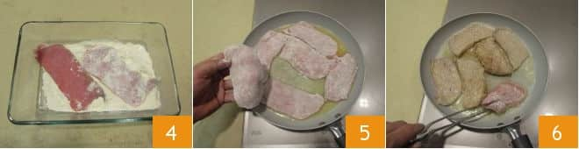

Add salt and black pepper **(FIGURE 7)**, to pour the lemon juice into the pan and cook on a low heat for 2-3 minutes (FIGURE 8). When the sauce starts to thicken and becomes creamy, to turn off the heat and to serve immediately **(FIGURE 9)**!

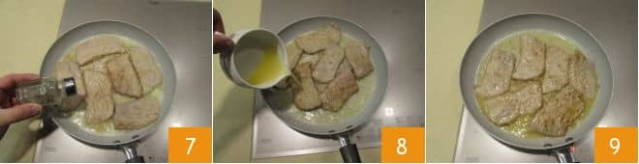

**3.2 POTATO PUREE**

***Preparation: 20 min******Cooking: 60 min******Yield: 50 PORTIONS***

|  |  |  |  |  |  |  |  |  |  |  |  |  |  |  |
| --- | --- | --- | --- | --- | --- | --- | --- | --- | --- | --- | --- | --- | --- | --- |
| |  |  | | --- | --- | | **LIST OF PRODUCTS** | ***YIELD: 50 PORTIONS*** | | Potatoes | 12.5 Kg | | Milk | 2.5 Lt | | Butter | 380 g | | Parmigiano | 380 g | | Salt | 200 g | | Nutmeg | 100 g | |

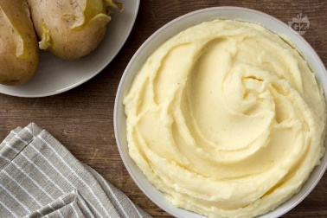

* ***LIST OF EQUIPMENT:***
* *POT*
* *KNIFE*
* *MASHER*
* *PANFUL*
* *GRATER*
* *WHISK*

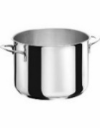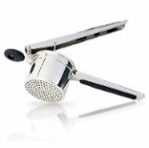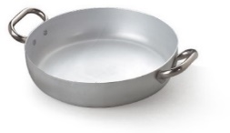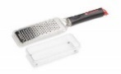

* ***METHODOLOGY:***

Boil the potatoes in a large saucepan and cover with plenty of cold water. After boiling, cook for 40-50 minutes (times vary depending on the size of the potatoes). It is appropriate to do the fork test: if the prongs easily enter then the tubers are cooked **(FIGURE 1)**. Drain and leave to cool for a few minutes **(FIGURE 2)** peel the potatoes when they are still hot **(FIGURE 3)**.

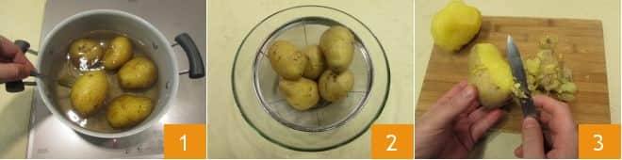

To crush the potatoes with a potato masher, and place them in the cooking pan **(FIGURE 4)**. To add a pinch of salt and a little nutmeg **(FIGURE 5)**. In the meantime, heat the milk in a panful **(FIGURE 6)**.

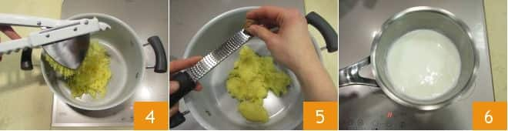

At low heat heat the pot with the puree and pour the hot milk **(FIGURE 7)**, mix with a whisk until it has been completely absorbed **(FIGURE 8)**. To turn off the heat, and stir in the butter **(FIGURE 9)**,

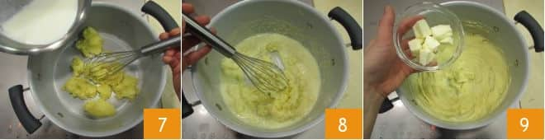

and the Parmesan cheese **(FIGURE 10)**. To mix **(FIGURE 11-12)**!

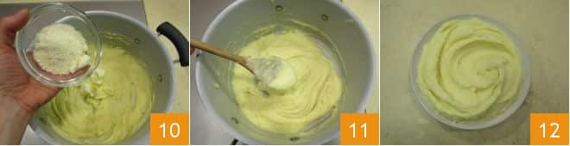

**3.3 GRILLED VEGETABLES**

***Preparation: 20 min******Cooking: 20 min******Yield: 50 PORTIONS***

|  |  |  |  |  |  |  |  |  |  |  |  |  |  |  |
| --- | --- | --- | --- | --- | --- | --- | --- | --- | --- | --- | --- | --- | --- | --- |
| |  |  | | --- | --- | | **LIST OF PRODUCTS** | ***YIELD: 50 PORTIONS*** | | Zucchini | 5 Kg | | Egg Plant | 6 Kg | | Peppers | 10 Kg | | Extra virgin olive oil | 400 ml | | Salt | 300 g | | Black Pepper | 300 g | |

* ***LIST OF EQUIPMENT:***
* *KNIFE*

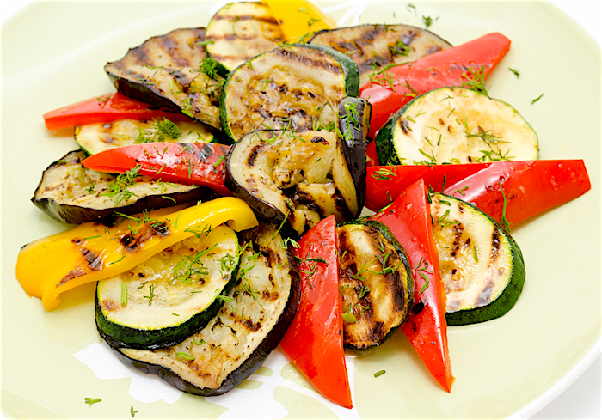

* *GRILL*

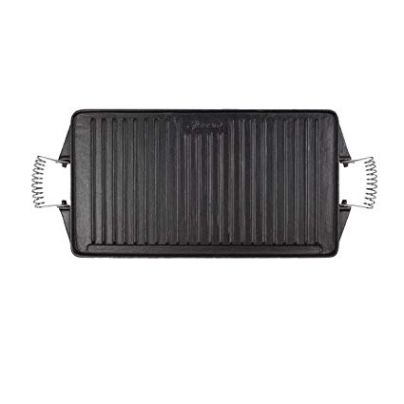

* ***METHODOLOGY:***

Wash all the vegetables, under plenty of fresh running water **(FIGURE 1)** and dry them. Cut the courgettes and Egg Plant into round slices 4-5 mm thick **(FIGURE 2-3)**;

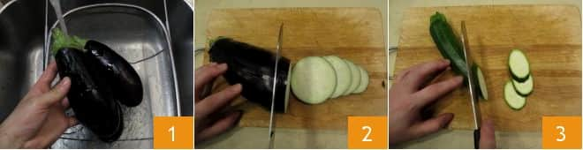

take the peppers, remove the upper part, divide them in half **(FIGURE 4)**, remove the white filaments and the seeds that are inside **(FIGURE 5)**. To cut them into slices, then into rather large cubes **(FIGURE 6)**.

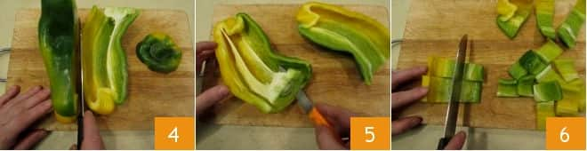

With the grill hot, cook the vegetables a little at a time, distribute the peppers next to each other **(FIGURE 10)**, grill them for 5 minutes and stir them for even cooking **(FIGURE 11)**, then put the courgettes on the heat **(FIGURE 12)**

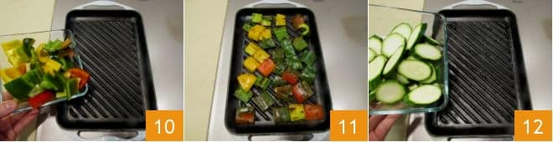

for 3 minutes **(FIGURE 13)** and continue with the Egg Plant for another 3 minutes **(FIGURE 14-15)**. To remember to always turn the vegetables for a homogeneous cooking.

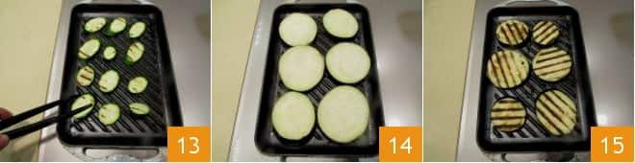

To finish with the tomatoes, to cook them for 4 minutes until they are well grilled**.** Serve the grilled vegetables, seasoning them with olive oil, salt and pepper.

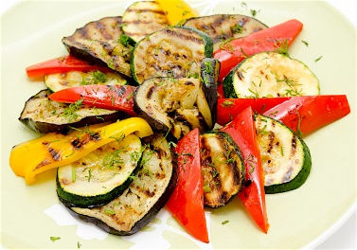

***ORDER GUIDE***



**Supplier: Yen Bros**

**Location: 1988 Vernon Drive, Vancouver, British Columbia V6A 3Y6**



**COST FOR EACH RECIPES:**

1.1 Gnocchi



1.2 Bolognese Sauce



1.3 Pea Stewed w/ Bacon



|  |  |  |  |
| --- | --- | --- | --- |
| 1. ***RECIPE CARD*** | ***AP*** | ***YIELD*** | ***EP*** |
| ***Total Cost Recipe Card*** | ***$ 5.17*** | ***85 %*** | ***$ 5.94*** |

2.1 Cannelloni



2.2 Filling Cannelloni



* 1. Zucchini Salad w/ Mint &Basil





|  |  |  |  |  |  |  |  |
| --- | --- | --- | --- | --- | --- | --- | --- |
| 1. ***RECIPE CARD*** | ***AP*** | | ***YIELD*** | | ***EP*** | | |
| ***Total Cost Recipe Card*** | | | ***$ 3.94*** | | ***90 %*** | | ***$ 4.33*** |

* 1. Scaloppine



3.2 Potato Puree



3.3 Grilled Vegetables



|  |  |  |  |
| --- | --- | --- | --- |
| 1. ***RECIPE CARD*** | ***AP*** | ***YIELD*** | ***EP*** |
| ***Total Cost Recipe Card*** | ***$ 6.33*** | ***70 %*** | ***$ 8.23*** |

***References:***

Giallo Zafferano. “Ricette”. Apr 07, 2019. Web

<<https://ricette.giallozafferano.it/.html>>

<https://ricette.giallozafferano.it/Gnocchi-di-patate.html>

<https://ricette.giallozafferano.it/Ragu-alla-bolognese.html>

<https://ricette.giallozafferano.it/Piselli-stufati-con-pancetta.html>

<https://ricette.giallozafferano.it/Cannelloni.html>

<https://ricette.giallozafferano.it/Insalata-di-zucchine-alla-menta-e-basilico.html>

<https://ricette.giallozafferano.it/Scaloppine-al-limone.html>

<https://ricette.giallozafferano.it/Pure-di-patate.html>

<https://ricette.giallozafferano.it/Verdure-grigliate.html>