Portfolio
Color theory by charis adeline
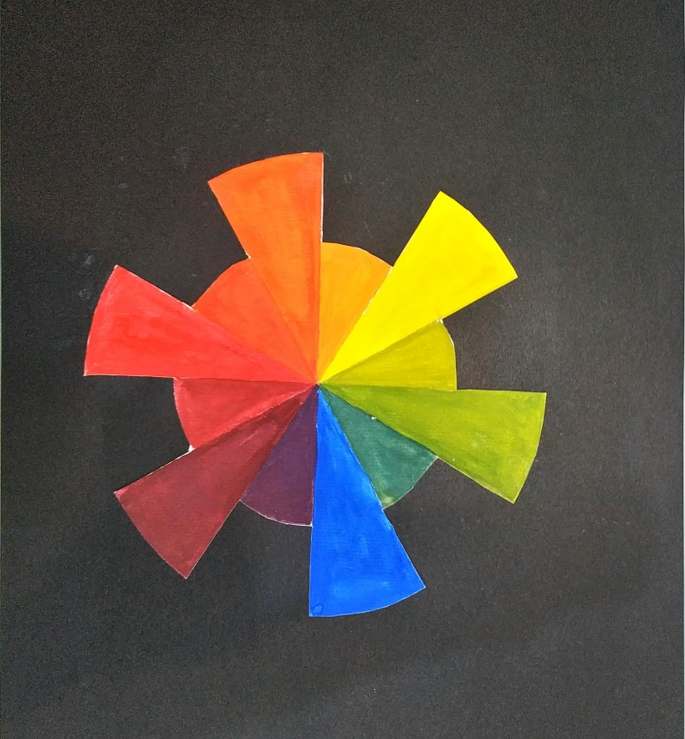
project 1: color wheel

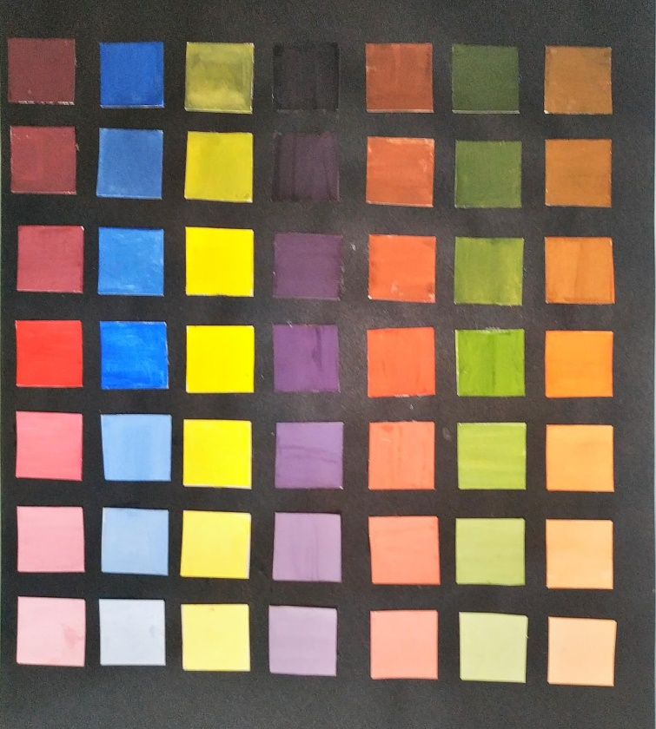
Project 2: value
Project 3: color analysis
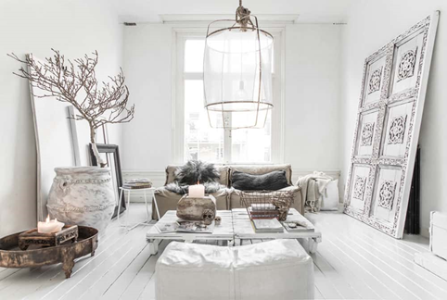

White color:
White (#FFFFFF) creates a refreshing and clean look in your home. It also creates airy appearance and clean look for rooms. White for walls will create a spacious look into a small room.
White may also give the impression that it looks much higher than it is and will give an invigorating freshness
to the room.

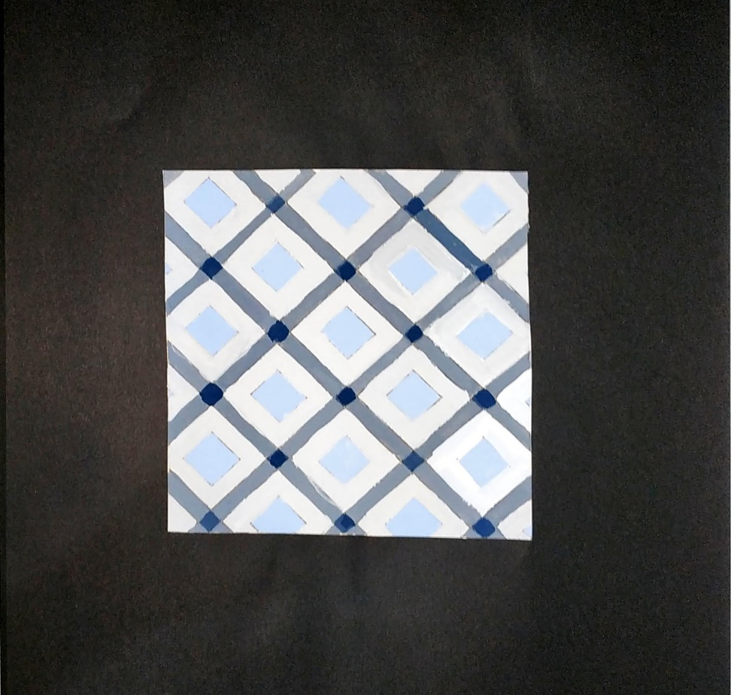
project 4: tone

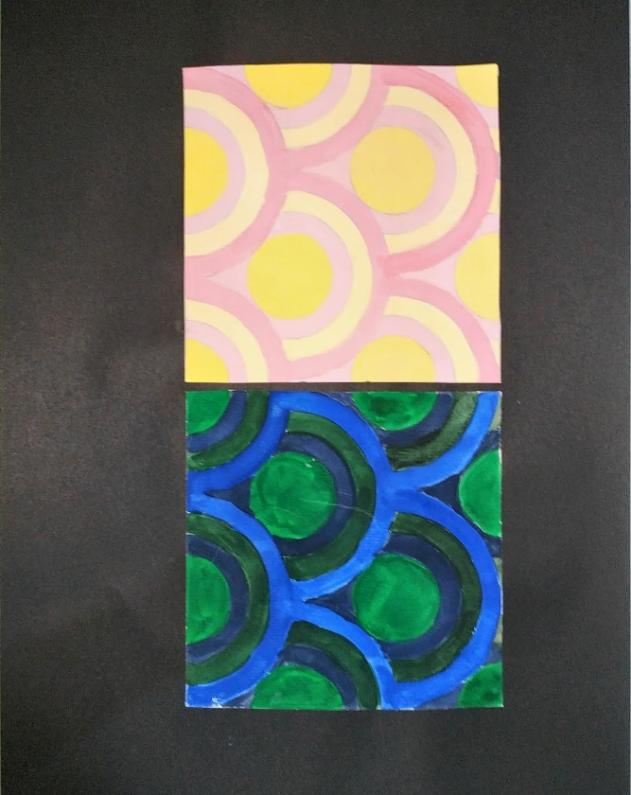
Project 6: warm and cool color
project 7: color scheme
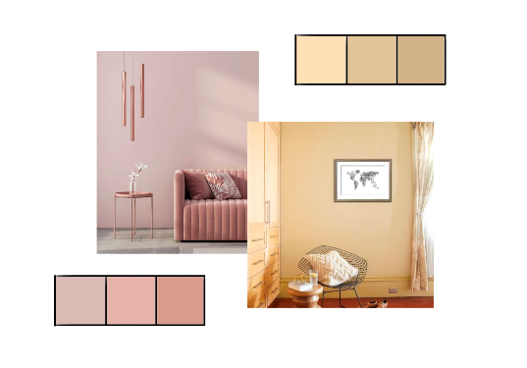
Monotone:

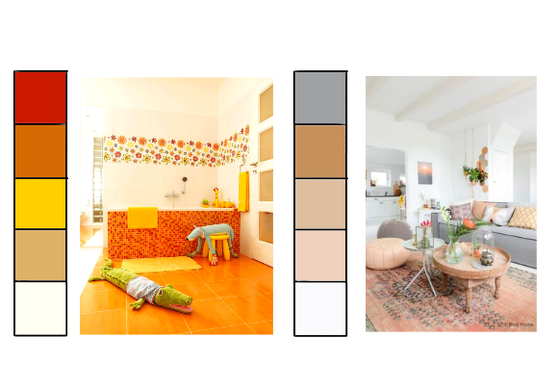
monochrome:

Achromatic:
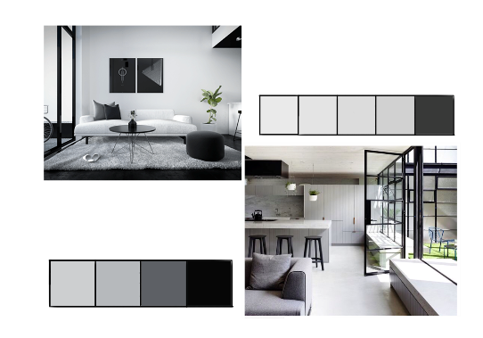
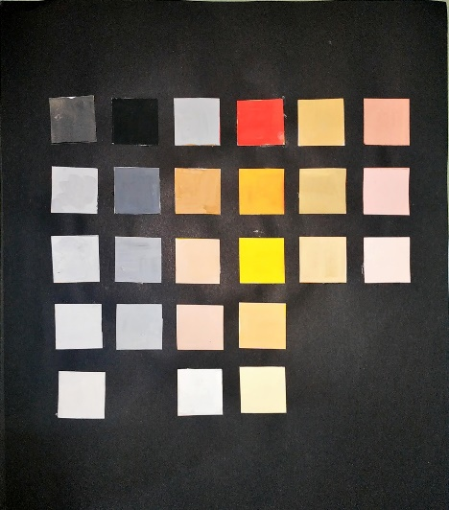
Acrylic paint color scheme:

Project 8: neutral color
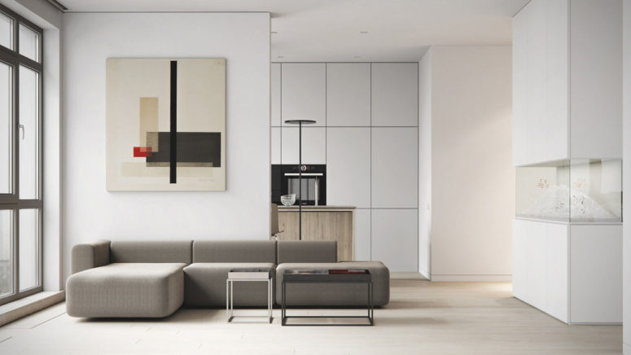
Reference image:

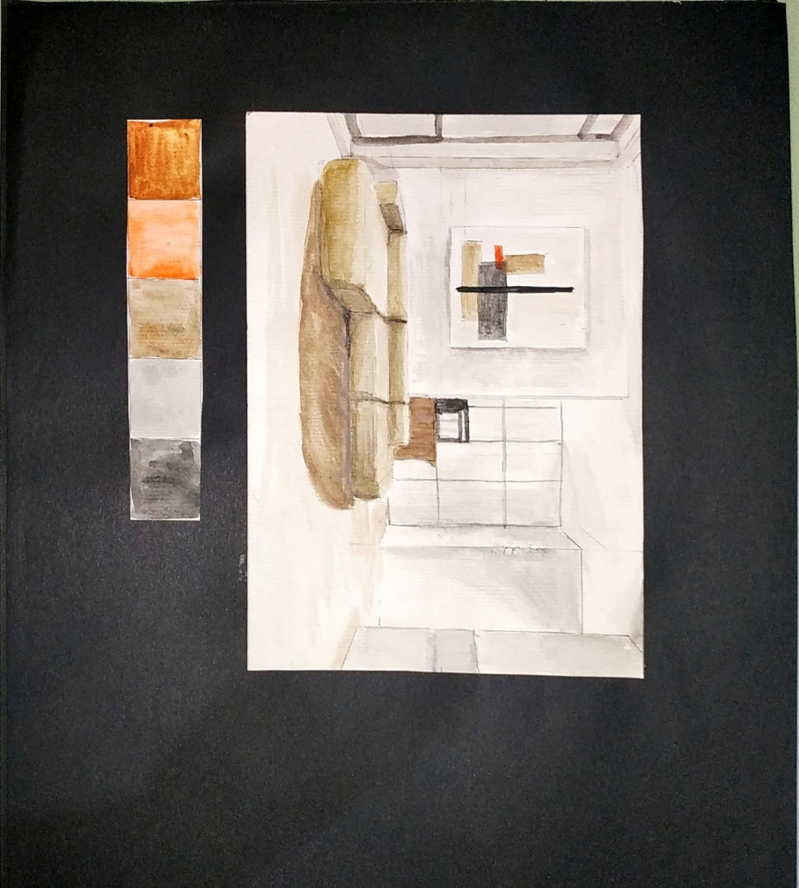
Coloring and color scheme:
project 9 : analogous and triad color
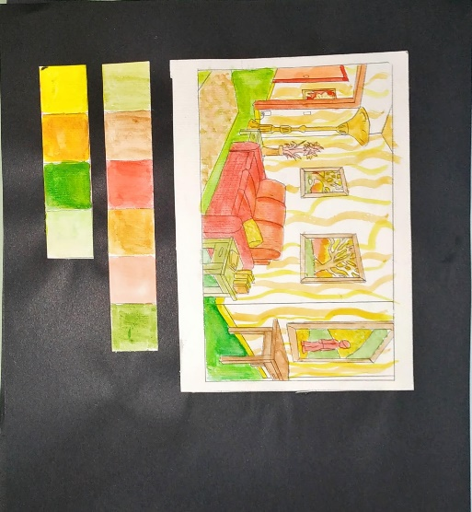
analogous:

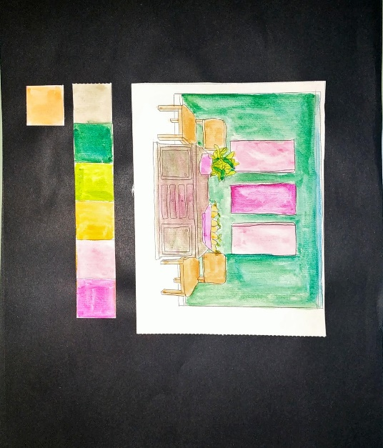
Triad:

Project 10: final presentation
Elegance
Definition
Noun : dignified grace in appearance, movement, or behavior. good taste in design, style, arrangement, etc.
Cambridge :graceful and attractive in appearance or behavior
Element of design
Lines: straight lines
Shape and form: organic and geometric, but mostly geometric
Color: natural/ no overpowering colors
Texture: smooth & rough
Value: tint and tones
Principle of design
Patterns: clean, Contemporary Lines.
Contrast: texture
Emphasis: bright colors that could be inserted in sofas or etc.(pale pink/pale color)
Balance : symmetrical balance
Harmony: alignment and similarity
Rhythm: progression
Coloring:
