Title: diversity of Grey
Designer: Issey Miyake

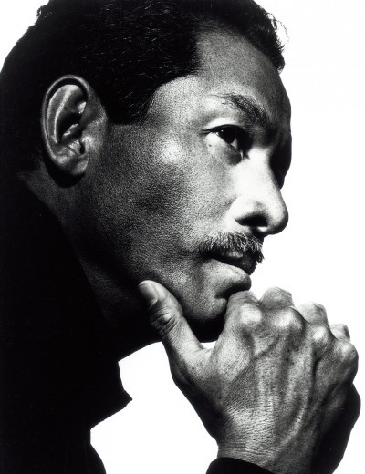
http://www.fashionmodeldirectory.com/designers/issey-miyake/

Color: Grey
Quote:
https://www.pinterest.com/pin/66568900716523567/

Favorite picture:
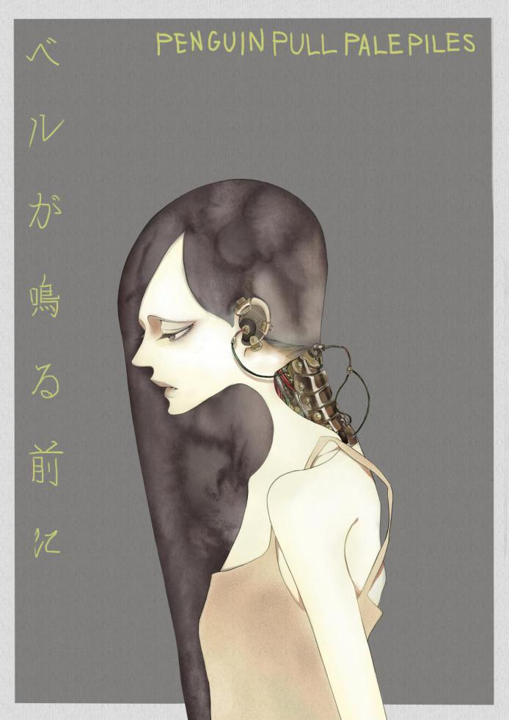
From my favorite mangaka/animator Nakamura Asumiko

http://www.iecbag.com/index/5Lit5p2R5piO5pel576O5a2Q.html

Nature:
Bamboo forest
http://www.nipic.com/show/1/63/bfbe147e51accfbc.html
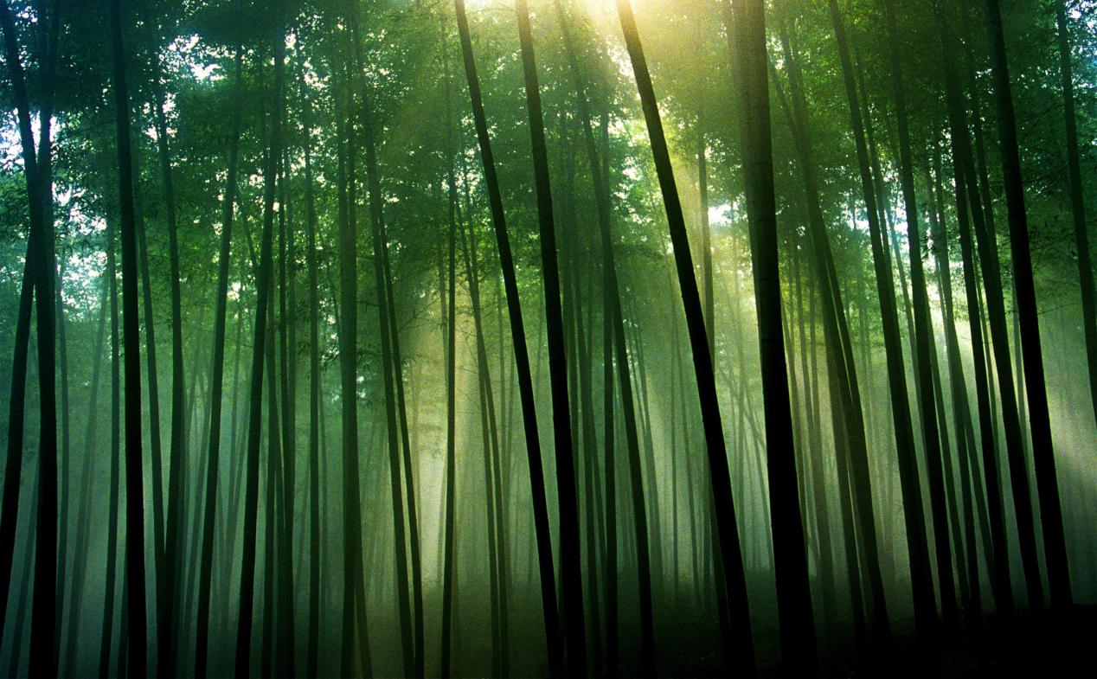

Favorite movie: The fall
https://www.pinterest.com/pin/269441990181344298/
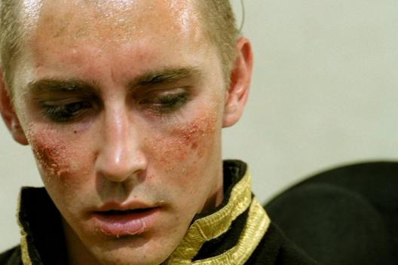
Lee Pace is my favorite actor
http://drivebyanon.tumblr.com/post/109992436875/the-fall-in-a-hospital-on-the-outskirts-of-1920s

Fashion pictures:
http://www.vogue.fr/defiles/defile/pret-a-porter-femme-automne-hiver-2017-2018-new-york-thom-browne/20606
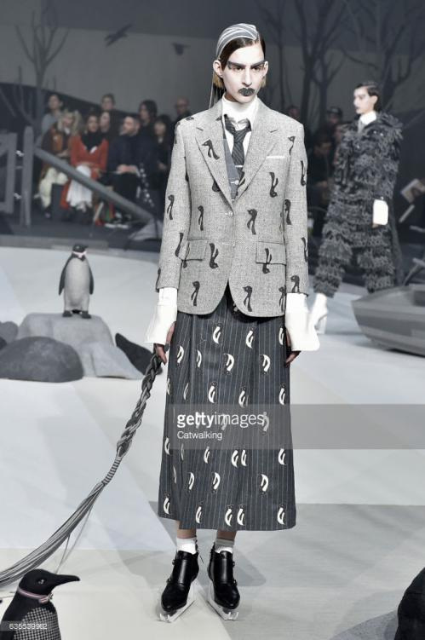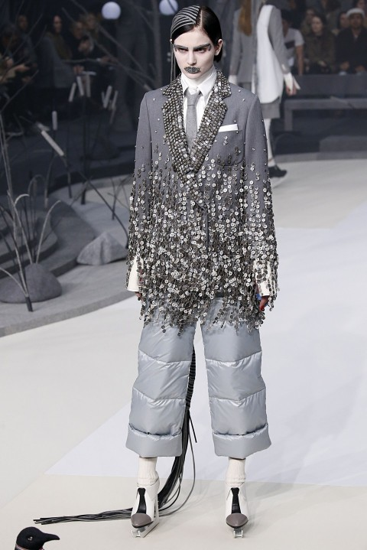
http://www.vogue.com/fashion-shows/fall-2014-ready-to-wear/comme-des-garcons-comme-des-garcons
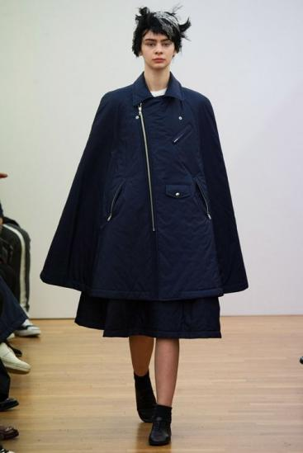
http://www.isseymiyake.com/brand/images/INEI_2014apr_top.jpg
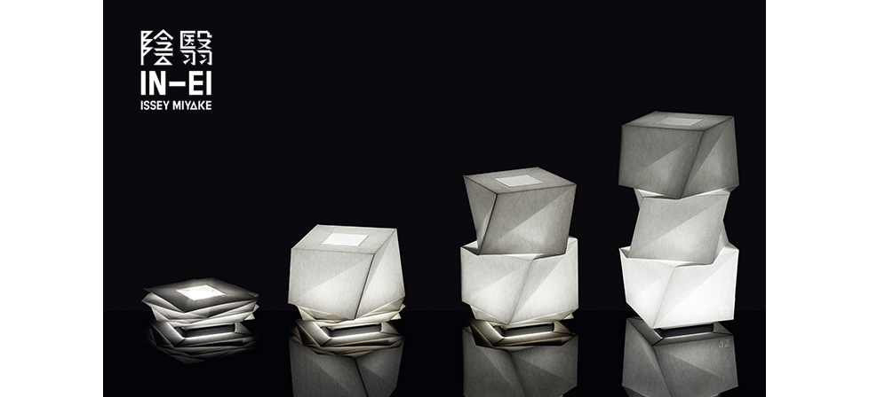
https://www.finnishdesignshop.com/images/12Iittala_X_Issey_Miyake_iso.jpg
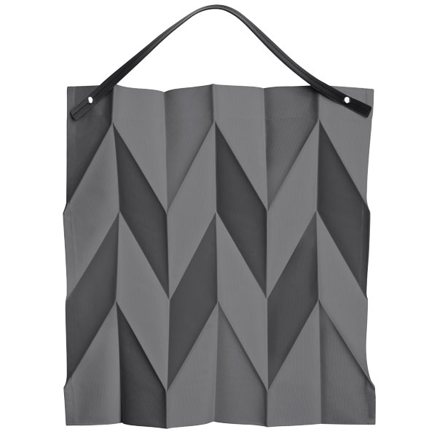
Logos: comme des garcons play
https://pbs.twimg.com/profile_images/2991032484/695477887b562ac96827f58cec49829e_400x400.png

figure skater: Yuzuru Hanyu
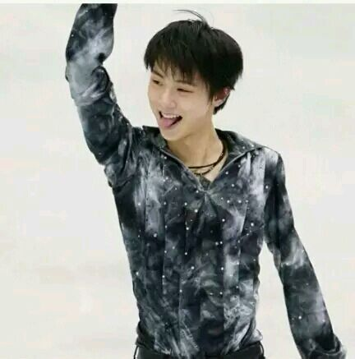
https://twitter.com/hashtag/

My doll:
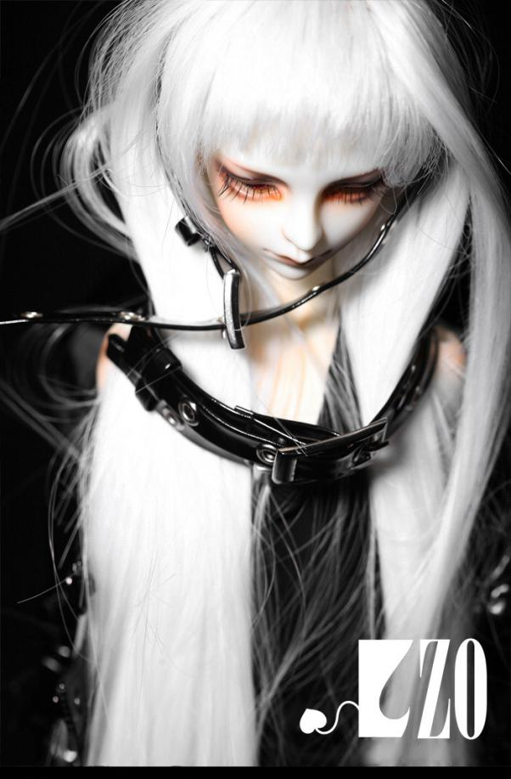
http://www.bjr027.com/image/aHR0cDovL2ltZzQuZHVpdGFuZy5jb20vdXBsb2Fkcy9ibG9nLzIwMTUwMi8wNy8yMDE1MDIwNzE0MjAyNF9TUUJ4Uy5qcGVn.html

Presented by Ningji Wang

