Instructor: Chef Paul Massincoud
Thanh Ngan Do [Lynn]
ID Student: 1810292
Instructor: Chef Paul Massincoud
CUL260 - CHOCOLATE, CONFECTIONS & CENTERPIECES

TABLE OF CONTENT

Week 1 | 2
Week 2 | 5
Week 3 | 10
Week 4 | 13
Week 5 | 15
Week 6 | 17
Week 7 | 19
Week 8 | 21
Week 9 | 23
Summary | 24

WEEK 1
The key points of the lesson
- White chocolate is mixing of cacao powder, sugar and milk powder.
- Temperature for tempering chocolate:
- Start tempering the chocolate is at 40°C.
- Stop the tempering is at 28°C in 75% of bowl, and mix with 25% of remaining chocolate into 30-32°C.
- In tempering chocolate, if the different temperature chocolate does not mix together it makes the chocolate fragile.
- Start splashing sugar is at 120°C and changing color the sugar is at 140-145°C.
- There are two kinds of fat mix together for truffles: High and Low fat.
- Two enemies of chocolate are water and opened flame.
- For coloring, the Chocolate using the air wash is after cooking and gel color is used before cooking.
- Inverted sugar is like Glucose, corn syrup, etc. which are used for not to separate the cream and chocolate.

GANACHE 70% FOMULA
Ingredients:
Cream 35% | 330g
Glucose | 105g
Vanilla Bean | 1
Dark Chocolate 70% | 435g

Method:
- Scrape down the vanilla bean in a pot.
- Use the cold Glucose and pick it up with the wet hand (about 100 grams)
- Add cream, sugar, glucose and vanilla bean then come to a boil. When adding the glucose to the pot and the cream and Vanilla also, shouldn’t mix the glucose because it is going to the bottom and prevent of making skin of cream and the bottom of pot.
- Take out from heat and allow to infuse about 15 mins.
- Place cream mixture back to heat and come to a boil again.
- Pour the mixture into the chocolate then wait for 1-2 minutes.
- Add the softened butter and mix up to melt the butter.
- Pour in the container and wrap it for 1 day at room temperature.
- For making Truffles pipe the Ganache in size of Hazelnuts on top of the parchment paper and cool them in the fridge. When ready to use, pour the Ganache in a piping bag with small round tip and piped it in tempered chocolate.
- The melted chocolate which the temperature is around 40°C using the clean Marbled and 25% of warm Chocolate and cool it up to 28°C with the pallet knife and back to warm chocolate. The final temperature is 30-32°C to cover the Truffles and round ready tempered chocolates.

CANDY FRUITS
- Peel oranges and grapefruits and cut them in portion size.
- Then separate the white part of skins.
- Add cold water on top.
- Bring to boil then strain 2 times.
- Add 1 kilograms sugar and 1-liter water and 200g glucose in the pot.
- Add the peels and bring to boil.
- Cut the parchment paper into a circle which is a little bigger than pot and has a hole in the middle and cut a hole in the center.
- Remove from heat and cover with circle parchment paper. Then wrap it and cool overnight.
- Then the following day unwrap.
- Add some sugar (100g) and bring to boil again one time. Put in fridge for next week.

GJANDUSA
Ingredients
Hazelnut, toasted | 2165
Sugar | 250g
Butter | 25g
Vanilla Bean | 1
Milk Powder | 25g
Milk Chocolate | 125g
White Chocolate | 70g
Dark Chocolate | 70g

Method:
- Add some Glucose in a pot and heat it up.
- Add some sugar and mix well.
- Toast the hazelnuts.
- After the sugar is dissolved, add more sugar and continue until the color is golden brown.
- Then remove from heat and add all the butter and warm toasted hazelnuts.
- Pour to the silpad and soft it with a spoon and cool in the fridge.
- Scape the Vanilla bean and add to the milk.
- Sift the milk-vanilla mixture with hazelnuts powder and mix well, then add the milk powder and mix melted chocolate mixture to the mixture.
- Pour in container and cool in the fridge.

WEEK 2
The key points of the lesson

- Cocoa Butter is yellow in color and hard to melt.
- Warm in the microwave at 29°C and grease the molds with special papers and a small amount just for unmolding easier.
- Should not use too much cocoa butter because when unmolding there are some white/yellow parts on top of chocolate.
- Making ganache: when use dark chocolate 100% in amount, the cream is also 100% in amount; for milk and white Chocolate because they have some milk fat and cocoa butter, if use 100% chocolate, use just 50% cream.
- Trimolin, Honey and Glucose are all inverted sugar.

DARK & STORMY CHOCOLATE
Ingredients:
Heavy cream | 170g
Ginger, sliced | 80g
Vanilla bean | ½
Milk | 40g
Dark rum | 80g
Butter very soft | 40g
White chocolate | 1000g

Method:
- Melt the white chocolate over a Bain Marie.
- Melt the glucose and cream in the pot.
- Slice the gingers, scrape vanilla bean and add with small amount of milk into the pot.
- Bring to boil and then remove from heat and wait for some minutes to exit all of the extracts to the mixture.
- Strain it over the melted chocolate.
- Whisk well and add the softened butter and rum.
- Then whisk to mix together.
- The temperature of the melted chocolate should be a little warm for not to curd and separate the mixture.
- Pour into the container, wrap by U-shape to make sure no air and put in room temperature for the following day.
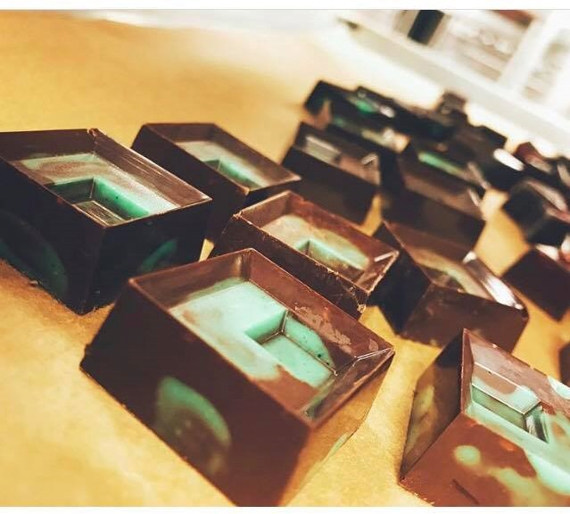
DARK & STORMY CHOCOLATE

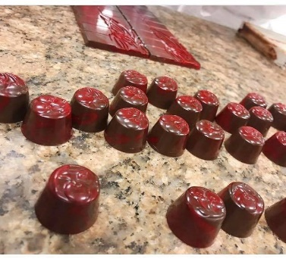
EARL GRAY GANACHE
EARL GRAY – DEMO

Ingredients:
Heavy cream | 410g
Earl gray tea | 20g
Milk | as needed
Glucose | 130g
Dark chocolate, melted | 260g
Milk chocolate, melted | 440g
Butter, softed | 100g
Milk chocolate for covering | as needed

Method:
- Melt the dark and milk chocolate together.
- Bring to boil the cream, Earl Gray tea and a small amount of milk.
- Soft the butter.
- Remove from heat and wait some minutes to exit the extract.
- Strain the mixture over the melted chocolate mixture.
- If needed, add some milk because the leaves of Earl Gray absorb some milk.
- Add the softened butter and whisk well.
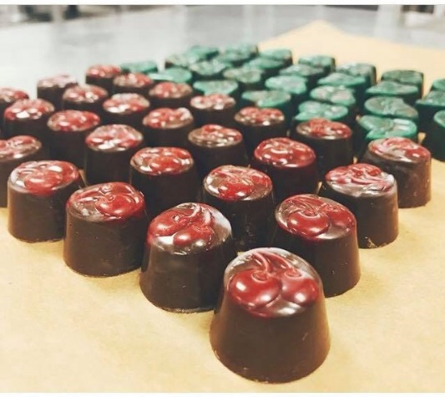
- Transfer to the container, wrap and put in room temperature for the following day.
EARL GAY GANACHE CHOCOLTE

LIQUERE TRUFFLES
Ingredients:
Heavy cream | 280g
Milk | 90g
Glucose | 100g
Dark chocolate, tempered | 510g
Liqueur or spirits | 70g

Method:
- Melt the dark chocolate.
- Bring to boil the cream and glucose.
- Pour over the melted dark Chocolate, whisk well and add the liquor.
- Pour into the container, wrap well and put in room temperature.

POODLE TRUFFLE
Ingredients:
Heavy cream | 180g
Dark coffee bean, roasted | 10g
Milk | as needed
Dark chocolate, tempered | 400g
Butter, soft | 60g
Coffee liqueur | 40
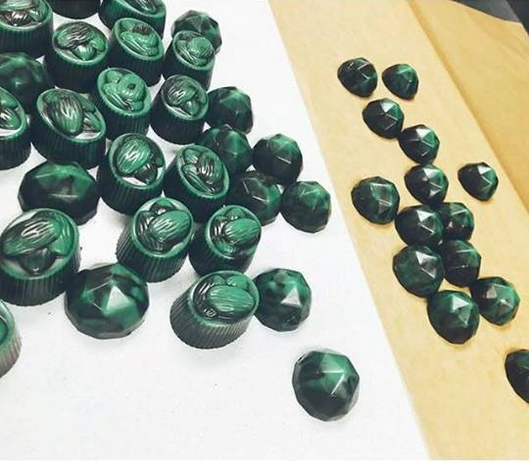
POODLE TRUFFLES

Method:
- Bring to a boil the cream
- Add the hot cream to the unmelt Chocolate.
- Pour into the container, wrap well and put in room temperature.

MOLD
- All the molds have to be clean and dry.
- Use the warmed Cocoa Butter and with the special papers grease all molds.
- Wrap well.
- When ready to use, unwrap and use a brush or finger to rub some colored cocoa butter inside the molds and upside down them to dry.
- Rub tempered dark chocolate inside the molds, flip upside down and wait to dry.
- Pour the tempered chocolate and flip upside down and bang it just to make sides for the chocolates.
- Scratch the edges of mold to clean.
- Pipe the ganache into the mold (two third) and press down the top of Ganache with cocoa butter by finger.
- The fill the top with tempered chocolate and scratch again.
- Place in fridge for just 15 minutes and wait for dry
- Bang the mold to destroy bubble air inside the chocolate.
- The chocolate is not shiny that means it is dry and ready to upside down.

WEEK 3
NOBLE (RASPBERRY GANACHE CHOCOLATE)
Ingredients:
Raspberry Puree | 300g
Glucose | 60g
Semisweet Chocolate, chopped | 300g
Raspberry Liqueur | 45g
Trimoline Or Honey | 30g
Butter | 90g
Cocoa Butter, melted | 60g
White Chocolate | 60g

Method:
- Place chocolate in a clean and dry bowl.
- In a pot, bring the raspberry puree and glucose to a boil.
- Then pour to the chopped chocolate and stir well.
- Add liqueur and trimoline and stir until combined.
- Then add butter. Stir well until combined.
- Use in the mold with cocoa butter and tempered white chocolate as desired.

LEMON LOGS
Ingredients:
Butter, softened | 130g
Fondant Pastry | 100g
Lemon Zest | 10g
White Chocolate, melted | 510
Lemon Juice | 40g
Dark Chocolate, tempered | as needed

Method:
- Strain the lemon juice and reserve.
- Over the Bain Marie, melt the white chocolate.
- Add the butter, lemon zest and fondant and stir to combine should be melted completely, no lumps.
- Add the strained juice slowly
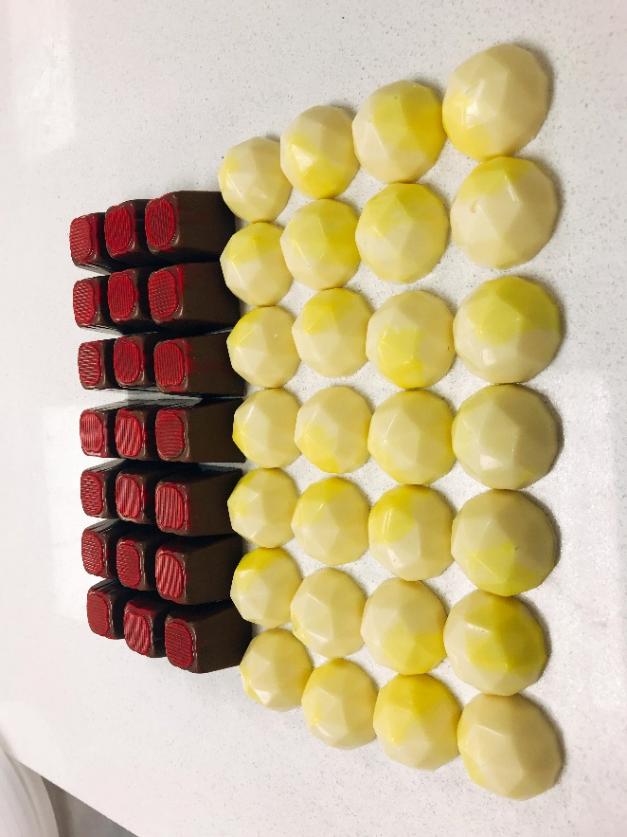
- Cool and wrap completely. Use the piping bag to pipe it.
LEMON LOGS & NOBLE

PASSION FRUIT GANACHE
Ingredients:
Butter, softened | 100g
Honey | 80g
Milk Chocolate, tempered | 450g
Passionfruit puree | 690
Dark chocolate | as needed

Method:
- Over the Bain Marie, melt chocolate.
- In a pot, bring the passion fruit puree with honey to a boil until reduced to half in amount.
- Add butter into the melted chocolate and stir. Make sure the chocolate still be warm enough to melt butter completely.
- When the passion fruit cool add to chocolate
- Pour into the mold and let it cool.
- Cut and dip in the tempered dark chocolate.

SPIKED EGGNOGS
Ingredients:
Butter, soft | 170g
Glucose | 40
Nutmeg Ground | 1tsp
White Chocolate, tempered | 500g
Vanilla Bean | 1
Dark rum | 40g
Dark Chocolate, tempered | as needed

Method:
- Over the Bain Marie, melt the white chocolate.
- When the chocolate melts completely, add nutmeg ground, vanilla and glucose. Stir well to combine.
- Add rum, stir and wait to cool
- Pour into the piping bag.
- On parchment paper, pour dark chocolate then wait until starting to set into small round circles and remove the extra chocolate.
- Pipe the eggnogs on top of small round chocolate.

WEEK 4

CANDY FRUITS
- Drain all fruit peels well from the syrup.
- Place in small boxes and put parchment paper between each layer to make sure not get stick together.
- Place in the fridge for next week.

WALNUT CARAMEL
Ingredients:
Sugar | 20g
Cream | 100g
Glucose | 150g
Walnuts, chopped | 100g
Vanilla Bean | ½

Method:
- Prepare, grease the foil and ring.
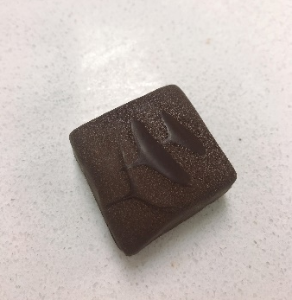
- In a saucepan, cook the sugar and glucose to caramel stage.
- When the sugar-glucose mixture starts caramelizing, warm the cream in the microwave.
- Then add the warm cream to the caramel mixture.
- Add the walnuts and pour on the foil.
- Let cool down.
- Pour the tempered chocolate on top.
- Remove from the ring and cut as desired.
- Dip in tempered dark chocolate.

DARK MODELING CHOCOLATE
Ingredients:
Dark Chocolate | 150g
White Chocolate | 45g
Glucose | 70g
Cacao powder | 15g
Simple Syrup | 25g
Vanilla Bean | 1

Method:
DARK MODELING CHOCOLATE – DEMO
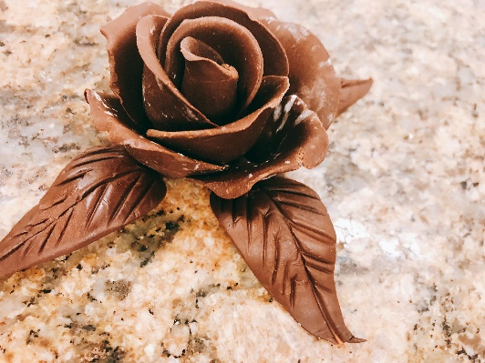
- Over the Bain Marie, melt dark chocolate.
- Combine the glucose and vanilla, and then add the cocoa powder. Mix slowly to combine.
- Add simple syrup and mix quickly to combine well.
- Knead then cover completely with the plastic wrap then let cool down.
- Before start making the rose flower from the dark modeling chocolate, knead the dough again to make it soft.
- Roll into a long tube and then divide into small balls. Roll1 small ball into a bud.
- Place between the plastic and shape the petals. Stick them together to make flowers. Over the Bain Marie, melt dark chocolate.
- Combine the glucose and vanilla, and then add the cocoa powder. Mix slowly to combine.
- Add simple syrup and mix quickly to combine well.
- Knead then cover completely with the plastic wrap then let cool down.
- Before start making the rose flower from the dark modeling chocolate, knead the dough again to make it soft.
- Roll into a long tube and then divide into small balls. Roll1 small ball into center bud.
- Place between the plastic and shape the petals. Stick them together to make flowers.

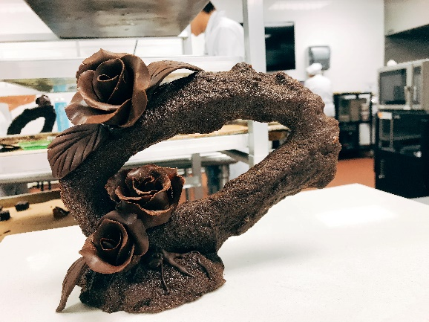
SHOWPIECES
Make the showpieces from brown sugar, use a finger to make the base, scratch and use them to decorate.
Add some white chocolate into the food processor and blend with icing sugar to be a dough.
Shape the white chocolate dough as desired to decorate.
Decorate with dark modeling chocolate flowers.

WEEK 5

NOUGAT DE MONTELIMAR
Ingredients:
Honey | 200g
Glucose | 140g
Sugar [1] | 600g
Water | 120g
Cream of Tartar | pinch
Egg White | 100g
Albumen | 60 g + 10g
Sugar [2] | 60g
Almond and Hazelnut, roasted | 600g
Pistachio, roasted | 60g
Mixed peel fruits | 40g
Vanilla Bean | 1
Cocoa butter | 40g

Method:
- Prepare parchment paper lined sheet pan.
- In a clean pot, mix sugar [1], water and cream of tartar together then heat it up.
- Pour honey and glucose into the other clean pot and heat.
- In the mixer bowl, whip the egg whites, albumen and a pinch of cream of tartar with low speed to soft peak.
- Then when the honey reached to 120ºC, add the sugar [2] gradually and keep whipping at medium-high speed.
- When the sugar reached 165ºC add to the egg white mixture but keep whipping in low speed, then turn to medium-high speed until stiff peak.
- Add the peels, nuts and vanilla.
- Add the melted cocoa butter and pour over a parchment paper and smooth the surface. wait to cool. Wear cotton and plastic gloves to prevent burning.
- Cut into rectangles and dip half in white and half in dark chocolate.

NOUGAT DE MONTELIMAR
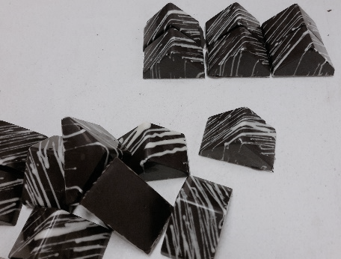
MARBLED CHOCOLATE
- Freeze marble at least 1 week before start.
- Temper the dark chocolate.
- Pour in paper-cone and on top of cold marble which is freezed.
- Draw as desired. So, the outcomes can set quick and stable.

WHITE CHERRY GANACHE
- Over Bain Marie, melt white chocolate.
- Bring the glucose and cream to a boil.
- Then pour into melted white chocolate and mix well.
- the liquor from cherry.
- Wrap and store in room temperature.
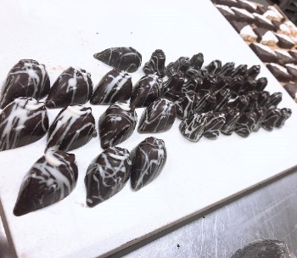
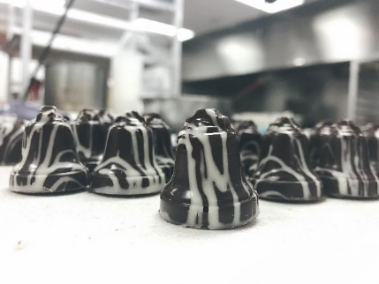

WHITE CHERRY GANACHE CHOCOLATE

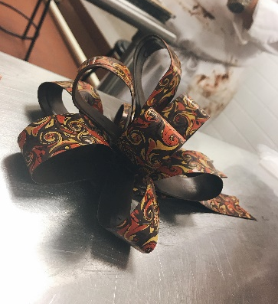

CHOCOLATE RIBBON – DEMO

WEEK 6
SUGAR CONFECTION
Ingredients:
Sugar | 500g
Isomalt | 500g
Water | 400ml

Method:
- In a pot, add the sugar, isomalt and water, and then bring to a boil. Should cook fast. If cook slowly, the sugar will brown.
- When the sugar isomalt mixture reaches 120C, use the wet brush to brush the side of the pot, so the sugar will not crystallize.
- Meanwhile, prepare and grease the ring, line with the foil
- For the color: the gel color is available to add directly when the sugar is boiling; however, with the airbrush color, should be add when the sugar mixture is done at 165ºC and stop boiling. If add the gel color when the sugar mixture is boiling, it will evaporate the water inside but the gel color not.
- When sugar reaches 140ºC, wear cotton glove and latex glove covered outside.
- When the sugar reaches 165ºC, stop boiling and pour in the ring. And pour on Silpat lined over the marble and add color as desired.
- Knead the sugar to reduce the temperature and make the color evenly.
- Place under the hot lamp to keep warm the sugar.
- For making rose: make the center and add 2 small petals, then 3 medium petals and then 5 large petals. Melt by the torch to stick the petals together.
- Use hair dryer to dry up.
- The petals should be thin in edges and thick in bottom.
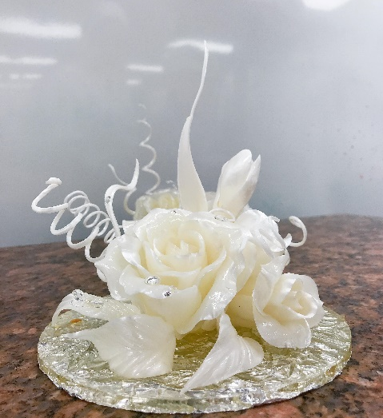

SUGAR CONFECTION – CHEF DEMO

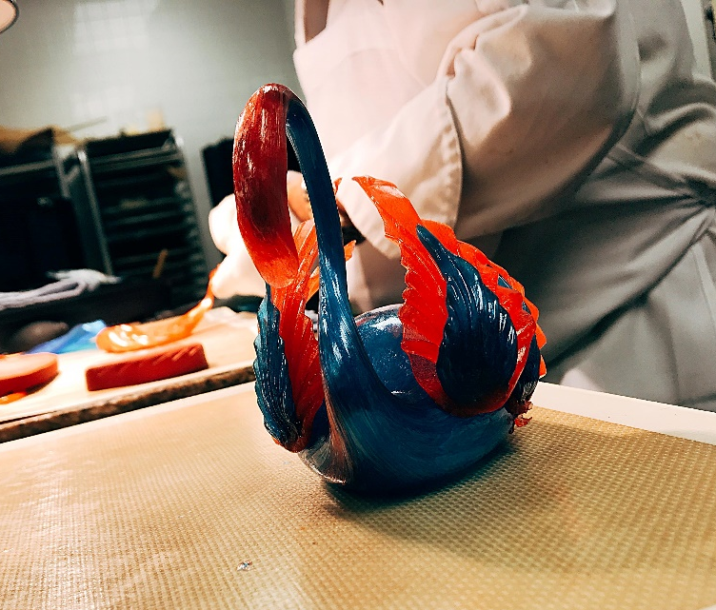

SWAN

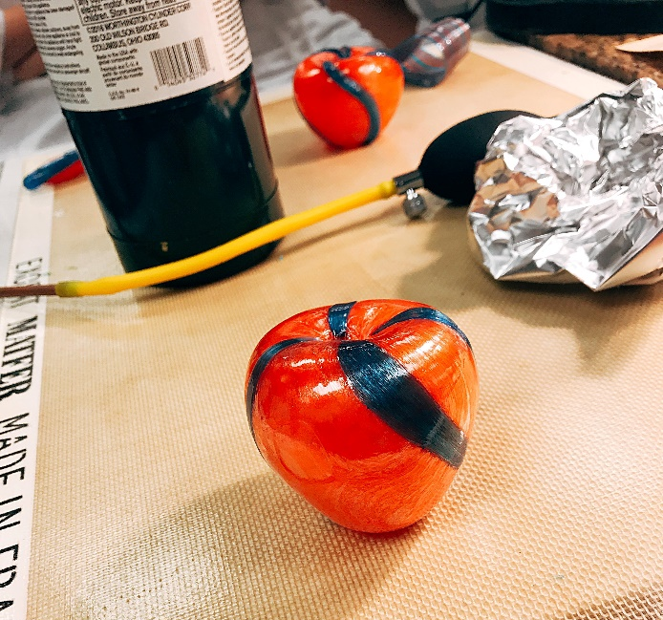

APPLE
Week 7
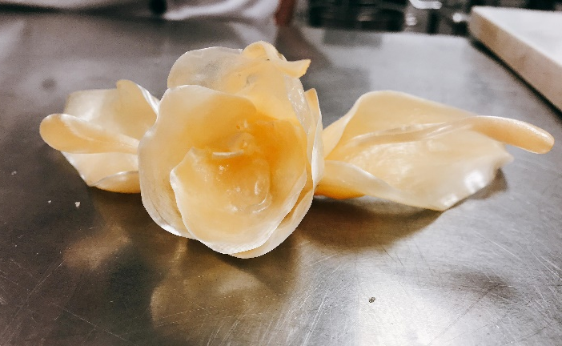
SUGAR CONFECTION [Continue]
FLOWER
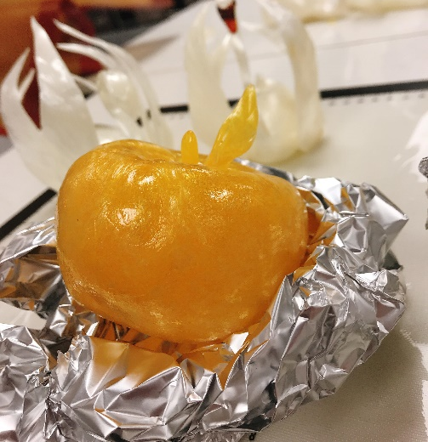
APPLE

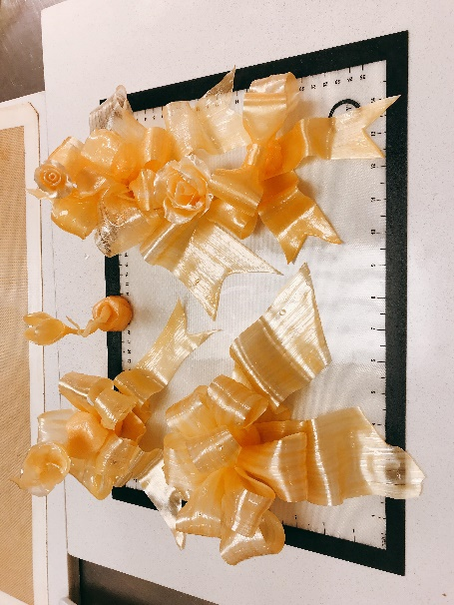
BOW
SWAN
Ingredients:
Sugar | 500g
Isomalt | 500g
Water | 400ml

Method:
- Cut small piece of sugar.
- Make a hole inside of that then heat the peak tube of the pump and put inside the hole of sugar.
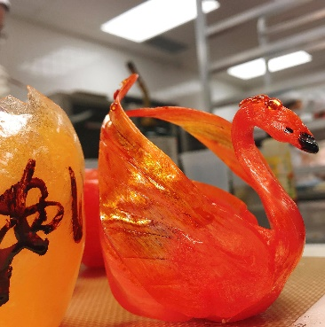
- Pump to add the air into the sugar and meanwhile dry up the outside of the sugar to keep the shape. And pull the end of sugar to make the head and neck of the swan. Make sure pulling when the end of sugar is still hot and soft, so the sugar won't be broken.
- Shape and dry up the neck to make the curve of the neck for the swan.
- For the wings of swan: pull a small amount of sugar under the lamp and cut and shape it, make the lines for wings with the spine of the knife.
- Cool down with hair dryer and melt by torch to stick the wings.

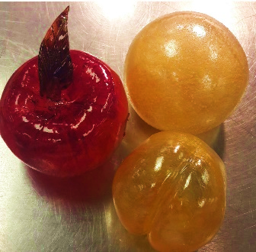
LEMON - ORANGE
- Add some sugar to the cooked sugar and knead.
- Then make a hole and pump like making swan but the shape should be like baseball ball, meanwhile cool down.
- Pull the end of sugar a little bit.

APRICOT
- Same method with lemon/orange but no adding sugar to the cooked sugar and use the spine of paring knife to make the line for apricot.

WEEK 8

SHOW CASTING
Ingredients:
Sugar | 500g
Isomalt | 500g
Water | 400ml
Method:
- In a pot, add sugar, isomalt and water, and come to a boil, up to 150ºc and then add some white airbrush color to the boiling sugar, should be 10-15 drops, and keep heating to 165ºc then remove from heat.
- Wait for bubbles disappear and add 1-2 drops of other colors, should add in the right part of the pot.
- Use the skewer to stir a little bit to combine the colors but not mix them up.
- Pour inside of the ring which lined with the foil and greased, and then wait for cooling.
- Pour into metal tools that shaped into triangles or rectangles then wait for cooling.
- Once cooling, remove the tools stick together.
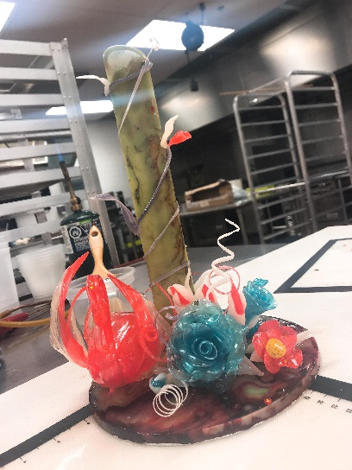
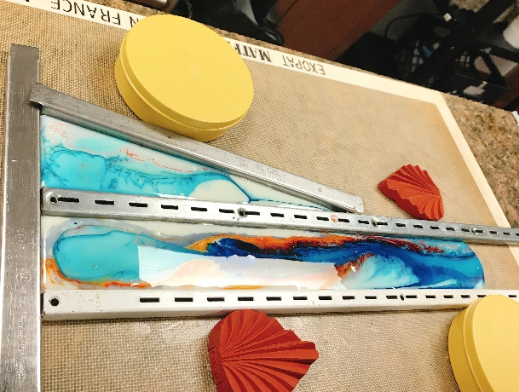

SHOW CASTING – CHEF’S DEMO

ROCK SUGAR
Ingredients:
Water | 400ml
Sugar | 1000g
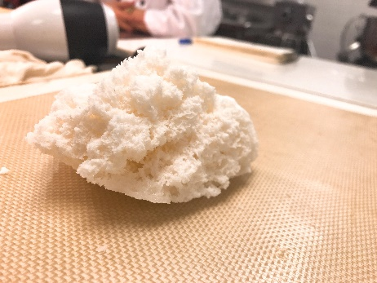
Method:
- Bring the sugar and water to a boil in a pot up to 140ºC.
- Then add some Royal icing to crystallize.
- After that, pour in a greased bowl. Leave a few mins until being puff then place in the oven to dry for 5 mins.
- Cut and shape as desired.
ROCK SUGAR – CHEF’S DEMO

ICE SUGAR
Ingredients:
Isomalt | 500g
Water | 150ml

Method:
- Stick three same size rings together by the tape and fill up with ice. Place on top of the cooling rack and on the tray and put in the freezer for 20 min - 1hr.
- In a pot bring isomalt and water to a boil up to 170ºC. When the sugar reaches 170ºC, remove from heat, then add the colors as desired, 1-2 drops of each.
- Pour on the ice.
- Use the torch to heat the side. Remove the rings.
- Keep heat the side a few times for moving the remaining ice.
- The outcome should look like coral.
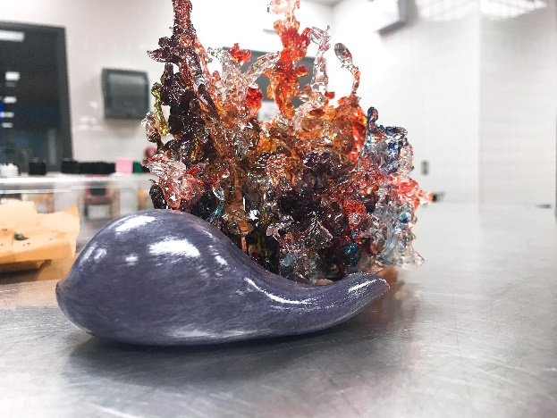

ICE SUGAR
WEEK 9

GJANDUSA CHOCOLATE
Ingredients:
Milk Chocolate | 200g
Cream | 100g
Glucose | 50g
Gjandusa | 2 tbsp
Cocoa Butter Color | as desired
Milk Chocolate, tempered

Method:
- Heat the cream.
- Add milk chocolate and glucose.
- Then add the gjandusa and whisk well to make ganache.
- Wrap well and let ganache cool down in room temperature.
- To make the chocolate, melt and temper the milk chocolate.
- Temper the cocoa butter color to 28oC and brush to the mold to decorate. Turn over the mold on the parchment paper and let dry.
- Brush the tempered milk chocolate. Turn over the mold again and let dry and set.
- Fill the tempered chocolate, turn over and bang the mold. Clean the edges of the mold and let dry.
- Fill 2/3 mold with ganache and cover with the tempered milk chocolate.
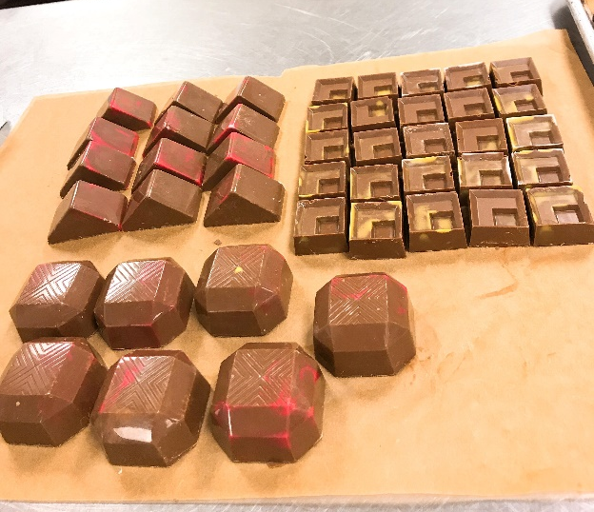
- Refrigerate 15 - 20 mins. If the molds are big, should be more time in the fridge.

SUMMARY
Through this chocolate and confection course, I got more information about chocolate and sugar. It was really professional and interesting for me. I experienced making some kind of ganache chocolate, the correct temperature of chocolate; knew how to shape flowers from modeling chocolate and use sugar for making flowers, fruits, fish and swan to decorate cakes and desserts. I had a nice course with opportunities and experiences challenging myself as well as exploring the amaze of sugar and chocolate. Chef PAUL MASSINCOUD, who is dedicated, professional and enthusiastic instructor, is really helpful and friendly to make me able to develop my creativity and always ready to answer and guide me.

