MARKETING RESEARCH
COURSE: 410-DB4-AS
GROUP: 08332
MARKETING RESEARCH PROJECT
Ricardo Vázquez
Gabriel Cifuentes
Sebastian Santamaria
John Carlo Malate
Teacher: Jacqueline De Stefano
November 30th, 2016
TABLE OF CONTENTS

INTRODUCTION 3
EXECUTIVE SUMMARY 3
RESEARCH OBJECTIVES 4
METHODOLOGY 5
SECONDARY DATA 6
External Secondary Data 7
Flickr competition (alternatives) 7
Flickr (exclusivity) 8
SAMPLING PLAN AND SIZE 9
LIMITATIONS 10
RESULTS AND CONCLUSIONS 10
APPENDIX 13
Survey 13
Results 15

INTRODUCTION

Flickr is a website for photo and video sharing created by Ludicorp in 2004 and acquired by Yahoo in 2005. The website is available in English, Chinese, French, Spanish, German, Italian, Portuguese, Korean, Indonesian and Vietnamese. Lots of bloggers use this website to host their pictures and videos in order to promote their works. However, Flickr has been facing difficulties that lead the website to decrease its sales and therefore its revenue. Competition and exclusivity are the main causes of Flickr’s problems.
This marketing report was done to study the causes of why Flickr has decreased its revenue and the business is having different problems in terms of sales. This report will also analyze the methodology used to analyze the information, the results, limitations and recommendations that the business could consider in order to increase its effectiveness and sales volume.

EXECUTIVE SUMMARY

Our team decided to conduct descriptive research to understand the consumer behavior. We decided to collect primary data for our research and created a survey with different kind of questions. We used a software that allows us to control, share, collect and analyze the answers via online to save time. In addition to primary data, we also included an internal and external secondary data research in our project. Moreover, we analyzed the competition of Flickr. We found out that many competitors offering the same service are affecting our business, being Instagram the number one competitor because they include customization tools to edit your pictures. Furthermore, Flickr requires exclusivity to access the website namely: doing a Yahoo account that might me time consuming; asking the clients for subscription in order to get the full experience; to have expensive equipment to produce decent pictures. While there are many competitors that offer the same service without this exclusivity.
We used the Non-Probability Sampling method to select our sample. Also, we used the Convenience Sampling to reach the people to answer the survey. The size of our sample is 42 people in order to be meaningful and easy to analyze.
Unfortunately, we had some limitations when doing our Marketing Research Project. For instance, we did not have enough time to collect many surveys. Also, we did not have a reasonable budget to conduct this research. Moreover, we made some mistakes in the draft of our survey.
We can conclude that

RESEARCH OBJECTIVES

Flickr.com “- almost certainly the best online photo management and sharing application in the world-.”
This is the up to date statement that the photo application has on its website. Moreover, it is mentioned what the two main objectives of the company are; “We want to help people make their photos available to the people who matter to them, and, we want to enable new ways of organizing photos and video.” However, sometimes one could be the best, but not the most popular, that is the reason why this research is taking place.
The research objectives are basically; to identify the main popularity problems, to determine the changes that should be made to the app in order to improve it, to analyze the results, and finally to provide possible solutions to the company’s problems.
Thereby obtaining appropriate data for the analysis, every question has a meaning towards the objectives. The most relevant questions are related to; the popularity of Flickr, equipment of potential users, Flicker’s features strengths and weaknesses, competition and demographic factors.

METHODOLOGY

In order for us to understand the consumer behaviour, our team decided to conduct descriptive research. We created a survey to understand the different causes of the problems that Flickr faces. The survey has different kind of questions such as category questions in which we will analyze which group a person fits the best, demographic questions as well as questions about Flickr in order to understand the relations between people and Flickr, a Contingency question to separate the groups of people between the ones that know Flickr and the ones that do not know anything about it. The survey also contains Dichotomous questions to be clearer about some information such as gender or whether or not a person uses Flickr and finally, Likert scale questions in order to analyze the performance of different features of the application. The survey was created using both open and closed questions in order for us to get a wider knowledge. We believe that the survey was the best way to collect primary data for our research because it allows us to measure the situation objectively. It will give us the opportunity to measure attitudes and analyze facts. The survey will provide us with new information due to the fact that it is a primary research method. Through the use of a survey we collect new information that we cannot find in any other place or website. It is new information that will answer our questions to the problems that Flickr has. We created specific questions to find answers for specific problems such as competition, exclusivity in terms of cost, age range, equipment, and worldwide availability. On the other hand, a survey is easier to carry out for this research. We created the survey through the use of a software which also allows us to control and analyze the answers. We can administrate the survey via online, mobile devices, e-mail, face to face or telephone. Also the survey could be answered by the participants with different backgrounds at any time because they do not need to be present to answer the survey. And finally we could send the survey to a large amount of people in order to get the answers. We consider that a survey is the best research design for the analysis of Flickr because we found many advantages that we did not find in other research designs such as focus groups or the observation technique.

SECONDARY DATA

The company Flickr is an online website for photo-sharing and video-sharing created by Ludicorp in 2004 (Vancouver based company that created Flickr and Game Neverending founded by Stewart Butterfield, Caterina Fake and Jason Classon). On their debut, the main focus of Flickr was to create a chat room named FlickrLive. The chat room allows the users to exchange pictures instantly with other users. Despite that, Flickr decided to end the chat room feature and changed it to a more personal and professional platform. Just after a year of its debut, the company was bought by Yahoo in March 2005 and it was announced to be sold for $22 to $25 million.

External Secondary Data

The users of Flickr are divided into two groups: avid photographer and photographer with business purposes. If your purpose is to gain revenue with your photos, one needs a commercial application.
The user is responsible for:
- Users are charged a fee for your product or service which includes some sort of integration using the (Flickr, Flickr API Terms of Use) APIs.
- You sell services to (Flickr, Flickr APIs Terms of Use) users and use the APIs to bring users' Flickr content into your service.
- Your site is a "destination" site that uses Flickr photos to drive traffic and generate ad revenue.

Flickr competition (alternatives)

According to our research, Flickr’s position in the market is not doing good as it was back when it opened that is because they have many competitions that offer the same service. Based on the data information that we found, the number one competition of Flickr today is Instagram. Instagram started as mobile sharing-photo and video-sharing where users are also divided into different categories: amateur, avid photographer and professional photographers. However, even if Instagram users are divided into groups, everything seems to workout for every user because everything you need is on the application such as: editing tools and camera function that allows you to upload the picture instantly. Whereas in Flickr uses a third part application in their platform called Aviary (owned by Adobe). The second competition of Flickr is 500px which is more likely to be similar to Flickr in terms of platform construction and features. One advantage of 500px over Flickr is that instead of paying for custom memorabilia produced from your library of pictures, you can in fact sell it to the other people instead. Another competitor of Flickr is Photobucket which opened even before Flickr existed; the platform offers more than 10 billion images and over 100 million registered users. The content of Photobucket is mixed with photos, animation, quotes etc… which allows the users or potential users to have different choices. There is also Twitter, Facebook, Snapchat, Pinterest, Tumblr etc. who could be the potential competitor of Flickr in the future. In general, Flickr has a lot of competitor which is why their sales and popularity decreased over the years.

Flickr (exclusivity)

Based on our research, Flickr requires exclusivity in order to access the website which potentially caused why the sales and popularity of Flickr decreased. One exclusivity that it requires is to have a Yahoo account to access Flickr, it may not be a problem for some people to create a Yahoo account however, it could be also a turn off for some because it’s time consuming just to set up an account also someone could find that irritating for creating a new email account. Another exclusivity that Flickr has compared to other major competition is that they ask their consumers for subscription in order to get the full experience of website whereas other platform doesn’t require subscription to get the full experience such as Instagram, Photobucket, Pinterest etc.… Lastly, an exclusivity that Flickr requires a person is to have an acceptable equipment in order to produce some decent pictures to showcase to the world of Flickr. The equipment price may vary between $500 and more (DSLR Camera). Since the website is mainly used by avid photographers and professional photographers, it requires some exclusivity which is why the sales and popularity of Flickr decreased over the years.

SAMPLING PLAN AND SIZE

In order to select our sample, the team used the Non-Probability Sampling method. Through the use of Convenience Sampling we reached the people to answer our survey. We believe this was the best sampling method due to the ease to reach our survey participants. Also, thanks to the Convenience Sampling we reached photography students. We consider that they are more prone to have knowledge about photography and design applications. Therefore, they are an appropriated target to get our sample group. The size of our sample is forty-two people. The team believes that this is a good sample because we can get relevant information from it. We did not want to get a large amount of people because it will be harder to analyze the information and to get the conclusions. However, we could not have a sample of less than thirty people due to the fact that we got our primary data through the use of a survey. Therefore, if we had a sample of less than thirty people, our survey would not be meaningful and reliable because it would not represent properly the information. So we considered that forty people are a significant sample size in order to get significant information.
We considered the practicality to get the data. We reached students from our college and friends of the team members. Most of the sample participants are photography students at LaSalle College. However, there are also students from different programs at the college and people from different nationalities. Most of them live in Canada but there are also people who live in different countries in different continents. We take advantage of their different backgrounds so we can have different point of views and answers for our survey.

LIMITATIONS

We had some limitations when we did this marketing research project, and we will use these results in order to make a better plan next time. Our main complication was the time and budget given to de the plan. Other major complication is that we did not have the time to find people that regularly use flickr. We also found several mistakes in the drafting of the survey. Firstly, as you may notice in the survey attached in the (appendix section), the first question indicates that many people don´t even know flickr and answered the survey nevertheless. Therefore the authenticity of the rest of the answers might not be trustworthy. In addition to the amount of people that don´t even know flickr, many people avoided questions 5 and 6. We can observe that only between 18 and 21 people answered those questions. Moreover, there is an extra option which is in blank in question 13th; it was included in the results of our plan. Thankfully, no one clicked it, so no damage was made and we will correct it next time.

RESULTS AND CONCLUSIONS

Our survey consists of 14 questions which results have helped us to understand what the problem with the company could be. 42 people are the sample for our research. Through the results, many aspects will illustrate the reasons why certain type of people use or not this social media.
To start, we asked if they knew Flickr, and the 52% of our sample are not aware of the existence of the app. We have concluded that the advertising process of the app was not well done, because with the high quality features of the app, people would be really interested in opening an account.
Bad news does not stop there. From the percentage who knows the app, 48% of them have never used it. It means that an incentive must be offered to the potential customers in order to make them open an account. Probably, free premium features for a specific period of time could work in this case.
Moreover, we have discovered that most of the people use Flickr for sharing their pictures or for pleasure, instead of for business purposes, which for the exclusivity of the features it could be thought that business level is the main target for Flickr, according to this information we conclude that the features should be more friendly with the average customer in order to attract more users.
The feature total average by customers is 3.39 over 5; it leads again to make the features easier for the average customer to use.
We have realized that the strongest competition that Flickr has is Instagram. Even though, Flickr has more and better features than Instagram, people still choose Instagram to post photos and short videos. From our view the popularity of Instagram came not only with basic and useful features, but with celebrities who made it popular. In a nutshell, Flickr must encourage leaders and celebrities to use the app thereby obtaining more and more users.
The demographic results show that people from 18 to 45 years old tend more to use this type of app, however, the active users and the actual target are mainly well educated people (in terms of photography) who want to enjoy of high level art pieces on the app. On the other hand, to be more popular, the app should not be so exclusive. Most of the people who answered the survey, and most of the people Flickr should target in order to increase its popularity, are amateur and intermediate level photographers, this group is bigger and easier to satisfy with the presence of celebrities and incentives (that we recommended to offer) than the well-educated, hardly-satisfied user Flickr is trying to attract.

APPENDIX

Survey
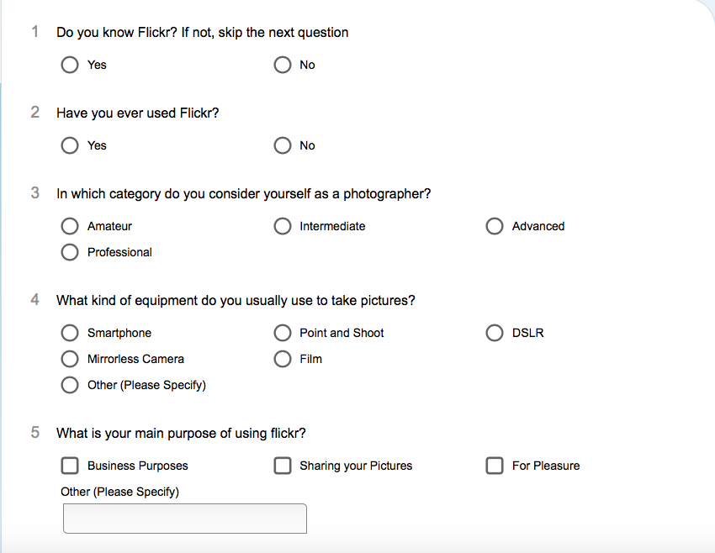
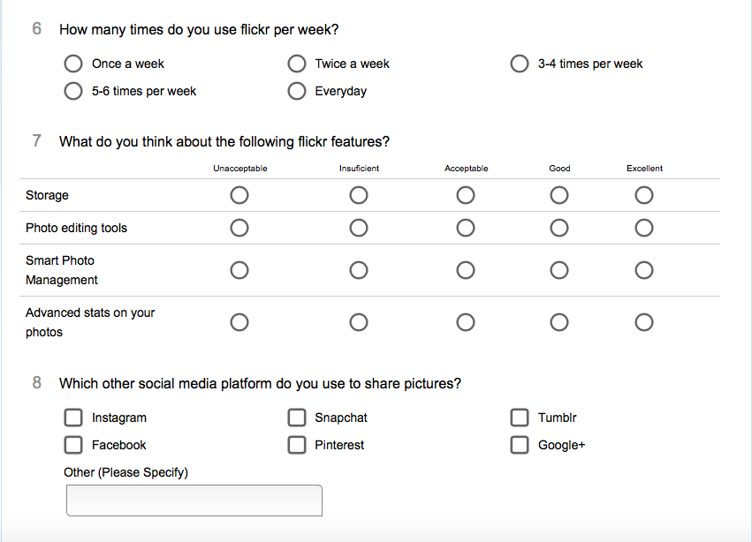

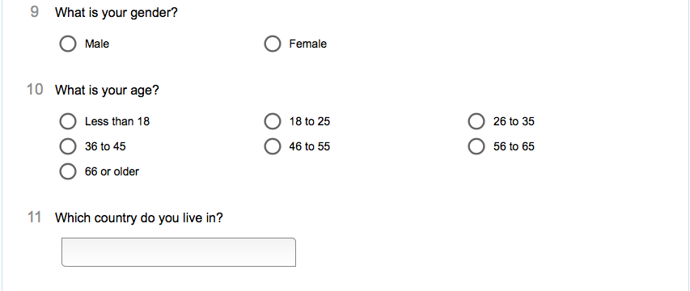

Results
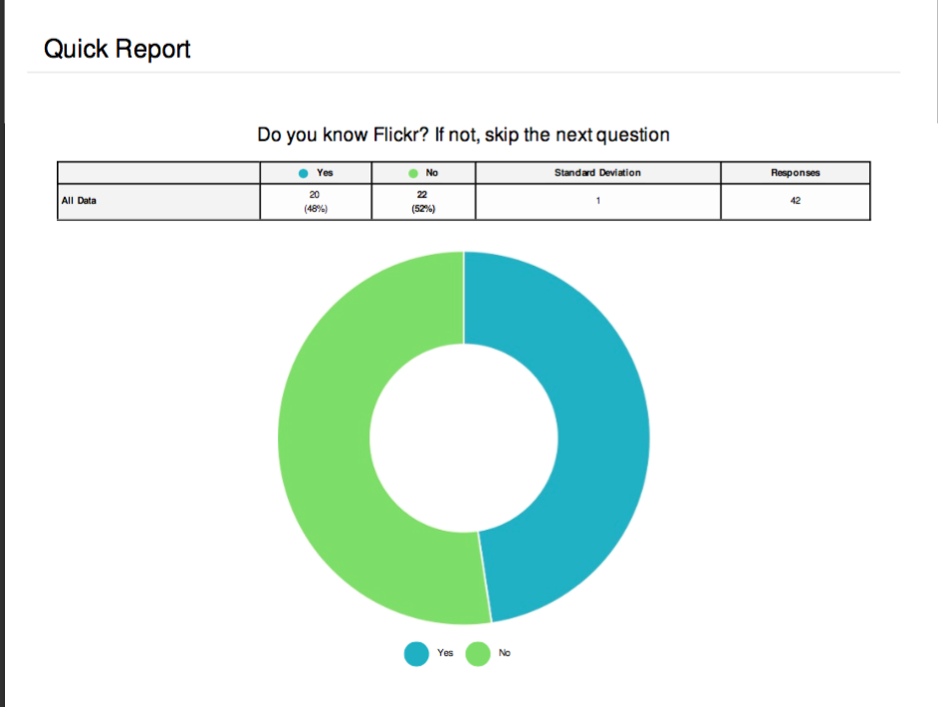

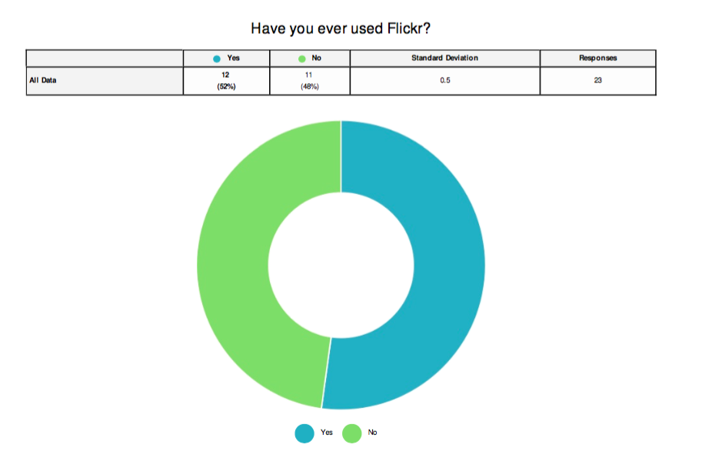
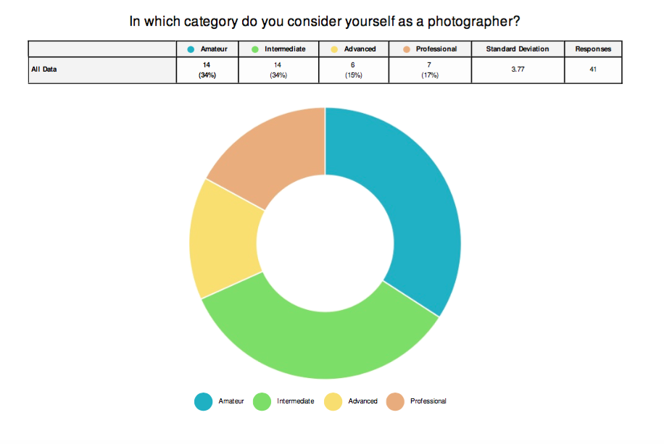
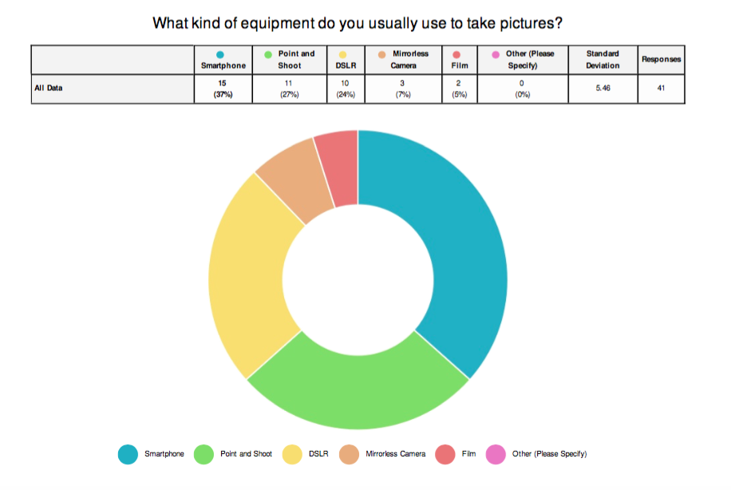
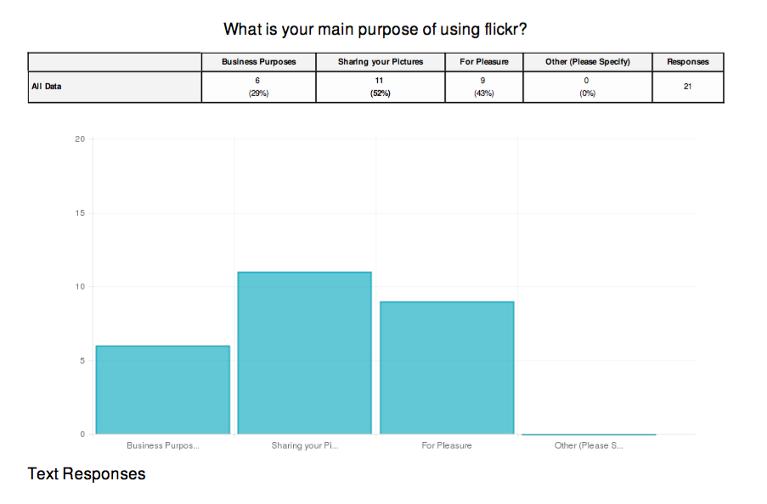
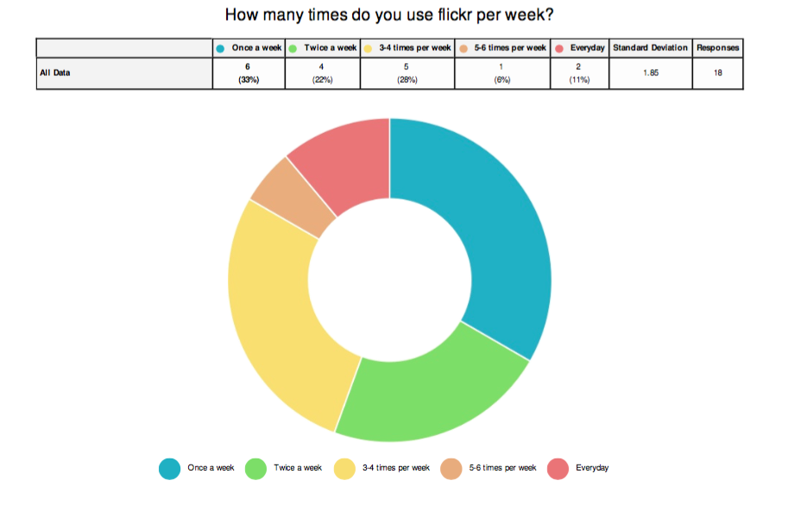
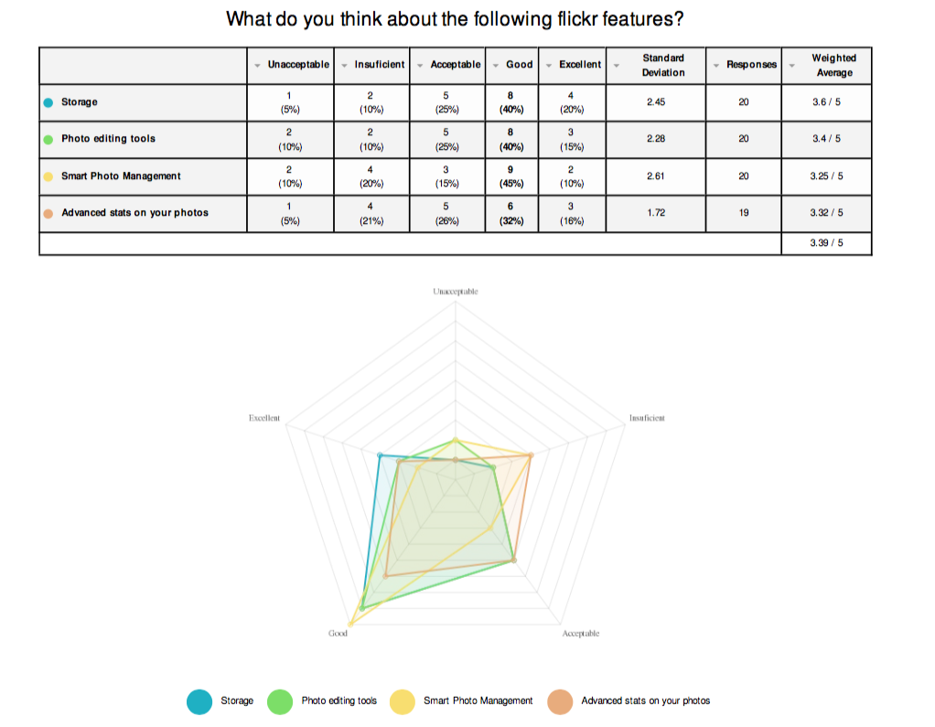
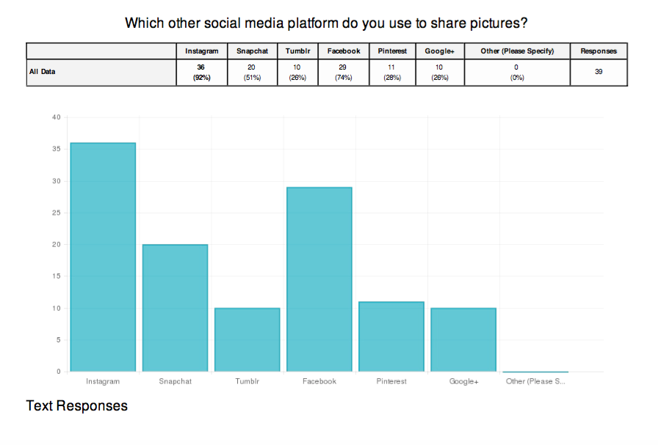
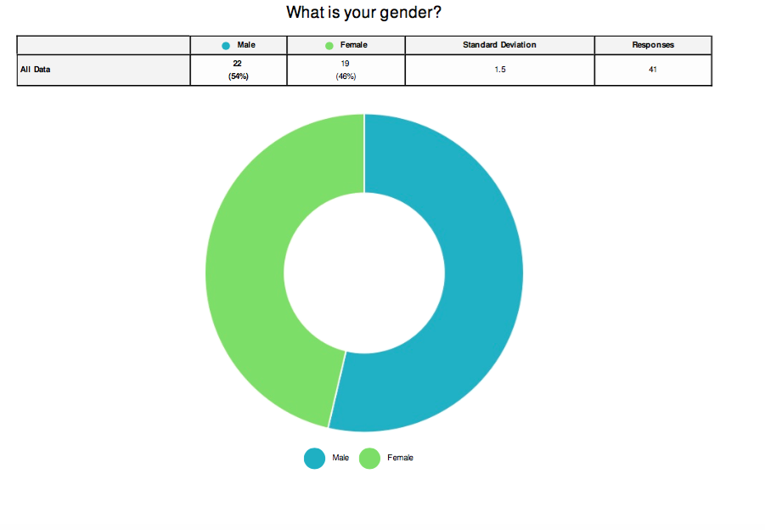
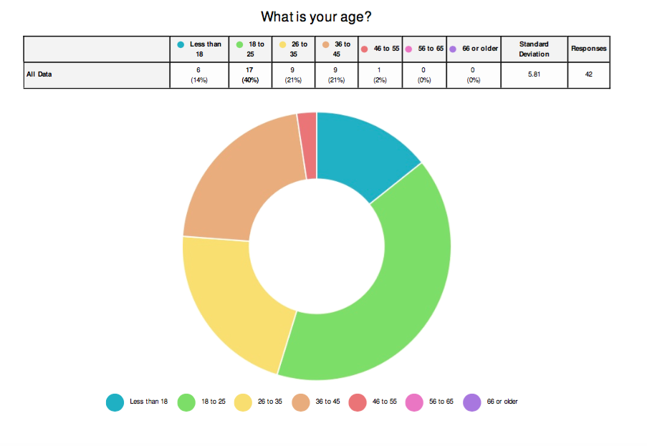
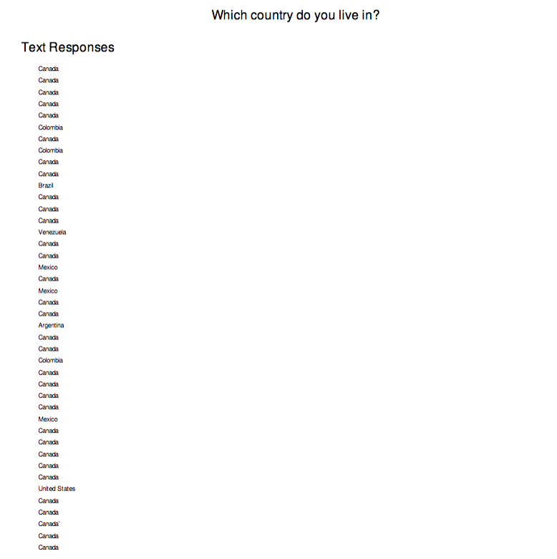
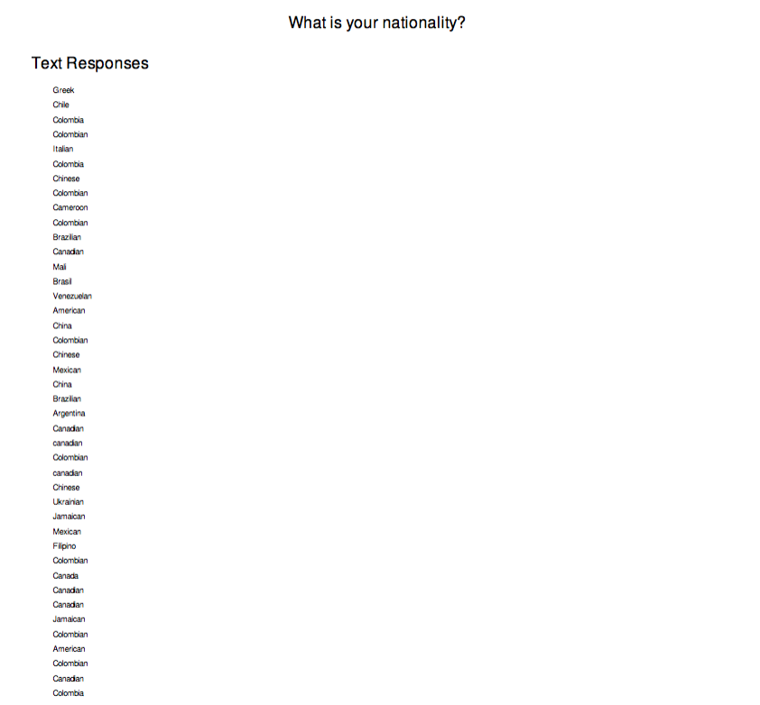
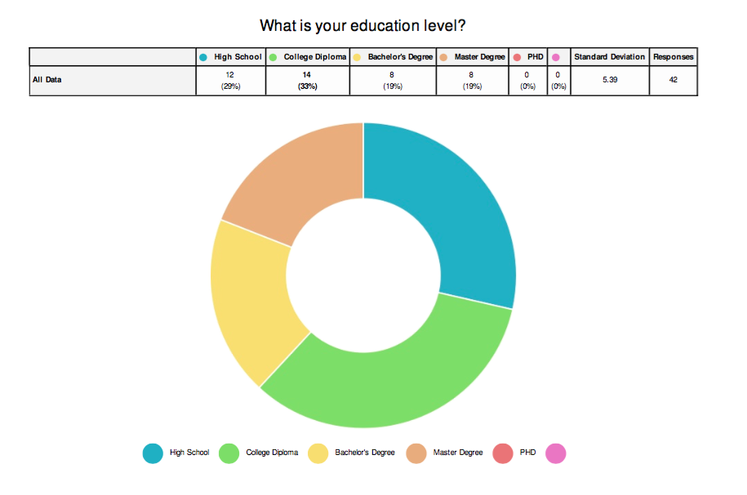
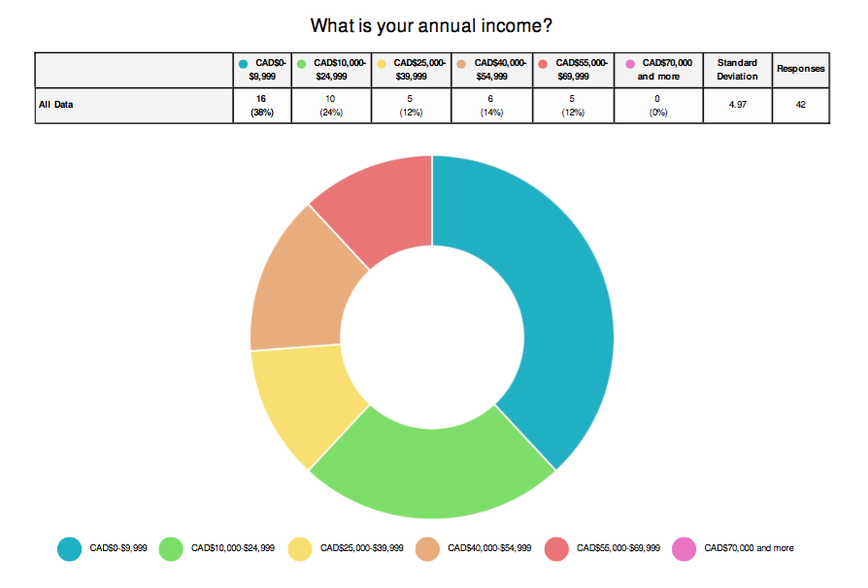

REFERENCES

Flickr. (n.d.). Flickr APIs Terms of Use. Retrieved from https://www.flickr.com/services/api/tos/
Media Ridge. (2016). Retrieved November 30, 2016, from Media Ridge: https://mediaridge.com/blog/why-flickr-is-better-than-instagram/
techboomers. (2016). Retrieved november 30, 2016, from techbommers: https://techboomers.com/t/flickr-alternatives

(Flickr, Flickr APIs Terms of Use)
(Flickr, Flickr APIs Terms of Use)

