Implementation of Omnivox
at LaSalle College Montreal

INTRODUCTION TO E-BUSINESS

ANTHONY IBRAHIM

November 27th 2015

Students:
- Beatriz Gouveia de Meirelles
- Francisco Antonio Bezerra de Meirelles
- Karelle Lorlane Mbapte Pagué
- Zameer Dewji

INDEX
Pg.

PRESENTATION OF THE BUSINESS 3

DESCRIPTION OF THE TECHNOLOGY 4

CHALLENGES INVOLVING THE IMPLEMENTATION 5

BEFORE AND AFTER 6 – 7

CONCLUSION 8

APPENDIX 9 – 11

REFERENCES 12

PRESENTATION OF THE BUSINESS
Presentation of the business, its mission statement (if existent) and its strategy. The nature of the industry and of the competition.
LaSalle College International was founded by Mr. Jean-Paul Morin in 1959. It used to be located in the LaSalle borough of Montreal. The mission was to create job opportunities for the Quebec population by providing a kind of education that matches the job market demands and, because of that, its first program offered was Secretarial Training. After a while, the college started focusing on fashion training and now it is strongly recognized in that area. Nowadays, LaSalle College is composed of 5 schools: Fashion, Arts & Design, Hotel Management & Tourism, Business & Technologies, Humanities & Social Sciences and E-Learning.

LaSalle College has a strong international focus and is the keystone of LCI Education Network, an international network of 21 establishments in 11 countries and 4 continents. LaSalle College offers various international opportunities to its students and its international students represent close to 20% of LaSalle College’s student population.

In the Quebec educational system, LaSalle College is qualified to grant 3 types of diplomas: a diploma of college studies (DEC), an attestation of college studies (AEC) and a diploma of vocational studies (DVS or DEP in French).

In the entrance of the main building, located in Montreal, you can read is large letters the company’s mission statement: Member of the LCI Education Network, LaSalle College Montréal is a private post-secondary education establishment whose mission is to offer superior education and keeping with labour market needs, self-actualization and globalization.

DESCRIPTION OF THE TECHNOLOGY
Description of the technology.

The platform was developed by a company called Skytech Communications and it is directed to institutions such as Colleges and Universities. The developers defend that it is affordable and can easily be implemented by both colleges with a range of 100 students or universities. It has already been adopted by more than 100 colleges and universities and has a really strong participation in Quebec’s educational system.

The technology bases itself in cloud computing information and can be accessed from any location through a simple electronic device. Omnivox equally has a mobile platform for cellphones and tablets, which can be easily found in Google Play and App Store.

The main objective of Omnivox technology is to make the exchange of information between the students, the college and the staff flow faster and easier.

It is available in English and French and has a high satisfaction rate, around 97% of approval according to a recent survey.

Omnivox platform includes services like MIO and LEA, which have their own features as well.

CHALLENGES INVOLVING THE IMPLEMENTATION
Financial, technical and cultural challenges involving the implementation of the technology.
- Financial:
When you implement a new technology in your business, you are taking the risks that it does not work out as expected and you lose your investment. When LaSalle implemented Omnivox, the investment was not limited to the purchase of the platform. It also included acquiring equipment to work on this new technology, hiring personal to manage the tools and maintain all the information actualized and providing the necessary material to both students and employees, such as wifi signal in all the common areas of the building and computer labs with free access. The main financial challenge that LaSalle faces is probably the risk of not having the investment returned and staying with a deficit in that area.
- Technical:
To implement this new technology, was necessary to develop a new department only related to managing this new platform. Although Skytech Communications offer a good support for its clients, LaSalle still had to prepare its structure to receive Skytech’s product. In addition to that, there is also the risk-taking aspect of if someone breaks the security system and accesses all the information included in the platform. Until now, it has never happened to LaSalle but in January 2013, a student at Dawson College Montreal broke into Omnivox security system and stated that it was a sloppy coding that put in risk all the other 250,000 students personal data, he was expelled from the institution after the incident.
- Cultural:
As all the new things, the implementation of Omnivox met barriers related to the acceptation of students and employees. For the people that are used to papers and traditional methods, it is hard to face radical changes. The institution also got a new task of convincing the students that Omnivox was a good tools and that the teachers and students should constantly use it.

BEFORE AND AFTER
The Announcement feature of Lea

This is one of the great added value to the Omnivox system. On Lea the teachers can inform their students regarding any information, news, details regarding their course. The main difference and benefit between traditional method of announcement and now that “Announcement” is over Lea is neither the student nor the teachers do not need to be present in school to inform the student about making an announcement. The students can be notified of important teacher announcements as it can be easily accessible online. The announcement feature can help teachers make sure all the student are made aware of any announcement by tagging all their students in the class.

The Documents feature of Lea

Teachers can upload and send e-documents to their students. Students tend to lose or forget where they keep their paper documents. The “Document” feature of Lea students is always aware where to find their course document and access them whenever they wish to. Most of the time students are working on their project or studying using their laptops, iPads or on their mobile phones so they prefer it if they have it in form of e-documents. The teacher can learn about the student’s behaviour if they open the documents or not.

The Assignment feature of Lea

The “Assignment” feature of Lea reminds and informs students on the number of tasks and the tasks they need to complete. It provides them with information regarding the assignments such as submission deadlines and the form of submission, either if they need to submit the assignment in class or via Lea WEB version. Also inform them of the number of assignments they have looked at or not opened yet. Before Lea, the students could not keep track of their assignments performed.

The Grade feature of Lea

The Grade feature of Lea helps students keep record of every grade they have received and the number of grades they have received so far. The Grade feature as well keep record of the type of assessment they were graded on. The teachers can upload the students grade, show the class average so that students can compare themselves on how well they have performed on their assignments. It also keeps track of the student’s average progression and portray on a chart so that they can evaluate their study development. Before Lea, students had to wait till they come to school to see their grade and get to compare their performance with other students.

The Event feature of Lea

It is an electronic form study timetable that informs the students of the tests days and assignments deadlines dates. The deadlines are updated automatically on “Event” as the teachers post the assignment on Omnivox. This is going to be beneficial to help students to organize their study routine. Before Lea, it was difficult for students to remember their assignment deadline or they would not remember where they had noted the deadlines.

The Teacher feature of Lea

The “Teacher” feature will inform students regarding the teacher’s office hours, the days of their office hours, and the room he is situated. This information is available to students to view on Lea if they need to see them. Before Lea, students did not know of their teacher’s office hours or they would happen to forget them or forget where they have written it.

The “Web sites” feature of Lea

Before Lea existed, the teachers sent the website on Mio but now they have a special area for every course for teachers to post websites for their students to access easily. “Website” has made it more easy for both students and teachers to keep track of every website shared in the class and to review it again.

The Absences

The “Absence” feature has made it possible for students to keep track of their absences, which they could not be able before so sometimes students could go over the absence hours restriction for every course which they should not surpass.

The Forum

Lea has come up with the “Forum” where students and teachers can come together to discuss and share information and ideas. Before Lea this beneficial feature was not available to students.
CONCLUSION
Conclusion about the case: opinions, lessons learned and recommendations.

The Omnivox Platform played an important role on helping LaSalle College Montreal to improve its performance. By providing a tool that promotes the student interaction with their teachers and the college itself, the number of students that drop out and do not reach the end of the course has been largely reduced. When the students feel that they are being accompanied and supported, they are less likely to give up on their careers when they encounter any kind of difficulty. That decision from the students reflects directly on the college’s revenue because once a student abandons the course, his/her spot will continue reserved even if no payment is being received.
We also analyzed that the implementation of Omnivox in LaSalle College happened not only by the necessity of that tool (which has its importance), but also because as the other colleges were implementing it, LaSalle had to fight fairly with the concurrence to guarantee its place in the market.
Skytech has developed a really good platform for its clients; there is no surprise on their growing participation in the market. Although, improvements and updates must always be developed, as all the types of technology are constantly changing and no kind of settling should take place.

APPENDIX

LaSalle College Montreal

Jean-Paul Morin

Skytech Communications website

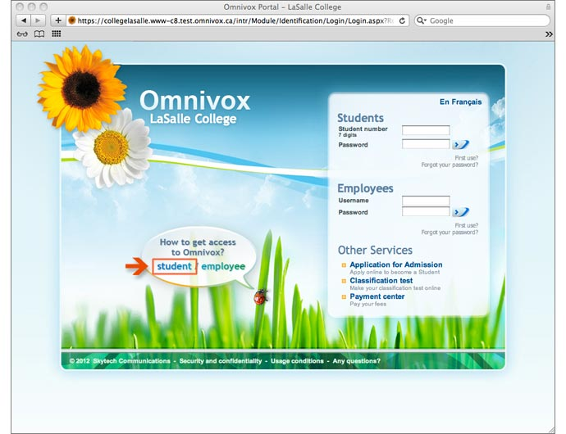

Connecting page of Omnivox LaSalle

Hamed Al-Khabaz, former computer science student of Dawson College

REFERENCES

- LaSalle College Montreal Website:
http://www.lasallecollege.com/about-us/history.aspx

- Wikipedia about LaSalle College:
https://en.wikipedia.org/wiki/LaSalle_College

- Skytech Communications Website page about Omnivox:
http://www.skytech.com/en/omnivox.sky

- Harvard Business Review Website about Implementing a New Technology:
https://hbr.org/1985/11/implementing-new-technology

- E-How Website about The Positive & Negative Effects of Technology in Business:
http://www.ehow.com/list_6943594_positive-negative-effects-technology-business.html

