PORTFOLIO OF INTRO TO BAKING

Student Name: Duong Thi Mai, Phuong
Student ID: 1830126
Chef: Azriel Paz

Week 1
Blueberry Muffins
Method | - Creaming method: Cream butter, sugar and salt until the mixing combination looks creamy and smooth, then beat eggs alternatively.  - Then add the dry ingredient and buttermilk to the creamed mixture. The blueberry should be dredged in a small amount of flour and gently fold into batter (final added)
Baking Temperature | - 375$°$F for about 30 minutes until golden brown
Outcome and Chef Critique | - Our blueberry muffins were not scale adequately, it still had a different size. It was supposed to have 12 muffins in total with the recipe, but outcome had only 10 muffins. The color of muffins looks good in golden brown.  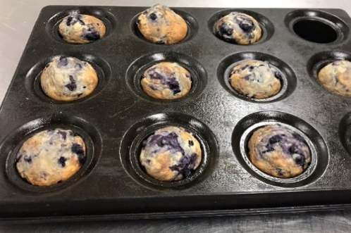

Peanut Butter Sandies
Creaming Method | - Creaming method: cream the butter and sugar combination  - Then add gradually eggs and peanut butter and salts.  - Later, add the dry ingredients (flour, baking soda, baking powder) to the mixture and mix to make a firm dough.  - After getting the dough, scale the dough into 1 small piece and then roll into a bow shape then press them down into flatten piece. The edge of cookies will develop some cracks after baking, which is a desired outcome
Baking Temperature | - 400$°$F (200$°$C) for about 12 minutes until golden brown
Outcome and Chef Critique | - the cookies did not have the proper looking because we lacked of knit to make the decoration. However, the size and the shape still have a good look. The cookies should be pressed more equally to have a proper edge  - The creamy mixture is good when it looks creamy, smooth, double in mass and lightened to a whites-yellow color  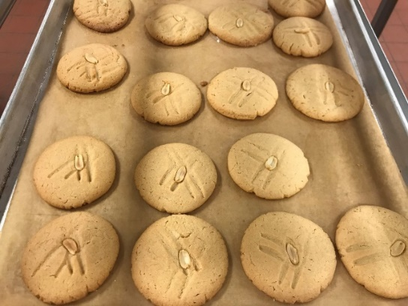

Soft Yeast Dinner Rolls
Method | - Straight dough method: dry yeast activated in warm water before mixed with the flour and other ingredients to form dough, known as the direct or straight yeast method, is the leavening method
Baking Temperature | - 200°C
Outcome and Chef Critique | - My product was not completed; the dough still need time to proof.  - Note: Measure the ingredients correctly on the scale based on the recipe.  - The dough is mixing good under the work of hand and also the temperature of palm (body temperature)  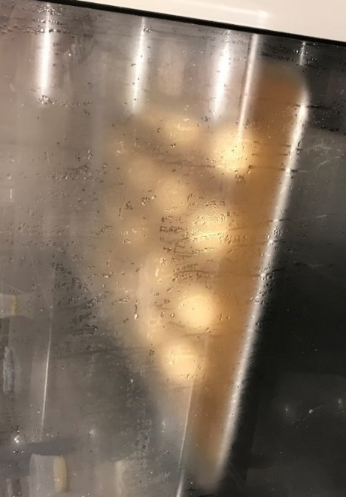
Week 3
Italian Rosemary rolls
Method | - straight dough method  - Mix all of the ingredients except the date and olives, then knead until smooth, then mixing with olives and shape into a rounded ball then wait for the dough be fermented in double size. Portion the dough into 50g smaller and place them on a parchment-lined sheet tray. Proof until into double size then brush with egg wash and top with rosemary. Then baking until done
Baking Temperature | - 400$°$F
Outcome and Chef Critique | - Our tram product had a good color of bread after baking, also the taste was good  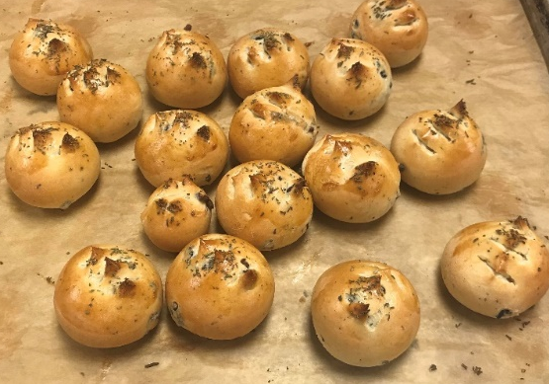

Carrot bread and Banana Bread
Method | - Muffin method: 2 mixtures are created: all the wet ingredients and all the dry ingredients  - Stir all the dry ingredients together and set aside.  - Eggs and sugar are mixing until thick, then add the oil gradually until combined and homogenous. Then mixing all the dry ingredient and the wet ingredients together. Pour into the pan and let the batter stay for 10 minutes before baking.
Baking Temperature | - 325-350$°F$
Outcome and Chef Critique | - Our team product had a good looking at color after baking. For the carrot bread should take a time to bake in the oven longer for the top of the bread could not be down.

Fudge Brownie Batter
Method | - Muffin method  - Melt the butter and chocolate at the temperature of 120$°F$. Mixing the egg and sugar until it mixture well altogether and then mix all of the ingredients together and blend until combined.  - After baking, put the brownie batter in to cooler or freezer. Then cut into a bar as bar cookies size
Baking Temperature | - 325$°F$
Outcome and Chef Critique | - Our product was good in taste and color. The edge is crack.  - However, the size when cutting should be like a bar, not square shape  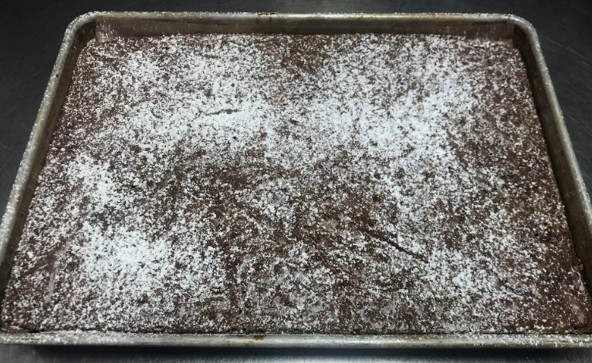

Week 4
Traditional shortbread cookie
Method | - Biscuit method  - In the class, I learned how to mixing by hand, it could also be mixture by machine. In the bowl, put flour, butter, sugar, salt, vanilla extract, mixing until the mixture just combined.  - Divide the dough into 4 equal portion, roll each portion into a roll and wrap with the plastic (make the roll looks round and equal), then put into refrigerator.  - After the dough shape and cold, take out then take off the wrap, brush egg wash around the dough then cut into slice.  - Using the fork to dock on the surface.
Baking Temperature | - 375°F or 190°C for around 15-20 minutes
Outcome and Chef Critique | - The cookies look good in color with the golden brown at the edge and taste is good. However, the shape of cookies is not much equally.  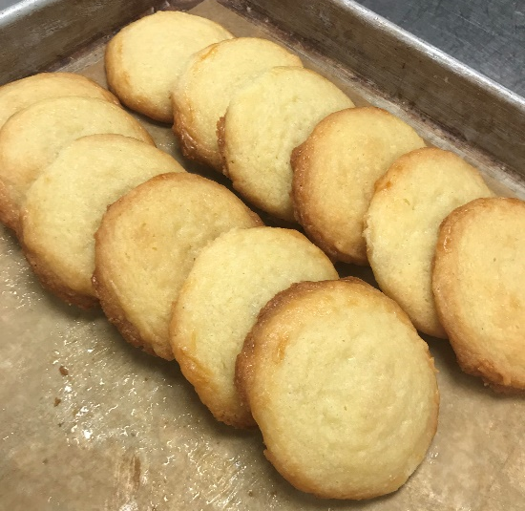

Cheddar-Chives Scones
Method | - Blitz method  - Combine all dry ingredients in a bowl. On the table, spread the dry ingredients and add eggs, milk, cream and mix until just combined. Mixing until just combined the dough with chives and cheddar.  - Roll the dough into a thick circle and cut into 8 wedges. Then garnish and brush egg wash
Baking Temperature | - 400°F for 15-20 minutes
Outcome and Chef Critique | - Our wedges are not same in the portion but the overall is good with nice baking, golden brown and tender  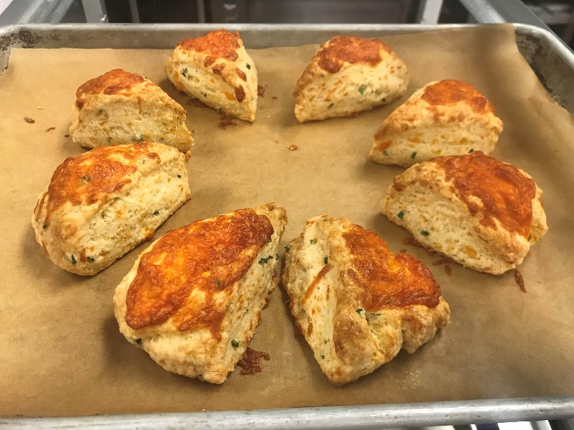

Whole-wheat sandwich bread
Method | - straight dough method  - Combine the eater, milk powder, sugar, salt, yeast. Then stir in remaining flour and knead until the dough get mixture well.  - Place the dough to ferment at room temperature until double around 1-2 hours.  - Divide the dough into 4 pieces, roll and shape into greased loaf pan and proof until double size. Then brush with egg wash
Baking Temperature | - 375°F until the brown and hollow sounding, around 50 minutes.
Outcome and Chef Critique | - Our product had a good in color and taste in general, brown color.  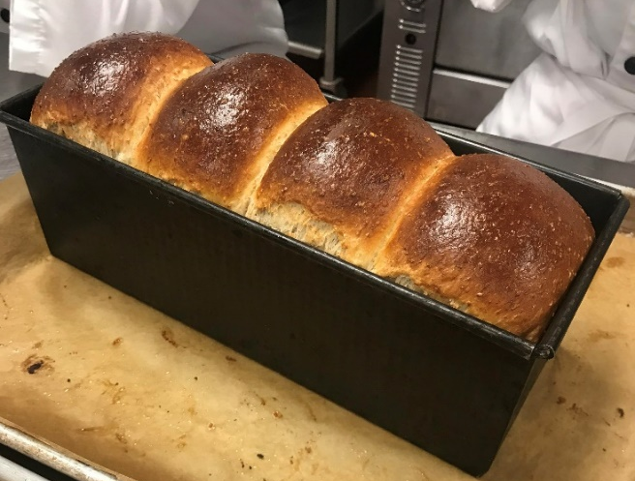

Pate Fermentee (old dough)
Method | - I was shown how to make old dough by Chef, the history of making dough long ago.  - There was no yeast therefore the dough was made by add flour, water with the ratio 600g water and 1 kg flour.  - The nature of yeast would come from organic grape.  - Moreover, the dough need 3 days to feed gain with mixture of flour and water when put in the cooler, if it in temperature room, should be feed day by day. The acidity of the dough should be between 4 to 5 that make the pathogen cannot live

Week 5
Baguette
Method | - Straight dough method  - After making a paper towel, spread it long enough to form a shape, then bake it again. At this time, place the modified dough on a French cloth and insert the cloth between the loaves on the bread that does not stick together when it is baked  - When modifying an accompaniment, the dough is not well prepared due to its elasticity. At that time, the dough is modified with time for the writing routine to increase
Baking Temperature | - Bake at 400'F for 25 minutes
Outcome and Chef Critique | - Our baguettes were over-expanded in the process of maturing them and glued to each other. So I separated the dough before baking. So it was not pretty  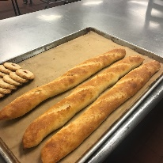

Bird’s Net Cookies
Method | - Cookie method  - After making a cookie dough, freeze it slightly. Before cutting the dough, cover it with coconut powder and cut it into a round shape. Place a small round hole in the center and get raspberry jam on it
Baking Temperature | - Bake at 375°F for approximately 15-20 minutes
Outcome and Chef Critique | - If put too much raspberry jam on top of a cookie, the cookie will not come out in a pretty shape because the jam will make a large circle. Or it is flattened.  - Our cookies are baked to a fixed shape. If it's baked a little more, the color will be brown, but the scent is good  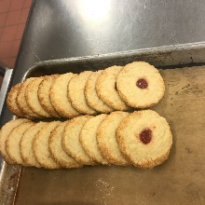

Pecan Pie
Method | - It is pie that is baked separately with pecan and syrup on it
Baking Temperature | - Line with foil and par bake at 300°F. /Bake at 300°F until set.
Outcome and Chef Critique | - Our pie didn't swell. Maybe because we didn't boil syrup until it bubbles up.
Week 6
Soft yeast dinner roll
Method | - Straight dough method  - Making: (using the mixer machine) dissolve the yeast in the water, then mix altogether the ingredient left, flour, salt, sugar, milk, shortening, butter and egg.  - Then add the yeast mixture. Stir until the ingredients combined. Then cover the dough in a warm spot and let ferment around 1 hour until doubled.  - After that, punch the dough down to let the gluten relax few minutes then cut into portion 50g, roll the dough into shapes, then proof until double.  - Finally, brush with egg wash then bake in oven.
Baking Temperature | - 200$°$C
Outcome and Chef Critique | - Our bread was nice in color. The dough was made good because of the mixture making the dough combined ingredient well, proof enough.  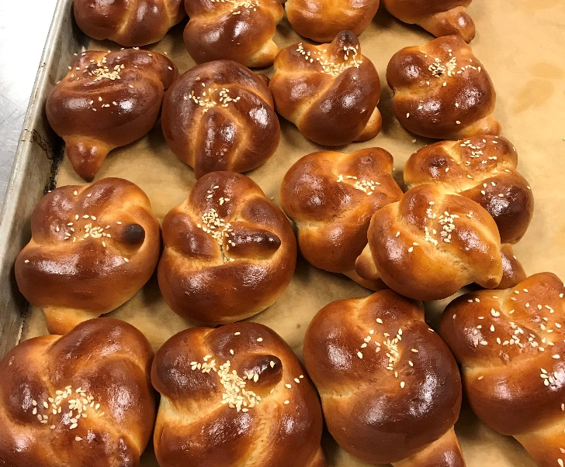

Raisin bread
Method | - Straight dough method  - Making: similar to dinner roll, raisin bread had the similar steps to make, except put more raisin in the step during ferment the dough,  - Add raisin then continue ferment until the dough raising, then divide the dough into 2, then round off.  - Shape the dough into loaves then proof until double in size. Bring to bake in the oven.  - After bring out the oven, brush with butter and sprinkle with some sugar on the surface.
Baking Temperature | - 200$°$C
Outcome and Chef Critique | - The bread was good in making dough, also baking good to give the bread nicely color in golden brown.

Chocolate Cream Pie
Method | - Prepare the pie crust before making the filling. Using the recipe of pie dough, after baking and cooling out the crust.  - Start making the filling. In the sauce pan, add half of brown sugar, milk and cocoa powder.  - After boiling the liquid, add the egg yolks and remaining sugar, add cornstarch and whisking well until the liquid fluffy and thick.  - Remove from heat and add chocolate, vanilla, and butter then stir until incorporated.  - Pour into the pie shell and cool in the refrigerator.  - For the top, making whipped cream, then decorating with chocolate shavings
Baking Temperature | - 375°F
Outcome and Chef Critique | - The crust was made good, however, the filling was not good, still moving means not thick enough the liquid. Also, do not have enough time to make the whipped cream on the top.  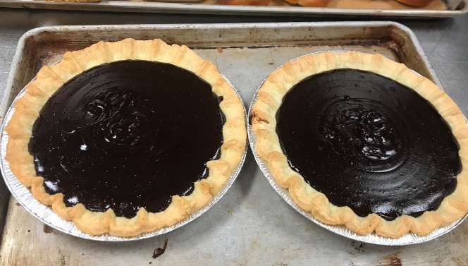

Oatmeal Cookies
Method | - Creamy method  - Making: stir altogether the dry ingredients and set aside. Then cream the butter and sugar in mixing bowl until light and fluffy. Add egg one at a time.  - Then add salt, pinch of orange grated and salt. Then bring the creaming butter mixture to the flour mixture and fold until combine.  - Portion the dough onto sheet pan then bring to bake in the oven
Baking Temperature | - 190$°$C
Outcome and Chef Critique | - Our cookie had a good color of baking with light brown in the edge of crust.

Week 7
Pound Cake
Method | - Creaming method  - Making: set the dry ingredient on the side, while cream the butter with sugar until light and fluffy then add gradually sugar, finally the rest of the moisture ingredients, except butter milk.  - Until the mixture combined, fold alternative dry ingredients and butter milk in 2 or 3 times.  - Then pour in 2 loaf pan, then bring to bake.
Baking Temperature | - 180$°$C, around 15-20 minutes until golden brown and the cooked evenly inside out, checking by pressing lightly to the center of the cake, if it bounce back. It means doneness.
Outcome and Chef Critique | - The pound cake was good, the color is nicely brown, cooked in oven evenly.  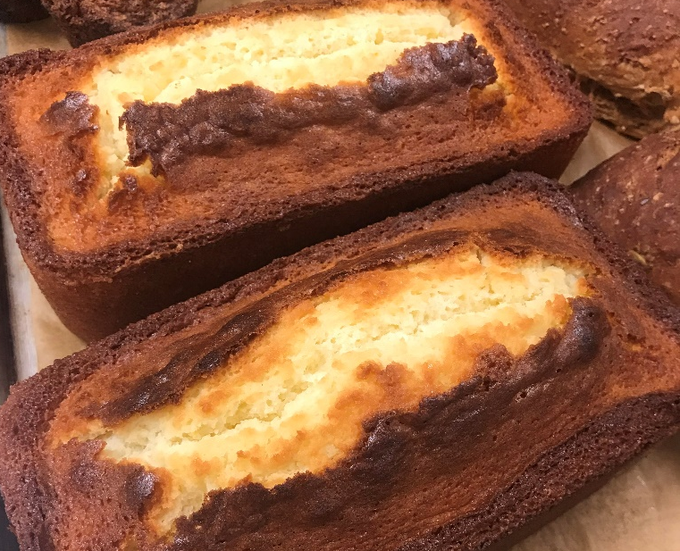

Multigrain Sourdough Bread
Method | - Straight dough method  - Making: the cracked wheat should be put in warm water, until it soft then dries it. Then mix sourdough, yeast and water together.  - Then add altogether the dry and wet ingredients except flax seed and sunflower seeds folded at the end. Place the dough in warm place, covered to let it ferment.  - After ferment, punch down, portion into 3 batch, roll in the bread shape then let proof.  - After proof, brush with egg wash on the surface then bake in the oven
Baking Temperature | - 375°F, 190°C
Outcome and Chef Critique | - The bread was good, nice color, however, it should be let the knit under to let it not be break apart when baking.  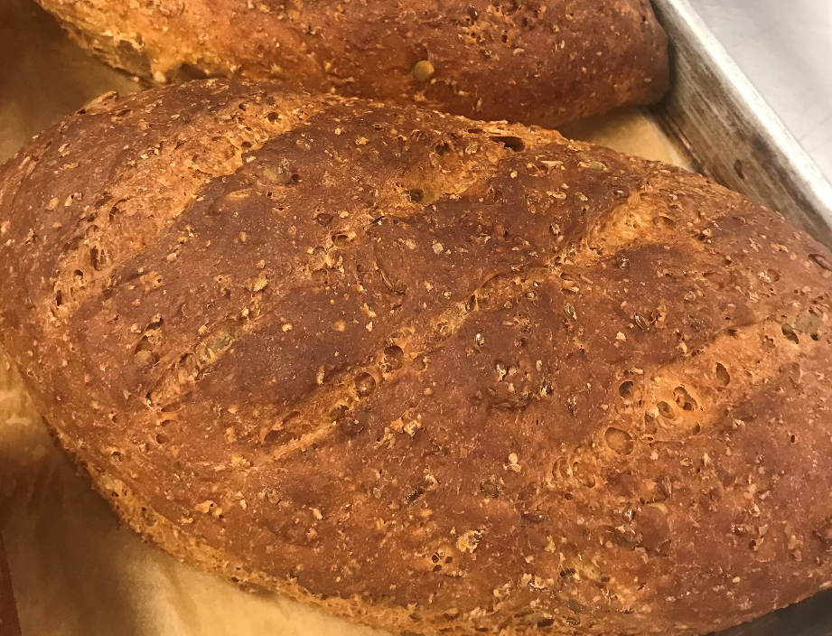

Cranberry White Chocolate Orange Scones
Method | - biscuit  - Making: sift all the dry ingredients in mixing bowl, then add cold cubed size butter, blend to pea-sized. Then add the cranberries and orange zest.  - Combine eggs, milk, cream together then add to the mixture. The dough just come, take out, don’t over mix.  - Then roll the dough and cut into 8 wedges, bake in the oven
Baking Temperature | - 400°F
Outcome and Chef Critique | - Each wedges should have more equal in size, however in general the scones are good in baking color, nicely tastes.

Morning Glory Muffins
Method | - muffin method  - Making: sift all dry ingredients together and set aside. Then mix with carrots, raisin, pecans, coconuts and apple grated.  - Whisk eggs, oil, vanilla in mixing bowl. Then add altogether with dry ingredients.  - Portion into the muffins tins and bring to bake
Baking Temperature | - 350°F
Outcome and Chef Critique | - The muffins were over cook, withdrawn from that, the egg mixture should be whisk more to make the muffins are more soft when eating.  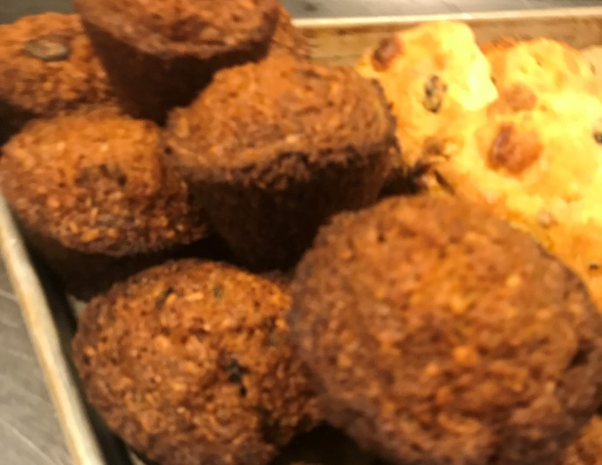

Week 8
Soft Yeast Dinner Roll
Method | - straight dough method  - Making: Firstly, dissolve yeast in water. Combine all remaining ingredients in a mixing bowl. Then stir to combine altogether. Keep kneading until the dough is combined and smooth.  - Transfer the dough to warm place with cover on. Let the dough ferment for an hour.  - After that, punch down and divide the dough into 40 or 50 grams’ portion, roll into round shape.  - Then let the dough proof until double in size. \  - Brush each one with egg wash and put some sesame on top
Baking Temperature | - 200°C
Outcome and Chef Critique | - Our rolls were good, nice in making dough and baking.  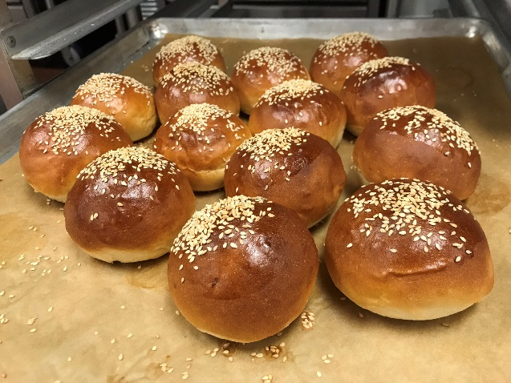

Cinnamon Bun and Caramel Glaze
Method | - straight dough method  - The filling for the pan: caramel glaze: add all ingredient into a bowl then stir until make a smooth paste. Then smearing into the bottom of a pan  - The dough: dissolve the yeast in to water. Combine all remaining ingredients in a mixing bowl. Then stir until combine. kneading until the dough is combined and smooth.  - Transfer the dough to warm place with cover on. Let the dough ferment for an hour.  - After that, punch down, spread the dough into flat, then brush with cinnamon sugar, chopped pecan, then roll into pipe shape. cut into 12 x 10” rectangle, then roll and shape into a smearing caramel pan.  - Leave for proofing until double
Baking Temperature | - 375$°$F
Outcome and Chef Critique | - Our cinnamon bun was good in making and baking, nice color and  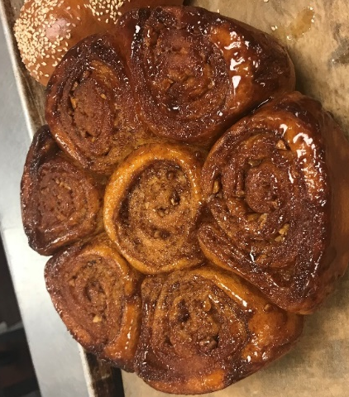

Sour Cream Coffee Cake
Method | - creaming method  - Making: cream the butter and sugar until it lightly in color and smooth, then alternatively add egg. Then after the mixture is lightly, add sour cream and stir until smooth.  - Then add about 3 times differently the combination off dry ingredients until the batter is smooth and well combined.  - Place the batter in a tube pan, put the filling in the middle and top of the batter
Baking Temperature | - 350°F
Outcome and Chef Critique | - Our cake was good, nice in color and shape

Butter Cookies
Method | - creaming method  - Making: cream the butter and sugar until it smooth and lightly in color, fluffy in state. Then gradually add egg. Blend until combine. Using the piping bad and star tip to make portion of cookie, then decorating with dried cherry, almond, pistachio.
Baking Temperature | - 350°F around 10-14 minutes.
Outcome and Chef Critique | - Our butter cookies were good in making and baking, nice taste and color  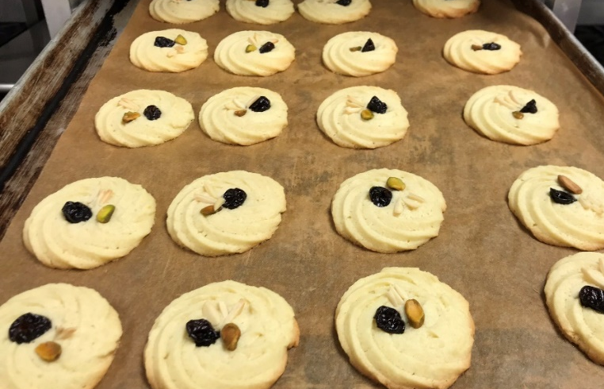

Summary
Questions | Answers
- What did you learn during the 11 weeks? | - This is the first time I learned how to make dough and cookie by using hand. It was a good experience. Also, I learned the basic steps and stages when making dough, old dough style, new style, using different type of yeast, roll and made the dough into many shapes and types of bread.  - I have learned and practiced many times with the creaming method, which I can understand when the stage of cream mixture is good enough and how to fold gently into other ingredients to make a good firm of mixture  - Moreover, I learned many small tips but useful and essential for me  - Not only about the knowledge in baking, also I have learned how to work in the kitchen, get used to with ovens and equipment and how to control temperature when baking. Every skills when in baking class could help me to improve my organization and my abilities in working area
- What were some difficulties or challenges? | - Some difficulties are about how to control time and temperature when baking and how to evaluate the product have good outcome and bake well or still under bake or over bake.
- What was the highlight or the most memorable event? | - During week 8, when all of my products that days I got 5/5. After many weeks past, any I got many mistakes, that day made me so happy when I can follow and make good products if I keep working hard and improve from my mistakes before. It also helps me in the future if I focus on baking and pastry career.  - Also, when I learned how to make cookies, I understood about the creaming method, and also the step when folding ingredients into the cream mixture. I was trying to make cookies before but most of the time I failed. I can see Im more confident to make cookies at the moment.
- What did you take away from the Intro to Baking Course? | - My class was wonderful, except the second week I could not go to class, the rest of the class, I got so many excitement and motivation when I came to class because of the teacher, classmates and also the class environment.

