INTRO TO BAKING

SUBMITTED TO: SUBMITTED BY:
AZRIEL PAZ KULWINDER SINGH

MENU
Blueberry Muffins (Yield: 12 muffins)
Ingredients:
125 g Unsalted Butter
250 g Sugar
3 g Salt
100 g Eggs
300 g All Purpose Flour
10 g Baking Powder
120 ml Buttermilk
200 g Frozen Blueberries
Flour for dredging

Method: (Creaming and quick bread Method)

- Cream butter, sugar and salt.
- Beat eggs in one at a time.
- Sift together the flour and the baking powder.
- Alternately add the dry ingredients and buttermilk to the creamed mixture.
- Dredge blueberries in a small amount of flour and gently fold into batter.
- Portion into greased muffin tins.
- Bake muffins at 375°F for about 30 minutes or until golden brown.
- Remove from pan shortly after removing from oven. Cool.

Peanut Butter Sandies (YIELD 24 SERVINGS OF 37G)
Ingredients
flour, pastry (or all-purpose flour) | 302.4 g | 100%
baking soda | 1.76 g (2.24 mL) | 0.6%
baking powder | 1.76 g (2.24 mL) | 0.6%
butter, unsalted (softened) | 201.6 g | 67%
sugar, granulated | 201.6 g | 67%
eggs | 41.58 g (1 ea.) | 14%
peanut butter | 126 g | 42%
salt | 5.04 g (4.34 mL) | 1.7%
sugar, granulated | as needed
peanuts (use halves, optional) | 25.2 g | 8.3%

Directions
- Sift together the flour, baking soda and baking powder. Set aside. Cream the butter. Add the sugar and continue creaming. Gradually add the eggs, followed by the peanut butter and salt.
- Add the dry ingredients to the butter mixture and mix to make a firm dough.
- Scale the dough into 1-pound (480-gram) pieces. Roll the dough into 12-inch (30-centimeter) logs. Cut into 1-inch (2.5-centimeter) pieces.
- Roll each cookie into a ball and place on a paper-lined sheet pan. Press each ball down using the bottom of a measuring cup to slightly less than 1/2 inch (1.2 centimeters). The edges of the cookies will develop some cracks, which is a desired look.
- Using a fork, press crisscross markings on the surface of each cookie. Lightly brush the cookies with water. Sprinkle lightly with granulated sugar and press one peanut half into each cookie, if using.
- Bake at 400°F (200°C) until golden brown, approximately 12 minutes

Soft Yeast Dinner Rolls (YIELD 24 SERVINGS OF 35G)

Ingredients
yeast, dry active | 20.25 g | 4.55%
water (temperature controlled) | 243 g | 55%
flour, bread | 445.5 g | 100%
salt | 10.13 g | 2.3%
sugar, granulated | 40.5 g | 9.1%
milk, non-fat dry | 20.25 g | 4.55%
shortening, vegetable | 20.25 g | 4.55%
butter, unsalted (softened) | 20.25 g | 4.55%
eggs | 32.4 g (3/4 ea.) | 7.3%
Egg Wash | as needed

- Dissolve the yeast in the water in a bowl. Combine the flour, salt, sugar, milk powder, shortening, butter and eggs in the bowl of a mixer fitted with a dough hook.
- Add the water-and-yeast mixture to the mixer bowl; stir to combine.
- Knead on medium speed 10 minutes or until the dough reaches 77°F (25°C).
- Transfer the dough to a lightly greased bowl, cover and place in a warm spot. Ferment until doubled, approximately 1 hour.
- Punch down the dough. Let it rest a few minutes to allow the gluten to relax.
- Divide the dough into 1 1/4-ounce (38-gram) portions and round. Shape as desired and arrange on paper-lined sheet pans. Proof until doubled in size.
- Carefully brush the proofed rolls with egg wash. Bake at 400°F (200°C) until medium brown, approximately 12 to 15 minutes.

Streusel Topping
Ingredients
flour, all purpose | 169.25 g | 100%
cinnamon, ground | 0.74 g (1.82 mL) | 0.4%
salt | 2.12 g (1.82 mL) | 1.25%
sugar, light brown | 58.18 g | 34%
sugar, granulated | 42.31 g | 25%
butter (cold) | 126.94 g | 75%
Directions
- Combine the dry ingredients. Cut in the butter until the mixture is coarse and crumbly.
- Sprinkle on top of muffins or quick breads before baking. Streusel topping will keep for several weeks under refrigeration and may be frozen for longer storage. There is no need to thaw before use.
Glossary Terms
streusel — (stroo-zel) a crumbly mixture of fat, flour, sugar and sometimes nuts and spices; used to top baked goods
crumb — the interior of bread or cake; may be elastic, aerated, fine or coarse grained
baking — a dry-heat cooking method in which foods are surrounded by hot, dry air in a closed environment; similar to roasting, the term baking is usually applied to breads, pastries, vegetables and fish
mix — (1) to combine ingredients in such a way that they are evenly dispersed throughout the mixture; (2) a blend of dry ingredients to which liquid, eggs and other ingredients are added in order to make a batter or dough
quick bread — a bread, including loaves and muffins, leavened by chemical leaveners or steam rather than yeast

REFLECTION WEEK 1
KULWINDER SINGH
1810297
INTRO TO BAKING
WEEK 1
DATE 2018-07-07
MENU
Blueberry muffins
Peanut butter sandies
Soft yeast rolls
Streusel topping
While making blueberry muffins we learn how to cream the butter and sugar, first mix them then beat together until it doubled in mass and has a light texture. To start mixing them butter should be on room temperature and soft. Don’t over mix, if butter start separate it means it overrun. Then we learn how to make quick bread by mixing flour, buttermilk and creamed mixture. We call it quick bread because it leavened by chemical leaveners and consume less time to make. Peanut butter sandies, again cream the butter with sugar and mix with other ingredients. then we make rolls of it and press down with the cup to get some cracks on it and sprinkle sugar on it and bake. Soft yeast rolls dinner rolls, learn how ferment the dough. First mix the all dry ingredients and dissolve yeast in water the knead all remaining ingredients together. For fermentation we need warm temperature and yeast start consuming sugar and generate alcohol in the dough. This fermentation grows air bubbles in the dough and give mellow flavour. Then we portion the dough and give desired shape to rolls and proof until it doubled. After brushing egg wash on rolls we bake it. streusel topping, all dry ingredients crumbled in butter and use for topping on quick breads.
Outcome: I was absent that day.
Question: how to make sure to get even rise in genoise.

WEEK 2

MENU
Focaccia (Roman Flatbread)
Ingredients
sugar, granulated | 11.34 g (14.79 mL) | 2.2%
yeast, dry active | 11.34 g (14.79 mL) | 2.2%
water (temperature controlled) | 354.84 mL | 67%
flour, all purpose | 510.3 g | 100%
salt, kosher | 8.51 g (9.76 mL) | 1.7%
oil, olive | 14.79 mL | 2.8%
rosemary, fresh (crushed) | 5.67 g (29.57 mL) | 1.1%

Directions
- Combine the sugar, yeast and water. Stir to dissolve the yeast. Stir in the flour, 4 ounces (120 grams) at a time.
- Stir in 1 1/2 teaspoons (7 milliliters) of the salt. Mix well, then knead on a lightly floured board or in the bowl of a mixer fitted with a dough hook until smooth.
- Place the dough in an oiled bowl, cover and ferment until doubled.
- Punch down the dough, then flatten it onto an oiled sheet pan. It should be no more than 1 inch (2.5 centimeters) thick. Brush the top of the dough with the olive oil. Let the dough proof until doubled, approximately 15 minutes.
- Sprinkle the crushed rosemary and the remaining 1/2 teaspoon (2 milliliters) salt on top of the dough. Bake at 400°F (200°C) until lightly browned, approximately 20 minutes.

CHOCOLATE CHUNK COOKIES
INGREDIENTS
butter, unsalted (softened) | 108.86 g | 80%
sugar, granulated | 54.43 g | 40%
sugar, light brown | 81.65 g | 60%
eggs | 34.02 g (3/4 ea.) | 25%
vanilla extract | 2.13 mL (2.34 mL) | 1.5%
salt | 2.72 g (2.34 mL) | 2%
flour, pastry | 136 1/8 g | 100%
baking soda | 0.95 g (1.21 mL) | 0.7%
pecan pieces (can use chopped walnuts) | 54.43 g | 40%
chocolate chunks (can use chips) | 217.73 g | 160%

DIRECTIONS
- Cream the butter and the sugars in the bowl of a 6 quart (6.5 liter) or larger mixer fitted with the paddle attachment. Beat until light, approximately 5 minutes at medium speed.
- Add the eggs to the creamed mixture one at a time. Add the vanilla.
- Stir the salt, flour and baking soda together and add to the creamed mixture.
- Stir in the pecans or walnuts and chocolate chips.
- Portion the dough using a #20 scoop onto a paper-lined sheet pan and bake at 350°F (180°C) until the cookies are golden brown and cooked through, approximately 10 to 12 minutes.

PIE DOUGH
350 g Pastry Flour
5 g Salt
12 g Sugar
225 g Cold, Unsalted Butter, cut into small cubes
75 – 100 ml Ice Water

Method:

1. Sift flour, salt and sugar into bowl.
2. Cut or rub butter into flour to desired size.
3. Gradually add water to flour mixture. Mix gently, just until water is absorbed and dough comes together. Do not overwork dough.
4. Wrap dough in plastic wrap and chill for at least an hour.
5. Scale dough at 300 g for bottom crust and 250 g for top crust.
6. Roll pastry 1/8” thick.

Apple Pie

Ingredients:
820 g Apples, peeled, cored & sliced (~5)
1 Lemon, zested & juiced.
180 g Sugar
60 g Cornstarch
Pinch Salt
Pinch Cinnamon
Pinch Nutmeg
20 g Butter

Method:

- Combine apple slices with lemon juice in a bowl.
- In a separate bowl combine sugar, cornstarch, salt and spices.
- Add dry ingredients to apple slices. Toss gently until well mixed.
- Fill previously-rolled bottom pie crust. Dot with butter. Egg wash edges of pastry.
- Roll pastry for top crust. Place on top of filling. Press down at edges.
- Finish edge of pie.
- Before baking, brush with egg wash and sprinkle with sugar.
- Bake @ 400°F for approximately 45 minutes or until pastry is browned, and filling is bubbly and soft.

REFLECTION WEEK 2

KULWINDER SINGH
1810297
INTRO TO BAKING
WEEK 2
GRADE-48%
DATE 2018-07-15
FOCACCIA:
- First make the smooth dough using straight dough method knead all ingredients together.
- Then ferment until double.
- Flat the dough into a lined pan.
- Brush top with oil and sprinkle rosemary and salt.
- Bake until lightly brown 400°f. 20 minutes.
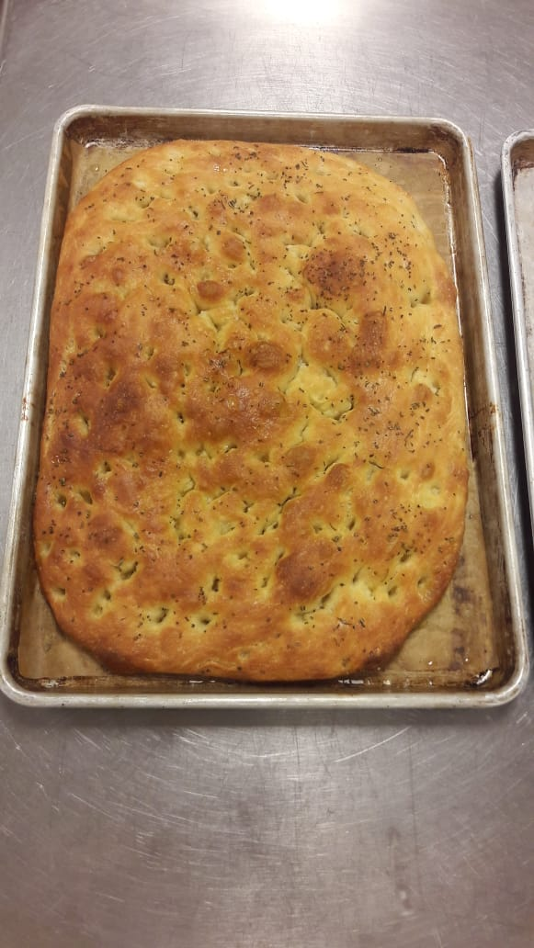
CHOCOLATE CHUNK COOKIES:
- Cream butter and sugar.
- Add all liquid ingredients. gradually.
- Stir dry ingredients.
- Mix nuts and chocolate chunks.
- Portion with scoop on lined sheet pan. Also known as drop cookie method. Bake 350°f for 10-12 minutes.
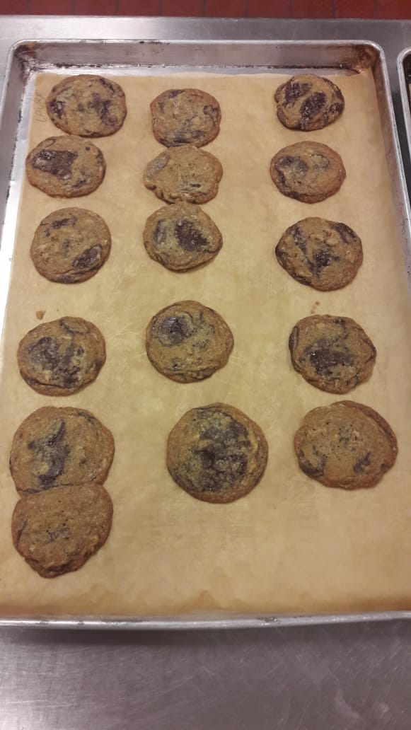

PIE DOUGH:
- Sift dry ingredients.
- Rub butter in dry mixture or use cutting method. In rub method use your hand and rub butter in flour and in cutting method cut butter several times with a sharp object until. Butter should be not melt.
- Add little water to keep dough together.
- Wrap and chill.
- Portion dough for top and bottom part for pie.
- Roll.
APPLE PIE:
- Remove moisture from apple slices as much as possible.
- Combine dry ingredients and mix with apple slices toss.
- Fill mixture in the bottom part of pie dough. Put cubes of butter on top.
- Put the top of pie dough close edges. Cut little holes on the top part of pie help to evaporate the moisture from pie.
- Egg wash the top and sprinkle sugar.
- Bake on 400°f for 45 minutes. Brown.
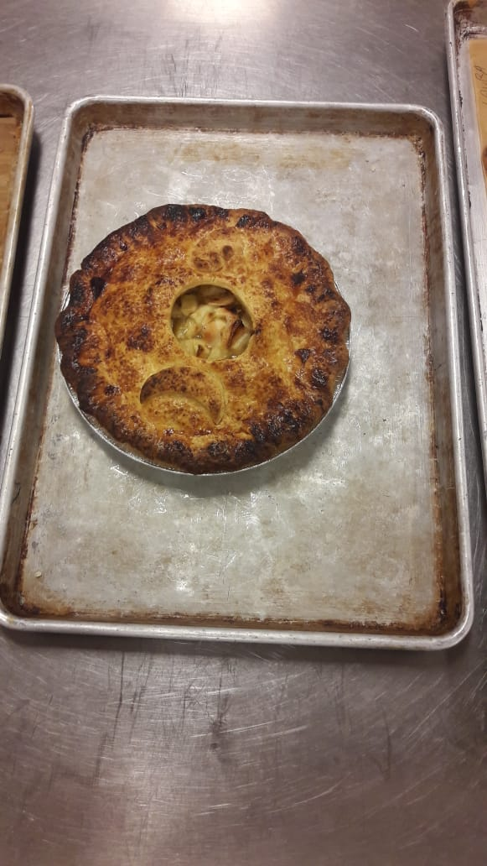

CRITICS:
FOCACCIA: focaccia cooked well nice structure and beautiful color.
CHOCOLATE CHUNK COOKEIS: nice and crispy good brown color.
APPLE PIE: over bake on the top the filling still fine and soft.
PERSONAL THOUGHTS: over all everything was nice and on time. Some new techniques learn like straight dough method and drop cookie method. While dropping cookie dough in sheet pan we place some cookies near to each other and they stick, and we got half mark less because of it.
Question: while rubbing butter into flour if butter melts can we fix this with refrigerating the mixture?

WEEK 3

MENU
Italian Rosemary Rolls
Ingredients:

180 g Warm water
18 g Yeast (fresh)
35 g Olive Oil
1 tsp Dried Rosemary, Crushed
100 g Eggs (~2)
506 g All Purpose Flour
80 g Dates or Olives (Pitted)

Method:

- Straight dough method. Use all ingredients except the dates or olives.
- Autolyze for 10 to 15 minutes.
- Knead until smooth and shape into a round ball.
- Ferment (covered) until soft and doubled. (at least an hour)
- Degas (or punch down) dough.
- Knead in the olives/dates.
- Portion into 50g portions (~18).
- Bench (covered).
- Shape into rolls and place them on a parchment-lined sheet tray.
- Press down and proof until doubled. (at least 20 minutes)
- Brush with egg wash and top with more dried rosemary.
- Snip the top with an “X” and bake @ 400 F for 12-15 minutes or until done.
- Cool on rack.

Carrot Bread

Ingredients:

100 g Eggs
200 g Sugar
135 g Vegetable Oil
220 g Bread Flour
4 g Baking Powder
3 g Baking Soda
Pinch Salt
2 g Cinnamon
1 Cup Finely Grated Raw Carrot

Method: Muffin Method. (As follows)
- Sift the dry ingredients together and set aside.
- In a mixing bowl beat the eggs and sugar until thick.
- Add the oil gradually and continue beating until thoroughly combined and homogenous.
- Mix the grated carrot with the dry ingredients until coated and separate.
- Stir the dry ingredients into the wet ingredients until just combined.
- Pour into prepared pan and allow the batter to stand in the pan for ~ 10 mins.
- Bake in a preheated 325 F oven for an hour until light golden brown and a skewer comes out clean.
- Cool. Remove from pan when half cool.

Banana Bread
Ingredients:
150 g Peeled Ripe Bananas
150 g Brown Sugar
35 g Eggs
85 g Vegetable Oil
85 g Milk
5 g Baking Soda
155 g Bread Flour
Method:
- Combine bananas and sugar in a mixing bowl with the paddle attachment.
- Add remaining wet ingredients and combine.
- Sift flour and baking soda together in a large bowl. Make a well.
- Add wet ingredients to the dry ingredients and mix until dry ingredients are just moistened.
- Pour into greased and lined loaf pans.
- Bake @ 350F for approximately 40-50 minutes until golden.
- Cool.

FUDGE BROWNIE BATTER
INGREDIENTS
butter, unsalted (room temperature) | 168.98 g | 113%
chocolate, unsweetened | 150.21 g | 100%
eggs | 150.21 g (3 1/4 ea) | 100%
sugar, granulated | 375 1/2 g | 250%
salt | 1.88 g (1.67 mL) | 1.25%
vanilla extract | 9.79 mL | 6.25%
coffee extract (optional) | 4.9 mL | 3.1%
flour, pastry (can use all-purpose) | 150.21 g | 100%
pecan pieces | 75.1 g | 50%
- Melt the butter and chocolate over a double boiler to 120°F (49°C). Hold the chocolate at this temperature.
- While the chocolate is melting, beat the eggs and granulated sugar in the bowl of a large mixer fitted with the paddle attachment on medium speed for 10 minutes. Add the salt and extracts. Scrape down the bowl, then add the melted chocolate, blending until well combined. Add the flour and mix until combined. Fold in the nuts.

REFLECTION
1810297
INTRO TO BAKING
WEEK 3
GRADE 62%
DATE 2018-07-19
Focaccia:
- straight dough method mixes all ingredients together and knead.
- Ferment dough.
- Proof in small roll portion.
- Egg wash and x on top.
- Bake 400°f 12-15 min.
Watching points:
- Ferment dough properly.
- Add flavorings and add-ons after first fermentation.
- Punch down the dough before portion and proofing second time. Doing this help to remove the gasses form while fermenting. Also, evenly distribute yeast and sugar to reactivate fermentation.
- Cutting or sniping x on top help in evaporating the moisture while baking.
CRITICS: the dough was nice and soft. Little over ferment and rise in volume after baking.
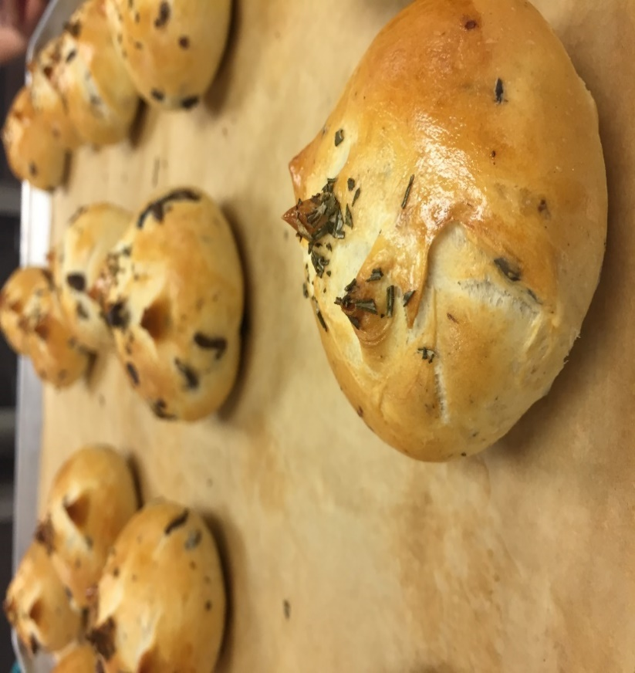

Carrot bread:
- Muffin method used. Beating sugar and eggs.
- Two mixtures one with dry ingredients second wet ingredients. combine both.
- Pour in pan. Bake on 325° for an hour.
Watching points:
- Beat eggs and sugar until it forms thick texture.
- Carrots should coat evenly with dry ingredients.
- Keep pan stand for some time to give time to batter for sit properly in pan.
- Bake until golden brown.
Banana bread:
- Muffin method.
- mix dry and wet ingredients separately.
- combine both.
- pour in loaf pan and bake 350°f for 40-50 minutes.
Watching points:
- mix well dry and wet dry ingredients. combine well.
- bake until golden brown or check with toothpick test.
CRITICS: not combined well overall good flavour.
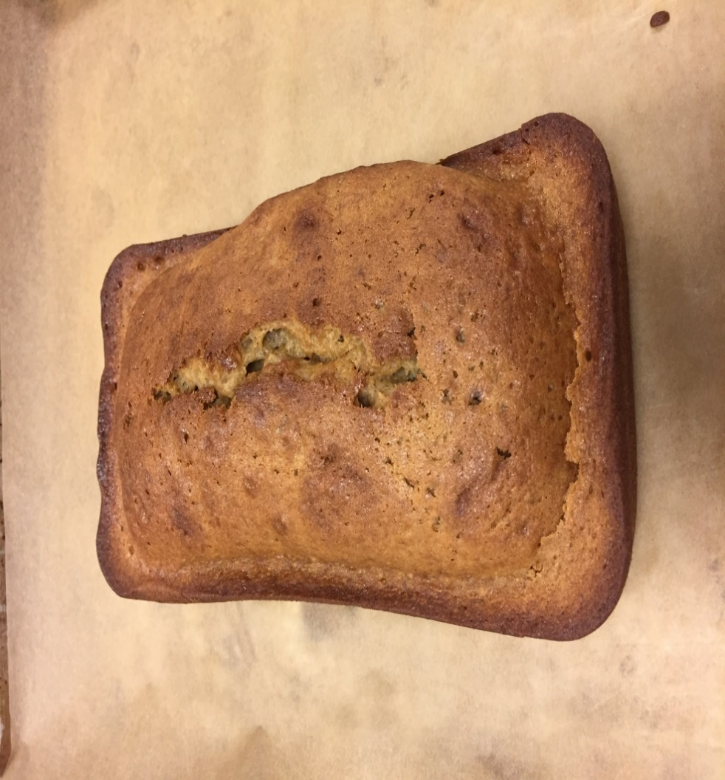

Fudge brownie bar:
- Melt chocolate and butter on double boiler (place the chocolate and butter in a bowl on the top of hot water 120°f.
- Beating: beat egg and sugar until thick. Add other ingredients.
- Pour in sheet pan. 1/8 thick.
- Bake 325°f for 15 minutes.
Watching points:
- No lumps in melted butter and chocolate.
- Beat sugar and eggs for thick liquid. Helps to incorporate air and make liquid thick and light.
- Combine nut evenly.
CRITICS: little over baked and become dry. Good flavours. Should be cut into bar shapes.
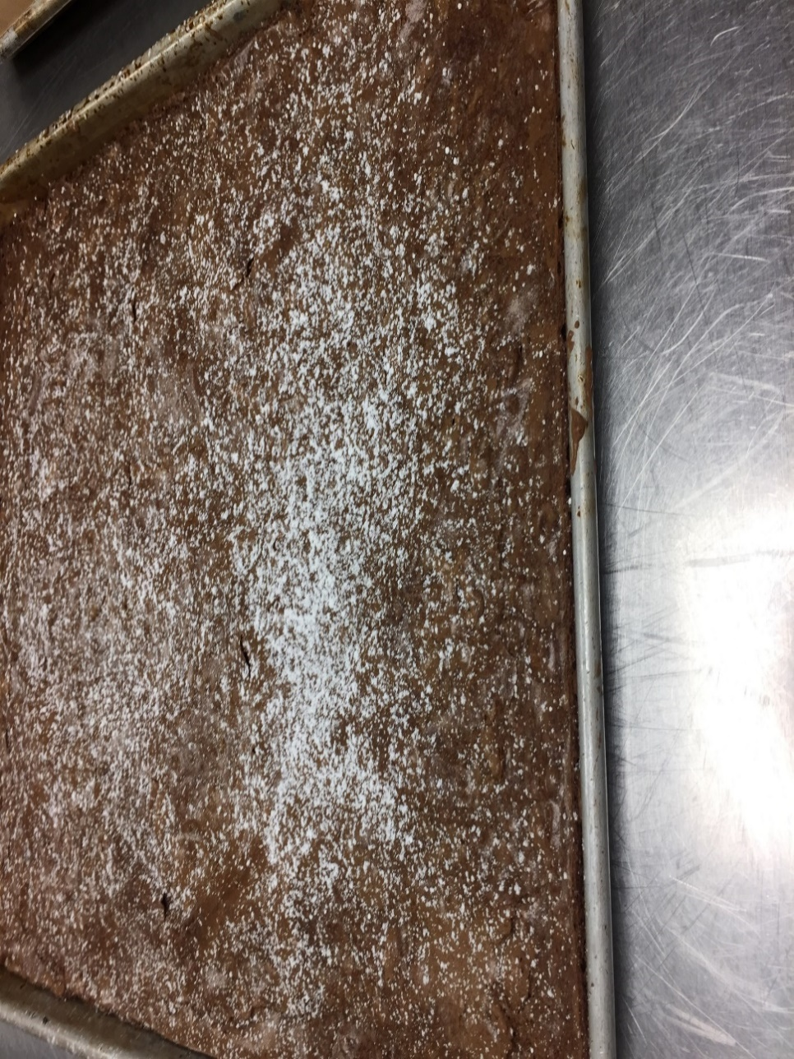

WEEK 4

MENU
Blueberry Muffins (Yield: 12 muffins)

Ingredients:
125 g Unsalted Butter
250 g Sugar
Pinch Salt
100 g Eggs
300 g All Purpose Flour
10 g Baking Powder
120 ml Buttermilk
200 g Frozen Blueberries
Flour for dredging

Method: (Creaming and quick bread Method)
- Cream butter, sugar and salt.
- Beat eggs in one at a time.
- Sift together the flour and the baking powder.
- Alternately add the dry ingredients and buttermilk to the creamed mixture.
- Dredge blueberries in a small amount of flour and gently fold into batter.
- Portion into greased muffin tins.
- Bake muffins at 375°F for about 30 minutes or until golden brown.
- Remove from pan shortly after removing from oven. Cool.

Traditional Shortbread
Ingredients
butter, unsalted (softened) | 168.62 g | 84%
sugar, confectioners | 84.31 g | 42%
vanilla extract | 5.5 mL
salt | 2.11 g | 1.05%
flour, pastry (or use all-purpose flour) | 200.24 g | 100%
Egg Wash | as needed
Directions
1.Blend the butter and powdered sugar in a mixing bowl without creaming. Stir in the vanilla and salt, mixing thoroughly. Add the flour and mix until just combined.
2. Divide the dough into four equal portions. Roll each piece of dough into 8-inch (20-centimeter) disks. Wrap in plastic. Freeze until hard, approximately 30 minutes.
3.Remove from the freezer and unwrap, then lightly brush each disk with egg wash. Cut each disk into eight wedges. Dock the wedges with a fork.
4.Bake at 375°F (190°C) until pale golden brown, approximately 15 to 20 minutes.

Cheddar–Chive Scones (Yield: 8 Scones)

Ingredients:

200 g All Purpose Flour
2 g Salt
12 g Baking Powder
80 g Cold, Unsalted Butter
10 g Chopped Fresh Chives
50 g Grated Cheddar Cheese
30 g Eggs
45 g Milk
45 g Cream

Egg wash and grated cheddar for garnish

Method: Biscuit (as follows)

- Combine dry ingredients with paddle attachment.
- Add cold, cubed butter and blend to pea sized pieces.
- Add chives and grated cheddar cheese.
- Add egg, milk and cream and mix just until dough comes together.
- Roll into a ½” thick circle and cut 8 wedges.
- Egg wash and garnish with grated cheddar.
- Bake at 400°F for about 15 – 20 minutes.

WHOLE WHEAT SADWITCH BREAD
INGREDIENTS
water (temperature controlled) 354.84 mL
milk, non-fat dry 35.44 g 5.2%
sugar, granulated 28.35 g 4.2%
salt 14.18 g 2.1%
yeast, dry active 14.18 g 2.1%
flour, bread 340.2 g 50%
flour, whole wheat 340.2 g 50%
butter, us (softened) 28.35 g 4.2%
eggs 90.72 g 13%
Egg Wash as needed
Directions
1.Combine the water, milk powder, sugar, salt, yeast and 12 ounces (360 grams) of the flour. Blend well. Add the butter and eggs and beat 2 minutes.
2.Stir in the remaining flour, 2 ounces (60 grams) at a time. Knead 8 minutes or until the dough reaches 77°F (25°C).
3.Place the dough in a lightly greased bowl, cover and ferment at room temperature until doubled, approximately 1 to 1 1/2 hours.
4.Divide the dough into two uniform pieces. Shape into loaves, place the dough into greased loaf pans and proof until doubled.
5.Brush the dough with egg wash. Bake at 375°F (190°C) until brown and hollow-sounding, approximately 50 minutes

REFLECTION
KULWINDER SINGH
1810297
INTRO TO BAKING
WEEK 4
GRADE 62%
DATE 2018-07-29
Menu:
- Traditional shortbread.
- Cheddar chive scones.
- Whole wheat sandwich bread.
Temperature chart:
- 375°f for short bread and whole wheat bread.
- 400°f for cheddar chive scones.
Production:
- Traditional shortbread: CUT COOKIES METHOD
- Cut butter in sugar stir salt and vanilla add flour just combine.
- Freeze in cylinder shape and cut wedges of after egg wash.
- Dock with fork to keep moisture out.
- Bake for 15-20 min.
- Golden brown.
CRITICS: not combined well and should be bake as fast as remove from freezer.
- 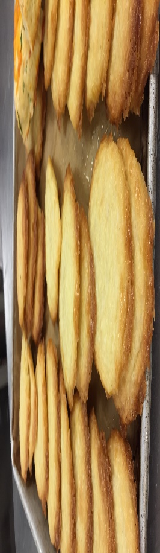

1. Cheddar chive scones: BISCUIT METHOD

- Cut butter in dry ingredients pea size. In the end it results in flaky texture
- Add chives and cheese.
- Add milk cream and egg to keep dough together.
- Roll into circle ½” inch thick cut 8 wedges.
- Egg wash and garnish with cheese.
- Bake 15-20 min.
CRITICS: need some more liquid to keep dough together it to dry and not flaky.
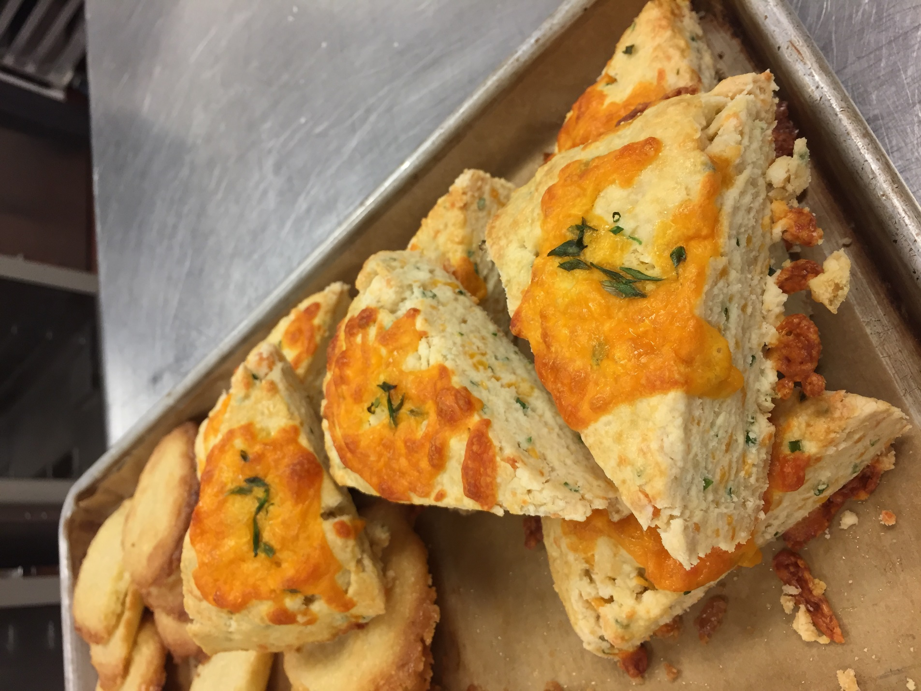

- Whole wheat bread: SANDWITCH BEAD METHOD
- Dissolve yeast in warm water.
- Combine dry ingredients. make a well in the centre add liquid wet ingredients.
- Combine well and start folding the dough to form the gluten.
- Place in room temperature for fermentation to increase volume.
- Punch down the dough and cut into four parts and shape into loaf pan by stacking each other.
- Proof for 30 min.
- Egg wash on top and bake for 50 min.
CRITICS: nicely baked and proofing. Good volume and color.
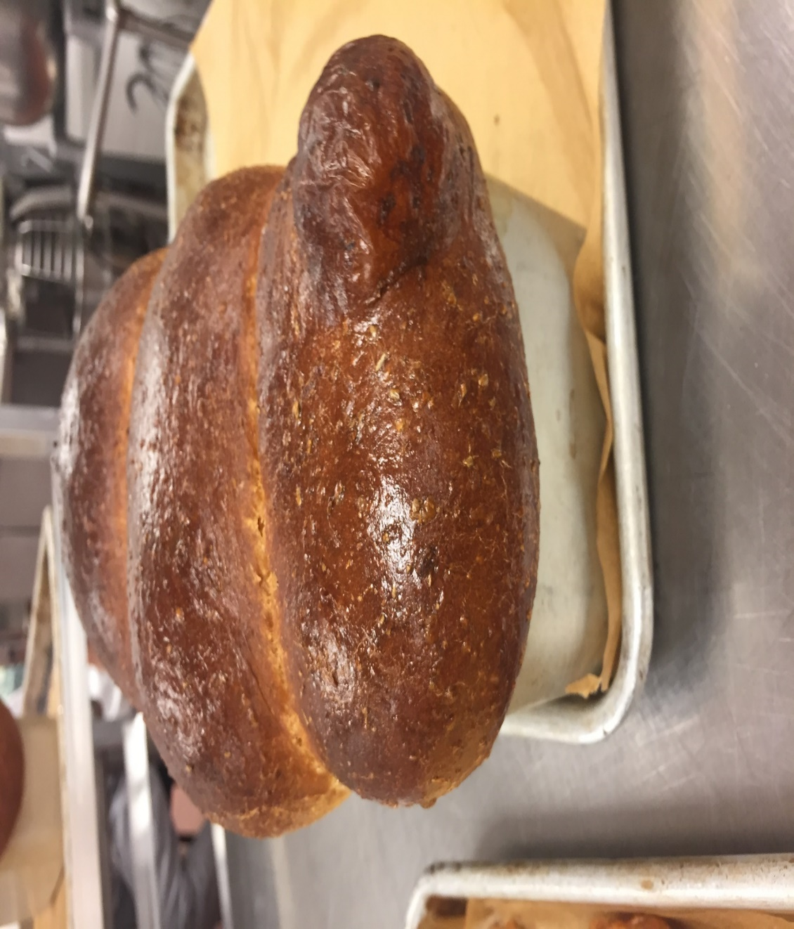
Personal thoughts: all over it was a good week for leaning cut cookies method, biscuit method and old dough method. I made short bread and scones. In both I did not combined ingredients very well and it effect the texture in the end. Next time I will give my best.

WEEK 5

MENU

Baguette (Yield: 4 baguettes @ 400g each)
Ingredients:

1 kg Bread Flour
625 ml Water
20 g Salt
25 g Yeast

Method:

“Straight dough method”

Pie Dough (Yield: 1 x 9” pie crust – top & bottom)
Ingredients:

350 g Pastry Flour
5 g Salt
12 g Sugar
225 g Cold, Unsalted Butter, cut into small cubes
75 – 100 ml Ice Water

Method:

- Sift flour, salt and sugar into bowl.
- Cut or rub butter into flour to desired size.
- Gradually add water to flour mixture. Mix gently, just until water is absorbed and dough comes together. Do not overwork dough.
- Wrap dough in plastic wrap and chill for at least an hour.
- Scale dough at 300 g for bottom crust and 250 g for top crust.
- Roll pastry 1/8” thick.

Pecan Pie
Ingredients:
225 g Pie Dough
150 g Pecan Halves
170 g Brown Sugar
170 g Golden Corn Syrup
150 g Eggs
35 g Butter
2 g Vanilla Extract

Method:

- Line form with pie dough. Chill in fridge.
- Line with foil and par bake at 300°F.
- Deposit pecans evenly in pastry shell.
- Heat brown sugar, corn syrup vanilla and butter into a pot until melted & combined.
- Whisk eggs and temper with sugar mixture.
- Strain & cool.
- Pour filling over pecans.
- Bake at 300°F until set.
Lemon Meringue Pie
Ingredients:

300 g Sugar
45 g Cornstarch
1 pinch Salt
360 ml Cold Water
100 g Egg Yolks
120 ml Fresh Lemon Juice
12 g Lemon Zest
15 g Unsalted Butter

1 Pre baked Pie Shell

120 g Egg whites
120 g Sugar

Method:

- Combine 300 g of sugar with the cornstarch, salt and water in a heavy saucepan. Cook over medium-high heat, stirring constantly, until the mixture becomes thick and almost clear. Remove from heat.
- Temper the yolks with a small amount of the hot thickened mixture, whisking well. Whisk the tempered mixture back into the filling.
- Return to heat and cook, stirring constantly, until thick and smooth.
- Stir in lemon juice and zest. Remove from heat and add butter. Stir until the butter is melted. Cool briefly.
- Fill the pie shell with the lemon filling. Cool to room temperature.
- For the meringue, whip the egg white until soft peaks form. Slowly add the remaining sugar while whisking. Whisk until the meringue becomes stiff and glossy, not dry, grainy or spongy.
- Mound the meringue over the filling, creating decorative patterns with a spatula. Spread meringue completely over the surface of the filling, meeting the crust.
- Bake at 400°F until the meringue browns, approximately 5-8 minutes. Cool. Serve the same day.

BIRDS NEST COOKIES
Ingredients:

180 g Bread Flour
140 g Butter
80 g Sugar
1 g Baking Soda
50 g Raspberry Jam

Method:
- Mix all ingredients except the raspberry jam with the paddle attachment until smooth. Do not overmix.
- Divide dough into 2 x 200g balls.
- Roll each piece into a cylinder about 12 inches long. Roll each cylinder in coconut.
- Cut each cylinder into 12 portions.
- Place 6 x 4 on a parchment lined pan.
- Press a small indent in the centre of each cookie and fill with raspberry jam
- Bake at 375°F for approximately 15-20 minutes.

REFLECTION
KULWINDER SINGH
1810297
INTRO TO BAKING
WEEK 5
GRADE 61%
DATE 2018-08-05
MENU:
- BAGUETTE
- PECAN PIE
- PIE DOUGH
- BIRDS NEST COOKIES.
TEMPRATURE CHART:
- 375°F FOR BAGUETTE AND COOKIES.
- 300°F FOR PIE.
PRODUCTION:
- Baguette: straight dough method
- Mix all ingredients together and knead.
- Ferment the dough. Should be double in volume.
- Punch down to release gases.
- Portion equally.
- Proof in warm and humid atmosphere.
- Before baking make some rough cuts on the top of bread to release gases.
- Bake until golden brown.
CRITICS: dough was nice and smooth. Need to bake some more time for making the outside crispy. Otherwise flavours were good and mellow.
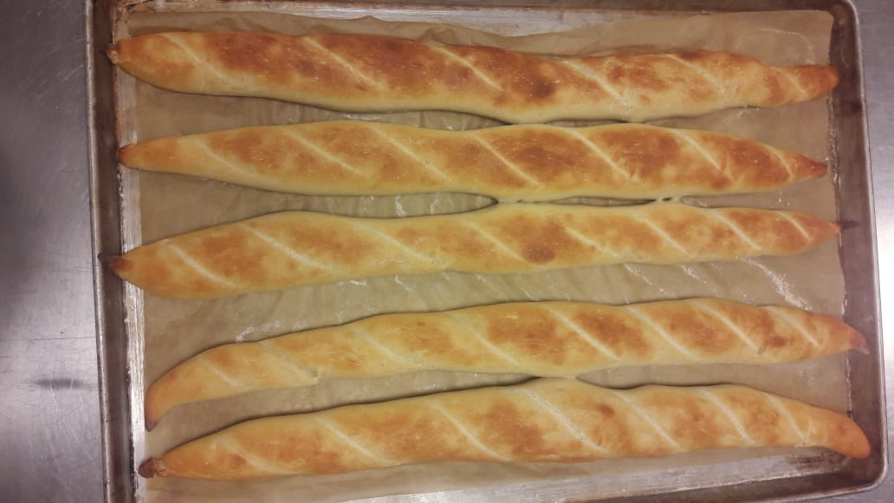

- Pie dough: mealy dough or flaky dough
- Mix dry ingredients and cut butter in it until butter become shape of pea.
- Add some liquid in it to keep dough together. Chill in refrigerator.
- Divide into two portions.
- Pecan pie:
- Roll pie dough and blind bake, a baking technique in which you pre bake the pie crust for 10-15 minutes so the crust can hold the filling.
- Dissolve the sugar and fat on heat and temper (adding the small amount of hot liquid in the eggs to make a balance in the both liquids and save the eggs from crumbling) the eggs in the mixture.
- Divide the pecans in both pie crusts and pour liquid mixture on top.
- Bake until the filling set properly.
CRITICS: pie crust should be thicker for holding the filling. Filling was tasty and good baked.
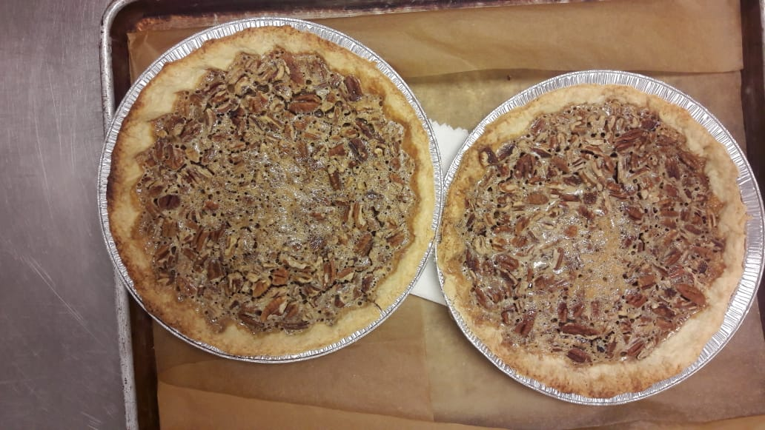

- Birds nest cookies: cut cookies method
- Sift all dry ingredients and mix.
- Cut butter in dry ingredients. just mix.
- Divide into two parts.
- Egg wash both and roll in grated coconut.
- Cut each portion into 12 parts.
- Press in the centre of each cookie with the handle of wooden spoon.
- Fill jam in the centre of cookie.
- Bake until golden brown on the sides.
CRITICS: nicely baked and flavoured but shapes were not equal some were big some were small, and it effect the baking time some are more baked some less.
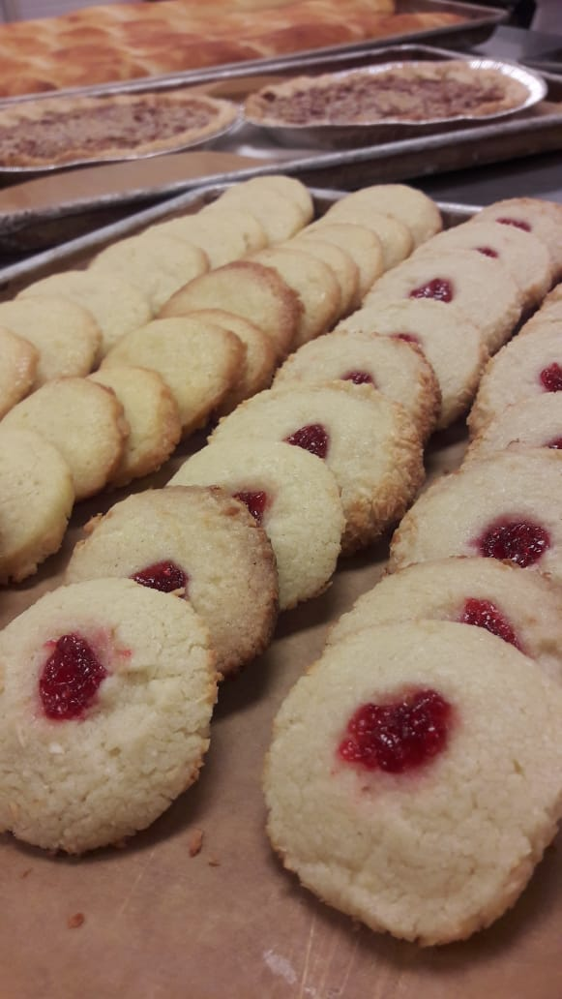
PERSONAL THOUGHTS: every week give us more knowledge about baking. This week we learn how to check the gluten form in dough by stretching the dough. Also, we practice again on making cut cookies. Main thing we learn about making pie, to make pie crust flaky while cutting or rubbing the butter into flour make sure that the butter should not melt at least it should be size of a pea.

WEEK 6

MENU
Raisin Bread (Yield: 2 Loaves)
Ingredients:
450 g Bread Flour
8 g Salt
36 g Butter
20 g Sugar
28 g Milk Powder
20 g Egg
260 g Water (warm)
28 g Fresh Yeast
226 g Raisins

Method:
- Combine first 6 ingredients in the mixing bowl.
- Dissolve yeast in the water and add to ingredients in the bowl.
- Combine until sides of bowl are clean.
- Knead dough into a round ball. Autolyze.
- Knead dough for 2 minutes or until supple, smooth and elastic feeling.
- Ferment until doubled.
- Degas and knead in raisins until fully incorporated.
- Portion dough into two and round off. Bench 20 minutes.
- Shape dough into loaves and place into prepared bread tins.
- Proof.
- Bake at 400 F for 25 – 30 minutes.
- Wash the top of the crust with melted butter while still hot.
- Cool.

VARIATION: For Cheese Bread – Replace raisins with 120 g grated cheese.

Chocolate Cream Pie (Yield: 1 pie)
Ingredients:
140 g Brown Sugar
640 ml Milk
10 g Cocoa Powder
48 g Egg Yolks
30 g Cornstarch
140 g Bittersweet Chocolate
40 g Butter
10 ml Vanilla Extract

1 Pre-baked Flaky Pie Shell

300 ml Whipping Cream
7 ml Vanilla Extract
10 g Icing Sugar
80 g Chocolate Shavings

Method:
- In a sauce pan, dissolve half of the brown sugar in the milk. Add the cocoa powder and bring to a boil.
- Mix the egg yolks and remaining sugar until smooth. Add cornstarch, whisking well.
- Temper the egg mixture with some of the hot milk mixture. When the eggs are hot, pour them back into the remaining milk mixture and boil, whisking constantly.
- Allow the cream to boil for 2 minutes until thick, while whisking constantly.
- Remove from heat and add the chocolate, vanilla and butter. Stir until incorporated.
- Pour into pie shell and cool completely. Refrigerate.
- Whip cream until soft peaks. Add vanilla and icing sugar. Whip until stiff peaks.
- Top pie with whipped cream, making sure that the entire surface is covered.
- Decorate with chocolate shavings.

Soft Yeast Dinner Rolls

Ingredients
yeast, dry active | 20.25 g | 4.55%
water (temperature controlled) | 243 g | 55%
flour, bread | 445.5 g | 100%
salt | 10.13 g | 2.3%
sugar, granulated | 40.5 g | 9.1%
milk, non-fat dry | 20.25 g | 4.55%
shortening, vegetable | 20.25 g | 4.55%
butter, unsalted (softened) | 20.25 g | 4.55%
eggs | 32.4 g (3/4 ea.) | 7.3%
Egg Wash | as needed
Directions
1.Dissolve the yeast in the water in a bowl. Combine the flour, salt, sugar, milk powder, shortening, butter and eggs in the bowl of a mixer fitted with a dough hook.
2. Add the water-and-yeast mixture to the mixer bowl; stir to combine.
3. Knead on medium speed 10 minutes or until the dough reaches 77°F (25°C).
4. Transfer the dough to a lightly greased bowl, cover and place in a warm spot. Ferment until doubled, approximately 1 hour.
5.Punch down the dough. Let it rest a few minutes to allow the gluten to relax.
6.Divide the dough into 1 1/4-ounce (38-gram) portions and round. Shape as desired and arrange on paper-lined sheet pans. Proof until doubled in size.
7.Carefully brush the proofed rolls with egg wash. Bake at 400°F (200°C) until medium brown, approximately 12 to 15 minutes.

Oatmeal Cookies
Ingredients
flour, all purpose (can use pastry flour) | 167.45 g | 100%
baking soda | 2.23 g | 1.3%
cinnamon, ground | 3.19 g | 1.9%
oats, quick-cooking | 143.52 g | 86%
butter, unsalted (softened) | 143.52 g | 86%
sugar, granulated | 143.52 g | 86%
sugar, light brown | 143.52 g | 86%
eggs | 51.03 g | 30%
orange juice concentrate | 24.95 mL
vanilla extract | 8.32 mL
salt | 3.19 g | 1.9%
Butterscotch chip | 191.36 g | 114%
Directions
1.Sift together the flour, baking soda and cinnamon. Stir in the oats and set aside.
2.Cream the butter until light and fluffy. Add the sugars and continue creaming until the mixture is lightened. Add the eggs one at a time, scraping down the bowl frequently and mixing well after each addition. Add the orange juice concentrate, vanilla extract and salt.
3.Fold in the flour mixture and the raisins. Portion the dough onto paper-lined sheet pans.
4.Bake at 375°F (190°C) until golden, approximately 10 to 12 minutes.

WEEK 7

MENU
Pound cake
Ingredients
flour, cake | 396.9 g | 100%
baking powder | 7 g | 1.8%
butter, unsalted (room temperature) | 283.5 g | 71%
sugar, granulated | 434.7 g | 110%
corn syrup, light (or use additional granulated sugar) | 18.9 g | 4.8%
salt | 7 g | 1.8%
eggs (room temperature) | 302.4 g | 76%
vanilla extract | 4.92 mL
almond extract (optional) | 4.92 mL
Lemon Zest | 0.76 g
Orange Zest | 0.76 g
buttermilk (room temperature) | 157.7 mL
Directions
1. Sift the flour and baking powder together. Set aside.
2. Cream the butter until light and lump-free. Add the sugar, corn syrup and salt. Cream on medium speed until light and fluffy. Add the eggs a few at a time, allowing them to be completely incorporated before adding more eggs. Scrape down the bowl after each addition.
3. Add the vanilla and almond extract (if using) and the lemon and orange zest.
4. Fold in the dry ingredients alternately with the buttermilk in three additions each.
5. Divide the batter evenly into three 9-inch × 5-inch (22-centimeter × 12-centimeter) greased loaf pans. Bake at 400°F (200°C) for 15 minutes, then reduce the oven temperature to 350°F (180°C). Bake until the centers of the cakes bounce back when lightly pressed, approximately 45 to 55 minutes. If the cakes begin to darken, cover them loosely with aluminum foil.
6. Cool the cakes in their pans on a wire rack for 10 minutes. Unmold and cool completely.

Multigrain Sourdough Bread
Ingredients
Ingredients
cracked wheat | 127.58 g | 23%
water (warm) | 236.56 mL | 40%
butter (melted) | 56.7 g | 10%
molasses | 42.53 g | 7.5%
honey | 42.53 g | 7.5%
salt | 5.67 g (5.03 mL) | 1%
milk, non-fat dry | 56.7 g | 10%
flax seeds | 56.7 g | 10%
sunflower seeds (roasted) | 56.7 g | 10%
Simple Sourdough Starter [On Baking 3e] | 623.7 g
yeast, dry active | 4.25 g (5.03 mL) | 0.75%
flour, whole wheat | 283.5 g | 50%
flour, bread | 283.5 g | 50%
Egg Wash | as needed
Directions
❶ Combine the cracked wheat and hot water in the bowl of an electric mixer. Add the butter, molasses, honey, salt and milk powder. Set aside to cool.
❷ When the mixture has cooled to lukewarm, stir in the flax seeds, sunflower seeds, starter and yeast. Stir in the whole-wheat flour, then gradually add the bread flour. When the dough begins to stiffen, attach the bowl to a 6 quart (6.5 liter) or larger mixer fitted with a dough hook and continue adding the bread flour. dough is smooth and elastic, approximately 5 minutes.
❸ Place the dough in a lightly oiled bowl, cover and ferment until doubled.
❹ Punch down the risen dough, cover and ferment again.
❺ After the second rise, punch down the dough and divide into two equal portions. Place the dough into two well-greased loaf pans, cover and proof the dough until doubled again.
❻ Brush the surface of each loaf with egg wash and make two or three cuts across the top of each loaf. Bake at 375°F (190°C) until done, approximately 30 minutes.

Cranberry White Chocolate Orange Scones (Yield: 8 scones)

Ingredients:

200 g All Purpose Flour
25 g Sugar
1 g Salt
10 g Baking Powder
80 g Cold unsalted Butter
5 g Orange Zest
50 g Dried Cranberries
30 g Eggs
45 g Milk
45 g Cream
150 g White Cho chips
Method: Biscuit

- Sift together dry ingredients.
- Add cold, cubed butter and blend to pea-sized pieces.
- Add dried cranberries and orange zest.
- Combine eggs, milk and cream and add to dry ingredients.
- Mix until dough just comes together.
- Add Cho chips
- Roll or part into a ½ “thick circle and cut 8 wedges.
- Bake at 400°F for 15-20 minutes or until golden and puffed.

Morning Glory Muffins

Ingredients:

200 g All Purpose Flour
40gr whole wheat flour
170 g Granulated Sugar
100gr Brown Sugar
10 g Baking Soda
Pinch Salt
2 g Cinnamon, ground
210 g Carrots, grated
90 g Raisins
60 g Pecan pieces
60 g Coconut, shredded
90 g Apple, grated
150 g Eggs
160 g Canola Oil
10 ml Vanilla Extract

Method: muffin

- Sift the dry ingredients together and set aside.
- Combine the carrots, raisins, pecans, coconut and apple. Mix in with the dry ingredients until each piece is coated with flour evenly.
- Whisk together the eggs, oil and vanilla. Add to the dry ingredients.
- Mix batter until just combined.
- Portion into greased muffin tins and bake at 350°F until done.

WEEK 8
MENU
Soft Yeast Dinner Rolls
Ingredients
yeast, dry active | 20.25 g | 4.55%
water (temperature controlled) | 243 g | 55%
flour, bread | 445.5 g | 100%
salt | 10.13 g | 2.3%
sugar, granulated | 40.5 g | 9.1%
milk, non-fat dry | 20.25 g | 4.55%
shortening, vegetable | 20.25 g | 4.55%
butter, unsalted (softened) | 20.25 g | 4.55%
eggs | 32.4 g (3/4 ea.) | 7.3%
Egg Wash | as needed
Directions
1. Dissolve the yeast in the water in a bowl. Combine the flour, salt, sugar, milk powder, shortening, butter and eggs in the bowl of a mixer fitted with a dough hook.
2. Add the water-and-yeast mixture to the mixer bowl; stir to combine.
3. Knead on medium speed 10 minutes or until the dough reaches 77°F (25°C).
4. Transfer the dough to a lightly greased bowl, cover and place in a warm spot. Ferment until doubled, approximately 1 hour.
5. Punch down the dough. Let it rest a few minutes to allow the gluten to relax.
6. Divide the dough into 1 1/4-ounce (38-gram) portions and round. Shape as desired and arrange on paper-lined sheet pans. Proof until doubled in size.
7. Carefully brush the proofed rolls with egg wash. Bake at 400°F (200°C) until medium brown, approximately 12 to 15 minutes.

Sour Cream Coffeecake
Ingredients
Filling
flour, all purpose | 11.34 g | 5.4%
cinnamon, ground | 5.67 g | 2.7%
sugar, light brown | 170.1 g | 81%
pecan halves (chopped) | 113.4 g | 54%
butter, unsalted (melted) | 28.35 g | 14%
Cake
butter, unsalted | 113.4 g | 54%
sugar, granulated | 226.8 g | 108%
eggs | 93.56 g | 45%
cream, sour | 226.8 g | 108%
flour, cake (sifted) | 198.45 g | 95%
salt | 1.42 g | 0.7%
baking powder | 3.97 g | 1.9%
baking soda | 3.97 g | 1.9%
vanilla extract | 4.44 mL
Directions
1.to make the filling, blend all the filling ingredients together in a small bowl. Set aside.
2. To make the cake batter, cream the butter and sugar. Add the eggs one at a time, beating well after each addition. Add the sour cream. Stir until smooth.
3. Sift the sifted flour, salt, baking powder and baking soda together twice. Stir into the batter. Stir in the vanilla.
4. Spoon half of the batter into a greased tube pan. Top with half of the filling. Cover the filling with the remaining batter and top with the remaining filling. Bake at 350°F (180°C) for approximately 35 minutes.

Cinnamon Buns (Yield: 6 buns)
Ingredients:

25 g Brown Sugar
4 g Salt
37 g Shortening
18 g Milk Powder
15 g Egg
175 g Water
16 g Fresh Yeast
282 g Bread Flour
33 g Pastry Flour
Egg Wash
60 g Raisins or Chopped Pecans
Cinnamon Sugar

Method: (Enriched straight dough)

1. Place first four ingredients in a bowl and mix with a dough hook until combined.
2. Add egg and mix.
3. Dissolve yeast in water and add to mix.
4. Add flours and mix for 2 minutes or until combined.
5.Knead on bench until gluten is fully developed.
6.Bench for 20 – 30 minutes @ 29°C dough temperature.
7. After benching, roll dough to about a 12” x 10” rectangle. About 1/8” thick.
8.Egg wash, sprinkle with cinnamon sugar and raisins or chopped pecans, leaving one long edge free.
9.Egg wash bottom and roll into a cylinder.
10.Cut into 2” units.
11. Place into a greased 8” cake ring prepared with caramel glaze.
12.Proof and bake at 375°F

Caramel Glaze
Ingredients:

100 g Brown Sugar
10 g Glucose
15 g Water
25 g Butter
2 g Cinnamon

Method:
1.Combine ingredients to make a smooth paste.
2.Smear onto bottom of pan.

Butter Cookies (Yield: 2 Dozen Cookies)

Ingredients:

250 g Butter, softened
150 g Icing Sugar
50 g Egg
15 ml Vanilla Extract
5 Drops Orange Extract
5 ml Almond Extract
6 g Salt
330 g Pastry Flour
As Needed Pistachios
As Needed Dried Cherries
As Needed Slivered Almonds

Method:

1.Cream butter and sugar. Gradually add the egg, flavourings, and salt.
2.Blend in the flour until just combined.
3.Using a piping bag and medium star tip, pipe 2” rosettes on parchment-lined sheet pans.
4.Place a pistachio, dried cherry and almond on each cookie.
5.Bake at 350°F until golden. ~ 10-12 minutes.

1. ITALIAN ROSEMARY ROLLS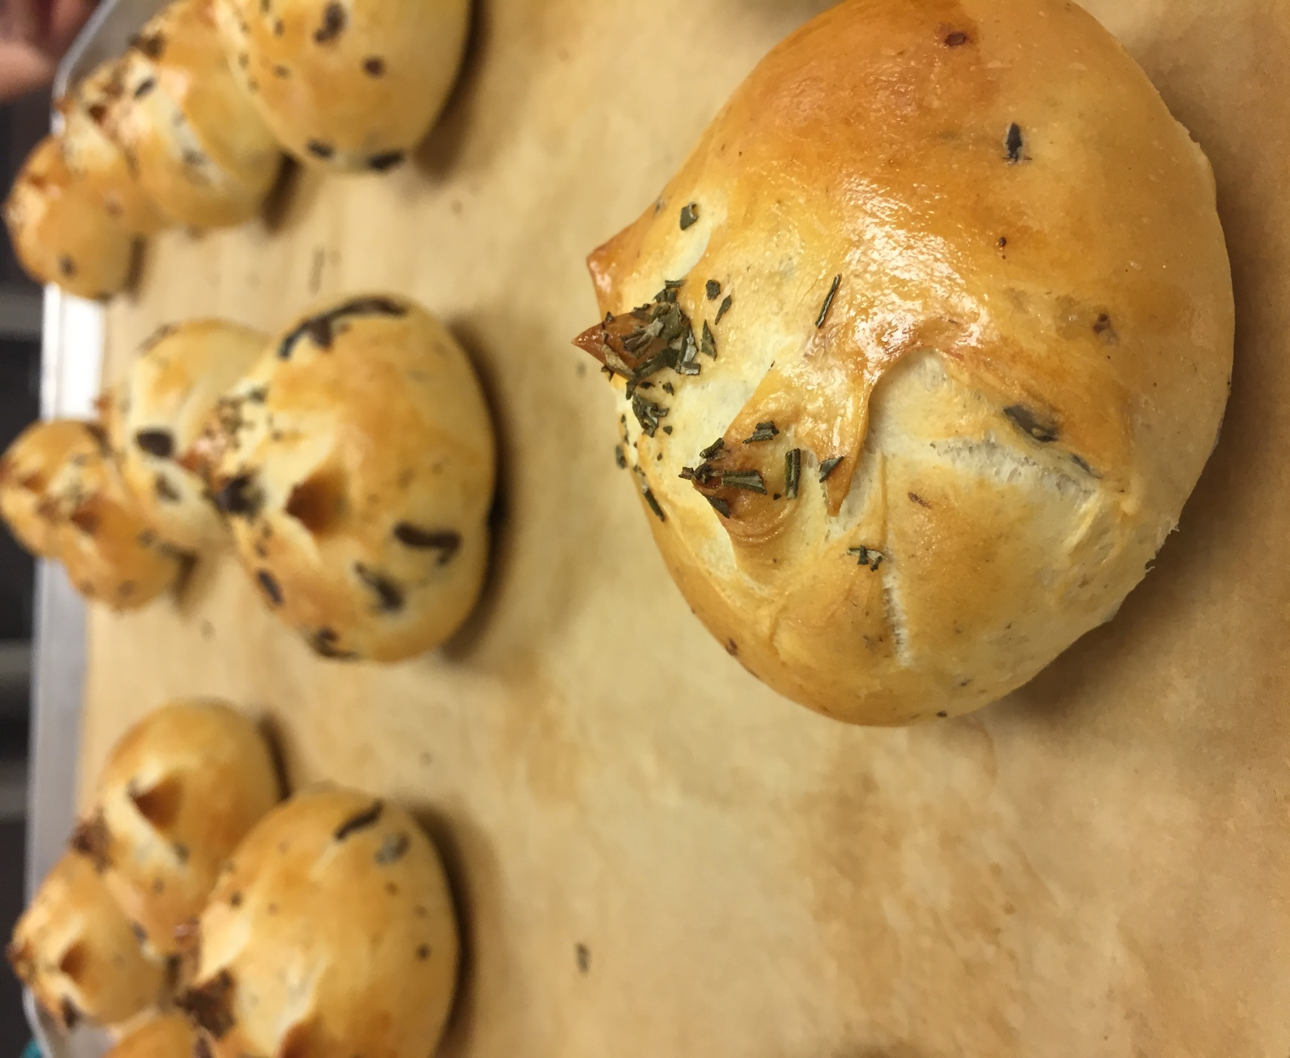

1.WHITE CHOCOLATE ORANGE SCONES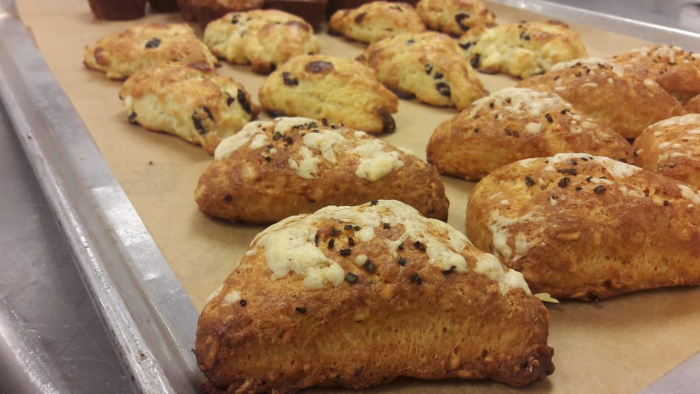

3.BAGUETTE
4.DINNER ROLLS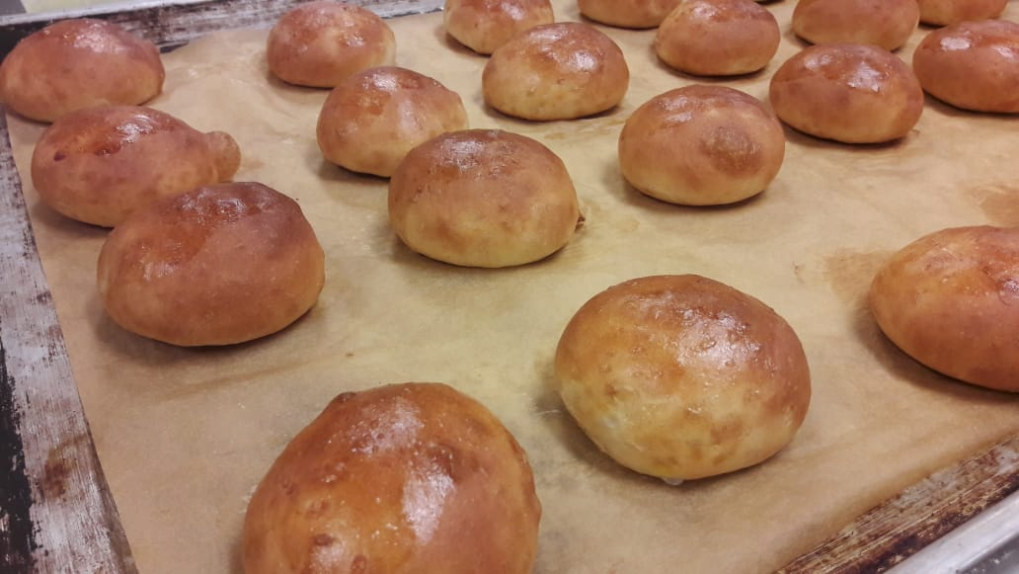5.FOCACCIA BREAD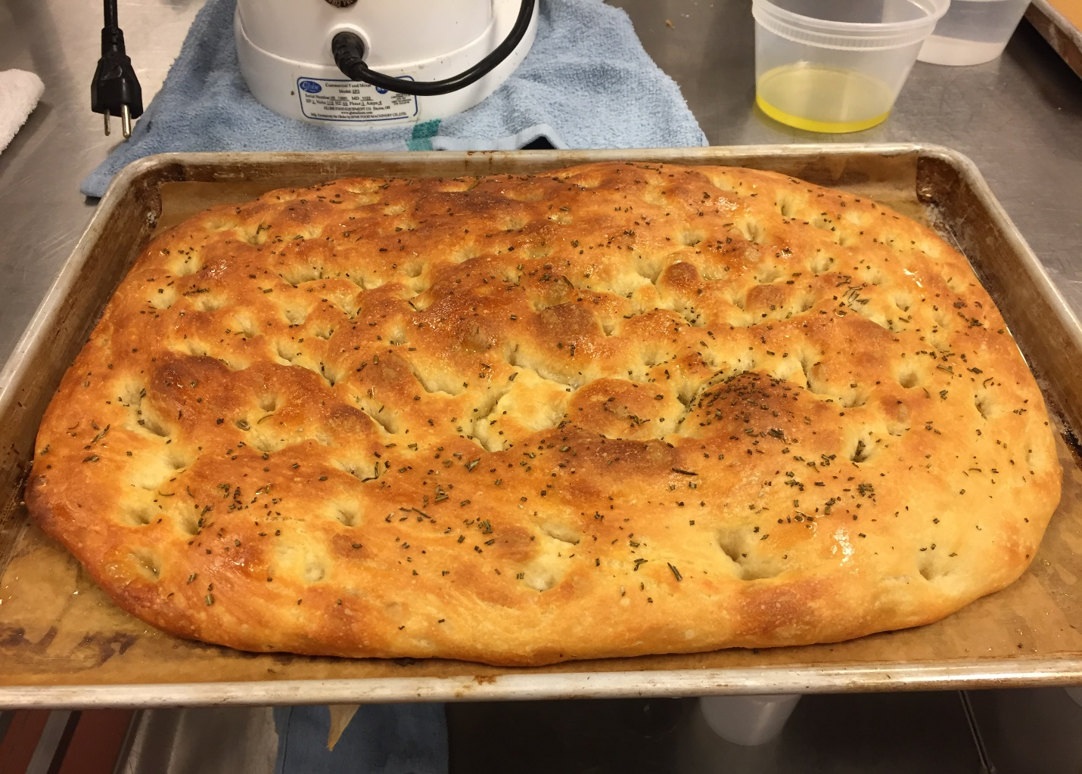
6. MORNING GLORY MUFFINS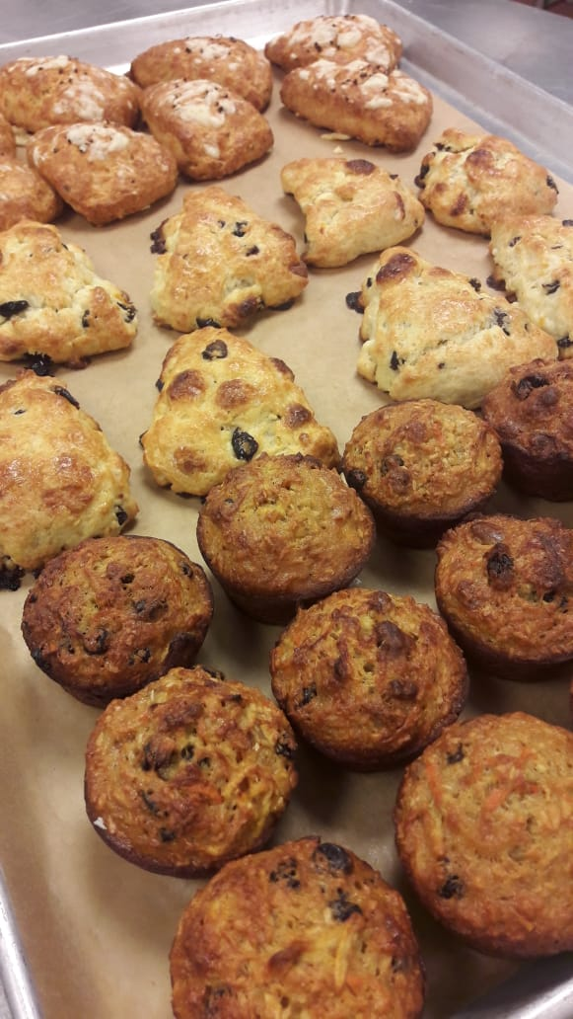

7.APPLE PIE
8.BIRD`S NEST COOKIES

9.CHOCOLATE CHUNK COOKIES
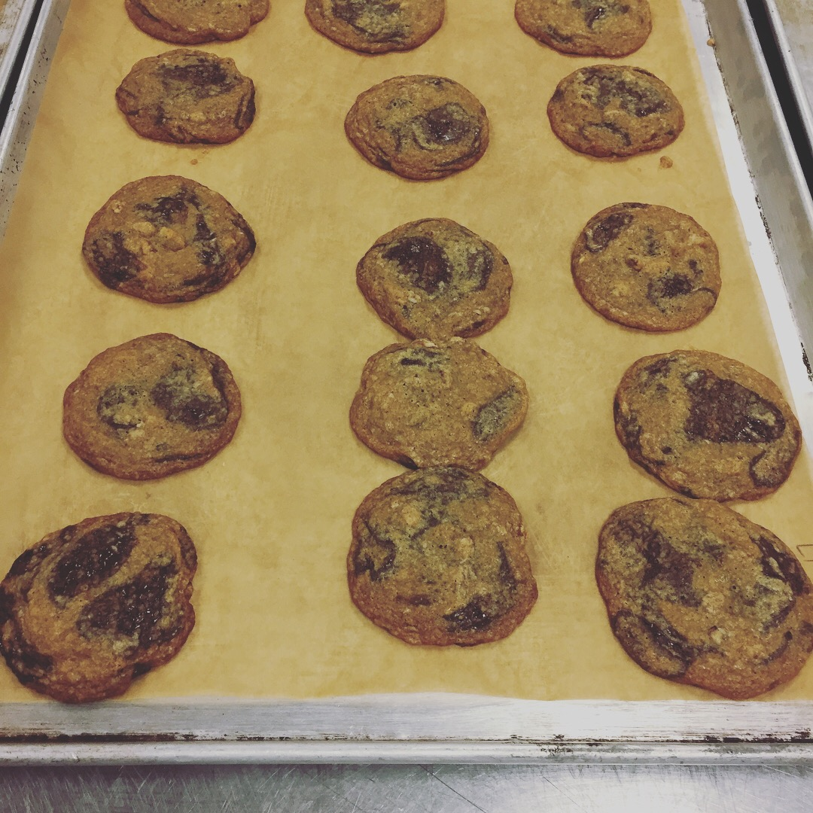
10.CHEDDAR CHIVE CHEESE SCONES
11.WHOLE WHEAT BREAD
