Holt Renfrew

Holt Renfrew was founded in 1837 and is known to be a chain of high-end Canadian department stores specializing in an array of luxury brands and designer boutiques. This is what differentiates Holt Renfrew from other retailers

Strengths Weakness
-Skilled work force -Mainly targets: wealthy People
-High profitability and revenue - Not affordable to all
-Well known store and logo -Investments in research and
-High growth rate development can be costly
-Quality of High-end brands -online website lacking
-Customer Service
(Personal Shopper)
-Restaurant within the store
-Beauty Section
(pampered)
-Targets Both Male, Female
-Variety of products that are more
affordable (second floor)
-Website
-Collaborations ( ex.Spa Nuva) Threats
-Rising cost of raw materials
-Global economy
Opportunities
-Growing economy -price changes
-income level is at a constant increase - increasing costs
-growth rates abd profitability -Government regulations
-growing demands -Unexpected problems
-new markets -External business risks
-Financial capacity

Holt Renfrew Targets wealthy people who can afford luxury brands. Holt Renfrew is located downtown for the reason being that most of their target audience live close, making it easier for them to access the store. Holt renfrew targets a demographic ages 30-60 years old. The Upper class wealthier people live differently than those who have a middle class lifestyle. many of these wealthy people who live in these neighbourhoods aren’t your average Canadians: They have stronger conservative views than the general population, they’re more likely to be married and they have slightly larger families, They are all settled in with stable jobs/ careers. They have an authentic and glamorous lifestyle. They like to get pampered, they like to shop, they like to travel they may have memberships at clubs ex. Golf.
according to detailed data provided by Environics Analytics. 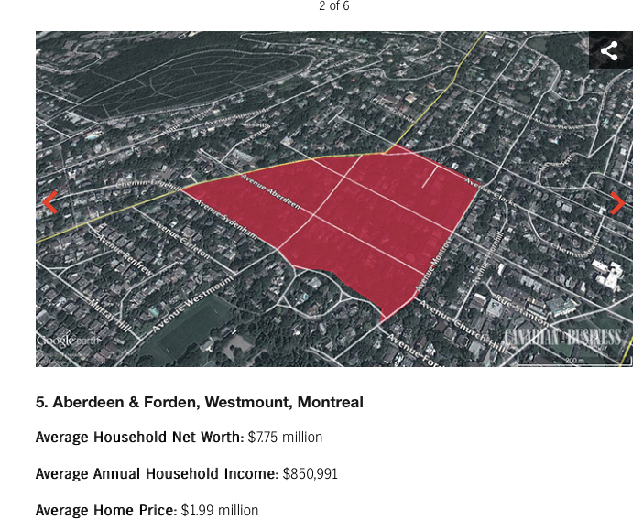
http://www.canadianbusiness.com/lists-and-rankings/richest-neighbourhoods/quebec-2014/image/6/

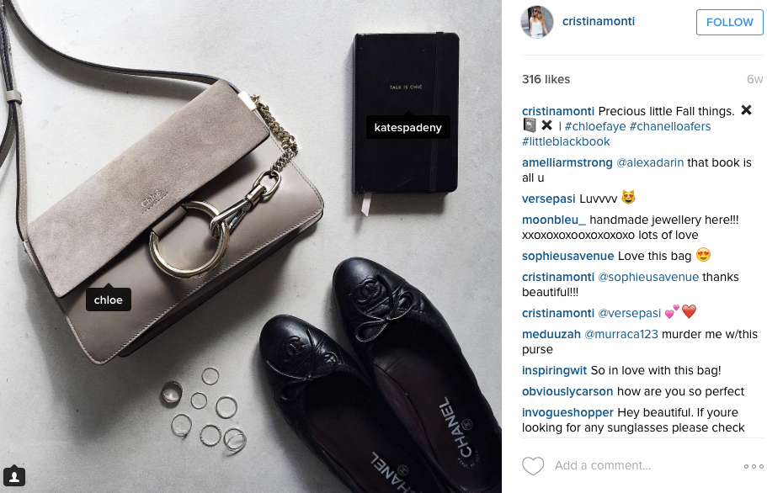
In Montreal, HR may have famous instagram fashion bloggers who shop regularly at HR with a large amount of followers. These bloggers post pictures wearing their apparel and tagging HR and their brands which is providing HR with earned media and at the same time may influence these followers to go to Holt Renfrew.

As an example, this fashion blogger is known to wear high end brands. She has over 600 pictures demonstrating her daily outfits to her followers and although she does not tag directly the store Holt Renfrew, she tags brands that are available at HR. Since HR is known as a high end luxury store, people will automatically think of the store to go ahead and purchase. People also prefer going directly to the store because to purchase a high end brand online can sometimes be more costly and a lot of people would prefer to see and try on the product especially when purchasing an expensive product.

Since Holt Renfrew isn’t strong on social media, the fact that the brands that they carry are very well known and popular to most is a tremendous asset to them. Especially when these brands come out with new products and release campaigns. This is basically like free advertisement for Holt Renfrew because people know it is available at HR.

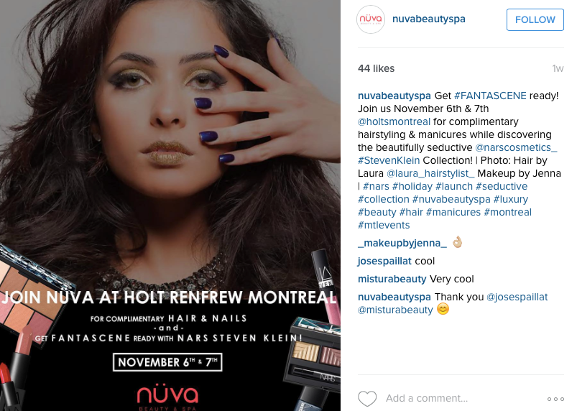
As an example, HR did a collaboration with SPA NUVA. Spa Nuva has a hairdresser, Maggie Seeman, that was nominated for this year’s top ten hairstylist worldwide. This is good advertisement for HR because Nuva is becoming more and more popular and the fact that they did a collaboration with HR will send more clients.

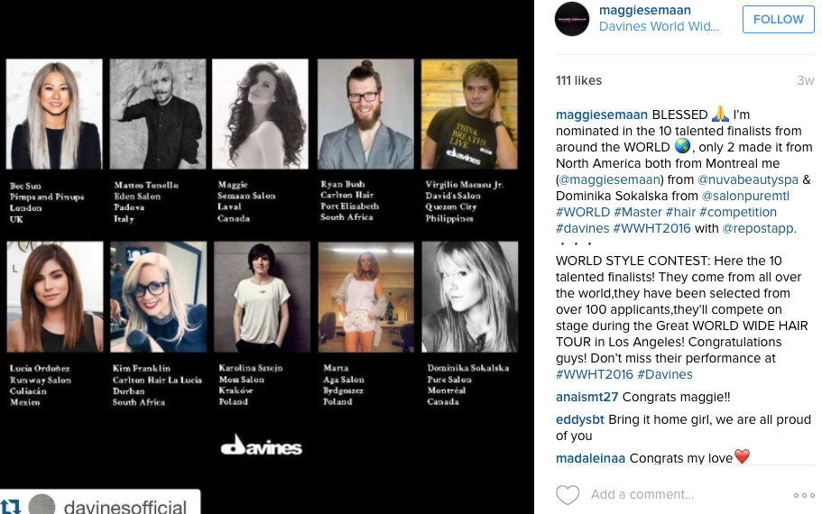

HR is present on Instagram, Twitter, Facebook, Youtube, Pinterest, Google Plus & Weibo

The platforms that talk about fashion are Instagram, Facebook & Twitter

Because HR is a large corporation, they do not buy directly from the websites. They hire buyers for this.

Because they mostly target an older demographic, they don't necessarily read blogs from fashion bloggers. They’re most likely to buy and read magazines?

Their target market is wealthy people who have an interest for fashion and care about keeping up with the latest trends.

HR does not provide any entertainment in the sense of games. However, this may be a gap they are failing to fulfill. This possibly can attract more clients.

platforms platform

