CUL 122 Intro to Pastry Portfolio
Prepared for Chef Mandy Vial
Student: Anika Xu
ID: 2042883

- Mini Frangipan Tartlets
Method
Creaming
Filling
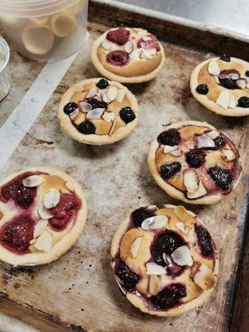
Personal Thoughts
The most challenging part for me was shaping the tart shells. It was a longer process for me as I had to shape it, re-roll the pate and create the shapes again. It was not complicated but most of the effort was on creating a shape and shaping it to fit the tart holder. The frangipane was easier to piped when the texture was not hard. The frangipan was required to be piped evenly inside the tart, along with the side of the tart. One interesting fact that I learnt was that the fruits on the tarts should be in odd numbers. It was a personal choice to have different berries on the top. The garnish of almonds created aroma and taste to the tarts.

- Choux puffs and eclairs filled with pastry cream
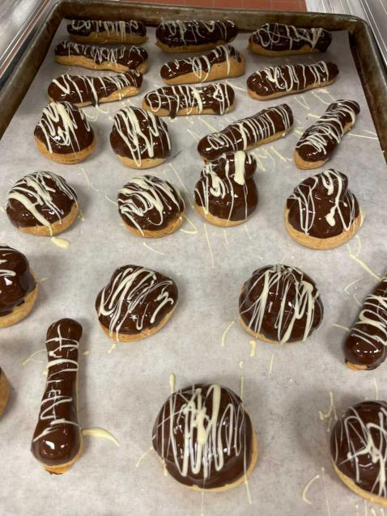
Method
Dough
Stirred Custard
Personal Thoughts
The most challenging part was piping the choux paste into uniform sizes. I think this could only be improved through practice. The only thing to pay attention while making pastry cream was not to get burnt as the vigorous whisking could lead to milk mixture to spill and splash onto our hands. Piping was fun and I enjoyed the chocolate dipping very much. Chef Mandy suggested for us to move away the puff until the chocolate stopped dripping. This is to avoid the chocolate running down the sides of the puffs when they are set back to the rack.

- Panna Cotta with tuille cookies
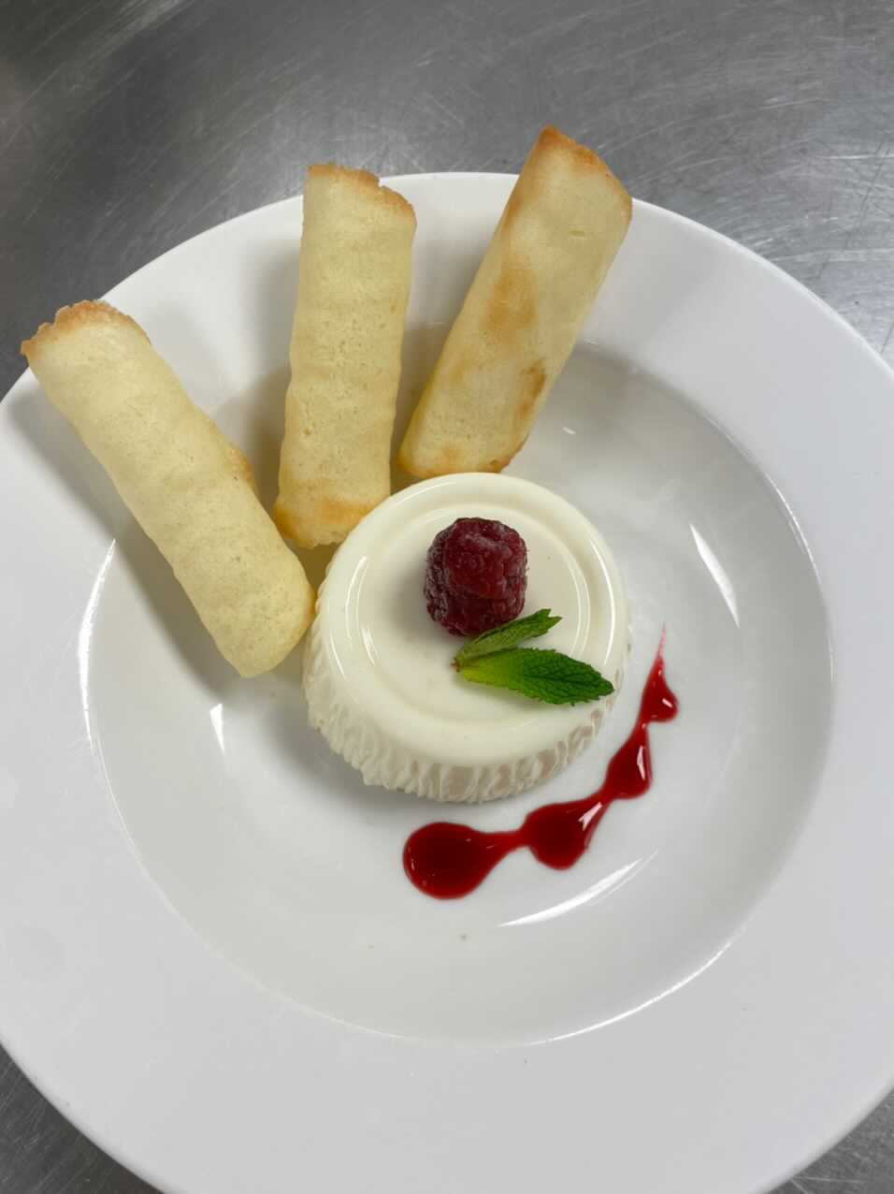
Method
Cream Custard
Personal Thoughts
The panna cotta was easy to make. The most challenging part was rolling the tuile cookie. The temperature and texture were the most important part, therefore Chef Mandy suggested us to do it in several batches. It tasted like vanilla cookies except it is thinner. The cookies needed to be rolled while they were still soft in the middle. It is important to watch the tuile cookies while they are in the oven. It was important to take them out when the sides are brown and the middle is dry but still soft. Try to roll them as soon as they are out of the oven as they cool very fast. It was also important to try not to burn yourself.

Lemon Sabayon Torte
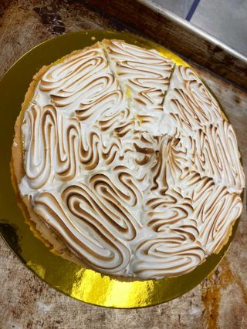
Method
Dough
Filling
Meringue
Personal Thoughts
I learnt the definition of blind baking. It simply refer to docking and adding weight.This is to avoid the rising of the pastry in the oven. The sabayon required to be whisked vigorously when it was heated on the boiler. To determine if the lemon mixture was in good consistency, simply shake the mixture lightly. It should not have a big jiggle and the centre should be little bouncy. It was fun for me to torch the swiss meringue. It was a nice experience for me.

- Fruit Flan
Method
Dough
Stirred Custard
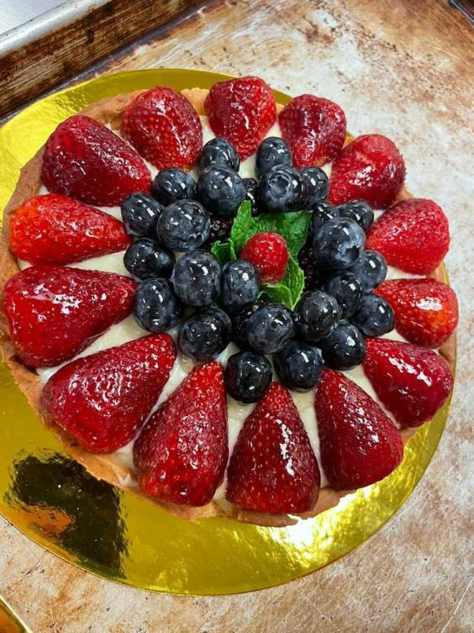

Personal Thoughts
The tart shell was broken when it was baked in the oven. The tart sides were cracked and middle part of the tart was removed from the bottom shell. This was very unfortunate and I think this is due to the reason of the pate sucree was rolled too thin. This was reparied later through glueing with melted chocolate. Chef Mandy said in real life, bakers would just stick the shell back with icing sugar or chocolate. Apart from the failure of the tart shell, everything else was in good outcome. It was fun for us to decorate the top of the tart through creativity.

- Creme Brulee
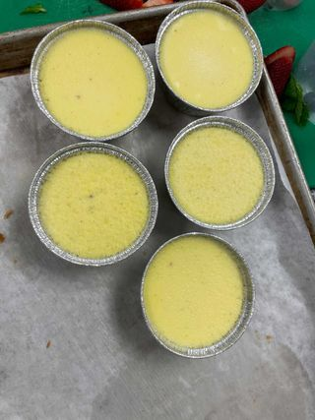
Method
Stirred Custard
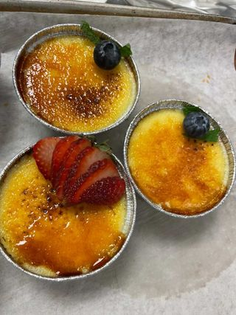
Personal Thoughts
Some of the technical issues occured during production as I was not able to realize that one side of the oven was higher. Therefore it lead to the egg custard being overbaked. I think the most challenging part was torching. It was difficult to make sure that every part of the surface was caramelized. It was challenging but it was fun as it was my first time.

- Mango Sorbet
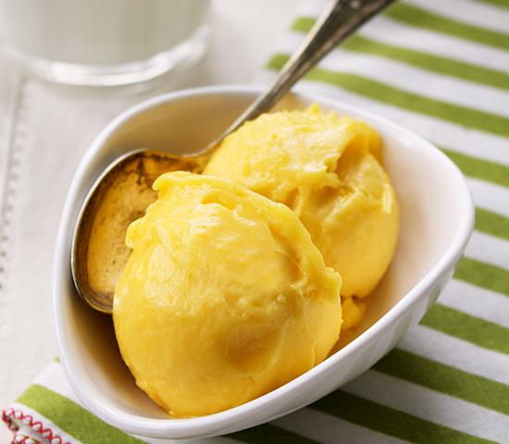
Method
Churned
Personal Thoughts
The most fun part was to play with glucose. Chef Mandy emphasized that the hands needed to be wet to avoid the stickness of glucose. The glucose should be put into the saucepan as oppose to be in container. This is to avoid stickness of glucose in the container. It also leads to wastage if glucose stick in the containers. The sorbet was made through ice cream machine. The constant mixing technique in the ice cream machine creates thickness to the sorbet. It was very fun experience for me.

- Ice Cream
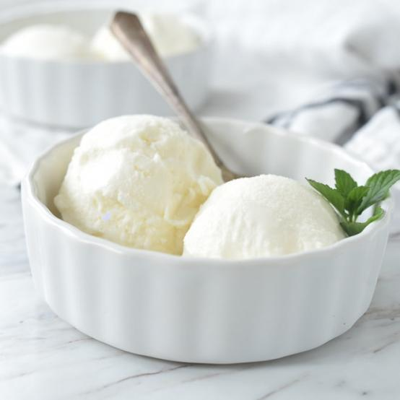
Method
churned
Personal Thoughts
One of the most important part that required attention was the temperature. When the custard was cooking in the pot, the temperature should be monitored frequently. Chef Mandy emphasized that curdle would occur once it was beyond 185.1F. We need to make sure the custard should be removed from heat as soon as it was reached 180F. Once the custard was prepared, we were asked to make sure to chill in an ice bath. The cream should be ice cold before putting into ice cream machine. It was a nice experience making ice cream and it was important to ensure all the steps were under temperature control. We wanted to ensure the outcome to be smooth.

- Eclairs and Profiteroles filled with Chantilly Cream
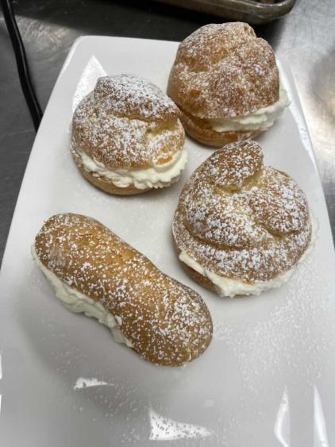
Method
Dough
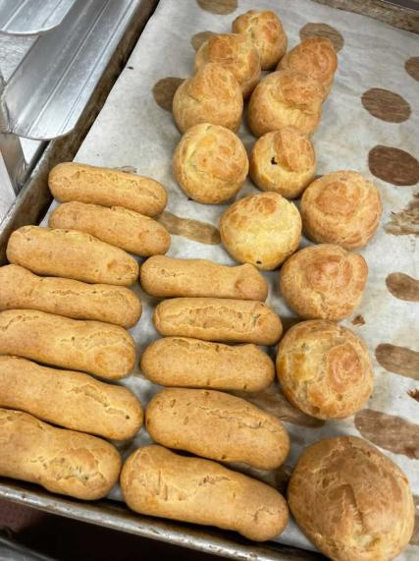

Personal Thoughts
It was my second time making choux and I think I made improvements from the first experience. One thing that I need to pay attention was my speed. I noticed my piping speed was slower than majority of the students in class. I think that can only be improved by practicing. The cream was easy to make but the most challenging part was to determine the whipness. It was very important not to overwhipped as it took me two attempts to reach the correct whipness for the chantilly cream.

- Chocolate Peanut Butter Pie
Method
Dough
Filling

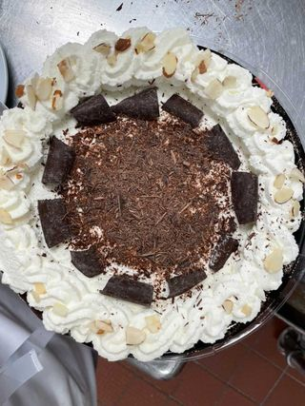

Personal Thoughts
Based on the mistake I made for tart shell last week, I made sure my dough was not rolled too thin. I also feel good when I don’t make the same mistake again. The most challenging part for me was whisking the custard in the pot. I am still not very sure which part I did wrong as it lead to the lumps in my custard filling. It could either be when I was preparing the egg mixture(cornstarch not mixing properly) or I did not whisk vigorously in the pot. I already noticed the lumps in my mixture when it was in the pot, I though it would get better when I whisked more but that did not happen. The most fun part was the whipping cream, it was so fun to learn how to pipe cream into nice shape. The nice wavey shape of the whip cream provides a better presentation to the pie.

- Toffee Caramel Flan
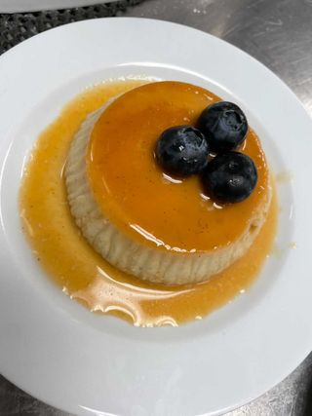
Method
Baked custard
Personal Thoughts
The process was smiliar to creme brulee. I think it was important to ensure the pudding was bouncy but not jiggly. Once the flan was removed from the ramekin, it sat on the plate nicely with the extra sauce around the flan. The steps of making this flan was pretty straight foward. The most challenging part was to determine the right color for the caramel. Lucky I had Chef Mandy to watch for me when I was cooking the sugar. I was asked to pay extra attention to pour the browned sugar into ramekin as it should form a thin layer. The layer should not be thick.
Method
Dough
Filling
- Lemon Sabayon Torte
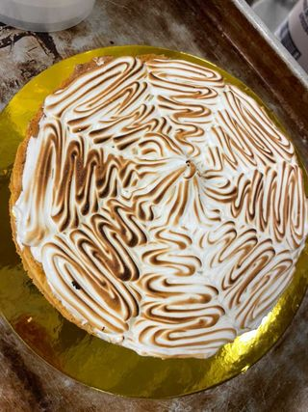
Personal Thoughts
I was definately more confident and comfortable with making lemon sabayon tart after the first 3 weeks of practices. Chef Mandy re-emphasized several points for evaluating the torte. First, the tart shell should not be too thin as there should not have much crust left; second, the sabayon mix should nappe the spoon to test the consistency; lastly, to determine the doneness of swiss meringue, it should form a shape when the whisk is held up. It is important to ensure all these points are meeting standards in order to produce a complete lemon tart.

- Paris-Brest
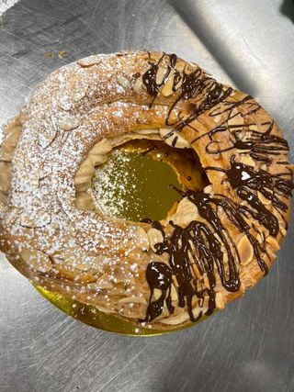
Method
Dough

Personal Thoughts
The most challenging part was to pipe the appropriate shape for the donut. The three circles need to be in the same thickness in order to create the puffness and it should rise to a higher level when it is baked. It was fun to play around with piping the paris brest cream. I chose to pipe the rose shape. Chef Mandy told me I could pipe two layers to so the choux will be higher after I cover the top. Mine was still pretty flat after piping two layers. Maybe I can try with some other patterns next time.

- Lemon Sabayon Torte
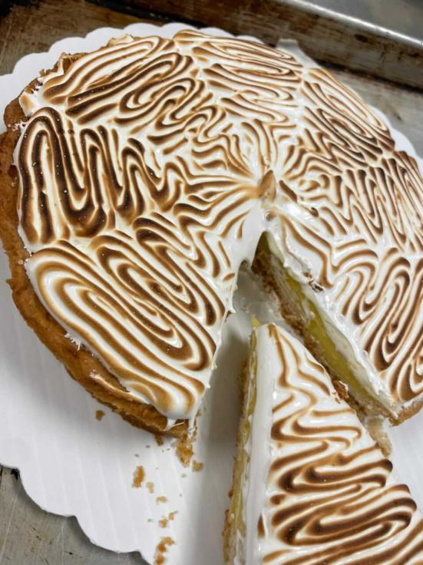
Method
Dough
Filling

Personal Thoughts
With the previous experience, I made sure I watched the important points during the production. I made sure that the tart shell was shaped and baked well; the sabayon filling to be smooth and the swiss meringue whipped properly. It was useful to make a timeline and follow the timeline.

- Puffs and Elciars with Pastry Cream
Method
Dough
Stirred Custard
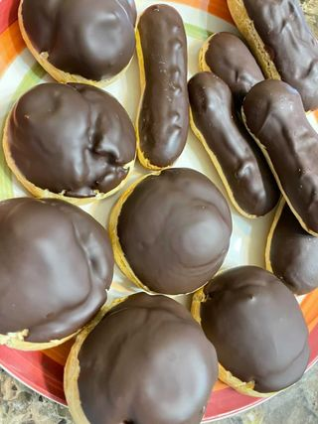

Personal Thoughts
I am already very familiar with preparing choux and piping them out. The most challenging part was to make sure to pipe them into the same sizes and shapes. I think this can only be improved by practicing. I think preparing a baking sheet with drawn shapes would help. The chocoalte coating part was very easy but it took some patience. I knew it would take me some time so I left this part to be the last thing to complete in my timeline. After I finished all other things on my list, I would not feel rushed and all I needed to do was to focus on dipping the puffs and eclairs into the chocolate.

- Panna Cotta with tuille cookie
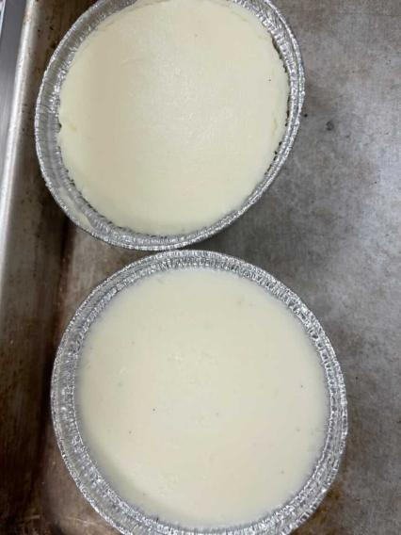
Method
Cooked Custard
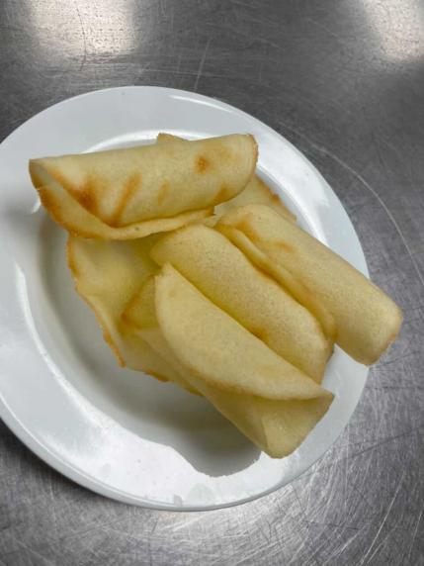
Personal Thoughts
The panna cotta was not mixed very well as the gelatin did not melt completely during the mixing process. The vanilla also fell to the bottom. Luckily, with the help of gelatin, the panna cotta stayed jiggly and I managed to remove it from the cup. The process of making tuille cookies were straight forward. I made 2 each time so they were warm while I was shaping them.

- White/Chocolate Genoise
Method
Egg foam
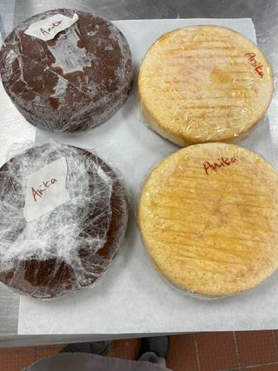

Personal Thoughts
It was my first time making a genoise cake, it was very difficult for me to determine when the batter was ready for the next step. It was difficult for me to determine when the egg mixture was whipped properly. I think I did not fold in the flour properly. It took me more time folding in the flour than I expected. Both of the genoise that I made was not springy or jiggly. I think the next time I make genoise I should make sure I whip the egg for 13 minutes and make sure not to overfold in the flour. One thing that we also learnt was making a pan bottom for the mold with parchment paper. The purpose of this was to avoid the batter coming out from the ring mold.

- Croissants
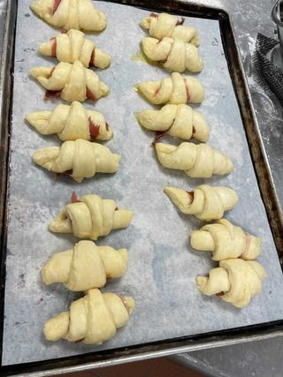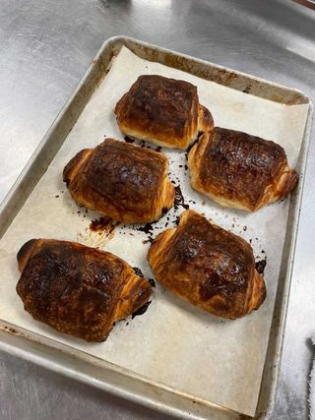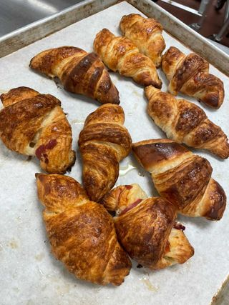
Method
Roll-in Dough

Personal Thoughts
Croissant is one of my favourite bread and I have been eating it since I was a kid. It was my first time making it and I learnt so much from this production. Chef Mandy emphasized that the dough should be kept cold at all time. We should not rush it because in order to get the layer, fat needs to be cold. One thing that I noticed when I was folding the dough was that I could still see a lot of butter in between the dough layer. Folding the dough like a pamphlet could lead to the layer within the croissant. The folding book could also determine the layer of the croissant. We could do a single book or a double double. We only did single this time. It think double would be nicer in presentation. We made three flavours. One in savory, one in plain and one in chocolate. The chocolate danish that we made turned out to be very nice. They looked just as good as the ones we would buy from cafes and bakershop. The chocolate was very dark therefore it affected the flavour of the danish, otherwise everything was good. One thing that I noticed was that the tip of my croissant came up during baking. Chef Jill told me that I need to make sure the tip is right at the bottom and I could gently push the croissant down a bit. The second batch that I made was a lot better. Overall, this was a great experience. It took a lot of time but it was all worth it. I doubt it I would make it at home due to the time consuming but it was a great learning experience.

- Almond Orange Croissant/Pain Au Chocolat
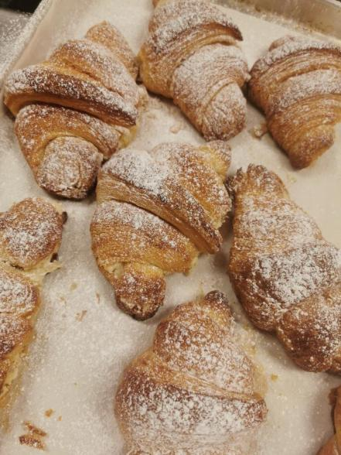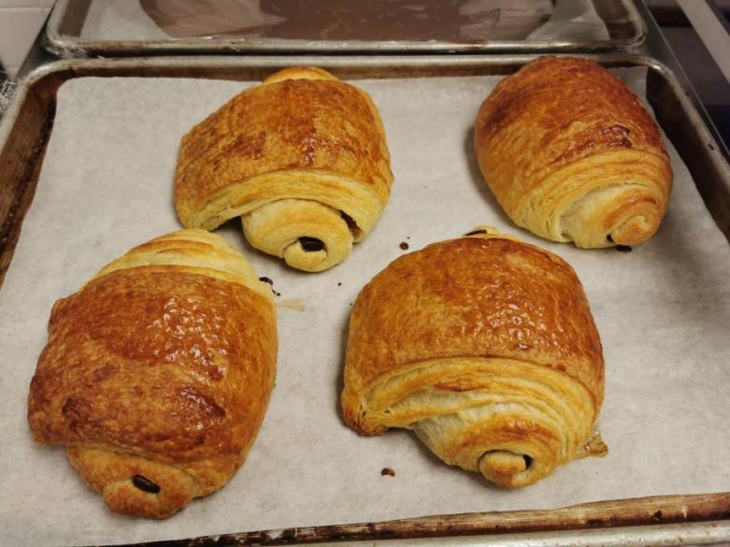
Method
Roll-in Dough

Personal Thoughts
After last week’s experience, I would say I am quite confident with making croissants now. Some of the key points that I should be keeping in mind were to make sure to fold the dough three times, make sure the dough is cold and make sure to proof them before baking. Something that I did differently this week for the croissants was that I tried double folding book. Double folding book creates more layer than single folding when the croissants are baked. The sheeter was definitely very helpful as it saved some strength and time. The croissants were made successful this week.

- Black Forest Cake
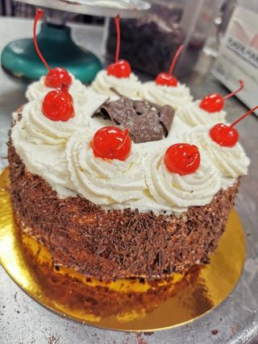
Method
Egg Foam

Personal Thoughts
Thie genoise that were used to make the black forest cake was the ones we baked last week. I tried the cake and it was not as good as expected. It was dry and hard. The genoise was a failure therefore I should pay more attention to make sure I do all the steps right in order to make a genoise sponge. Watching point for chantilly cream was to ensure not to overwhip. Overwhipping would turn into butter. Applying cream was not an easy job. I think this can only be improved by lots of practicing. It was challenging for me to make a smooth and even surface. It was difficult for me to apply the enough cream onto all sides. Overall, this was a challenging recipe as it was not easy to ensure every step was right.

- Birthday Cake/ Tuxedo Cake
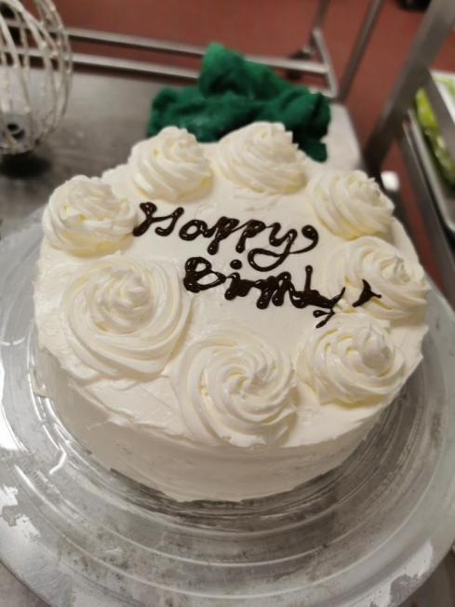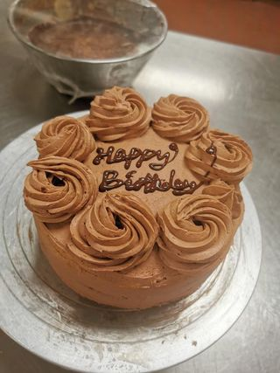
Method
Egg Foam

Personal Thoughts
Base on the mistakes made last week, I have made adjustments and made the genoise successfully this week. The genoise was whipped for 14 minutes and I tried to stop folding when the flour was just all mixed into the batter. That really made a big difference, my genoise was risen to a higher level and I could feel the softness in the middle of the cake. Chef Mandy also told us that the best condition to work on the cakes is when they are semi-frozen. They should not be completely soft nor completely frozen. Again, the piping took some time as I still needed more practice. It was difficult for me to make the surface smooth. The rossets were better after several practices. Overall, this was a great practices on completing a cake.
- Coconut Cream Danish/Cream Cheese Danish
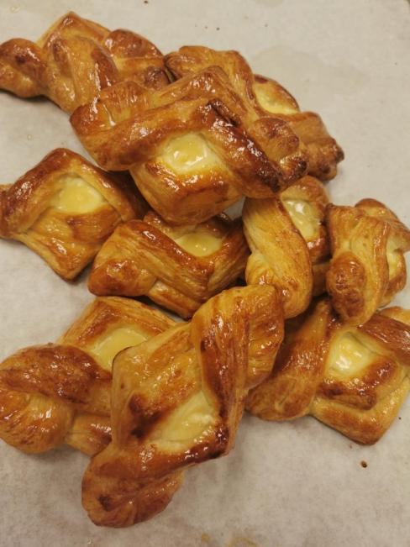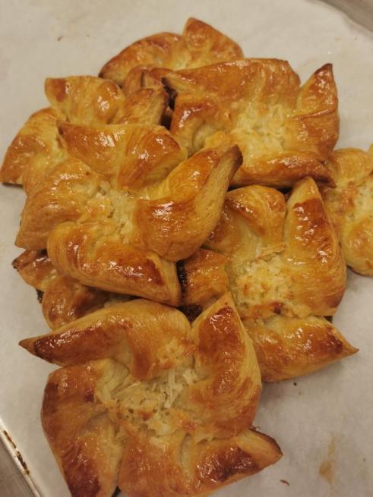
Method
Roll-in Dough

Personal Thought
Danish shares the same recipe as croissants as they are both enriched laminated dough. I was definately feeling confident with making them based on the previous practices. I prefer double folding as it made the dough rise to higher level. I love how the folding creates the layer of the pastry rised in the heat. It was really amazing how the chemistry worked in the baking process. Danish is one of my favourite breads to eat and I enjoyed every bit of making it. I was also so fasinated about the shapes of them. We learnt three shapes in class. I loved the pin wheels the most as they looked very presentable and sellable when they were baked from the oven.
- New York Cheesecake
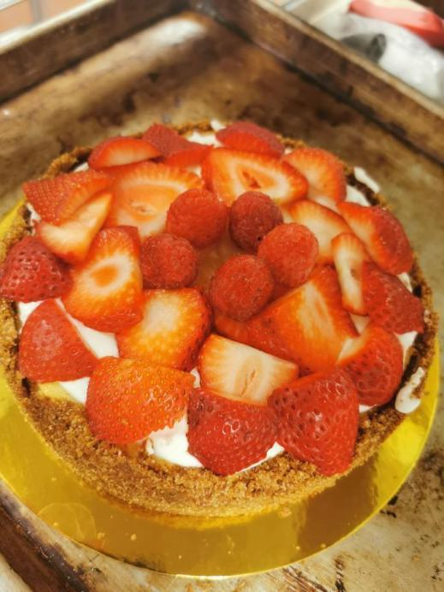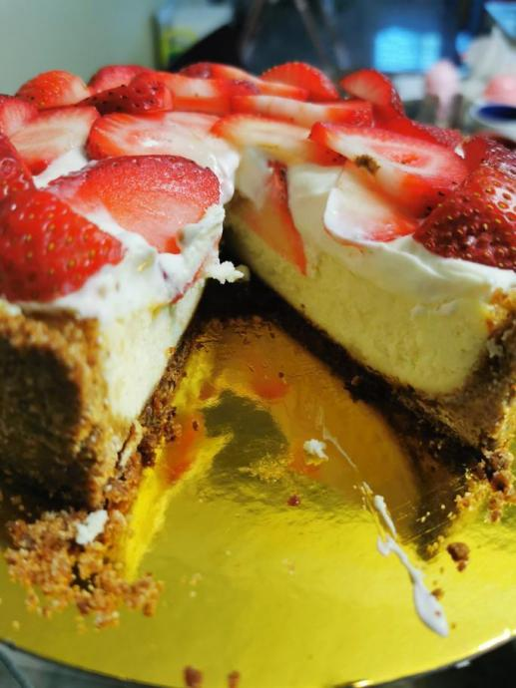
Method
Dough
Baked Custard
Personal Thoughts
Chef Mandy emphasized that the most important point for making the cheesecake is to make sure it is smooth. Cream cheese are an expensive item therefore we should try out best to avoid wastage. The cheesecake batter should be lumpfree as when it should taste smooth and creamy. Therefore it was important to put into enough patience when the cream cheese was blending in the mixer. We should keep scraping the batter from the batter and put in enough time to let the paddle keep blending the cream cheese. It was also important not to have a huge temperature change when the cheesecake is in the oven. In other words, we should not let the oven door be opened(sneaking from the door seam is fine) so the temperature drop will cause the collapse on the surface of the cheesecake.

- Raspberry Mousseline
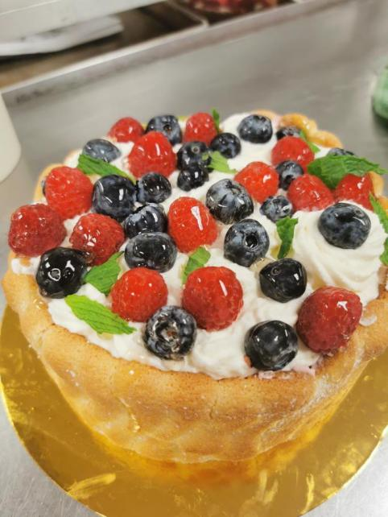
Method
Egg Foam
Mousse Filling
Personal Thoughts
It was such a fun experience to learn to make such a pretty cake. This mousseline was surrounded by the lady fingers. The lady fingers were sponge and sweet. It tasted well with powdered sugar. I did not make the barvarian cream properly therefore the mousse was lumpy. The recipe asked to keep stirring while it was chilled but I just left it there as it was a busy day. I was still suppose to whisk it when it was chill. This is to make the gelatin working better with causing lumps. The mousse was suppose to be very smooth and no lumps, just like the cheesecake batter. However, the help of straining made it better. The straining process helped to avoid all the lumps. The outcome was still meeting standard as the chantilly cream and fruits on the top covered the mistakes that were made in the mousse, which it was covered underneath. It was a fun experience to learn how to make mousse cake.

- Mille Feuille/ Palmiers
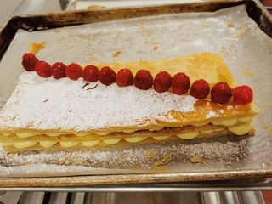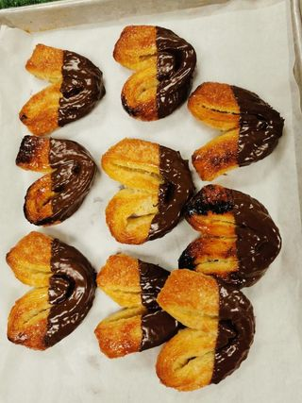
Method
Puff Dough

Personal Thought
The method of puff dough shares similar process but did not require rising therefore no yeast or proofing were needed. One thing that was different was the roll in fat process. We only needed to apply the butter by little amount until it is enough to cover half of the sheet dough. The dough was required to be cold at all times otherwise it would not be easy to dealt with. It saved lot of time by using a sheeter. In order to make the mille feuille, Chef Mandy emphasized that we need to make sure to dock enough holes on the dough so it would not rise. I could see the dough rising in the oven and Chef Mandy said we could put a tray on the top to stop rising. Overall, this was a great experience learning how to make puff dough. I could still see the layers after the puff sheet was baked. It was amazing how they turned out to be such delicious pastry with shaping and decorating techniques.

- Chocolate Mousse Cake
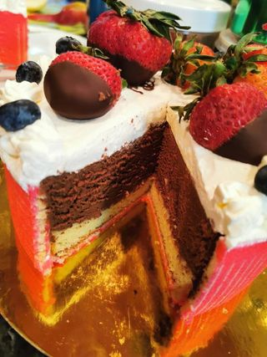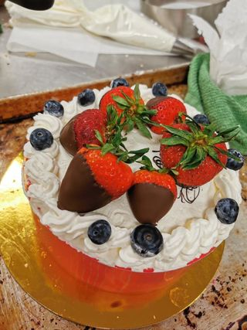
Method
Egg Foam
Mousse filling

Personal Thoughts
I was not really sure how the egg whites were overwhipped but I will definitely pay more attention next time when I make chocolate mousse. The joconde was very creative and it was fun to play with when it was on the sheet pan. I created my own color and pattern through a cutter. It was a wonderful experience decorating the cake with jocond sides. Although the chocolate mousse was not smooth, it still tasted very good after it was being chilled in the fridge. It tasted like chocolate ice cream cake. Overall, it turned out to be a pretty cake and I got to decorate the cake with my own creativity.
- Almond Genoise with Italian Buttercream
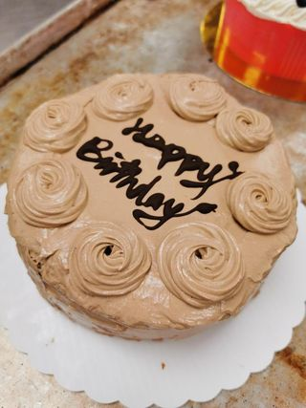
Method
Egg Foam

Personal Thoughts
I thought I was confident with making genoise but it did not turn out to be successful. One thing that I could think of was because I heated up the egg sugar too high. I also noticed my batter was too much after folding in the flour. I had extra batter that was almost enough to make one more cake. I knew I must did something wrong at that moment when I saw the extra batter. The batter should have been enough for two cakes but that was too much. I think it was because I overheated the egg sugar. It was such a busy day and it was difficult for me to multi-task to do everything. For the buttercream, the melted chocolate was still warm when I poured into the mixer which caused the buttercream too runny. Also, I think I need to speed up the piping process as the temperature goes up when it is under room temperature. I should have a bowl of ice to place underneath the buttercream next time when I pipe.

