6/19/2020
Charles Brent Lowther

Catering Operations Lasalle college
On-premise
Final Project

Event Location
The venue of choice for the On-premise service will be Marine Drive Golf Course which is a local venue that provides fantastic spaces to host wedding receptions overlooking its amazing landscape and golf courses.
Established in 1922, this historical Club blends the graceful beauty of the past with contemporary facilities. From the moment you step into the Lobby, you are surrounded with classic dignity. This clubhouse, our third on this same location, is anchored by a grand staircase leading to our banquet facilities complete with all modern amenities.
The Leonard/Roxburgh rooms combined will be our choices for the Ballroom they can hold weddings and events up to 200 people. The brightly lit rooms featuring large picture windows looks onto the spectacular golf course. The subtle interiors are accented with splashes of muted color and the minimalism of the rooms creates an intimate ambiance for your special event.
Supported Layouts and Capacities
Banquet - 10 per
Capacity: 180 People

Reception
Capacity: 200 People

Theater
Capacity: 250 People

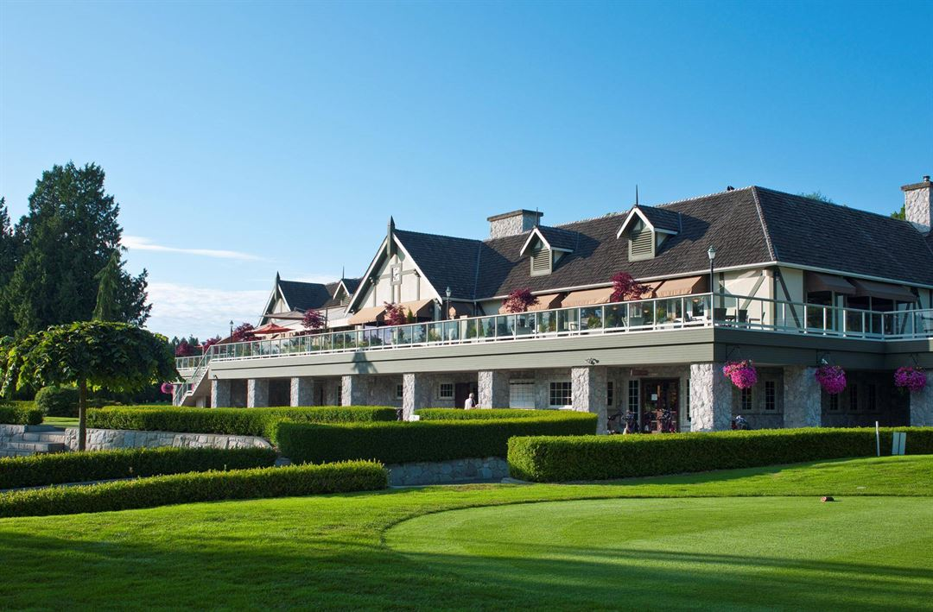

Theme
The event would be during the Summer months with a Modern Rustic style Wedding. The wedding will be matching shades of peach and gold with touches of greenery and cascading icicle lights hanging from the ceiling. This cool colors in tones is enough to be eye catching and unique, these colors create a gorgeous summertime wedding palette.

WEDDING RECEPTION DECOR
- Guest Book + Sign
- Gift Table
- Menu Sign
- Dessert Table
- Cake Stand
- Dessert Displays
- Bar Station Display
- Bar Menu or Signature Cocktail List
- Reception Lighting
- Hanging Decor
- Lounge Area
- Flowers and nonfloral centerpieces (for dining tables, guest-book table, ladies' room, gift table, etc)
- Greenery, lanterns for entryway
Summer Wedding Menu
Appetizers
Seafood bar
Lobster rolls
Grazing Table
Signature Drinks
Cocktail Paletas
Main Courses
Grilled chicken with sweet summer vegetables
Brisket with mashed potatoes
Ocean Salad
Cake and Desserts table:
Naked wedding cake
Desserts Table

Recipes
Lobster Rolls 4 servings
1 1/2 pounds lobster meat
1/2 cup mayonnaise
3 tablespoons freshly squeezed lemon juice
2 inner celery stalks and leaves, finely chopped
2 tablespoons chopped fresh parsley leaves
Salt and freshly ground black pepper
4 rolls, split and lightly toasted
Melted butter, for brushing
- Remove the meat from the lobsters, chopping any large chunks into bite-size pieces. In a bowl, combine the lobster meat, mayonnaise, lemon juice, celery, parsley, and salt and pepper to taste.
- Brush cut sides of the rolls with melted butter and fill with the lobster salad.
Cocktail Paletas
2 cups chopped seedless watermelon

3 tablespoons sugar

3 tablespoons light rum

3 tablespoons fresh lime juice

3 tablespoons water

3 small fresh mint leaves
4 Lime slices
In blender, place all ingredients except lime slices. Cover; blend until smooth.
Divide mixture among 5 (5-oz) paper cups. Cover cups with foil; insert craft stick into center of each pop. Freeze about 8 hours or until frozen. Garnish with fresh lime slices.

Grilled chicken with sweet summer vegetables
4 skinless boneless chicken breast halves, pounded to 1/2 inch thickness
1 tablespoon olive oil
1/2 teaspoon cumin
1/2 teaspoon kosher salt
1/4 teaspoon fresh cracked pepper
2 ears of corn, shucked
2 zucchini sliced to 1/4-inch thickness
1 tablespoon chopped thyme
1/4 cup thinly sliced red onions
2 tablespoons green onions
1/4 cup Cojeta Cheese
salt and pepper to taste
- In a large pot of boiling water, cook the corn for 3 minutes. Remove corn and place corn in a large bowl of ice water to stop the cooking. When the corn is cooled, cut the kernels off the cob. Toss with zucchini and thyme in grilling basket; set aside.
- Drizzle and rub olive oil onto chicken breasts. Combine cumin, salt and pepper and rub mixture onto chicken breast. Spray grill with cooking spray. Heat to medium high heat. Grill for 4-5 minutes, on each side. Remove from heat; set aside. Place vegetable basket on top and grill for 5-8 minutes tossing occasionally. Remove from heat.

Brisket with mashed potatoes
3 tablespoons whole-grain mustard
2 tablespoons turbinado sugar
3 garlic cloves, minced (about 1 tablespoon)
2 tablespoons olive oil
2 ½ pounds beef brisket, trimmed
1 teaspoon kosher salt
1 teaspoon black pepper
2 medium red onions (6 to 8 ounces each), each cut into 8 wedges
1 cup unsalted beef stock
2 tablespoons tomato paste
1 fresh rosemary sprig
1 (24 ounce) package frozen steam-and-mash potatoes (such as Ore-Ida Steam n' Mash Cut Russet Potatoes)
1 tablespoon unsalted butter, cut into pieces
¼ cup chopped fresh flat-leaf parsley
- Stir together the mustard, sugar, and garlic in a small bowl, forming a paste; set aside.
- Heat the oil in a large nonstick skillet over medium-high. Sprinkle the beef with the salt and pepper. (If needed, cut the beef into 2 pieces to fit in the skillet and slow cooker.) Add the beef to the hot skillet; cook until browned, about 4 minutes on each side. Transfer the beef to a 5- to 6-quart slow cooker, reserving the drippings in the skillet. Spread the paste over the brisket.
- Add the onions to the reserved drippings in the skillet; cook, turning once, until the onions are lightly browned, about 4 minutes. Place the onions on the top of the beef in the slow cooker, reserving the drippings in the skillet. Whisk together the beef stock and tomato paste in a medium bowl; add the stock mixture to the reserved drippings in the skillet, and cook, stirring to loosen the browned bits from the bottom of the skillet, about 30 seconds. Pour the stock mixture over the onions and beef in the slow cooker. Add the rosemary sprig. Cover and cook on LOW until very tender and the beef is beginning to fall apart, about 8 hours. Transfer the beef to a cutting board, reserving the cooking liquid in the slow cooker. Discard the rosemary sprig. Let the beef rest 10 minutes.
- Meanwhile, prepare the potatoes according to the package directions. Transfer to a serving bowl and stir in the 2 tablespoons butter until melted.
- Thinly slice or coarsely shred the beef. Serve the beef and onions over the mashed potatoes; sprinkle with the parsley, and serve with the reserved cooking liquid.
Ocean Salad
Bread:
1 baguette, cut in 3/4-inch-thick slices
1 garlic clove, split in half
Extra-virgin olive oil
Salad:
1 head red oak lettuce
1 head frisee lettuce
Aioli:
3 egg yolks
1 pinch saffron threads
2 cloves garlic, peeled and smashed
1 teaspoon lemon juice
Sea salt and freshly ground black pepper
1/2 cup chopped garlic scapes (if in season)
1 cup extra-virgin olive oil
Seafood:
2 tablespoons extra-virgin olive oil
1 pound fresh head-on large shrimp
1 cup cleaned squid
- For the bread: Arrange baguette slices on a sheet tray and toast under the broiler until golden brown. Rub bread with cut-sides of raw garlic clove and drizzle with oil.
- For the salad: Rinse lettuces and spin dry. Tear into bite-sized pieces. Place in a large bowl.
- For the aioli: Add the yolks, saffron, garlic, lemon juice, a pinch each of salt and freshly ground black pepper, and garlic scapes to a large mixing bowl. With an immersion blender set to pulse, combine ingredients, then slowly drizzle in half of the oil. Switch to a whisk and whisk in the remaining oil in a slow, steady stream. Set aside.
- For the seafood and assembly: In a large saute pan over medium-high heat, add the oil; when smoking, add the shrimp and squid. Saute until shrimp is pink and squid opaque, 2 to 3 minutes. Add the aioli, stir quickly then quickly remove from heat. Pour seafood over greens and toss lightly. Serve warm, garnished with red bell pepper, with the toasted baguette slices.

Plate Presentation
Ocean Salad
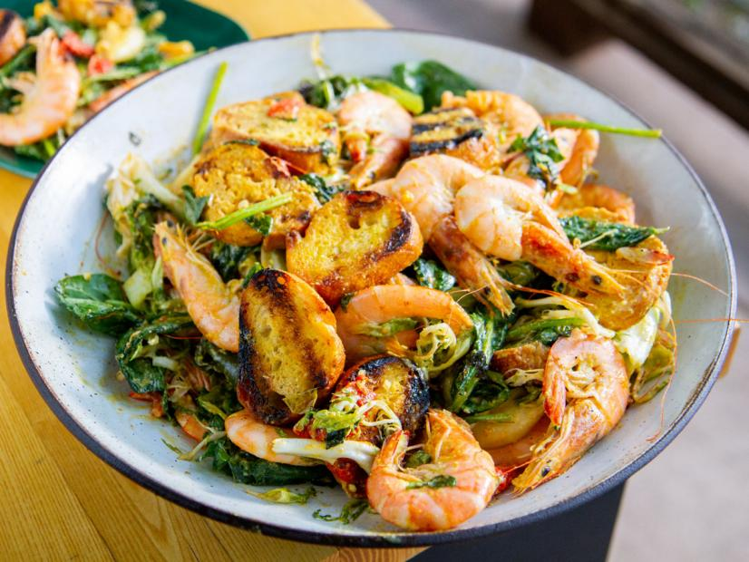

Brisket with mashed potatoes
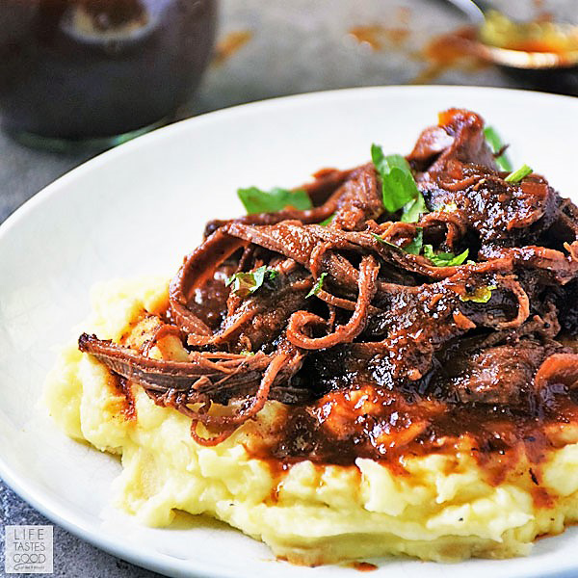
Lobster Rolls
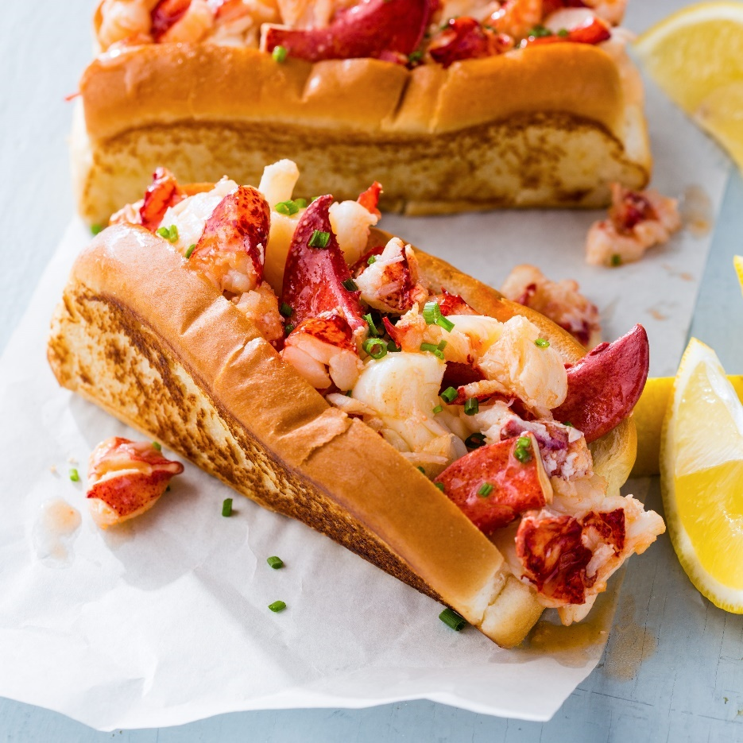

Grilled chicken with sweet summer vegetables
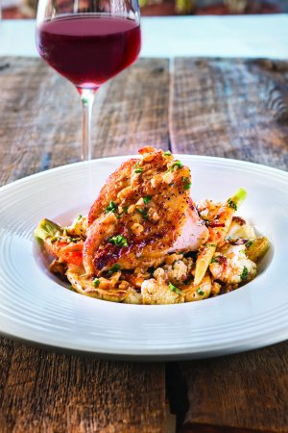
Seafood Bar
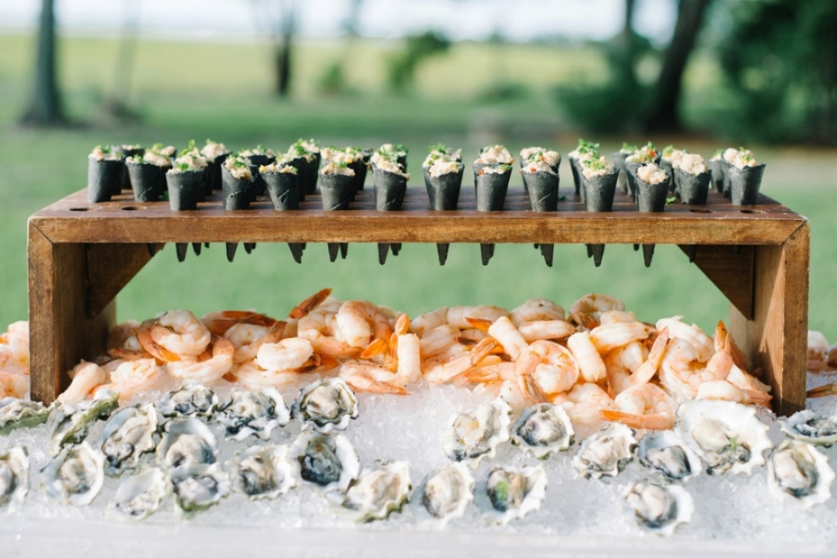
Cocktail Paletas
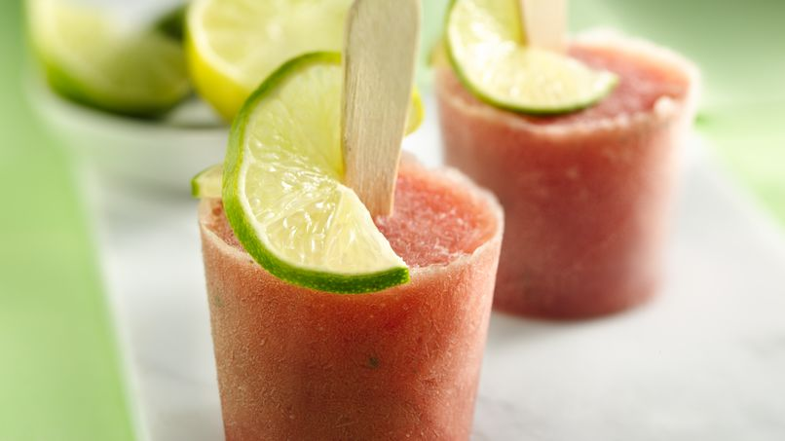

Desserts Table
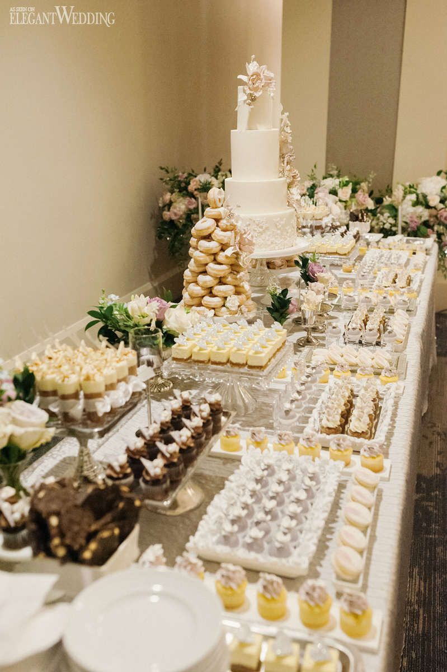

Bar Set-up
The venue will have one bar with a soft bar style offering the signature cocktail mentioned before, red and white wines, champagne and beer. We will assume each guest will consume one drink per hour of the reception. Some guests might drink more, some might drink less, So, for a 7-hour wedding reception with 150 guests, you’d need to have enough alcohol for 750 drinks.
This is the volume to quantity calculations:
- Bottle of wine x 40 (750 ml) = 5 glasses
- Bottle of champagne x17 (750 ml) = 8 flutes
- Keg (15.5 gallons) = 124 pints
- For a soft bar we will need: 75% wine, 25% beer
Red Wines
- Merlot
- Shiraz
White Wines
- Sauvignon Blanc
- Chardonnay
Local Craft Beer
- Lager
- Pale Ale

Table Setting
WEDDING DINNER TABLE DECOR
- Centerpieces
- Table Garland
- Table Runner
- Table Numbers
- Escort Cards
- Menus
- Place Mats
- Chargers
- Salad Plate
- Dinner Plate
- Silverware
- Napkins
- Water Glass
- Wine Glass
- Chair Back Decor
- Candles
Service Schedule
9:00 a.m.—Hair and makeup / Getting ready
11:00 a.m.–1:00 p.m.—Vendors arrive for ceremony setup
12:00 p.m.—Wedding party and family photos start
1:30 p.m.—Doors open / Guests begin to arrive / Pre-ceremony music starts
2:00 p.m.—Ceremony invite time
2:15 p.m.—Ceremony starts
3:00 p.m.—Ceremony ends
3:00 p.m.—Vendors start to arrive for reception set up
3:30 p.m.—Guests gone from ceremony area
4:00 p.m.—Ceremony site cleaned up
4:30 p.m.—Doors open / Guests begin to arrive / Ambient music starts
5:00 p.m.—Reception invite time / Cocktail hour starts
6:30 p.m.—Move guests into dinner
6:45 p.m.—Dinner served
7:00 p.m.—All guests have food
7:15 p.m.—Toasts
8:00 p.m.—First dance
8:05 p.m.—General dancing music starts
8:05 p.m.—Second set of pre-sunset portraits
8:26 p.m.—Sunset
8:45 p.m.—Dessert
9:45 p.m.—Last call
9:55 p.m.—Music off
10:00 p.m.—Guests depart
11:00 p.m.—Breakdown done / All staff departs
The staff needed for the event goes as follows
- Venue coordinator
- Event captain
- Kitchen staff 7
- Servers 15 to 17
- Bartender 2
- Coat check attendant. 1
- Cleaning Team 3
Banquet Equipment
- Crockery
- Wine glasses, champagne glasses and cocktail glasses
- Tumblers and jugs
- Coffee/teacups and saucers
- Enough cutlery for each course
- Tongs and serving spoons
- Chopping boards
- Chef knives
- Serving trays
- A sous vide or heat lamp to keep food at a perfect serving temperature
- Dessert plates or bowls
- Signature cocktail glasses such as martini glasses
- Cake knife
- Food display trays to use as cheese boards and serving plates
- Variety of cheese knives for both hard and soft cheeses
- Additional small plates, napkins, and cutlery
- Utensils
- Food storage
- Clearing trolleys
- Rubbish bins
Front of House Equipment
- Dinner, bread, and salad plates
- Bowls for soup and desserts
- Wine glasses and champagne flutes
- Water glasses and jugs
- Coffee/teacups and saucers
- Cutlery
- Tablecloths, napkins and centerpieces
- Salt and pepper shakers
- Decorative dishes for condiments, butter and sugar
- Signature cocktail glasses
- Cake knife and slice
- Cheese boards and serving plates
- Variety of hard and soft cheese knives
- Additional small plates, cocktail napkins and cutlery
Back of House Equipment
- Modular kitchen equipment (heavy duty ovens, fryers, table stands, shelving, sinks etc.)
- Food warmer
- Bain-marie
- Stick blender
- Hot water urn
- Coffee machine
- Microwave
- Food storage containers
- Rubbish bins
- Cookware
- Kitchen furniture
- Tea towels
- Gas ovens
- Fryers
- Modular shelving
- Char Grills
- Cookware
- Professional kitchen knife

Props/Entertaining
- Stage for DJ or band
- Adequate power source for band
- Dance floor
- Photo booth
- Photo-booth props
- Luminaria for outdoor walkway
- Small white lights on trees, cake table
- Candelabra for dining tables
- Candles
- Amber bulbs
- Tent lighting
- Special toasting flutes
- Mic
- Toys, puzzles, coloring books, crayons
- Plastic cups for kids
Marketing Strategy
Defined goals and the detailed route the plan to take to reach the catering operation goals are an essential element of the marketing plan. Goals can be simple or large scale, but should be specifically, detailed in the plan. The plans to reach these goals affect the promotion and advertising choices you make in the catering business. For example, a catering business may specify a goal to be the primary resource for large conventions in the local area. The plans to reach that goal include advertising to local convention centers, providing food for smaller conventions and asking about upcoming conventions taking place at local sites and contacting the event coordinators directly.
Internal Marketing ensures that everyone in the catering company follow the practices which leads to build the brand, reflect its image, its quality, and its process. It starts with recruiting, training, and motivation the employee to serve customer in a better way. For example, the fast food chain McDonald all employee has the same dress code. They have their batch tagged on their shirts.
The catering industry is growing day by day. It has been said that there is a lot of potential available for catering industry because of the changing food habits and lifestyle of people. By conducting in depth marketing research, a caterer can open the venture which should be ideally placed near to the target market. Think Customer should be the focus of any caterer. Taste, aroma, and presentation of the food are very critical for the success of any catering company.

Cover/Thank you Letters
Fish in a Barrel Catering Company
123 main St,
Vancouver BC V6A3J4
September 1st, 2020

Lucas Johnson
President
890 First Avenue, Suite 23
Vancouver BC V6A9G2

Dear Mr. Lucas:

Thank you for picking Fish in a Barrel Catering for your especial wedding day on August 21st, 2020. We hope your event was everything you had dreamed of and that your guests had a wonderful time sharing this incredibly special day.

Our management and staff would love to hear your impressions. If you would take a few minutes to fill a small survey and return it to us in a closed stamped envelope.

Thankyou once Again. We hope we’ll have the opportunity to be part of your next event.

Sincerely.

Fish in a Barrel Team

Fish in a Barrel Catering Company
123 main St,
Vancouver BC V6A3J4
September 1st, 2020

Lucas Johnson
President
890 First Avenue, Suite 23
Vancouver BC V6A9G2

Dear Mr Lucas,
Thank you for choosing Fish in a Barrel as your wedding caterer/planner on August 21st, 2020. It is our pleasure to confirm for you the following reservations

Friday August 21st, 2020 The Leonard/Roxburgh rooms From 1 to 11 pm

Please sign these letter, and send it along with a signed copy of the terms and conditions. Our email is Fishinabarrell@hotmail.com

We will be in touch with you soon to review the menus and décor. My staff and I very much look forward to working with you and creating what we hope will be a truly memorable event for the couple and the guests.

Sincerely.

Fish in a Barrel Team

