PORTFLOLIO
CUL204 ADV. PATISSERIE & DISPLAY CAKES Instructor: Chef Timothy Budd Thanh Ngan Do (Lynn) ID Student: 1810292

Table of Content

Plated Dessert | 2
Week 1 | 3
Week 2 | 7
Week 3 | 11
Week 4 | 16
Week 5 | 20
Week 6 | 24
Week 7 | 25
Week 8 | 27
Week 9 | 29
Week 10 | 32
Bibliography | 38

PLATED DESSERTS

There’re four components of a plated dessert:
- Main item
- Sauce
- Crunch component
- Garnish
Besides, flavor, form and color, texture and temperature help create the attractive desserts.
Main item: The main dish of the dessert should not be too big, but must be bigger than the other garnishes, and must be in the center and be the main focused point of the dessert presentation. The main item should be prepared more carefully than any others in the plated presentation. It should also be the main idea of flavor for the presentation and the other ingredients are elements to contrast and complement the main item to highlight it.
Sauce: A plated dessert should have sauces. The sauce is very important for the plated dessert, especially dry items such as pies or cakes. However, the sauce can add to any dessert to be the garnish item. Nevertheless, the sauces should not be too much unless that is flooded design. The sauces used should be consistency.
Crunch: Crunch is usually a dry dessert cookie for decorating, such as a tuille, nougat or biscotti.
Garnish: Common garnishes are fresh mint leaves, powdered sugar, decor chocolate, fruits, etc. Garnish should be small and used tastefully.
Taste: Taste includes seasonal flavors, unique essences of the region, flavors combined with each other, and texture and temperature are also factors that influence and create flavor.
Flavour: The combination of flavor is interesting and almost limitless. The discovery and creation of new flavors is always made, combining different flavors, and experimenting with how to make the most of the flavor to create new things. There’re common flavor combinations such as chocolate and caramel, chocolate and mint, chocolate and raspberries, bananas and caramel, bananas and strawberries, cinnamon and nutmeg, cinnamon and apples, etc.
Shape: The most common shapes in desserts are round, triangular and square. Should not use only one shape for all items. Many shapes will make the impression and attractiveness to plated desserts.
Height: The height creates a unique feel for a dessert presentation. Height can be difficult to achieve because most ingredients in dessert are very fragile. However, a height-matched plate has a great artistic feel by using long garnishes such as sticks, décor chocolate, and tuile or such.

WEEK 1
The key points of the lesson

VANILLA BEAN PARFAIT
- Scrap the vanilla bean.
- Bring the milk and scraped vanilla to a boil in a clean pot.
- Pour egg yolks to a clean and dry bowl. Add sugar to the egg yolks and whisk to combine, warm to 30ºC.
- Temper of the milk-vanilla mixture to the egg-sugar mixture, cook to 63ºC until the mixture is thickened, stir by a spatula, not whisk.
- Cool immediately over ice bath.
- Whip the cream and chill to 2ºC.
- Fold the whipped cream into the mixture, 21ºC.
- Pour into chilled forms, freeze.
- Take out when needed. Use the hot knife (dip in the hot water and dry by a clean towel) to cut quickly into 3cm cubes and cover and return to freezer.

SPONGE FOR DONUTS
- Add all ingredients into mixer and mix until well incorporated.
- Place the sponge to a water bath and allow to ferment at room temperature.

FINAL DOUGH FOR SPICY RAISED DONUTS.
- Sift flours and add to mixed bowl with eggs, salt and sponge on first speed about 5 mins with the hook.
- Soften the butter.
- Then turn to second speed and mix until the gluten is developed.
- When the dough pulls from the side of bowl, add sugar.
- When the gluten is well developed, add the soft butter all at once and mix until incorporate.
- Place a clean and dry bowl and cover with the plastic wrap and place in the fridge to allow fermenting until double in size.
- Cut the parchment paper into 3 strips.
- Take out the dough and roll out into 1cm thickness and use the stainless-steel circle round shape to cut the dough into donut shape.
- Place the shaped donut doughs on parchment paper.
- Poof for 15 – 20 mins.
- Heat the oil.
- There are bubbles when place the chopsticks in the oil, it means oil boils well to deep fry.
- Fry the donuts in the hot oil for 1 min on every sides.

FINAL DOUGH FOR CHOCOLATE DONUTS
- Sift flours
- Combine the sugar and atomized couverture.
- Add flours, eggs, salt, yeast and sponge to mixed bowl
- Mix on first speed about 5 mins with the hook.
- Soften the butter.
- Then turn to second speed and mix until the gluten is developed.
- When the dough pulls from the side of bowl, add sugar.
- When the gluten is well developed, add the soft butter all at once and mix until incorporate.
- Place a clean and dry bowl and cover with the plastic wrap and place in the fridge to allow fermenting until double in size.
- Cut the parchment paper into 3 strips.
- Take out the dough and roll out into 1cm thickness and use the stainless steel circle round shape to cut the dough into donut shape.
- Place the shaped donut doughs on parchment paper.
- Poof for 15 – 20 mins.
- Heat the oil.
- There are bubbles when place the chopsticks in the oil, it means oil boils well to deep fry.
- Fry the donuts in the hot oil for 1 min on every sides

SPICED SUGAR
- Pour the star anise, coriander and peppercorn in the parchment paper sheet pan.
- Toast in the oven about 15mins.
- Cool down in room temperature.
- Press as finely as possible.
- Sift together through a fine tamis.
- Combine with sugar and cayenne then mix evenly.
- Set aside.

LAYERED HOT CHOCOLATE
- Layer 1 for Layered Hot Chocolate
- Pour chocolate in a clean and dry bowl.
- Bring the cream to a boil.
- Pour the boiled cream over the chocolate and stir to combine evenly.
- Use the whish to stir the mixture until forming.
- Cover and keep at room temperature for serving.

- LAYER 2 FOR LAYERED HOT CHOCOLATE
- Bring the milk to a boil.
- Add the layer 1 and use the whisk to whisk dissolving.
- Cover and reserve for serving.

FOAM
- Bring the milk to a steam.
- Use whisk to create foam.
- Spoon the foam on top of the hot chocolate glass for serving.

SPECIAL MACARON
- Sift the powdered sugar, flours together and set aside.
- Whip the egg whites with sugar.
- When the whipped egg white almost reaches stiff peak, add the color, mix until combine and there’s no streaks of white.
- The whipped egg white should not be over and under whipped.
- Gently fold the dry ingredient to whipped egg.
- Pour the batter to the pastry bag with a tip.
- Prepare the sheet pan with parchment paper. Use couple of sheet pan -> not overbake the bottom of macaron
- Pipe the batter into macaron/dacquoise shape.
- Set in room temperature about 20 – 30 mins before baking to set the bottom.
- Bake at 325ºF about 30 mins.
- Cool down in room temperature.

DARK CHOCOLATE PLAQUES
- Temper the dark chocolate.
- Spread the chocolate into 1mm thickness on a acetate.
- Use the oval rings to cut out the chocolate when the chocolate sets.
- Set aside for décor and serving.

VANILLA CRÈME BRULEE
- Scrape the vanilla bean to the pot with cream, milk.
- Bring the cream, milk and vanilla to a boil.
- Bloom the gelatin.
- Add egg yolks and sugar to a clean and dry bowl, whisk to combine.
- Temper 1/3 of the cream mixture into the egg mixture, stir by spatula.
- Pour the tempered mixture back to the cream mixture then stir consistency.
- Strain through the fine mess strainer.
- Add the gelatin.
- Stir until the gelatin is dissolved completely.
- Cool down.
- Pour to the mold and place in freezer.

RASPBERRY FOAM
- Bring the water and sugar to a boil. Remove from heat after boiling.
- Whisk immediately and add lecithin gradually.
- Add the pure and continue whisk.
- Place in fridge.

- PLATE 1:
- Dust 2 donuts in the spiced sugar and place in the center of a plate.
- Rewarm layers for hot chocolate
- Pour layer 1 in the glass carefully, about ½ up from the bottom of glass.
- Pour layer 2 on top of the layer 1, about 1/4.
- Spoon the foam on top of the glass, then sprinkle zested chocolate on top. Place the glass on side of donuts.
- Place a round chocolate plaque on the other side of donuts.
- Place a cubed vanilla parfait on top the chocolate plaque.
- Use the other ring chocolate plaque to decorate on top.

- PLATE 2:
- Place 1 disc of dacquoise on the plate.
- Unmold the brulee and place on top of the dacquoise, then place 1 disc of dacquoise on top.
- Place 3 raspberries on top with small amount of fresh mint.
- Place 2 macarons on side of dacquoise brulee
- Press the raspberry foam on the other side.
- Décor with caramel sugar and sliced peaches.
WEEK 2
The key points of the lesson

ÉCLAIR PASTE
- Prepare parchment-sheet pan.
- Add the milk, water in a saucepan. Bring to a boil.
- Add salt and butter and stir well to make sure the butter is fully melted.
- Remove from the heat and add all the flour. Use a whisk to whisk combined and until the dough comes away from the sides of the pan.
- Pour the dough into the mixing bowl fitted with the paddle attachment.
- Beat at medium speed, add the eggs one at a time, until the mixture is shiny but firm and pulls away from the sides of the mixing bowl.
- Pour the mixture into a pastry bag with tip.
- Fold the parchment paper and pipe onto 4 edges of the sheet pans.
- Hold 90° angle straight down and pipe into circles, approximate 2 inch.
- Press down the peaks by water because they're easily burned.
- Bake at 400°F (200°C) for 20 minutes.
- To check for doneness, press both sides of Éclair, it must bounce back.

PATE SABLEE
- Bring the eggs to a boil. Cool down and separate the egg yolks. Press the egg yolks through a sieve. Set aside.
- Sift powdered sugar. Set aside.
- Sift pastry flour. Set aside.
- Cream the butter in a mixing bowl fitted with the paddle attachment.
- Add the powdered sugar to mix until combined well.
- Add the vanilla, salt and nut flour and keep mixing.
- Then add the sieved egg yolks, mix until combined.
- Add the pastry flour and mix by low speed until combined together. Do not overmix.
- wrap the dough with plastic wrap and chill in the fridge overnight.
- When needed, roll out the dough into 3 millimeters.
- Bake at 350°F (180°C) for 20 - 30 mins or until golden brown and fully cooked.
- Cool down.

PASTRY CREAM
- Bring the milk, vanilla extract/bean to a boil in a clean saucepan.
- Whisk the egg yolks in a clean bowl. Then add sugar in eggs when milk is boiling.
- Temper the yolk mixture with one-quarter of the boiling milk, whisk well. Then put this mixture to the remaining milk and stir.
- Combine the mixture and the cornstarch or flour. Return the mixture to the saucepan and cook, whisk until the mixture boils and is well thickened, approximately 2 minutes, stirring constantly.
- Turn heat off and remove the pastry cream and pour it into a clean mixing bowl.
- Fold in the butter.
- Cover by placing plastic wrap and chill over an ice bath.

BABA SAVARIN
- Melt butter and set aside.
- Sift flour.
- In a mixing bowl, combine sifted flour, water, eggs, yeast, salt, and sugar.
- Mix with the dough hook about 5 minutes by medium speed.
- Add the melted butter in the dough when the dough is developed, then continue mixing in slow speed.
- Next, add the raisins.
- After mixing, divide and shape the dough then shape and place the dough into molds, should fill halfway up the mold.
- Proof to ferment about 30 minutes.
- Bake at 400°F (205°C) until golden brown.
- Unmold and cool down.

BABA SYRUP
- Add the water, sugar, vanilla, and zest in a pot.
- Come to a boil.
- Heat off and set aside to let cool down to warm.
- Add the rum.

ORANGE MILK CHOCOLATE MOUSSE
- Prepare molds for mousse.
- Melt milk chocolate over a Bain Marie.
- Add gelatins into cold water to bloom them. Set aside.
- Add sugar and water to the pot and come to boil to prepare pate a bombe mixture.
- Whip cream (the cream should be cold before whipping) into the soft peak.
- Take gelatins out of cold water and remove excess water from gelatin completely. Add the bloomed gelatin to the pate a bombe mixture.
- Stir in the liqueur.
- Stir melted chocolate in the orange oil.
- Fold the bombe mixture into the melted chocolate.
- Gently fold in the whipped cream.
- Pour in the molds then place in fridge.

CHOCOLATE TART DOUGH
- Sift the pastry flour and cocoa powder together then set aside.
- Cream the butter until light in the mixing bowl fitted with the paddle attachment. Scrape down and continue creaming.
- Add the sugar, salt and vanilla in the bowl and keep creaming. Scrape down the bowl.
- Add the eggs one at a time.
- Add the nut flour.
- Add the pastry flour-cocoa powder mixture to the butter mixture.
- Mix by low speed to combine. Do not overmix.
- Take out and wrap completely.
- Place the dough in fridge and chill, approximately 30 minutes.
- When needed, take out and roll out the chilled dough on a lightly floured board to a thickness into 3 millimeters and cut into the same portion of mousse bars.
- Bake at 350°F (180°C) for 20 mins.

BAKED STREUSEL FOR CRUMBLE
- Prepare paper-lined sheet pan.
- Add all of the ingredients in the mixing bowl with the paddle attachment and blend until the mixture turns to lumps form.
- Do not overmix to a smooth form.
- Spread out the mixture into small lumps onto a paper-lined sheet pan.
- Bake at 375°F (190°C), approximately 8 - 10 minutes.
- cool down and set aside.

DRIED FRUIT SLICES
- Rinse the fruit. Peel if necessary.
- Prepare paper-sheet pan.
- Slice the fruit as thin and intact as possible.
- Dip the fruit slices on both sides in icing sugar, shaking off to remove the excess sugar.
- Place to the sheet pan.
- Bake at 175°F (80°C), approximately 1.5 – 3 hours. Check every 30 minutes.
- Cool down and set aside.

PLATE 1
- Temper chocolate rings.
- Position 3 - 5 eclairs on a piece of the baked pate sablee dough on a serving plate.
- Place chocolate rings on the composition and decorate as desired.
- Pour Mango Coulis on the plate. Create a design in the sauce.
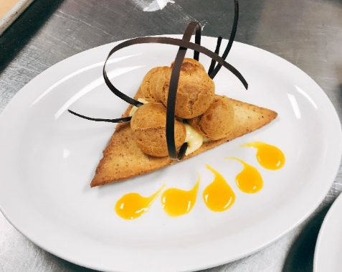

PLATE 2
- Dip the Baba Savarin into warm Baba syrup, let leave few seconds then take out and let Baba Savarin drain excess syrup itself.
- Place on plate.
- Whip cream, vanilla extract and icing sugar into the medium stiff peak. Pour into the pastry bag with star tip then pipe in the hole of Baba Savarin.
- Decorate as desired with fruits.
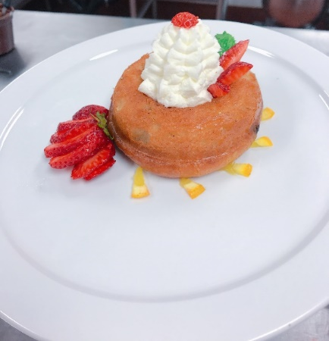

PLATE 3
- Unmold Orange Milk Chocolate Mousse.
- Place Orange Milk Chocolate Mousse on top of a baked chocolate tart dough.
- Decorate with a nougatine curl as desired.
- Sprinkle a small area of the plate with the Baked Streusel for Crumble. Use a square scoop to portion some of the Orange Sorbet onto the streusel or Nougatine.
- Garnish with a dried orange slice.

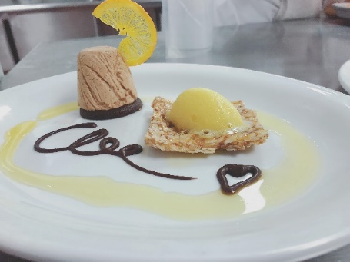

WEEK 3
The key points of the lesson

REDUCED-FAT LEMON POUNDCAKE
- Prepare loaf pan.
- The butter should be room temperature.
- Sift the flour, baking soda, and baking powder together then set aside.
- Sift the sugar set aside.
- Add the butter in the mixing bowl with the paddle attachment.
- Cream the butter until fluffy.
- Add the sugar and corn syrup into bowl. Cream well.
- Add the egg and egg whites and mix, one at a time.
- Add the lemon zest, vanilla, and salt and continue mixing.
- Fold in the flour mixture in the mixture.
- Pour the batter into loaf pan and spread. Bake at 350°F, approximately 1 hour.

DRIED FRUIT SCLICES <Strawberry>
- Rinse and dry well.
- Prepare the parchment sheet pan.
- Slice the strawberry into thin as possible and try keeping the fruit shape.
- Sift the icing sugar on the parchment paper.
- Place the fruit slices on top of icing sugar.
- Sift 1 more layer of icing sugar on top of the sliced strawberries. Bake at 175°F (80°C) approximately 90 to 180 minutes. Check every 30 minutes to make sure that they are drying out evenly and not burn.
- Take out and flip over the dried strawberries.
- Let dry and cool down properly.

REDUCED-FAT TRIFLE CREAM
- Bloom the gelatin in cold water.
- Combine the ricotta cheese, cottage cheese, sweetened condensed milk, vanilla in the bowl.
- Use a food processor to bend until the mixture is smooth.
- Warm the mixture over a Bain Marie to 100°F (38°C).
- Add the softened sheet gelatin in the mixture and stir well.

ISOMALT LACE
- Line a flat sheet pan with a silpat.
- Pour the isomalt on silpat and sprinkle food coloring on top of isomalt as desired.
- Place a second silpat on top of the isomalt.
- Bake at 375°F (180°C) for approximately 15 minutes.
- Remove from the oven and let cool and dry.

PANNA COTTA
- Bloom the gelatin in cold water.
- Pour one-third of the milk and sugar and chèvre into a pot.
- Warm the milk mixture up over low heat. Use the spatula to stir breaking up the cheese and until melted properly.
- Remove from the heat and pour into a metal bowl.
- Add the gelatin to the hot milk mixture and whisk until melted, then whisk in the remaining milk.
- Place the bowl over an ice bath and stir constantly until cool and slightly thickened.
- Prepare molds. Spray oil into the mold and sprinkle a little but icing sugar to take out easier.
- Pour the panna cotta mixture into the molds.
- Cover and place in the refrigerator, at least 4hrs.

TAWNY PORT SAUCE
- Pour tawny port into a pot. Heat it up over low heat.
- Reduce the tawny port by half.
- When reduced, come to a boil and add icing sugar and whisk until combined well.
- Let cool into room temperature then pour into container.
VANILLA GRANNY SMITH APPLES
- Rinse and peel the apples. Then slice them as thinly as possible.
- Pour the sugar and water into a pot, come to a boil, then add vanilla bean and bring to a simmer.
- Turn to lower heat and keep the syrup hot.
- Immerse the apple slices in the syrup to poach the apples.
- When the apples are cooked through, about 5 minutes, take out and drain well.

NUTMEG TUILES
- Sift the sugar and set aside.
- Sift the flour and nutmeg together and set aside.
- Cream with butter until light in color. Butter should be room temperature.
- Add the egg whites and mix well. Add flour mixture.
- Add coffee extract to the butter mixture and mix until smooth.
- Wrap and place in the refrigerator, at least 1 hour.
- Pipe onto silpat in thin shape as desired.
- Bake at 325°F (163°C) about 5 -7 minutes, until golden brown.\
- Take out and shape quickly.
- Cooldown.

THYME GELÉE
- Bloom the gelatin in cold water.
- Blanch the parsley quickly in the boiling water for few seconds.
- Drain immediately in ice water.
- Blend until smooth. Strain through cheesecloth and discard the solids. Set the liquid aside.
- Bring the thyme and sugar to a boil.
- Remove from the heat and wrap the pot and let leave for 20 minutes. Strain through a new cheesecloth and discard solids.
- Cool down to room temperature.
- Add gelatin into the thyme infusion. Stir the mixture to the other remaining and stir well.
- Pour it into the mold.
- Cover and place in refrigerate until set well.

PLATE 1:
- Cut the Reduced-Fat Lemon Poundcake into thin slices. and cut them into shapes that fit the bottom in each glass.
- Place the glasses on an ice bath into the tilt.
- Spoon the Reduced-Fat Trifle Cream on top of each lemon poundcake then let trifle cream sets up.
- Evenly divide the mango puree among the glasses.
- Fill on top the glasses with cubed mangoes.
- Garnish the glasses with the dried strawberries, chocolate rings, and Isomalt Lace as desired.
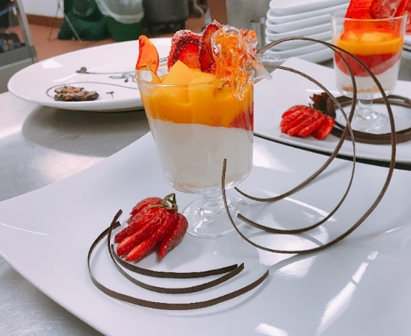

PLATE 2:
- Cut the thyme gelée into the desired shape.
- Draw as desired by the port sauce
- Gentle unmold panna cotta. Place it on the plate.
- Wrap on side of panna cotta by vanilla apple.
- Place tuiles on top of the panna cotta.
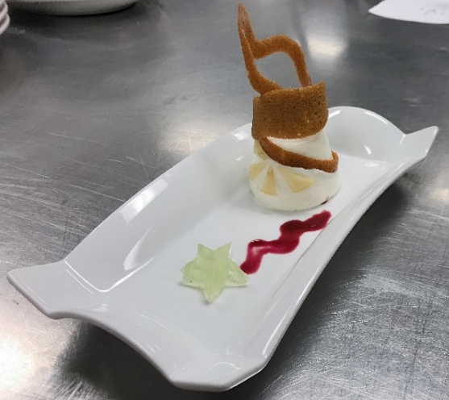

WEEK 4
The key points of the lesson

PEAR SORBET
- In a clean bowl, mix the stabilizer with approximately 1/3 -1/4 of the sugar and set aside then mix the remaining of the sugar with the dextrose and powdered glucose.
- In a pot heat the water to warm.
- At 86°F add the glucose mixture into the pot and stir well.
- At 113°F add the stabilizer mixture and stir until well combined.
- Then bring the mixture to a boil.
- Turn off the stove and remove the pan then wrap by plastic wrap and let cool down over an ice bath.
- Set aside and let mature.
- Then add the puree to the mixture and combine.
- Pour into the ice cream machine and process.
- Reserve in the freezer.

CHAMOMILE JUS
- In a pot, bring to boil the water.
- Pour over the Chamomile and cover by a cap then wait approximate 5 mins.
- Meanwhile, in a saucepan, caramelize the sugar.
- Strain the chamomile and bring it to boil again.
- Pour the caramelized sugar into the boiled chamomile.
- Stir well to make the chamomile jus.

HAZELNUT FINANCIER
- In parchment sheet pan, toast the hazelnut flour until golden brown.
- Sift the dry ingredients and set aside.
- Then cool it down and set aside.
- In a saucepan, brown the butter and set aside.
- In mixing bowl with an attachment, mix half of sugar, egg whites and whisk into soft peaks.
- Fold the dry ingredients and the remaining sugar and flour in the egg mixture.
- Then pour the brown butter into the mixture and mix well until combined.
- Spray the molds and pour mixture in by two-thirds of mold and bake at 350°F approximately 15 - 20 minx.
- Cool down and unmold.

PEAR CHIPS
- Cut the pears in very thin layers and set aside.
- Sift the icing sugar on top of silpat.
- Place the pear layers on the icing sugar silpat.
- Then sift the icing sugar on top of the pear layers.
- Place the other Silpat on top of layers.
- Bake at 225°F until crispy, approximately 3 hrs.

CHAMOMILE SUGAR
- Mix the sugar and dried chamomile together and set aside.

ROASTED PEARS
- Rinse, peel and cut in half the pears.
- In a saucepan, caramel the sugar, then put the pears in the sugar.
- Add butter to make the pears golden brown.
- Then put in the oven, bake at 350°F approximately 20-25 mins, until softened.

VANILLA SPONGE CAKE
- Prepare lined parchment paper sheet pan.
- Sift flour and set aside.
- In a clean mixing bowl, whip the eggs and vanilla and sugar into the ribbon stage.
- Fold the flour into the whipped egg mixture.
- Meanwhile, in the other clean mixing bowl, whip the egg whites and powder sugar into soft peaks then fold in the mixture.
- Spread on top of parchment paper and bake at 425F approximately 7-8 mins.

VANILLA ICE CREAM:
- In a saucepan, bring the cream, milk and vanilla to boil.
- Meanwhile, in a clean + dry bowl, add sugar and egg yolks and whisk to combine.
- Then temper the cream mixture to the egg yolk mixture.
- Add back to the saucepan and heat and stir until slightly thickened.
- Immediately cool it over an ice bath.
- Then use an ice cream machine and process.
- Freeze the ice cream.

RASPBERRY SORBET
- Combine the raspberry puree, water, sugar and stabilizer
- Process by the ice cream machine.
- Freeze.

ITALIAN MERINGUE
- In a pot, add the sugar, water and glucose.
- Heat up into soft ball stage.
- Whip egg whites.
- Pour the hot sugar mixture in the egg whites and whip until stiff peaks.

PLACE 1
- Warm the plate for serving.
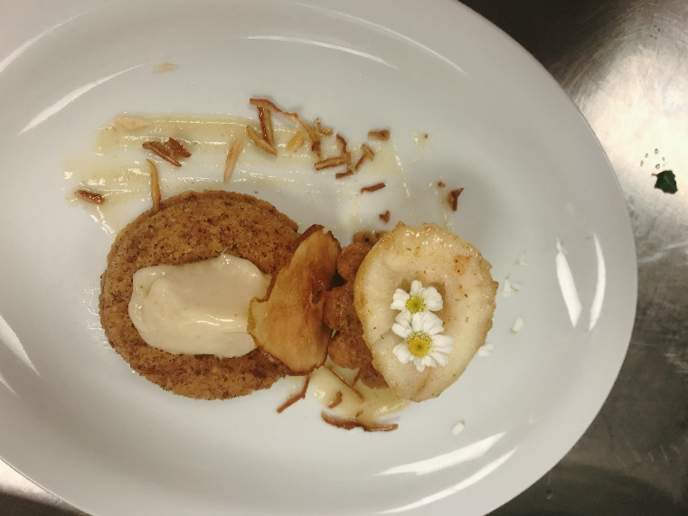
- Soak the unmolded Hazelnut cake in Chamomile jus then place on the plate and the Roasted Pear on top. Place the pear chips on top to decorate.
- Place 1 more hazelnut cake or dried pear in the other side of the plate and place the sorbet on top.
- Add some pear pure or caramel sauce in the plate and decorate with fresh chamomiles.
- For the pear caramel sauce, add some cream in the saucepan which roasted pears in it and warm it up, therefore get the taste/flavor of pears.

PLATE 2
- Pour red sorbet in the ring.
- Then after freezing, add the Vanilla ice cream on top and continue freezing.
- Unmold it and put on top of vanilla sponge cake and cover them with Italian Meringue and torch.
- Decorate with the flowers of mint and fresh raspberries or the puree of raspberry.
For Baked Alaska, the plate should be cold, so the ice cream and sorbet wouldn't be melted for a long time. Italian meringue should cover completely all sides of ice cream, so when torched, ice cream and sorbet wouldn't be melted
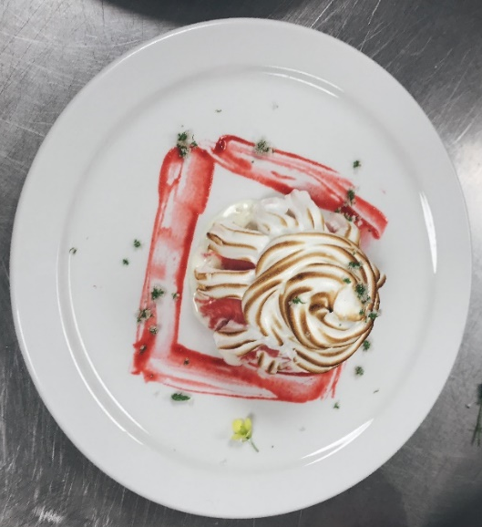

WEEK 5
The key points of the lesson

PETIT FOUR GLACE
- A petit four is a small-bite dessert.
- Bake Joconde Spongecake and make sure Spongecake isn't too thin or too thick.
- Combine simple syrup and raspberry liqueur.
- Cut the Spongecake into four equal strips. Place one of the strips on a parchment paper-lined sheet pan. Add the syrup mixture to moisten the cake.
- Pour raspberry jam on the cake and spread out a thin and even layer.
- Cover with another sheet of Spongecake.
- Moisten the second layer of cake by the raspberry syrup mixture and spread out with 1 more raspberry jam layer.
- Repeat once again. Cover with another sheet of cake and moisten by syrup and spread out jam process.
- Add the top with 1 Spongecake layer.
- Make sure the layered cake isn't too high.
- Freeze until firm.
- Cut the cake into small squares approximately 5 cm of edges.
- On a stove, warm the fondant to 38°C over a Bain Marie. shouldn't heat over 38°C then remove from the heat.
- Add a small amount of the raspberry syrup mixture to thin the fondant slightly. Do not add too much.
- Strain the fondant through a fine sieve to remove crumbs. Add fondant to the pastry bag with a plain tip.
- Cover the top of the cake with warm fondant.
- Decorate with fresh raspberries and tooth teeth.

RASPBERRY GELÉE
- Bloom the gelatin in ice cold water and no more than 10 mins.
- Warm the simple syrup, add the bloomed gelatin and melt then mix well.
- Temper the simple syrup into the puree in a clean bowl.
- Use the spatula to not make bubble air.
- Bang the bowl to push the air on top then skim the bubble.

CHOCOLATE MOUSSE
- Bake the chocolate tart dough in half way then cut into same size of the bottom mousse mold then continue baking until baked well. Cool down.
- Make a ganache by 35% cream and chocolate and set aside.
- Make a pâte à bombe with the egg yolks, sugar, and water.
- Whip the other cream to soft peaks and then refrigerate.
- When the pâte à bombe is approximately 40°C, add it to the warm ganache, which should be the same temperature.
- Cool down the mixture.
- Fold in the soft peak whipped cream.
- Deposit into molds by half. Add the gelee in the middle then add the mousse mixture and smooth the top by offset spatula.
- Freeze in big freezer with right temperature.
- Use the raspberry ganache to stick the baked tart dough to the bottom mousse cake.
- Melt dark chocolate and add 10% oil of chocolate weight and stir well. Strain through a fine sieve.
- Unmold the mousse and place on the wire rack and pour the ganache mixture and bang the grill to make sure the ganache is poured evenly.
- Place 1 raspberry/blackberry on top.
- Freeze.

LEMON CRÉMEUX
- Bring the lemon juice and half of the sugar to below the boil.
- Add egg yolks, whole eggs, and remainder sugar to a bowl and whisk to combine.
- Add 1/3 lemon juice to the egg mixture and stir by spatula to prevent incorporating air.
- Return the egg mixture to the remaning lemon and continue to stir even the sides and bottom of the pot.
- Cook mixture to reach approximately 82°C and thickened. Do not overcook.
- Strain through a fine sieve into a clean and dry container.
- When the mixture is approximately 35°C, add the soft butter and whisk to combine and the butter is melted.
- Deposit into baked tarts and refrigerate.

PLAIN MACARONS
- Sift the almond flour and icing sugar together and set aside.
- In a mixing bowl, add the egg whites, sugar, and egg white powder then whip to stiff peaks by balloon attachment. Add color as desired when the egg mixture starts
- Fold the almond sugar mixture into the meringue.
- Pour to pastry bag with plain tip and pipe approximately 3 cm circles onto silpat-lined sheet pans.
- Let a skin form approximately 20 - 30 mins.
- Bake at 310°F approximately 10 - 15 mins.

PISTACHIO MACARON FILLING
- Melt the white chocolate.
- In a pot, bring the cream, cinnamon, and inverted sugar to a boil.
- Then add the melted chocolate and stir/whisk to combine.
- Add the pistachio paste and stir well.
- Add the soft butter.

SALTED CARAMEL
- In a pan, heat Trimoline up, then add the sugar and caramelize.
- In the caramel stage, add the salted and unsalted butter so the mixture will be deglazed.
- Cook this mixture, stirring constantly.
- Drop 1 drop in cold water to check the hardness and crack.
- Pour the mixture on a silpat, place another silpat on top of it.
- Use a rolling pin to roll it out thin.
- Cool down and break up.
- Melt the cocoa butter and toss with caramel.
- Reserve.
PRALINE CREAM WITH SALTED CARAMEL
- Make the pastry cream and set aside.
- Pour the praline paste in mixing bowl fitted the paddle attachment, smooth the praline paste.
- Add the soft butter and then mix until incorporated well.
- Add the pastry cream to the mixer and mix until smooth, and then fold the praline mixture into the pastry cream mixture.
- Fold in the salted caramel.
- Refrigerate.

PASTILLAGE

Pastillage is the thick sugar paste and ít texture is similar to gum paste. It can be molded into different forms and shapes as desired. When pastillage is dried, it is very hard and brittle, easy to be broken. However, not like gum paste, pastillage is stronger, dries and hardens faster. It is made of gelatin, water and powdered sugar. If treated too long, the surface will begin to dry and crack. It should be rolled on the surface with cornstarch to make sure not sticky.

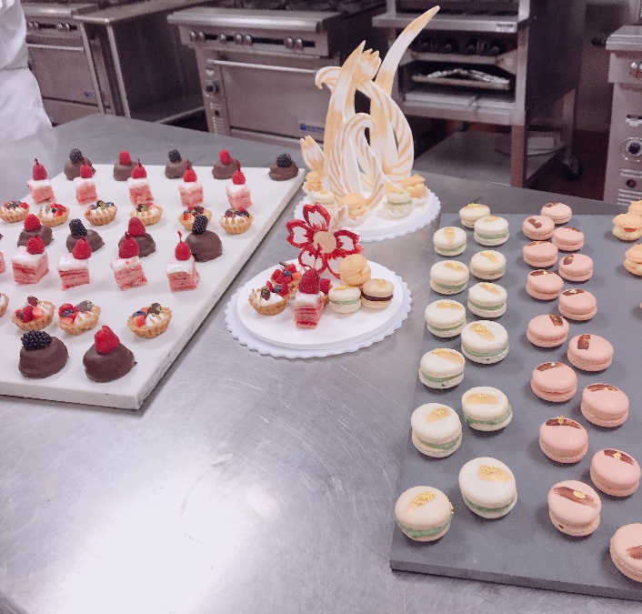
.
CAKE

WEEK 6
The Key Points of The Lesson

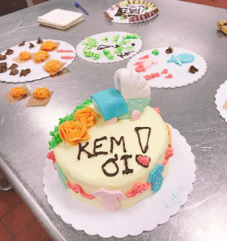
HIGH-RATIO CHOCOLATE CAKE
- It’s high in fat and moisture and very soft.
- It’s easy to fall down, and difficult to layer because of its softness.
- Don’t need to soak in sugar.

ITALIAN BUTTERCREAM
- If it’s too soft to shape and difficult to work, place in fridge to be stable.

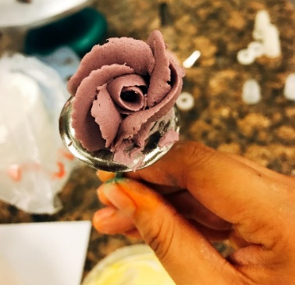
SIMPLE BUTTERCREAM
- Buttercream is the best consistency for flowers piping with medium to stiff peaks.
- More stable to pipe the flowers.
- Because Vanilla Extract browns the buttercream, so just use small amount too keep the white colour.

WHITE MODELING CHOCOLATE
- Warm the fondant and glucose/cornsyrup a little bit.
- Melt coca butter and cool down. It must be warmed to 90°F/32°C.
- Pour warm fondant+cornyrup mixture into mixing bowl fitted paddle attachment.
- Add sugar and mix at low speed [2] until just combine.
- Add cocoa butter slowly. Shouldn’t add all at one, it won’t mix and combine.
- Scrape down frequently.
- Wrap well.
WEEK 7
The key points of the lesson

DEVIL CHOCOLATE CAKE
- Melt the butter.
- Sift the flour.
- Use the whip attachment.
- Whip the butter and then add the eggs and whip until combined well.
- Add the vanilla, buttermilk, sugar and salt and whip until combine.
- Then add the sifted dry ingredient and whip to combine.
- At the end, add the brewed coffee and keep whipping a few second.
- Bake at 350ºF (180ºC) approximately 45 mins.
- This cake is very rich and moist enough so don't need to soak in syrup.
- When add vanilla, buttermilk, sugar and salt then keep whipping, the mixture is liquid, so when add the dry ingredients, it will combine and turn into batter.
- Do not over whip, it will make the outcome has some holes or sth like thunders.

SILKY GANACHE DELUXE
- Pour the Choco chips to a clean bowl.
- In a pot, bring the cream, sugar and glucose to a boil together.
- Pour the mixture to the chocolate chips and then mix by spatula.
- Should start from the center/middle of bowl and make a smooth ganache.
- Wrap and place in room temperature.

ITALIAN BUTTERCREAM
- Butter should be in room temperature.
- In a pot, bring sugar and water to a boil and up to soft ball stage (116oC).
- When the sugar reaches 110oC, start whipping the egg whites.
- Then add the soft ball sugar to the whipping egg whites and then add the softened butter to the mixture and keep whipping until smooth and white color, approximately 10 mins.
- Then wrap and place in the fridge.
- Take out when needed and place over on top of Bain Marie or heat/warn up by torch and whip then.
- Add color and flavour as desired.

WHITE MODELIG CHOCOLATE [make flowers/roses]
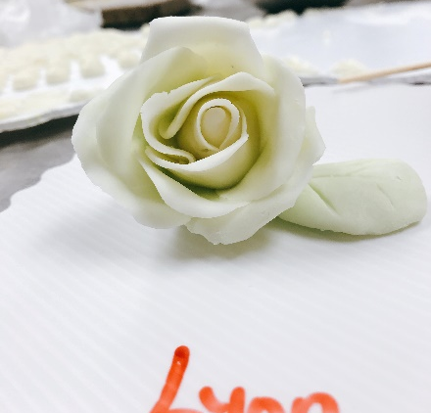
The modeling chocolate is pretty easy to use. It can be manipulated flexibly in a way similar to gum paste. After softening chocolate modeling, could shape the little things, or roll it out and cut into shapes with cookie cutters. However, it is easily torn, melted because of warm in the palm. Place in the fridge for short time or roll with cornstarch to prevent sticky.
- Knead the dough until soft and easy to work.
- Add the color cocoa butter as desired. Should warm it in microwave.
- Make a center for the rose
- Make the petals by press down in the plastic and should be odd number.
- Stick the petals to shape a flower with blooming.
- All the petals should be in the same level.
- The petals should turn into larger.

ASSEMBLY:
- Layer the cake into 3 layers.
- Pipe buttercream into the circle on the edge of surface then pipe the ganache. Should be 4 - 5 circles, on 2 first layers. For ganache, should be paid attention about temperature of cake because if it was very cold, ganache would be set very fast and it and make the crumble.
- Icing for the top and the side of cake.
- Decorate as desired with flowers and leaf and writing chocolate.
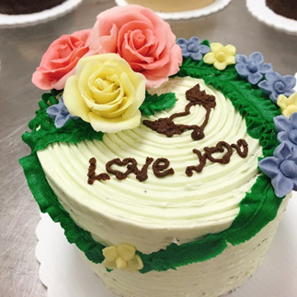

Week 8
The Key Points of The Lesson

PASTRY CREAM
- Bring the milk, vanilla extract/bean to a boil in a clean saucepan.
- Whisk the egg yolks in a clean bowl. Then add sugar in eggs when milk is boiling.
- Temper the yolk mixture with one-quarter of the boiling milk, whisk well. Then put this mixture to the remaining milk and stir.
- Combine the mixture and the cornstarch or flour. Return the mixture to the saucepan and cook, whisk until the mixture boils and is well thickened, approximately 2 minutes, stirring constantly.
- Turn heat off and remove the pastry cream and pour it into a clean mixing bowl.
- Fold in the butter.
- Cover by placing plastic wrap and chill over an ice bath.

DIPLOMAT CREAM FILLING
- Bloom the granulated gelatin in the water to dissolve.
- In a mixer bowl, add pastry cream and whip on high speed to make it smooth.
- Add the raspberry liqueur to pastry cream.
- Add gelatin to 1/4 of the raspberry-flavored pastry cream.
- Place over low heat and whip by hand until smooth and incorporated.
- Add this mixture to the remaining pastry cream.
- Fold in the whipped cream.

WHITE CHOCOLATE BUTTERCREAM
- Melt white chocolate.
- Cut the butter into small pieces and let it be room temperature.
- Add the egg whites in a mixer bowl.
- Place the sugar in a heavy saucepan with. Bring to a boil over high heat.
- When the sugar’s temperature reaches 110°C, start whipping the egg whites by high speed.
- When sugar's temperature reaches 240°F (116°C) for soft ball stage, take out from the heat. (The sugar should not exceed soft ball stage)
- When the egg whites reach soft peaks form, gradually pour the sugar-water mixture into egg whites while the mixer is running, and the egg whites are being whisked continuously. Continue whisk until it’s room temperature and cool completely.
- Take the bowl out of the mixer, scrape down the bowl and continue whipping. (Italian meringue)
- Gradually add the butter to the Italian meringue, and the butter should be room temperature.
- When all the butter is incorporated and cool, add the chocolate to the buttercream and whip well. Take out from the mixer and scrape down. Then put it back to the mixer and mix again a little to make sure that it’s consistency.

VANILLA RASPBERRY WEDDING CAKE WITH WHITE CHOCOLATE BUTTERCREAM
- Prepare three cake pans: 5-inch, 7-inch and 8-inch, lining with parchment paper.
- Sift the flour, sugar, baking powder, eggs and salt together in a mixer bowl. Whip about 8 minutes at high speed.
- Add the Fluid Flex and milk. Whip about 8 more minutes at medium speed.
- Divide the batter between the prepared cake pans. Should fill each pan in halfway, because it will be explored when baked.
- Bake at 350°F approximately 60 minutes.

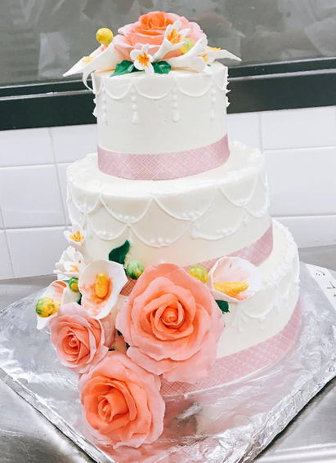
ASSEMBLY
- Slice each round into 2 evenly layers.
- Brush Simple Syrup on the bottom layer and then pipe buttercream on circle edge of cake, then top it with Diplomat Cream Filling, raspberry jelly and fresh raspberries.
- Place the top layer on top of the filled bottom layer and crumb coat by buttercream, then chill the crumb-coated cake in the fridge.
- Repeat with each of the other two cake tiers.
- Add and spread buttercream on the tops and sides, smoothen by spatula.
- Use ribbon or piping to make border.
- Stack the tiers and pipe dots on each tier sides. Then decorate with roses and flowers from gum paste as desired

WEEK 9
The Key Points of the Lesson
HIGH-RATIO YELLOW CAKE
- Prepare parchment paper lined pans.
- Sift the flour, sugar, salt, baking powder together.
- Combine the flour, sugar, shortening, salt, baking powder, milk powder, corn syrup and a quarter of the cold water in the mixing bowl fitted with the paddle attachment. Then beat 5 minutes on low speed.
- In a clean and dry bowl, combine the remaining ingredients. Then add liquid ingredients to the flour-shortening mixture.
- Scrape down the sides of the bowl.
- Mix 2 minutes on low speed.
- Divide the batter into half of the pans.
- Bake at 350°F approximately 12 to 18 minutes. Use tester to check, if cleaned, it has done.

ITALIAN BUTTERCREAM
- Cut the butter into small pieces and let it be room temperature.
- Add the egg whites in a mixer bowl.
- Place the sugar in a heavy saucepan with water (just need water enough, not too much). Bring to a boil over high heat.
- When the sugar’s temperature reaches 110°C, start whipping the egg whites by high speed.
- When sugar's temperature reaches 240°F (116°C) for soft ball stage, take out from the heat. (The sugar should not exceed soft ball stage)
- When the egg whites reach soft peaks form, gradually pour the sugar-water mixture into egg whites while the mixer is running, and the egg whites are being whisked continuously. Continue whisk until it’s room temperature and cool completely.
- Take the bowl out of the mixer, scrape down the bowl and continue whipping. (Italian meringue)
- Gradually add the butter to the Italian meringue, and the butter should be room temperature.
- When all the butter is incorporated and cool, add flavoring. Take out from the mixer and scrape down. Then put it back to the mixer and mix again a little to make sure that it’s consistency.

ROYAL ICING
Royal Icing is from pure powdered sugar and egg white, and when setting, it's so hard, therefore, it is the best choice for sophisticated piping and delicate shapes.
- Sift icing sugar and set aside.
- Place the egg white and lemon juice in a bowl.
- Add the sugar gradually into the bowl and beat until blended and consistency.
- Keep continuing to beat a couple minutes.
- The icing sugar should be white, smooth and thick enough to hold a stiff peak.
- Cover with a wet towel and wrap well.

- FONDANT AND GUM PASTE
Fondant and Gum Paste look the same, and their textures are similar, and they work almost same. However, there are some significant differences between fondant and gum paste.

GUM PASTE
When making the choice between gum paste and fondant to model items such as bows, flowers, gum paste will be the best choice. Because the gum paste can be rolled very thin, so the petals of flowers would look more realistic and attractive. Besides, it dries very quick, so the shapes of flowers would be kept.
Gum paste won't be used to cover a cake because when it dries, it would be hard to be like rock.
- Lightly beat the egg whites.
- Add one-third of sugar gradually, beating at medium speed for 2 to 3 minutes.
- Then add a little tylose powder and mix for a few seconds.
- Then add 1 more one-third of the sugar. Then add more tylose and mix well.
- Then add last remaining of icing sugar, and tylose 1 more and mix well.
- Don't add tylose too much because it makes the gum paste hard and thickens quickly.
- Scrape the mixture out of the mixer.
- Add the shortening into the mixture and knead until smooth.
- Wrap the gum paste in plastic wrap well and tightly.

FONDANT
The fondant is mainly used to cover the cake, it rolls out thin, and is placed over crumb-coat or to make small details that do not require much stability. It is smoothed around the cake for a final smooth finish. Moreover, the fondant maintains its soft consistency. However, the fondant is not hardened by the moisture from the cake and the frosting. When fondant dries, it is not too hard, but it is less stable than gum paste.
ASSEMBLY
- 3 Layers: Lemon cake
- 2 Layers: Buttercream
- Roll fondant: 1/8 – ¼ inch of thickness
Décor as desired.

.

Week 10
The Key Points of the Lesson

FLOURLESS CHOCOLATE CAKE
- Prepare the parchment lined sheet pans. [1 large and 1 small, or 3 small sheet pans]
- Melt chocolate over the Bain Marie.
- Melt butter to be soft.
- Combine the melted butter and egg yolks with the melted chocolate. Make sure the melted chocolate is warm, so when combined, the mixture is evenly and consistency.
- In the mixing bowl, whip the egg white and sugar into stiff meringue.
- Add the color as desired (red color) to the whipping egg whites. Should be 1 – 2 drops, so the color will be light and nice, the meringue shouldn’t be too dark color.
- Fold the chocolate mixture to the whipping egg.
- Pour into the sheet pans.
- Bake at 350°F for 10 -15 mins.

ITALIAN MERINGUE FOR MILK CHOCOLATE BUTTERCREAM
- Melt milk chocolate.
- Butter should be in room temperature.
- In a pot, bring sugar and water to a boil and up to soft ball stage (116°C/250°F).
- When the sugar reaches 110°C [241°F], start whipping the egg whites on medium speed.
- Then pour slowly the soft ball sugar to the whipping egg whites and whip until cool down.
- Bring the milk to a boil and meanwhile whisk the egg yolks with sugar in the other clean mixing bowl.
- Temper the milk to egg yolk mixture.
- Whip the tempered mixture on medium speed.
- Then add the softened butter to the mixture and keep whipping until smooth and incorporated, approximately 7 – 10 mins.
- Add the melted chocolate to the mixture and whip until combine evenly and consistency.
- Then wrap and place in the fridge.
- Take out when needed and place over on top of Bain Marie or heat/warn up by torch and whip then.

PECAN DACQUOISE
- Toast pecans.
- Prepare a half parchment paper lined sheet pan.
- Egg whites should be room temperature and completely no egg yolk.
- The bowl of mixer should be clean and dry completely.
- Add toasted pecans and icing sugar to a food processer and process and sift the mixture.
- Add the egg whites to the mixing bowl.
- Use the balloon whisk and with low - medium speed to whisk the egg white.
- Slowly add sugar to egg whites when whipping (French meringue). Don't add sugar to egg whites until the egg whites almost are the soft peak.
- Add cream of tartar.
- When it is the stiff peak, slowly add the flour mixture and fold.
- Bake at 350°F approximately 30 mins
- To check: press on the middle, if it bounces back, it’s done.

MOLASSES GANACHE
- Soften butter in room temperature.
- Place the chocolate in a clean bowl.
- In a pot, bring the milk to a boil.
- Pour the boiling milk to the chocolate and stir well until the chocolate is melted completely.
- Add the molasses into the chocolate-milk mixture and stir well until incorporated.
- Make sure the chocolate-milk mixture is still warm then add the butter. If the chocolate-milk mixture isn’t warm, place over the Bain Marie.
- Cover and place in fridge.
PECAN CROQUANT
- Grind pecan in the coffee grinder.
- Toast the pecan flour and cool down completely and set aside.
- In a pot, cook the fondant and glucose/corn syrup until caramelized.
- Add pecan flour and stir frequently.
- Pour over a silpat and place another silpat on the caramelized mixture and use a rolling pin to roll out the caramel thin as possible.
- Place the sheet pan back to the oven for 10 mins at 350$℉$. Then take out, wear gloves (cotton and and latex gloves), peel off the top silpat and shape the caramel.
- Let cool at room temperature.

CANDIED PECAN
- In a saucepan, heat an amount of sugar to caramelize.
- Add pecans and stir thoroughly.
- Remove from heat at take caramelized pecan out on the silpat.
- Cool in room temperature.

BOURBON SABAYON
- In a small bowl over a Bain Marie, whisk egg yolks, bourbon and sugar together at fast speed.
- Cook the egg to 163$℉$. Should remove from heat frequently so the egg won’t be cooked and set on the bottom of the bowl and be consistency.
- Remove from heat and add the crème fraise. The crème fraise should be warm, so when fold, it won’t separate.

ASSEMBLY
- Unlined parchment paper for dacquoise.
- Add the buttercream and spread out.
- Place 1 half sheet pan of flourless cake on top.
- Add ganache and spread out.
- Place 1 more half sheet pan of cake.
- Add butter cream and spread out.
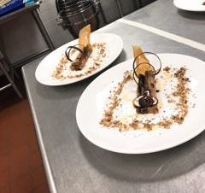
- Place last half sheet pan of the cake and add buttercream on top.

Timeline
Day 1
12:00  12:30  13:00  13:30  14:00  14:45  15:30  16:00 | - Set up station.  - Scale ingredients  - Make the Flourless Chocolate Cake  - Make the Italian Meringue  - Make the Milk Chocolate Buttercream  - Make the Pecan Dacquoise  - Make the Molasses Ganache  - Cleaning

Day 2

12:00  12:15  12:45  13:30  13:50  14:45  15:30  16:00 | - Set up station  - Assembly the cake  - Make the Pecan Croquant  - Make the Candied Pecan  - Make the Bourbon Sabayon  - Make the Décor Chocolate  - Presentation  - Cleaning

Equipment:
- Mixer: 1
- Saucepan: 1
- Pot: 3
- Containers
- Bowl:
- Acetates
- Cuisinart chopper grinder

Tools:
- Whisk
- Spatula
- Spoon
- Paring knife
- Off=set spatula
- Cake ring
- Rolling Pin
- Silpat
- Sheet pan
- Parchment paper
- Gloves

Mis En Place
Day 1: <Labeling>
- Flourless Chocolate cake
- Milk Chocolate Buttercream
- Pecan Dacquoise
- Ganache
- Ingredients
Day 2: <Labeling>
- Red Velvet Opera Cake

SANITATION PLAN

- Change sanitation water every 1 hour
- Clean dishes after finished

PLATE DIAGRAM
Crumbs

Décor Chocolate (3)
Cake (1)
Candied Pecan (1)
Sauce
Pecan Croquant (1)

BIBLIOGRAPHY

- Sarah R. Labensky, et al. On Baking: A Textbook of Baking and Pastry Fundamentals. 3rd ed., Pearson, 2016.
- Suas, Michel. Advanced Bread and Pastry. 1st ed., Cengage Learning, 2008.

