CUL 121 Intro to Baking Portfolio
Prepared for Chef Mandy Vial
Student: Anika Xu
ID: 2042883

- Soft Yeast Dinner Rolls
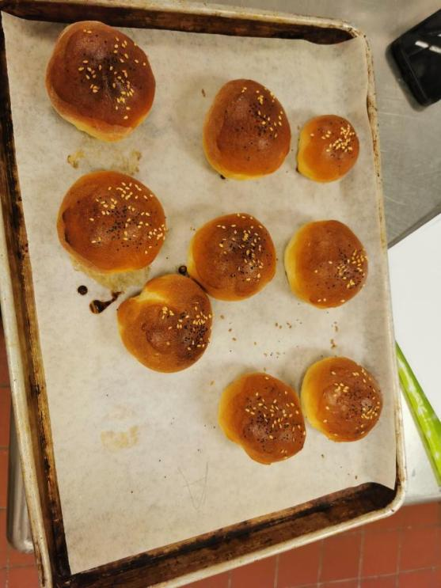
Method
Straight Dough
Personal Thoughts
My past experience with dough was all with the electric mixer. Therefore the dough making process was very challenging for me. It was interesting that Chef Mandy told us that it was okay when the dough was sticky and moist as long as all the scalingwas correct. It is okay for some dough to be moister or dryer. The science will do its job. The gluten window test for determing the doneness of the dough was also interesting for me to learn. The gluten window should be clean and see through. With the help of yeast and correct temperature, the gluten was fermented and rised to a bigger size. It was also the first time for me to use fresh yeast. The fresh yeast should be 2.2 times sized to dry and instant yeast. That was also an useful fact for me to learn.

- Blueberry Muffins
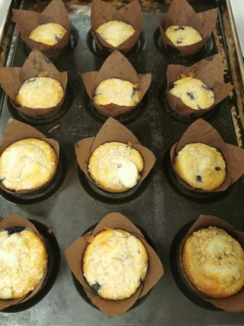
Method
Muffin
Personal Thoughts
The muffin was aromatic with a fresh smell as it was added with lemon zest. The lemon zest was something I did not expect to be so effective and changing. It tasted exactly like the ones that we buy from the outside bakery. It was interesting for me to learn about the folding technique of batter mixture as this is something that I will be using for a long time if I want to stay in the baking industry.

- Peanut Butter Sandies
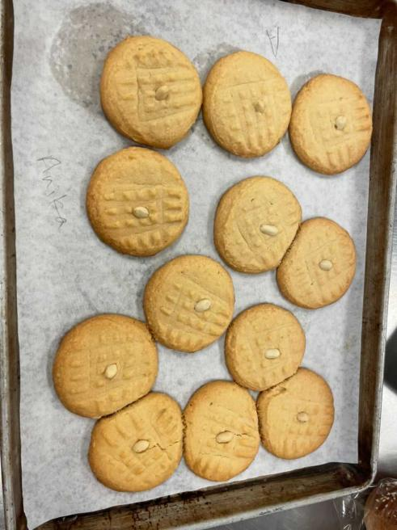
Method
biscuit

Personal Thoughts
The process of making cookies was easy and handy. The recipe was great as ingredients and procedures were clear to follow.

- Focaccia
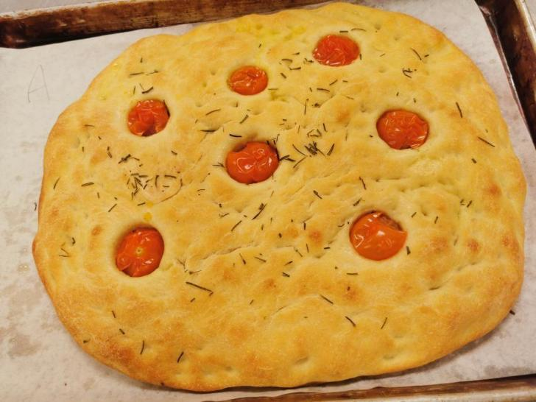
Method
Straight dough
Personal Thoughts
The most useful information I learnt from this was to determine the desired fermentation temperature. The desired dough temperature in British Columbia is 77F. This can also be determined by a formula which is 77 times number of factors minus total value factors. This calculation is used to determine the water temperature for dough. With the correct temperature, a dough can be fermented very quickly. This is important because I realized when I made dough at home, the fermentation required different time due to different temperature within the enviroment. Focaccia is a very common italian bread. With the sprinkle rosemary on the top, the bread has a very strong aroma and it is perfect to serve as before entree bread.

- Apple Pie
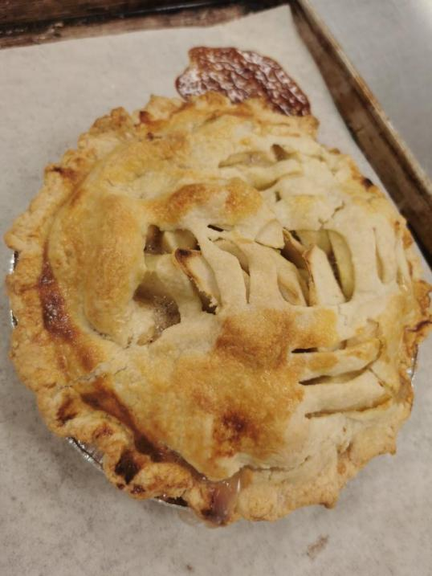
Method
Pie Dough
Baked Fruit Filling

Personal Thoughts
The most difficult part for me was preparing the top for the pie. It was challenging for me to adjust the top in the middle and made sure the side cuts were symetrical. I think I still need a lot more practices on preparing dough and shaping them into the desired shape. Overall, this pie had a great taste and smell. The apples tasted good with the pie crust with the addition of cinnamon and nutmeg. It would taste even better with ice cream, especially in summer right now.

- Chocolate Chunk Cookies
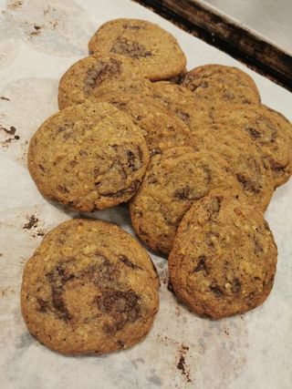
Method
Drop Cookies
Personal Thoughts
The process of making the cookies were very straight foward. With last week’s experience, I made sure I leave enough space for each cookie so they are not crowded.The addition of peacans enhanced the taste and smell of the cookies. The outcome turn out to be thinner than I thought but Chef Mandy said it was okay.

- Soft Yeast Rolls toppeed with Conchas
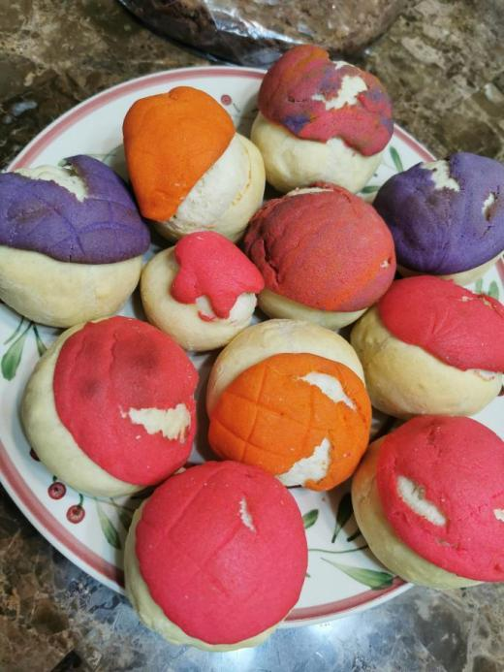
Method
Straight Dough

Personal Thoughts
It was my second time to make yeast rolls. The dough was not wet nor dry. It was better to dealt with during the kneading process. However, due to technical issue, the dough got too dry on the top. When it was baked with conchas, the conchas fell apart on the top. The color mixing was the most fun part. It was nice to see everyone with creativity in the class. I was traded with different color dough with other classmates. It was a fun experience coloring the conchas and making them into nice pattern.
- Banana Bread
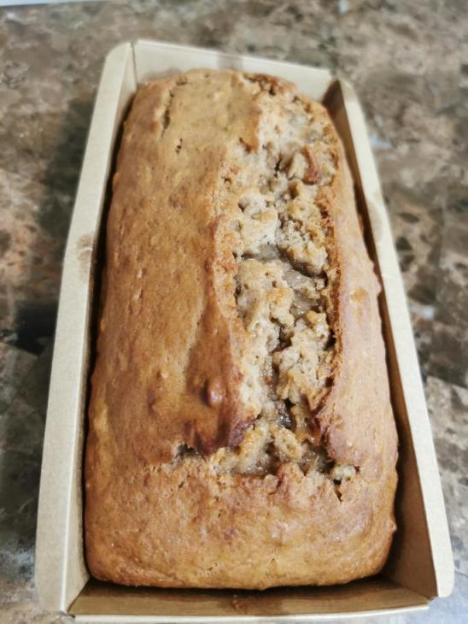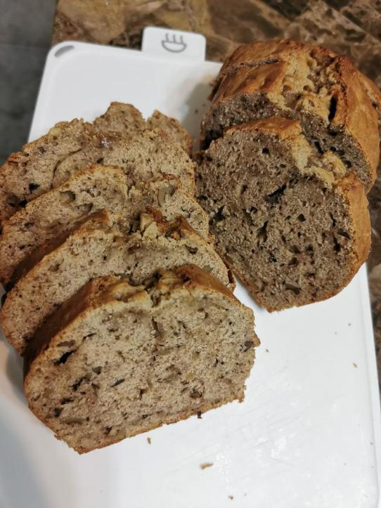
Method
Creaming
Personal Thoughts
Banana bread is a widely made recipe. The steps were very straight foward. The creaming method started with paddling in the mixer but Chef Mandy said whisking was also fine for making banana bread. One new word that I learnt from this recipe was Alternate. To alternate, it simply means to add ingredients following the steps as dry to wet and back to dry and wet, etc.

- Fudge Brownies
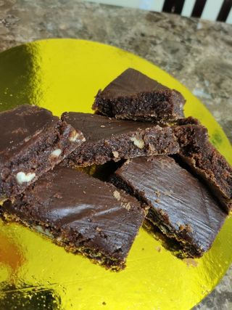
Method
Sheet Cookies
Personal Thoughts
Chef Mandy told me brownies were hard to bake because you want the centre to be slightly under baked so when it cools, it would reach to the correct texture. I came home with the brownies and still felt underbaked. I put into the oven for a little longer time to reach the correct texture. It was my first time to make brownies and it was challenging for me to ensure the brownies were not cooked completely as the centre should remain moist.

- Whole Wheat Bread
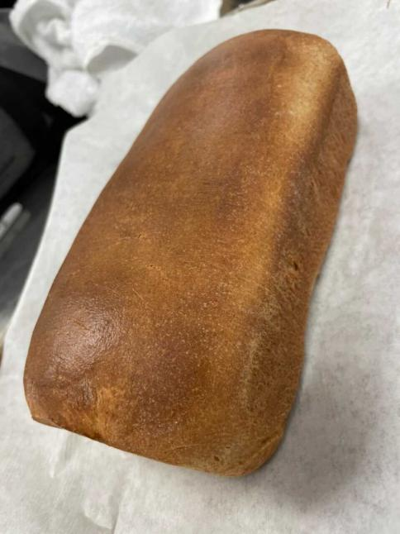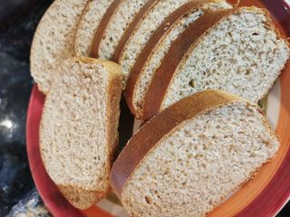
Method
Straight Dough

Personal Thoughts
After 3 classes of kneading dough, I have felt more confident in preparing my own dough now. The dough was little bit moist today but I think I did pretty well in kneading it and shaping it. Fermentation was successful. I learnt a new technique in folding the bread dough today. As well, pushing out and back motion helped to seal the seam at the bottom. The outcome of the bread was in good presentation but did not rise very high. Chef Mandy said a little more time in the proofer will help to rise the bread higher.

- Chocolate Cherry Scones
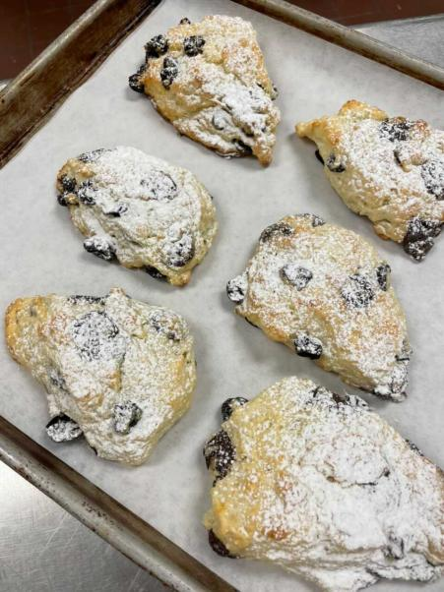
Method
Biscuit
Personal Thoughts
The process of making scones were straight forward. The most challenging part for me was cutting the scones into uniform shapes. I was hoping the outcome to be more triangular and the tip to be pointy. Chef Mandy told us that the pressure could affect the angle. This can be improved by cutting it straight or shaping it with hands. We made the scones by hands but Chef Mandy said this can also be done by mixer. Scones are made through biscuit method.

- Shortbread Cookies
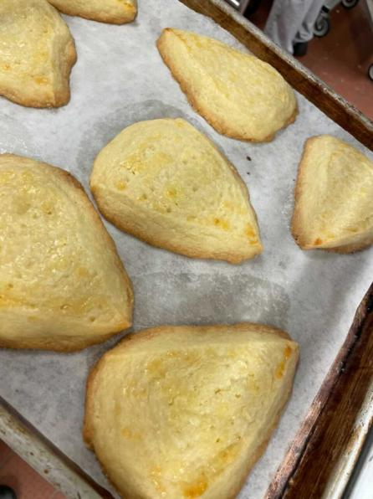
Method
Icebox Cookies
Personal Thoughts
The most challenging part for making shortbread is to ensure not to overmixed. Overmixing could lead to the batter spreading during cooking. It was difficult for me to tell when it was the time to stop mixing. I think it might be because I spent too much time in shaping it therefore I kneaded the batter more than it should be kneaded. Another technique that I learnt was to determine the doneness of shortbread. Shortbread should not be the same as other cookies. Shortbread should be in a light yellow, buttery color. Therefore, observing the bottom of the parchment paper should be used as a method to determine the doneness of the cookies. As soon as we notice the brown color at the bottom of the cookie from the bottom of the parchment paper, that is when we take the cookies out.

- Baguette
Method
Old Dough

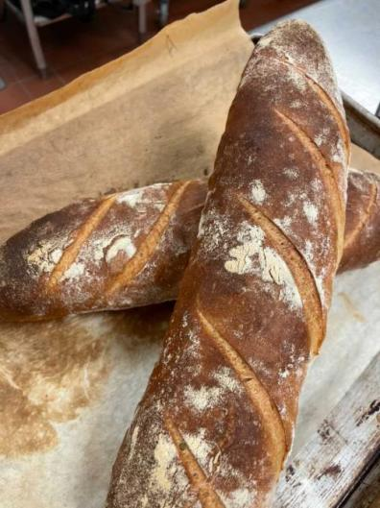
Personal Thoughts
It was very nice experience to learn about how to make baguettes. We used a dough that was prepared overnight. The purpose of using a prepared dough was the gluten that was already deveoped helps to cut down the time. Another purpose was to develop extra flavour because the yeast overnight allowed more strength. Baguettes are made in the same way as other bread. The ingredients for baguette are only flour, water, salt and leavening agent. In addition, Chef Mandy applied steaming after the baguette are put into the oven. The steaming helped to create more crunchness and crispyness for the baguettes. One thing to keep in mind was that the flour should not be dusted off, they should stay on the baguettes after they come out from the canvas cloth.

- Pecan Pie
Method
Pie Dough
Custard Filling
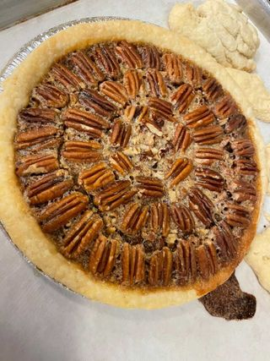
Personal Thoughts
I am still a little stressed with making pie dough. I think this can only be improved by practicing. The pie crust was cracked when I tried to roll it out. With Chef Mandy’s help, I managed to use majority of the dough for the bottom of my pie. The pecan filling was easy to make as all I needed to do was to whisking all the ingredients together. The glucose was fun to play with. To test the doneness of the pie, we applied the jiggle but not wiggle test. The pie turned out to be well baked. The pie tasted good, especially with ice cream.

- Chocolate Spritz Cookies
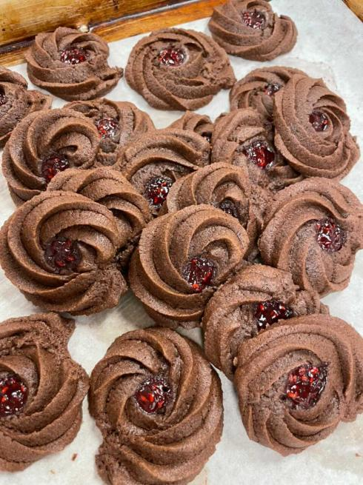
Method
Pipe Cookies

Personal Thoughts
The process of preparing the batter was very straight forward. It follows creaming method like all other cookies. The most challenging part was the piping. The batter was too tough to pipe it out. I am glad that I am learning this technique at school. In order to pipe a hard batter like this, we should try to squeeze from the bottom, close to the tip. We should use the strength of hand to squeeze the front part of the piping bag. It was challenging for us as the batter kept sticking the parchment paper when the parchment paper will flip up when the batter was piped. Other than that, the cookies were totally worth spending the time. The outcome was nicely presented and they tasted good. Overall, this is a great chocolate cookie recipe.

- Cinnamon Swirl Raisin Bread
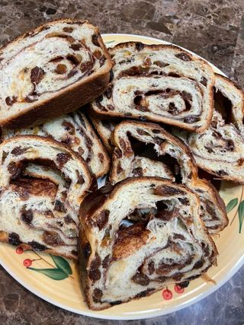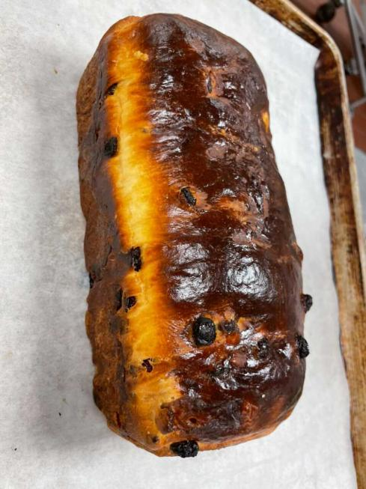
Method
Enriched Dough

Personal Thoughts
It was not a fun experience as the dough was too sticky. Chef Mandy said it is not a bad thing as dough could be stickier or drier depending on the recipe. It took me more time to prepare the dough than it took me for normal dough. My hands were too sticky as the dough was also sticking the table. Chef Mandy advised me to do the drag and fold motion until the dough gets smoother. The most challenging part was to speed up, as my speed was only speed 1 as comparing to a electric mixer. The butter should not be added at the beginning as this would stop the gluten working in the dough. The outcome turned out to be good. It was worth the hard work and patience.

- Chocolate Cream Pie
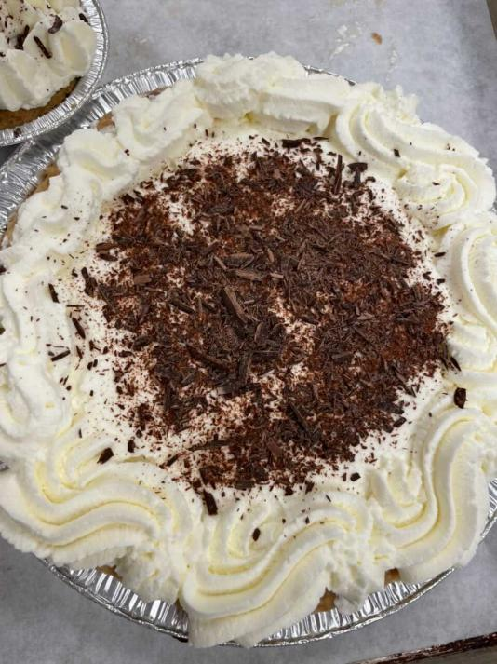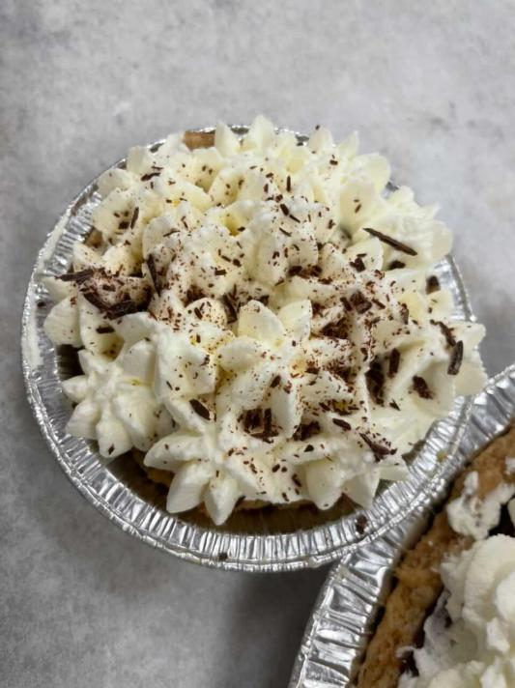
Method
Pie Dough
Cream Filling

Personal Thoughts
The pie crust required blind baking today because the chocolate filling should only be refrigerated. Pie crust was easy to make as we have already done it several times. The method of making chocolate cream required bain marie and tempering. Chef Mandy emphasized that the cooking of custard required 2 minutes, due to sanitary health standard. The chocolate cream should be refrigerated or put on ice bath after it wass strained. Making chantilly cream was the last thing to do for this recipe. It was an easy step but it was easy to get overwhipped. I got distracted and the cream was overwhipped. I should have paid more attention to the cream while it was in the mixer. Maybe I should have hand whipped the cream.

- Oatmeal Cookies
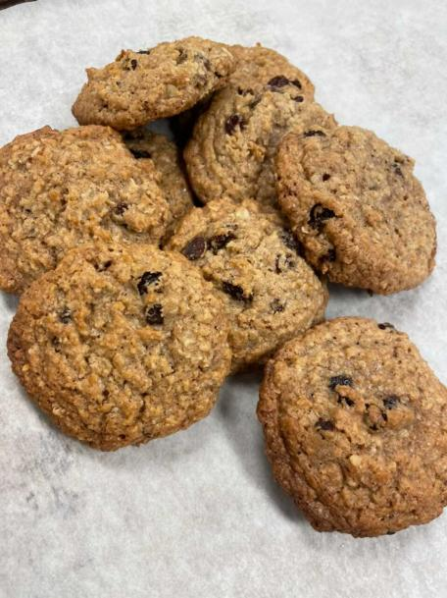
Method
Drop Cookies
Personal Thoughts
Another week of making cookies. Cookies are easy to make as all I needed to do was following creaming method. The taste was good but it was little bit sweet for me. One thing to keep in mind was to make sure they are in uniform sizes as we should always make sure customers receive the same cookies as they are paying the same price as everyone else.

- Multigrain Sourdough
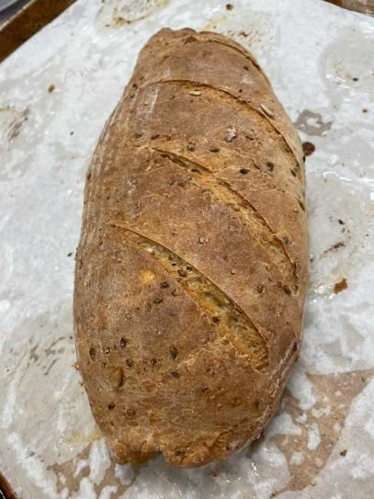
Method
Sourdough Starter
Personal Thoughts
This dough was better to be working with as it was neither too dry nor too moist. It amazed me how big it turned into with the help of bacteria. To help to grow into such big size, a dough started was added into the production. An dough starter was made with mixing of flour and water. The dough would grow bigger through the growth of bacteria. This is to help the sourdough grow bigger within shorter amount of time. The most challenging part for me was to shape it into a football size. It was hard for me to close the seam at the bottom and on the sides. The dough was very dry by the time it was out of the proofer, thus it was hard to close the seam even when water was added onto the work surface. Overall, this was a fun experience and it really amazed me how big this dough turned into.
- Pecan Sticky Buns
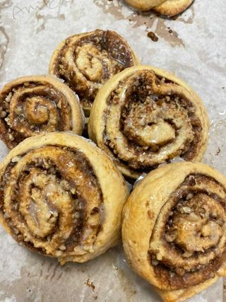
Method
Straight Dough
Personal Thoughts
This recipe is a similar cinnamon bun recipe with pecans. The products did not turn out to be expected. They still tasted good but me and other classmates were expecting to be more like cinnamon buns that we buy from the outside. The dough turned out to be quite crispy instead of soft. It was good that we used the mixer for mixing the dough. The dough was sticky because 240g warm butter was added. The most challenging part for me was rolling the dough. It was difficult for me to roll it into even layer. When I was rolling, it was also difficult for me to ensure that it was in the same thickness because I already failed to roll it into a even-flat dough. Other than that, this is a delicious recipe to work with and I would do it again at home with a mixer.

- Cranberry Sourcream Scones
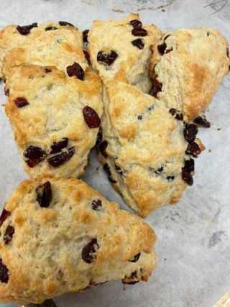
Method
Biscuit
Personal Thoughts
With the previous experience, I made sure I kept the butter cold and not to over mix the batter. I missed a couple steps as it was a rush day. I did not adjust the tip of the scones after they were divided. Therefore a few of the scones fell to the side due to pressure. I should have adjusted the tip of the scones with my hands before putting into oven. I also forgot to add orange zest therefore the scones lost that orange refreshing smell when they came out from the oven. They were very minor mistakes but I should always keep in mind when I work on every baking items because I should not serve to any buyers or customers with food items that are missing ingredients.

- Focaccia
Method
Straight Dough

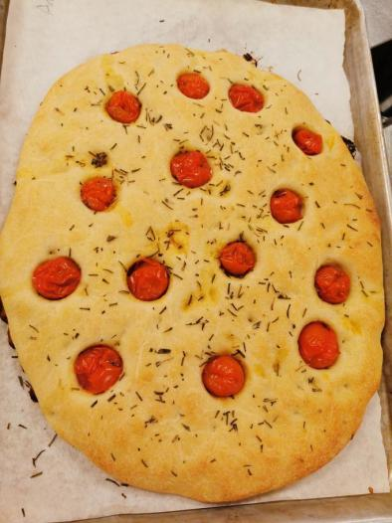
Personal Thoughts
Something that we did differently this week was to bulk ferment the dough twice. The degasing technique for this type of dough is different from the other ones. To degas the focaccia dough, make sure the dough is covered with oil to avoid stickiness; pull the center bottom to the side and knead it to the middle top. Keep doing this until all the sides are folded into the middle. Flip the dough upside down so the flat surface is on top. After degasing, the dough can be put back to the proofer for second fermentation. By doing this, the dough can be more flavoured and have better fermentation. I tried the focaccia after baking, the taste was more enriched. If I have more time, I would definately do two fermentations.

- Blueberry Muffins
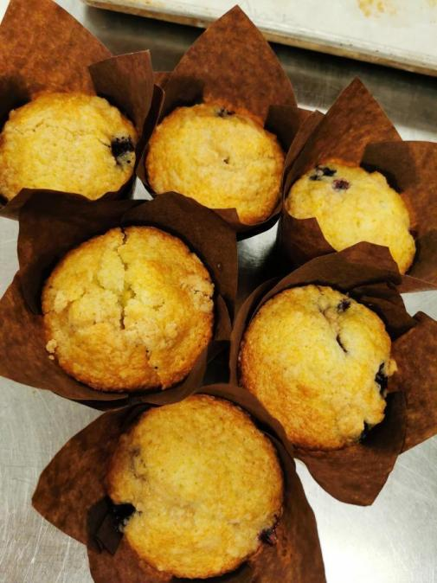
Method
Muffin
Personal Thoughts
I really like this recipe because the lemon zest smell always make the muffins smell more delicious. The streusels were not mandatory but I added onto the muffin to create better coloring. The streusels were made in week 1 and kept refrigerated till now. They are still usable and it is always good to use them till they are expired. We should always try to avoid wastage. The muffins were made by using folding technique. The batter should not be overmixed therefore I made sure I stop folding as soon as the dry ingredients were folded in. The outcomes looked great.

- Greek Savory Scones
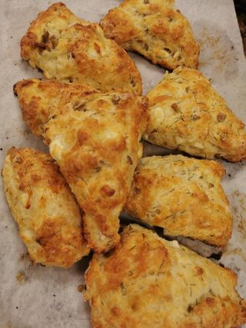
Method
Biscuit
Personal Thoughts
Chef Mandy emphasized that the butter for making scones needed to chill or be cold at all times. Therefore I made sure I kept the butter in the fridge till I needed it. As soon as all the dry and wet ingredients were incorporated, I stopped kneading. This was to avoid over mixing. I made sure I set the tip of the triangular shapes to the middle so the scones would not fall to the sides by pressure. Overall, I would say I am pretty confident with making scones now. I always had sweet or plain scones. I am not a big fan for savory scones but it was still a great experience to make them and get a taste of them.

- Brioche Braid
Method
Enriched Dough
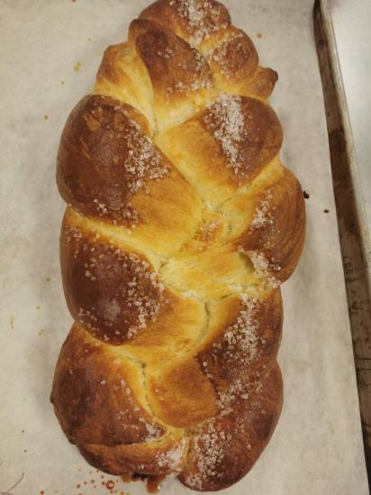

Personal Thoughts
Chef Mandy emphasized that the most important watching point for brioche was to make sure the dough to be cold. Due to limited timeframe, we let the dough in the freezer for 10 minutes to ensure the temperature. If the temperature was not cold, the dough would be very difficult to work with as we needed to shape them into a braid. As this was an enriched dough, we used an electric mixer insteading of hand kneading it. It would save a lot of time by using a mixer as the dough was sticky and the process of kneading butter into the dough needed to take more time. I could feel the dough was very soft and smooth as it was almost dripping from my hand when I held it upwards. The dough was a creamy color. One thing that I learnt new today was to braid them. It was important to divide them into the same weight to braid them.

- Morning Glory Muffins
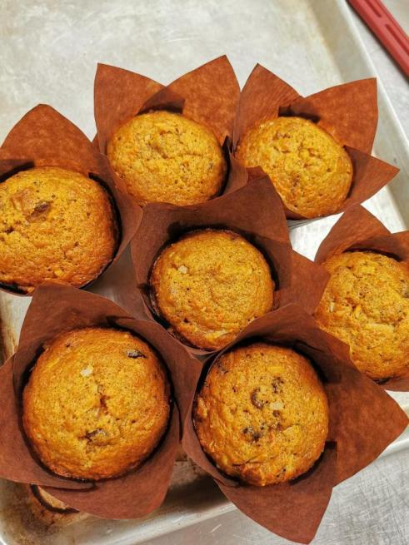
Method
Muffin
Personal Thoughts
This is a good recipe as it includes lots of ingredients. This recipe was easy to make as all I needed to do was folding all the ingredients until they are all corporated. The mixture was wet as I added grated carrots and apples. The grating process made the carrots and apples very juicy therefore all the juiciness were added into the mixing batter. The outcome was great as the muffin was crispy on the outside and soft inside. The muffins tasted great and I really enjoyed eating them.

- Chocolate Bread
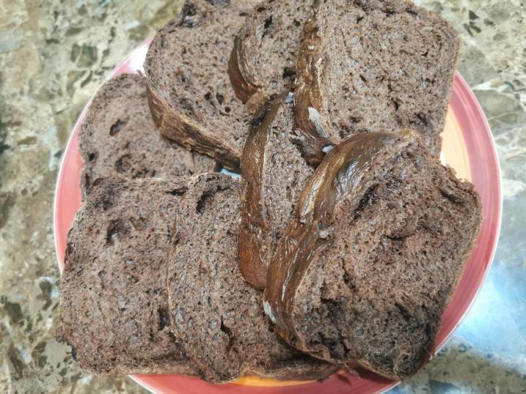
Method
Straight Dough
Personal Thoughts
This was a great recipe as the dough was neither too wet nor too dry. The dough was a little sticky at the beginning but as soon as I folded it in motion, the dough started to get smooth. The most challenging part was kneading the chocolate in as I wanted to make sure the chocolate would not melt during kneading. Based on the previous bread experience, I made sure to seal the bread and leave the seam at the bottom. The bread turned out to be in great presentation and taste.

