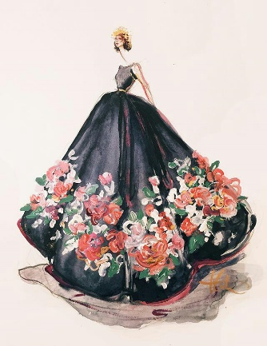
Shyna Shyna
EMAIL – shyna.1321996@gmail.com
PHONE- 4388878266
MONTREAL CANADA

☆LANGUAGES
English, Hindi, Punjabi (Native language)

☆EDUCATION
• 2018 Present :- Fashion Marketing LaSalle College Montreal (Canada)
• 2014-2016 :- Bachelor of Science In Fashion designing (India)

☆EXPERIENCES
• 2015-2017 :- Krishana Fabric Mills in India as a General Merchandiser.
• 2014-2015 :- Permeshwari Silk Mills in India as a Merchandiser.
• 2013-2014:- Hand embroidery and Stitching Trainer in INIFD.
☆ AWARDS AND ACKNOWLEDGEMENTS
• 2016 – Awarded for best collection in Fashion show.
• 2016 – Awarded for best using of waste material.
• 2015 – Awarded for best fine arts designer.
• 2015 - Awarded for best Hand embroidery.
• 2014- Awarded for Academic Honour roll.

☆INTERESTS
• Stitching
• Drawing
• Read Historical books
• Photography

☆References upon request.

