MUSEUM ASSIGNMENT
ON THE EXHIBITION OF
ELEGANZA: ITALIAN FASHION
FROM 1945 TO TODAY

Written by Annalie Cheang

Annalie Cheang
Fashion Phenomena
571-KNA-03 gr. 2222

MUSEUM VISIT ASSIGNMENT ON THE EXHIBITION OF
ELEGANZA: ITALIAN FASHION FROM 1945 TO TODAY

Presented to Ms. Jennifer Millen

Lasalle College
October 5th, 2016
OBJECT 1: ANKLE BOOTS BY DOLCE & GABBANA
V&A: T.70:1,2-2012

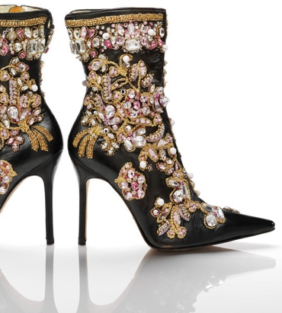

In the year 2000, Dolce & Gabbana (D&G) made a pair of women’s ankle boots for their Spring/Summer 2001 collection. In order for the embellishments to remain intact, these black leather ankle boots were embroidered with gold, white and pink beads, crystals and metallic gold sequins. The beads were encrusted strategically to form what resembles leaves and flowers. D&G were inspired by the baroque fashion by using their influence on decorative and colorful wear. Nevertheless, they also applied a zipper opening on the inner leg, a stiletto heel and a pointed toe box. Although the boots are considered to be ankle boots, the height reaches below the calf but above the ankle and the platform underneath the toe box was kept flat.

In the exhibition, the boots were exposed in the section of The Cult of the Fashion Designer. Inside the section, it also held garments and accessories that appeared on celebrities on the red carpet. Some of the garments were from influential designer names such as Prada, Gucci, Fendi and Versace. The boots were placed in this section because they are a familiar piece to designer loyalists who worship these brands’ creations. The word “cult” explains itself in this context – religious followers of prominent fashion designers.

These eye-catching ankle boots serve for the basic purpose of decoration. It would be a mistake to walk in a stiletto-heeled shoe to go on a promenade for several hours therefore, the décor is external and the boots are meant to be worn during special occasions. On the subject of its heel, it additionally represents a sociological aspect of gender. In the twentieth and twenty-first century, heels are worn predominantly by women.

OBJECT 2: A MAN’S WOOL COAT BY CARLO PALAZZI
V&A: T.109&A-1985

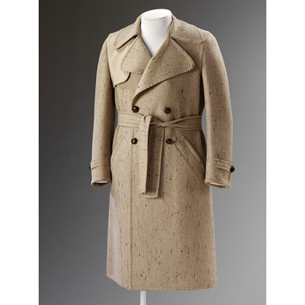

In 1969-1970, Carlo Palazzi designed a man’s wool coat. It is composed of pale-brown wool with small black streaks, plaited brown leather and silk lining. It has large lapels with a uniformed pale-brown wool cape attached from shoulder to shoulder and placed underneath the right sleeve. The coat has two front pockets set at a 45-degree angle and a wool belt around the waist. In addition to the coat’s closure, there are four plaited brown leather buttons placed on the center of the torso. The buttons are also placed underneath the wool-strapped cuffs. The closing of the coat seems to be double-breasted but it only has 2 buttons to lock the body. When the coat’s belt is untied and the buttons are detached, it takes a straight rectangular shape. Furthermore, the outerwear is semi-fitted as well as its sleeves.

In the exhibition, the coat belonged in the section of Tailoring. Other garments were also shown in this area such as pea coats, blazers and trousers. This wool coat was placed in this section because tailoring is one of the methods used to sew fitted clothing in order to satisfy the need of protection against the colder weather.

This wool outerwear demonstrates the basic but obvious function of protection from the climate. Ideally, the coat is used during cold seasons. Although many garments offer the same function of dress, a wool coat can be studied at on a communicative aspect for wealth. It is fabricated with an authentic composition of wool and leather. In other words, only wealthy individuals could afford to buy such a heavy-garmented valuable piece.

OBJECT 3: EVENING GOWN BY MARIA GRIMALDI
V&A: T.120&A-1978

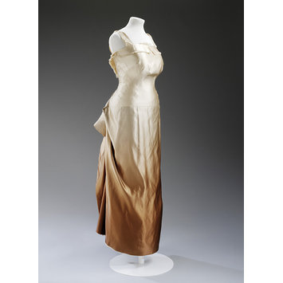

During the 1950s, dressmaker Maria Grimaldi produced an evening gown. The gown is composed of satin with an ombré effect gradually going from cream to bronze. The shoulder straps are wide and attached to a fringed pleat contouring its squared neck line and around the middle of the back forming a V shape which exposes the upper half of a women’s back. Furthermore, the gown’s bodice is long but fitted, tailored in a way that the dress is synched at the waist and tightened until the mid-hip area. The skirt has a straight and rectangular shape. Its side extremities are gathered to the center, above the posterior, and sewn into place creating drapes. The excess fabric of the drapes was sewn shut which created a form similar to butterfly wings.

This evening gown was displayed in the section of The Birth of Italian Fashion. Tailoring was a method used to fabricate the dresses in this section and that is when fashion began. Before tailoring, dressmakers were limited with the silhouettes they could create. Maria Grimaldi used this technique in Italy to produce her evening gown which why it was placed in this section.

This captivating piece has a communicative meaning of dress demonstrating status. There was an excessive amount of satin that it created drapes on the skirt. Also, authentic satin is a high quality and heavy fabric. This illustrates conspicuous consumption from the prior owner of the dress Margaret Abegg. The dress was made to measure for herself. Married to an important local dressmaker and art collector, she was able to hang garments of the highest quality in her closet. In addition, the gown has been worn for a basic function of dress: notions of nudity. Abegg most likely wore this dress for a special occasion or ceremony. No doubt, the dress caught people’s attention and the women who wore it did as well. She had the confidence to have a decent amount of her skin revealed by the opening on the back of the dress, the décolleté and the sleeveless arms.

CONTEMPORARY ITALIAN FASHION

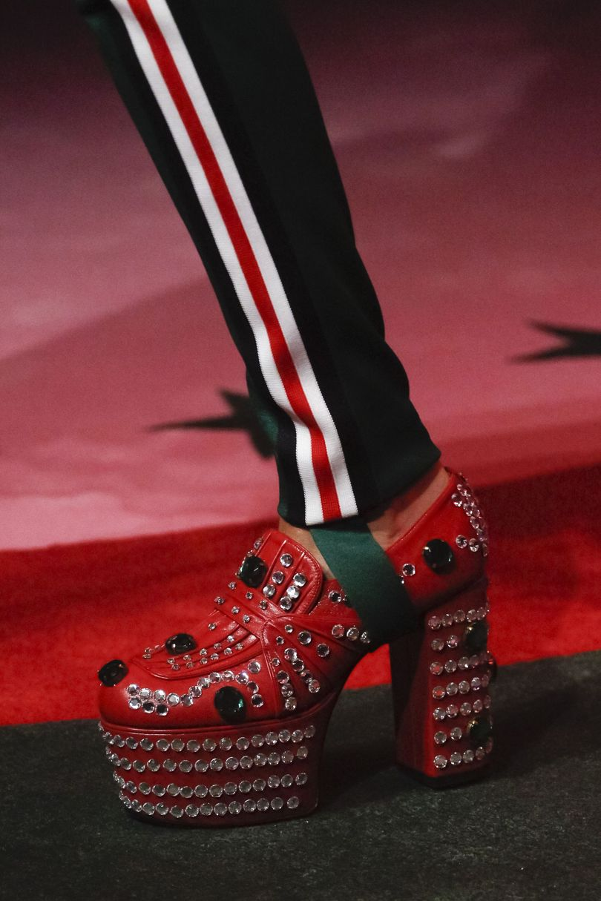

Platform Loafers by Gucci
Vogue’s Ultimate Shoe Guide Spring/Summer 2017 page 108
Published by Orla Pentelow on October 1st, 2016

For their Spring/Summer 2017 collection, Gucci designed a pair of red platform, block-heel loafers. Similar in design to Dolce & Gabbana’s ankle boots with the embroidered embellishments on leather, these heels share the same functions and meanings of dress. These Gucci heels are also used as external decoration. They can be worn temporarily for special events but not on a daily-basis. Furthermore, these shoes are also dressed for the sociological function of group identity. In this case, heels are identified with women. They presently are known to be women’s wear.

RECENTLY DISCOVERED DESIGNER

GIAMBATTISTA VALLI

Giambattista Valli is an Italian-French designer that was born on June 27th, 1966 in Rome, Italy. After his studies in arts and illustration, he became the assistant of Roberto Capucci and that’s when he discovered haute couture. Two years into working for Capucci, Fendi’s luxury brand requested that Valli become senior designer for their Fendissime collection. Bouncing from one designer mentor to another, in 1997, he finally decided to follow his dreams and move to Paris.

A few years later, he launched his own collection and in 2005, the Giambattista Valli label made its appearance. His label is sold in more than 39 countries in more than 235 retail stores. Valli’s name is repetitive on the red carpet. He designed dresses for celebrities such as Sarah Jessica Parker, Natalie Portman, Halle Berry, Zoe Saldana, Brooke Shields, Diane Kruger, Penelope Cruz, Julianne Moore, Jessica Biel, Lupita Nyong’o and Rihanna. Although he dressed many celebrities, Valli says “I won’t dress somebody I don’t like,” and that “[His] list of no’s is longer than [his] list of yeses.” Every year, Valli’s ready-to-wear creations are expected to appear in Paris Fashion Week.

Throughout his life, he was strongly influenced by empowered women which is why he caters his designs to women’s fashion. His pieces are romantic and he often uses colorful floral adornment.

FAVORITE OBJECT: SILK AND TULLE DRESS BY GIAMBATTISTA VALLI

The object I would have stolen from the exhibition is the Silk and Tulle Gimbattista Valli dress. This piece is breath-taking it can be looked at for hours due to its attractive red color and floral embellishments. The dress has silk draped over the shoulders and wrapped around the waist giving a woman a flattering hourglass silhouette. Also, the dress is see-through at the bottom which gives the illusion of flowers scattered on bare legs like a garden on a women’s body.

SOURCES

- http://collections.vam.ac.uk/item/O1247536/pair-of-boots-dolce-gabbana/
- http://collections.vam.ac.uk/item/O365624/coat-and-belt-palazzi-carlo/
- http://collections.vam.ac.uk/item/O365995/evening-dress-and-unknown/

- https://en.wikipedia.org/wiki/Italian_fashion

- http://www.uexpress.com/real-style/2014/6/22/where-italian-fashion-came-from

- http://www.vogue.co.uk/gallery/shoe-trends-spring-summer-2017

- https://www.google.ca/search?q=giambattista+valli&cad=h

- http://www.famousfashiondesigners.org/giambattista-valli

- http://www.wmagazine.com/fashion/2015/05/giambattista-valli-designer/

