Final Project
Marketing Research
410-DB4-AS

Made by
Majd Al-Najjar
Macira Sacko
Himani Sharma
Adrien Ouellette

Presented to
Jacqueline De Stefano

LaSalle College
Introduction

Google plus is a social network media designed by google to compete against Facebook, Twitter, and other social media platforms. Unfortunately google plus didn’t success as google was expected from this new platform. Since it lunched in 2011 google plus didn’t attract customers to use this new website as much as the other social websites, and even the people who are estimated as 2.2 billion who uses the services from google company didn’t seem to use google plus and only less than 1% used it.

Body

The problem with Google + is that this new social media website didn’t attract people or made any impact on the way we use or interact with social media such as Instagram or snapchat. The purpose of research is find out why people are using other social medias and they are not using google + and main aim is to find why google + did fail and its hard for google to fix it. For that our research objectives are:
1-Finidng the reason(s) of google plus fail.
2- Finding What makes other social media websites grow or make an impact.
We are going to use the exploratory research design because, it focusses on the discovery of ideas and insights as opposed to collecting accurate data. The use of this method will helps define terms, gain background information, clarify the problem and establish research priorities.
As a start point we will collect a secondary research to gain information about the problem, the first thing we will search is the growth of the social media starting from AOL and the chat rooms and Live Journal and whole host of other social networks. Since 2004, the growth of social media has been near exponential. Facebook the most mature of the top social networks only had one about one million users. By 2011 the network had grown so large, its population was being compared to that of a country. Comparing that to google +, which saw the biggest growth of all in 2013, most like because of Google’s interrogation of Google + into all associated services. If you have a Gmail account, you have a Google + profile.

In this paragraph, will be focusing on some of the things that Google + did wrong and made the network fail starting with failure to offer something genuinely new which means that every thing google tried to offer was there by other network such as Facebook or twitter at that time. Also, one of the main reasons why Google + failed is the company tried to make it too much like Facebook, which the people love and like to spend time on and even that Google + add new things and fixed the bad about Facebook such as privacy settings, Facebook adapted all the new features and fixed all the things that people hate or didn’t like and made the people stay on the network.

Google plus user timely

two weeks after the launch June 2011 | 10 million
a month after the launch | 25 million
in October 2011 | 40 million
the end of the year | 90 million
October 2013 | 540 million

The biggest market was the United States followed by India. As we can see the number of the user start growing very fast that lead Google plus to take notoriety among the competitors. But user engagement on Google+ was low compared with its competitors. ComScore estimated that users averaged just 3.3 minutes on the site in January 2012, versus 7.5 hours for Facebook. In March 2013, average time spent on the site remained low: roughly 7 minutes, according to Nielsen, not including traffic via apps. In February 2014, The New York Times likened Google+ to a ghost town, citing Google stats of 540 million "monthly active users", but noting that almost half don't visit the site. The company replied that the significance of Google+ was less as a Facebook competitor than as a means of gathering and connecting user information from Google's various services. The automatic subscription once you have any google account lead them to the result. Most of the subscribed don’t know about heir existing account on google plus.
When Enge extrapolates this number across Google’s 2.2 billion user base. He arrives at just 111 million users that have “active profiles,” which is about 0.5 percent of all Google users. The results get even more interesting when he looks at the numbers further still: Of those 111 million users, just 6.7 million have at least 50 posts ever while just 3.5 million have at least 50 posts in the last 30 days of the study.
Enge determined that some 90 percent of people with a Google Plus profile never made a public post. This is expected, though, given that people create a Google Plus profile automatically when signing up with Google, and the Google Plus universe encompasses more than just the social networking stream.
Users review are almost the same. It about that the Google plus is nothing new. The platform is the production of other platform gathered together at once. They preferred using the platform that they already have and accustomed to.

Users profile
A Google+ User profile is a public visible account of a user that is attached to many Google properties. It includes basic social networking services like a profile photo, about section, background photo, cover photo, previous work and school history, interests, places lived and an area to post status updates. It also includes several identity service sections, such as a contributor and other profiles area that let one link their "properties across the web". These sections optionally link to other social media accounts one has, any blogs one owns or have written or sites one is a contributor to. This area is used for Google Authorship. Customized or Vanity URLs were made available to the public starting on October 29, 2013 to any account that is 30+ days old and has a profile photo and at least 10 followers. Google removed author photos from search results in June 2014 and in August 2014 Google has stopped showing authorship in search results, both photo and author name.

We are going to make a survey because it has a lot of advantages because:
- Sensitive to subgroup differences
- Standardization
- Ease of administration
- Ability to tap the unseen
- Suitable for statistical analysis
Also, we are going to use computer-assisted survey the method of data collection because it will provide speed, relatively error free, can include the use of media and quick capture of the data.
The Data from the online survey
All the data will be included in a different file, because it is 6 pages.

The questions were simple and collected all the data needed for us and to maintain the project objectives to find what people are thinking about Google +.

Analysis of Data
From the given data, the overall collected data shows the declining of google plus with various aspects. According to the first question, the pie chart presents the 71% of people knows about the Google plus and only 9% not heard about the Google plus. Secondly, the majority of people doesn’t create a Google plus with nearly 68%. However, 90% of people have created an account of google and only 10% of people responded no answer. Fourthly, the high size of population (61%) does not know about the signup to Google plus, creates the automatic subscription of Google account. Whereas, 12 persons responded who knows the subscription. Next, the high rate of percentage (48%) who thinks that the Google plus in not so common and with least amount of population (4%) think that it is not worthy for interaction as compared to other social media. The majority of people spend time on social media is approximately 43% with more than two hour. Where, only 10 number of people usually spend one hour on the social media. Moreover, the above than half of the percentage (57%) is neutral that google plus is secure but 33% agree with the given statement. Nearly 70% of people is neutral that it is a great platform for news and with the constant amount of percentage with 13% agree and strongly agree with the statement. Adding more, 60% is neutral that the google plus is difficult to use and 17% of people disagree with this statement. Further, more than the one fourth of people disagree with they don’t understand the concept. However, 40% of people is neutral.
The sample size of survey, mostly covered by female with nearly 60% and male with approximately 42% only. Most of the people who had participated in the survey are lives in north America with total 100 percentage.

Conclusion:
To recapitulate, the decline of Google plus is concluding from the obtained data that we have analyzed above. As we could see from the above, most of the people has created account in Google but doesn’t know that same account can use for the Google plus. Similarly, the most of people doesn’t show interest in having google account as they think that it’s not for interaction. Last but not a least, google plus is mostly use for business purposes and declining a because it’s not same and popular as other social media to interact with others.

Annexes

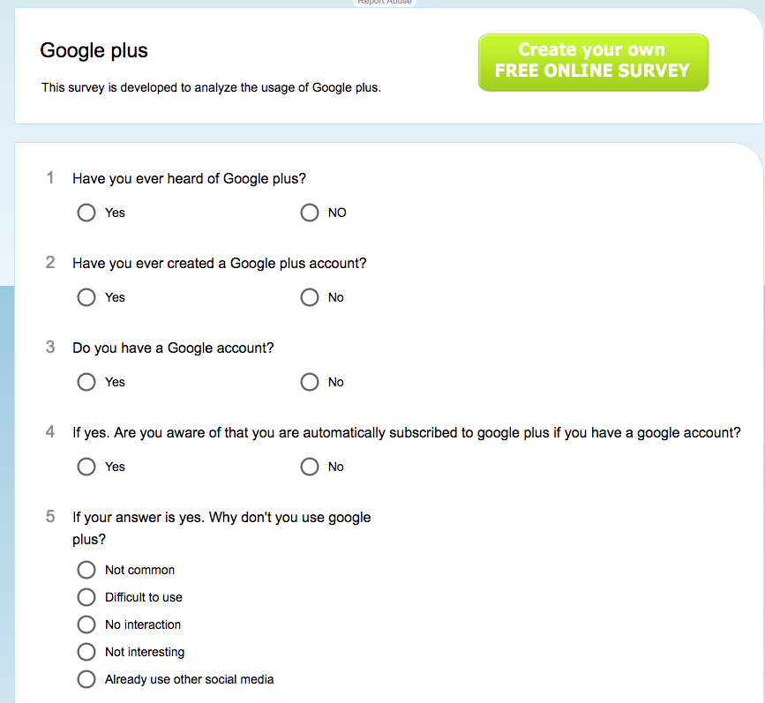

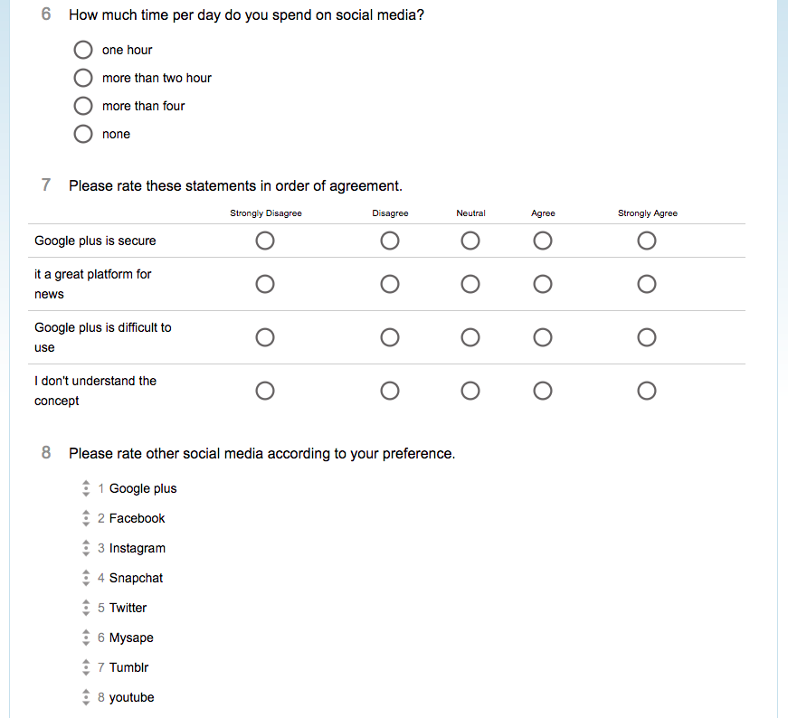
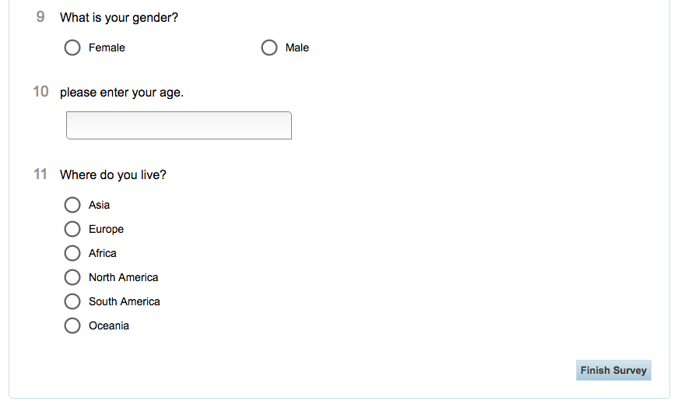

References
- Has Google+ Really Died? Forbs
http://www.forbes.com/sites/stevedenning/2015/04/23/has-google-really-died/#5721e71f16e9

- 3 Types of survey research when to use them, and how they can befit your organization.
https://fluidsurveys.com/university/3-types-survey-research-use-can-benefit-organization/
- The growth of social media
http://www.adweek.com/socialtimes/the-growth-of-social-media-from-trend-to-obsession-infographic/142323

- Why Google +m failed, according to Google insider
http://www.businessinsider.com/what-happened-to-google-plus-2015-4
- New study suggests google plus’s active usage may be much lower
http://www.digitaltrends.com/social-media/study-suggests-far-fewer-active-google-plus-users-than-google-claims/

