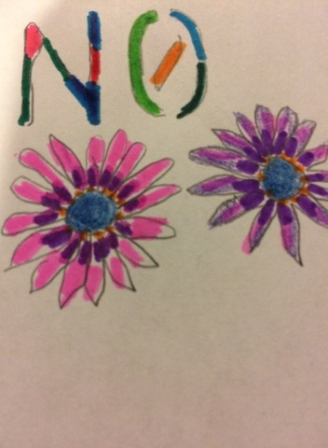

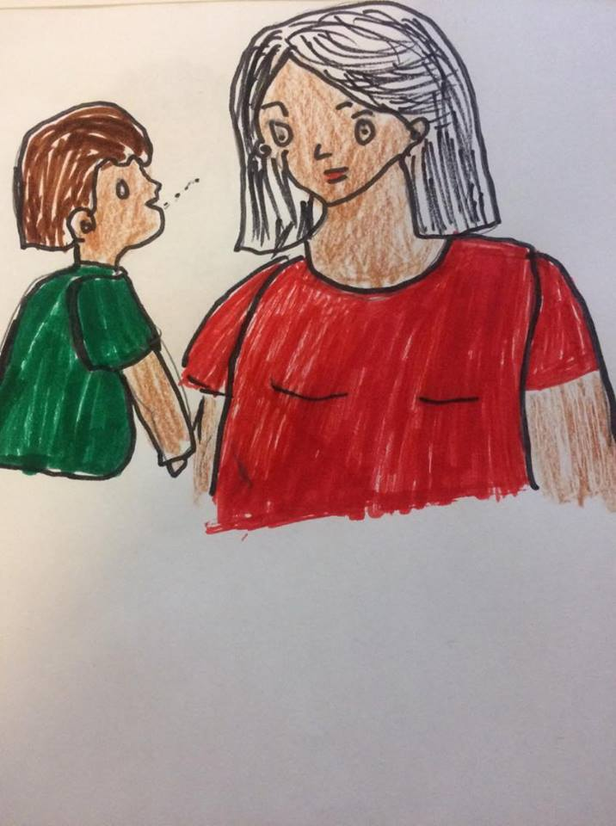
Guide for the parents
Prepared by Ranee Nundoo

TABLE OF CONTENTS

Introduction……………………………………………………………………………………..1
Facts……………………………………………………………………………………………..2
Statistics………………………………………………………………………………………...3
Appropriate behaviors for your child…………………………………………………....3,4
What the parents should do to protect and help their children........................5,6,7,8
Sexual abuse…………………………………………………………………………………..9
When should the parents feel concern…………..……………………………….……..10
What to do in case of concerns……………………………………………………………11
Who to call and what to do (DYPreport)…… …………………………………...12-15
Communication skills……………………………………………………………………16,17
List of books to read to your children and for yourself……………………………….18
Other resources……………………………………………………………………………...20
Conclusion……………………………………………………………………………………21
References…………………………………………………………………………………22-22

Pg 1
INTRODUCTION:
It is very important for parents to create and to maintain an affective relationship with their children (their precious assets). Parents are the first educators for their children and they are the ones who know their children better in all aspects. Parents need to have meaningful conversation with their children in everyday life to create a meaningful relationship and a favourable environment for them. The children will therefore feel happy to be at home and will be more comfortable to confide with their parents about anything that bothers them. The parents also need to form a secure attachment with their children at an early age. According to John Bowlby, a British psychologist, he believes that secure attachment plays a critical role in the later development and mental functioning of a child.
To establish an affective relationship with the children, “Respect” plays a very important role. Each child should feel respected and also respect others. According to Maslow’s hierarchy of needs, we can note, that he points out that esteem needs is very important in a child’s life. He indicates that the need for respect is most important for children and precedes real self-esteem and dignity. My specific goal is to provide the parents a guide about the importance of “respect” and what can be done to show the children how to respect themselves and others, when the parents should feel concern and what the parents should do in case of concerns. The children need to respect their bodies and when they don’t want something they need to know how to be assertive and say “no” is “no”. This guide is also to show the importance for a child to feel respected and if not what are the consequences on the child’s future life. It is also a way to prevent your child from being a future victim.
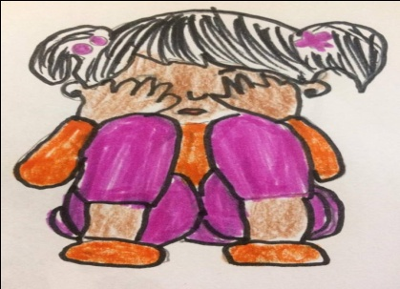
Pg 2
Facts:
Even you keep your children always within your eyesight; your children do go at family or friend’s places, school buses, parks and other public places. Children are not aware of the dangers that are awaiting them. Young children are developmentally incapable of protecting themselves. Sometimes children lack the knowledge and believe that anybody can touch them, kiss them, hug them and they are safe with everyone. There are also children who follow strangers and there are some children who are afraid to say “no” and they do things that they don’t want to. They are even afraid and lack the ability to reveal to another person their secrets. They don’t really understand why they should say “no” and for what they should say “no”. These children become victims and suffer in their future life. It is sad to see all these children being a victim. So you parents who knows your child better than every one, you are the first one to show your children why it is important to be assertive and to say “no” when they don’t want something. You must not assume that they are learning these types of things at school or with others but you must show your children how to protect themselves. The parents should also inform the children about the things that they are allowed to do and what they can’t do for e.g. the good touches and the bad touches. Being aware of this information and by following them, the children will feel happy and will develop more positive relationships with others. The children will build on their confidence and self esteem. They will learn how to express themselves and at the same time build on their social and emotional skills. They will be able to speak for themselves, learn and express themselves in an appropriate way therefore feeling safer and won’t be the future victims. When the children have this knowledge, they will be happier, the families will be stronger and the community will be safer.
The parents should also show their children how to respect others and not to force their friends. The children should be aware that they should always ask before doing something with their friends. This will prevent aggressive behaviors and conflicts within friends.
Pg 3

Statistics: 1 in 5 girls, 1 in 10 boys report having been sexually abused before the age of 18.
97% of the sexual cases, the victims know the abuser.
More than 50% of sexual assaults are under the age of 18 years old.

The appropriate behaviors of a child:

- A child should respect others:
A child should respect others by understanding other’s feelings and needs and by always asking before touching his/her friends. A child should not force his/her friend to do what he/she doesn’t want to. He/she should also interact with others in appropriate ways, share toys and play together in a respectful way to establish an affective relationship with them and to avoid conflicts. The child should understand his/her boundaries and limits.

- To be assertive and be able to say “no”
A child should be able to say “no” when he/she doesn’t want something. He/she should understand what he/she really wants. A child should also understand that he/she is not forced to accept whatever someone else asks them to do if they don’t want to do it. They should be able to say “no” to someone hurting them, not respecting them or forcing them to do something that they don’t feel comfortable of doing. A child should talk with someone he/she feels comfortable with and he/she wants to be with. If they feel uncomfortable with someone they can just leave and go.

Pg 4
- Using of words and no aggression.
A child should be assertive and use the word “no” to others respectfully or by using other words. They should not fight with the other children. He/she should be able to convey his/her feelings to others easily. He/she should be able to explain to others about how he/she feels, what he/she likes and what he/she doesn’t like without being afraid or shy.
A child should also be able to use the “I” message and be firm when they don’t want something and resolve problems firmly and fairly.

- A child should love his/her body.
A child should love himself/herself and be able to understand his/her own emotions.

- A child should not keep secrets:
A child should talk with an adult in case of concerns, (if someone touch him/her, touch his/her private parts, kiss him/her, force him/her to hug them, took photographs of him/her, force him/her to undress). A child should feel comfortable to talk with you when he/she has something that is bothering him/her or someone is forcing to do an act that he/she doesn’t want to.

Pg 5
What should the parents do to protect and help their children:
- To make your child feel safe and provide him/her a caring environment:
Parents need to find ways to make their children feel safe and supported. They need to care, be warm, love, play and help their children. They should always be available to their children and spend quality time with them so that their children can trust them and feel no fear to confide to them in case of concerns.

- To use meaningful conversation and the right communication skills with their children.
Parents need to use effective and meaningful communication skills with their children and always be ready to listen to them. They need to make their children feel they are important. Using effective communication, they can show the children how to interact with others in the appropriate manners. By active listening, the children will also be able to express themselves about how their thoughts, feelings, ideas and concerns. When the children feel they are important, this will make them feel confident to share information with the parents. The parents can also show the children how they can use the assertive communication skills and to use their own words when they have to express themselves instead of using inappropriate behaviors or fighting with others.

- Explain to their children how to be assertive and be able to say “no”:
The parents should explain to their children the importance of being assertive and to show them how they should say “no” to others when they are forced to do something they don’t want to. The parents themselves should not pressure their children to talk and kiss every person. They have to let their children speak with whom they want to and to interact with others that makes them feel comfortable. The parents need to explain to their children that they too, they have rights and choices and that others need to respect their choices.

Pg 6

The parents should also show the children the rules of privacy:
The parents can show the children the private parts of their bodies (People from outside can’t see them or touch them), the appropriate and inappropriate behaviors, the good touches, the bad touches, the good people and the bad people, the good secrets and the bad secrets. They can also inform their children with the correct information about sex (using of proper names which are age appropriate) and about their body safety so that the children are aware of what is good, what to do and what is not good and what not to do. They can inform the children that whenever they feel uncomfortable with the company of someone, they can just leave and go. Parent can also say to their children: “mommy and daddy can touch your private parts when cleaning you or when applying cream, but no one else should touch (no friends, no uncle, even if you like them). The parents are the best source of answers, if you don’t provide your child with the right information, he/she can have wrong information from others or he/she can make false assumptions which are not good. Having the right knowledge will help the children understand when they have to come see their parents for concerns.

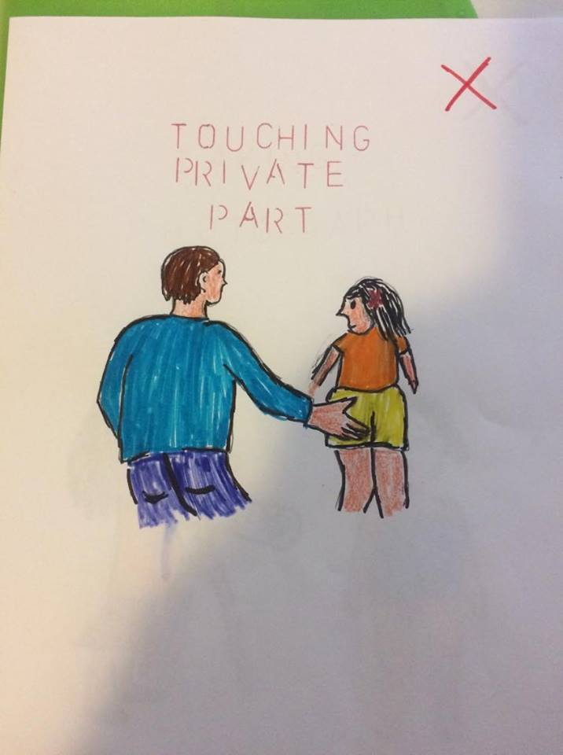

- To be a model and to teach the children that they should always wear clothes in public places and in front of others.

Pg 7
- Inform the children that nobody should take pictures of themselves, especially when naked or their private body parts.

- To answer the children’s questions by using the right words, no need to elaborate but give important information for e.g., if a child asks “where does baby comes from”, the parents can answer: “man and woman, mother and father can make a baby. The baby grows inside the mother’s womb”.

- Parents also need to control their feelings in case of concerns and assist their children in recovering from the abuse.

- To read books.

- Parents should explain their children that they should also respect their friends and always ask before doing or taking anything from their friends. They need to inform their children that they should also respect their friends by sharing and asking. They should explain their children about how to show empathy to others.

- Parents should be aware that children enjoy being naked. It is a normal part of life. They are just curious. The parents should not respond in anger, surprise or use disapproving words when they see their child naked, but talk with him/her and inform him/her that it is not good to be naked in a public place.

- Parents should respect their children’s personal space. If a child says he/she wants to be alone for a while or wants to sleep alone or he/she doesn’t want his/her mother to see him naked, the parents should respect their children’s choice and take it positively.

Pg 8

- Parent should understand the development of a child for e.g. a child from 2-5 years old are able to understand body parts, gender identity, understand the basic principles of human reproduction, understand the concept of privacy.
- Parents should leave their children always with a trusted person.
- Parents should keep their children at their sight in public places. In public restrooms, it is preferable that a parent accompany the child or to use the family restroom.
- Parents should also know what the children are doing on the internet if they are accessing it.
- Parents should instill their values and expectations to the children.
- Parents should report any situation that they seem to be dangerous, otherwise the abusers remain free and other children become victims.

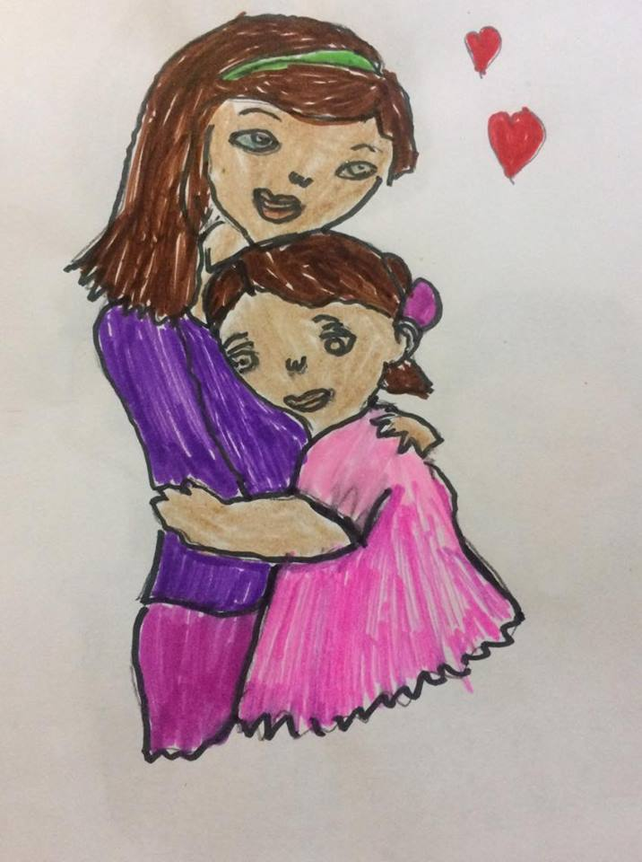

Pg 9
Sexual abuse:
All forms of violence: Physical or psychological that manifest in a sexual way.
Child expose to gestures of a sexual nature (with or without physical contact).
Child runs a serious risk of being exposed to gestures of a sexual nature.
Sexual assault:
- An act of sexual with or without physical contact.
- An act through emotional manipulation.
- The use of force or power over a child.
- Fondling, kissing, oral-genital contact, voyeurism.
- Child luring; Seduce a child using the internet or new technologies with the aim of sexual assault.
Physical abuse:
- A victim of body injuries – Being touched by force.
Consequences:
- When a child goes through a sexual or physical abuse, he/she suffers major emotional psychological and physical health problems such as:
- Post – traumatic stress (nightmares, avoidances, changes in mood and behaviors).
- Fear, anxious, hypersensitivity.
- Depression (bad mood and sad).
- Aggressive (disrespect, lying, theft, aggressive acts to others).
- Poor developmental skills, not meeting the milestones.
- Leading to significant dysfunction and distress when they become older.

Pg 10
When should the parents feel concern:

- Child talks about sex:
Parents should feel concern when their child starts to ask questions such as “what comes out when a penis is hard” or when their child says that he/she has been through sexual acts. They should also feel concern when their child says different words like “my body is dirty or damage”. They should be also be concern if a child talks about pornographic experience or has too much knowledge of sexual behaviors which is not age appropriate. The parents should also interfere immediately if their child confides to them that someone does not respect his/her privacy or if someone has hurt him/her.

- Changes in the child’s behavior:
Parents should feel concern if they notice any changes in the mood, health, poor appetite, nightmares in the child. They should also ask questions if they feel that the child has become too clingy, avoidant or depressed and says that he/she is afraid and doesn’t want to go at the day cares or at a person’s place.

- Injuries and bruises:
Parents should also show concern if their child complains of having pain and swelling in genital or anal areas. They should also ask questions if the child has blood in the underwear or if the child has regular sexually transmitted infection, frequent bladder infection or frequent urinary infection.
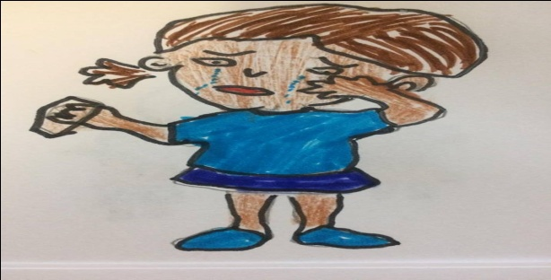
Pg 11

What should parents do in case of concerns:
In case of concerns the parents should immediately address the situation by
- Using effective communication skills with the child, asking open ended questions (without making the child feels uncomfortable to talk) and actively listen to the child without interrupting and judging the child.

- To stay calm in front of their child and to help and support him/her. The parents should not over react but understand their child.

The parents are the ideal one to support the child because they know their child better than everyone. They can state to their child that he/she is not alone and to reassure him/her that he/she did the right thing by confiding to them. The parents should also show their child that they believe him/her and that their child can trust them. Showing their child that they are always available to them will make him/her feel safe and secure and will develop a trustful and meaningful relationship.

- Do not lie to your child or promise that you will keep it as a secret.

- The parents can also ask for advices with professionals or with the home family day care providers about what to do in such situations.

- To file a report.

Pg 12

As parents you can call and file a report for another child also if you believe he/she is in danger.

Who do you call to file a report? 24 hours a day, 7 days a week.
Montréal (Centre de Jeunesse de Montréal): 514 896 3100
English speaking (Batshaw): 5149356196
Website: Ministère: de la Santé et des Services sociaux : www.msss.gouv.ca/jeunes.
Association des centres jeunesse du Québec : www.acjq.qc.ca
Commission des droits de la personne et des droits de la jeunesse : www.cdpdj.qc.ca

The DYP Report:
It is a report to the Director of Youth Protection. (You can file a report by telephone or in writing)
The DYP intervenes to end or prevent a situation in which a child is in danger.
File a report when you have concerns to have answers about questions and to be guided about what to do (the necessary and next steps).

Pg 13
The director of youth protection – Enforcing the YPA works with other members who:
- Receive reports.
- See whether the reports should be evaluated or retained.
- Evaluate the situation.
- Enforcing corrective measures.
- Review the child’s situation.

When to file a report:
- When you believe that your child or another child is in danger or a child’s development is threatened and is need of protection. When the child shows signs of concerns listed above.

Even if the DYP deem that the parents are taking steps to put an end to the situation. It is up for them to access whether these steps are sufficient.
The DYP protects the act of fling a report. Identity of the one filing the report will not be disclosed without consent.
After filing a report:
The DYP analyses the situation (s.38.2 YPA)
- The nature, the gravity, persistence, frequency of the facts reported.
- The child’s age, personal characteristics.
- The capacity and the parent’s will to put an end to the situation.
- The community resources available to help the child and the child’s parents.
- Conducts a summary analysis.
- Decides if retain or not for evaluation.
- Determines the degree of urgency to intervene.
Pg14
Information you required to file a report: (by telephone and in writing)
(If you don’t have all the information, you can still file a report)
- Your name,
- Your contact information.
- All important information to help identify the child.
- The child’s name.
- The child’s date of birth or age.
- The child’s telephone number.
- The name of the child’s mother.
- The name of the child’s father.
- Who does the child live with?
- What school or daycare does the child attend?

- All important information that the child security/ development is in danger:
Facts:
- Statements or secrets the child confided to you. Actions or attitudes of the child or parents. Injuries or bruises observed on the child.
Nature of these facts:
- Occur frequently.
- Past or current situation,
- Have the facts been happening for a long time.
- Do you believe the child is in danger?
Child’s vulnerability factors:
- What impact do you believe the events you required have on the child?
- Does the child have any physical or mental disability?
Pg 15

- How has the child reacted to the situation?
- Does the child have personal characteristics (strengths or weaknesses) you feel the DYP should know about?
How able and willing are the parents to address the situation:
- Are the parents aware of the problematic situation?
- Do the parents have personal characteristics or weaknesses, problems you feel the DYP should know about?
- Have the parents tried to seek help to correct the situation.
Have the child or parents have already received help from community resources?
- Is there someone around the child that can help the child or his parents (extended family, neighbors)
- Are there resources that have already intervened with the child or his parents (community, organizations)

For sexual or physical abuse only:

- Do you know who the suspected perpetrator of the abuse is?
- What is the name and age of the suspected perpetrator?
- Is the child still in contact with this person?
- Have the police already been notified?

Pg 16
To have a good communication with your children: You can use these techniques
Good communication skills:
Having a good communication skill with your children will provide a strong base for healthy relationships and therefore you will be able to have a conversation with your children more easily in case of concerns and the children will feel more at ease to convey their needs and feelings.
Good communication skills will also help as a guidance of information and ensure understanding.
- Will help the children to better understand the concept of respect towards themselves and to others.
Assertive communication: Able to say “no” and to be respected by others.
Features of good communications skills:
- Focus and share main ideas.
- The use of body language when necessary.
- To encourage your children to participate in the conversation.
- Make your children feel comfortable.
- Use simple words, and to speak clearly.
- To use the right tone of voice and the right pace.
- The use of appropriate verbal and non verbal communication (eye contact, facial expression, body language, tone of voice, gestures and postures)
- Use of “I” message.
- You need to be honest.
- You do not have to exaggerate.

Pg 17
Active listening skills:
Active listening skills is also important to make your children feel important and to show them that you are listening to them. By using active listening skills, you will also be able to better understand the message they want to convey to you,
Features for active listening:
- To listen to your children with a purpose and not planning ahead of what you will say.
- To pay attention to each word your children are saying.
- To show signs that you are listening like nodding your head and words like “yes”.
- To respond appropriately.
- To paraphrase and reflect while listening to ensure that you got the right message.
- To ask questions for better understanding.
- Not to interrupt.
To remove barriers of communication:
- Talking too much and your children not having time to talk.
- To laugh at your children.
- To remove all noises (physical noises, technical noises, psychological noises)
- Lack of interest.
- Other distractions such as mobile phones or others.
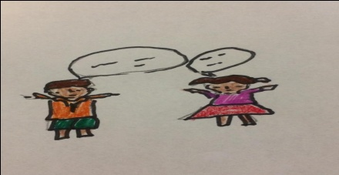

Pg 18

Books to read with your children:
- The mouse, the monster and me by Pat Palmer.
- Your body belongs to you by Cornelia Spelman.
- The trouble with secrets by Karen Johnsen.
- My body belongs to me by Jill Starishevsky.
- No, no the little seal by Sherry Patterson.
- The right touches by Sandy Kleven.
- Amazing you by Dr. Gail Saltz.
- I said no by Kimberly King.
- Those are my private parts by Diane Hansen.
- Body safety by Jayneen Sanders.
- My body what I say goes by Jayneen Sanders.
- No means No by Jayneen Sanders.

Books for the parents:
- Protecting the gift by Gavin de Becker.
- The sexwise Parent by Janet Rosenzweig.
- Body Safety Education by Jayneen sanders.
- What your child needs to know about sex by Fred Kaeser.

Pg 19
Other resources you can access:
- Cavac website: cavac.qc.ca
Phone number: 1-866-532-2822
Provide help to people who are victims and also to the parents.
Prevent worsening of the situations.
Post trauma and psychological interventions/ information on crime rights and remedies.
- Montréal (Centre de Jeunesse de Montréal): 514 896 3100
- English speaking (Batshaw): 5149356196
Website: Ministère: de la Santé et des Services sociaux : www.msss.gouv.ca/jeunes.
Association des centres jeunesse du Québec : www.acjq.qc.ca
Commission des droits de la personne et des droits de la jeunesse : www.cdpdj.qc.ca
- Marie Vincent Community : Phone number : 514-362-6226
Website: https://marie-vincent.org/en/
Mission: to build a world free of sexual violence towards children.

Pg 20

To conclude:
I hope this guide will help you in showing your children how to be assertive and when you should feel concern if your child is in danger and what to do in case of concerns. This will also help you to show your children the importance of saying “no” to others when they don’t want something. By using this information both you and your family will be safe. Your child will have the required knowledge and will benefit a sexually healthy life. You will lead a happier life too, your families will be stronger and the community will be safer.
This guide can help protect and save the future of many innocent children in the society.

Please share them.

Thank you.

Pg 21

References:

Bibliography
Batling abuse, restoring lives. (2018). Retrieved 02 2018, from Chicago children's advocy: https://www.chicagocac.org/books-children-sexual-abuse/
Batshaw's youth and family centers. (2009). Retrieved 02 2018, from Youth protection interventions: http://www.batshaw.qc.ca/en/who-we-are/what-we-do
Cherry, K. (2017, 10 19). Very well mind. Retrieved 02 2018, from John Bowlby: https://www.verywellmind.com/john-bowlby-biography-1907-1990-2795514
Crime victim assistance center. (2018, February 05). Retrieved 02 2018, from Cavac: http://www.cavac.qc.ca/english/index.html
Help us build a world of sexual violence. (2017, 12 19). Retrieved 02 2018, from Marie vincent: https://marie-vincent.org/en/
How can I protect my child from sexual assault. (n.d.). Retrieved 02 2018, from RAINN: https://www.rainn.org/articles/how-can-i-protect-my-child-sexual-assault
It shouldn't hurt to be a child. (n.d.). Retrieved 02 2018, from Victim of violence: http://www.victimsofviolence.on.ca/research-library/child-sexual-abuse/
Maslow's Hierarchy of needs. (2017). Retrieved 02 2018, from Simply Psychology: https://www.simplypsychology.org/maslow.html
Nemours. (2014, October). Understanding early sexual development. Retrieved 02 02, 2018, from Kid's health: http://kidshealth.org/en/parents/development.html
www.msss.gouv.qc.ca/jeunesse
www.cdpdj.qc.ca
Educational childcare Regulation. (2017, Dec). Retrieved Feb 2018, from Legis Quebec: http://legisquebec.gouv.qc.ca/en/showdoc/cr/S-4.1.1,%20r.%202
Four playful activities to help children develop assertiveness. Retrieved Feb 2018, from Moments a day: http://www.momentsaday.com/help-children-develop-assertiveness/

Pg 22
Book “The sex-wise Parent”, the parent’s guide to protect your child, strengthening your family and talking to kids about sex abuse by Janet Rosenzweig, Ms, PHD, MPA
Home family day care provider: Samia
Day care “Les petits amis”: Educator Mary.
Teacher at La salle College: Milena Turiello and Erica Nadler.

Other courses:
Communication: Notes on effective communication skills.
Active listening skills
Barriers of communication
Safety:
The youth protection act
How to report a situation
Sexual abuse/physical abuse
What to do if a child confides in you
Who to call to file a report

