Portfolio

Jiachen Wang
1910279
12/10/2019

- Intro to baking

Week 1
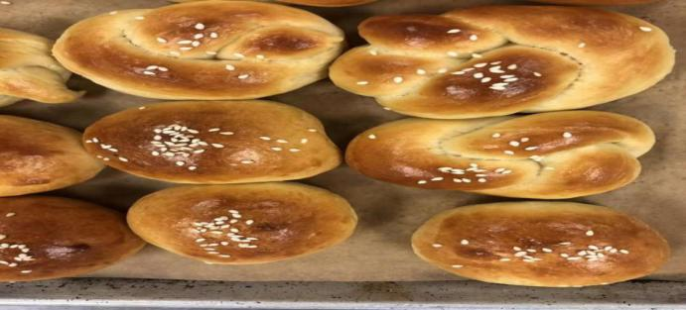
Soft Rolls
A.Method
We use the Straight Dough Method and the rolling method
B.Outcome
The soft rolls should be golden brown outside and the bread should be soft and the. There is quite a bit of yeast in these rolls to give you the ultra light and fluffy texture.
C.Temperature
Knead the dough on medium speed 10 minutes or until the dough reaches 77°F (25°C).
Bake at 400°F (200°C) until medium brown
D.Personal though of the product
I think the the Soft Rolls that we make this week is not so bad. the size of our product is good and the color is also not bad. but our bread is not soft enough, because, we didn’t leaven the dough for enough time.
E.chef's critique and recommendations
For the soft rolls chef give us 4 point. Chef said the color of the bread is not bad, but it is not soft enough, the dough should be leaven longer. so the final product will be soft.

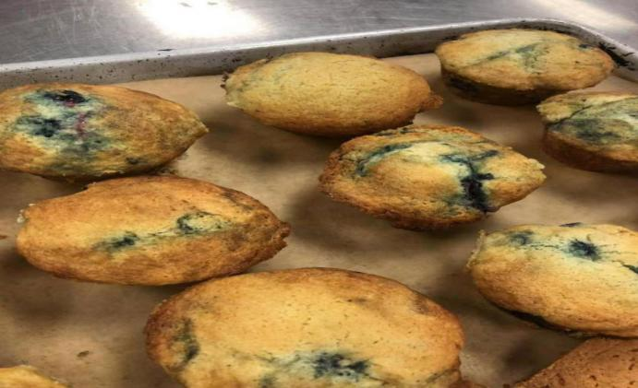
Blueberry Muffins
A.Method
We use the Creaming Method
B.Outcome
The outcome of the blueberry muffins is moist and the color it’s should be golden brown. And it should sweet and with the blueberry flavor.
C.Temperature
The muffins should be bake at 375°F for about 30 minutes or until golden brown.
D.Personal though of the product
For the finial product i think it is good. The muffins is at the right size, and the texture of it is moist and soft. And the taste of it is also not bad. But it is broken when we take out it. Next time we should put enough oil in the muffin tins.
E.chef's critique and recommendations
For the muffins, chef said it is not bad. The texture of it is good, it is moist and soft. But some of the muffins is little bit green, because when we mix the blueberry in the mixture, the blueberry is not freeze . next time we need to freeze the blueberry before we put it in the mixture. And some of the the muffin is broken when take it out. So next time we need to put more oil in the muffin tins

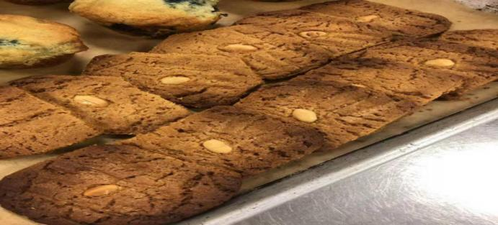
Peanut butter Cookies
A.Method
We use the Creaming Method
B.Outcome
The color of it should be golden brown. And the all the cookies should be in equal size and the shape should be circle. And the texture should be crisp and sweet and we the nut flavor.
C.Temperature
Bake at 400°F (200°C) until golden brown
D.Personal though of the product
For the peanut butter cookies, i think we didn’t do so well on this one. Because the cookies is over baked, so the cookie’s color become a little so dark. And the cookies didn’t shape so well. Because we put each cookie too close before we put it in the oven.
E.chef's critique and recommendation
For the peanut butter cookies, chef said it is over baked. And it didn’t shape so well. Next time we should given more space between each cookies and we should watch the time after we put the cookies in the oven. Make sure it is not over baked.

Timeline:
1:30 - get all the ingredient.
2:00 - start to make the soft rolls
2:10 - mix all the ingredient to make a dough
2:40 - let the dough rest Ferment until doubled,
3:00 - start to make the muffins
3:10 - cream the butter
3:20 - Beat eggs in one at a time.
3:30 - add the dry ingredient and the buttermilk
3:40 - add the blueberry in the mixture.
3:45 - put it in the muffins tins and put it in the oven
3:50 - start to shape he soft rolls
4:20 - out it in the oven
4:25 - start to make the cookies
4:30 - cream the butter
4:35 - add the egg
4:40 - add the dry ingredient
4:50 - shape the cookies
5:00 - put it in the oven.

Week 2
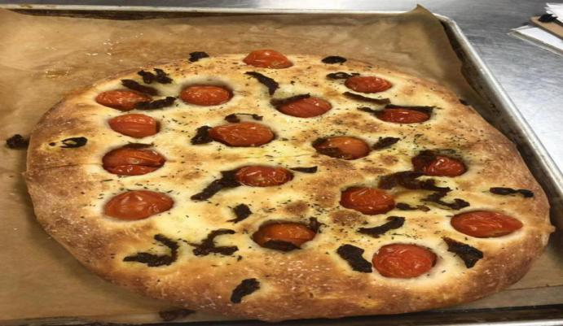
Focaccia
A.Method
We use the Slack Dough Method and Straight Dough Method
B.Outcome
The Focaccia should be golden brown outside. And the inside should be soft, and it should have an fluffy texture.
C.Temperature
It should be bake at 400°F (200°C) until lightly browned, approximately 20 minutes.
D.Personal though of the product
I think the Focaccia that we make this is not be. The color of it is lightly brown. And it has the good fluffy texture. The only problem is we didn’t pass it to evenly. So the final product is a little bit high in the middle part.
E.chef's critique and recommendations
Chef said it is a good product. The color is good, and the texture is also good. But the bread is not evenly. The middle part is a little bit high.
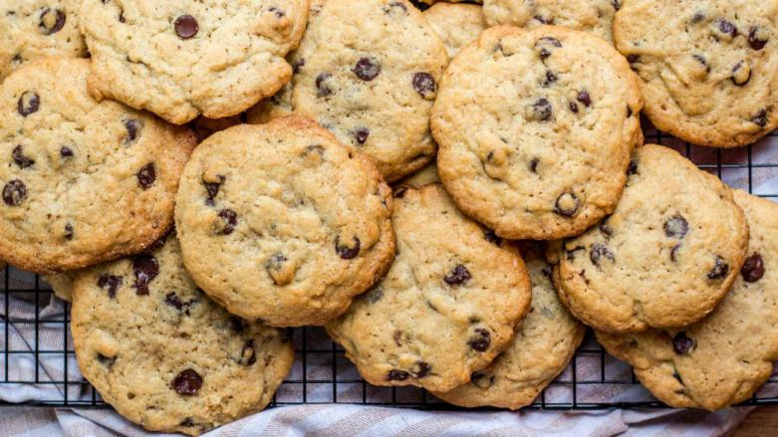

Cho Chip Cookies
A.Method
We use the Creaming Method and the Drop Cookie Method for the cookies.
B.Outcome
The color of it should be lightly brown. And the shape of it should like circle. The texture of it should be soft.
C.Temperature
It should be bake at 350°F (180°C) until the cookies are golden brown and cooked through.
D.Personal though of the product
For the Cho Chip Cookies that we make this week. I think it is good. The cookies was at the right size. And the texture is soft. The color of it is light brown. And the taste of it is also not so bad.
E.chef's critique and recommendations
For the cookies. Chef said it is a good product. The shape is good. And the texture is also not bad. The only problem is we may add to much flour. But the other things is all good.

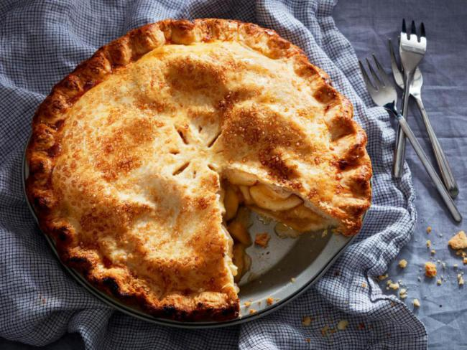
Apple Pie
A.Method
Make the Flaky Pie dough
B.Outcome
The outside of the pie need to be golden brown and the inside of the pie need to be soft .
C.Temperature
We need bake the pie at 400°F for approximately 45 minutes or until pastry is browned, and filling is bubbly and soft.
D.Personal though of the product
I think this product is not bad. The outside is golden brown, but the inside of the pie is not soft enough. Next time we need to cook for a long time.
E.chef's critique and recommendations
Chef said the pie looks good. But the pie was not cooked for enough time. So the inside of the pie is still soft. And also the filling is a little bit sour. We may put too much lemon juice in it.

Time line
1:30 - prepare the ingredient for Focaccia
1:40 - make the dough set side
2:00 - start to prepare the ingredient for the pie dough
2:10 - make the pie dough and chill it
2:20 - first fold for the Focaccia
2:30 - cut the apple and make the pie filling
2:50 - prepare for the cookies
3:00 - second fold
3:20 - make the cookies
3:10 - third fold
3:30 - make the pie and put it into the oven
4:00 - put the Focaccia into the oven

Week 3

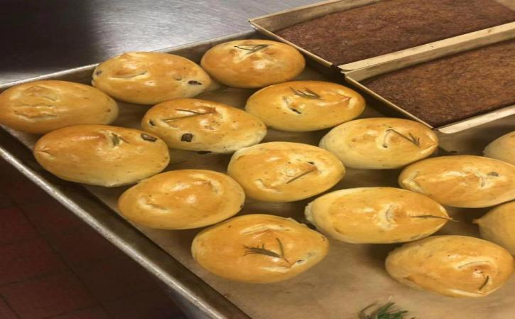
Italian Rosemary Rolls
A.Method
We use the Straight Dough Method and the rolling method.
B.Outcome
It should be soft and golden brown outside.
C.Temperature
It should be bake at 400 F for 12-15 minutes.
D.Personal though of the product
I think this product is quit good. The outside of the bread is golden brown and the inside of the bread is soft.
E.chef's critique and recommendations
Chef said it is a good product. The texture of the bread is good, and the out said is golden brown.

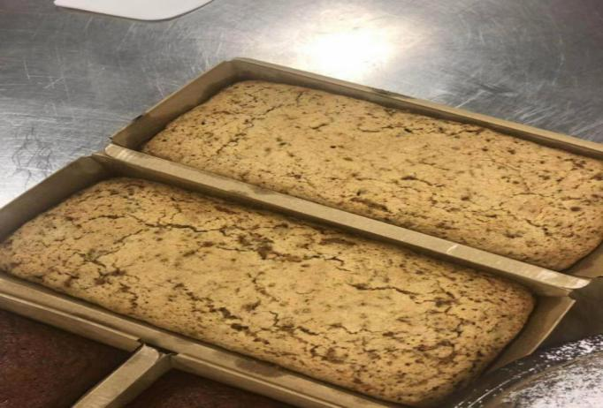

Carrot Bread
A.Method
We use the Muffin Method
B.Outcome
It should be with the soft texture. The color of it should be golden.
C.Temperature
It should be bake in a preheated 325 F oven for an hour until light golden brown
D.Personal though of the product
I think we did well on this product. The outside of the carrot bread is baked well. It is golden brown outside and the inside of the carrot bread is also soft.
E.chef's critique and recommendations
Chef said it is a good product. The color is good. It is golden brown. And the texture of it is also good.

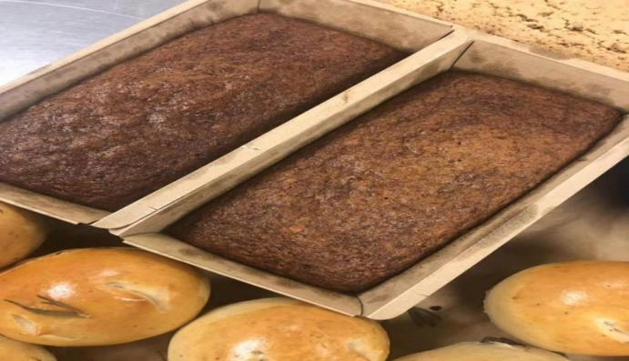
Banana Bread
A.Method
We use the Muffin Method.
B.Outcome
The texture of the banana bread should be soft. And the color should be brown.
C.Temperature
It should be bake at 350F for approximately 40-50 minutes until golden.
D.Personal though of the product
I think it is a good product. The texture of the banana bread is soft. And the color is golden brown. And it is shaped well.
E.chef's critique and recommendations
Chef said it is a good product. It is shaped well and baked well. The texture is soft. And the color is golden brown.

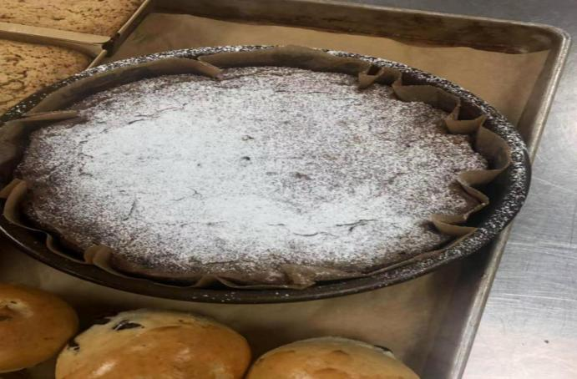
Fudge Brownie Batter
A.Method
We use the Autolyze method and Adding Inclusions method.
B.Outcome
The center of the brownie need to be soft . the color should be brown.
C.Temperature
It should be bake at the 325 F.
D.Personal though of the product
I think the brownie is not bad. It is shaped well and the texture is not bad. It is soft. The only problem is the center of the brownie maybe to soft. Maybe we are not bake it enough time.
E.chef's critique and recommendations
Chef said it is a good product. The only problem is the center is a little bit soft. It should be bake more time.

Week 4
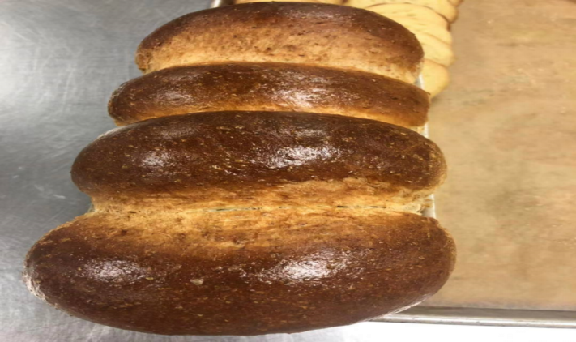
Whole Wheat Sandwich bread
A.Method
We use the rolling method and the fermentation method.
B.Outcome
It should be golden brown outside and soft inside.
C.Temperature
It should be bake at 375°F (190°C) until brown and hollow-sounding.
D.Personal though of the product
I think it is a good product. The color is good and the inside is soft enough. The only problem is we may proof it too much time, the head of the bread is become too big.
E.chef's critique and recommendations
Chef said it is a good product. The outside is baked well and the inside is soft. Chef also said it is proofed to much time. So the bread is become so big in the oven.

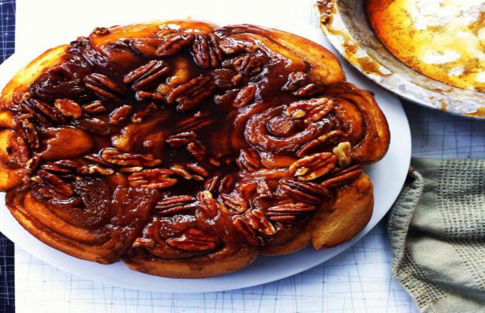
Sticky Buns
A.Method
We use the rolling method and the fermentation method.
B.Outcome
The outcome of the bread need to be soft and it should covered well with the Caramel Glaze.
C.Temperature
It should be bake at 375°F.
D.Personal though of the product
I think we didn’t do so well on this product,first the roll is not proof enough time in the proofer. So the bread didn’t become the right size. And the second is we didn’t make the glaze so well.
E.chef's critique and recommendations
Chef said the bread is not proof enough time. It not at the right size.

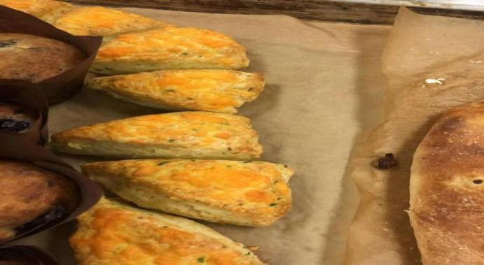
Cheddar Chives Scone
A.Method
We use the mixing method.
B.Outcome
It should be golden brown outside.
C.Temperature
It should be bake at the at 400°F for about 15 – 20 minutes.
D.Personal though of the product
I think we did a good job on this product. It is shaped well and the color is golden brown.
E.chef's critique and recommendations
Chef said it is a good product. The color is good and the texture is also good. And the only problem is we may over bake the Cheddar Chives Scone.

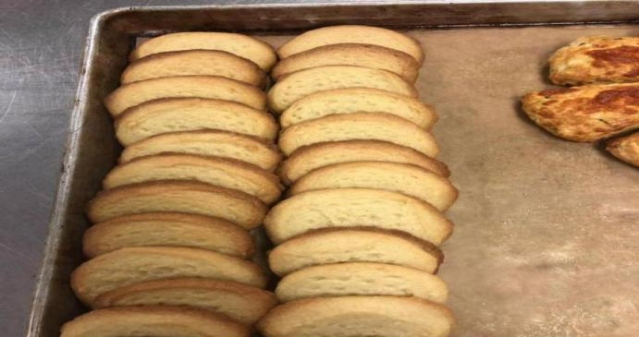
Traditional Shortbread Cookies
A.Method
We use the Cut & Pressed cookies method.
B.Outcome
It should be golden brown and with the some shape.
C.Temperature
It should be bake at 375°F (190°C) until pale golden brown, approximately 15 to 20 minutes.
D.Personal though of the product
I think we did a great job on this product. The cookie is baked well and the color is golden brown. And the texture is also good.
E.chef's critique and recommendations
Chef said the cookie is good. It is shaped well. And the color of it is golden brown. And the texture is also good.

Week 5
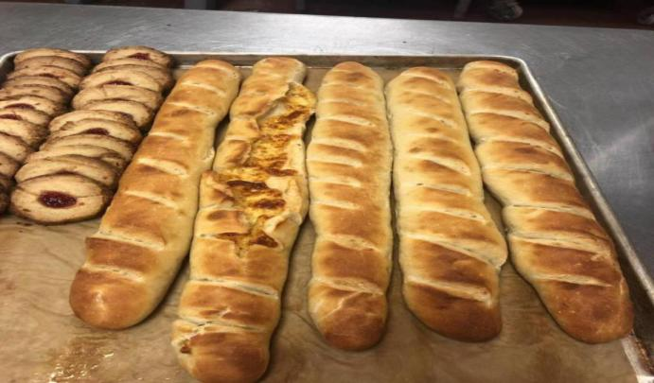
French Baguette
A.Method
We use the Baguette Method.
B.Outcome
It should be shaped well and it should be baked golden brown.
C.Temperature
The temperature should be 480 F
D.Personal though of the product
I think this product is not bad. The texture is good and the color is also good. But the shape is not that good. We still need to practice more abut the shaping.
E.chef's critique and recommendations
Chef said the product is not bad. But it is cut in the wrong way. And the shape of the bread is not good and we still need to practice more. But the texture of the bread is good.

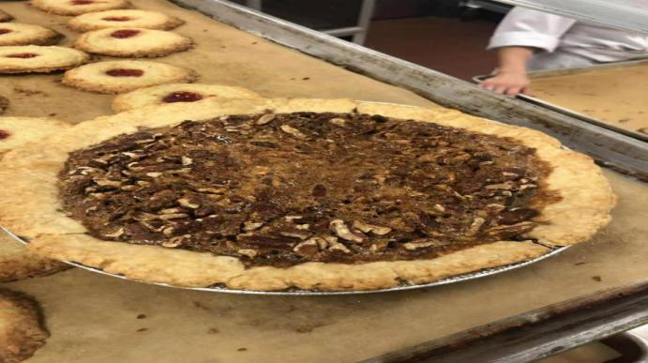
Pecan Pie
A.Method
We use the Custard Filling method.
B.Outcome
The shell need to be baked first to golden brown and then put the filling in the shell.
C.Temperature
The temperature should be at 300°F until set.
D.Personal though of the product
We didn’t finish this product. Because I break the shell when I take it out of the oven.
E.chef's critique and recommendations
We didn’t finish this product.

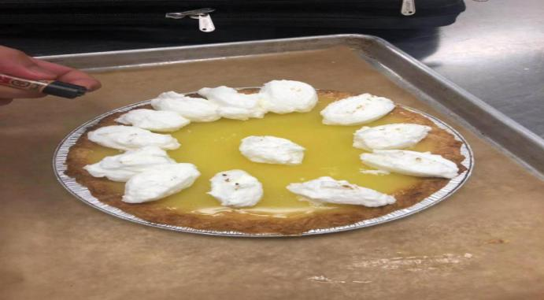
Lemon Meringue Pie
A.Method
We use the Custard Filling method.
B.Outcome
The filling should be flat. And we should put the meringue on the pie.
C.Temperature
The pie need to be cool to room temperature.
D.Personal though of the product
I think we did a good job on this product. The filling is cooked well and the shell is also baked well. The color is golden brown and the texture is good.
E.chef's critique and recommendations
Chef said it is a good product and the texture is good and the color is also good.

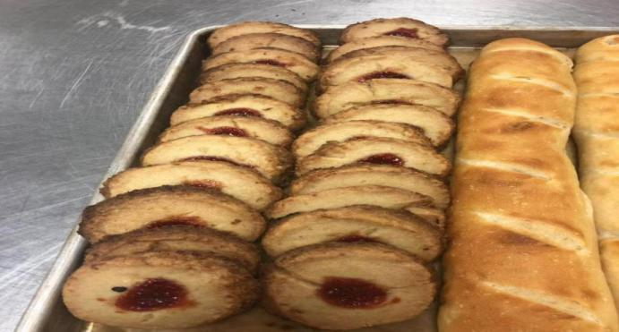
Bird’s nest cookies
A.Method
We use the Icebox cookies method.
B.Outcome
The cookie need to be baked golden brown. And put a little bit jam in the medium of the cookies. And the outside should be row with the coconut.
C.Temperature
It should be bake at 375°F for approximately 15-20 minutes
D.Personal though of the product
I think the product is not bad. It is shaped well. and the texture is also good. But I think we may overbake the cookie. So the color become a little bit dark.
E.chef's critique and recommendations
Chef said it is a good product. The texture of it is good. And the shape is also good. But the color is a little bit dark. We need to watch the baking time.

Week 6
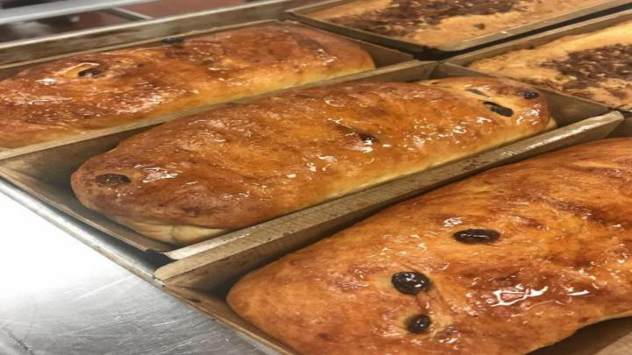
Raisin Bread
A.Method
We use the Enriched dough method.
B.Outcome
The color of it should should be golden brown. And the texture need to be soft. And it should be covered with the simple syrup to make it shiny.
C.Temperature
It should be bake at 400 F for 25 – 30 minutes.
D.Personal though of the product
I think it is a good product. The color of the bread is golden brown, and the texture of the bread is also very good. And the syrup is covered well on the top of the bread.
E.chef's critique and recommendations
Chef said it is a good product. The texture is soft. And the bread is baked well. Ans color is golden brown.

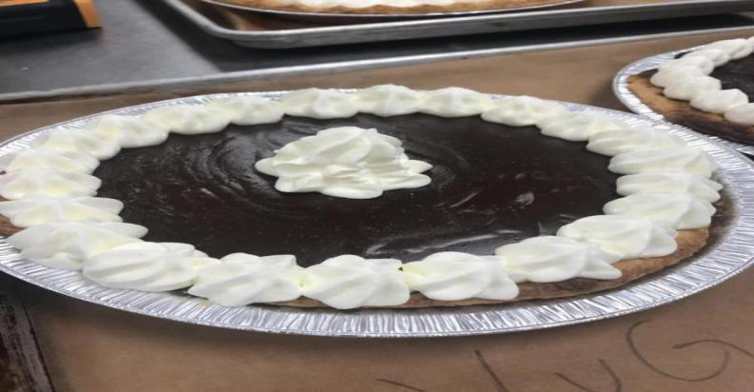
Chocolate cream Pie
A.Method
We use the Mealy pie dough method.
B.Outcome
The shell of the pie need to be baked well. It should golden brown. And the chocolate filling need to be thick enough.
C.Temperature
The shell need to bake at the 350F. and it should be put in the fridge.
D.Personal though of the product
I think the product is not bad. The shell is baked well. The color is golden brown. And I think the filling is to thick, it didn’t shaped very well.
E.chef's critique and recommendations
Chef said it is a good product. But the facade of it is not so good. We may put to much coco powder on it.
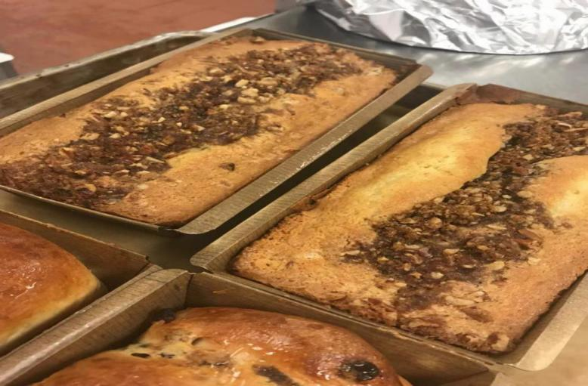
Sour cream coffee cake
A.Method
We use the Creaming method.
B.Outcome
The outside of the cake should be golden brown. And inside of the cake need to be soft. And the filling of the cake should be stay in the middle of the cake.
C.Temperature
It should be bake at 350°F (180°C) for approximately 35 minutes.
D.Personal though of the product
I think it is not bad. The texture is good. But it is not looks so good. We may put to much filling on the top of the cake.
E.chef's critique and recommendations
Chef said it is not looks so good. We put to much filling on the top of the cake. We should just put a little bit in the middle of the cake.

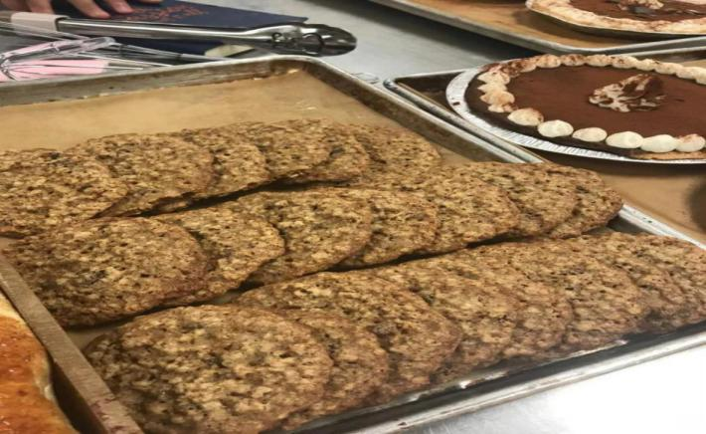
Oatmeal cookies
A.Method
We use the Creaming method and the Drop cookies method.
B.Outcome
It should be golden brown and shaped well.
C.Temperature
It should be bake at the 375°F (190°C) until golden, approximately 10 to 12 minutes.
D.Personal though of the product
I think this product is not so bad. The texture is good. But it didn’t shaped so well. Maybe we put to much fat in it. And it is over baked.
E.chef's critique and recommendations
Chef said it is over baked. So the product is a little bit dark.

Week 7
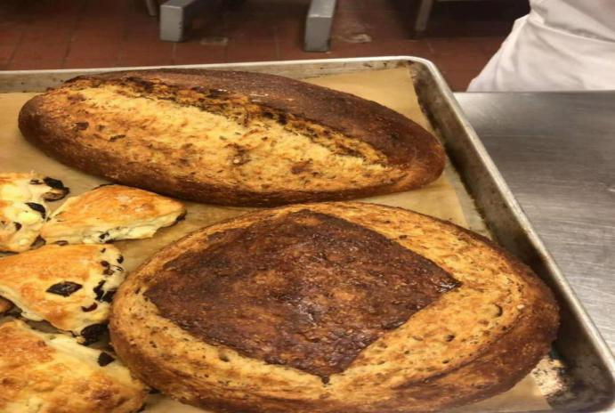

Multigrain Sourdough Bread
A.Method
We use the Sourdough Method.
B.Outcome
It should be golden brown outside and with the soft texture inside.
C.Temperature
it should be bake at Bake at 375°F (190°C) until done.
D.Personal though of the product
I think we did a good job on this product. The bread is baked well. And outside is golden brown and the texture of the bread is nice and soft.
E.chef's critique and recommendations
Chef said it is a good product. The texture of the bread is good. And the inside of the bread is also very nice.

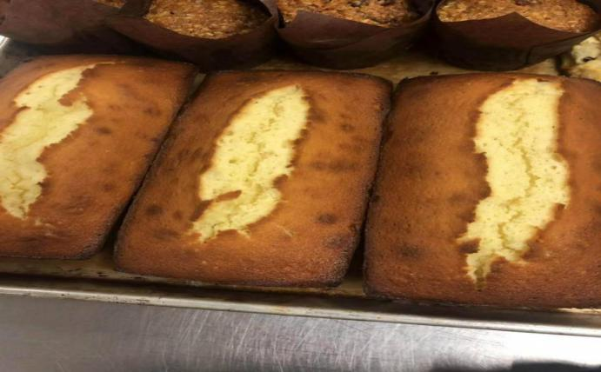
Pound cake
A.Method
We use the Creaming method.
B.Outcome
It should be golden brown outside and soft inside.
C.Temperature
It should be bake at the 400°F (200°C) for 15 minutes.
D.Personal though of the product
I think it is a good product. The outside is baked well and the inside of the cake is also good. But the middle part of the cake is a little bit under bake. May the oven temperature is not right. Maybe because somebody keep open the oven, so the oven temperature is not getting there.
E.chef's critique and recommendations
Chef said it is a good product but the middle part of the cake is still not formed well. Maybe it is not at the right temperature.

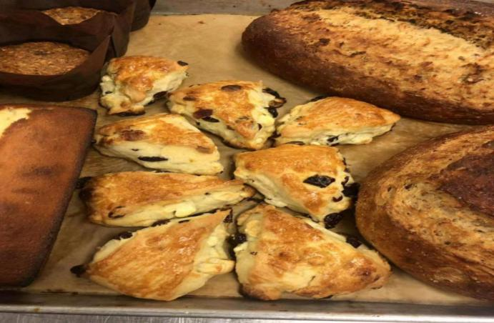
Cranberry White Cho. Scones,
A.Method
We use the Biscuit method.
B.Outcome
It should be golden brown outside.
C.Temperature
It should be bake at 400°F for 15-20 minutes.
D.Personal though of the product
I think we did a good job on this product. the scone is puffed well and the color of the scone is also very good.
E.chef's critique and recommendations
Chef said it is a good product. It was baked well. The color is golden brown and the it is also puffed well.

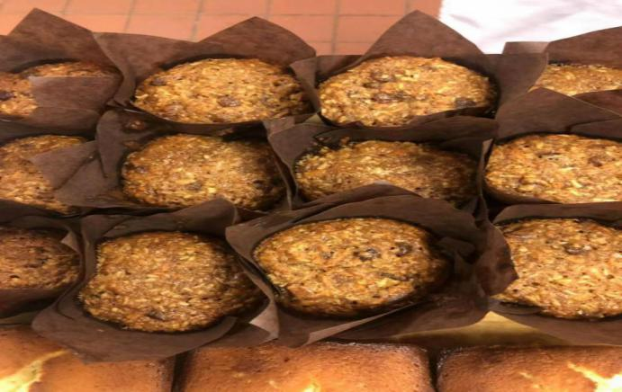

Morning Glory Muffins
A.Method
We use the Muffin Method.
B.Outcome
It should be golden brown outside and soft inside.
C.Temperature
It should be bake at 350°F until done.
D.Personal though of the product
I think it is not bad. The outside is baked well. It is golden brown and the inside of the muffin is a little bit under baked.
E.chef's critique and recommendations
Chef said it was a good product. The color of the muffin is good. But the inside of the muffin is a little bit under baked.

Week 8
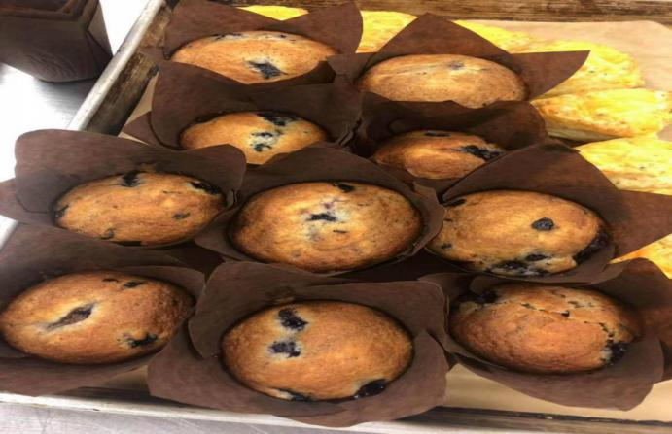
Blueberry Muffins
A.Method
We use the Creaming Method
B.Outcome
The outcome of the blueberry muffins is moist and the color it’s should be golden brown. And it should sweet and with the blueberry flavor.
C.Temperature
The muffins should be bake at 375°F for about 30 minutes or until golden brown.
D.Personal though of the product
For the finial product i think it is good. the texture of it is moist and soft. And the taste of it is also not bad. And the color is also golden brown.
E.chef's critique and recommendations
For the muffins, chef said it is not bad. The texture of it is good, it is moist and soft. And the color is also golden brown, but the size of each muffin is not equally. Next time i will make all the muffin at the right size.

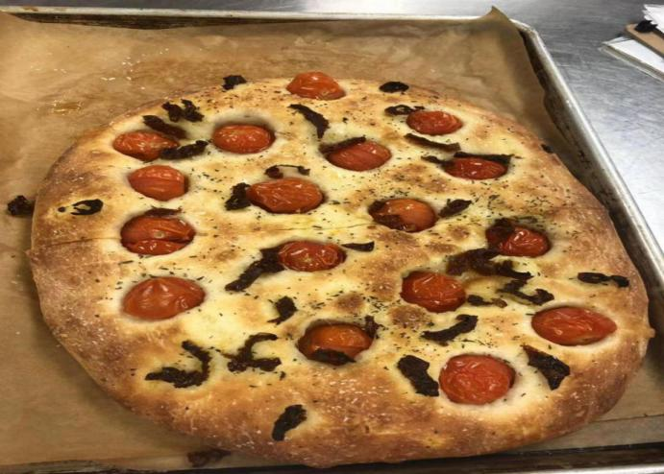
Focaccia
A.Method
We use the Slack Dough Method and Straight Dough Method
B.Outcome
The Focaccia should be golden brown outside. And the inside should be soft, and it should have an fluffy texture.
C.Temperature
It should be bake at 400°F (200°C) until lightly browned, approximately 20 minutes.
D.Personal though of the product
I think the Focaccia that we make this is not bad. The color of it is lightly brown. And it has the good fluffy texture. And the taste is also not bad.
E.chef's critique and recommendations
Chef said it is a good product. The color is good, and the texture is also good. And the bread was pressed evenly.

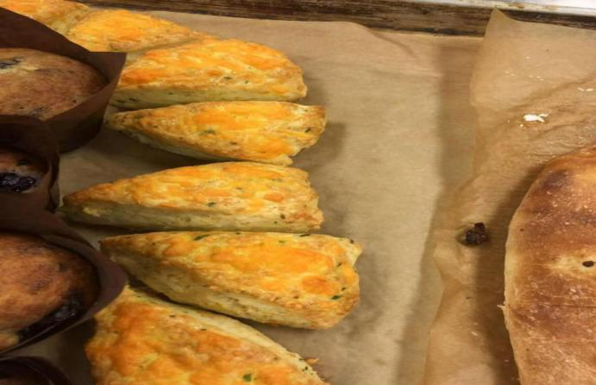
Cheddar Chives Scone
A.Method
We use the biscuit method.
B.Outcome
It should be golden brown outside.
C.Temperature
It should be bake at the at 400°F for about 15 – 20 minutes.
D.Personal though of the product
I think we did a good job on this product. It is shaped well and the color is golden brown. And it is puffed well.
E.chef's critique and recommendations
Chef said it is a good product. The color is good and the texture is also good. And it is baked well. The taste of it is also not bad.

Summary
The semester is almost over. In general, I think this semester is very interesting. During this semester, this class makes me like baking. This semester is my first time to touch baking. During the first baking class. I know nothing about baking. But after 9 weeks of study. I learned some basic knowledge about baking. My work gets better and better each time. Although I still have some problems. The basic knowledge that we have learned in class is very important. This knowledge will help us understand some advanced baking knowledge in the future. If you don't learn the basic knowledge well, it will be very difficult for you to learn more advanced knowledge in the future. So I think this class is very helpful to my future study. I will practice the knowledge that we have learned in class.

- Classical french cuisine

Week 1
Today’s Objective:
POTAGE AUX SIX OIGNONS (SIX ONION SOUP)
SAUTÉ DE POULET“MARENGO” (CHICKEN MARENGO)

Standard of Cooking and Techniques:
SAUTÉ DE POULET“MARENGO” (CHICKEN MARENGO)
We need to Sauté the chicken in one ounce of oil and one ounce of butter, browning well on all sides. And we need to Sprinkle with 2 tablespoons flour and cook to make a blonde roux, that can make the source thicker.

POTAGE AUX SIX OIGNONS (SIX ONION SOUP)
For the potato six onion soup we need to grind the onion and potato through food mill. after it is final cooking. The soup have to be thick.

Additional Information:
For the POTAGE AUX SIX OIGNONS (SIX ONION SOUP) we need to cut the ingredient at the same size, that can make all the ingredient cook evenly.

For the SAUTÉ DE POULET“MARENGO” (CHICKEN MARENGO), we need to season the chicken with the salt and pepper before the cooking. And before sante the chicken we need to put some flour on the chicken. Strain the source before serve.

What could I have done different:
For the first week in classical french cuisine class. I think we were a little bit mess in the class. I was always missing the equipment during the cooking. So that cause me waste a lot of time on take the equipment. Next time I need prepare all the equipment before cooking. For the dish that we make today. The chicken was good. The chicken was tender, and the source was thick enough. And the flavor is also good. For the six onion soup. It was also good to eat. The soup was thick and flavorful.
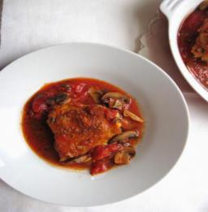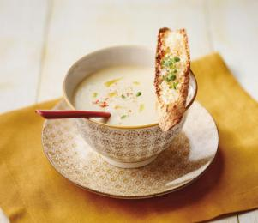
Time line
2:30 - 3:00
Prepare the ingredient
Cut the chicken
3:00 - 4:00
Start to cook the soup
Cook the chicken
4:00 - 4:30
Serve

Recipes
POTAGE AUX SIX OIGNONS (SIX ONION SOUP)
Yield: 6 servings Preparation Time: 0:45

AMOUNT MEASURE INGREDIENT PREPARATION

4.00 Ounces Bacon Diced
0.25 Ounce Butter
3.00 Each Leeks White Part Only
3.00 Each Scallion Thinly sliced
1.00 Each Large Yellow Onion Thinly sliced
2.00 Each Shallot Minced
3.00 Each Garlic Clove Coarsely chopped
24.00 Ounces White Stock
12.00 Ounces Idaho Potatoes Peeled and diced
Salt To taste
Pepper To taste
1.00 Tablespoon Fresh Chives Chopped
0.25 Cup Sour Cream Or crème fraîche

1.Cook bacon with butter over low heat until meat begins to color.
2.Add the various onions and cook over low heat until soft. NO COLOUR!!.
3.Add potatoes, sauté further until the starch begin to release.
4.Add stock and bring slowly to a boil.
5.Simmer for 30 to 40 minutes and taste; adjust seasoning if necessary.
6.Pass through food mill.
7.Taste and adjust seasoning.
8.Pass sour cream or crème fraîche.

SAUTÉ DE POULET“MARENGO” (CHICKEN MARENGO)
Yield: 4 servings

AMOUNT MEASURE INGREDIENT PREPARATION

1 Chicken 8 - cut
To taste Salt and Pepper chicken
As needed All-purpose Flour For dredging veal
1.25 Ounces Vegetable oil (corn/canola)
2.50 Ounces Butter Clarified
10.00 Ounces Yellow Onion Sliced fine
8.00 Ounces Carrot Peeled, sliced fine
2.00 Each Garlic cloves Crushed
0.33 Ounce Tomato Paste
2.00 Tablespoons All-purpose Flour
5.00 Ounces White Wine Dry
1.00 Pint Veal stock
6.00 Ounces Mushroom Washed and quartered
12.00 Ounces Tomato Peeled and Diced
18.00 Each Pearl Onions Peeled and glazed
4 Each Eggs
4 Slice White bread Crust removed and cut as per demo
Canola oil for frying
Bouquet Garni:
1.00 Each Celery 4” stick
1.00 Each Leek, split 4” , green only
1.00 Sprig Thyme
1.00 Each Bay Leaf

1.Season the chicken with salt and pepper and dredge with flour.
2.Sauté the veal in one ounce of oil and one ounce of butter, browning well on all sides. Remove the meat and set aside.
3.Add 1¼ ounce of butter and sauté the onions, carrots, and garlic without coloring. Stir in the tomato paste and return the chicken to the pan. Sprinkle with 2 tablespoons flour and cook to make a blonde roux.
4.Add the wine, let cook off to get rid of some of the acidity, then the stock as wellas the bouquet garni. Bring to a boil, cover and braise until the meat is tender.
5.Sauté the mushrooms until dry in the remaining oil and butter without browning. Add the tomatoes to the pan and sauté over high heat for 3 minutes. Season with salt and pepper. Remove from the heat and reserve.
6.When the chicken is tender, remove from the pan with a slotted spoon and set aside. Strain the sauce.
7.Heat the oil to 300º F in a shallow pan. Crack the eggs into individual bowl, and proceed to cook the eggs like you would poach eggs (beware the sputter.)
8.Fry the croutons in clarified butter.
9.Return the veal to the sauce along with the mushrooms, tomatoes and pearl onions. Bring to a boil and simmer for 5 minutes. Taste, adjust the seasonings, taste again and adjust until you are proud of your dish. Just before serving garnish the dish with the croutons, the eggs and chopped parsley.

VELOUTÉ SAUCE (THICK) preparation for week 2
Yield: 1 quart

AMOUNT MEASURE INGREDIENT PREPARATION

4.00 Ounces Butter
4.00 Ounces Flour
1.00 Quart Chicken Stock Prepared
Salt and White Pepper To taste

1.Heat the butter and add the flour to make a roux.
2.Add the chicken stock, bring to a simmer and simmer for 30 minutes.
3.Adjust seasoning with salt and white pepper to taste.
4.Strain through a double thickness of cheesecloth.

Week 2
Today’s Objective:
Crème de Cresson
Cuisses de Grenouilles à la Provençale
Suprème de Volaille “Belle Hélène”
Croquettes d’Asperges
CarottesTournees
Riz aux Amandes

Standard of Cooking and Techniques:
Crème de Cresson
The soup need to be thick and flavorful. It should be served with croutons. The leaves need to be blanch and pulse in a food processor to make a smooth puree. And it should be add into the soup at the end.
Cuisses de Grenouilles à la Provençale
Dredge frog legs in flour; shake off excess. Do not brown the frogs leg
Suprème de Volaille “Belle Hélène”
The chicken breast need to be dredge in the flour. And it should be pan fried until golden brown on broth side
Croquettes d’Asperges
The croquette need to shaped well. And it need to covered with the Bread Crumbs and egg.then we need to pan fry it. And it should be served with the chicken
CarottesTournees
It should be shaped well, and served with the chicken
Riz aux Amandes
The technique of this dish is same as the risotto

Additional Information:
For the soup the watercress stem need to be cut of from the leaves.
The shape of the chicken need to make like a heart.
The VELOUTÉ SAUCE need to be very thick, so it can be shaped well

Chef's critique and recommendations for improvement.
Chef said the flavor of each dish is nice. But some of the dish was served late. We need to need focus on the time management.

What could I have done different:
This is the second week to study in the french cuisine class. Compare with the last week. I think did better than last week. Chef said the flavor of the food is good. But it is half an hour late. So next week we need to more focus on the time management part. So I need to make a good time line. And I also need to make more communication with the group member.

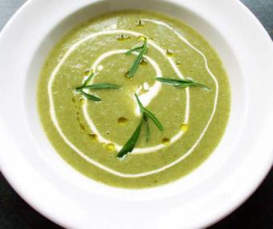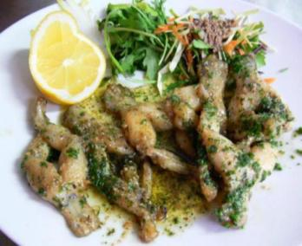
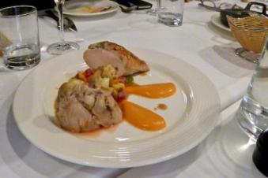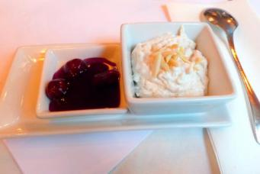
Timeline
2:30 - 3:00
Prepare the ingredient
Cook the soup
3:00 - 3:30
Start to cook the frog leg
Serve the soup
3:30 - 4:00
Start to cook the main course
Cook the side dish
4:00 - 4:30
Cook the dessert

Recipe

CRÈME DE CRESSON (Cream of Watercress)
Yield: 4 servings Preparation Time: 0:30

AMOUNT |  | MEASURE |  | INGREDIENT |  | PREPARATION
25 |  | grams |  | Butter
3 |  | each |  | Leek |  | Sliced
3 |  |  |  | Shallots |  | sliced
2 |  | bunch |  | Watercress |  | Washed
1 |  | each |  | Russet potato |  | Peeled and grated
70 |  | Ml |  | Dry Vermouth
1 |  | liter |  | Chicken Stock |  | Prepared
150 |  | ml |  | Whipping Cream
Garnish:
 |  |  |  | Croutons |  | Butter fried
0.5 |  |  |  | Dry Vermouth
 |  |  |  | Watercress leaves
- Separate the watercress leaves from the stems. Keep both
- Blanch the leaves (keep a few to for garnish) and pulse in a food processor to make a smooth puree. Keep.
- Saute the leek, shallots and watercress stems w/ o colour. Add the potatoes and sweat until the starch from the potatoes form strands.
- Add the Vermouth and cook off, then add the chicken stock and simmer the soup until the vegetables are tender. Add the cream, simmer a further 5 minutes and strain( no cheese cloth)
- When serving, heat the soup and stir in the puree and adjust the seasoning. Pour the vermouth into the tureen, ladle in the soup and top with the watercress leaves. Serve the croutons a part.

CUISSES DE GRENOUILLES À LA PROVENÇALE (Frogs Legs)
Yield: 4 servings Preparation Time: 0:30

AMOUNT |  | MEASURE |  | INGREDIENT |  | PREPARATION
8.00 |  | Pair |  | Frog Legs |  | Trimmed, trussed
4.00 |  | Ounces |  | Milk
 |  |  |  | Flour for dredging |  | One set-up per class; see Chef
2.00 |  | Ounces |  | Vegetable Oil |  | For sautéing
1.00 |  | Clove |  | Garlic |  | Minced
2.00 |  | Ounces |  | White Wine
2.00 |  | Each |  | Tomato |  | Concassé, ¼” dice
0.50 |  | Each |  | Anchovy Fillet |  | Minced
1.00 |  | Ounce |  | Black Olives
1.00 |  | Teaspoon |  | Basil |  | Julienne
- Cross the frog’s legs by inserting one leg through the calf muscle of the other. Soak legs with milk, salt, and pepper for at least a ½ hour.
- Dredge frog legs in flour; shake off excess.
- Sauté in oil until browned on both sides, remove and pat dry, arrange on a platter and keep warm.
- In the same skillet, add garlic, sauté, deglaze with wine, and reduce by half.
- Add tomatoes, anchovy, olives, and half of the basil. Simmer until sauce consistency and season.
- Pour the sauce over frog legs and sprinkle with the remaining basil.

SUPREME DE VOLAILLE BELLE HÉLÈNE
Yield: 4 servings Preparation time: 0:30

AMOUNT |  | MEASURE |  | INGREDIENT |  | PREPARATION
2.00 |  | Each |  | Whole Chicken |  | Heart shape supremes
 |  |  |  | All-purpose Flour |  | As needed
2.00 |  | Ounces |  | Butter |  | Clarified
2.00 |  | Each |  | White Bread Slices |  | Croutons, heart-shaped
2.00 |  | Ounces |  | Butter |  | Beurre Noisette
8.00 |  | Ounces |  | Brown Stock |  | Jus Lie
1.00 |  | Pound |  | Russet Potato |  | Tourné
2.00 |  | Ounces |  | Butter
- Dredge heart-shaped chicken breast in flour, shake off excess, sauté in clarified butter.
- Arrange a heart-shaped crouton in circle on a dish, top with a heart-shaped croquette made of asparagus tips.
- Arrange sautéed suprêmes on croquette and top with beurre noisette.
- Garnish plate with potatoes and carrots.
- Serve jus lie on the side.

CROQUETTES D’ASPERGES (ASPARAGUS CROQUETTES)
Yield: 4 servings Preparation time: 0:30

AMOUNT |  | MEASURE |  | INGREDIENT |  | PREPARATION
3.00 |  | Ounces |  | Asparagus |  | Cut very fine and blanched (if possible make before class)
1.50 |  | Ounces |  | Mushroom |  | Cut very fine
1.00 |  | Ounce |  | Ham |  | Cut very fine
2.00 |  | Ounces |  | Velouté |  | Very thick prepared
2.00 |  | Each |  | Egg White
4.00 |  | Ounces |  | Bread Crumbs |  | For breading station; seasoned
2.00 |  | Each |  | Eggs |  | Lightly beaten
8.00 |  | Ounces |  | Butter |  | Clarified
- Combine the first 5 ingredients, mix together, and spread on sheet pan. Let sit in the freezer before cutting flattened heart shapes and chill again.
- Dredge in flour, shake off excess, dip in chilled egg wash, and roll in breadcrumbs.
- Pan-fry in clarified butter, drain on absorbent paper.

VELOUTÉ SAUCE (THICK)

Yield: 1 quart

AMOUNT |  | MEASURE |  | INGREDIENT |  | PREPARATION
4.00 |  | Ounces |  | Butter
4.00 |  | Ounces |  | Flour
0.75 |  | Liter |  | Chicken Stock |  | Prepared
 |  |  |  | Salt, White Pepper and Nutmeg |  | To taste
- Heat the butter and add the flour to make a roux.
- Add the chicken stock, bring to a simmer and simmer for 30 minutes.
- Adjust seasoning with salt, nutmeg and white pepper to taste.
- Strain through a double thickness of cheesecloth.

CAROTTES TOURNEES
Yield: 4 servings Preparation time: 0:30

AMOUNT |  | MEASURE |  | INGREDIENT |  | PREPARATION
1.50 |  | Pounds |  | Carrot |  | Peeled and turned
4.00 |  | Ounces |  | Butter
1.00 |  | Ounce |  | Sugar
 |  |  |  | Salt and Pepper |  | To taste
- Tourne carrots.
- In a sauté pan cover carrots with water. Add butter, sugar, and a pinch of salt. Parboil carrots al dente.
- Remove the carrots saving the liquid. Reduce liquid to syrupy consistency.
- At serving time reheat carrots in syrup.

RIZ A L’AMANDES
Yield: 4 servings Preparation time: 0:45

For the rice
AMOUNT |  | MEASURE |  | INGREDIENT |  | PREPARATION
150 |  | gram |  | Arborio Rice |  | washed and blanched
1 |  | liter |  | Milk
50 |  | gram |  | Sugar
3 |  | gram |  | Salt
2 |  | tblsp. |  | Vanilla essence
½ |  |  |  | Lemon |  | rind only
75 |  | grams |  | Almonds |  | slivers,
500 |  | ml |  | Whipping cream |  | whipped to soft peaks
- Bring the milk to a simmer with the sugar, salt and vanilla.
- Add the blanched rice and let simmer under lid until the rice is tender and all the milk has been absorbed. Be careful it burns easily. Chill.
- Fold in the lemon peel and the almonds, and finally the whipped cream.
- Arrange and serve in a bowl, nicely decorated with Cherry Sauce separately.

For the sauce:
AMOUNT |  | MEASURE |  | INGREDIENT |  | PREPARATION
300 |  | ml |  | Cherry Juice
100 |  | ml |  | Water
2 |  | slice |  | Lemon
½ |  |  |  | Cinnamon stick
 |  |  |  | Cornstarch |  | to thicken
½ |  | Cup |  | Frozen cherries
- Combine the liquids and add the lemon and cinnamon
- Bring to a boil and thicken with the cornstarch slurry. Adjust the flavour with sugar if needed.

Week 3
Today’s Objective:
Consommé “Alexandra”
Coeur de Laitue “Mimosa”
Fillet de Sole Aux Courgettes
Ris de Veau Braisés
Pommes de Terre Noisettes
Flan de Légumes
Standard of Cooking and Techniques:
Consommé “Alexandra”
The soup need to be pure. There is no impurities should be found in the soup. For the garnish the chicken need to be cut into julienne.
Coeur de Laitue “Mimosa”
The vegetable need to be fresh. For the garnish the egg need to be chopped, and put it on the top of the vegetables.
Fillet de Sole Aux Courgettes
Stew the fish with the vegetable, and garnish with the basil.
Ris de Veau Braisés
Cook the Calf’s Sweetbreads with the seasoning and vegetables and serve with the onion and the carrot and the green pea.
Flan de Légumes
Cook broccoli by boiling method, drain shock, and drain well. Reserve. Sauté onion in clarified butter until translucent. Purée in a food processor. Mix purée, heavy cream and eggs. And Bake in a water bath
Additional Information:
For the Flan de Légumes the broccoli need to be strained well.
For the Ris de Veau Braisés cook the Sweetbreads well. It should be lightly brown on each said
Chef's critique and recommendations for improvement.
Chef said the flavor of each dish is quit good. But some of the dish was served late. We need to make a good time line, make sure we can finish all the dish on time.
What could I have done different:
For this week, some of the part i think a did a good job. I help other group member to prepare the ingredient. But my dish is served late. So next week i need to finish my job first. And than i can go to help other people. I need to organize my time effectively.
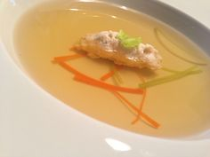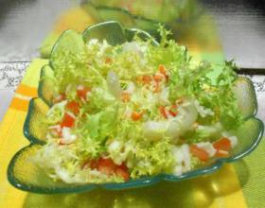

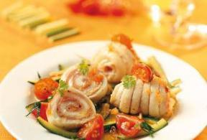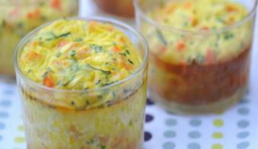
Time line
2:30 - 3:00
Prepare the ingredient
Start to cook the soup
3:00 - 3:30
Start to make the salad
Serve the soup
Start to make the fish
3:30 - 4:00
Start to make the main course
4:00 - 4:30
Start to make the dessert

Recipe
CONSOMMÉ ALEXANDRA (CHICKEN CONSOMMÉ)
Yield: 4 servings Preparation Time: 1:00

AMOUNT |  | MEASURE |  | INGREDIENT |  | PREPARATION
3.00 |  | Quarts |  | Chicken Stock
1.50 |  | Pounds |  | Ground Beef |  | Or ground chicken
4.00 |  | Each |  | Chicken Giblets
1.00 |  | Each |  | Whole Chicken |  | Lightly roasted
2.00 |  | Ounces |  | Carrot |  | Chopped fine
8.00 |  | Ounces |  | Leek |  | Chopped fine
4.00 |  | Each |  | Egg Whites
 |  |  |  | Seasoning or spice |  | As needed
- Fabricate the chicken into 8 pieces. Reserve carcass for stock. Poach one breast for garnish. Dark meat and second breast for forcemeat.
- Combine ground meat, vegetable, egg whites, and spices as required (mix well, keep chilled).
- Mix stock into above mixture (agitate well to evenly distribute ingredients throughout stock to insure better clarification).
- Place mixture in a heavy-bottomed stock pot.
- Bring gently to a simmer (stir occasionally until a raft forms then do not stir).
- Simmer carefully through several layers of cheese cloth.
- Degrease and adjust salt.
- Add garnish just before serving.
Note: Garnish for each service: 1 tablespoon fine julienne of cooked white of chicken; 2 tablespoons small grooved quenelles made from chicken forcemeat; 1 tablespoon chiffonade of lettuce

COEUR DE LAITUE “MIMOSA” (LETTUCE HEARTS “MIMOSA”)
Yield: 4 servings Preparation Time: 0:30

AMOUNT |  | MEASURE |  | INGREDIENT |  | PREPARATION
1.00 |  | Head |  | Butter Lettuce |  | Prepared
0.40 |  | Cup |  | Bacon Vinaigrette |  | Prepared
1.00 |  | Each |  | Hardboiled Eggs |  | Chopped for garnish
- Remove the blemished outer leaves of the butter lettuce.
- Soak the heads of lettuce in ice water for 1 hour, drain and dry.
- Cut each head into 8 wedges; dip them in the bacon dressing.
- Place 2 wedges per serving on a salad plate and sprinkle them with the chopped hardboiled eggs.

BACON VINAIGRETTE
Yield: 4 servings Preparation Time: 0:20

AMOUNT |  | MEASURE |  | INGREDIENT |  | PREPARATION
0.40 |  | Ounce |  | Bacon |  | ¼” diced
1.20 |  | Ounces |  | Onion |  | ¼” diced
0.80 |  | Ounce |  | Sherry Wine Vinegar
0.80 |  | Ounce |  | Olive Oil
1.60 |  | Ounces |  | Chicken Stock |  | Prepared
 |  |  |  | Salt and Pepper |  | To taste
- Prepare all the ingredients as listed above. Set up in ramequins for tableside presentation.
- Place the bacon in a sauté pan and render the bacon lightly, not crisp.
- Add the onions to the bacon and sweat until translucent.
- Deglaze with the sherry vinegar, add the oil and stock.
- Bring to a boil, remove from the heat and season to taste.
Note: Set up gueridon with induction burner for table side preparation

FILET DE SOLE AUX COURGETTES (FILLET OF SOLE WITH ZUCCHINI)
Yield: 4 servings Preparation Time: 0:30

AMOUNT |  | MEASURE |  | INGREDIENT |  | PREPARATION
10.00 |  | Ounces |  | Zucchini |  | Cut into ¼” slices
1.00 |  | Ounce |  | Butter |  | Whole
3.00 |  | Ounces |  | Tomato |  | Concassé, ¼” dice
0.25 |  | Teaspoon |  | Lemon Juice
1.00 |  | Pinch |  | Basil Leaves |  | Chopped
 |  |  |  | Salt and Pepper |  | To taste
4.00 |  | Each |  | Sole Fillet |  | 4 – 5 oz each seasoned
0.50 |  | Cup |  | Breadcrumbs
- Stew the zucchini in butter with tomato, lemon juice, basil, salt and pepper.
- Fold the sole fillets. Place in the bottom of a buttered casserole.
- Cover fish with zucchini mixture, sprinkle with breadcrumbs.
- Bake in a hot oven until the fish is done and crumbs are brown.

RIS DE VEAU BRAISÉS (BRAISED CALF’S SWEETBREADS)
Yield: 4 servings Preparation Time: 0:45

AMOUNT |  | MEASURE |  | INGREDIENT |  | PREPARATION
2.20 |  | Pounds |  | Calf’s Sweetbreads |  | Not trimmed; 4 x 8.5 oz
1.50 |  | Ounces |  | Butter
3.50 |  | Ounces |  | Carrot
3.50 |  | Ounces |  | Yellow Onion
1.00 |  | Each |  | Sachet d’epices
2.00 |  | Ounces |  | White Wine
1.00 |  | Ounces |  | Madeira |  | Or Port Wine
16.00 |  | Ounces |  | Beef Stock |  | Thickened
0.50 |  | Ounces |  | Butter
 |  |  |  | Accompanying Garnish:
12.00 |  | Ounces |  | Green Peas
1.00 |  | Ounce |  | Butter
8.00 |  | Each |  | Pearl Onion
4.00 |  | Ounces |  | Lettuce Leaves |  | Romaine, Bib, Butter
4.00 |  | Ounces |  | Carrot
4.00 |  | Ounces |  | Turnips
1.00 |  | Ounce |  | Butter
- Prepare the calf’s sweetbreads (preferably the day before):
  - Soak the sweetbreads in ice cold water, changing the water frequently.
  - Blanch them for 3 – 4 minutes, then refresh and drain well.
  - Remove any fatty parts, as well as any nerves and cartilages and trim into shapes if necessary.
  - Place the trimmed sweetbreads under pressure, together with the trimmings, in a refrigerator until required.
- Prepare the aromatic garnish:
  - Peel, wash, and slice the carrots and onions
  - Wash and stalk the parsley; make a sachet
- Cook the sweetbreads:
  - Season the sweetbreads with salt and pepper and brown them in a sauteuse in order to tighten them up. Remove.
  - Add the aromatic garnish and trimmings from the sweetbreads and cook without browning for 3 – 5 minutes.
  - Remove excess fat, if any, and place the sweetbreads on the garnish.
  - Deglaze with the white wine and let reduce.
  - Add the Madeira or Port and reduce again.
  - Add the brown stock.
  - Check the seasoning and add the sachet.
  - Cook the sweetbreads in a preheated 400°F oven for about 35 to 40 minutes.
- Prepare the garnish:
  - Shell and wash the peas if fresh.
  - Peel wash and tourné “turn” the carrots and turnips (1 – 2 pieces per servings).
  - Cook carrots and turnips by glazing “a blanc” method.
  - Peel, wash, and cook the pearl onions by the same method.
  - Remove damaged outside leaves from the lettuce, pull off good leaves removing stalks. Wash well.
- Cooking fresh green peas:
  - Sweat the chiffonade of lettuce in butter in a saucepan.
  - Add the green peas and 6 oz of water.
  - Cook the green peas slowly, covered, for about 20 – 25 minutes if fresh peas and just a few minutes if frozen peas are used. Pay attention to the reduction of the water. It is usual to thicken the peas with a little butter kneaded with flour “beurre manie” – ask the Chef.
  - Correct seasoning with salt and pepper.
- Finish and glaze the calf’s sweetbreads:
  - Check that they are cooked and transfer them to a plate.
  - Pass the sauce through a fine strainer without pressing it.
  - Remove excess fat, if necessary. Check the consistency and seasoning.
  - Glaze the sweetbreads just inside the oven or under the salamander.
  - Keep sauce hot separately.
- Finish the green peas:
  - Check that they are cooked, and add the carrots, turnips, and onions.
  - Check the seasoning and adjust. Serve.

FLAN DE LEGUMES (VEGETABLE FLAN)
Yield: 4 servings

AMOUNT |  | MEASURE |  | INGREDIENT |  | PREPARATION
8.00 |  | Ounces |  | Broccoli |  | Or other vegetables
1.00 |  | Ounce |  | Butter
1.00 |  | Ounce |  | Onion |  | Medium dice
4.00 |  | Ounces |  | Heavy Cream
4.00 |  | Each |  | Whole Eggs |  | Beaten
 |  |  |  | Salt and Pepper |  | To taste
 |  |  |  | Nutmeg |  | Lightly, to taste
- Cook broccoli by boiling method, drain shock, and drain well. Reserve.
- Sauté onion in clarified butter until translucent.
- Combine the drained broccoli and onion. Purée in a food processor.
- Mix purée, heavy cream and eggs.
- Season and pour into buttered 3 ounce soufflé cups.
- Bake in a water bath (loosely covered in a 325°F oven until set, about 45 minutes).
- Un-mold delicately and plate.

Week 4
Today’s Objective:
Bisque de Crevettes
Artichauts nature a la sauce
Piece d’Agneau “Provencale”
Poire Belle Helene
Standard of Cooking and Techniques:
Bisque de Crevettes
This is the thick soup. It should be thick enough and with the shrimp flavor.
Artichauts nature a la sauce ravigotte
This is the artichauts salad. The artichauts should be boiled well. It should be soft.
Piece d’Agneau “Provencale”
The lamb need to be cooked to middle and it should be coat well with the bread crumb.
Poire Belle Helene
The pear need to be boiled in the seasoned water. It should be soft. Serve it with the melt chocolate.
Additional Information:
For the lamb it need to be marinade with the Dijon mustard. The temperature need to achieve140 F
For the soup. We need to cook the shrimp shell to increase the flavor.
Chef's critique and recommendations for improvement.
Chef said the soup was a little bit thick and for the other dish is all good. But we still need more group work.
What could I have done different:
For this week I think I did better that last week. I manage my working time better. And my work table is not like the last week. My working table is clean. It was so mess last week. And the flavor of my dish is also not bad.
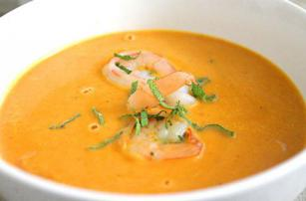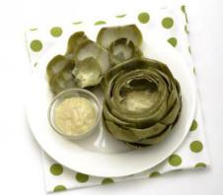
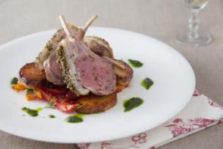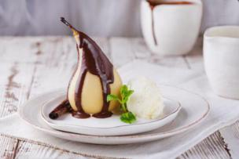
Time line
2:00 - 2:30
Prepare the ingredient for the soup
Cook the soup
2:30 - 3:00
Prepare the ingredient for Artichauts nature a la sauce
Cook the Artichauts
3:00 - 3:30
Cook the lamb
3:30 - 4:00
Prepare the side dish
Start ti make the dessert.

Recipe
BISQUE DE CREVETTES

AMOUNT MEASURE INGREDIENT PREPARATION
1000 gram Prawn or lobster shells
125 gram Onion Diced
50 gram Celery Diced
50 gram Carrot Diced
2 Shallot Diced
4 cloves Garlic Chopped
¼ cup Rice
3 Tomato Rough chop
1 Bouquet garni
50 ml Brandy
175 ml White wine
1 liter Clam nectar
200 ml Whipping cream

150 gram prawns Peeled and deveined

1. Heat a little vegetable oil in a pot. Caramelize the prawn shells.
2.Add the vegetables and let caramelize. Then add the rice and let them coat in the oil.
3.Add brandy, flame briefly, then add the tomatoes, the bouquet garni and the white wine and let reduce by half.
4.Add the nectar and let simmer for 1 hour, skimming occasionally.
5.Remove the shells and the solids and puree in a food mill, the return to the liquid and simmer a further 15 minutes.
6.Strain the bisque and add the cream.
7.Adjust the seasoning, and then poach the prawns in the bisque.
8.Serve the bisque garnished with the shrimp.

ARTICHAUTS NATURE A LA SAUCE RAVIGOTTE
Yield: 4 servings Preparation Time: 0:45

AMOUNT MEASURE INGREDIENT PREPARATION

4.00 each Artichokes
4 slices Lemon
1.00 recipe Dijon Vinaigrette
2 Eggs Hard boiled, yolk and white separated
2 Tblsp. Mixed mild herbs (fix: parsley, chives, tarragon,) chopped

1.Trim the tip off the leaves of the artichoke with scissors. Cut the stem off the artichoke and cover the cut with the lemon slice, and then truss the artichoke to keep the lemon in place.
2.Place the artichoke in boiling salted water and cook until tender but with the leaves still attached to the bottom. Let the artichoke cool to room temperature in the cooking liquid ( remember this when timing the cooking)
3.To make the dressing: Whisk the cooked egg yolk with the vinaigrette to make an emulsion, then add the copped whites and the herbs (optional: capers).
4.To serve take the artichoke from the pan and drain thoroughly, then untie. Place the artichoke on a folded napkin. Serve the dressing separately.

PIECE D’AGNEAU “PROVENÇALE”
Yield: 4 servings

AMOUNT MEASURE INGREDIENT PREPARATION

1 Lamb rack Trimmed and frenched
2 Tblsp Dijon mustard
1/3 Cup Bread crumbs sifted
½ bunch Parsley Finely chopped
1 clove Garlic Finely chopped
1/2 teasp Fresh Thyme Finely chopped

4 Cloves garlic Not peeled
75 ml Red wine
350 ml Demi-glace

1.Season the rack very carefully and brown on all sides in a little olive oil. Let rest
2.Brush the rack on the top and sides with the Dijon mustard. Let marinate 1 hour at room temperature
3.Sauté the chopped garlic very lightly in olive oil, and add the breadcrumbs. Mix well and toast the crumbs to golden. Let cool and mix with the chopped herbs
4.Coat the rack with the herbed crumbs and roast in a preheated 425º F oven to medium with the whole garlic in the same pan.
5.Remove the lamb from the pan, deglace with the red wine and reduce by half. Add the demi-glace and reduce further to sauce consistence. Strain the sauce, monté with butter and serve a part. Keep the whole garlic for garnish.
6.Serve the rack whole for carving garnished with the whole garlic, two suitable vegetables and Maxim Potatoes.

POIRES BELLE HELENE
Yield: 4 servings

AMOUNT MEASURE INGREDIENT PREPARATION

4 Pears Peeled and cored

1 liter water
1 lemon One strip of peel and all the juice
½ Vanilla pod
½ Cinnamon stick
125 Gram Sugar

150 gram Semisweet chocolate
100 ml Whipping Cream

1.Bring the water to a simmer with the sugar lemon, vanilla and cinnamon to make syrup. Place the poached pears in this, cover with a cartouche and simmer until the pears are tender. Let cool in the syrup.
2.Prepare the sauce by melting the chocolate in the cream in a Bain Marie.
3.To serve arrange the pears in a service platter, napper with the sauce and sprinkle with toasted almond flakes. Serve with Vanilla Ice cream (find recipe) and whipped cream.

Week 5
Today’s Objective:
Crème de Topinambours Truffee
Mille-Feuille de Saumon au Cerfeuil
Julienne de Légumes
Tournedos “Choron” (Chateaubriand)
Pommes “Soufflees”
Tarte des Demoiselles Tatin
Standard of Cooking and Techniques:
Crème de Topinambours Truffee
It is the cream soup that is made by Jerusalem Artichokes. It should be thick.
Mille-Feuille de Saumon au Cerfeuil
It is the dish that is made by the salmon and the baked puff pastry and with the flavor sauce.
Julienne de Légumes
it is the side dish of the main couse. The vegetable need to be julienne and saute with the butter.
Tournedos “Choron” (Chateaubriand)
We use the Beef Tenderloin of this dish. Each portion need to have 4OZ beef on each plate.
Pommes “Soufflees”
This dish is a deep fried sliced potato. The potato need to be puff up.
Additional Information:
For the soup the Jerusalem Artichokes need to be peeled.
For the Pommes “Soufflees”. it need to be sliced in 1/8”.
Chef's critique and recommendations for improvement.
Chef said the dish’s flavor is not bad. But it is still served late. Next time we may need to make a good time line. And for the soup. I didn’t put the Truffle oil on it.
What could I have done different:
I think I did a good job on this week. The flavor of our dish is quit good. The presentation is good. But we still served it late. Next time i will make a better timeline.
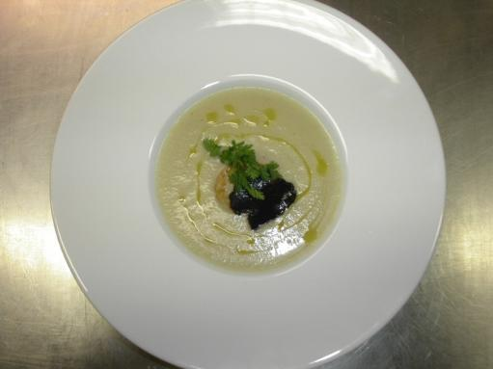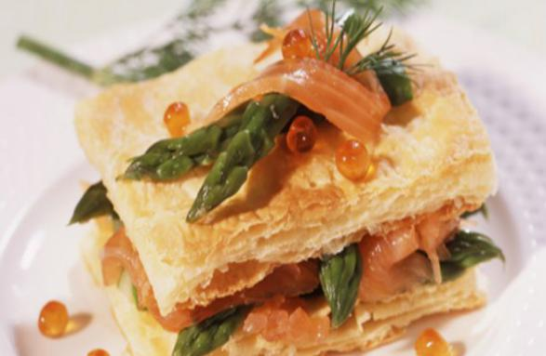
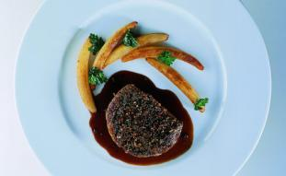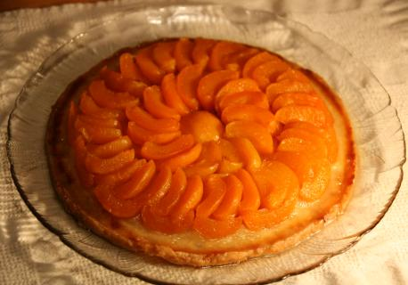
Timeline
2:30 - 3:00
Start to prepare the ingredient for the soup
Cook the soup
3:00 - 3:30
Start to prepare the ingredient for Mille-Feuille de Saumon au Cerfeuil
Cook the Mille-Feuille de Saumon au Cerfeuil
3:30 - 4:00
Start to make the main course
Make the side dish
4:00 - 4:30
Start to make the dessert

Recipe
CRÈME DE TOPINAMBOURS TRUFÉE
Yield: 4servings

AMOUNT MEASURE INGREDIENT PREPARATION

2.00 Ounces Butter
4.00 Ounces Onions Diced
2.00 Ounces shallots Diced
2.00 Pounds Jerusalem Artichokes Sliced

1.00 Quart Chicken Stock Cold
Salt and Pepper To taste

8.00 Ounces Heavy Cream Heated

2.00 Each Egg Yolks
Truffle oil to taste
Garnish:
Jerusalem Artichoke chips Fried

1.Sweat the onions and shallots in the clarified butter until translucent. Add the Jerusalem Artichokes and sweat until the they begin to release their juices.
2.Add the stock, simmer until reduced by one-quarter, then stir in cream. Let simmer until the Jerusalem artichokes are very soft
3.Purée the soup with a stick mixer or food mill. Return the velouté to the pot and bring to a simmer. Season with truffle oil and salt and pepper to taste and strain through a fine chinois.
4.Combine additional cream and the egg yolks. Temper and add the liaison to the soup.
5.Garnish with the chips.

JULIENNE DE LEGUMES (VEGETABLES JULIENNE)
Yield: 4 servings Preparation time: 0:20

AMOUNT MEASURE INGREDIENT PREPARATION

1.00 Ounce Butter Whole
2.00 Ounces Carrot Julienne
2.00 Ounces Turnip Julienne
2.00 Ounces Yellow Squash Julienne
2.00 Ounces Zucchini Julienne
Salt and Pepper To taste

1.Sweat carrots and turnips in butter until half-way cooked. Then sweat 2 – 3 minutes longer.
2.Add yellow squash and zucchini and cook until tender.
3.Season. Serve.

MILLE-FEUILLES DE SAUMON AU CERFEUIL
Yield: 4 servings Preparation Time: 0:45

AMOUNT MEASURE INGREDIENT PREPARATION

0.75 Pound Puff Pastry Rolled into 17 x 14
1.50 Tablespoons Butter Whole melted
2.00 Teaspoon Shallot Finely minced
1.00 Teaspoon White wine vinegar
4.00 Ounces Dry Vermouth Dry
4.00 Ounces Fish stock
8.00 Ounces Heavy Cream
Salt and Cayenne Pepper To taste
1.00 Pound Salmon Sliced ⅛” thick
0.13 Bunch Chervil Fresh finely chopped

1.Preheat oven 425°F.
2.Cover a perfectly flat sheet pan with parchment. Place puff pastry on it and dock well with fork. Cover with another parchment and on top of it another perfectly flat sheet pan to control rising.
3.Bake in a pre-heated oven for 20 minutes then reduce heat to 350°F and cook 15 minutes longer. Remove sheet pan and check doneness. It must have a nice, light brown color and be crispy and flaky. If necessary put back in the oven to finish cooking without the top sheet pan liner and paper but be careful now because it will pick up color fast not that it is uncovered and almost done.
4.Prepare the sauce: melt 1 tablespoon butter over low heat.
5.Add shallots and cook (sweat) until softened but not colored.
6.Add the vinegar and reduce over medium heat until au sec, but shallots remain wet.
7.Add the vermouth and reduce by half.
8.Add the fish stock and reduce by half
9.Add cream, salt, and cayenne pepper to taste.
10.Reduce to sauce consistency (nappé).
11.Using a serrated knife, cut puff pastry sheet in 4 even-sized rectangles lengthwise. Keep warm.
12.Cook the salmon in remaining butter (use no stick pan). Do not overcook.
13.Build mille-feuilles: start with a rectangle of pastry. Cover with a layer of salmon top with another layer of pastry and repeat until all ingredients have been used. Your 4th layer of puff pastry should be the top of your mille-feuille prior to slicing.
14.Trim the edges lightly with a serrated knife, and divide in 4 even portions.
15.Adjust the flavour of the sauce, add some chopped chervil.
16.Set the julienne of vegetables as a nest, then arrange mille-feuilles on top and spoon sauce over the top and around the bottom of the pastry.
17.Decorate with chervil sprigs.

Note: Work with your puff pastry cold, and keep it covered when not in use. Flour your table, your rolling pin and a little on the top of the dough when rolling it. Do not allow it to stick. Work swiftly as not to allow your dough to warm up and get sticky. Brush the flour off the dough before cooking.
Note: Roll your puff pastry thin. Make sure your oven has reached 425°F prior to baking.

TOURNEDOS CHORON
Yield: 4 servings

AMOUNT MEASURE INGREDIENT PREPARATION

16.00 Ounces Beef Tenderloin Tournedos – 4 oz each
0.25 Each French Bread Croutons
4.00 Each Artichoke Bottoms Trimmed and braised
6.00 Ounces Snap peas
8.00 Ounces Sauce Choron Prepared
2.00 Ounces Demi Glace

1.Sauté tournedos. Set on top of crouton.
2.Set artichoke bottom on top. Fill with buttered peas or asparagus. Surround with Demi-glace
3.Serve sauce and Souffle potatoes on the side.

SAUCE CHORON
Yield: 4 servings

AMOUNT MEASURE INGREDIENT PREPARATION

3.00 Ounces White Wine
2.00 Ounces Tarragon Vinegar
2.00 Tablespoons Shallot Chopped
0.50 Ounce Tarragon Chopped
4.00 Each Black Peppercorns Chopped
1.00 Pinch Salt
1.00 Ounce Water
3.00 Each Egg Yolks
9.00 Ounces Butter Clarified
Tomato Purée As needed, up to ¼ volume of sauce

1.Combine first 6 ingredients. Reduce until almost dry (au sec). Refresh with water.
2.Add reduction to egg yolks in a stainless steel bowl. Whip until soft peak over a water bath or simmering water.
3.Remove from heat. Whisk in butter adding slowly.
4.Strain and finish with tomato purée. Taste and adjust seasoning.

POMMES DE TERRE SOUFFLÉES
Yield: 4 servings Preparation Time: 0:45

AMOUNT MEASURE INGREDIENT PREPARATION

3 Russet Potatoes Peeled and trimmed as per chef demo

Method:
1.Slice potatoes 1/8’ thick and soak in plenty of ICED water.
2.Heat oil to 275º F. Dry the potato slices on a towel and oil-blanch in small batches, stirring to avoid the slices sticking together. When they begin to blister, remove them to a fat absorbent paper. Line the cooked potato on parchment strips.
3.To serve, bring the temperature up to 385º F. Drop the potatoes one by one into the fryer and fry until they puff and are golden. Drain them well and serve immediately in a potato basket.

TARTE DES DEMOISELLES TATIN (UPSIDE-DOWN APPLE TART)
Yield: 6 servings Preparation Time: 0:45

AMOUNT MEASURE INGREDIENT PREPARATION

6.00 Each Granny Smith Apples Peeled, keep whole
6.00 Ounces Butter
8.00 Ounces Granulated Sugar
8.00 Ounces Puff Pastry

1.In a 6” sauté pan place the butter and sugar and melt slowly, stirring occasionally, allowing it to caramelize to a light brown.
2.Remove both ends of the apple with a melon baller. Cut the apple in half from stem end down. Remove core with the melon baller (see Chef Demo).
3.Roll puff pastry to ⅛” thick and 8” diameter. Dock and refrigerate.
4.Place the apple halves standing up and back-to-back in a crown in the caramelized butter-sugar mixture until you cover the entire bottom of the sauté pan. Wedge smaller pieces of apple in between to ensure tight packing.
5.Place the sauté pan back on low heat for 4 minutes.
6.Cover the apples with the puff pastry and tuck in the edges.
7.Place in a preheated 375°F oven for 20 minutes to finish baking the apples and the puff pastry.
8.When done refrigerate to gelatinize the cooked apples and the juice.
9.When ready to serve you might have to reheat the sauté pan a little to loosen the apples.
10.Carefully turn over the tart onto a platter. Et voila! Seve with whipped unsweetened cream.

Week 6
Today’s Objective:
Consomme Royale
Paupiettes de Sole au Saumon, Sauce Ciboulette
Carre de Porc Roti, Sauce Piquante
Pommes Savoyarde,
Harcots Verts et Choux-fleurs a la Polonaise
Les Iles Flotantes
Standard of Cooking and Techniques:
Consomme Royale
The soup need to be clear, and it should be flavorful.
Paupiettes de Sole au Saumon, Sauce Ciboulette
The fish need to cut well and wrapped well, and it also need to pouched well.
Carre de Porc Roti, Sauce Piquante
The pork need to be tender, and the source need to be thick enough and flavorful.
Pommes Savoyarde,
The potato need to be sliced and baked in the oven. And we also need to covered the potato with the cheese. And the cheese also need to be golden brown.
Les Iles Flotantes
The egg need to be whipped and pouched in the water.
Chef's critique and recommendations for improvement.
Chef said we did a great job this week. The dish is flavorful. The plating presentation is also good. But the pork is a little bit hard to eat. Because we may let the meat stay out of the oven of to much time.
What could I have done different:
Next time we need to watch the cooking time. Mark sure all the dish is serving at the right time. And don’t let the meat stay out said for a long time. Or it will be so hard to eat.

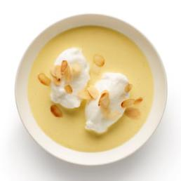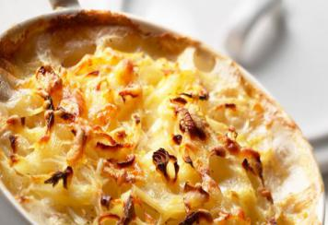
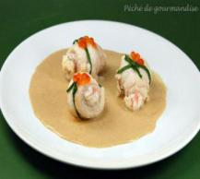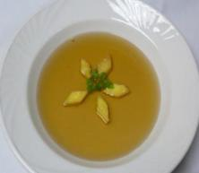

Timeline:
1:00 - 2:00
Prepare the ingredient for the soup
Clean the pork
Start to make the soup.
2:00 - 3:00
Cut and clean the fish
Start to make the pork
3:00 - 4:00
Start to cook the potato
Start to make the fish
4:00 - 5:00
Start to make the dessert
plating

Recipe:
CONSOMMÉ ROYALE
Yield: 4 servings Preparation Time: 0:30

AMOUNT |  | MEASURE |  | INGREDIENT |  | PREPARATION
2.00 |  | Quarts |  | White Veal Stock
12.00 |  | Ounces |  | Lean Ground Beef
1.00 |  | Ounce |  | Yellow Onion
1.00 |  | Ounce |  | Carrot |  | Sliced
1.00 |  | Ounce |  | Celery |  | Sliced
1.00 |  | Each |  | Shallot |  | Minced
4.00 |  | Each |  | Egg White |  | Beaten
2.00 |  | Each |  | Parsley |  | Stems
1.00 |  | Each |  | Bay Leaf
6.00 |  | Ounces |  | White Wine
 |  |  |  | Garnish:
 |  |  |  | Royale  Parsley leaves |  | Cut into diamonds
- Combine all clearmeat ingredients and mix together.
- Add wine to cold stock, mix well with the clearmeat, and bring to a simmer stirring occasionally.
- When the raft forms stop stirring. Simmer 1 ½ hours, strain carefully through a double cheese cloth, degrease, season, taste, and adjust seasoning.
- Just before serving add the garnish.

ROYALE
Yield: 4 servings Preparation Time: 0:30
Research recipe for royale from handout on Escoffier

PAUPIETTES DE SOLE À LA MOUSSE DE SAUMON
Yield: 4 servings Preparation Time: 0:30

AMOUNT |  | MEASURE |  | INGREDIENT |  | PREPARATION
2.00 |  | Each |  | Sole filet |  | Skinless and fillet
8.00 |  | Ounces |  | Salmon
2.00 |  | Each |  | Eggs |  | Separated
3.00 |  | Ounces |  | Heavy Cream
2.00 |  | Ounces |  | Butter
4.00 |  | Ounces |  | White Wine
8.00 |  | Ounces |  | Fish Fumet
1.00 |  | Head |  | Shallot |  | Minced
0.50 |  | Ounce |  | Butter |  | Softened
1.00 |  | Tblsp. |  | Tomato paste
2.00 |  | Tblsp. |  | Chives |  | Finely sliced
- Clean fish and fillets.
- Make salmon mousseline with salmon, egg white, 2 oz of the cream, and seasoning.
- Season fillets, cover with plastic film, and flatten slightly with a mallet. Spread with the mousseline and roll the fillets starting with the wide end first and finishing with the tail end. Hold together with a toothpick.
- Sprinkle the bottomof a buttered sauté pan with shallots.Place the paupiettes on top and add wine and fish fumet. Cover with buttered parchment paper.
- Heat on stove until reaches a simmer and finish in a 350°F oven.
- Do not overcook. Remove from oven; remove sole rolls and set aside, keeping warm.
- Stir the tomato paste into the liquid and reduce slightly.
- Add the cream and bring the sauce to a boil. Strain through a fine chinois. Add the chives, mount with butter and adjust seasonings.
- Serve 2 paupiettes per portion on a pool of sauce.

CARRÉ DE PORC RÔTI AU JUS LIÉ (ROASTED PORK LOIN)
Yield: 5 servings Preparation Time: 0:45

AMOUNT |  | MEASURE |  | INGREDIENT |  | PREPARATION
4.00 |  | Pounds |  | Pork rack
 |  |  |  | Salt and Pepper |  | To taste
0.50 |  | Pound |  | Mirepoix |  | Prepared
2.00 |  | Ounces |  | Flour
1.00 |  | Sprig |  | Rosemary
1.00 |  | Sprig |  | Thyme
1.00 |  | Clove |  | Garlic |  | Crushed
2.00 |  | Each |  | Roma Tomatoes |  | Quartered
4.00 |  | Ounces |  | White Wine
1.00 |  | Quart |  | Brown Stock |  | Prepared
 |  |  |  | Salt and Pepper |  | To taste
 |  |  |  | Veal glace
4.00 |  | Ounces |  | Dijon  Butter
 |  |  |  | Salt and Pepper |  | To taste
- Prepare pork loin. Remove shin bone and back bone.
- Chop bones into large chunks. Truss the loin and season.
- Prepare the mirepoix, herbs, and vegetables.
- Place bones in the bottom of a roasting pan.
- Add the mirepoix, flour, herbs, garlic, and tomato.
- Place the loin on top of the bones and vegetables. Place the roasting pan in a preheated oven at 450°F. Sear the roast on one side for 15 minutes, turn the roast, and on the other side for 15 minutes.
- Deglaze the roast with wine and stock, turn down the heat to 350°F and roast the loin to 145°F internal temperature. Remove from oven and set the roast aside to rest. Keep hot. Just beore service brush with veal glaze mixed with a little Dijon mustard and glaze lightly in the salamander.
- Stir the sauce, bones, and mirepoix. Strain the sauce through a chinois, adjust seasoning and thickness if necessary, mount with Dijon and butter and keep hot.
- Cut the ribs off the roast, slice the roast and arrange on the bones with the vegetables for French service.

POMMES DE TERRE SAVOYARDE (SAVOYARD POTATO)
Yield: 4 servings

AMOUNT |  | MEASURE |  | INGREDIENT |  | PREPARATION
0.50 |  | Pound |  | Potatoes |  | Peeled and sliced
2.00 |  | Ounces |  | Gruyere Cheese |  | Grated
0.50 |  | Clove |  | Garlic |  | Minced
1.00 |  | Each |  | Egg |  | Beaten
1.00 |  | Teaspoon |  | Salt
1.00 |  | Teaspoon |  | Pepper
6.00 |  | Ounces |  | Chicken Stock
- Mix together all ingredients except stock.
- Shingle potatoes in an ovenproof pan.
- Add stock and cook 30 minutes loosely covered in a 350°F oven.
- Remove cover and finish baking until potatoes are tender.

HARICOTS VERTS AU BEURRE (GREEN BEAN BUNDLES)
Yield: 4 servings

AMOUNT |  | MEASURE |  | INGREDIENT |  | PREPARATION
10.00 |  | Ounces |  | Green Beans |  | Trimmed
2.00 |  | Strips |  | Bacon |  | Cut in half
 |  |  |  | Salt and Pepper |  | To taste
- Prepare and parboil the green beans in boiling water for ~ 5 – 6 minutes.
- Shock the beans in ice water and drain.
- Make bundles of green beans and wrap them with half a strip of bacon. Trim the beans.
- Reheat in the oven at 350°F until hot when needed for service.

CHOX-FLEURS À LA POLONAISE
Yield: 4 servings Preparation Time: 0:30

AMOUNT |  | MEASURE |  | INGREDIENT |  | PREPARATION
1.00 |  | Head |  | Cauliflower |  | Cut into florets
1.00 |  | ounce |  | Clarified butter |  | Prepared
1 |  |  |  | Hardboiled egg |  | Yolk and white chopped separately
2.00 |  | ounce |  | Butter
1.00 |  | ounce |  | breadcrumbs
- Prepare the cauliflower and simmer in salt water until tender. Drain well, and shock.
- Toast the breadcrumbs in a dry frying pan, then add the butter and let toast further.
- Top the cauliflower florets with the breadcrumbs.
- For service reheat in the oven at 350°F until hot, then sprinkle with the egg and some chopped parsley.

ISLES FLOTTANTES (OEUF À LA NEIGE)
Yield: 4 servings Preparation Time: 0:30

AMOUNT |  | MEASURE |  | INGREDIENT |  | PREPARATION
1.00 |  | Quart |  | Crème Anglaise |  | Prepared
4.00 |  | Ounces |  | Granulated Sugar
2.00 |  | Ounces |  | Water
2.00 |  | Drops |  | Lemon Juice
2.00 |  | Ounces |  | Sliced Almonds |  | Toasted
6.00 |  | Each |  | Egg Whites |  | From the crème anglaise
3.00 |  | Ounces |  | Granulated Sugar
- Make 1 quart of crème anglaise.
- With the whites, whip a pinch of sugar until soft peak. Add the remaining sugar to tighten meringue.
- With large serving spoons make quenelles and poach in poaching water. Turn quenelles around every other minute.
- In a small clean pot, mix water, sugar, and lemon juice. Bring to a simmer and cook on medium heat until caramelized while cleaning the edges of the pot with a clean brush dipped in clean cold water.
- In a soup plate, pour 4 oz of sauce and arrange 3 meringue quenelles floating in sauce.
- As soon as the caramel is at the right temperature shock the bottom of the pan in an ice bath. With a spoon pour a little caramel sugar over the quenelles.
- Sprinkle with a few toasted almonds.
- Serve right away.

CRÈME ANGLAISE (VANILLA SAUCE)
Yield: 8 servings Preparation time: 0:20

AMOUNT |  | MEASURE |  | INGREDIENT |  | PREPARATION
2.00 |  | Cups |  | Milk |  | Scald
6.00 |  | Each |  | Egg Yolks (reserve whites) |  | Separate out yolks
4.00 |  | Ounces |  | Granulated Sugar
1.00 |  | Teaspoon |  | Vanilla Extract
- In a small pot, scald the milk on low heat while prepping the rest of the ingredients.
- In a small mixing bowl place the yolks and, stirring vigorously, progressively incorporate the sugar.
- Whisk vigorously to blanch the yolks.
- Temper the yolks with a little milk. Progressively add more milk to dilute the yolk mixture.
- Return the mixture to the pot and return to medium heat, stirring with a wooden or plastic spoon in a figure eight motion until the sauce coats the spoon.
- Shock the sauce in an ice bath to stop the cooking process.
- Strain in a chinois and refrigerate.

Week 7
Today’s Objective:
Soupe aux Courges
Fillet de Truite Aux Amandes
Concombres a la Creme
Canard Roti au Cidre avec Navets
Pommes “Sarladaises”
Salade d’Endives “Dijonnaise”
Souffle Glacee Grand Marnier
Standard of Cooking and Techniques:
Soupe aux Courges
The soup need to be thick enough, and flavorful.
Fillet de Truite Aux Amandes
The fish need to be tender.
Canard Roti au Cidre avec Navets
The duck need to be tender and the skin need to be golden brown.
Chef's critique and recommendations for improvement.
Chef said the we did a good job on it. The plating presentation is good. And flavor of the dish is good but the duck was a little bit hard.
What could I have done different:
I think we did a good job this week. But we still need to control the cooking time. Because of the duck was set out form the oven for a long time after it is done. So the duck become a little bit hard.
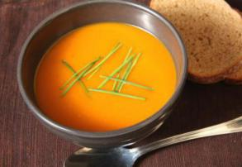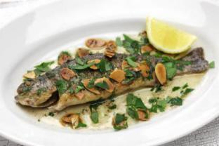
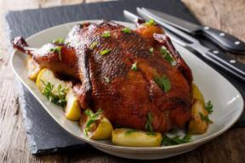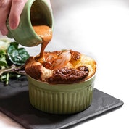
Time line
1:00 - 2:00
Prepare the ingredient of the soup
Clean the duck
Cook the soup
2:00 - 3:00
Start to cook the fish
Start to cook the duck
3:00 - 4:00
Start to prepare the said dish
Prepare the desert
4:00 - 5:00
Serve

Recipe:
SOUPE AUX COURGES (PUMPKIN SOUP SOUP)
Yield: 6 servings Preparation Time: 0:30

AMOUNT |  | MEASURE |  | INGREDIENT |  | PREPARATION
1.00 |  | small |  | Pumpkin
1.00 |  | Ounce |  | Butter
8.00 |  | Ounces |  | Leek |  | White only, sliced
1.25 |  | Quart |  | Chicken Stock
 |  |  |  | Salt and Pepper |  | To taste
 |  |  |  | Sugar |  | To taste
 |  |  |  | Grated Nutmeg |  | To taste
8.00 |  | Ounces |  | Heavy Cream |  | Per serving
- Wash the pumpkin. Cut out the stem and trim the opening, then remove the seeds. Hollow out the pumpkin to create a Tureen (keep the flesh) . Place the reserved flesh on a baking sheet, season well with salt pepper and nutmeg and bake in a 375°F oven until soft.
- Melt the butter over moderate heat. When foam subsides, add the leeks and sauté over low heat, stirring frequently, until soft. Add to the squash and cook under lid for 10 minutes, then purée until very smooth. Add the stock and pulse a few times to liquefy the mixture. Transfer to a soup pot.
- Bring to a boil, then lower heat and simmer for 10 minutes. Let cool.
- To serve, insert a hot S/S bowl into the pumpkin tureen, then pour in the very hot soup. Float the heavy cream on top of each serving. Serve with a side dish of grated Gruyere cheese.

FILLET DE TRUITE POÊLEÉ AUX AMANDES (PAN-FRIED TROUT WITH TOASTED ALMONDS)
Yield: 1 serving Preparation Time: 0:30

AMOUNT |  | MEASURE |  | INGREDIENT |  | PREPARATION
1.00 |  | Each |  | Trout |  | Pan-dressed
 |  | To taste |  | Salt and Pepper
 |  | As needed |  | All-purpose Flour
1.00 |  | Ounce |  | Butter |  | Clarified
0.50 |  | Ounce |  | Butter |  | Whole
2.00 |  | Tblsp. |  | Almonds |  | Sliced thin
1.00 |  | Ounce |  | Lemon Juice
0.50 |  | Tablespoon |  | Fresh Parsley |  | Chopped
- Season the trout with salt and pepper. Dredge in flour.
- Pan-fry the trout in the clarified butter until lightly browned and cooked through. Remove and reserve.
- Degrease the pan, add the whole butter, and cook until it begins to brown.
- Add the sliced almonds and sauté a few seconds, until the almonds begins to brown.
- Add the lemon juice and parsley and swirl to combine with the butter.
- Top the fish with the sauce and serve.

CONCOMBRES A LA CRÈME.
Yield: 4 servings Preparation Time: 0:30

AMOUNT |  | MEASURE |  | INGREDIENT |  | PREPARATION
1.00 |  | each |  | Field Cucumbers |  | Peeled and Tourneed
2.00 |  | Ounces |  | Butter
2.00 |  | Ounces |  | Whipping Cream
0.10 |  | Ounce |  | Dill |  | Finely chopped
 |  |  |  | Salt, Pepper and lemon juice |  | To taste
- Combine cucumbers and cream and simmer until cucumbers are cooked, but stil “al dente”.
- Swirl in the butter and adjust the seasoning. Serve very hot with the trout

CANETON AUX NAVETS (DUCKLING WITH TURNIPS)
Yield: 4 servings Preparation Time: 1:00

AMOUNT |  | MEASURE |  | INGREDIENT |  | PREPARATION
1.00 |  | Each |  | Duck
3 |  | Sprigs |  | Thyme
1 |  |  |  | Bayleaf
2.00 |  | Ounces |  | Butter |  | Whole
15.00 |  | Each |  | Pearl Onion |  | Peeled and boiled
1.00 |  | Pound |  | Turnip |  | Peeled and tournéed
1.00 |  | Pinch |  | Salt
4.00 |  | Ounces |  | White Wine
 |  |  |  | Veal stock
1.00 |  | Clove |  | Garlic |  | Minced
1.00 |  | Each |  | Bouquet Garni |  | Tiny
2.00 |  | Tablespoons |  | Parsley |  | Chopped
- Season the duck inside and out and place the thyme and bay in the cavity. Truss the duck.
- Brown the duck in a pan deep enough to allow the duck to be covered with a lid using 1 oz of butter.
- When golden brown, cover pan and cook in pre-heated oven 275º F for 25 minutes.
- Prepare the garnish: Brown the onions in 1 oz of butter.
- Remove onion but save cooking butter.
- Add turnips to this butter and sauté.
- Season with salt. When the turnips are lightly browned, add the garlic and de-glaze with the wine, cook off the acid and cover turnips with veal stock.
- Return the onions and the bouquet garni,
- Place the browned duck with the onion and turnip and simmer under lid until completely cooked.
- Remove the duck and the vegetables. Keep warm and reduce liquid to rich sauce consistency. Thicken if necessary.
- Carve and serve duck tableside with vegetable and sauce.

POMMES DE TERRES SARLADAISES
Yield: 4 servings Preparation Time: 0:30

AMOUNT |  | MEASURE |  | INGREDIENT |  | PREPARATION

2 each Russet potatoes peeled and sliced thin
Tblsp Duckfat

- Melt the duck fat in an iron pan.
- Arrange the sliced potato overlapping to in at least two layers, being extra careful with the bottom layer.
- Cook stove-top until golden, finish in the oven until done. Pour off the fat and reverse the potato “cake” onto a service platter. Serve piping hot.

SALADE D’ENDIVES “DIJONNAISE”
Yield: 4 servings Preparation Time: 0:30

AMOUNT |  | MEASURE |  | INGREDIENT |  | PREPARATION
4.00 |  | Each |  | Belgium Endives
2.00 |  | Each |  | Roma Tomatoes |  | Peeled, seeded
0.25 |  | Ounce |  | Chives
 |  |  |  | Dijon Mustard Dressing:
2.00 |  | Tablespoons |  | Dijon Mustard
3.00 |  | Tablespoons |  | Red Wine Vinegar
0.50 |  | Cup |  | Vegetable oil
1.00 |  | Each |  | Shallot |  | Minced
 |  |  |  | Salt and Pepper |  | To taste
- Make mustard dressing and set aside.
- Trim Belgium endive and reserve 3 nice leaves per plate.
- Make tomato petal and marinate in dressing.
- Cut endive ½” thick perpendicular to length. Toss with dressing and plate.
- Garnish with chives.

Week 9
Today’s Objective:
BISQUE DE CREVETTES
OEUFS EN COCOTTE “FLORENTINE”
JARRET DE CHEVREUIL EN SALMIS,
PANNEQUETS SOUFFLÉS COULIS DE FRAMBOISES
Standard of Cooking and Techniques:
BISQUE DE CREVETTES
The soup need to be flavorful and the color need to be orange, and the soup need to be thick.
OEUFS EN COCOTTE “FLORENTINE”
The egg need to be cooked well, the egg need to be liquid. And the dish need to finish in the oven. In the water bath.
JARRET DE CHEVREUIL EN SALMIS
The meat need to be tender and the, and the source of the chicken need to be thick and flavorful.
PANNEQUETS SOUFFLÉS COULIS DE FRAMBOISES
The souffles need to be puffed up well. And the pannequets need to be golden brown.
Chef's critique and recommendations for improvement.
Chef said most of the dish was did well. But we still have some problem, such as we didn’t put enough salt in the JARRET DE CHEVREUIL EN SALMIS, and the souffles didn’t puffed well.
What could I have done different:
Next time we need to seasoning well with all the dish. Did the watch the cooking time of all the dish.

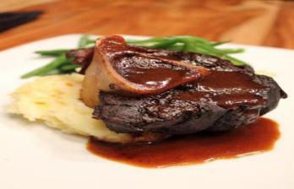

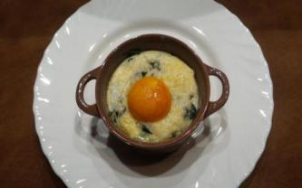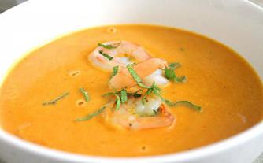

Timeline
1:00 - 2:00
Prepare the ingredient for the soup
Clear the meat
Start to cook the soup
2:00 - 3:00
Start to prepare the ingredient for the egg dish
Make the OEUFS EN COCOTTE “FLORENTINE”
Start to make the main course
3:00 - 4:00
Start to prepare the said dish
Prepare the ingredient for the dessert
4:00 - 5:00
serve

Recipe:
BISQUE DE CREVETTES
Yield: 4 servings Preparation Time: 1:00

AMOUNT |  | MEASURE |  | INGREDIENT |  | PREPARATION
1000 |  | gram |  | Prawn or lobster shells
125 |  | gram |  | Onion |  | Diced
50 |  | gram |  | Celery |  | Diced
50 |  | gram |  | Carrot |  | Diced
2 |  |  |  | Shallot |  | Diced
4 |  | cloves |  | Garlic |  | Chopped
¼ |  | cup |  | Rice
3 |  |  |  | Tomato |  | Rough chop
1 |  |  |  | Bouquet garni
50 |  | ml |  | Brandy
175 |  | ml |  | White wine
1 |  | liter |  | Clam nectar
200 |  | ml |  | Whipping cream
150 |  | gram |  | prawns |  | Peeled and deveined
- Heat a little vegetable oil in a pot. Caramelize the prawn shells.
- Add the vegetables and let caramelize. Then add the rice and let them coat in the oil.
- Add brandy, flame briefly, then add the tomatoes, the bouquet garni and the white wine and let reduce by half.
- Add the nectar and let simmer for 1 hour, skimming occasionably.
- Remove the shells and the solids and puree in a food mill, the return to the liquid and simmer a further 15 minutes.
- Strain the bisque and add the cream.
- Adjust the seasoning, then poach the prawns in the bisque.
- Serve the bisque garnished with the shrimp.

OEUFS EN COCOTTE “FLORENTINE”
(Eggs baked en cocotte with Spinach and Mornay Sauce
Yield: 4 servings Preparation Time: 0:45

AMOUNT |  | MEASURE |  | INGREDIENT |  | PREPARATION
8.00 |  | Each |  | Eggs
1.00 |  | Recipe |  | Mornay Sauce |  | With egg yolk added
1.00 |  | Bunch |  | Spinach
 |  |  |  | Gruyere Cheese |  | Grated
1.00 |  | Ounce |  | Parmesan Cheese |  | Grated
1.00 |  | Ounce |  | Butter |  | Melted
 |  |  |  | Salt pepper and nutmeg to taste
- Saute the spinach in butter, season well then drain and place in a ramequin.
- Sprinkle a little gruyere on top then add the eggs. Mask with Mornay sauce and bake in Bain-Marie until the eggs are set.
- Top the eggs with Gruyere and Parmesan and glaze quickly in the Salamander.
- Serve with tear-shaped croutons.

JARRET DE CHEVREUIL EN SALMIS,

Yield: 4 servings

AMOUNT |  | MEASURE |  | INGREDIENT |  | PREPARATION
2 |  | Pounds |  | Venison Shank |  | Marinated in red wine (Carrots, celery, onion, garlic, juniper, rosemary, thyme, bay)
2 |  | Tblsp. |  | Oil
2 |  | Tblsp. |  | Flour
 |  |  |  | Brown Veal stock to cover
2 |  | Each |  | Chicken livers
20 |  | Ml |  | Cognac
30
1 |  | slice |  | Slab Bacon |  | Cut into “lardons”
8 |  |  |  | Mushroom |  | Fluted
12 |  |  |  | Pearl onion |  | Peeled and blanched
Serve this dish with halved poached apples filled with Red Currant Jelly, Braised Cabbage and Noisette Potatoes.
- Separate the meat from the marinade. Drain the red wine from the mirepoix, keeping both the mirepoix and the wine.
- Bring the wine to boil and strain immediately through a cheesecloth.
- Season the meat, then brown very carefully. Remove the meat, add the mirepoix and caramelize. Dust with the flour and cook to create a brown roux.
- Place the meat on the mirepoix and add in the boiled wine and enough veal stock to cover. Bring to a simmer and cook until the meat is fork tender. Remove the meat, Keep warm and strain the sauce through a cheese cloth and skim very carefully.
- Puree the livers and the cognac, then whisk into the sauce like you would a Liaison. Mount with a little butter, adjust the seasoning and strain again. (be careful not to boil the sauce once you have added the livers).
- For the garnish, render the bacon a bit, then add the mushrooms and the onions and caramelize gently.
- Place meat in a service platter, cover with the sauce and top with the garnish.

PANNEQUETS SOUFFLÉS COULIS DE FRAMBOISES
Yield: 4 servings Preparation Time: 0:30

AMOUNT |  | MEASURE |  | INGREDIENT |  | PREPARATION
2.00 |  | Each |  | Eggs |  | Whole
4.00 |  | Ounces |  | Milk |  | Whole
1.00 |  | Ounce |  | Butter |  | Melted
2.00 |  | Ounces |  | Flour
1.00 |  | Ounce |  | Sugar
1.00 |  | Pinch |  | Salt
1.00 |  | Teaspoon |  | Vanilla Extract
 |  |  |  | Soufflé Batter:
2.00 |  | Ounces |  | Pastry Cream |  | Prepared as directed
4.00 |  | Each |  | Eggs |  | Separate, white part only
2.00 |  | Ounces |  | Sugar
1.00 |  | Ounce |  | Grand Marnier
 |  |  |  | Raspberry Coulis:
6.00 |  | Ounces |  | Frozen Raspberries |  | Blended and strained
2.00 |  | Ounces |  | Sugar
- Combine all ingredients and whip together into a smooth paste, adjust the thickness of the batter to the consistency of heavy cream. Refrigerate the batter for 30 minutes.
- Preheat a crêpe pan to medium heat and brush with some clarified butter.
- Place a sufficient amount of batter into the crêpe pan to coat the bottom of the pan with a thin layer.
- Cook the crêpes until dry. Turn the crêpes and cook the other side.
- Prepare the raspberry coulis and set aside.
- Place 2 tablespoons of pastry cream and one egg yolk in a small bowl. Flavor with Grand Marnier.
- In the mixer, place the egg whites and pinch of sugar. Whip until soft peak, add the balance of the sugar, and whip to tighten.
- Carefully fold in the meringue into the pastry cream mixture.
- Fold each crepe in half, then fold again to create a triangular pocket
- Place 3 oz. of the soufflé batter in pocket and bake in hot 425°F oven for 3 – 4 minutes or until the soufflé batter is fully cooked.
- Dust with powdered sugar, serve immediately with raspberry coulis on the side.

Week 10
Today’s Objective:
Crème de Topinambours Truffee
Mille-Feuille de Saumon au Cerfeuil
Julienne de Légumes
Tournedos “Choron” (Chateaubriand)
Pommes “Soufflees”
Tarte des Demoiselles Tatin
Standard of Cooking and Techniques:
Crème de Topinambours Truffee
It is the cream soup that is made by Jerusalem Artichokes. It should be thick.
Mille-Feuille de Saumon au Cerfeuil
It is the dish that is made by the salmon and the baked puff pastry and with the flavor sauce.
Julienne de Légumes
it is the side dish of the main couse. The vegetable need to be julienne and saute with the butter.
Tournedos “Choron” (Chateaubriand)
We use the Beef Tenderloin of this dish. Each portion need to have 4OZ beef on each plate.
Pommes “Soufflees”
This dish is a deep fried sliced potato. The potato need to be puff up.
Additional Information:
For the soup the Jerusalem Artichokes need to be peeled.
For the Pommes “Soufflees”. it need to be sliced in 1/8”.
Chef's critique and recommendations for improvement.
Chef said the dish’s flavor of the dish is not bad. And the plating presentation is also good, all the dish was better then last time.
What could I have done different:
I think I did a good job on this week. The flavor of our dish is quit good. The presentation is good.
The meat is tender, and soup is flavorful,I think we did better then before.

Timeline
2:30 - 3:00
Start to prepare the ingredient for the soup
Cook the soup
3:00 - 3:30
Start to prepare the ingredient for Mille-Feuille de Saumon au Cerfeuil
Cook the Mille-Feuille de Saumon au Cerfeuil
3:30 - 4:00
Start to make the main course
Make the side dish
4:00 - 4:30
Start to make the dessert

3.A La Carte kitchen class

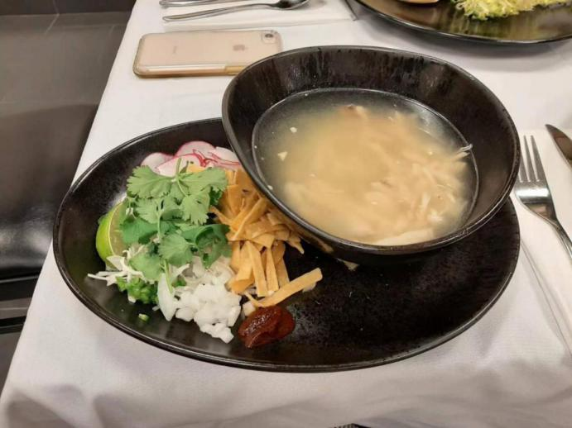

Chicken and hominy soup with crispy garnishes
3 whole chicken cut into legs thighs and breasts
Cold water to cover
3 yellow onion, peel and cut into large pieces
6 ribs of celery. Chopped and 3 carrots peel and chopped
1 can 25 oz hominy ,( salt and lime only additives)

- Place the chicken piece in pot and cover with water to 3 inches above the meat.
- Bring to boil, the turn down to simmer. Skim the top to clear the broth
- Add the onion carrot, celery and simmer for about 20 minutes, or until the chicken pieces are just cooked.
- Remove the chicken piece with a spider onto a full hotel pan. Then cool. When the chicken has cooled enough remove the meat from the bones, keeping both the bones and the meat.
- Put the chicken bones back in the broth and continue to slow aim
- Shred the meat into bite size pieces and put into a cambro container.
- After the chicken bones have been simmering for an hour, strain the broth into another pot, discard the bones and all else from the strainer.
- Skim the broth to clear if needed.
- Add the hominy, shredded chicken pieces to the broth and bring back to simmer do not boil for 5 minutes.
- Add the salt to taste
- Put soup in a cambro and cool in an ice bath.
- Label, date and store in walk in or reach in fridge.
Garnish；
Shredded cabbage
Sliced radish
Minced jalapeno
Cilantro leaves
Salsa Guajillo
3qts Guajillos, stems removed, toast on comal, place in 8 qt. Cambro soak in water
8 roma tomatoes
6 cloves garlic, whole, raw
Salt to taste
Blend guajillos with their soaking water, the tomatoes and the garlic, pass through the larger sieve into a non- reactive pot and bring to boil, then simmer for 10 minutes. Label and store in 1 quart plastic snap lid containers.

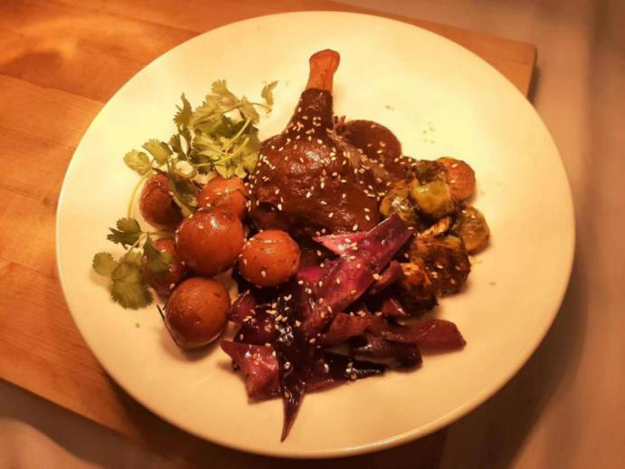

Mole oaxacaqueno
Gather together and place in bowls:
4 oz guajillo chiles or chilhuacles negroes, if you can get them
2 oz pasilla chiles
2 oz mulato chiles
1/2 # tomato - romas - char on the comal
1cup water
3 whole cloves- grind in the spices grinder
3 whole allspice - grind in the spice grinder
1/4 tsp. Gried thyme leaves
1TB Mexican oregano, or 2 Tb. Oaxacan oregano if you can get it.
3/4 cup lard or duck fat - homemade
1/4 cup sesame seeds - toast in a dry fry pan until dark golden brown, the grind in the spice grinder
1/4 cup shelled peanut
10 whole（with skins）almond.
1/4 cup raisins
1 small yellow onion
5 small cloves of garlic, peeled
1 stick of canela/Mexican, 3 inches long- slivered
1 ripe plantain, skinned and cut into slices
2 corn tortillas day old
3 thick slices of day old french bread - plain - no herds
2oz Mexican chocolate tablet- like lbarra- in the spice gringer
Salt to taste
1-4 cups chicken stock
Method；
Clean chilies - reserve the seeds and veins. Toast carefully by laying the opened chiles on a hot comal and pressing down to flatten them with a spatula. Hold them on the comal until dark golden brown, turn and toast the other side. Place all the chiles in a bowl, rinse with cold water, drain, then cover with hot water and soak for 30 minute. Keep the chiles in the soaking water.

Toast the reserved seeds to almost black- cover with cold water and soak for 5 minutes, strain and put in the blender. Be careful when you add the water to the seeds as the hot smoke the rises off the seeds can burn your eyes.

Add charred tomatoes to the blender as well as the clove, allspice, thyme, oregano as well as some of the water or stock. Blend wel. Add the toasted and ground sesame seeds, blend well.
Duck leg confit
- Melt the duck fat, check the seasoning in the fat
- Rinse and pat dry the duck legs
- Lightly season the duck legs with four spice
- Place in deep hotel pan, cover woth duck fat
- Cook, uncovered, in a350 degree oven until the legs are tender , approx2.5 hours
- Remove from the oven, cool place duck legs in new clean hotel pan.
- Strain the duck fat and juices
- Pour the duck fat only over the duck legs, and cool for storage.
- Cover well, label and date
- Store the duck jus in quart snap lip containers, label, date and freeze for future

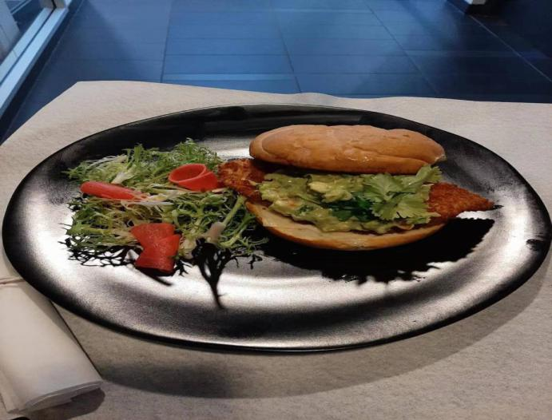
Fish sandwich
1/2inch slice artisan bread 2 pieces per sandwich
Mayonnaise spread on each outer side of bread
2oz refried black bean:
Oliver oil, 1/4 inch diced onion, garlic minced, beans ( reserve the broth from can) ground cumin to taste
1oz monterey jack , slice
( prep cheese on the slicer, shrink wrap in package 30 slices for each week)
Avocado sliced, 1/4 avocado per sandwich
4oz, snapper pieces, breaded with a panko crust
(set up a fry pot for fish, filter each week, refrigerate fat when cool)
Pico de gallo: 1/6 diced cherry tomatoes; green onion 1/4 inch dice; jalapeno1/4 inch diced; clean, pick and rough chop cilantro.
Griddle the top slice of bread same as the bottom

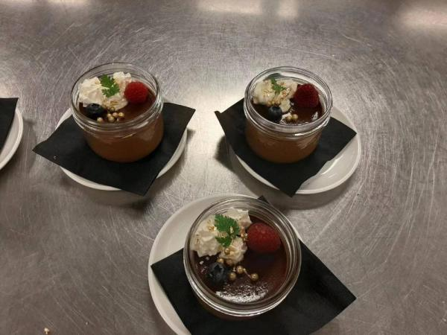
Pot de creme
Cream 2L
Milk 400 ml
Yolk 27
Sugar 270
Heat the cream and the milk
Sugar and sugar whisk together
Temper the mike in the egg yolk
Strain the mixture and cool it down
Put the chocolate into the jar and bake it in the oven with an water bath

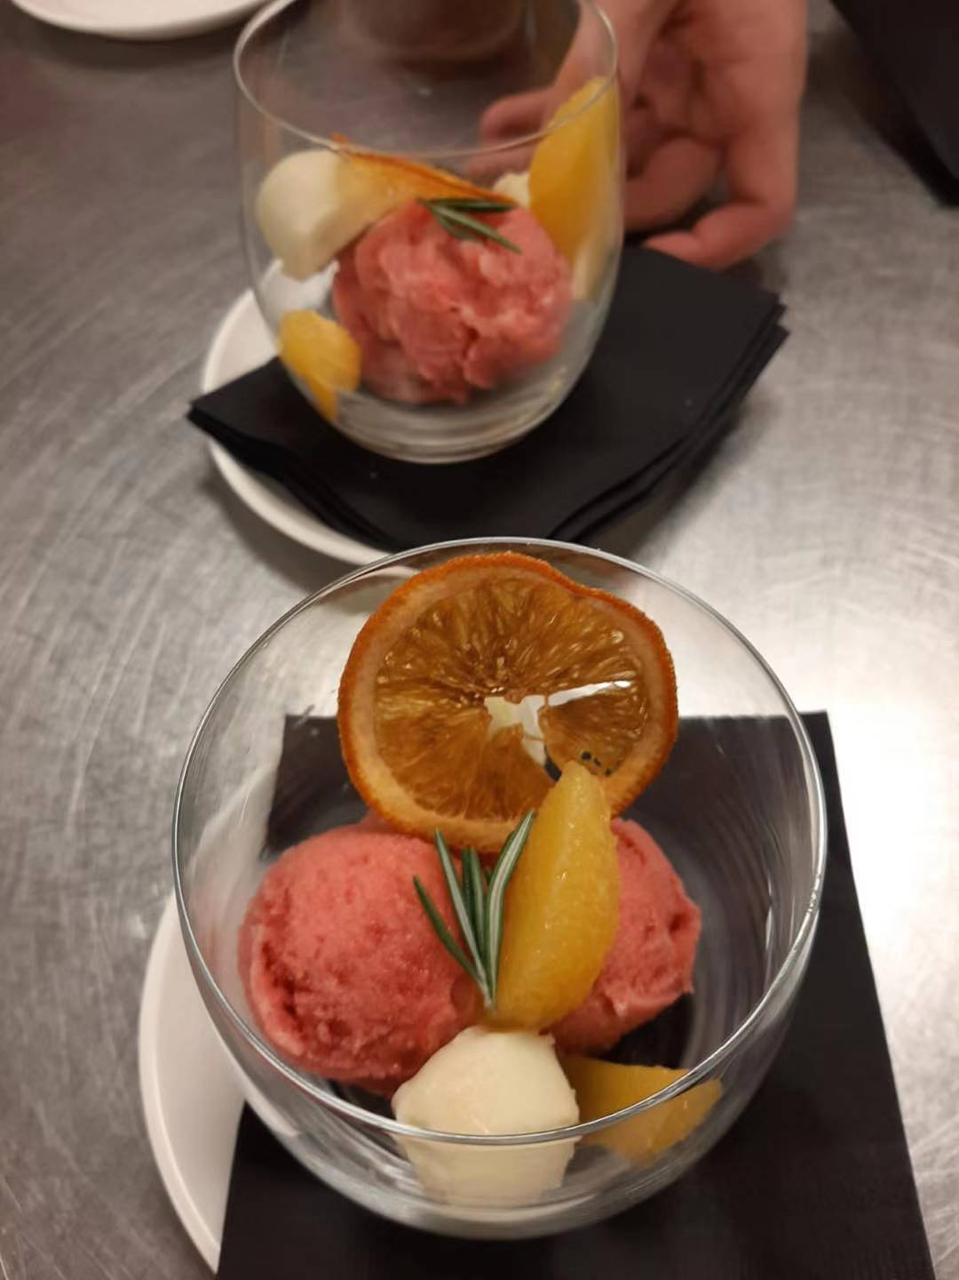
Blood orange ice
4cups fresh- squeezed orange juice
1oz fresh squeezed lime juice
2cups sugar
2cups water
Method:
Bring the sugar and water to boil and simmer until clear, about 1 minute. Cool strain the orange and lime juice and mix with the cool sugar syrup
Freeze this mixture in your ice cream maker, following manufacturer instructions (we spin the mixture for 15 to 20 minutes)
The ice needs to be packed into a container and frozen in your freezer for at least four hours for it to be firm enough to scoop.
Serving suggestion: served in a pistachio tulle cookie cup with a tequila truffle.

