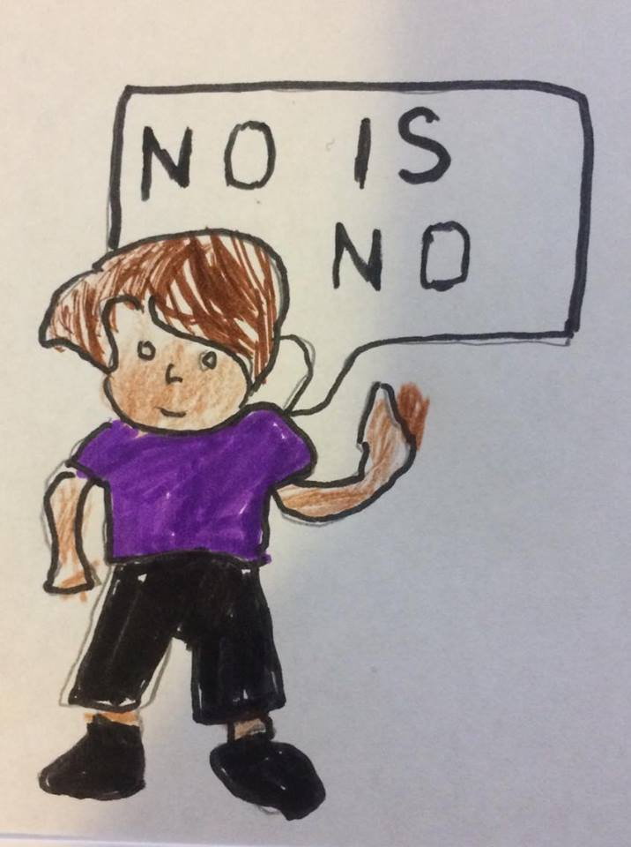
Guide to the children
Prepared by Ranee Nundoo

TABLE OF CONTENTS:

BODY PARTS……………………………………………………………………………..1

SMILEY…………………………………………………………………………………….2

CLOTHES CHILDREN NEED TO WEAR………………………………………………3

PEOPLE………………………………………………………………………………….4,5

THINGS A CHILD CAN DO………………………………………………………,6,7,8,9

THINGS A CHILD CAN’T DO…………………………………………………10,11,12,13

