Course Number: 420-P16-AS
Course Title: Structured Programming
Session: Autumn 2016

final project

TITLE: Grade tracking application in c++

Due DATE: 2016/12/06

submitted

to

TEACHER: Quang Hoang Cao

By

HAURYLCHYK EDUARD/ 1632491
Heading

I. Project description 3
1. A short description of the project 3
II. project development 5
Phase i Analysis and design 5
Program structure 5
The list of functions: 6
Algorithms (Pseudocode/Flowcharts) 8
The flowchart of the Main Function and Teachers’ menu. 8
The flowchart of Students’ menu. 9
Phase ii implementation 10
1. Header File (s) 10
2. Implementation File(s) 12
3. Application File (The function main() must be in this file) 40
phase iii testing the program 43
III. conclusion 59

- Project description
- A short description of the project
The project is created in Microsoft Visual Studio.
Requirement: The teacher must login with the following valid user name and password:
Username: 5257
Password: quanghoang.

The application allows the teacher to perform the following operations:
1. List all the courses he is teaching
2. Enter students’ grades for a given course
3. Search a student’s grades by Student ID/First Name/Last
Name/First Name and Last Name
4. Sort the student list by Student ID
5. List all the students’ grades for a given course
6. Quit the application

Teacher options:
Option 1: List all the courses he is teaching
The information displayed includes Course Number, Course Title, Group
Number and Total Number of Students
Option 2: Enter a student’s grades
The teacher has to enter the following data:
- Student ID (7-digit number, unique value)
- First Name
- Last Name
- Project Grade
- Midterm Exam Grade
- Final Exam Grade
- Password
To keep it simple, username is Student ID.
Note: A grade entered must be between 0.0 and 100.0 included.
Option 3: Search a student’s grades by Student ID / Firstname/Lastname/
Firstname and Lastname (the example is given)
Option 4: Sort the student list by Student ID in ascending order
Option 5: List all the students’ grades (the example is given)
Option 6: Quit the application
The teacher selects this option to exit the application. Confirmation message
must be shown to the teacher.

Student options:
1. List all the courses he/she is taking
2. View the grade for a given evaluation component
(Midterm Exam, Final Project or final Exam) related to
a course he/she is taking in this session (Autumn 2016)
3. List all the grades for a given course
4. Quit the application

Users and Operations
User | Operations
Teacher | - See the list of courses he is teaching.  - Create the list of students for three groups of students.  - Enter students’ grades for a given course.  - Search the student by student ID, First Name, Last Name, First and Last name.  - Sort the student list by Student ID in ascending order.  - List all the students’ grades for a given course.  - Quit the application.
Student | - Log in to application using its’ ID and password, created by the teacher.  - List all the courses he/she is taking  - View the grade for a given evaluation component(Midterm Exam, Final Project or final Exam) related to a course he/she is taking in this session (Autumn 2016)  - List all the grades for a given course  - Quit the application

- project development

Phase i Analysis and design

Program structure
The main structure of the program:
struct Student
{
string StudentId;
float Project_Grade;
float Midterm_exam_grade;
float Final_exam_grade;
float Final_Result;
string firstName;
string lastName;
string stud_password;
string group_number;
string course_number;
string course_description;
int StudentGroupQuantity;
};

The Structure Student involves all the data of the students, courses, groups, grades. Also the structure involves the calculation of final result.
The structure Student is formed, when user insert the data of students in the function inputStudentData(Student arrStudent[]).

The list of functions:
№ | Name of function | Header function | Menu | Short description
1 | int loginAs(); | The Main menu function | Main menu | Choise to login as Teacher or as a Student
2 | int checkloginAsStudent(Student arrStudent[]); | int loginAs() | Main menu | Check the login and password of the student
3 | void checkloginAsTeacher(); | int loginAs() | Main menu | Check the login and password of the teacher. Returns whether login inserted is equal to login of the teacher.
4 | int getTeacherMenuChoice(); | checkloginAsTeacher() | Teacher menu | Calls main menu call of the teacher, returns teachers choice.
5 | void displayCourseList(); | getTeacherMenuChoice() | Teacher menu | Displays the List of all courses of the teacher
6 | int inputStudentData(Student arrStudent[]); | getTeacherMenuChoice() | Teacher menu | The function, allowing to input the data of the students. Retuns total quantity of the students.
7 | int chosecourse_select(); | getTeacherMenuChoice() | Teacher menu | List all the students’ grades for a given course. Menu for choise of the course; Returns choice of the course;
8 | void displayGrades(Student arrStudent[]); | getTeacherMenuChoice() | Teacher menu | displays grades for all the student, in dependance of the course and the group;
9 | void sortStudent(Student arrStudent[]); | getTeacherMenuChoice() | Teacher menu | Sort the student list by Student ID in accending order
10 | int searchstudentby_choise(); | getTeacherMenuChoice() | Teacher menu | Menu for Search a students grades by Student ID/First Name/Last Name / First Name and Last Name"; Returns chosen criteria for search;
11 | void searchstudentby(Student arrStudent[]); | searchstudentby_choise() | Teacher menu | The swich-case function for search of the student by different parameters
12 | void searchbystudentId(Student arrStudent[]); | searchstudentby_choise() | Teacher menu | The function for search students by ID
13 | void searchbyfirstname(Student arrStudent[]); | searchstudentby_choise() | Teacher menu | The function for search students by First name
14 | void searchbylastname(Student arrStudent[]); | searchstudentby_choise() | Teacher menu | The function for search students by Last Name
15 | void searchByFirstAndLastName(Student arrStudent[]); | searchstudentby_choise() | Teacher menu | The function for search students by First and Last Name
16 | bool quitApplication(); | getTeacherMenuChoice() and studentmenu_choise() | Teacher and Student menu | log out from of the application
17 | bool quitProgramm(); | The Main menu function | Main menu | The Main menu function, choice whether to exit the programm;
18 | bool isValidId(string, int); | inputStudentData(arrStudent) | Teacher menu | Check whether student ID consists from 7 digits;
19 | bool NumberBetween0and100(float number); | inputStudentData(arrStudent) | Teacher menu | Check whether the grades are between 0 and 100;
20 | bool uniqueStudId(Student arrStudent[], int, string); | inputStudentData(arrStudent) | Teacher menu | Check whether student ID is unique;
21 | float isACorrectFloat(string); | inputStudentData(arrStudent) | Teacher menu | Check whether the grades are correct floats;
22 | void stud_evaluation_grade(Student arrStudent[], int, string); | student_menu( arrStudent, int, string, string) | Student Menu | View the grade for a given evaluation component (Midterm Exam, Final Project or final Exam) related to a course he / she is taking in this session(Autumn 2016)
23 | void student_menu(Student arrStudent[], int, string, string); | checkloginAsStudent( arrStudent) | Student Menu | Use switch - case function ti call the functions of student menu.
24 | bool isValidgroup_quant(string tempgroup); | inputStudentData(arrStudent) | Teacher menu | Check whether the inserted number of students in the group is integer
25 | int studentmenu_choise(); | student_menu( arrStudent, int, string, string) | Student Menu | The main menu for the student;
26 | int stud_eval_component_choise(); | stud_evaluation_grade(arrStudent, int, string) | Student Menu | Choise of the evaluation component of students

Algorithms (Pseudocode/Flowcharts)

The flowchart of the Main Function and Teachers’ menu.
The return to the previous menu is marked with red arrow
The direction of logic flow is marked with blue arrow
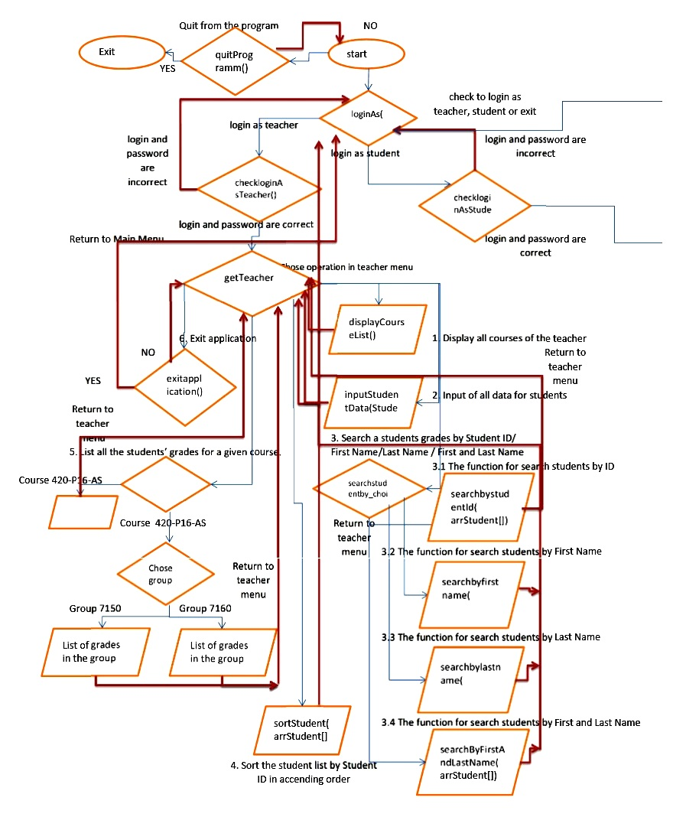

The flowchart of Students’ menu.

The return to the previous menu is marked with red arrow
The direction of logic flow is marked with blue arrow

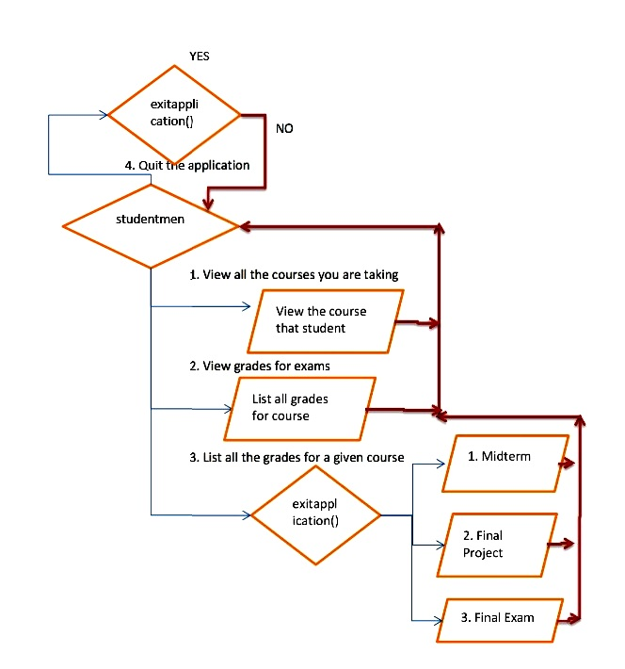

Phase ii implementation

The focus of this phase is on the HOWs.
Included in this phase are the source code files of your program.

- Header File (s)

- #pragma once
- #ifndef Student
- #include <regex> //used for function isACorrectFloat(string)
- #include<iostream>
- #include<string>
- #include <stdlib.h>
- #include<iomanip>
- #include<math.h>
- #define COURSE_QUANT 3 //Quantity of all the groups in the courses
- #define NUM_STUDENT 20 //The average number of students in the group
- using namespace std;

- // The Structure Student involves all the data students, courses, groups, grades.
- struct Student
- {
- string StudentId; //The ID of students
- float Project_Grade; //Progect Grades of students
- float Midterm_exam_grade; // Midterm exam grades of students
- float Final_exam_grade;// Final exam grades of students
- float Final_Result; // Final result of students, is calculated during data entry
- string firstName; // The first name of the student
- string lastName; // The last name of the student
- string stud_password; //Student password
- string group_number; //Group number of the student, assigned to every student during data entry
- string course_number; //Course number of the student, assigned to every student during data entry
- string course_description; //Course description, assigned to every student during data entry
- int StudentGroupQuantity; //the number of student in each group
- };

- int loginAs(); // The Main menu function, Choise to login as Teacher or as a Student
- int checkloginAsStudent(Student arrStudent[]);//Main menu - int loginAs().Check the login and password of the student
- void checkloginAsTeacher(); //Main menu - int loginAs(). Check the login and password of the teacher. Returns whether login inserted is equal to login of the teacher.
- int getTeacherMenuChoice(); //Teacher menu - checkloginAsTeacher(). Calls main menu call of the teacher, returns teachers choice.
- void displayCourseList();//1. Teacher Menu - getTeacherMenuChoice();. Displays the List of all courses of the teacher
- int inputStudentData(Student arrStudent[]); //2. Teacher Menu - getTeacherMenuChoice(); The function, allowing to input the data of the students. Retuns total quantity of the students.
- int chosecourse_select();// 5. Teacher Menu - getTeacherMenuChoice() - displayGrades(arrStudent); List all the students’ grades for a given course. Menu for choise of the course; Returns choice of the course;
- void displayGrades(Student arrStudent[]);//Teacher Menu - getTeacherMenuChoice(); displays grades for all the student, in dependance of the course and the group;
- void sortStudent(Student arrStudent[]);//Teacher Menu - getTeacherMenuChoice(); Sort the student list by Student ID in accending order
- int searchstudentby_choise(); // 3.Teacher Menu - getTeacherMenuChoice(); Menu for Search a students grades by Student ID/First Name/Last Name / First Name and Last Name"; Returns chosen criteria for search;
- void searchstudentby(Student arrStudent[]); //getTeacherMenuChoice()-searchstudentby_choise() - The swich-case function for search of the student by different parameters
- void searchbystudentId(Student arrStudent[]); //getTeacherMenuChoice()-searchstudentby_choise()-searchstudentby() - The function for search students by ID
- void searchbyfirstname(Student arrStudent[]);//getTeacherMenuChoice()-searchstudentby_choise()-searchstudentby() - The function for search students by First name
- void searchbylastname(Student arrStudent[]); //getTeacherMenuChoice()-searchstudentby_choise()-searchstudentby() - The function for search students by Last Name
- void searchByFirstAndLastName(Student arrStudent[]); //getTeacherMenuChoice()-searchstudentby_choise()-searchstudentby() - The function for search students by First and Last Name
- bool quitApplication(); //3. Teacher Menu - getTeacherMenuChoice(); And Student Menu int studentmenu_choise() - log out from of the application
- bool quitProgramm(); //The Main menu function, choice whether to exit the programm;
- bool isValidId(string, int);//Teacher Menu -inputStudentData(arrStudent).Check whether student ID consists from 7 digits;
- bool NumberBetween0and100(float number);//Teacher Menu -inputStudentData(arrStudent).Check whether the grades are between 0 and 100;
- bool uniqueStudId(Student arrStudent[], int, string);//Teacher Menu -inputStudentData(arrStudent).Check whether student ID is unique;
- float isACorrectFloat(string);//Teacher Menu -inputStudentData(arrStudent).Check whether the grades are correct floats;
- void stud_evaluation_grade(Student arrStudent[], int, string); //Student Menu -student_menu(arrStudent, int, string, string). View the grade for a given
- //evaluation component (Midterm Exam, Final Project or final Exam) related to a course he / she is taking in this session(Autumn 2016)
- void student_menu(Student arrStudent[], int, string, string); //Student Menu - checkloginAsStudent( arrStudent) - Use switch - case function ti call the functions of student menu.
- bool isValidgroup_quant(string tempgroup); //Teacher Menu -inputStudentData(arrStudent).Check whether the inserted number of students in the group is integer
- int studentmenu_choise(); //Student Menu - student_menu( arrStudent, int, string, string).The main menu for the student;
- int stud_eval_component_choise();// stud_evaluation_grade(arrStudent, int, string). Choise of the evaluation component of students

- //Constant values of the exams in the final result, is used in the evaluation of the final grade;
- const float MidtermExamWeight = 0.3f; //The constant value of the midterm
- const float ProjectWeight = 0.3f; //The constant value of the Project
- const float FinalExamWeight = 0.4f;//The constant value of the final exam
- //List of phrases, asking user, whether user wants to return to the previous menu, or choice
- const string BACK_TO_Main_MENU = "\n\n\tPress ENTER to return to the Main Menu.";
- const string BACK_TO_Teacher_MENU = "\n\n\tPress ENTER to return to the teacher Menu.";
- const string BACK_TO_Student_MENU = "\n\n\tPress ENTER to return to the student Menu.";
- const string BACK_Stud_Exam_Choice = "\n\n\tPress ENTER to return to the choice of student exam.";
- const string BACK_TO_Stud_Search_MENU = "\n\n\tPress ENTER to return to the student search choice.";
- //Strings for displaying the number of students, who passed or failed the course.
- const string string_student_passed = "\n\n\tThe number of students, who passed the course: ";
- const string string_student_failed = "\n\n\tThe number of students, who failed the course: ";
- //List of phrases, the header of the output for the search student funstion, and for the search of the course grade function.
- const string COURSE0 = "ASSESSMENT SUMMARY";
- const string COURSE1 = "Course Number:";
- const string COURSE2 = "Course Title:";
- const string COURSE3 = "Teacher: Quang Hoang Cao";
- const string COURSE4 = "Session: Autumn 2016";
- const string COURSE5 = "Group:";
- #endif;

- Implementation File(s)
……………………………………………………..

- Application File (The function main() must be in this file)
- #include "FinalProject.h";
- Student arrStudent[NUM_STUDENT*COURSE_QUANT]; //Structure Student

- bool exitApp = true;
- bool exitProgr = true;
- int main()
- {
- int loginAs();
- do
- {
- system("cls");
- int choice2 = loginAs(); // The Main menu function, Choise to login as Teacher or as a Student
- switch (choice2)
- {
- case 1:
- system("cls");
- checkloginAsTeacher(); // The Main menu function, checking login of Teacher for correctness
- {
- do
- {
- system("cls");
- int choice = getTeacherMenuChoice(); //The menu of teacher
- switch (choice)
- {
- case 1:
- system("cls");
- displayCourseList(); // List all the courses that you are teaching";
- exitApp = false;
- system("pause>>null");
- break;
- case 2:
- // 2. Enter students’ grades for a given course";
- system("cls");
- inputStudentData(arrStudent); //Input of student data with validation
- exitApp = false;
- break;
- case 3:
- // 3. Search a student’s grades by Student ID/First Name/Last Name / First Name and Last Name";
- system("cls");
- searchstudentby(arrStudent); // Searching students by different parameters
- exitApp = false;
- break;
- case 4:
- // 4. Sort the student list by Student ID ";
- system("cls");
- sortStudent(arrStudent); // The function for sorting students
- exitApp = false;
- system("pause>>null");
- break;
- case 5:
- // 5. List all the students’ grades for a given course";
- system("cls");
- displayGrades(arrStudent);
- exitApp = false;
- system("pause>>null");
- break;
- case 6:
- // 6.Quit the application";
- system("cls");
- exitApp = quitApplication(); //Quit the application
- break;
- default:
- cout << "\n\n\tYou entered a wrong choice! Please enter 1,2,3,4,5 or 6.";
- cout << BACK_TO_Teacher_MENU; //Return to teacher menu
- system("pause>>nul");
- exitApp = false;
- break;
- }
- } while (!exitApp);
- exitProgr = false;
- break;
- }
- case 2:
- system("cls");
- checkloginAsStudent(arrStudent); //Check the login and password of the student
- {
- exitProgr = false;
- break;
- }
- case 3:
- system("cls");
- exitProgr = quitProgramm(); //Quit if the program function
- break;
- default:
- cout << "\n\n\tYou entered a wrong choice! Please enter 1,2 or 3.";
- cout << BACK_TO_Main_MENU;
- system("pause>>nul");
- exitProgr = false;
- break;
- }
- } while (!exitProgr);
- cout << "\n\tPress any key to exit the program..";
- system("pause>>null");
- return EXIT_SUCCESS;
- }

phase iii testing the program

Included in this phase are the test results (in the table format) of your program.
Step1. Main Menu choice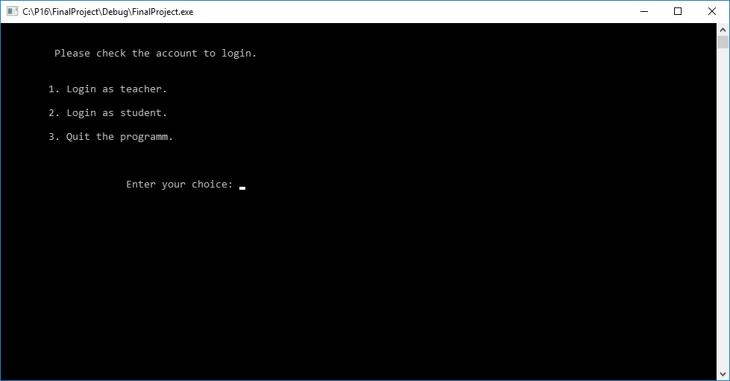
Step2. Check if mistake, Main Menu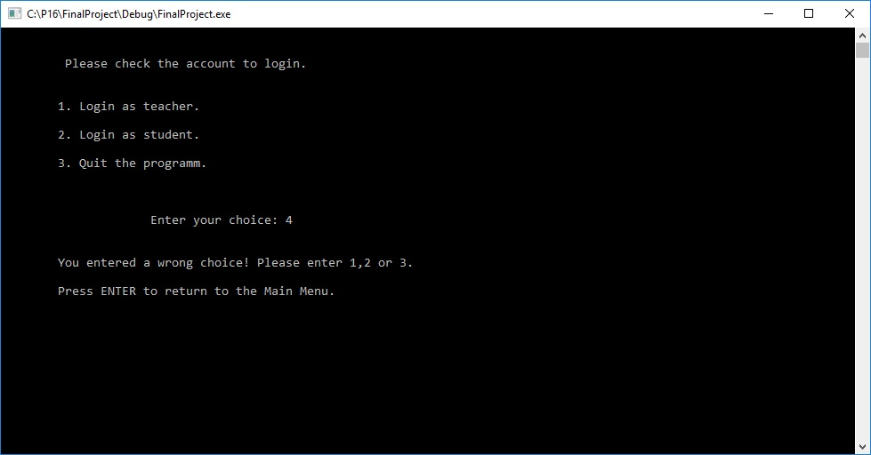
Step3. Login as teacher.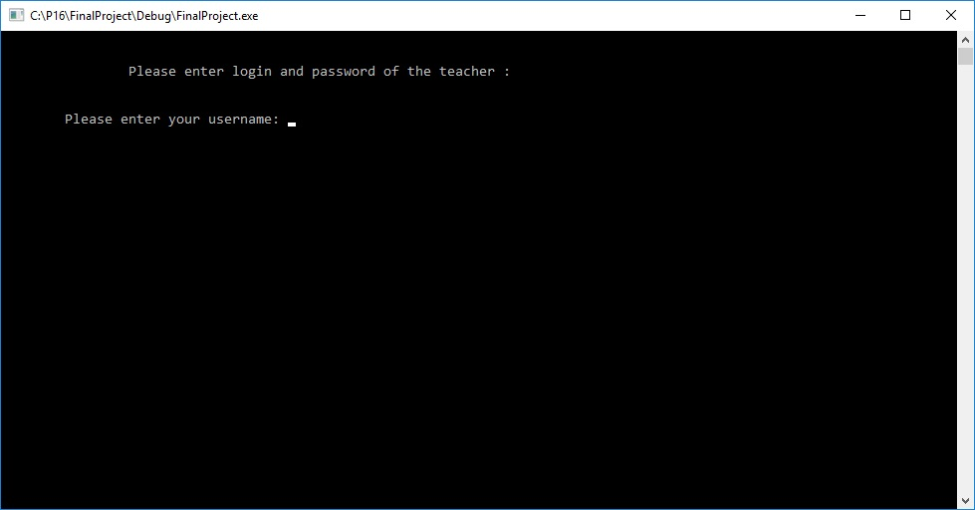
Step4. Check if login as teacher is wrong.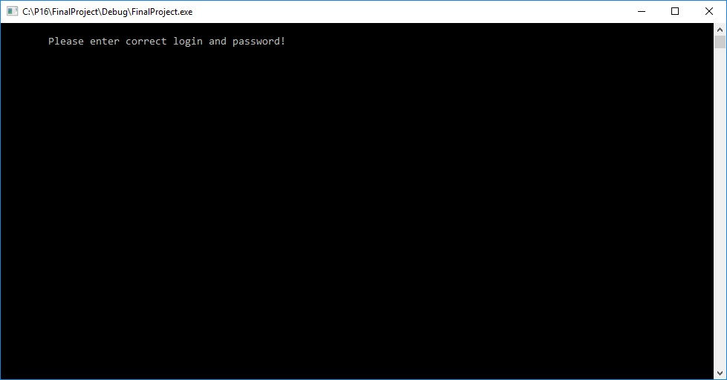
Step5. Teacher’s menu.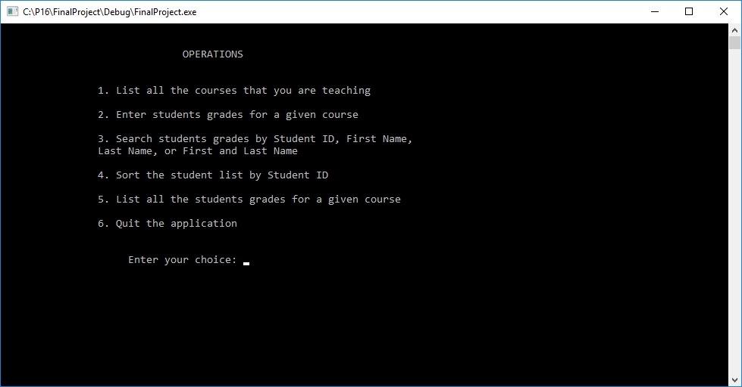
Step6. The choice in teachers’ menu is wrong.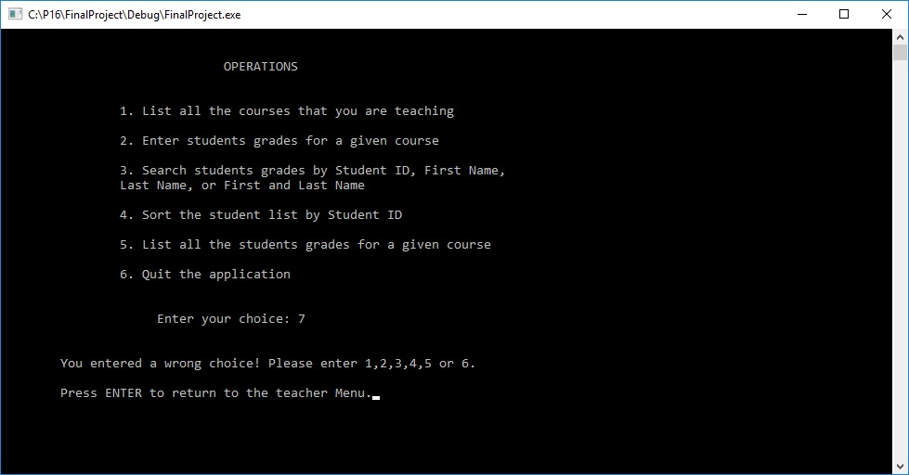
Step7.The list of all the courses that teacher teaching. 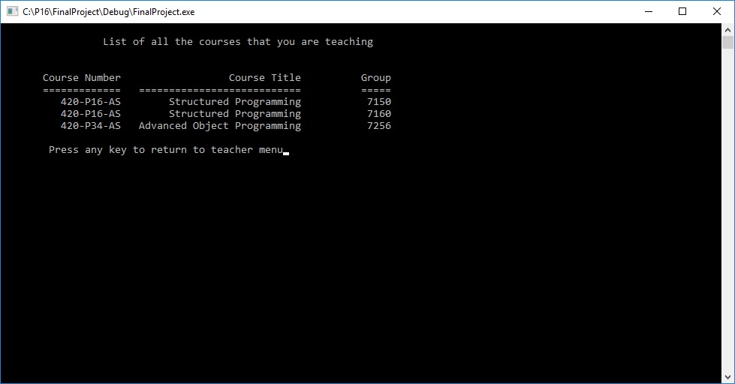
Step8.The mistake in typing of quantity of students in the group. 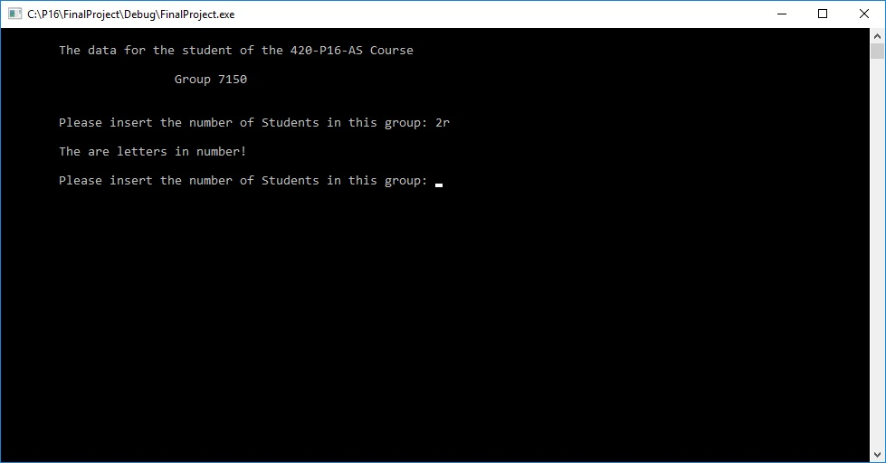
Step9. Insert of student data 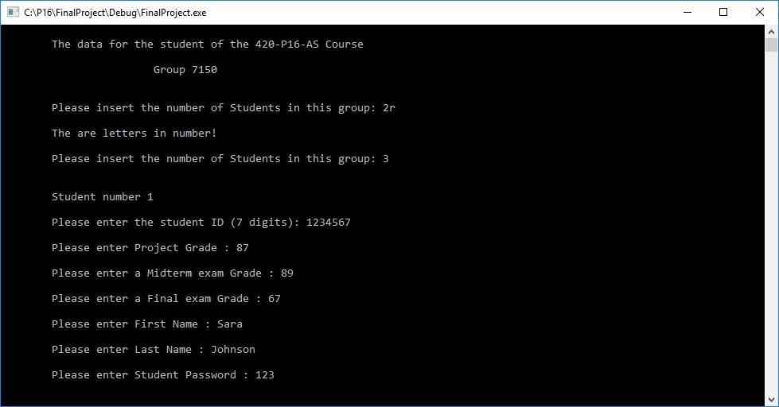
Step10.The duplicating of student ID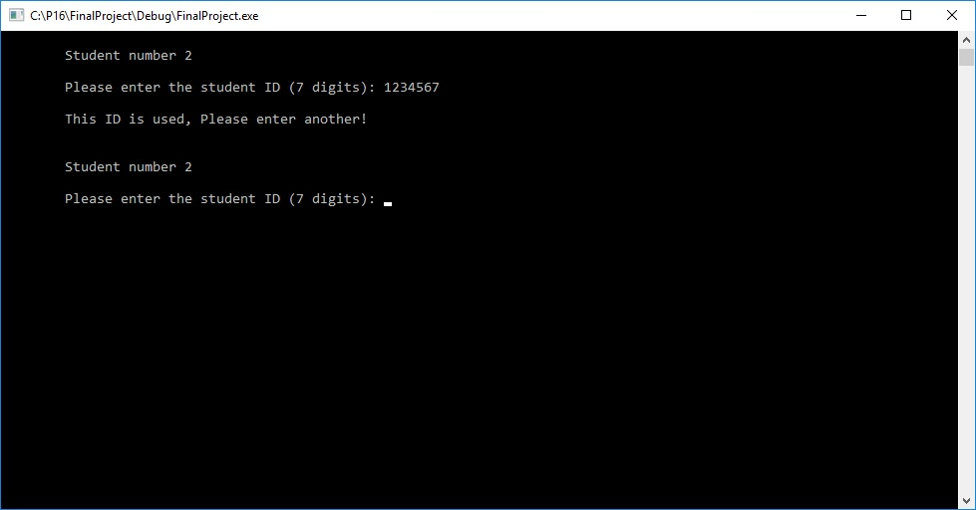
Step11.The mistake in writing project grade 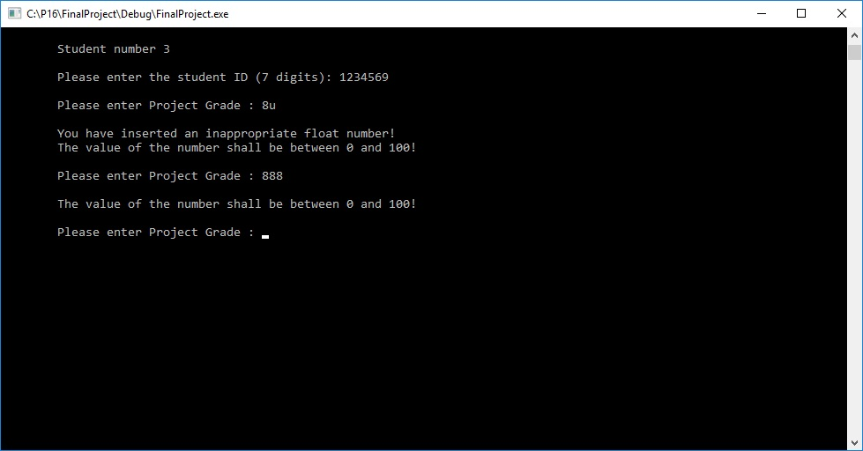
Step12.At the end of inserting the students the program asks for continue 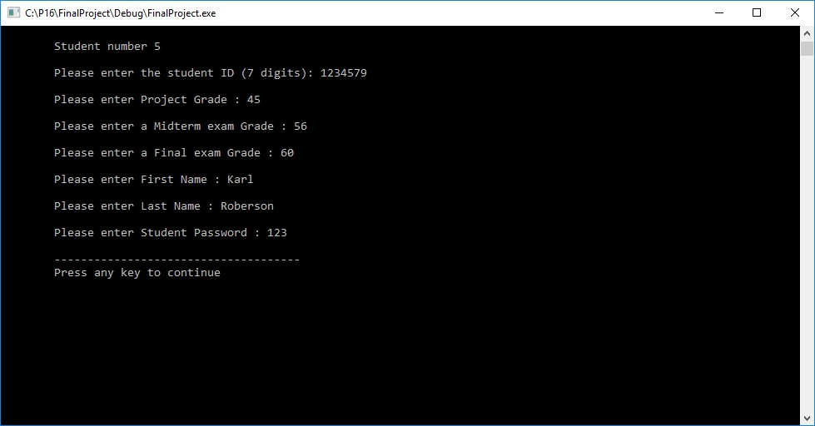
Step13.Menu of choice of the students by different parameters. 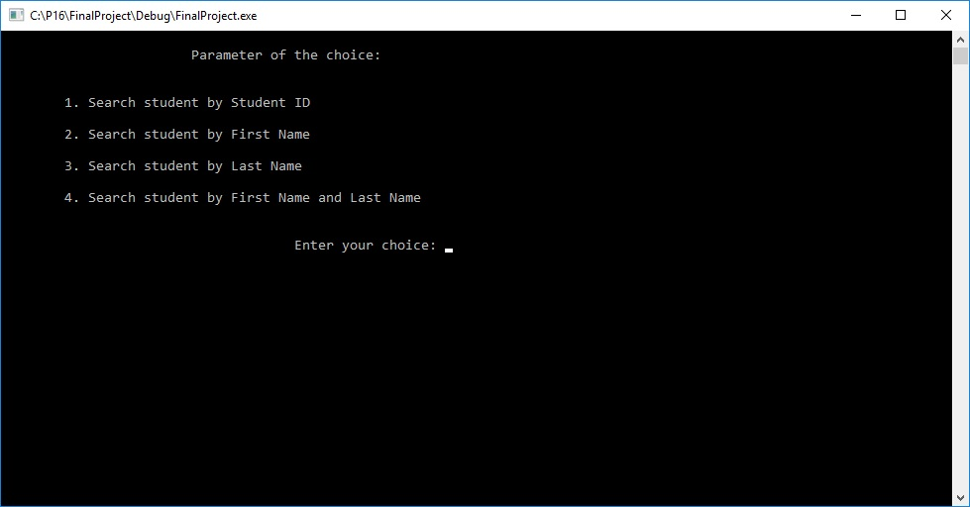
Step14.Result of search by student ID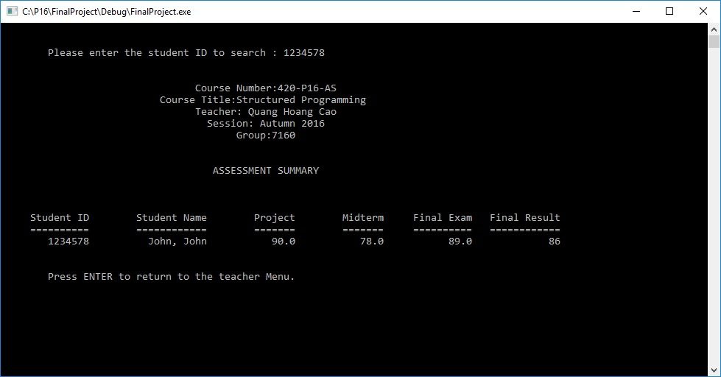
Step15.Mistake message if Name of student is not found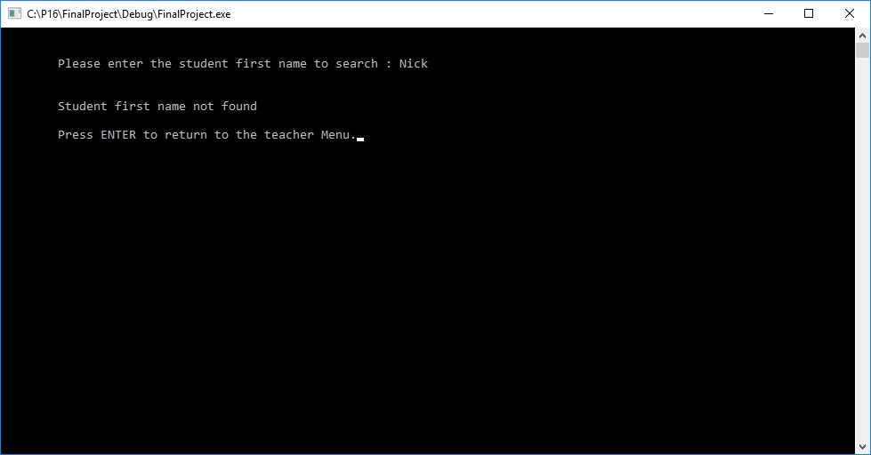
Step16.Result of search by Name of student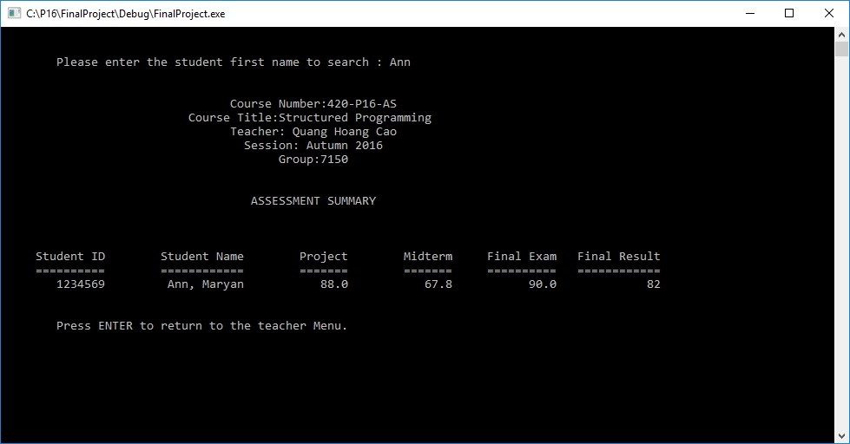
Step17.Result of search by last name 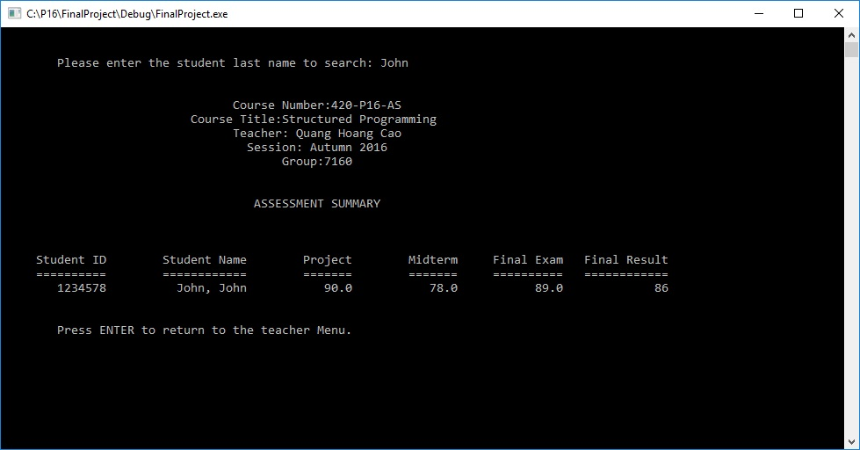
Step18.Result of search by first and last name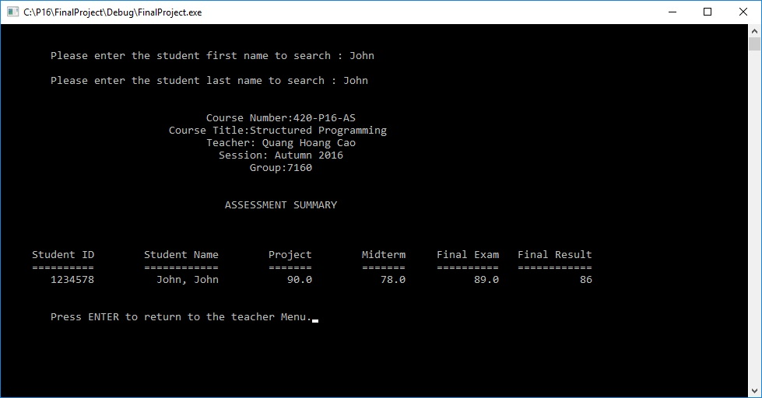
Step19.Sorting function, asks to press any key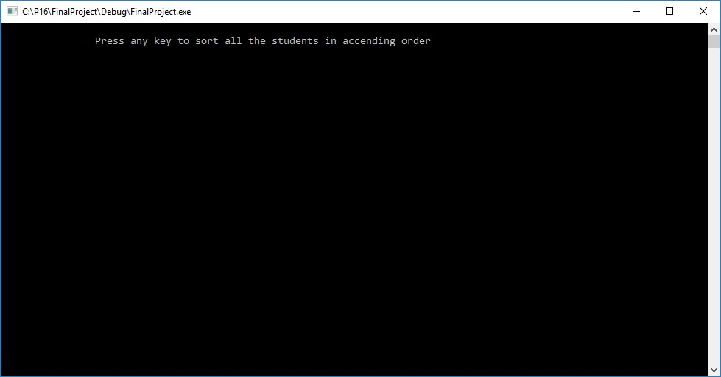
Step20.Search by course, selection between two courses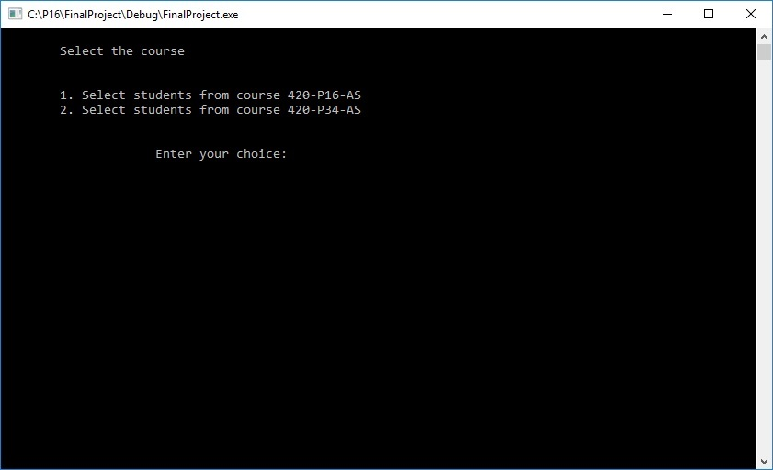
Step21.Search by group in course 420-P16-AS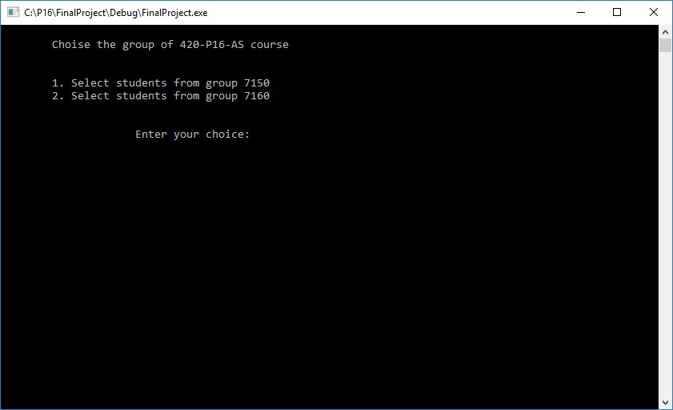
Step22.Result in search by course-group 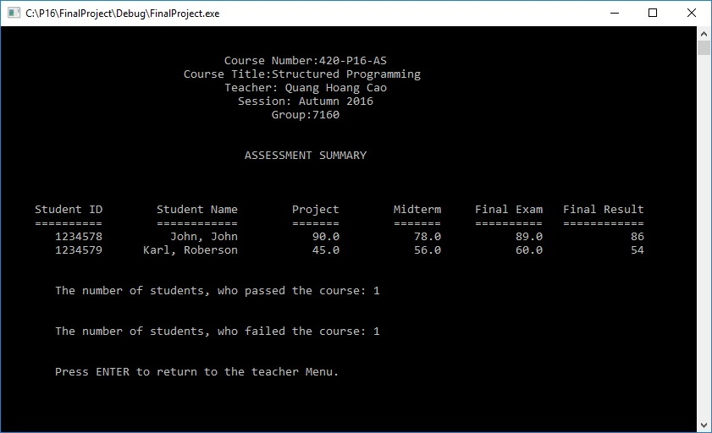
Step23.Log out of the teacher application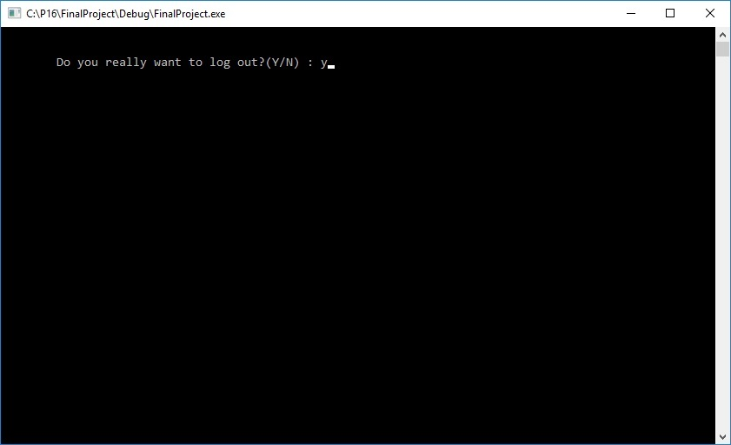
Step24.Login as student, if mistake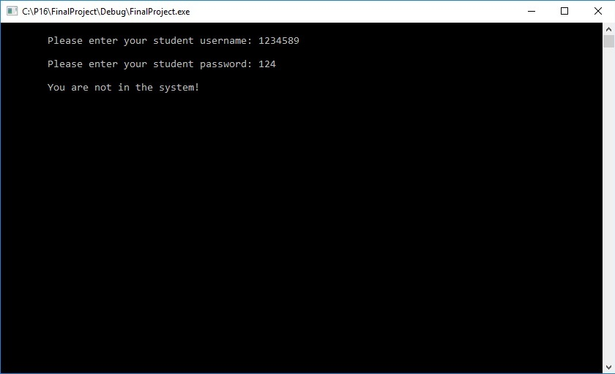
Step25.Student menu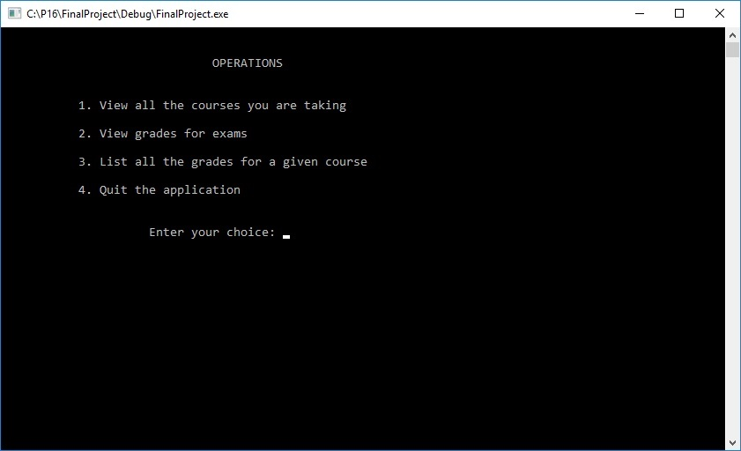
Step26.List of courses of Student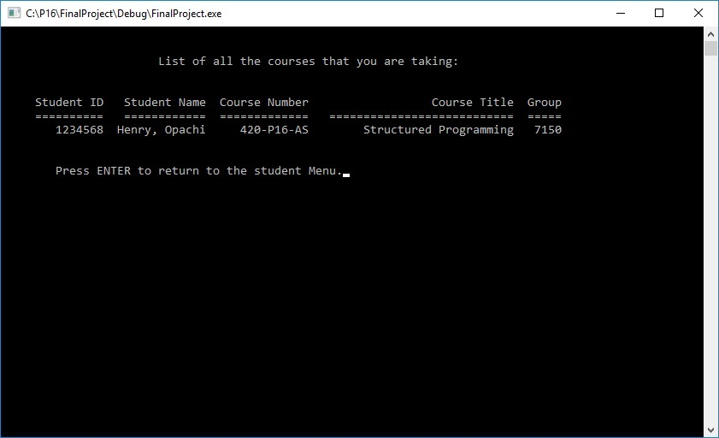
Step27.Choice of exam, by which grade shall be selected. 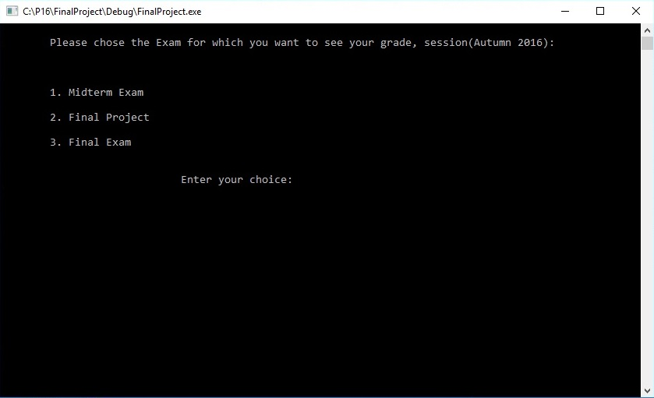
Step28.Mistake message, if choice of grade is wrong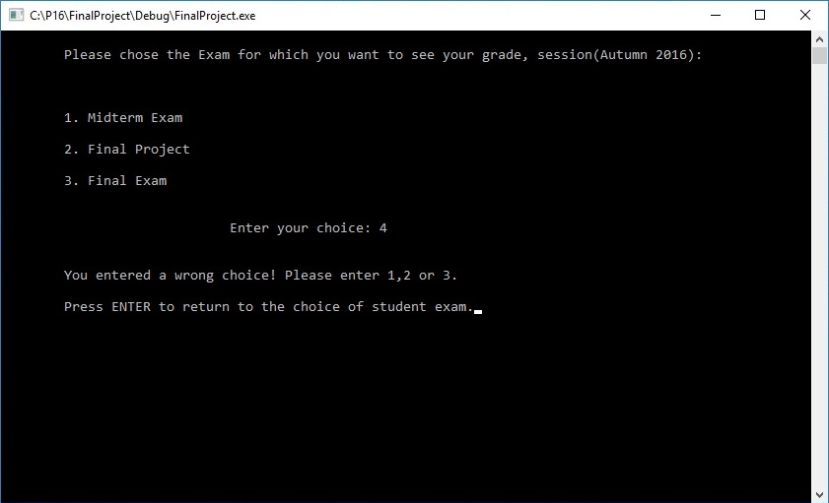
Step29.The result, displaying to the student. The output is similar for all the exams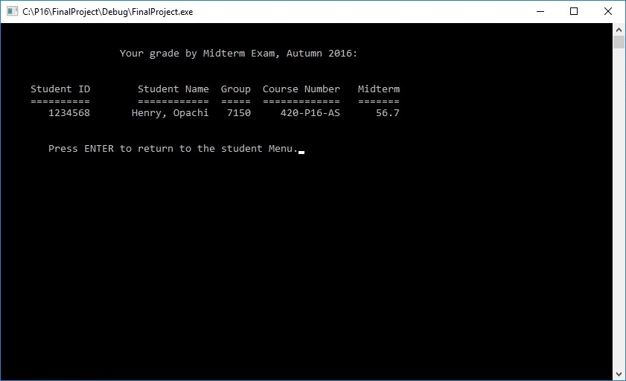
Step30.Displaying of all grades of the course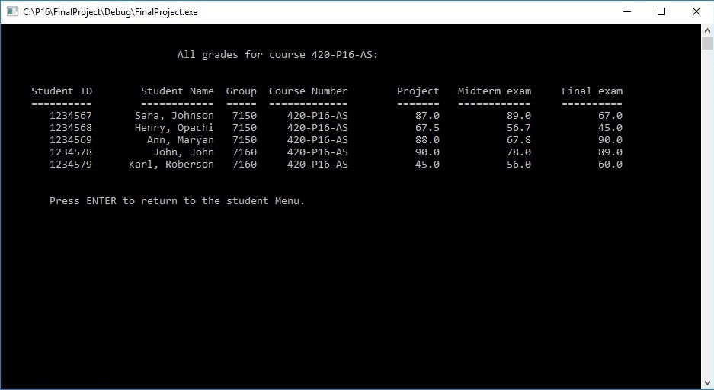

Step31.Exit from the program 