Felipe caballero
Chef tim budd 07/12/2017
Food and beverage term proyect

Table of Content
Part 1- Menu, concept and theory……pg2
Part 2-Mis en place…………………………..pg3
Part 3-job description……………………….pg4
Part 4-floor plan……………………………….pg5
Part 5-Style of service………………………pg6
Part 6-Wine assessment………………….pg7
Part 7-Beer and spirits menu…………..pg8
Part 8-Bar setup………………………………pg9
Part 1-menu, concept and mission
Mission
Our mission is to make guests feel like the restaurant is their home while sharing and learning about Colombian food.
Concept
Tairona’s concept is to provide Colombian cuisine to Vancouver and Canada, preserving tradition, yet renovation techniques and ingredients. The restaurant will constantly teach its guests about the culture and diversity in the country. The rotating menu will challenge the staff, while keeping the customers interested in coming back and trying new creations and representations.

All products will be local to maintain the best quality and to support local farmers. In Colombia, every produce is local, which highlights the flavours of the ingredients, rather than overwhelming them with spices. The animal protein will be bough from Canadian suppliers and the restaurant will work hard to receive the best products in the market.
Menu
Appetizers
Stuffed Arepas with shredded chicken
Corn patties stuffed with shredded chicken tossed with tomatoes, onions and peppers and blend of spices
Chicharron con Yuca al Vapor
Fried pork skin with a side of steamed cassava
Entrée
Rack of lamb with Pepitoria
Rack of lamb smoked with a blend of Colombian spices. Served with Colombian style lamb rice cooked with lamb blood and bits
Bandeja Paisa
Powdered beef, fried pork belly, chorizo, fried eggs, Ham hock cooked in beans, and avocado. Served with rice and beans
Desserts
Torta de Tres Leches
Cake baked with condensed milk, evaporated milk and heavy cream
Platano with homemade Bocadillo
Grilled stuffed plantain stuffed with guava paste and cheese
Part 2-Mis en Place
Mise en place before service

Drinking glasses ready and besides drink dispenser
Drink dispenser on
Napkins folded and placed in proper places
Beer kegs full and replacement ready
Cutlery properly distributed
Cashier full of change
Menus cleaned and sanitized
Chairs and tables organized
Reservation tables ready
Service boards ready

Mise en place during service

Dinner trays constantly replaced
Pens return to the right spot after used
Dirty dishes section constantly organized
Organizing washed cutlery
Organizing washed trays
News papers updated
Refilling beer kegs if required

Mise en place after service

Folding more dinner trays
Taking all dirty dishes to the dish washer
Refilling drinks fountain
Disposing broken glasses
Packing all sauce containers
Lifting the chairs
Organizing glasses

Part 3-Job descriptions
Front of the house manager
- Manage all the staff from the front of the house, including scheduling, supervising and training.
- Inventory management is all items needed for the front of the house, including ordering and receiving.
- Handling guests’ comments and problem solving.
- Cashing out the restaurant and restocking the cashier.
- Providing customer service and leadership in during and after service.
Server
- Exceptional customer service, problem solving and communication skills.
- Constantly restocking items needed for before, during and after service.
- Training new staff.
- Basic understanding of cooking techniques and menu items
Bar back
- Understanding of every server’s task and items needed for service.
- Exceptional communication skills and customer service.
- Basic understanding of cooking techniques and menu items.
Bartender
- Serving items properly and with Serving It Right knowledge
- Restocking the bar and making sure everything is in its place
- Training new staff.
- Basic understanding of cooking techniques and menu items.

Part 4-floor plan
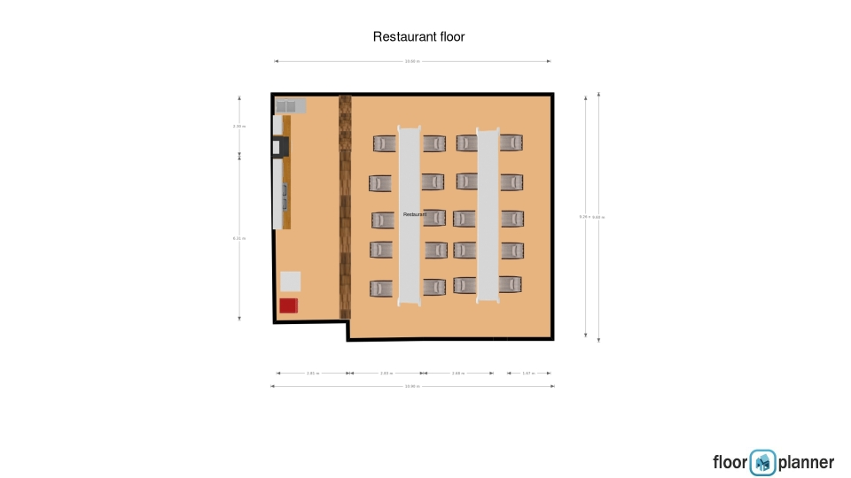
Part 5-style of service
The style of service for Tairona will be casual, where the guest would be first greeted by all the staff with a greeting in Spanish. Meanwhile the host will be walking the guests to an available table. The tables at Tairona while mostly be long and with a lot of seats available. Therefore, the guests might seat next to other customers. Drinks will be served first, so the guest can enjoy their drinks with the selection of music. The music would not be overwhelming, instead the music would be selected accordingly to the restaurant’s concept. The style would be family service, which would follow up with the restaurant decoration and tables.
Par 7- Beer and spirits menu
Beer Menu
Lagers
Revolver IPL-Red Collar brewing company
Recommended with the stuffed Arepas with shredded chicken
Steel Toe Lager-Dead Frog Brewery
Raspberry Lager- Spinnaker’s Brewery
Ales
Heroica Red Ale-Steamworks Brewing company
Recommended with the Lamb rack with pepitoria
Stay Gold Pale Ale-Powell Brewery
Coriander Pale Ale-Hathi Brewery
IPAs
Flying Dutchman North East IPA-Ravens Brewing Co.
Recommended with the bandeja paisa
Flagship IPA-Steamworks Brewing company
Limb from limb Rye IPA-driftwood brewery
All of our beer are locally brewed in BC
Spirits menu
Unruly Vodka-Wayward distillation house
Seaside gin-Sheringham distillery
Lohin McKinnon Single Malt whisky-central city Brewers & distillery

Part 8-Bar setup
The bar will be set besides the kitchen, which is exposed to the dinning room area. It will have a bartender and a bar back. The bartender will constantly serve guests and guide the bar back through service. Every aspiring bartender will have to start working as a bar back. There will be 9 tabs for our beer menu, which beer would be upsold by servers. Therefore, there will be beer glasses stored in a fridge under the tabs. The bar back will have to ensure that the bartender always has 50 glasses available. The bartender will have to know everything about the food served and they have to be able to explain it to guest. The bartender will also needed equipment for mixing drinks and they would have the liberty of coming up with creative cocktails. The equipment list is:
- 50 beer glasses
- 5 cleaning towels
- 15 shot glasses
- 20 glasses for cocktails
- Bottle openers
- Wine openers
- Bottles behind the bartender for decoration and serving
- Wine bottles stored at their proper temperature

