Business Plan
HORIZONTAL FLAME JAPAS
1920 Rosser St, Burnaby, BC, V5C0E1
Capstone- CUL272 10001
Chef Azriel Paz
10/1/2018
Anh Ngo
Adopting a vintage Japanese spirit, the Horizontal Flame Japas intends to recall the environment of the Edo Period in Japan with the several of Tapas food style with an eye toward health. The business plan outlines the strategies will develop to cater the growing of Brentwood community.

Table of Content
- Preface 3
- Concept Description 3
  - Business Concept
  - Mission Statement
  - Location and Market segmentation
  - Products and Services
  - Legal Type of Organization
- Management Team 5
  - Kitchen
    - Background of Head Chef/Senior Partner
    - Qualification
  - Front of House
    - Background of Manager/Owner
    - Qualification
- Statement of Purpose 8
  - Marketing Goal
  - Revenue and Expense Goal
  - Products and Service Goal
- Equipment Inventory 10
  - Equipment specifications
  - Silverware, Glass & Utensils Purchases
  - Front of House Furniture
  - Small Ware Inventory
  - Capital Equipment
- Menu Planning
  - Menu Engineering
  - Food Specification
6.2 Standardized Recipe with Food Cost
- Human Resources 9
  - Organizational Chart
  - Job Description
  - Labor Cost Analysis
  - Staffing Schedule
- Marketing Plan 20
  - Demographic
  - Location Description
  - Location and Accessibility
    - Major Traffic and transportation
    - The convenient accessibility
  - Competitors
    - Sushi Holic
    - Sushi Garden
    - Guu
  - Goals and strategies to achieve
  - Techniques
  - Target Audience
- Facilities Design 29
  - Facilities Measurement with decoration planning
  - Equipment and floorplan Layout
- Financial Analysis 30
  - Financial Statement
    - Financial Sources
    - Preopening Cost List
  - Revenue Forecast
  - Balance Sheet
  - Income Statement
  - Ratio
    - Operational Ratios
    - Essential Ratios
- Executive Conclusion 36

Preface
As well known for being a multi-cultural region, Vancouver has reflected one of the most important aspects is the cuisine. Especially, Japanese cuisine has been skyrocketing over the past few decades. Vancouver was the region that is leading in introducing Japanese food as well as being recognized as “the sushi capital of North America”. The Horizontal Flame Japas is designed to contribute the widely expansion of Japanese cuisine but in a different way. We are proud to be a team with interest in the classic Japanese cuisine but in the recall of Edo age (Medieval) in the middle of Brentwood downtown.

Concept Description
  - Business Concept
Our diner will be serving fresh and healthiest with variety of selection from the local seafood sources. The menu will be creative with the interchangeable ingredients with a twist of vintage fusion. As a team with highly interest in the vintage Japanese spirit, we are looking forward to bring our customers into a new environment that can help them to escape from the busy of their modern life. Our customers are welcome to join us with a different experience from enjoying a unique type of food in the Edo period (16th-19th century).
  - Mission Statement
“To deliver our customers into the environment of Edo Period in Japan fulfill of the spirit of vintage Japanese culture within the modern living.”
  - Location and Market Segmentation
Our location is at 1920 Rosser Street, in the heart of Brentwood, the thriving modern town of Burnaby. With the development of transit system as well as infrastructure, the population of Brentwood area is promising to highly increasing from 10500 (2011) to 25000 (2021) according to city of Burnaby. Other than that, the Brentwood area has a higher rate of international students as well as workers based on the high percentage of renting households will be a top choice for our business concept.
On the other hand, the presence of the BCIT of higher learning will provide the area with young age customers which are heavy consumers of the tapas environment. There are a highly rise of office and residential building with convention centre attract more events that bring visitors from throughout the region as well. Last but not least, the expansion of Brentwood mall with a new renovation will be a biggest reason for the thriving and growing in the population in this area.
  - Products and Services
Setting the mood of the vintage Japanese structure, 70% of the building will be built with wood and bamboo structure, elevated slightly off the ground with thatched roof. The Horizontal Flame Japas will be a simple 50 seat tapas with bamboo tile, wooden floor, traditional paper lamp instead of modern neon lighting. Most of the traditional tables (low wooden dining table) will be used; and only 2 high tables for special requests. Customers will seat on the cushion (a Japanese mattress that is used widely in Japan). There will be an open kitchen in the middle of the room to enhance the interaction with our customers as well as to bring the exact atmosphere of the old days.
Most of the menu will revolve around the traditional sushi, appetizer dishes, BBQ. One of the most important things is the liquor, spirit that is imported from Japan brewing company; those have been operating since 14th century, to be able to completely escape to the Edo period. As one of the strategy in our service, our customers will be given a paper that they can write down their orders or custom meals and directly transfer to our chef. It is considered as the traditional way since the presence of server is mostly on the behalf of the Emperor. Differed from other fast food restaurant, we focus on providing the good environment for customers to spend time and enjoyment with friends and family.
  - Legal Type of Organization
The Horizontal Flame is structured as a limited liability partnership business with the shared liability between Andy Ngo and Chef Hiraku Takahasi. This business will be a 70/30 for owner and head chef in terms of partnership. Andy will oversee all the front of house including papers, taxes as well as licenses, regulations. Whilst Hiraku will oversee all of the food products, equipment and inventory. Besides that, all of the house policies, and other aspects of business such as menu planning, designing and management will be discussed and decided by both owners.

Management Team
  - Kitchen
    - Background
Hiraku has started this project with a strong food service background. He has been trained by Sushi master Jiro Ono, one of the greatest sushi craftsmen for more than 14 years of training and apprenticeship. He has worked hard and gained Itamae “Master of sushi” title. Starting out as apprenticeship, with his enthusiastic in the classic Japanese culture, he has dreamed to open an Edo theme restaurant. He has been trying to learn and manage all of the aspects of the kitchen wherever he works in order to find a right formula for his dream comes true.

    - Qualification
- Itamae Tile Achievement
- Manage day-to-day operation
- Oversaw financial and personnel matters
- Planning public relation
- Inventory costing analysis
  - Front Of House
    - Background
Andy has started his career as the bus boy in small restaurants in his small towns. Since moved to Vancouver, he has started improving his skills and knowledge by working in the different area as well as getting involved in the management process. Implementing and learning from mistakes is one of his important keys to equip the valuable experience for his management career in the future. In charged of staffing and scheduling system, Andy has learned on hiring process; manage human resources as well as controlling products and services. Not only working in the restaurant, the time being in the hotel has helped him to improve the ability to solve problems as well as train new skills. He has a good understanding of Asian food especially Japanese as well as the interested in the old Edo Age will definitely be valuable at the Horizontal Flame Japas
    - Qualification
- Japanese Food and Beverage Knowledge
- Human Resources Management
- Costing and sales Management
- Products and Services controlling
- POS System knowledge

Statement of Purpose
  - Marketing Goal
This project report will be estimated based on the experience and researches within the Brentwood area. With the current population of mostly 14000 in the area only, we are looking forward to plan on attract at least 55% mostly on the local households, schools and office. Strongly focus and building on our website and social network is our top strategy in order to implement and achieve our goal faster.
  - Revenue Goal
We have divided our Revenue Goal into 3 categories:
- Pessimistic-level: $518,400/year in sales based on average of 80 customer per day (360 day/year) for the average check of $18/person
- Mid-Level: $684,000/year in sales on average of 95 customer per day (360 days/year) for the average check of $20/person
- Optimistic-Level: $910,800/year in sales on average of 115 customer per day (360 days/year) for the average check of $22/person
  - Product & Service Goal
We commit to bring our customer the freshest products from the local market. Through our chef skills, our customers will enjoy the old day environment with the high quality of today’s products. We are looking forward to see our customer to have the most enjoyable moment with friends and beloved family. All of our staffs will have custom uniform of the Edo age with the similar accent, behaviour as well as the spirit.
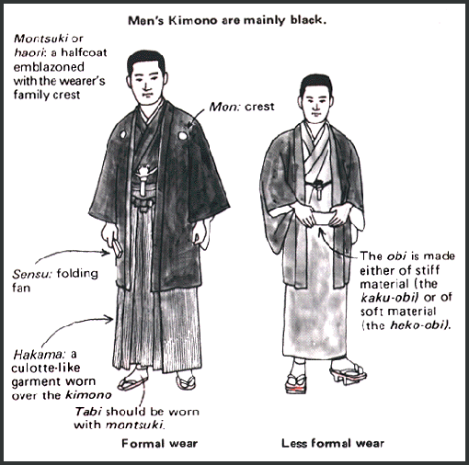

Besides good quality of food, the Horizontal Flame Japas also offered all of the unique arts in terms of the Edo culture: Geisha, Castle, Emperor, etc. Classical Japanese song will be mostly played through our collection of gramophone for a childhood memories as well as to experience those equipment that has been lost gradually nowadays. All of this combination will definitely bring not only customers but our team into a different space full of enjoyment and memories.

Product & Furniture specification
Check the Excel File: Total Inventory, Furniture & Capital Equipment for details

Menu Analysis
  - Menu
Check the PDF File “The Horizontal Flame Menu” for details
  - Standardized Recipe with Food Cost
Check the Excel file “Standardized Recipe with Food Cost” for details
  - Menu Engineering
Check the Excel file “Menu Engineering” for details

  - Food Specification
Check the Excel File “Food Specification” for details

Human Resources
  - Organizational chart
Owner

FOH Manager
Head Chef/Owner

Sous Chef
Supervisor

Dishwasher
Prep/Line Cook
Host/Hostess
Server

  - Front of House
7.2.1 Front Of House Manager
Document No. 001 | Title:  Front Of House Manager | Print Date:  11/16/2018
Effective Day:  11/23/2018 | Reviewed By:  Anh Ngo/Owner | Date Reviewed:  11/23/2018
 | Approved By:  Anh Ngo/Owner | Date Approved:  11/24/2018
      - Summary
The FOH Manager oversees the daily basis operation of the restaurant/s facilities, employees and directing the activities toward the maximum of food quality and customer services
      - Duties & Responsibilities
- Analyze the market and control all the daily activities toward to the restaurant’s annual goal
- Coordinate the operation between the kitchen and Front of House
- Deliver superior service to achieve the highest customer satisfaction as well as respond efficiently to customer complaints
- Researches on new vendor as well as products’ quality
- Review and appraise all staff’s performance as well as provide positive feedbacks in terms of productivity improvement
- Estimate the needs of goods, equipment and employee based on history record and POS system
- Ensure the sanitation and safety regulation
- Operational Cost and Food Waste Control
- Interviewing, Training & Coaching new employees
- Daily communicate with supervisor to ensure the smooth process
      - Requirement
- Minimum of 3 year experience in Hospitality Management or similar role
- 3 years of customer services and food handling
- Extensive Food & Beverage knowledge is mandatory. Knowledge in classic Japanese cuisine is an asset
- Strong Leadership and motivational skills
- Financial Management Skills
- Serving It Right Certificate
- Food Safe Certificate
- Hospitality Management or Culinary Diploma/Degree is a big plus

    - Head Server/Supervisor
Document No. 002 | Title  Head Server/Supervisor | Printed Date:  11/16/2018
Effective Date:  11/27/2018 | Reviewed By:  Junji Itto/Manager | Reviewed Date:  11/27/2018
 | Approved By:  Anh Ngo/Owner | Approved Date:  11/30/2018

      - Summary
Head Server/Supervisor is dedicated to provide exceptional customer services and coordinate with other staffs to maintain on a right tracking process. On other words, Head Server/Supervisor is Manager’s right hand in managing the operational daily basis
      - Duties & Responsibilities
- Assigned with Opening & Closing duties with a daily cashout report
- Giving order to server/host and instruct them on handling all the situation
- Support and communicate with both FOH & kitchen staff to maintain the operation flowing
- Stay connected with manager and report any incidents/situation during the service time
- Supervise all of staffs on premises
- Support other server/host in required
- Appraise and report staff’s productivities to manager
- Ensure all of the Mis-En-Place is set and ready before the service hour
- Ensure the sanitation & Safety Regulation
      - Requirements
- Minimum 3 years of Customer Service/Serving in Hospitality Industry
- Knowledge in Food & Beverage
- Experience in cash handling and ordering system (POS System)
- Attending to details & Multitasking
- Required to wear the Kimono during the shift
- Serving It Right Certificate
- High School Diploma is mandatory. Hospitality Management Degree/Diploma/Certificate is a plus
    - Waiter/Waitress
Document No.003 | Title:  Waiter/Waitress | Print Date:  11/30/2018
Effective Date:  12/01/2018 | Reviewed By:  Junji Itto/Manager  Gareth Bale/Supervisor | Reviewed Date:  12/01/2018
 | Approved By:  Junji Itto/Manager | Approved Date:  12/05/2018

      - Summary
Server represent for the image of the restaurant so we require the good appearance with excellent customer service and enthusiasm in food & beverage industry
      - Duties & Responsibilities
- Taking orders and deliver food to customers
- Provide outstanding service to maximize satisfaction (Moment of Truth)
- Arrange all table and station setup
- Making Menu Recommendation, answering questions with additional information to restaurant patrons.
- Upselling additional products when appropriate
- Communicate order details to the kitchen staffs
- Making beverages and delivering to customers
- Communicate with head server/supervisor to review daily specials or any changes on the menu
- Cleaning table and carrying all the dirty plates, utensils to kitchen for washing
      - Requirements
- Minimum of 2 years of serving in restaurant
- Experience in cash handling and ordering system (POS System)
- Strong organizational & multi-tasking skills
- Required to wear the Kimono during the shift
- Flexibility in schedule especially night time and weekend
- Serving It Right Certificate
- High School Diploma is mandatory. Hospitality Management Degree/Diploma/Certificate is a plus
    - Host/Hostess
Document No.004 | Title:  Host/Hostess | Print Date:  12/01/2018
Effective Date:  12/05/2018 | Reviewed By:  Junji Itto/Manager  Gareth Bale/Supervisor | Reviewed Date:  12/05/2018
 | Approved By:  Junji Itto/Manager | Approved Date:  12/07/2018

      - Summary
Present the first impression of the restaurant, host/hostess are required to show the friendliness as well as outstanding presentation

      - Duties & Responsibilities
- Greet incoming and departing guests warmly with a positive smile and eye contact
- Escort guests to their designated area/table
- Present and introduce menu/daily specials as well as server’s name
- Answering phone calls (make sure to write guests’ name & phone number) for reservation or take-out orders
- Provide the appropriate waiting list with the estimated waiting time to all guests
- Observant to guest’s needs throughout the restaurant to ensure their satisfaction
- Help and support server if required
- Receive payment (credit charges, cash handling)
- Ensure the sanitation & safety policies. Organize the station and menu
      - Requirements
- Experience in Customer Service is preferred
- Clearly communication skills with eye contact
- A desire to help out where needed and work as part of a team
- The ability to thrive and improve the performance in this industry
- Flexibility to work a variety of shifts
- Required to wear the Kimono during the shift
- Ability to memorize as well as basic math
  - Kitchen
7.3.1 Head Chef/Owner
Document No. S | Title:  Head Chef/Owner | Print Date:  01/01/2018
Effective Day:  01/01/2018 | Reviewed By:  Anh Ngo/Owner | Date Reviewed:  01/01/2018
 | Approved By:  Anh Ngo/Owner | Date Approved:  01/01/2018
      - Summary
The Spirit of the kitchen who takes care all of the recipes as well as product purchase based on the daily basis operation
      - Job Description
- Constructing menu with new & existing creation with the ensure of qualitative and quantitative
- Control & Direct the food preparation process as well as other relative activities
- Planning on order of equipment and ingredients on daily/weekly basis
- Fully in charge of recruitment and training process
- Oversee the work of subordinates
- Controlling labor and food cost
- Scheduling all the kitchen staff/Maintain the attendance
- Set the standard procedures as well as disciplines
- Nutrition & Sanitation Regulation
      - Requirements
- Minimum of 5 years of kitchen management experience in the industry
- Japanese Background who was raised with Japanese cuisine
- Sushi Master training
- Cost Controlling efficiency
- Outstanding communication & leadership skills
- Up-to-date all the culinary trends
- Knowledge of management software programs
- Food Safe level 2 & HACCP certified
- Degree in Culinary Science
    - Sous Chef
Document No. K01 | Title:  Sous Chef | Print Date:  11/01/2018
Effective Day:  11/05/2018 | Reviewed By:  Hiraku Takahasi/Owner | Date Reviewed:  11/05/2018
 | Approved By:  Hiraku Takahasi/Owner | Date Approved:  11/05/2018

      - Summary
Right hand of head chef who provide the most utmost cooperation & support with productive ideas and implementation
      - Job Description
- Control the basic daily operation
- Helping in preparation & design of the menu & food items
- Ensure the operation meets the quality standards
- Safety & Sanitation Regulation
- Manage & train all the kitchen staffs
- Commitment to performing daily duties e.g. opening, closing, and side work.
- Fill in for Head Chef in planning and directing food preparation for proper orders on daily basis
      - Requirements
- Minimum of 3 years of experience as Sous Chef
- Understanding various of cooking methods and skills
- Knowledge in Japanese cuisine
- Food Safe Level 1/First Aid
- Accuracy in handling emergency situation
- Degree in Culinary science
    - Line Cook
Document No. K02 | Title:  Line Cook | Print Date:  11/01/2018
Effective Day:  11/05/2018 | Reviewed By:  Hiraku Takahasi/Owner | Date Reviewed:  11/05/2018
 | Approved By:  Hiraku Takahasi/Owner | Date Approved:  11/05/2018

      - Summary
Important role in the kitchen that is responsible for preparing and producing items that meet the quality standard
      - Job Description
- Set up and stocking stations with all necessary supplies
- Prepare food for service (e.g. chopping vegetables, butchering meat, or preparing sauces)
- Cook menu items in cooperation with the rest of the kitchen staff
- Answer, report and follow executive or sous chef’s instructions
- Clean up station
- Stock inventory appropriately
- Ensure that food comes out simultaneously with high quality and timing
- Safety & Sanitation Regulation
      - Requirements
- Minimum of 2 years of experience working as line cook
- Knowledge of the culinary skills and methods
- Knowledge in Japanese cuisine
- Food Safe Level 1
- Efficiency in communication
- Culinary related certificate is a plus
    - Dishwasher
Document No. K03 | Title:  Dishwasher | Print Date:  01/01/2018
Effective Day:  01/01/2018 | Reviewed By:  Takeda Shingei/First Cook | Date Reviewed:  01/01/2018
 | Approved By:  Takeda Shingei/First Cook | Date Approved:  01/01/2018

      - Summary
Considered as the most important role in the kitchen as dishwasher will ensure the sanitation, safety as well as highly hygiene all over the kitchen
      - Job Description
- Ability to operate an industrial dishwasher safely and rapidly.
- Wash glassware and various kitchen items by hand, when necessary.
- Strength and stamina required to lift loads and empty/clean all trash receptacles.
- Ability to meticulously clean iced tea and coffee machines daily.
- Highly organized, managing placement of all kitchen items and dishes and mindful of need to rotate dishes to reduce wear and tear.
- Commitment to all around cleanliness, including dishwashing and dish storage areas.
- Willingness to follow sanitation and safety policies at all times.
- Willingness to assist prep cook and other staff as needed, especially during rushes.
- Basic janitorial skills to clean up spills, broken glassware, etc. immediately.
- Willingness to report any sanitation or janitorial issues to management.
      - Requirements
- No experience is required & we will provide training if needed
- Time Management skills
- Ability to operate dishwasher safely and carry loads up to 35 lbs
- Able to work in hot & humid environment
- Food Safe Level 1 is a plus
  - Labor Cost & Staff Schedule
Check the Excel File “Scheduling & Labour Cost” for details

Marketing Plan
  - Objectives
We have built our marketing team in order to achieve our success in any market in Vancouver Mainland especially the Brentwood Area. This mission will be carried and upheld in our restaurant along with our main objectives:
- To deliver a combination of local fresh items with classical Japanese cuisine to our customers
- Focus on our customers’ needs in order to provide the excellent services and build customers’ loyalty
- To become a customers’ choice in town by offering the unique atmosphere with top quality and wide range of choices and credibility to our customer. Other than that, we also work with a consulting team who will provide us with the exact database and planning.
- To understand our competitors in the area in order to become differentiate and overcome their reputation.
- Building an expansion plan outside the Brentwood area will be developed after the first 2 years based on the operation as well as customers’ feedbacks

  - Target Market
    - Geographic
According to Statistic Canada in 2015, 13.1% Canadian were living in British Columbia that makes it the third concentrated province nationwide. A report by BC stats shows that Burnaby is the second densely populated in BC after Vancouver despite of the declining in growth rate in the last few years. However, with the development of infrastructure in the Brentwood area, the population start improving dramatically since the majority of the high-rise building all sold out. This indicates that Brentwood is promising to be relatively more attractive market to target.
    - Area Description
20 minutes from Downtown Vancouver, Brentwood area is growing everyday based on the high demand of the investment that make real estate value becomes high rocketing. However, as the development just started for few years, this area is still considered as young town where the majority of population are students, laborers and young families. The town is considered as convenient as Metrotown area because of its location. Brentwood town is promising to be the central city of Burnaby where right next to highway 1 which is easily accessed both East & West Side. More than that, the extension of new sky-train line (Evergreen) which connect directly to the Tri-cities area has brought up a lot of people moving. According to City of Burnaby, the majority population of Brentwood mall are from the age range of 20-44 years old and there will be more younger people moving in next few years. There are three main occupations categories in the area: Sales & Service occupation (27%); Business, finance, administration occupation (25%) and professional, scientific and technical services (18%) in 2015. Those categories will be ideal for our target because of their age group, lifestyle & sociology.
The Horizontal Flame Japas right in the heart of Brentwood area where only 2 minutes walking from the Brentwood mall and sky-train system. The Restaurant is located right in the plaza in the whole complex.
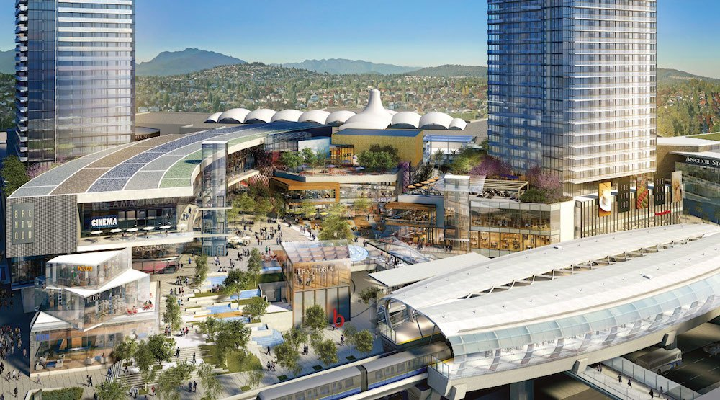
Brentwood Mall Complex
    - Store Location
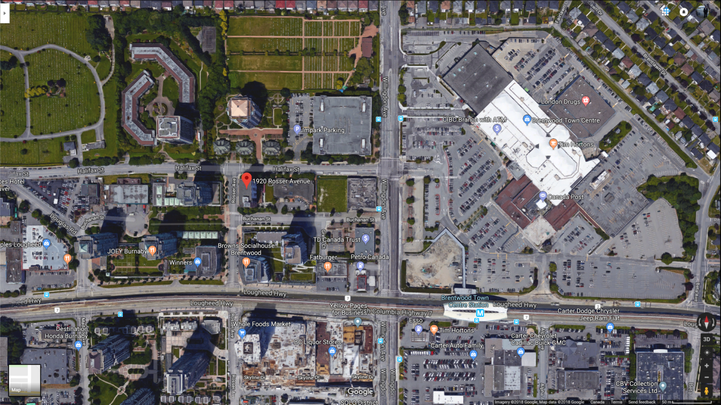
Address: 1920 Rosser Avenue, Burnaby, BC, V5C5E1
This location is right in the heart of Brentwood area that connected directly to the Brentwood mall & sky-train. This area is ideal for the commercial place because inside the plaza with a lot of parking lot as well as right next to the park. Other than that, our store is the only Japanese restaurant within 2 blocks radius. There are 2 main bus lines that connect to the main area: 130 Bus connect to North Vancouver and Metrotown; and 129 Bus connect to BCIT. Besides that, as mentioned above, the sky train will help brining a lot of customers from other area as well. The Horizontal Flame believes that if we follow to our strategy plan and procedure, we will not only attract the locals but also from other area. We will discuss on our plan to attract more people in the next section
    - Demographic
      - Psychographics
Our potential customers are considered as outgoing people especially those who are more active at night. However, we are expecting to be a hot spot in the area for during the lunch rush for office workers as well. Other than that, as followed by the concept, our customers tends to be independent on finance or being comfortable with their income. What our customers looking for not only for a good deal but a good experience with high quality of food.
      - Lifestyle
The Horizontal Flame Japas focuses on our customers’ lifestyle as well. We highly value those who enjoy being with family and friends. We commit to offer those special moments with the utmost and cheerful cooperation, as we understand those moments do not occurs frequently. On the other hands, as people have quick busy time every day, it is hard to become totally escape from the modern world. We definitely want to help them to preserve the lifestyle where they used to do before or have been forgotten. That is absolutely the most important thing to us. Moreover, those mentioned above also contribute largely to our customer pool.

8.3. Competitor
    - Sushi Garden
  - Location: 4269 Lougheed Highway, Burnaby, BC. 4 blocks away from the Brentwood Sky-train. They are 60 seat Japanese Restaurant with parking plaza.
  - Menu: They share pretty the same menu with us (up to 60%) but focus mainly on the sushi instead of tapas style food. However, with the same content and reputation, they are considered as the first competitor to our brand.
  - Price Point: According to their menu and feedbacks, their price point are actually a little expensive over average (almost $18/person without alcoholic beverage)
  - Their Advantages: They are highly reputation because of their franchise brand as well as they are almost monopoly within the area before we came
  - Their Disadvantages to our store: Their prices are quite high over average and they are losing customers who are not driving. Also, there is a construction right in that intersection which will affect their business during our grand opening time. There concept is just as normal as other restaurant without any impressions.
    - Sushi Holic
      - Location: 3311 East Broadway, Vancouver, BC. This location is actually far from our location but they are still under our competitor. (2 sky-train station away)
      - Menu: Their menu is a little similar except they have twisted their taste into Korean flavour with unique toppings and decoration.
      - Price Point: is averagely reasonable as it is around $14/person without alcoholic beverage)
      - Their Advantage: their reputation from the franchise brand. Their unique food might create attraction to new customers
      - Their Disadvantages to our store: that area is residential which means might be quite during the lunch and late night time. Also there are huge senior community nearby which might not interested in their type of food. There concept is just as normal as other restaurant without any impressions.
    - Guu
      - Location: 838 Thurlow Street, Vancouver, BC. Located on Robson Street (West End) downtown where is one of the busiest area in Vancouver
      - Menu: almost 90% similar to our menu with more options. They are real tapas style restaurant (Izakaya) with variety of small dishes various from seafood to any kind of protein
      - Price Point: is considered as high but acceptable for that area because of the high demand (Approximately $20-$22/person)
      - Their Advantages: they are always busy because of their reputation, good location and unique service as well. All of their staffs are trained to provide the positive impression to any customers.
      - Their Disadvantage to our store: their market location are completely different to ours which mean they are not directly compete with us even we share the same concept. They do not have a special them/atmosphere except open kitchen. The high competitive rate in that area might affect their business if they do not carefully follow to their procedures and what they have done properly.
  - Marketing Strategy
    - Price
As our brand is new to the market, we are planning to provide a lot of promotions to attract new customers especially for the first 3 months. We will focus on:
- Occupation: we will provide promotion for any students in BC (with valid student ID) 15% except alcoholic beverages and not valid on the weekends.
- Family package: for a total bill of $100 and over, there will be free one dessert and one appetizer for that table. (no split bills accepted)
- Lunch Rush: to attract more people during lunch rush, all the main items will take $1.00 off from Monday-Friday
- Happy Hour: 3pm-5pm and after 10 pm. There will be 15% of for appetizer and 20% for beverages.
    - Promotion
One of our top strategies is to build and maintain relationship with our potential customers through various channels. Our employees are well-trained to create good impression, deliver high quality of service and build trust among customers. In addition to that, we will provide the membership program through social network (Facebook, Instagram) not only to obtain customer loyalty but to keep in touch with them via direct contacts and receive feedbacks:
- Customers can follow our page to enjoy the atmosphere and service we provided. We will be daily active on social network with different videos about our concepts. The page will contain simple eye-catching aesthetics and friendly functions
- We will keep in touch and respond frequently to any reviews regarding of food & services
- We also built our website which can help customers to be easily kept in touch. Our teams will work be fast-in-respond about any concerns or feedbacks from our customers to make necessary improvements for our products
- On the early few months, we are planning to place posters near the public transport station, schools and offices in the surroundings area. These posters will be changed every few weeks to make it fresh and attractive to customers
    - Differentiation
The Horizontal Flame is confident to have several competitive edges.
- The most important one is our restaurant location which is close to any major transit system with free parking lots that make it convenient for our customers access our places
- The uniqueness in our concept and atmosphere are totally a big difference to our competitors. Also, we encourage the classical Japanese spirit that will not only attract the Japanese but also others who interested in cultural experience
- Last but not least, our active participation on social network is the key to gain success as we value this as the best way to keep in touch with our customers. The support we offer is not limited within the store; we also volunteer to help homeless people and food bank in the community as well.

    - Growth Strategy
To facilitate the growth of our brand, we would carefully develop our expansion plan over time (2-5 years)
- We are looking to work on new ideas and recipe daily to have a refreshment for our customers
- We will collect more vintage items and equipment to fulfill our collections to be able to provide the difference every time customers walk in
- We will provide catering services including (food platter pick up, delivery and catering from home) to any special requests
- Last but not least, we focus on opening the second and third store within 5 years to strengthen our reputation as well as to be easier to attract more customers outside the area.

Facilities Design
  - Floor Plan Layout
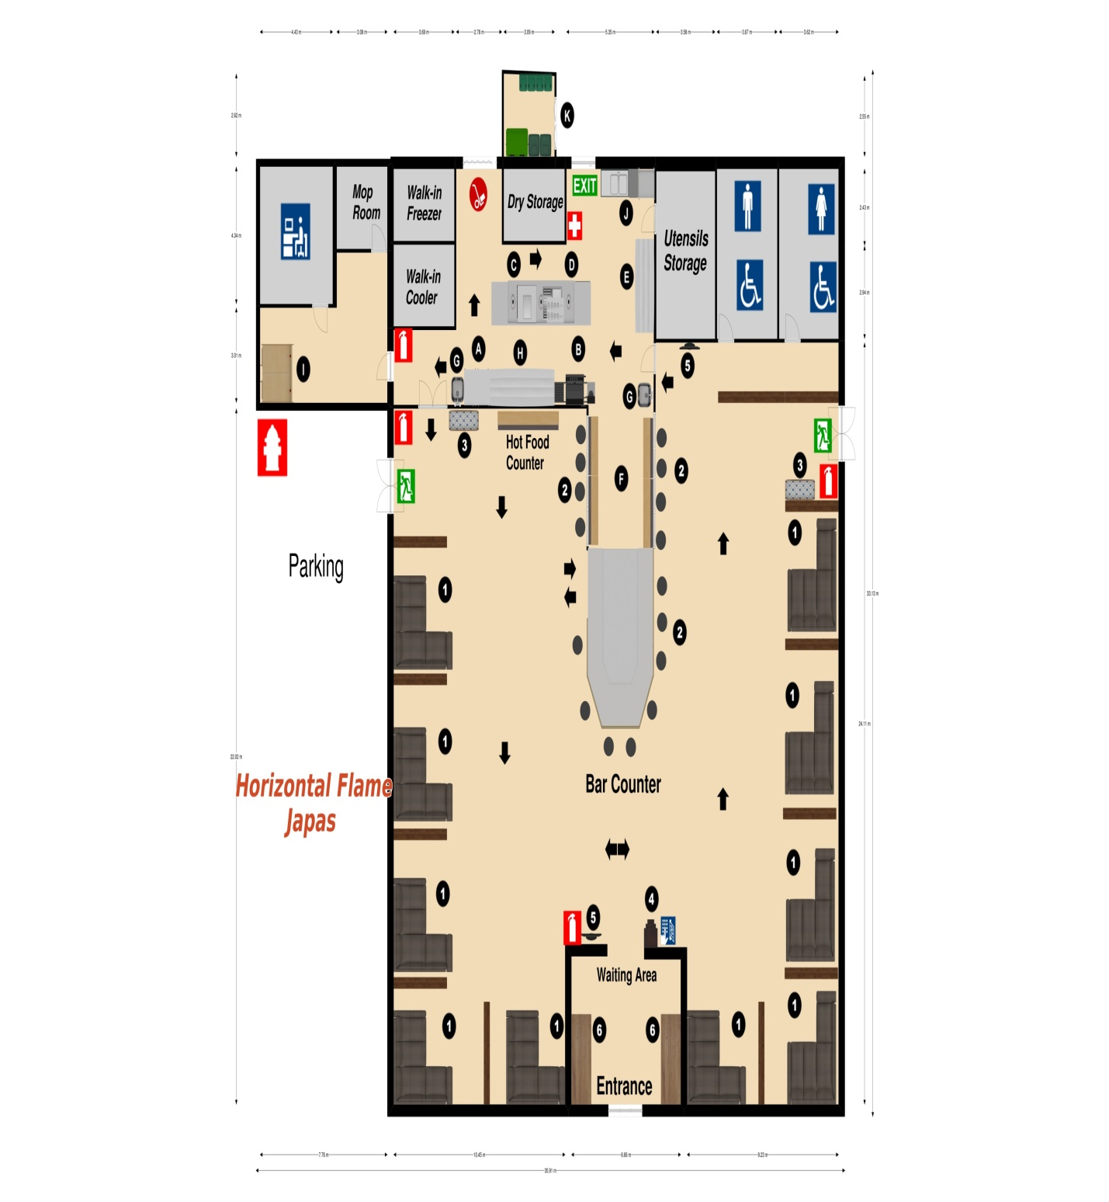
  - Floor Plan Equipment
Check the Excel File “Floor Plan Equipment” For Details”

Financial Analysis
  - Financial Statement
    - Financial Sources
The Horizontal Flame Japas is the Limited Liability Parnership (LLP) Company with the shares between Anh Ngo & Hiraku. We understand that the most important issue for our start-up is to obtain the appropriate levels of financing. There are three financial sources that our team will use with the various rates:
- Personal Savings: Both the owners have the savings after years of working in the industry $160,000 (Anh Ngo) & $140,000 (Hiraku). Our Savings are total of $300,000
- Angel Investors: after the fundraising presentation, we were invested by Japanese Chef Association of $200,000 with annual rate of 2% in 10 years
- Operating Loans: we were approved by the government bank with the loan of $200.000 with annual rate of 2.5% annual in 10 years. The bank mortgaged with our condo.

    - Preopening Cost List
Category | Price
Capital Equipment | $122,026.75
Capital Furniture | $30,032.66
Vintage Collection | $30,000
Total Food Inventory (first 2 weeks) | $4,003.23
Beverage Inventory (First 2 weeks) | $1716.34
Rent Deposit (3 months) | $18,600
Rent (First month) | $6,200
Payroll (1st month) | $8,438.60
Utility Set up + 1st Month | $1000
Land Lease Tax (1 year) | $480
Liquor License | $40,000
Business Permit & License | $2,000
Business Insurance (1 year) | $2000
Building Setup Labor | $2,500
Fire & Safety Installment | $1,000
Parking Permit | $575
Contingency Fee | $2,500
Total Cost | $260,572.24

  - Costing & Revenue Forecast
    - Operational Costing Forecast
Expenditure | Jan (Start) | Feb | Mar | Apr | May | Jun | Jul | Aug | Sep | Oct | Nov | Dec
Rent | 6200 | 6200 | 6200 | 6200 | 6200 | 6200 | 6200 | 6200 | 6200 | 6200 | 6200 | 6200
Training | 1000 | 1000 | 300 | 300 | 400 | 300 | 100 | 100 | 100 | 200 | 200 | 200
Advertising | 1500 | 1000 | 1000 | 1000 | 200 | 200 | 200 | 400 | 400 | 200 | 200 | 200
Print Menu | 300 | 0 | 0 | 0 | 300 | 0 | 0 | 0 | 0 | 300 | 0 | 0
Utilities | 1000 | 700 | 700 | 700 | 900 | 900 | 900 | 900 | 900 | 700 | 700 | 700
Business Insurance | 2000 | 0 | 0 | 0 | 0 | 0 | 0 | 0 | 0 | 0 | 0 | 0
Interest Rate | 9000 | 0 | 0 | 0 | 0 | 0 | 0 | 0 | 0 | 0 | 0 | 0
Payroll | 9732 | 9493 | 8879 | 8980 | 10100 | 11890 | 12210 | 8490 | 8943 | 7475 | 8290 | 11950
F&B Cost | 9003 | 8750 | 8100 | 8950 | 9400 | 10500 | 9850 | 10650 | 9420 | 9190 | 9890 | 12890
Other Fee | 900 | 800 | 800 | 1000 | 1000 | 1000 | 1000 | 1000 | 800 | 800 | 800 | 800
Total Expense | 40,635 | 27,943 | 25,979 | 27,130 | 29,500 | 30,990 | 29,340 | 29,740 | 26,465 | 25,570 | 26,780 | 32,865

    - Revenue Forecast
Sales | Jan | Feb | Mar | Apr | May | Jun | Jul | Aug | Sep | Oct | Nov | Dec
# of Guests | 2975 | 2375 | 2795 | 2360 | 2480 | 2510 | 2735 | 2141 | 2432 | 2108 | 2375 | 2990
Check Avg | 18.5 | 17.0 | 17.25 | 18.25 | 19.25 | 19.0 | 18.75 | 19.75 | 17.75 | 15.0 | 16.75 | 18.75
Revenue | 55,037 | 40,375 | 48,213 | 43,070 | 47,745 | 47,690 | 51,281 | 42,284 | 43,168 | 31,620 | 39,781.25 | 56,062

  - Balance Sheet & Income statement
Check the Excel File “Financial Statement” for more details
  - Financial Ratios
    - Operational Ratios
- Liquidity Ratio$=\frac{Current Asset}{Current Liabilities}$ = $\frac{\$257,940.30}{\$97,438.60}$ = 2.64
- Inventory Turnover$=\frac{Cost of Goods Sold}{Average Food Inventory}$ = $\frac{\$141590}{\$9820}$ = 14.41
- Profit Margin Ratio$=\frac{Net Income}{Total Revenue}=\frac{\$97,161}{\$546,326}$ = 17.78%
    - Essential Ratios
- Debt Equity Ratio$=\frac{Liabilities}{Owner^{'}s equity}=\frac{\$445,000}{\$300,000}$ = 1.48
- Long-term debt Capitalization
$=\frac{Long term debt}{(Long term debt+Owner^{'}sequity}=\frac{\$445,000}{(\$445,000+\$300,000)}$ = 59.73%
- Total Asset Ratio: $=\frac{Total Asset}{Total Liabilities}=\frac{\$700,000}{\$462,860}$ = 1.51

  - Analysis
According to our financial research and calculation, we have divided into positive/negative analysis on whether the business will maintain the income pool per investment.
Strengths | Negative
Our high rate of inventory of turnover will ensure the business operation | Long Term debt Capitalization is >50% which means we carry a high percentage of debt. However, with the expected variable % of 10%, we can pay off our debts before deadline
Total Asset Ratio >1 which means we are able to pay all the liabilities in case of incidents. Also, we believe that we can maximize our profit with our total assets as well. | Debt-Equity Ratio will show how the owner’s money can react to any incidents. As a private start up, we are low in capital funds. However, the value of our total assets can pay off the liabilities in case of any incidents
Liquidity ratio > 1 which means we are able to access our cash fast enough to be able to pay for the current liabilities
Profit Margin Ratio is between 15% which is average in the industry. With the variable ratio of 10% annually, we are able to pay off our liabilities within 4 years

Executive Conclusion
This Business Project is for our business “The Horizontal Flame Japas”, a Japanese style Tapas that provides the unique atmosphere as well as high quality food in Brentwood area. We predominantly target to people who are always be memorisable with the historical moments or those who are interested in the vintage culture of Japan. With the aim to maintain our targeted customers and attract new groups, we are planning to focus wide variety of high quality products at competitive prices, excellent customer services and convenient locations. Having identified and analyzed the market carefully, we believe that with our business plan proposal, The Horizontal Flame Japas has the full potential to succeed not only in the Brentwood Area but also Vancouver mainland.

