CULINARY
Hanoi is situated in the north region of Vietnam, near the Red River. It features a humid, tropical climate. Owing to its condition, the fertile land and the weather have contributed vital role to vegetable and breeding here. Besides, Vietnam cuisine has asserted its position in the world’s gastronomy and has several consecutive high-ranking dishes in the prestigious list. There are some of them:
- Pho
This is a famous tradionational Vietnam dish. People still have controversial about the origin of Pho. Most historicans concede that the source of “pho” comes from the word feu from Frenh dish “pot out feu”. Since then, Vietnamses has pronounced “feu” as “Pho” as the dish we know today. Some other that the soure of “pho” comes from the word
Most historians concede that “pho” first appeared in the late 19th century when French first colonized Vietnam. Some said that the source of “pho” comes from the word feu from French dish “pot au feu”. Since then, Vietnamese has pronounced “feu” as “pho” as the dish we know today. Some others said that the Vietnamese back at the time were impoverished by colonizers and had to gather the leftover bones, meat and stewed them to had it with noodles.
To cook this dish perfectly, the chef is required to have professional technique in both cooking methods and choosing ingredients.
The ingredients are:
- Beef broth
- irloin steak, round eye, or London broil
- cilantro, basil, mint, green onion
- cinnamon, anise, cardamom, coriander, ginger, purple onion, anise
- fresh noodles
People usually have side dishes such as poached eggs and fried bread
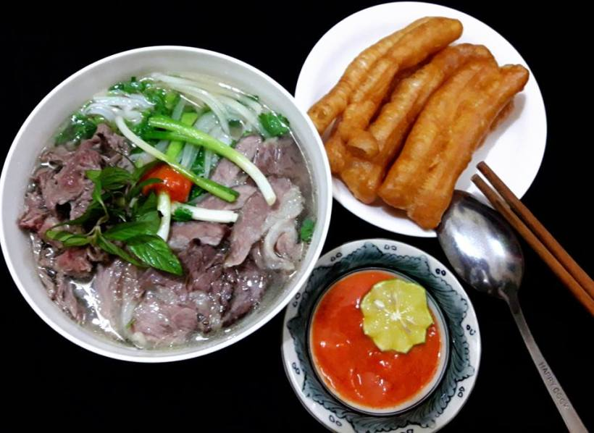
(Picture: Internet)
2. Bun cha (grilled pork with rice vermicelli noodles)
Vietnamese usually have this dish for lunch. Basically, they are grilled pork strips and balls served with a plate of rice vermicelli noodles. The pork is dipped in a bowl of fish sauce which consists of lime, sugar, chilli, garlic. The side dishes are a plate of fresh Vietnamese herbs and pickled vegetables like cabbage, carrots, onion or green papaya.
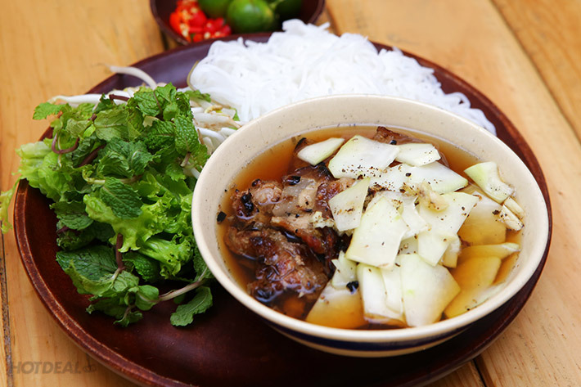
(Picture: Internet)
The 44th president of America Barack Obama used had this bun cha dish together with famous chef Anthony Bourdain and they loved it. Anthony Bourdain tweeted: “Low plastic stool, cheap but delicious noodles, cold Hanoi beer.” We are so proud to have our traditional dish complimented by a famous chef.
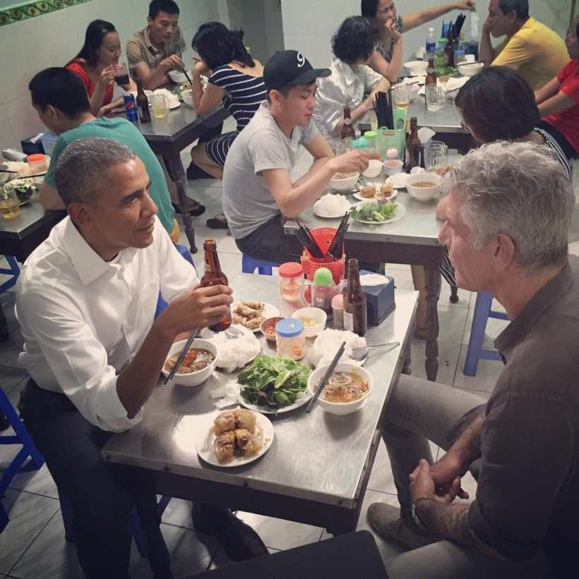
(Picture: https://twitter.com/Bourdain/status/734772293830737920)
In conclusion, cuisine has played an important role to the development of Vietnam’s tourism. Tourists, who travel to Vietnam, are not only impressed of beautiful sightseeing but also our delectable traditional food.

SCHOOLING
QUEBEC CITY TRIP
On November 3rd, my faculty – Food Service, Hotel Management, Toursim, paid a memorable trip to Quebec City.
We had chance to explore the one and only Fairmont Chateau Frontenac which is located in the heart of Quebec City, on top of Cap-Diamond hill and surrounding the St. Lawrence River. It was built in 1893 by a New York architect Bruce Price. It has witnessed the transformation of world history over 150 years. Churchill, Roosevelt and Mackenzie King plannedthe Invasion of Normandie in 1943 here; the Fathers of Confederation had ameeting here to discuss unifying British North American colonies.
Besides, we were guided by the house keeping manager around the hotel. It has 18 floors with 611 rooms that can contain thousands of guest per day. Moreover, we were very impressed of the ancient charm of Fairmont Chateau Frontenac. Although it has been restored a few times, the hotel still conserves the woodwork art and old-aged design of the origin. We also visited their five-star restaurant, kitchen, self-planted garden with bee hives and several kinds of seasoning plants. Everything is so well-organized and clean.
The manager was such an ardour man that he guided us around the hotel, patiently answered our questions and showed us some sample rooms of Fairmont Chateau Frotenac.
And I took a picture with this lovely manager:
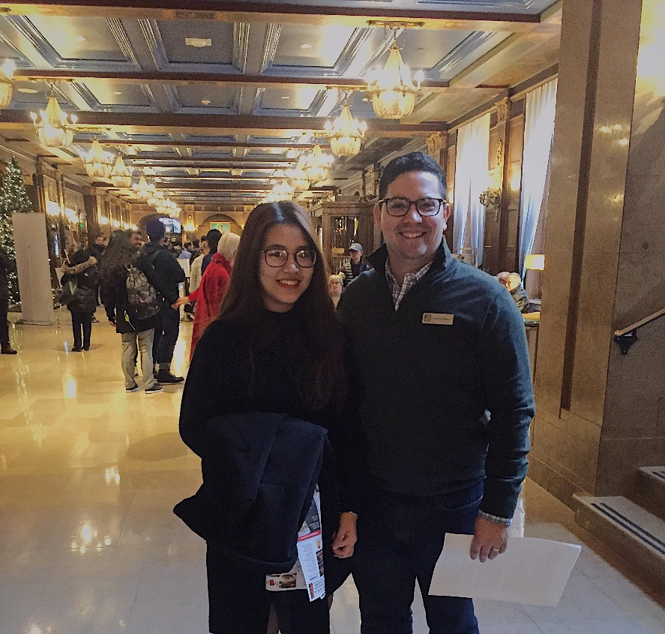

In conclusion, this field trip is like a motivation for me. Working in a hotel is a dream to me that I need to try my best to achieve my ambition. Firstly, I will improve French so that I am able to have part time jobs in some hotels and then I will spend definitely my summer break to have the internship. The more I work, the more I gain experience. This field trip has inspired me to work and study harder to achieve my dream.

SIGHTSEEING
“There’s certainly plenty to enjoy, ranging from mouthwatering street food to traditional entertainment, plus the fascinating history and culture of a city that has survived colonial occupation and war with its spirit intact” Sophie Hines – 10 things to do in Hanoi

- Hoan Kiem Lake
Hoan Kiem Lake (Hoan Kiem Lake) is not only a symbol of culture, history of the capital but also a favorite destination of domestic and foreign tourists while traveling in Hanoi.
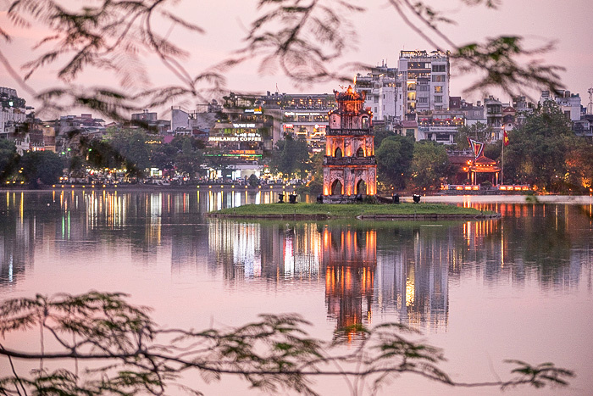
“Hoan Kiem Lake” means “Returning Sword Lake” because there is a famous legend about this name. It is said that there was a turtle god lived under the lake, during war time, he had lent the king a magic sword to strike against foreign invaders; after winning, the king came back this lake to return the sword.
Thus, Hoan Kiem Lake is situated in a complex of The Huc Bridge, Pen Tower, Ngoc Son Temple, making a beautiful sparkling picture of nature. They are impressive sightseeing that comprise Hanoi heroic historical events.
Despite the time’s ashes and dust, Hoan Kiem Lake – the popular historical and legendary beauty-spot is eternal for good as an evidence of a fairy and heroic Hanoi during the post wars and a romantic, charming Hanoi of today
2. Hoa Lo Prison
Hoa Lo Prison is located on Hoa Lo Street and it was built up in 1896 by French. Hoa Lo had a total area of more than 12000 meter squares, was one of the biggest and the most secure prison of Indochina during that time.
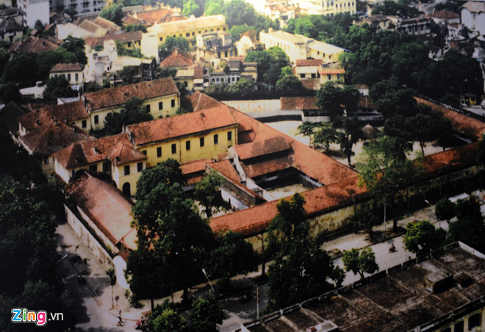
The prison was also called Maison Centrale, a place where confined thousands of Vietnamses political prisoners. The construction of Maison Centrale were able to contain more than 500 prisoners with extremely strict and severe dentention. With the most ferocious weapon of French colonizer was a giant guillotine (head cut machine) which made Maison Centrale became one of ten notorious prison in the world or in top five of the most lucrative sites in Southeast Asia.
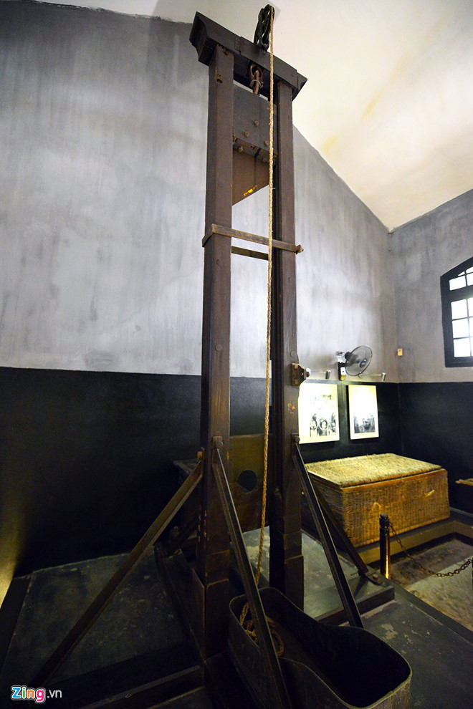
Tourism of Hanoi is developing days by days which attract more and more outbound tourists. They are not only impressed of our beautiful nature but also historical sites. Therefore, tourism has played a vital role in developing Vietnam’s economy.

Comments from two peers’ blogs:
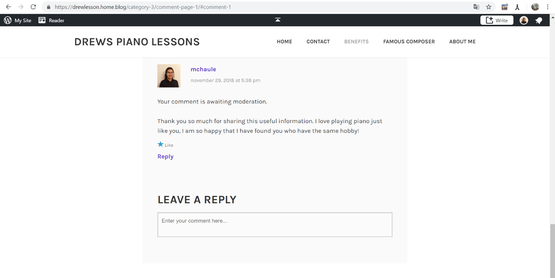

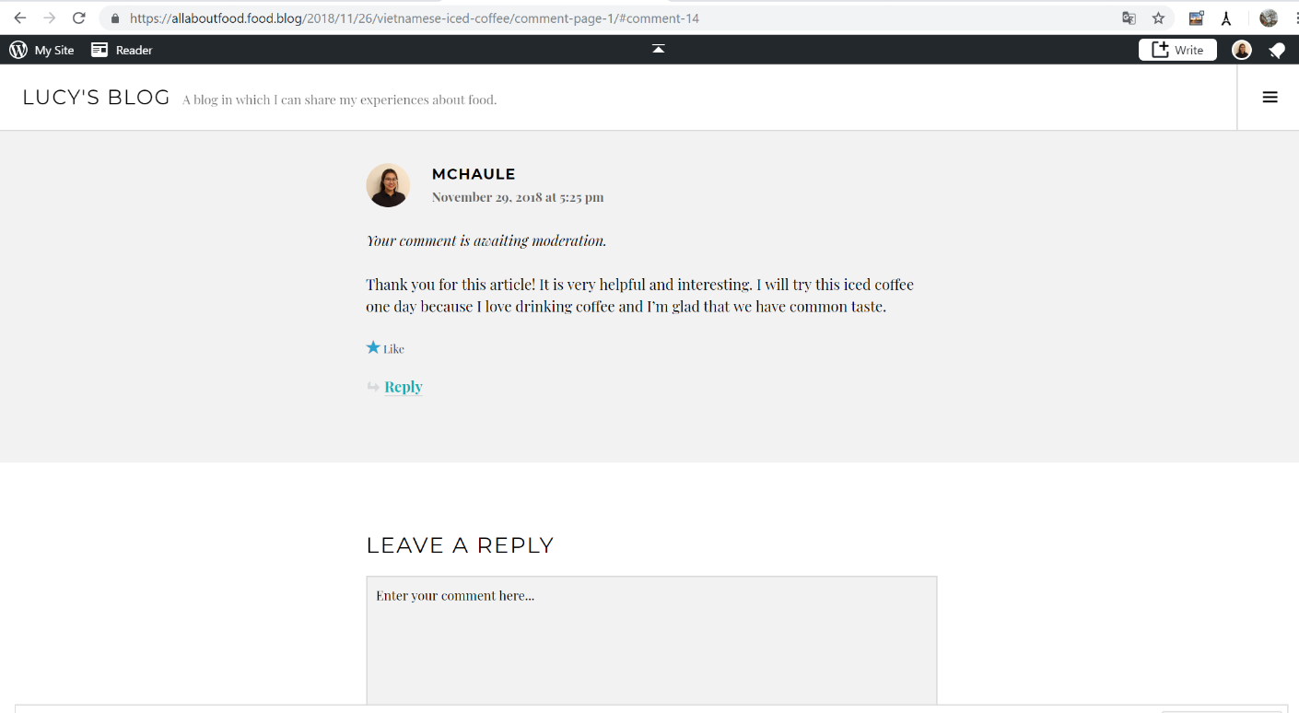

MY BLOG
