CALASH
BONNET

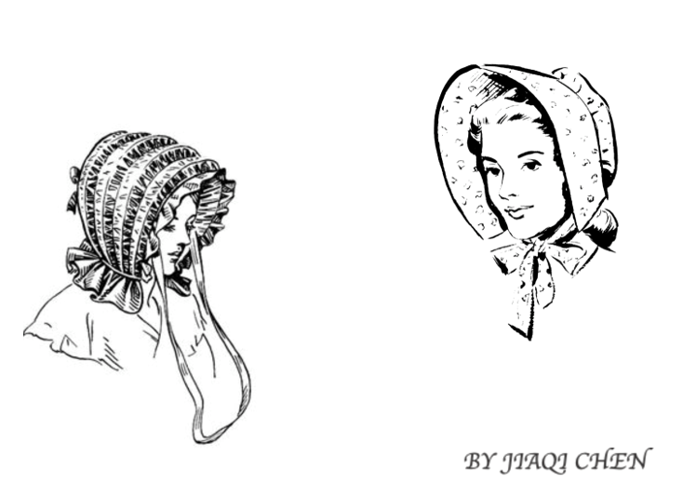
Jiaqi Chen
Calash Bonnet
571-KNA-03 sect. 02052

INDIVIDUAL RESEARCH OF CALASH BONNET
BY JIAQI CHEN

Presented to Mrs. Jennifer Millen

LaSalle College
February 26th, 2019

INTRODUCTION

My research topic is calash bonnet, it was from 1770 to 1830 years. When I first time saw calash bonnet pictures in Smithsonian Fashion Book, I think these hats are very interesting. I want to know for that period of time, women worn calash bonnet is not be hot or any uncomfortable. What is calash bonnet purpose and use? So I do the research of calash bonnet.
FACT FILE INFORMATION

Student name: Jiaqi Chen

Object researched: Calash Bonnet

WHO? | Who used this object?  Ladies who have towering hairstyles used this.  Was it used exclusively by men / women / children?  It used exclusively by women and girls.  Was it used by a person of a particular social class?  No, it used by a person of normal life, even children used it.
WHAT? | What does it look like?  Calash collapse flat much like the hood of a carriage.  What size is the object?  It is usually measures14” tall × 13” wide. But the high of calash was depend on personal required.  What is it made of? (materials)  The calash was customarily made of black or other dark-coloured silk taffeta  What colors is it found in? Decorations? Motifs?  The colour of calash bonnet was usually green or black because the calash was customarily made of black or other dark-coloured silk taffeta. Sometimes calash lined with pinkish red line because people thought it can improve any complexion.
WHERE?  WHEN? | Where was it worn? Specific city / country / continent?  It worn in French and America.  Was it used inside? Outside?  They were worn indoor, to keep the hair tidy, and outdoors, to keep dust out of the hair.  Was it used during a particular season?  It can use for all seasons.  Was it used during a particular event / ceremony?  It was extremely popular for promenading or traveling.  What historical era was it found in? Include dates.  It found during 1770-1830. Late 18th century and early 19th century.  Was it popular for a short or long period of time?  It popular for a short period of time. Later version were not as high, and had a more rounded opening.
WHY? | What was the purpose / function / meaning of this object?  Calash bonnet is convenient in the top part of calash that could easily collapse or raise as the personal required. In addition, calash bonnet primary purpose was protected people’s hairstyles. When a woman faced wind, rain or sun, the calash could protect her hairstyle and face.  What was it used for?  It used for protect a lady’s hairstyle from the elements.  Was it symbolic?  No, it wasn’t any symbolic.
OTHER INFO | The Calash bonnet, also called the “Bashful Bonnet” or Caleche in french.
SOURCES | Loretta Chase & Susan Holloway Scott, Covering Your Hair with a Calash (if it’s 1777) Wednesday, October 27th, 2010  http://twonerdyhistorygirls.blogspot.com/2010/10/covering-your-hair-with-calash-if-its.html  Geri Walton, The Calash Bonnet, May 16th, 2018  https://www.geriwalton.com/the-calash-bonnet/  Unknown, Constructing a Late Eighteenth-Century Calash, January 20th, 2013 at 9:50pm  https://sfcdyer.wordpress.com/2013/01/20/constructing-a-late-eighteenth-century-calash/

FACT FILE IMAGE 1

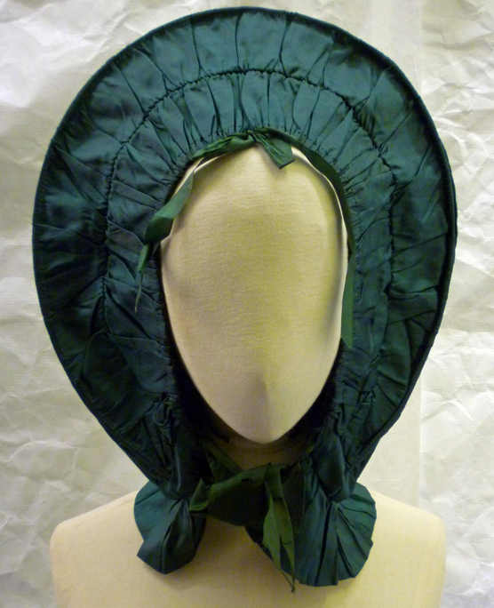
FACT FILE IMAGE 2

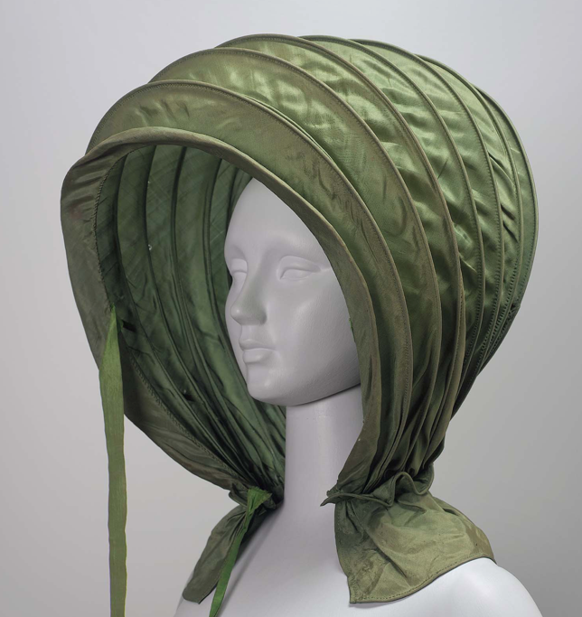

FACT FILE IMAGE 3

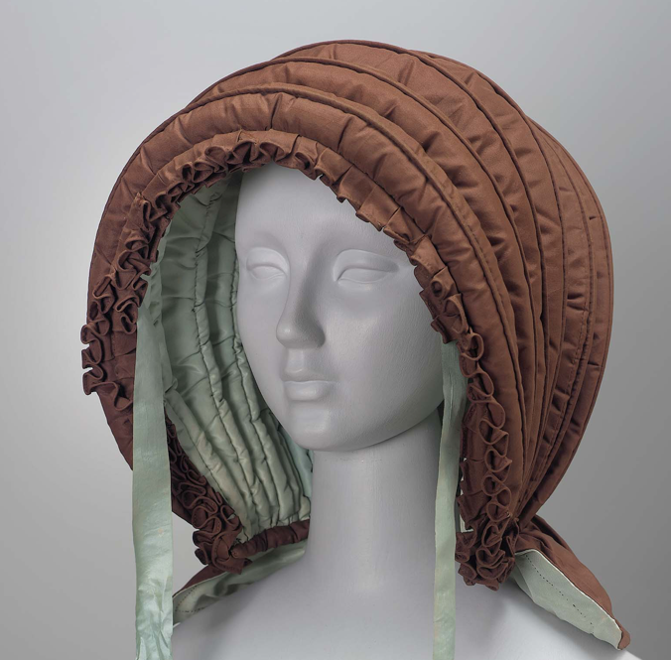

FACT FILE
IMAGE / OBJECT IDENTIFICATION

IMAGE 1
Name | Calash bonnet
Year / date | 1770 - 1790 (made)
Materials | Silk, silk thread, whalebone,Taffeta and Cotton
Color, decorations, motifs | A woman's calash of dark green silk, gathered over 4 whalebone ribs with dark green silk ribbon ties.
Label / artist | Unknown
Collection / location | Museum number: T.45-2015, Textiles and Fashion Collection  In storage
Source | http://collections.vam.ac.uk/item/O1316586/calash-bonnet-unknown/

IMAGE 2
Name | Woman’s calash bonnet
Year / date | Early 19th century
Materials | Silk plain weave, wire, and paper
Color, decorations, motifs | Green silk calash or bonnet with cane ribs, horseshoe-shaped caul or back portion, bavolet or neck curtain with corded edges, bow at back, two narrow green ribbon ties remain on proper right side.
Label / artist | Unknown
Collection / location | American, museum of fine arts Boston, Textiles and Fashion Arts
Source | https://www.mfa.org/collections/object/calash-48631

IMAGE 3
Name | Woman’s calash or hood
Year / date | Mid 19th century
Materials | Silk plain weave(taffeta), down filling, and silk plain weave ribbon, ribs unknot
Color, decorations, motifs | Woman’s brown padded calash with light blue lining; brown double ruffle around face; light blue taffeta ties; padded curtain at back; ribs possibly made from wood
Label / artist | Unknown
Collection / location | Museum of fine arts Boston  Collections: Europe, Textiles and Fashion Arts
Source | https://www.mfa.org/collections/object/womans-calash-or-hood-65962

CONTEMPORARY CONNECTION

IMAGE

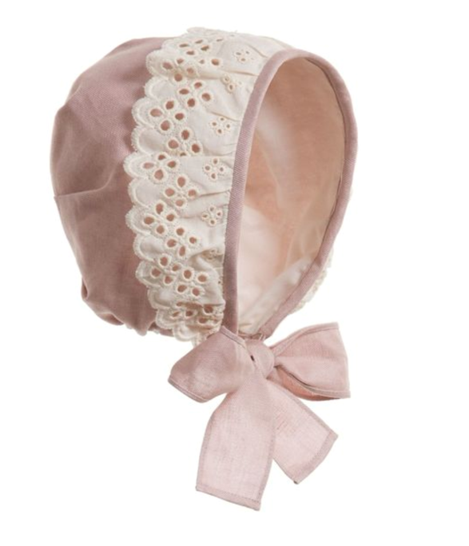

INFORMATION

Name of object | Bonnet
Year / collection | 21th
Label / designer | Unknown
Materials, color, decorations, motifs | It made of silk and cotton of pink colour. Having a nylon lace. In the Botton of bonnet have bowknot.
Reason chosen  (min. one paragraph) | The calash bonnet is not use today, but calash bonnet evolve into simple version of the bonnet. Some shape of bonnet is different than calash bonnet, I choose the image of bonnet that looks like calash bonnet, but this one is more simple, made by cotton and is smaller than calash bonnet. The function is similar with calash bonnet, both can protect person’s head to face wind and sun. But this one cannot protect ones hairstyle. Bonnets have more style and colour for people choose. Calash bonnet was used by women and girls. Now bonnet can use by men or women, but it usually use by women and girls too. Sometimes Bonnet can use for decoration people’s style. Person who is a baby or work in farm is would like to use bonnet. Now bonnet is more comfortable than calash bonnet because a lot of bonnet are made by cotton. Maybe bonnets are more suitable to people use now.
Source of image | Sara Ljubijankic, saved to Baby girl  https://www.pinterest.ca/pin/237353842847002302/

CONCLUSION

Calash bonnets are suitable for 18th century people and are more match their dress. Now bonnets are more match our dress. Although calash bonnet is not use today, the invention of calash bonnet is a great invention because we have bonnets that can protect our face when sun and wind come. Every age has a clothing that suits every era.

