2016
Group Name: Sovoitey Sovann, Vo Thi Mai Huong, Pedro Ivo De Macena
Lecturer: Amélie Rolland-Lamothe
2/15/2016
Marketing Plan Project
- Choice of Product/Company
Tea was originally a medicine and later grew into the popular beverage as it is today. According to researchers, tea is the second-most popular drink on the planet after water, which is $45-billion market worldwide. There is a tea war brewing with major North American hot beverage players having set their sights on the multibillion market for the world’s second most popular beverage.
Mainly, tea is essential to people’s life. It is what people needs for dehydrate the body function and skin. No one could live without drinking water. Basically, it gives health benefits include reducing the impact of stress, protect from every disease, and strengthen the immune system. As the result of this, the founder of David’s tea, who is David Segal started his business in 2008 in Toronto, Canada by persuade the coffee drinkers to drink teas, have smart distribution, and friendly stores conceptual ideas. David’s tea is the largest Canadian-based specialty tea boutique and tea accessory retailer based in Montreal, Quebec. They offer the variety of teas and tea accessories across Canada and United States.
Eventually, human needs a good five sense in life, one of them is taste. Most of all, drinkers want to have a better taste in any beverages of choices besides water, and tea is the great option to reach the satisfaction of the customer since it has so many taste and provide health benefits. With Canadian tea consumption, David’s tea nowadays influences the health-conscious consumers. The company grew rapidly in the last few years, since they innovated more than 150 types of high quality teas, which is kindly hit the market target of making what customer needs.
With all their objectives and efforts, David’s tea market opportunity is highly attractive to people. They also have their premium collection, which allows customer to have an extraordinary and passionate about the great tasting teas. In a brief view, tea is quite delicious, healthy and fun. Most people are having a great time with their family and friends when they drink teas. Consequently, tea is very simple, however, it gives a magnificent benefit to human’s life.

- Product Description
- Product characteristics
David’s Tea is a Canadian, Montreal company specialized in producing, compounding and preparing teas in the most variable ways and formats possible. While shopping at David’s Tea, consumers will be able to find several types of teas that can be already prepared its mix (flowers, leaf, seeds etc.) or the customer have the possibility to mix the ingredients together according its preferences.
While most of other brands have their tea mixes already prepared and crushed into sachets to add into hot water, David’s Tea has been known by its loose-leaf teas. This particularity brings a sense of a fresher product whereas customers usually have a sense of trying something new every time they come into shop.
This unique attribute enables customers to have thousands different combinations of teas, per its preferences. While shopping, online or at the physical shop, the customers have the possibility to combine over 60 different ingredients. Also, others attributes make David’s Tea a different brand since you can look for teas according certain criteria such as: organic and/or kosher, spicy, floral, sweet, citrus and even by the level of caffeine included in each mixture.
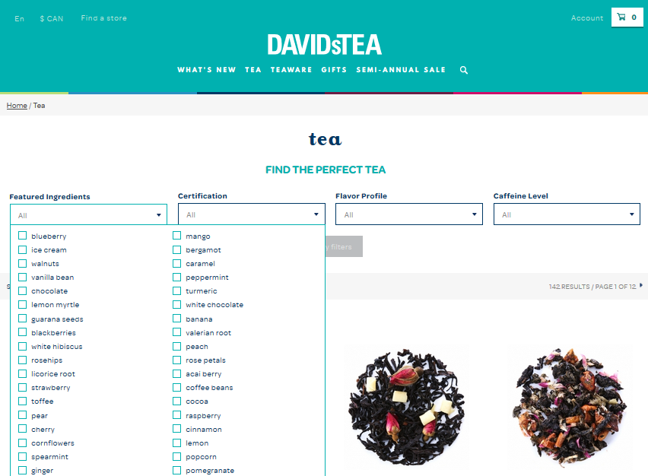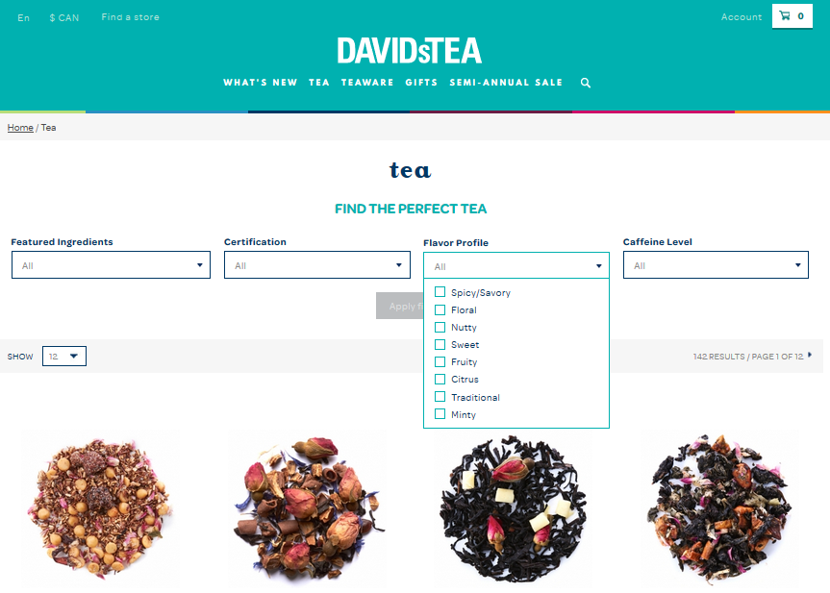
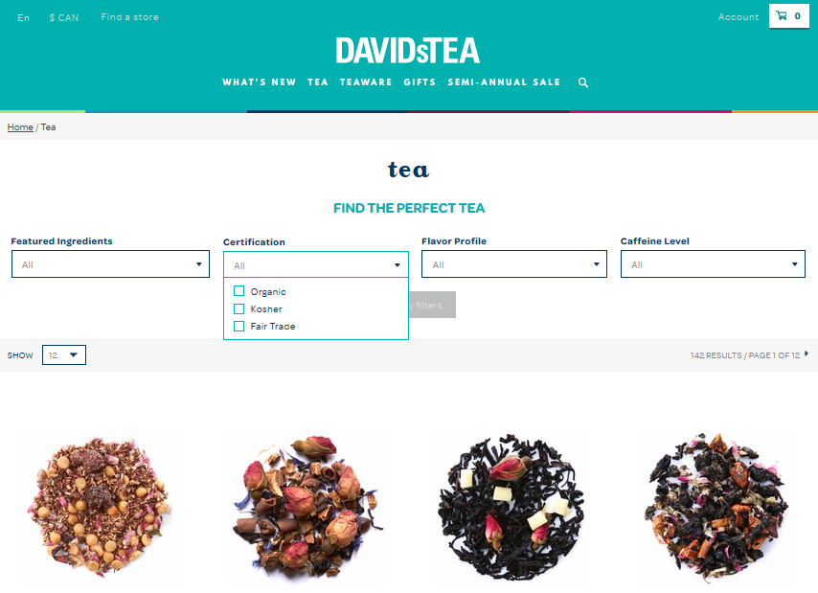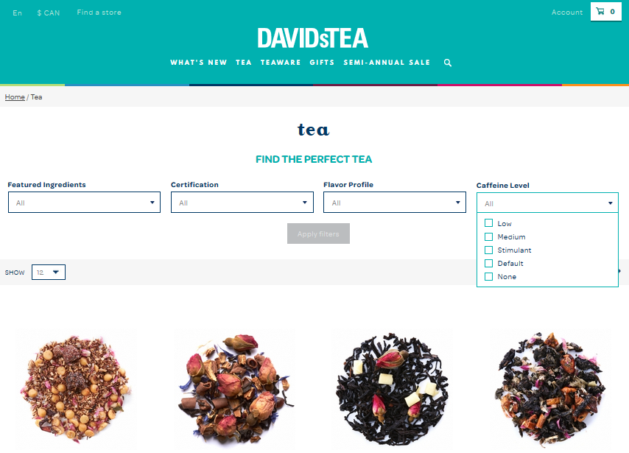
The products are available in several different formats at David’s Teas shops. Customers can find some mixture already compound into sachets, ready to be put into hot water, or by selecting specific loose-leaf to compound the tea, the product will come in a small container that will need an infuser to be drink.
The company has also other products, tea related, to sell to customers such as: tea mugs, tea infusers, tea-infused cosmetics, tea makers, among others. This variety of product do bring a uniqueness to the brand business.
All David’s Teas products come in a colorful and cozy package that is nice to the consumer’s eyes. This attribute enables the brand to be seeing as a possible gift option which can make the brand even more recognized and known.
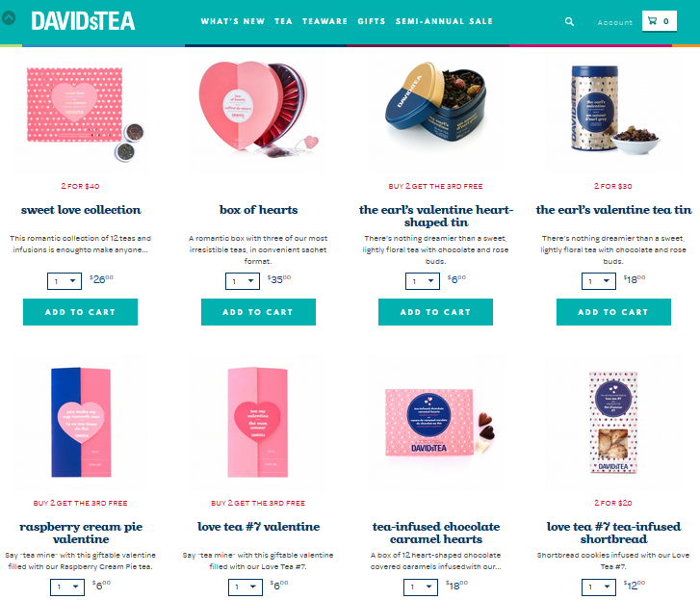
David’s Tea products are also known in the market for its quality. By the fact of being dealing with loose-leaf tea type, the product itself has to be fresh if compared to what is found in other brands. This freshness of the product makes it high quality but in the other hand makes the product more expensive the other brands.

- Unique selling attribute or competitive advantage
David’s Tea is known in the market by being loose-leaf tea seller. That is the main uniqueness of its products. By making the decision of selling its product in this different format, David’s Tea ensures that its products have higher quality then other teas. Although this business model grants a differentiation compared to competitors, it does make the product more expensive.
Aside of the quality product, the business model followed by the company enables the customers to create different mixes of the several ingredients available. This possibility for customizations is a great differential compared to its competitors. Since the customers have the possibility to mix several flavours together, sometimes those mixes might taste funny and/or different. In those cases, David’s Tea enforces that there are no problems with the mixture, it is just you that are not used to the several possibilities. This approach almost forces the customers to keep shopping and trying the products, which will increase the company’s revenue.
Another unique attribute for David’s Tea business is its usage a social media. Usually companies make usage of social media to promote their brands and business, but David’s Tea have a different approach to it. Twitter is used as a tool whereas the customer can have their doubts and questions answered by the company. A specific department inside the company makes sure that all questions made through Twitter is properly answered. Also, the customers can have orders placed by Twitter and schedule its pick up in the physical stores that is the best for their convenience.
David’s Tea have the preference to use Twitter because they understand is more efficient than Facebook. The customers simply have to open the software and leave a quick message, while in Facebook the customer would have to write a status which makes it longer and more difficult, specially if using a mobile phone.

- Brands, logo and trademark
David’s Tea logo is made with a clear turquoise color on the background and white color name written. The logo’s simplicity trans pass the image of clearness and simplicity, which is the same sense achieved whenever you walk inside one of the physical stores.
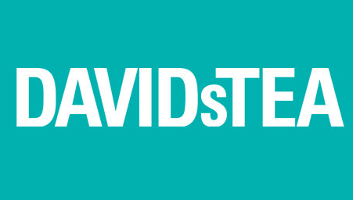

- Profile of typical end user
The typical consumer of David’s Tea’s products is very diversified. You could find people of different ages, different cultures and different customs on all its stores. The customers are usually people that enjoy drinking tea and some people that would rather have a cup of tea than a cup of coffee.
In times where most of the people are current looking for a healthier life style or at least looking to minimize the impacts of what they consume, drinking tea is a great option. Certainly, those people make the higher consumers of the products since drinking a cup of tea is healthier than drinking coffee.

- Seasonality and life cycle of your product/service
David’s Tea’s products are mostly consumed during the 1st and 4th quarter of the year as demonstrated by the sales table below:
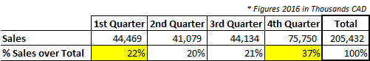
This seasonality for the products consumption can be explained by the colder months in North America (Canada and US) which will increase the search for hot beverages, as teas.

- COMPANY DESCRIPTION:
- Brief history:
DAVIS TEA is a Canadian speciality tea and tea accessory retailer based in Montreal, Quebec. It is the largest Canadian-based specialty tea boutique in the country. In 2008, David Segal and his cousin – Herschel Segal, launched their 1st store in Toronto and then a year later, 1st store in Montreal has came out. During 4 years from 2008 to 2011, they have opened 50 stores across Canada and by the end of 2012, David’s tea expanded more than 75 stores. However, there is a big change in David’s tea company at the time. In March 2016, co-founder David Segal resigned from DavidsTea then on December 8, 2016, Bullen was named Interim President and CEO, effective February 1, 2017

- Company’s mission, vision, values:
The company values are important to us, and we want to make sure they inform every single decision we make – from new hires to store design to social media. Our customers all our brand ambassadors and the key to our success. That’s why we would like to share our mission, our vision and our value to all customer.
- COMPANY VISION is to share our passion for tea with the whole world. At DAVIDsTEA, we share more than just the love of amazing tea or a great sense of humour, we share a culture – a philosophy. It’s all about how we treat our customers, our products and each other.
- COMPANY MISSION to make tea fun and accessible to all. It’s what makes us such a fun place to visit, an easy place to love…and a great place to work.
- COMPANY VALUES:
- FUN: Creating customers smiles with our special and unique light, energetic and un-academic tone of tea flavors.
- FRIENDLY: Demystifying tea associate with above-and-beyond service will surprising and delighting our customers.
- INNOVATION: We keen on innovating our products unique, exclusive blends and in-house designed accessories in order to adapt with our customers’ desires.
- RESPONSIBLE: Organic, compostable, recyclable, reusable.
- PASSION: Commitment, enthusiasm and pride in the company. Love and excitement for what we sell and what we stand for.

- Corporate structure and management:
- Christine Bullen - Interim President & CEO
- Luis Borgen - Chief Financial Officer
- Howard Tafler - Chief Accounting Officer
- Marc Macdonald - Chief HR Officer
- Edmund Noonan - Head of Real Estate
- Lisa Nordin - National Director of Operations
- Doug Higginbotham – Head of Supply Chain
- Ownership: DAVID SEGAL and HERSCHEL SEGAL

- OUR STRENGTHES AND COMPETENCIES:
- Experience management in entrepreneurship.
- Tea experts.
- High quality of tea, diversified blends from around the world.
- Friendly and outgoing staffs.
- Customization of each customers’ experience.
- Online orders and purchasing of products.

- FINANCIAL STATEMENT:
 | 2015 | 2016
ASSET | 62.35M | 116.25M
LIABILITIES | 62.39M | 21M
EQUITIES | (36.29) M | 95,25M

INCOME STATEMENT
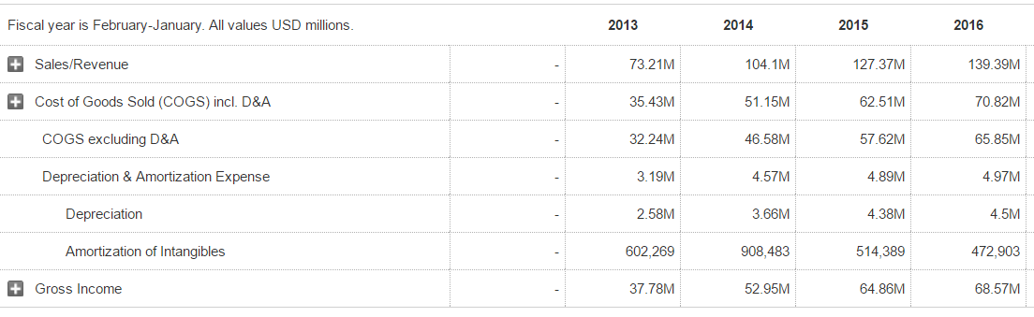

BALANCE SHEET

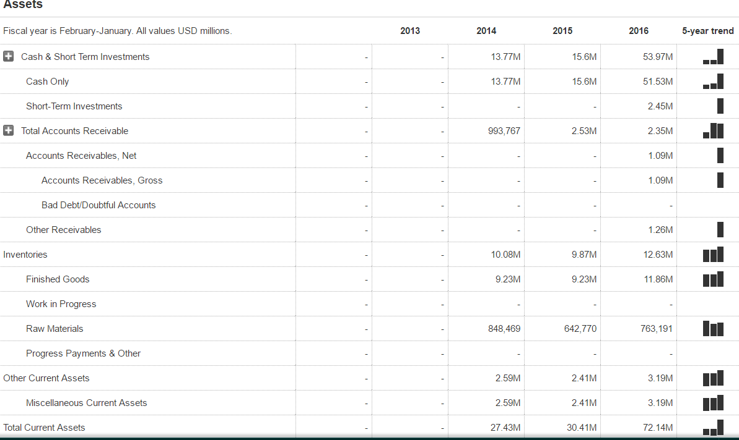
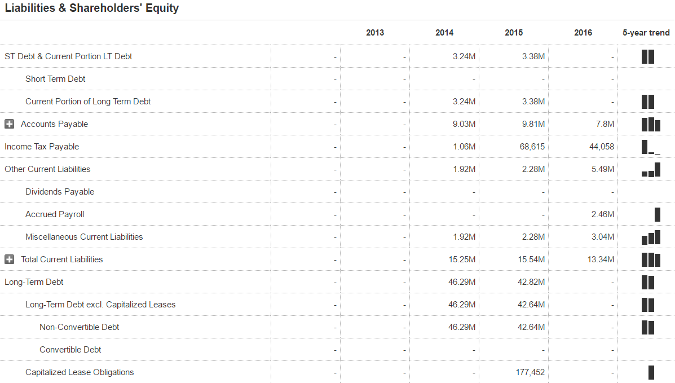
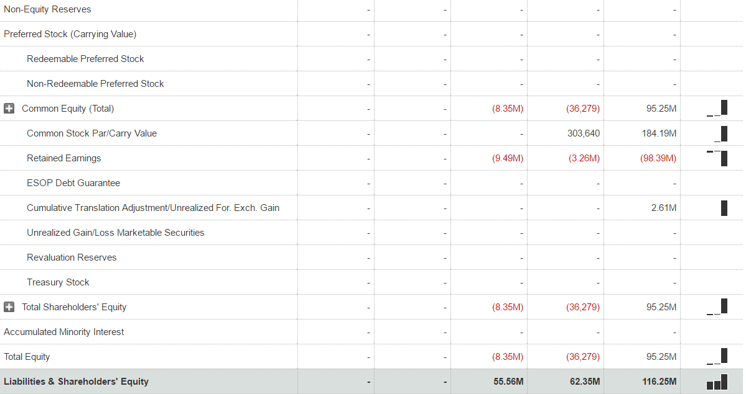

REFERENCES
http://www.marketwatch.com/investing/stock/dtea/financials/balance-sheet
http://ir.davidstea.com/phoenix.zhtml?c=253953&p=irol-stockquote
http://www.slideshare.net/BrendaThompson15/davidstea-mission-vision-values
http://ir.davidstea.com/phoenix.zhtml?c=253953&p=irol-stockquote
http://business.financialpost.com/news/retail-marketing/davidstea-co-founder-namesake-david-segal-resigns-as-chains-brand-ambassador
https://spafaxcontentmarketing.com/2015/07/28/davids-tea-brand-business/
http://montrealgazette.com/business/local-business/ceo-conversations-david-segal-on-davids-tea
http://www.canadianbusiness.com/business-strategy/steeped-in-success/
https://en.wikipedia.org/wiki/DavidsTea
http://www.marketwatch.com/investing/stock/dtea/financials
http://www.nasdaq.com/markets/ipos/company/davidstea-inc-962037-78037?tab=financials
https://www.davidstea.com
http://kimvallee.com/how-retailer-can-use-twitter-generate-sales/
http://www.sklarwilton.com/growing-your-brand/brands-we-love-davids-tea

