ABOUT THE RETAILER

COMPANY PROFILE
LE CHÂTEAU is a Canadian specialty retailer and manufacturer of contemporary fashion apparel, accessories, and footwear at value pricing for style-conscious women and men of all ages.

The brand's strong financial success is a result of their time-tested business strategies that include the quick identification of and response to fashion trends through their designs, product development and vertically integrated operations.

Today the LE CHÂTEAU brand is sold exclusively through their 179 retail locations across Canada. In 2015, the company generated sales of about $237 million CAD. The company also has a store in the New York metropolitan area, as well as five throughout the United Arab Emirates and Saudi Arabia.

MISSION STATEMENT
Our mission is to translate the latest runway fashion and global trends into must-have looks that clearly coordinate into a continuous flow of new collections, quickly delivered to an ageless customer by our dynamic sales team.

Every day we strive to ensure that our customers receive expert knowledge, quality service and satisfaction.

From their origins in 1959 as a family-run clothing store in downtown Montréal, to their position today as an international brand, LE CHÂTEAU has always embraced the spirit of the times for which it designs.

Their fashion-forward image continues to inspire and engage its stylish clientele at home and abroad. As they evolve, they will continue to offer high-quality, in-house designed accessible luxury clothing, shoes and accessories to a broadening unisex customer base.

COMPETITORS

Reitmans

Reitmans was founded in 1926 by Herman and Sarah Rietman.They started off as a modest publicly owned, family-controlled business with one store on Boulevard St. Laurent to Canada’s largest women’s speciality retailer. Reitmans (Canada) Limited operates six different banners; Reitmans, RW&CO, Penningtons, Additionelle, Thyme Maternity and Hyba which serves to the Canadian women and men through 800 stores across Canada. Reitmans is a direct competitor of Le Chateau, where they have similar positioning in the marketplace offering the same style of clothing to the same target market.

Suzy Shier

The first Suzy Shier store opened its doors in 1966. They have over 140 stores across the country, Suzy Shier offers the latest fashions at low prices. They have a lot of involvement in the community, where they are a proud sponsor of the Weekend to End Women’s Cancers since 2010, Make a Wish Foundation and they donate women’s clothing in support of women’s shelters. Suzy Shier is a direct competitor to Le Chateau because they are another Montreal based company that tailor to the same women consumer searching for a great look at a good price.

Tristan

Tristan & America emerged from the meeting of its two founders, Gilles Fortin and Denise Deslauriers, in the 1970’s.Now known as Tristan, they are a manufacturer and retailer that are known for quality craftsmanship, refined fabrics and impeccable cuts. They target style-conscious men and women, young urban professionals and businesspersons have found chic, elegant and comfortable apparel.The Tristan has 50 stores across Canada, they are a direct competitor of Le Chateau because they they entrust 30% of its production to the local manufacturing industry, which aligns with the values of the Le Chateau brand.

TARGET MARKET & Consumer Profile

Le Chateau has a broad target market that ranges between 25 to 55 year olds. They offer men and women clothing that fits the market of consumers looking for the perfect outfit for the office look or for a special event.

Our first target consumer that are between 25 to 30 years old are often women that are starting to get more interest into their future. However, they still want to have fun and profit their life but they take more consideration about their future. They are often young graduate that are trying to pierce and build their names in the industry that they are in. They want people to take them seriously and not some freshman that just came out from school. Their average range would around 30,000$. When it comes to clothes these target are looking for something comfortable, affordable, stylish and allows them to look older while also looking professional.

For our second target consumers that are between the age of 30 to 55 years old are women that are successful. They are advancing in fast rate to make a better life for their families. They are the type of person that doesn’t cares about the price of the product but more about the quality. However, they are not necessary takes importance to spend too much money on expensive clothes since they want to follow the trend and a little bit their style as they grow older. They want to look like ‘’goals’’, they want to look like they had achieved everything and they wanted to show it in a neutral way. Their average income is around 50,000$.

PRIMARY RESEARCH

In visiting the Le Chateau store we were able to see that Le Chateau fits multiple targets. They have clothes ranging from XXS to XXL and have styles that fit the business women and also fits someone looking for a great look for an event. The employees are at the mid age range of their clientele, that they are more than happy to find the exact look that you are searching. They also have accessories, shoes and purses to complete the client's desired look.

POSITIONING
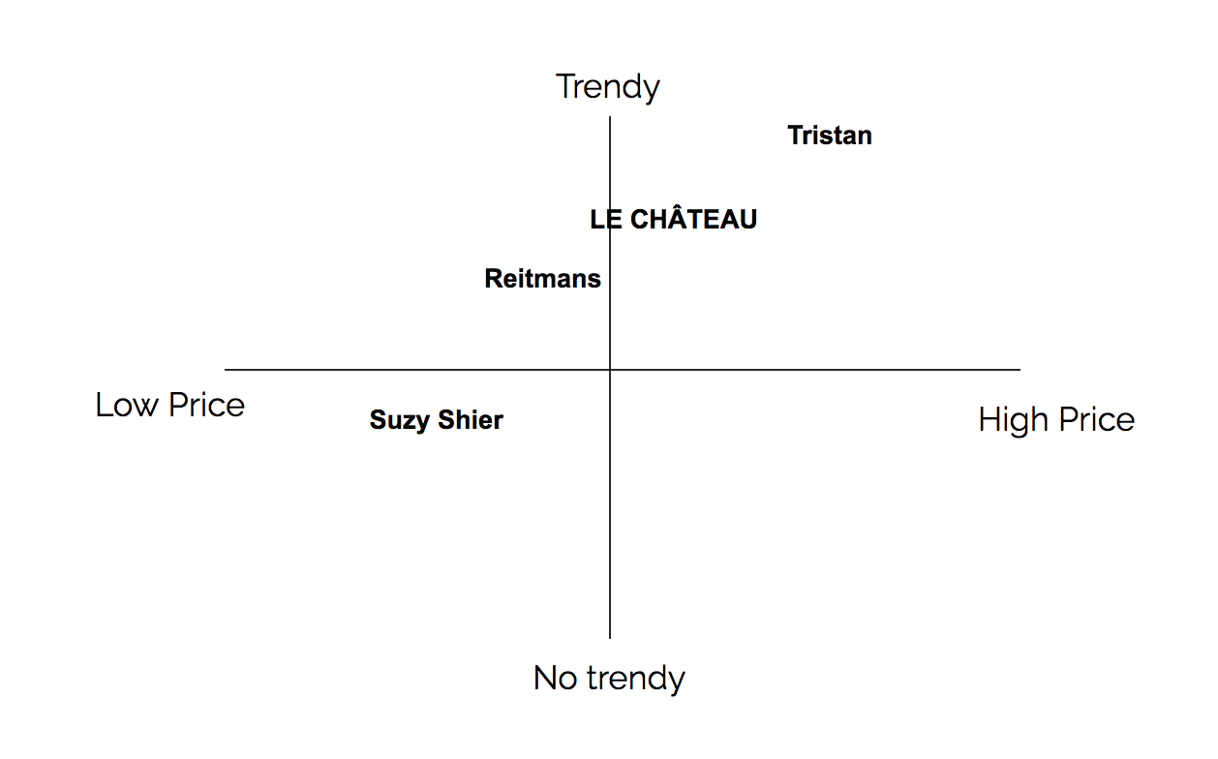
LE CHÂTEAU has a nearly half-century tradition of vertical integration, a hands-on design and manufacturing approach to retailing that makes them unique among Canadian fashion retailers. They are proud to be involved in each step of the clothing production, from their creative design team in MONTRÉAL and Canadian-based manufacturing.

On the website and in-store you can see how the brand uses the fact of being vertically integrated to market their products. They have created a campaign that they decided to integrate Montreal in their name. Also they work closely with Montreal magazine Clin D’oeil showing that they are a local company offering clothes that are produced in Montreal. Another way that they show this, is by displaying a little Canadian flag next to the products that are produced in Canada.

GARMENTS DESCRIPTION

For our first style we decided to create an office pencil skirt most of the target market are business woman. We wanted to offer women something sophisticated and neutral for work. We decided to use fabrics that women will be comfortable wearing in the office. The colors of black, navy and grey for the garment because the colors can easily be matched with a vibrant shirt or a basic top with a blazer. The price point of this garment is at $59.95 which is affordable and fits within the price range of Le Chateau’s office skirts. We chose to produce this garment offshore since it is a basic that we will sell a large quantity of.

For our second style we decided to create an elegant long satin skirt with a slit down the middle.We wanted to create a look that can be worn for the holiday season. The style of the skirt can be worn by any age of their target market where that it is a stylish piece that flows perfectly with your body as you walk. We chose autumn colors of taupe, mauve and grey that can be perfectly matched with a basic top and blazer. We chose the retail price of $99.95 because this garment is a unique piece that contains rich fabrics and colors. The garment will be produced domestically because of the fabric and color that we chose has to be of the greatest quality.

For our third look we have decided to create a suede fall skirt. This skirt is a must to be able to pull off the perfect fall look. We have chosen to add the lace up embroidery to make this skirt unique, where that it would fit well with a basic top. We chose some amazing fall colors of forest green, burgundy and a fall yellow. We have priced this skirt at $89.95 because of the fabric and embroidery. The garment will be produced by a wholesaler who will be able to create the details of this skirt perfectly.

PRODUCT LIFECYCLE

The definition of the product lifecycle is the process of managing the entire lifecycle of a product from inception, through engineering design and manufacture, to service and disposal of manufactured products. So with creating these garments we have integrated people, data, processes and the Le Chateau business system. These products will start at the introduction stage where that they will be introduced into the market as new products.

Sources:

https://www.lechateau.com/style/company/links/about.jsp

http://www.cbc.ca/news/business/le-chateau-s-comeback-plan-mature-styles-for-grown-up-former-fans-1.3154561

https://en.wikipedia.org/wiki/Product_lifecycle

http://suzyshier.com/about-us

https://www.tristanstyle.com/en/about-us/

http://www.reitmanscanadalimited.com/about-us.

