- Identify A Font:

I chose to write “LIVE A LITTLE” using Gotham Light because although delicate, this simple, but effective font makes a statement. Subtle but clear, Gotham sends the message I want to convey without overstepping any boundaries. Alongside such a bold statement, the Gotham font allows for minimalism to speak volumes.

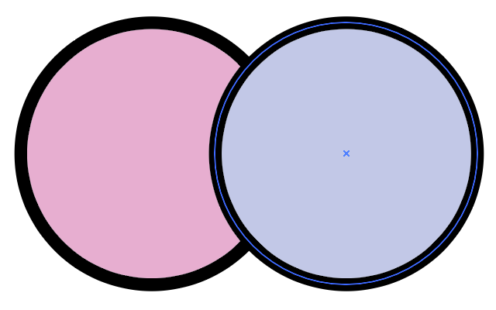
- Pantone Colours:

I chose to use pastel pink (Pantone 217 C) and blue (Panton 2707 C) for my main and secondary colours. I chose pink because it symbolises love, calmness and femininity. Although traditional womenswear doesn’t necessarily represent me, my somewhat masculine style doesn’t stop me from feeling feminine. I love flowers and sunsets and cotton candy skies. Nothing makes my heart as full as seeing pastel pink dance around the sky. I also chose pastel purple because its often represents creativity, individuality, and stimulation. I want to be challenged. I want to feel intellectually stimulated. I want to be pushed out of my comfort zone. A mixture of light pink and light blue, this purple tone symbolises the love, warmth and comfort I feel in my daily life, mixed with the brisk determination of becoming more aware and proactive in what could be a harsh world.

