Marriot International, INC
Industry overview
Travel and tourism outperformed the global economy for the sixth year running in 2016, reaching a total of 10.2% of world GDP ($7.6 trillion).
Travelers who are on the road for more than one day need a place to sleep and rest and there are various types of lodging across the world to accommodate for this. Clearly a valuable service, it is no surprise that Euromonitor International forecasted a 550 billion U.S. dollar revenue for the industry in 2016.
This statistic shows the global hotel industry retail revenue from 2010 to 2016 with forecasted figures for the year 2018. The global hotel industry revenue was 554.64 billion U.S. dollars in 2016.
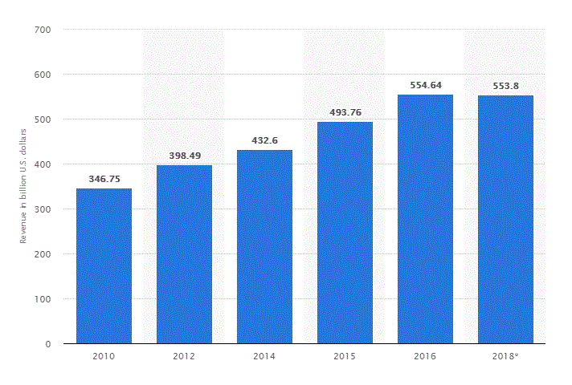
According to the World Tourism Organisation (UNWTO), international tourist arrivals grew for the seventh consecutive year, reaching 1.2 billion in 2016. Asia and the Pacific regions have shown the strongest growth. UNWTO projects that international travel will grow at an average of 4% p.a. to 2030.
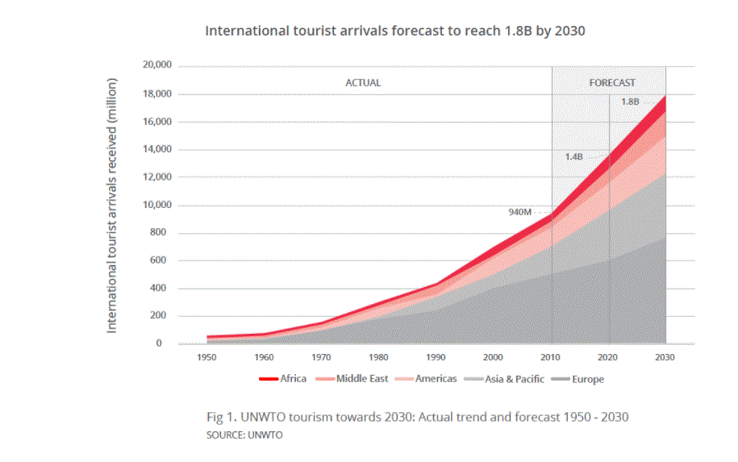
The travel and tourism industry outstripped many other global economic industries in 2016, including financial services and construction.
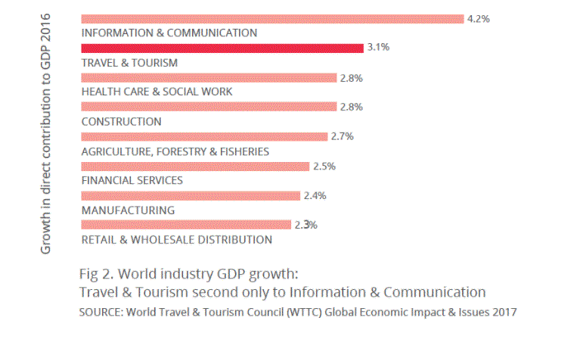
Hotel demand in most markets can be described by three primary demand segments: commercial, meeting and group, and leisure. Subdivisions under each (in some cases under all) of these categories include extended-stay patrons, government travelers, airline crews, sports teams, military personnel, truck drivers, and cruise ship passengers.
The largest geographic markets by consumption in the hotel and other travel accommodation sector are the Americas and Asia. North America was the largest region in the hotel and other travel accommodation market in 2017, accounting foraround36%marketshare.
Asia Pacific was the second largest region accounting for around 25% market share. Africa was the smallest region accounting for around 3% market share.
The company – Marriot International, NC
Marriott International started out as a humble root beer stand, set up by J. Willard Marriott and his wife in Washington D.C., United States in 1927. The couple opened their first hotel in Arlington, Virginia in 1957 and Marriott has since grown into a well-known hotel chain.
Corporate Structure and Business
The company is a worldwide operator, franchisor, and licensor of hotel, residential, and timeshare properties under numerous brand names at different price and service points. Consistent with the focus on management, franchising, and licensing, the company owns very few of our lodging properties. It was organized as a corporation in Delaware in 1997 and became a public company in 1998 when the company “spun off” as a separate entity by the company formerly named “Marriott International, Inc.” The company believes that the portfolio of brands, shown in the following table, is the largest and most compelling range of brands and properties of any lodging company in the world.
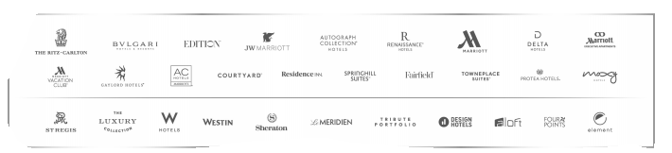

The company has franchising, licensing, and joint venture programs that permit other hotel owners and operators and two timeshare companies to use many of our lodging brand names and systems. Under hotel franchising programs, company generally receives an initial application fee and continuing royalty fees, which typically range from four to six percent of room revenues for all brands, plus two to three percent of food and beverage revenues for certain full-service hotels. The company is a partner in unconsolidated joint ventures that manage and, in some cases, own hotels. Some of these joint ventures also provide services to franchised hotels. We recognize our share of these joint ventures’ net income or loss in the “Equity in earnings” caption of our Income Statements. Franchisees and certain joint ventures contribute to our national marketing and advertising programs and pay fees for use of our centralized reservation systems.
At year-end 2017, the company had 4,432 franchised and licensed properties (685,365 rooms) and 129 unconsolidated joint venture properties (17,659 rooms).
The company believes that its brand portfolio offers the largest and most compelling range of brands and properties in hospitality, with two overall styles of hotels -- Classic, offering time-honored hospitality for the modern traveler, and Distinctive, offering memorable experiences with a unique perspective, each of which we group into three quality tiers: Luxury, Premium, and Select.
1.Luxury offers bespoke and superb amenities and services.
Luxury hotel brands include: JW Marriott, The Ritz Carlton Hotels, The Luxury Collection, St. Regis, EDITION, and Bulgari.
2.Premium offers sophisticated and thoughtful amenities and services.
Premium hotel brands include: Marriott Hotels, Sheraton, Westin,Renaissance, Le Méridien, Autograph Collection, Delta Hotels, Gaylord Hotels, Marriott Executive Apartments, Marriott Vacation Club, Tribute Portfolio, and Design Hotels.
3.Select offers smart and easy amenities and services with our longer stay brands offering amenities that mirror the comforts of home.
Select hotel brands include: Courtyard, Residence Inn, Fairfield Inn & Suites, SpringHill Suites, Four Points, TownePlace Suites, Aloft, AC Hotels by Marriott, Protea Hotels, Element, and Moxy.
Marriott believes all customers require a base service level and that customers differ in their willingness to pay for different levels of comfort and luxury. That is why they created a tier of different style hotels varying from price and amenities to meet each consumer wants, needs and income. Marriott uses multi-stage segmentation. They have tailored their brand-named hotels to cater to distinctive target markets.
In 2016, Marriott International employed approximately 226,500 people worldwide. Marriott International had over 6,000 hotels worldwide. In that same year, the occupancy rate of Marriott International hotels worldwide was 72.5 percent.
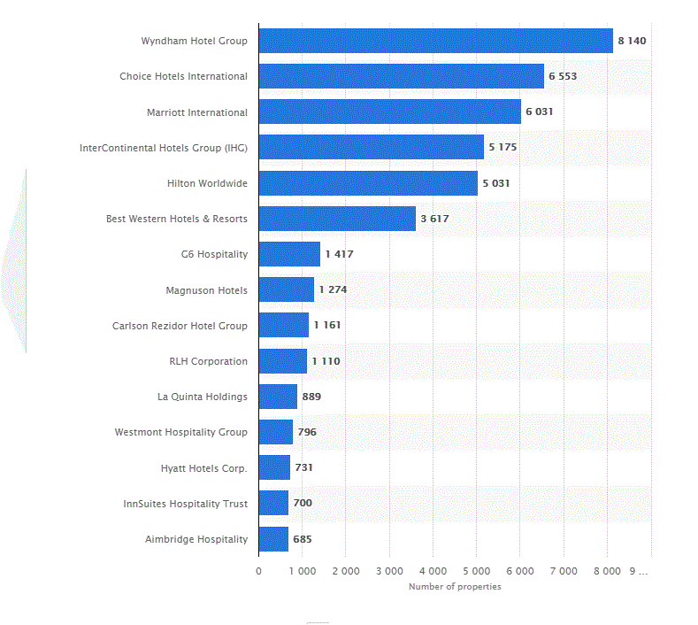
The analysis – the impact of top 10 global trends to the business
- Millennials the New Power Segment
The Millennial traveller, defined by age as being born between 1980 and 2000, already makes up over one third of the world’s hotel guests, with predictions that they will reach over 50 per cent by 2020. As the travel and hospitality industry gears up for the biggest disruption in decades, key attributes like design, experience, mobile and perceived value are imperative for attracting the millennial traveller. There has never been a demographic that is more connected, digitally savvy and demanding, and wanting contemporary design, high quality amenities, smart technology and locally inspired ambience, all wrapped into a single hotel experience.

Smart technology- User experience has never been more important for the truly connected Millennial traveller, with high expectations in discovery, payments and mobile experience prior to and during their stay.

Booking online through their phones, checking experiences through social media, check in and check out with their devices, add extra service though smart phones, payment faster through aap, communicate with help services though Whatapp, for example.
Statistic shows that sixty-five percent of Millennials reported taking at least one business trip within the last 12 months, and in many cases those trips were opportunities to mix business and pleasure.
It is important to update the technology and rethinking how to design the hotel model that is interested the new generation. Not only the young generation, the baby boomer also has the demand of experience the next generation style as well.

“The travel and tourism industry is extraordinarily robust and resilient. If you look back over time at hotels or airline businesses, car rental or cruise businesses… all of these sectors and companies have found ways of either pivoting their business model or reinventing and repositioning themselves as very different entities.” according to David Scowsill
President & CEO, World Travel & Tourism Council.
For the Marriot, the company has enough financial resources and
potential to update and keep up with the new technology as well as
create something news to attract the new generation.

For example, Marriott Hotels launched Six Degrees, a physical social network encouraging hotel guests to engage in the physical space through an app, digital wall projection and an interactive wooden table in the lobby. The system used guests’ LinkedIn accounts to pull information on the guests, including where they work and what their interests might be. Guests could express interest in organised activities from jogging in the park to craft beer tasting, through the app.

- Political tensions and terrorism

The effect of terrorism on the economy is quite enormous that eventually leads to homelessness, crimes, riots, unemployment, and crisis of food and shelter and at the same time deaths of many innocent people’s lives. The terrorists and political violence also destroys the tourism sectors supply and demand as this business is quite sensitive to all terrorist acts.

Hospitality industry is a dynamic industry as well as competitive business that needs the capability to continuously modify to consumers changing requirements and demands because the customer’s satisfaction, safety and safety are specifically the concentration of hospitality industries.

As a world-wide hotel and resort company, Marriot is totally affected by any political tensions, and terrorism. It might decrease on economy, lost of jobs, increase in unemployment rates, lots of human resources, increase cost for better security as well as promotions to attract customers. The demand of higher security while travelling is also a challenge for both the business itself as well as the government.

With the increased numbers of terrorism, meaning that the business will have to put more investment on security, insurance, as well as marketing. In my opinion, Marriot has financially ability to increase customers travel packages, promotions and security. It is also important to make the customer feel safer during their stays. The security also represents the brand, and quality for the business. Marriot might have to consider about travel insurance for their customers. It might cost more for both customers and the business, but many private sector insurer companies are now not willing to cover cross border trading due to terrorist attacks.

3.Deepening Income Inequality and The Working Poor

Inequality is one of the key challenges of all time. Income inequality specifically is one of the most visible aspects of a broader and more complex issue, one that entails inequality of opportunity and extends to gender, ethnicity, disability, and age, among others.

The map below shows that Asia is the region most affected by deepening income inequality. For those developing countries, improving education is a significant action to decrease the gap. Having skilled workers, with fair pay, as well as fair trade will help to improve the problem.

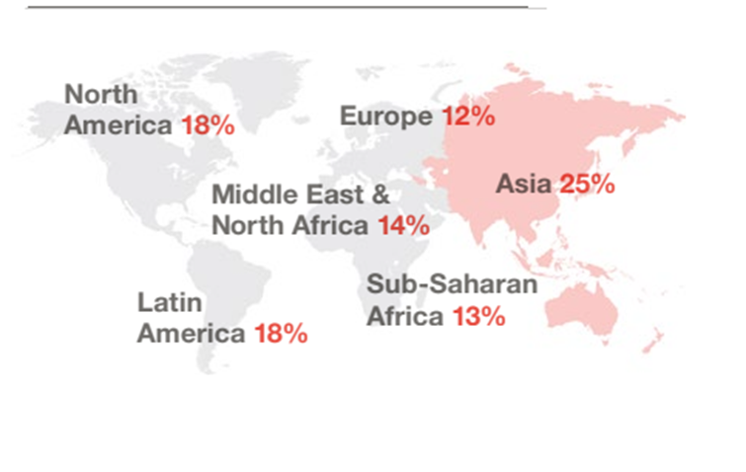
In my opinion, this trend also has a big influence on the hotel business. For example, for places like, Asia, Latin America, or Africa, the labor cost is much cheaper than some where else. Food, local suppliers, usually are not get the fair price. Many middle class or local might not effort to spend money.

The Marriot already acts on this trend. This problem is always a big challenge for every nation. By creating different models of hotel with different price tags and services, Marriot has a wider target market.
And may be , the business can focus on fair trade and training people to maintain , and improve serves and image.

4.Taking Control of Health and Personal Well Being

Taking charge of personal health will expand. With the technology is moving so fast that helps people to control their own personal health more effectively.

Human resource is an important factor for the hospitality industry. Not everyone can effort to pay for health insurance, not everyone can have an extra travel to go to the gym, and as a business, taking care of its own people is not a waste.
Marriot can have a resting room for its employees, so they can rest before or after the jobs. As well as built a fitness room, sauna to improve fitness and heath. Also, having a medical room with nurse, or doctor who can help the employees if they have any health problem. Provide insurance, and benefit to help employees with their health. Having events within the company to help and talk about stress and depression. Creating some events such as: art, cooking, running to connect people. Having a close look for health and personal well being will help increase the productivity as well as efficiency. To help prevent spread of infections if it happens, to create a healthy work environment.

5.Technology Driven Self-Sufficient Travelers

Digital technology is evolving with consumer adoption at an increasingly rapid pace. Customers are using their phones to search for specific pieces of information and these figures suggest that if they don’t find it they will quickly go elsewhere. Convenience is a key. The progression of digital technology continues to raise expectations and alter customer behaviours. Consumers are becoming increasingly empowered and discerning with the wealth of information available online.
While customers have more control of the choices, the business will have to be more a head of a game with products and services. “TripAdvisor’s consumer reviews, whether they’re for hotels or restaurants or attractions, have been fundamental to changing and improving the consumer experience… The whole review approach has put the power in the consumer’s hands.”, according to David Scowsill ,World Travel & Tourism Council.

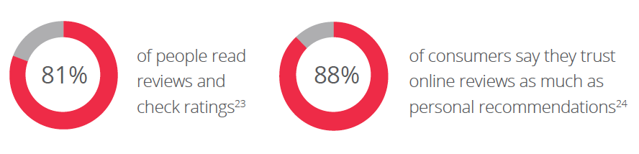

And yes, there will be a cost to upgrade technology, to train employees to use new technology. For this trend, Marriot can use technology to improve the workforce, control the quality through customers reviews, to create new products to attract more customers. There will be less cost on training by building a data base and app. It is easier to manage, access, control and schedule within the organization.

6.Sustainalibity and Resource Constraints

With the improvement of technology, human beings are seeking and looking for a new planet to move. And yet, Earth is in danger, people all around the world should all work together to slow down the global warming.More and more people are really care of eco-friendly products, such as: green policy, paper products, electric cars, etc.

As a world-wide organization, Marriot should have actions to react to this trend. The business should join the locals to help save resources such as clean water in the Middle East, Africa, South Asia. Also having option to use sustainable products that helps to save the wild environment. The business can limit the use of plastic, as well as separate different kind of garbage. Building and providing electric car charger, as well as no smoke policy in side the building.
The business needs to communicate with the local and join in the campaign of keeping the world green.

7.Disruption and the Sharing Economy

Sharing economy is not a new thing in any fields, or industries. With the growth of technology, improvement of education, new products are expanding these days.

Within the hospitality industry in general, and hotel business specifically, Airbnb has bulldozed its way onto the hotel market unleashing untold capacity and cratering prices. Airbnb’s business model focuses on a marketplace platform where hosts and guests exchange housing for money. Throughout the application process, hosts and guests can find reviews and social media connections to build trust amongst users in the marketplace. In 2015 the network orchestrator, as sector analysts describe the model, is likely to take $900m in disruption revenues. And over the next five years Airbnb’s planned the growth could take its global market share from 1 per cent to 9 per cent, challenging even the largest existing online travel agents (OTA) leaders.
However, I think this trend now is not too disruptive to the business, Marriot, or any big commercial business. For the most part people still prefer privacy, quality and commercial standards. With the increase of terrorism, and high demand on security, staying in someone house is not the first choice for most of traveller. With the big different on target market, the revenue of the Marriot will not be affected.

8.A Global Worldview

Globalization is a key to open more opportunities as well as connect people. Marriot has so many locations that are located around the world. It opens the door for many nations to create more jobs, improve economic. And more opportunities for the company to expand the business. Marriot can build more connection and increase the total capital. This trend has a significant affect on the labor pool and expect more human migration.

9.Fewer People and More Data

Even though technology plays an important role within the hospital industry, it can not replace human beings. People use technology to improve the productivity, and to satisfy conveniences. Human interaction is still a key to define a “good service”. I think, using the technology to help human beings works more efficient, not to replace human beings. Also, it is still a lot of works for human being to reach that stage. Marriot will not be affected too much if there are one or two hotels with robot service open now, because it might be too expensive for most people, or might be too uncomfortable for people who don’t know much about technology.

This trend will not affect the Marriot hotel. The business might invest some money into one special hotel, may be in Japan to create a new target market. However, this trend is still not a threat yet.

10.Emerging Growth Markets

Hospitality is a key sector for economic development and job creation throughout the world. However, the global economic crisis has led to reduction of the growth and development levels of most economies. This crisis has also led to massive unemployment and reduction of the disposable income. And this absolute has the affect on the hospitality industry. Even though the global economic is slowly recovering but it is still a challenge.

Is it affecting the business, yes. The reduction of incomes and leisure time has led to a decrease in purchase of services in the hospitality industry by consumers. Fewer people are able to travel for leisure or have meals at restaurants and hotels since they consider these services to be luxuries.

Financial data

Income statement

Annual Income Statement (values in 000's)Get Quarterly Data
Period Ending: | Trend | 12/31/2017 | 12/31/2016 | 12/31/2015 | 12/31/2014
Total Revenue |  | $22,894,000 | $17,072,000 | $14,486,000 | $13,796,000
Cost of Revenue |  | $19,192,000 | $14,446,000 | $12,363,000 | $11,830,000
Gross Profit |  | $3,702,000 | $2,626,000 | $2,123,000 | $1,966,000
Operating Expenses
Research and Development |  | $0 | $0 | $0 | $0
Sales, General and Admin. |  | $894,000 | $704,000 | $634,000 | $659,000
Non-Recurring Items |  | $159,000 | $386,000 | $0 | $0
Other Operating Items |  | $290,000 | $168,000 | $139,000 | $148,000
Operating Income |  | $2,359,000 | $1,368,000 | $1,350,000 | $1,159,000
Add'l income/expense items |  | $726,000 | $40,000 | $56,000 | $38,000
Earnings Before Interest and Tax |  | $3,124,000 | $1,418,000 | $1,422,000 | $1,203,000
Interest Expense |  | $288,000 | $234,000 | $167,000 | $115,000
Earnings Before Tax |  | $2,836,000 | $1,184,000 | $1,255,000 | $1,088,000
Income Tax |  | $1,464,000 | $404,000 | $396,000 | $335,000
Minority Interest |  | $0 | $0 | $0 | $0
Equity Earnings/Loss Unconsolidated Subsidiary |  | $39,000 | $10,000 | $16,000 | $6,000
Net Income-Cont. Operations |  | $1,411,000 | $790,000 | $875,000 | $759,000
Net Income |  | $1,372,000 | $780,000 | $859,000 | $753,000
Net Income Applicable to Common Shareholders |  | $1,372,000 | $780,000 | $859,000 | $753,000

Balance sheet

Annual Income Statement (values in 000's)Get Quarterly Data
Period Ending: | Trend | 12/31/2017 | 12/31/2016 | 12/31/2015 | 12/31/2014
Current Assets
Cash and Cash Equivalents |  | $383,000 | $858,000 | $96,000 | $104,000
Short-Term Investments |  | $0 | $0 | $0 | $0
Net Receivables |  | $1,991,000 | $1,695,000 | $1,103,000 | $1,100,000
Inventory |  | $0 | $0 | $0 | $0
Other Current Assets |  | $373,000 | $818,000 | $185,000 | $406,000
Total Current Assets |  | $2,747,000 | $3,371,000 | $1,384,000 | $1,610,000
Long-Term Assets
Long-Term Investments |  | $882,000 | $973,000 | $380,000 | $439,000
Fixed Assets |  | $1,793,000 | $2,335,000 | $1,029,000 | $1,460,000
Goodwill |  | $9,207,000 | $7,598,000 | $943,000 | $894,000
Intangible Assets |  | $8,805,000 | $9,270,000 | $1,451,000 | $1,351,000
Other Assets |  | $421,000 | $477,000 | $223,000 | $260,000
Deferred Asset Charges |  | $93,000 | $116,000 | $672,000 | $819,000
Total Assets |  | $23,948,000 | $24,140,000 | $6,082,000 | $6,833,000
Current Liabilities
Accounts Payable |  | $3,548,000 | $2,972,000 | $1,981,000 | $2,037,000
Short-Term Debt / Current Portion of Long-Term Debt |  | $398,000 | $309,000 | $300,000 | $324,000
Other Current Liabilities |  | $2,064,000 | $1,866,000 | $952,000 | $677,000
Total Current Liabilities |  | $6,010,000 | $5,147,000 | $3,233,000 | $3,038,000
Long-Term Debt |  | $7,840,000 | $8,197,000 | $3,807,000 | $3,447,000
Other Liabilities |  | $5,763,000 | $4,419,000 | $2,616,000 | $2,548,000
Deferred Liability Charges |  | $604,000 | $1,020,000 | $16,000 | $0
Misc. Stocks |  | $0 | $0 | $0 | $0
Minority Interest |  | $0 | $0 | $0 | $0
Total Liabilities |  | $20,217,000 | $18,783,000 | $9,672,000 | $9,033,000
Stock Holders Equity
Common Stocks |  | $5,000 | $5,000 | $5,000 | $5,000
Capital Surplus |  | $5,770,000 | $5,808,000 | $2,821,000 | $2,802,000
Retained Earnings |  | $7,391,000 | $6,501,000 | $4,878,000 | $4,286,000
Treasury Stock |  | ($9,418,000) | ($6,460,000) | ($11,098,000) | ($9,223,000)
Other Equity |  | ($17,000) | ($497,000) | ($196,000) | ($70,000)
Total Equity |  | $3,731,000 | $5,357,000 | ($3,590,000) | ($2,200,000)
Total Liabilities & Equity |  | $23,948,000 | $24,140,000 | $6,082,000 | $6,833,000

Cash Flow Statement

Annual Income Statement (values in 000's)Get Quarterly Data
Period Ending: | Trend | 12/31/2017 | 12/31/2016 | 12/31/2015 | 12/31/2014
Net Income |  | $1,372,000 | $780,000 | $859,000 | $753,000
Cash Flows-Operating Activities
Depreciation |  | $290,000 | $168,000 | $139,000 | $148,000
Net Income Adjustments |  | $693,000 | $811,000 | $558,000 | $443,000
Changes in Operating Activities
Accounts Receivable |  | $0 | $0 | $0 | $0
Changes in Inventories |  | $0 | $0 | $0 | $0
Other Operating Activities |  | $81,000 | ($77,000) | ($41,000) | ($120,000)
Liabilities |  | $0 | $0 | $0 | $0
Net Cash Flow-Operating |  | $2,436,000 | $1,682,000 | $1,515,000 | $1,224,000
Cash Flows-Investing Activities
Capital Expenditures |  | ($240,000) | ($199,000) | ($305,000) | ($411,000)
Investments |  | $94,000 | $35,000 | $147,000 | ($69,000)
Other Investing Activities |  | $1,166,000 | ($2,245,000) | $525,000 | $167,000
Net Cash Flows-Investing |  | $1,020,000 | ($2,409,000) | $367,000 | ($313,000)
Cash Flows-Financing Activities
Sale and Purchase of Stock |  | ($3,007,000) | ($534,000) | ($1,877,000) | ($1,332,000)
Net Borrowings |  | ($285,000) | $2,521,000 | $325,000 | $622,000
Other Financing Activities |  | $0 | ($24,000) | $0 | $0
Net Cash Flows-Financing |  | ($3,931,000) | $1,489,000 | ($1,890,000) | ($933,000)
Effect of Exchange Rate |  | $0 | $0 | $0 | $0
Net Cash Flow |  | ($475,000) | $762,000 | ($8,000) | ($22,000)

Financial ratio

Annual Income Statement (values in 000's)
Period Ending: | Trend | 12/31/2017 | 12/31/2016 | 12/31/2015 | 12/31/2014
Liquidity Ratios
Current Ratio |  | 46% | 65% | 43% | 53%
Quick Ratio |  | 46% | 65% | 43% | 53%
Cash Ratio |  | 6% | 17% | 3% | 3%
Profitability Ratios
Gross Margin |  | 16% | 15% | 15% | 14%
Operating Margin |  | 10% | 8% | 9% | 8%
Pre-Tax Margin |  | 12% | 7% | 9% | 8%
Profit Margin |  | 6% | 5% | 6% | 5%
Pre-Tax ROE |  | 76% | 22% | 35% | 49%
After Tax ROE |  | 37% | 15% | 24% | 34%

Competitor
Choice Hotels International

Financial ratio

Annual Income Statement (values in 000's)
Period Ending: | Trend | 12/31/2017 | 12/31/2016 | 12/31/2015 | 12/31/2014
Liquidity Ratios
Current Ratio |  | 137% | 131% | 149% | 163%
Quick Ratio |  | 137% | 131% | 149% | 163%
Cash Ratio |  | 80% | 77% | 93% | 107%
Profitability Ratios
Gross Margin |  | 100% | 100% | 100% | 100%
Operating Margin |  | 26% | 26% | 26% | 28%
Pre-Tax Margin |  | 22% | 22% | 21% | 23%
Profit Margin |  | 11% | 15% | 15% | 16%
Pre-Tax ROE |  | 106% | 64% | 46% | 41%
After Tax ROE |  | 54% | 45% | 32% | 29%

Vertical analysis: Marriot International Vs Choice Hotels International

The report showing that, the Choice Hotels International has stronger financial position than the Marriot International. The Marriot has weaker liquidly as well as the profitability. The Choice Hotels International has bigger cash flow and have more ability to survive and maintain after economy crunch. Even though both corporations are making money, but it is obvious that Choice Hotels has a higher retain earning and bigger gross profit margin.

Conclusion

According to the financial statement, Marriot has not been doing well in the last 4 years. Even though, it generates profit, but there is not a high percentage of cash flow and return in earning. The profit margin does not change much over the time. Cash flow is a bit weaker in 2017 compare to the 2016 years. Over all, the business does not have a very strong financial position, in my opinion.
After taking consideration, there are 2 trends that I think will most affect the business: the growth of technology and increased in focus on health and well being.
Technology to improve guest experiences, from booking, check in to checkout. These days, hotels’ mobile apps have an impressive list of features. Marriot can use the advantage of technology to reduce waiting time, to customize customer’s need, or to control the quality and to know customer experience.
The improvement of technology not only focus on customer satisfaction, it also helps to increase the efficiency at the workplace. With technology these day, it is easier for manager to monitor and control the work flow. Distance is not a problem for a world-wide corporation anymore. Training will be less expensive, hiring and communication will be easier.
Health and wellness is not a new trend in hospitality, but it’s certainly been gaining over the last few years. Business and leisure travelers of all ages are increasingly concerned with staying healthy and fit on the road. Generally, constantly connected, always-online millennials crave out-of-the-box wellness options, while baby boomers call for more relaxing. Marriot is expected to continue to boost its wellness offerings. For example: spa, fitness center, yoga center. Also, creating the healthy work environment for the employees will have a positive affect to the business. Happy people will be more productive than angry people who has no energy. It is important to make the employees happy , loyalty in order to provide good services.

Student name : Linh Nguyen
Instructor : V.Foster
Course : Financial Management for the hospitality industry
Date : March 8, 2018

Research and Financial Analysis Of A Changing Industry

