Final Project

Cul 252
Food and Beverage Management

Kanisa Jaisamran
ID: 425279

Instructor: Chef Timothy Budd

Fall 2017
12/06/2017

Table of Content

Page
Concept Statement…………………………………………………………………….3
Menu…………………………………………………………………………………………4
FOH Mise en Place………………………………………………………………………6
FOH Job Descriptions………………………………………………………………….8
Floor Plan………………………………………………………………………………….10
Style of Service………………………………………………………………………….11
Food and Wine Pairing Assessment……………………………………………..12
Liqueur,Beer, Spirits…………………………………………………………………..13
Bar Set-up………………………………………………………………………………...14
Bibliography………………………………………………………………………………15

Concept Statement

Thai Touch is a fast casual restaurant. It’s located on Burrard streets in Vancouver, Canada. It’s a Thai restaurant serving Thai traditional food using local and seasonal ingredients and serving in Thai style (we cook all food and keep them in bain marie for hot holding).
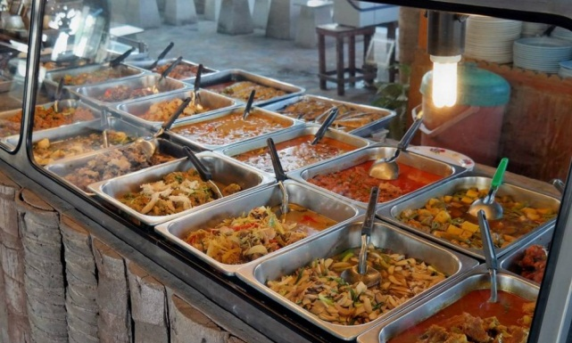
We provide Thai food with local and seasonal ingredients, and bring in some products from Thailand. Our mission is to provide customers with fast food but useful and not expensive. Thai Touch restaurant will be one of the best choices for our guests especially who are plain hungry and in a hurry.
We have a comfortable environment where guests can enjoy our food. We provide a Thai style of service. We will prepare many foods and place in bain marie. The customers can come to see and choose what foods do they want.
We have 40 seats. We provide lunch and dinner, open 10 am until 9 pm on Monday to Saturday. We are close on Sunday.

Food menu

Appetizer
Satay
Choice of chicken, beef or pork marinated in Thai spices, grilled to perfection and served with peanut sauce
Por Pia Tod
Deep-fried vegetarian spring roll (glass noodles, cabbage, carrot, onion, celery) served with plum sauce
Tod Mun Pla
Homemade fish cake (fish, red curry paste, kaffir leaves, green beans) served with plum sauce
Crispy Wonton
Deep-fried wonton stuffed with ground chicken and prawns served with chili sauce

Entrée
Tom Yum Goong
Hot and sour soup with tiger prawns, mushrooms, lemon grass, tomatoes, lime leaves, green onions and cilantro
Kang Dang Gai
Red curry in coconut milk with chicken, bamboo shoots, bell peppers, fresh basil, and lime leaves
Kang Kaew Warn Gai
Green curry in coconut milk with chicken, thai eggplant, bell peppers, fresh basil and lime leaves
Kang Luang Nuea
A flavourful yellow curry in coconut milk with beef, potatoes, and onions
Pad Med Mamuang Himaphan gung
Stir-fried with tiger prawn, roasted cashew nuts, onions, celery, bell peppers and fried chillies
Pad Bai Grapao Moo
Stir-fried with pork, onions, green beans, chili, bell peppers and fresh basil
Pad Prik Khing Moo
Stir-fried pork with spicy sauce, bell peppers, green beans and lime leaves

Pad Ped Gai
Stir-fried chicken with chili paste, bamboo shoots, fresh basils, bell peppers, green onions, lime leaves, and mushrooms
Pad Ma-kaeu-yaw Moo
Egg Plant stir-fried with ground pork, bell peppers, and fresh basils

Dessert
Mango Sticky Rice
Sweet coconut sticky rice with mango
Deep-fried Banana
Deep-fried banana served with coconut ice-cream

FOH Mise en Place

FOH Mise en Place Lists: Before, During and After Service
Before Service Mise en Place:
- Open the bar
- Polish flatware and glassware
- Mop the floor
- Set up the table
- Cruet sets should be cleaned and filled
- Sauce bottles should be filled
- Fill the stock, napkins, plastic spoon and fork for to go, bags
- Check the temperature, not too cold or hot
- Make sure that turn on all the entertainments
- Check the reservation book. If have it, check the time and set up the table for them.
- Take open sign on

During Service Mise en Place:
- Servers have to customers
- Give menu to customer when they sitting already
- Server should prepare pen and paper to take order form customers
- Take care all the customers and take order when the customer ready. Give them recommend if they want.
- Repeat the order for customer after they order
- When the customer asks about ingredient or allergy if server don’t know, ask in the kitchen first, don’t guest
- Serving the food
- Clean and set table as fast as possible after customer gone
- Servers have to smile all the time.

After Service Mise en Place:
- Clean the table and set up the table for tomorrow
- Take open sign off
- Clean the bar and sanitizer
- Sweep the floor
- Clean the washroom
- Throw the garbage away
- Turn off all the entertainments
- Turn off heater or air-conditioner

FOH Job Descriptions

Manager:
- Hiring staff
- Design the schedule for all staff, manage and ensure all staff do they job well
- Check the storage what the restaurant need in the next day. Monitor, manage and review the catering and cleaning contracts
- Purchase all ingredient and stuff in the restaurant
- Manage the team’s performance promoting achievements and identifying weaker areas for improvement
- Handle guest complaints according to provided guidelines
- Take care all staff and customer

Hosts and hostesses:
- Greeting customers and take care the customer to table
- Suggest the customer, how to order the foods and drinks
- Manage the reception, telephone, and room reservations
- Take care patio, clean, open and close

Waiter and waitress:
- Take orders both dine in and take out
- Serve foods and drinks
- Take calls, and note reservations
- Make recommendations or sharing additional information upon request
- Providing excellent customer services
- Clean and setting the tables
- Deliver checks and collect payments
- Sweep and mop the floor every day when the restaurant close

Bartender:
- Open and close the bar
- Take order drink
- Making beverage for customers and staff
- check drink storage
- Clean all glasses

Chef and staff in the kitchen:
- Hiring staff in the kitchen
- Cook the food for customer and staff
- Decide the food, what to cook daily because our menus will change everyday
- Prepare all ingredients that need for service
- Check the storage and stuff that need for the next day
- Clean in the kitchen
- Take care stuff in the kitchen
- Communicate with manager and servers

Floor Plan

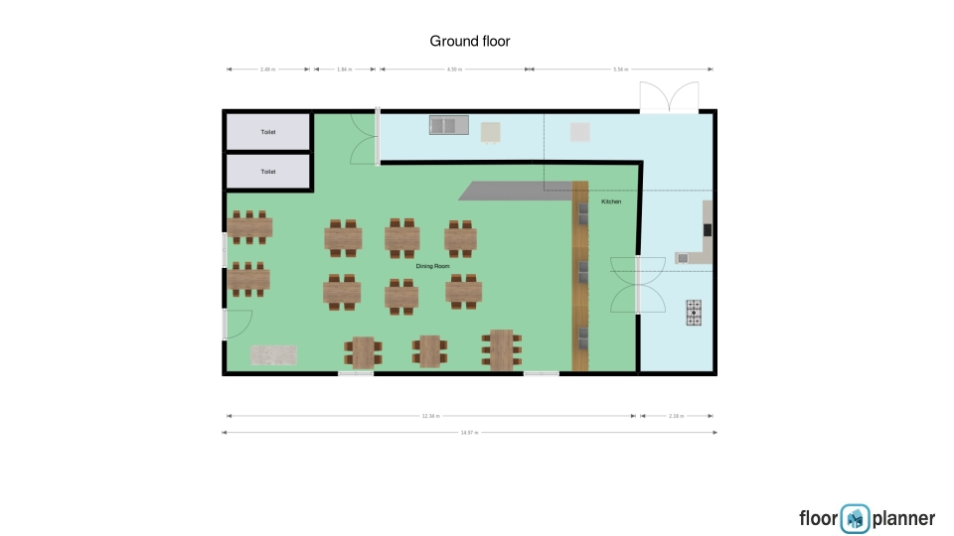

Flow of service
- Host or hostesses: greeting customers, take them to the tables
- Waiter or waitress: take food order
- Bartenders: take drinks order and make them
- Kitchen staff: make foods
- Server: serve food and drinks, give them a bill, cleaning a table

Style of Service

Our restaurant will provide Thai food and mixed style of service to give the best service. The customers can enjoy delicious food and they don’t have to wait for a long time. When the customers come to our restaurant, they will feel like they are home because our foods and our service. We always use fresh, natural, traditional and healthy ingredients to provide the foods. And we will provide a family-friendly environment to make the customers feel relax and warm. The customer will find out the favorite restaurant here.
When customers come into our restaurant, the host will find the suitable seats and give them the number of table. On the wall we will have a large board of menu of the day. After that the customers go to the food bar to choose the foods that they want with server. The servers can give the recommendation and information for customers if they want. Then the customers go to the bar to order drinks with bartenders. Behind the bar, the professional bartenders will take an order, give the recommendation and information, and make the drinks for the customers. When customers order foods and drinks already, they can wait at the table.
In the kitchen, a professional chef and kitchen staffs will cook the best foods for customers. They will refill the foods into bain marie when the foods almost gone. The server will serve the drink first, then serve the foods as soon as possible, actually it take time just a few minutes. And the servers will serve the dessert at last after the customers finish their food. Our servers will always take care the customers how they feel, refill water and clear the dirty dishes. After the customers enjoy meals, servers will help them to pay the bill and say thank you to the customer, clean up, and set the table for new customers.
The foods will are placed on plates after the customer order them by the servers (behind the food bar) and are served by the servers (outside the food bar). In our restaurant, the servers will serve the foods to guest from the left with the right hand and goes clockwise around the table. Servers and all staffs in our restaurant will always smile, keep take care, talking with the customer. We will create warm and friendly environment for customers. We will also provide comfortable soft lights and light music which will make customers feel relaxed but not noise.

Food and Wine Pairing Assessment

Menu Item | Main Food Consideration | Main Wine style  Characteristic | Colour | Sweetness | Body | Character | Other | Recommended Wine | Reason For Choice
Som-tum (Papaya salad) | Green papaya, tomato, green bean | Acidity | White | Dry | Light | Vegetal | Acidity | Selak’s Sauvignon Blanc | This wine has dry sweetness and intense with vegetal fruit flavour. So it matches with papaya salad.
Kang- Dang nuea (Red curry with beef) | Beef, coconut milk | Red, acidity | Red | Medium | Full | Spicy | Acidity | Mont Gras Cabernet Sauvignon | This wine has full body match with beef and coconut.
Mango Sticky Rice | Mango, sticky rice, coconut | Sweet, fruity | White | Sweet | Medium | Fruity | Oak | Mission Hill Riesling Ice Wine | This wine is sweet and fruit flavour match with mango.

Liqueur,Beer, Spirits

Beer
Domestics:
- Dead frog-Tropic vice tropical fruit ale: $3.95/341 mL
- Granville island-Cypress honey lager can: $3.95/355 mL
- Lighthouse-Shipwreck IPA: $3.95/355 mL
- Pacific western-Scandal ale organic: $4:95/341 mL
Imports:
- Singha beer (Thailand): $4.95/330mL
- Warsteiner premium verum (Germany): $4.95/330 mL
- Hoegaarden (Belgium): $5.95/330 mL
- Deschutes-Black butte porter (United States): $6.95/355 mL
Microbreweries:
- Henderson
- Fuggles and Warlockt
- Bomber Brewing
- Yellow Dog Brewing

Spirits
Well:
- Armorik classic
- Beefeater-London dry
Brand:
- Bacardi
- Jack Dniel’s
Premium:
- Svedka Vodka
- Avion silver Tequila

Liqueurs
- Amaro-Montenegro
- Blue curacao-Bols
- Butter ripple schnapps Phillips
- Jim beam-Apple

Bar Set-up

Outline of the bar set-up:
- Sommelier should be professional and have to know how to make any drink and also can explain/recommend any drink for customers
- Sommelier should have patient when he/she does this work
- Sommelier have to move fast and flexible when working
- Sommelier should know where the tools are
- Sommelier and bartender have to check stock everyday
- Liquor bottles must be arranged in a consistent order
- Glasses must be easy to grab
- Stock liquor bottles based on style
- Rails should be set up in the same horizontal order for every sommelier
- Top shelf brands and specialty liquors should be placed nearby
List tools:
- Wine glasses
- Pilsner glasses
- Highball glasses
- Triple sec
- Martini glasses
- Lime juice concentrate
- Assorted sodas
- Cherries
- Kosher salt
- Rocks glasses
- Sweet and dry vermouth
- Grenadine
- Orange slices
- Lemon slices
- Lime slices
- Toothpick
- Lychee
- Coconut syrup
- Sugar syrup
- Olive
Bar positions:
The bar is next to the counter of food. The customers can order drinks that they want after orders the food.
Bibliography

- Concept statement and food menus from my Purchasing Manual Project
- The power point of Food and Beverage Management
- Floor plan from my project of Management by Menu.
- http://www.bcliquorstores.com/
- https://www.leaf.tv/articles/how-to-set-up-a-bar-for-a-restaurant/
- https://www.thebalance.com/how-to-set-up-a-restaurant-bar-2888875

