NORTHERN CHINA
China made a huge impact on the world’s history with great contributions in philosophy in which Confucius influenced the Chinese’ way of living through education and families’ cultures, the Yin-Yang, that they based their life with. They also contribute in religion with the discovery of Taoism and Buddhism belief, in the field of science where many Chinese discovers paper, printing, gunpowder, and compass. Due to their strong army forces and resilient leaders, they became one on the countries with strong political influence and won series of civil wars. Chinese makes the bulk of the world’s population about 22%. With its geography, the regions in China has different climate and landscape that greatly affects their source of living and their cuisine.
Northern China has severe winters and short growing season, and that builds the type of cuisine they have, flavor profile of their food, and the choice of their ingredients. This region prefers noodles than rice, the food is salty, and usually flavored with onions, garlic, and dark soy sauce. This cuisine is also called as Mandarin or Beijing cooking, where Tofu is popular and other soybean derivatives like Hoisin sauce. With the influenced of Mongolia, to their region, Northern China extensively use fire pots in cooking and in daily activities in the absence of fuel.

Dish: Pungent and Hot Soup
Cooking techniques:
- Marinating- the julienned meat is marinated in cornstarch, soy sauce and sugar to give flavor and tenderize the meat more
- Boiling- the stock was boiled before adding the vegetables over high heat
- Simmering- the soup is allowed to simmer over medium low heat after the cornstarch was added into it
Chef facts:
- Tapioca powder- very fine white powder that works well in gluten-free baking. Made from starch extracted from cassava plant, and also use as a thickener
- Cornstarch-starch derived from corn grain. A common food ingredient, used in thickening sauces or soups and in making corn syrup, and other sugars
- Soy sauce- a liquid condiment of Chinese origin, made from fermented paste of soy beans, roasted grain, brine and molds
- Sesame oil- edible vegetable oil derived from sesame seeds. It use as a flavor enhancer in many cuisines, having a distinctive nutty aroma and taste
- White pepper-a spice produced from dried fruit of the pepper plant. Usually milder than black pepper with less complex flavor
- Black vinegar- also known as “Chinkiang vinegar”. It is an inky-black vinegar aged for malty, woody, and smoky flavor
- Rice vinegar-a type of vinegar made from fermented rice
- Dried black mushroom- it has an intense meaty flavor that enhances the flavor of the soups, stir fries, and braised dishes
- Dried black cloud ears- an edible jelly fungus that grows on trees in mountainous regions
- Bamboo shoots- edible shoots of bamboo species. Use as vegetable in Asian dishes and broths
- Soft bean curd- also known as “tofu”. It is a food prepared by coagulating soy milk and then pressing the resulting curds into solid white blocks of varying softness
- Cilantro leaves- a fast growing aromatic, annual herb that grows best in cool weather

Chef’s comment and recommendation:
Soup is very good, nice flavor. But if Red vinegar should have been added , the flavor profile should have been better

What I learned:
I learn the technique of heat control. I notice that high heat evaporates the soup really fast so I turn it lower because I keep adding stock and losing flavor if I stick on high heat. I also managed to multi-task while cooking this dish because I need to soaked first all the dried ingredients like dried mushrooms and dried cloud ears before I can cut them. I learn that reviewing the recipe thoroughly and having a nice plan before starting out saves time and makes more efficient.

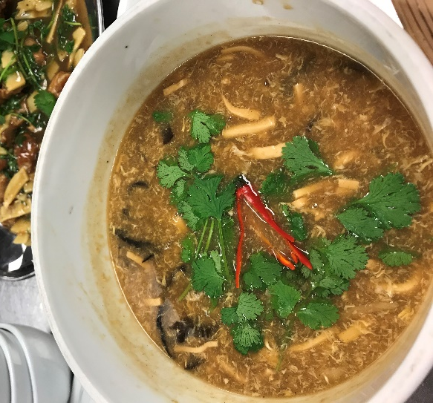

Pungent and Hot Soup

Dish: Mo Shu or Mu Shu Pork (Wood shavings Pork) and Mandarin Pancakes
Cooking techniques:
- Muffin method- mixing the wet ingredients in one bowl and the dry in another. You then pour the wet over the try and combine, mixing as little as possible
- Kneading- working the dough to develop gluten and makes the dough more pliable and easier to work with
- Pan frying- the dough and the dumplings were pan fried with small amount of oil just enough to cover the bottom of the pan with medium to high heat
- Marinating- the meat is marinated with ground peppers, minced ginger, cornstarch, dry sherry, and soy sauce for 30 minutes to absorb flavor and makes the meat more tender
- Stir frying- cooking over smoking high heat with small amount of oil for a short amount of time. The vegetables and the meat were stir-fried separately because they have different cooking times, and then combined together

Chef facts:
- Mo Shu or Mu Shu- a dish of Northern China possibly originating from Shandong. It is a typical stir fried dish in Northern China. It is made with pork, green onions, mushrooms, and scrambled eggs, all rolled into small, thin pancakes, instead of serving over rice
- All-purpose flour- general use white flour. It is a blend of hard and soft flours with a protein content of 9-12%
- Sesame oil- edible vegetable oil derived from sesame seeds. It use as a flavor enhancer in many cuisines, having a distinctive nutty aroma and taste
- Cornstarch- starch derived from corn grain. A common food ingredient, used in thickening sauces or soups and in making corn syrup, and other sugars
- Dry Sherry- a fortified wine with sweet taste and higher alcohol content
- Soy sauce- a liquid condiment of Chinese origin, made from fermented paste of soy beans, roasted grain, brine and molds
- Dried black mushroom- it has an intense meaty flavor that enhances the flavor of the soups, stir fries, and braised dishes
- Dried black cloud ears- an edible jelly fungus that grows on trees in mountainous regions
- Bamboo shoots- edible shoots of bamboo species. Use as vegetable in Asian dishes and broths
- Tapioca powder- very fine white powder that works well in gluten-free baking. Made from starch extracted from cassava plant, and also use as a thickener
- Hoisin sauce- it is a thick, fragrant sauce commonly used in Chinese cuisine as glazed for meat, an addition to stir fries, or as dipping sauce. It is darkly colored in appearance and sweet and salty in taste.

Chef’s comment and recommendation:
The dough became crispy and tough, working the dough too much develops the gluten, making it tougher. The pork is good, and flavor is also good, just a little bit thinner on the cuts of the eggs next time.

What I learned:
I learn that stir-frying should be done in batches because if the ingredient overcrowds the pan, the heat gradually lowers down and the food will not get that smoky flavor of the wok.
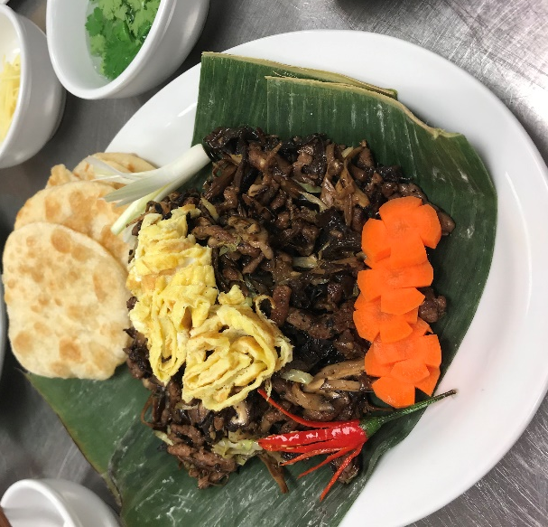

Mo Shu or Mu Shu Pork (Wood shavings Pork) and Mandarin Pancakes

Dish: Vinegar-Slipped Fish Chunks
Cooking techniques:
- Marinating- the fish were marinated with egg whites, cornstarch, dry sherry, salt and ginger to develop the flavor
- Pan frying- the fish were pan fried with small amount of oil just enough to cover the bottom of the pan with medium to high heat
- Deglazing- the work with garlic is deglazed with dry sherry wine to extract the flavor in the wok. Then the sauce mixture is added until thickened
Chef facts:
- Dry Sherry- a fortified wine with sweet taste and higher alcohol content
- Sesame oil- edible vegetable oil derived from sesame seeds. It use as a flavor enhancer in many cuisines, having a distinctive nutty aroma and taste
- Tapioca powder- very fine white powder that works well in gluten-free baking. Made from starch extracted from cassava plant, and also use as a thickener
- Cornstarch- starch derived from corn grain. A common food ingredient, used in thickening sauces or soups and in making corn syrup, and other sugars
- Red Rice vinegar- made from red yeast rice (fermented rice) and sometimes barley and sorghum. This sweet, tart, and salty vinegar is often used in Chinese seafood dishes and dipping sauces

Chef’s comment and recommendation:
The fish is okay, but there is no tartness because there was no red vinegar. The color of the fish and the flavor should have been better if red vinegar that makes the dish was added

What I learned:
I learn that the heat of the wok should be lowered down when making the sauce because it evaporates the liquid in the sauce mixture really quickly if the heat is too high. Heat control when working with woks are very essential in this cuisine.

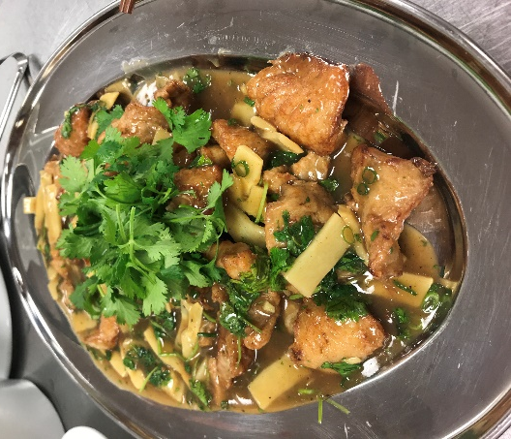

Vinegar-Slipped Fish Chunks

The Cuisine of Northern China

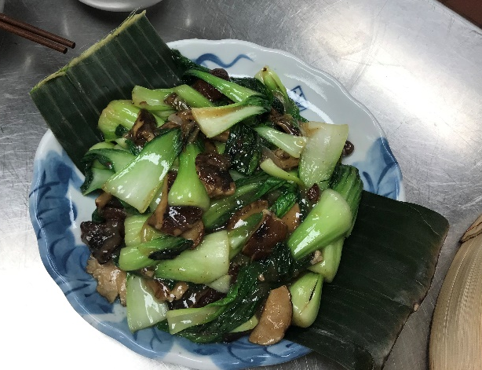
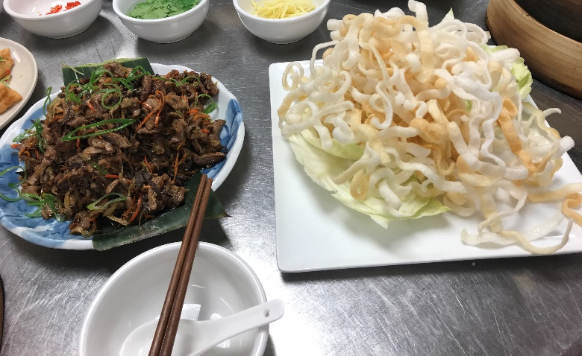

STIR-FRIED BOKCHOY

LAMB ON RICE STICKS

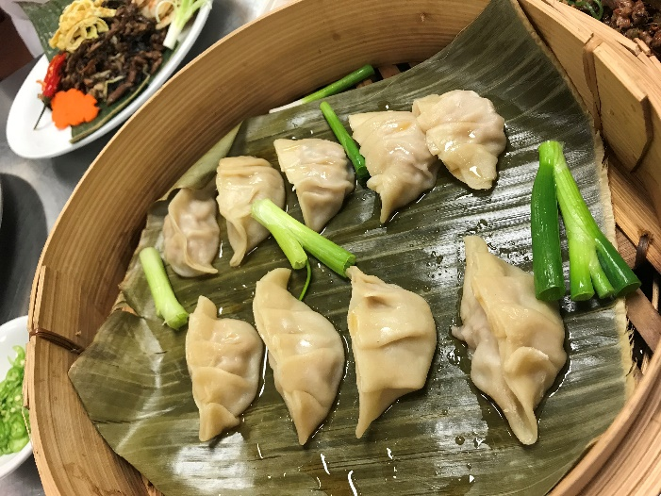
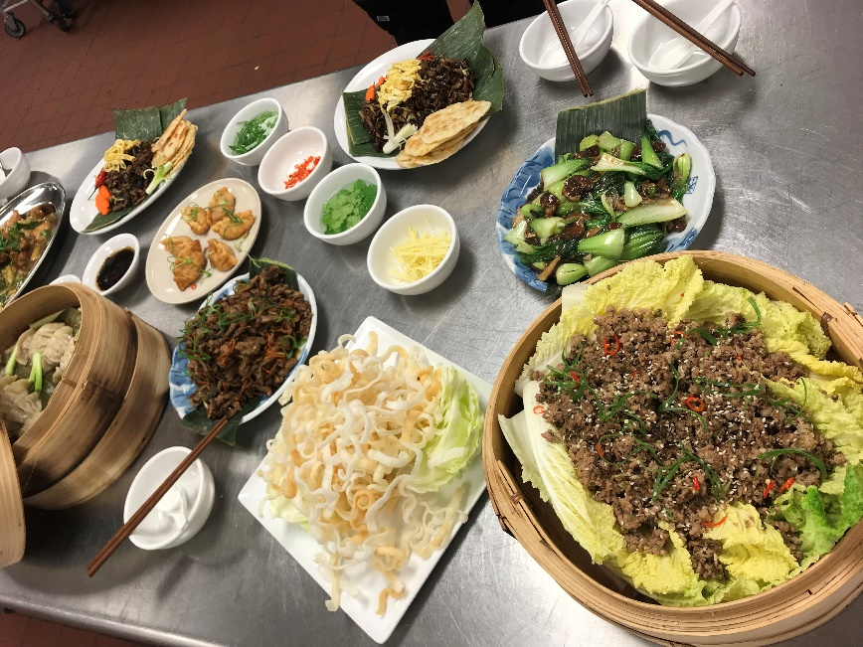
JIAO ZI

WESTERN CHINA
Western China which is also known a Szechuan cooking is very famous for their hot cuisine. They were regarded as “heavenly country” because of the abundance of food and natural resource. Rice is grown in this region during summer. Abundance of tangerines, bamboo groves, edible fungi in this area because of its hills and mountainous slopes. One of the greatest agricultural importance is their tea, where Yunnan province grows majority of it. Dishes were traditionally smoked with tea and several spices to incorporate flavor. Another well-known product of Yunnan is the Yunnan ham. This region grows some of the world’s hottest chile peppers which have given Sichuan a reputation for heat. Chile is the prominent ingredient in Szechuan cuisine which they believed that fire will stimulate the palate to distinguish the flavors, that heat induces perspiration and helps people to keep cool, and they say that spices are used to mask the taste of foods that rot quickly in the heat. The primary ingredient/spice and source of heat in Szechuan cuisine is the Szechuan peppercorns that causes numbing heat. This cuisine is composed of seven basic flavors: sour, pungent, hot, sweet, bitter, aromatic, and salty. This region also takes priority on food preservation. Salting, drying, pickling, and smoking are traditionally employed. Their common preparation technique includes stir frying, steaming, and braising. Beef is more common in this region compared to the other regions in China because of the prevalence of oxen.
Another type of cuisine in this region id the Hunan cuisine and also known as Xiang cuisine. It is one of the Eight Great Traditions of Chinese cuisine and is well known for its hot, spicy flavour, fresh aroma, and deep color. Their common cooking techniques are stewing, frying, pot-roasting, braising, and smoking. The feature of this cuisine is that their menu changes with the season.

Dish: Tea and Spice Smoked Quail with Sweet and Sour Cucumbers
Cooking techniques:
- Rubbing- the quail was rubbed with spices like toasted Szechuan peppercorns, five spice powder, vegetable oil, and salt to incorporate the flavor on the quail. This technique is similar to marinating
- Smoking- The marinated quail were smoked in long grain rice, dry mandarin peel, cassia bark, jasmine tea leaves, brown sugar, and star anise
- Deep-frying- after the quail has been smoked, they were deep fried in large amount of oil at medium high heat until they are golden brown
Chef facts:
- Quail- any numerous small birds that originates in Middle East. They are high in protein, very lean, delicate flavors, and good for grilling or pan-roast
- Szechuan pepper-spice in Chinese cuisine that originates from Sichuan province. It has unique aroma and flavor that is neither hot like chili peppers nor pungent like black pepper
- Five spice powder- a common ingredient in Chinese cooking. Mixture of equal parts of cinnamon, cloves, fennel seeds, star anise, and Szechuan peppercorns
- Long-grain rice- slim and lengthy. This type includes American long grain white and brown rice, Basmati rice, and Jasmine rice. Produces distinct firm grains that stay fluffy and separate after cooking.
- Dry Mandarin peel- “chimpi”; sun-dried tangerine peel used as a traditional seasoning in Chinese cooking and traditional medicine
- Star anise- whole star anise looks like an eight pointed star about 1 inch across. It gives a licorice flavor to savory dishes like pork or poultry.
- Cassia bark- it is considered as “Chinese Cinnamon”; an evergreen tree originating in Southern China and widely cultivated in Asia. The bark is aromatic and used as a spice
- Jasmine tea leaves- one of the most famous scented teas in China
- Thai bird chili- small, very pungent and hot type of chili. It measures around 50,000-100,000 scoville units
- Rice wine vinegar- made by fermenting the sugars in rice first into alcohol, then into acid

Chef’s comment and recommendation:
The quail is a little rare and a little bit tough. Good flavors with tea infused and spices

What I learned:
I learn the smoking process using the wok. That the spices and tea should be placed on the bottom part of the wok that is lined with a foil so it will not burn easily, then a layer of metal with holes is placed together with the quail and then covered. The wok must produced smoked first before placing the quail on it to avoid drying the quail.
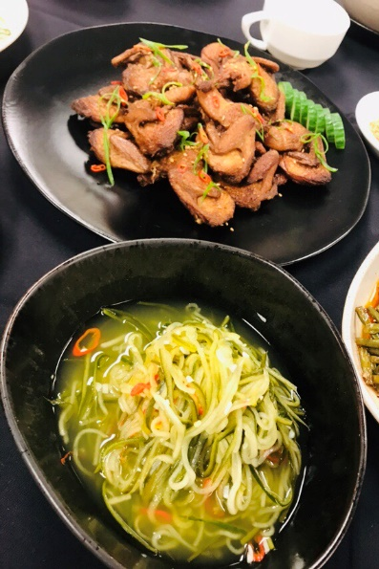
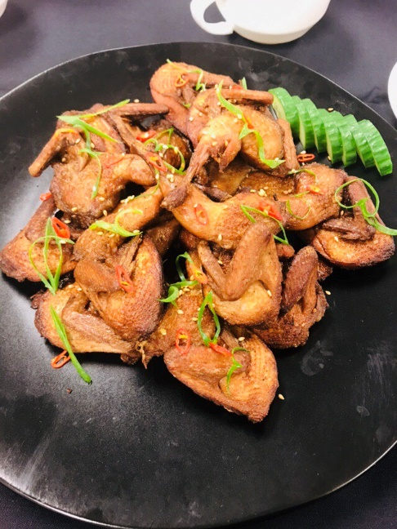

Tea and Spice Smoked Quail with Sweet and Sour Cucumbers

Dish: Ma-Puo Doufu
Cooking techniques:
- Stir-frying- the ingredients (except the tofu) were stir fried over high heat with small amount of oil
Chef facts:
- Dark soy sauce- dark colored soy sauce used mainly for adding colour and flavour to dishes. It is richer, slightly thicker and less salty than other types of soy sauce
- Shaoxing wine- one of the most famous varieties of Huangjiu, or traditional Chinese wines fermented from rice
- Dry sherry- a wine fortified with brandy
- Fermented chile bean paste- also referred to as “doubanjiang”-a salty paste made from fermented broad beans, soybeans, salt, rice, and various spices. Used particularly in Sichuan cuisine where they refer to as “soul of Sichuan cuisine”
- Ginger- the roots of ginger plant is valued for its clean, sharp flavor, and use to cover-up strong fishy odors
- Green onions- an immature onion with a white base and long green leaves. Both are edible.
- Tofu (semi firm)- used mostly for cutting into slices and cubes or pressed and shredded
- Sesame oil- edible vegetable oil derived from sesame seeds. It use as a flavor enhancer in many cuisines, having a distinctive nutty aroma and taste
- Szechuan peppercorn-also called anise pepper, brown peppercorn, fagara pepper, Sancho; spice in Chinese cuisine that originates from Sichuan province. It has unique aroma and flavor that is neither hot like chili peppers nor pungent like black pepper. They are not true peppercorns but rather dried flower buds
- Cornstarch- starch derived from corn grain. A common food ingredient, used in thickening sauces or soups and in making corn syrup, and other sugars
- Tapioca powder- very fine white powder that works well in gluten-free baking. Made from starch extracted from cassava plant, and also use as a thickener

Chef’s comment and recommendation:
Good taste, good job for this dish

What I learned:
I learn the technique in handling the semi soft tofu in the wok. Using the right equipment (wok and back of the ladle) to stir and move around the tofu to be well incorporated in the sauce

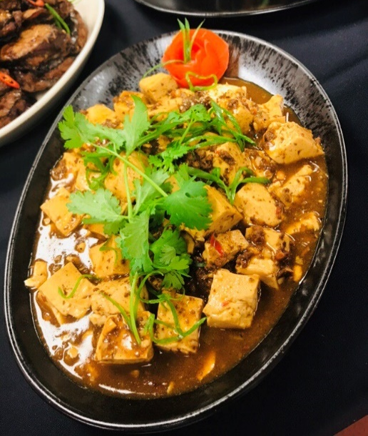

Ma-Puo Doufu

Dish: Dan Dan Mian Spicy Noodles
Cooking techniques:
- Boiling- the dan dan noodles should be boiled for 2.5 minutes, drain and run in cold water to stop the cooking process. The amount of boiling water should be enough to cover the noodles because it will expand when it is cooked
- Stir frying- the dried shrimp that has been soaked and drained, and preserved vegetables were stir fried in the wok with high heat and small amount of oil
Chef facts:
- Dan Dan Mian- noodle dish originating from Chinese Sichuan cuisine. It consist of spicy sauce usually containing preserved vegetables, chili oil, Sichuan pepper, minced pork, and scallions served over noodles
- Dried shrimp- shrimp that has been sun-dried and shrunk to a thumbnail size, they impart unique umami taste
- Sichuan preserved vegetables- also known as “Sichuan Preserved”; one of the most popular of large variety of pickle and preserved cabbages in China. A specialty of pickled in salt with hot chillies and garlic
- Dan Dan noodles-fresh noodle made from wheat flour that has been pulled
- Sesame seeds-one of the oldest oil seed known, domesticated well over 3000 years ago. Has one of the highest oil content of any seeds with a rich, nutty flavor, it is a common ingredient in cuisines across the world
- Sesame paste- roasted sesame seeds ground to thick aromatic paste
- Chile oil- condiment made from vegetable oil that has been infused with chile peppers
- Rice vinegar-Chinese rice vinegar are milder and less acidic than regular vinegar. Basic types includes black, red, white, and sweetened black vinegar
- Dark soy sauce- dark colored soy sauce used mainly for adding colour and flavour to dishes. It is richer, slightly thicker and less salty than other types of soy sauce
- Green onions- an immature onion with a white base and long green leaves. Both are edible.

Chef’s comment and recommendation:
Good presentation, perfect doneness of the noodles, very good sauce, and good broth

What I learned:
I learn how to determine the doneness of the noodles. At first it was undercook, but I placed it again in the boiling water for 30 seconds to cook it more then stop the cooking by running the noodles with cold water.
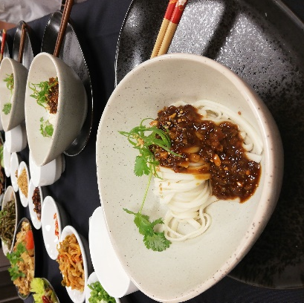

Dan Dan Mian Spicy Noodles
Spareribs

The Cuisine of Western China

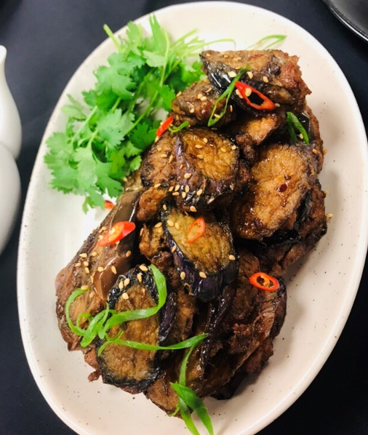
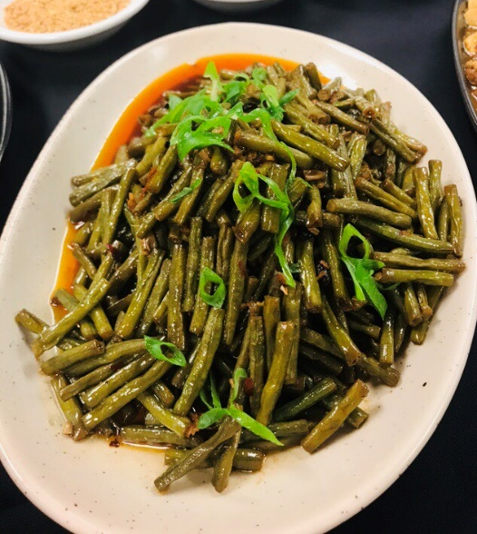

Sichuan Stuffed Eggplant

Stir fried Long beans

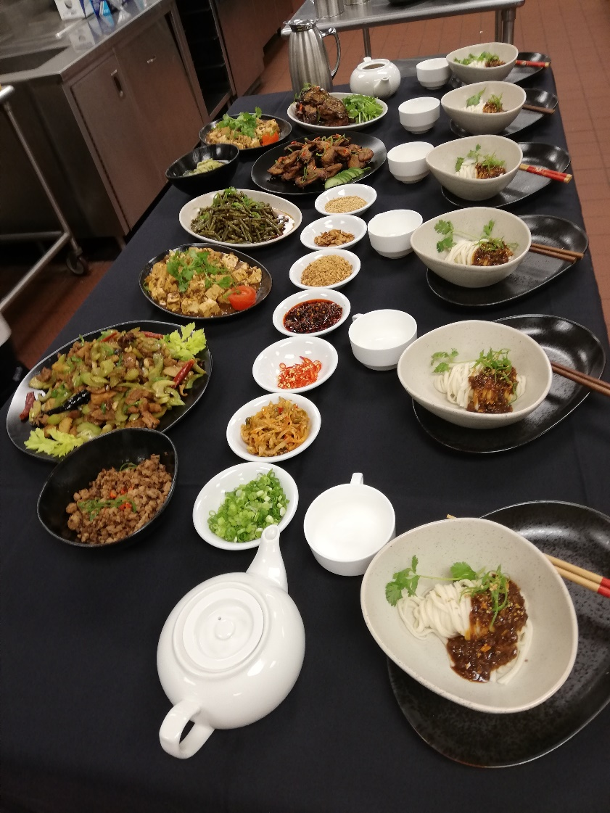
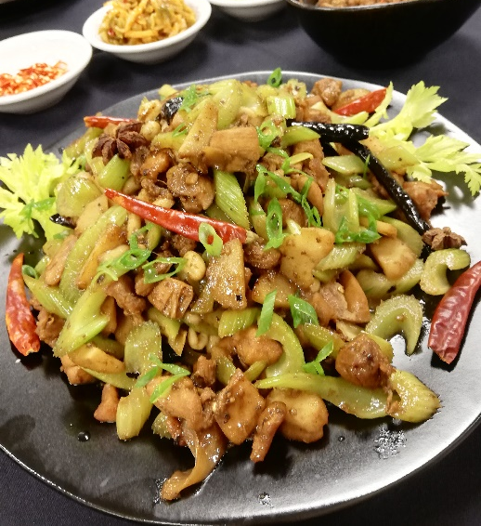

Kung Pao Chicken

SOUTHERN CHINA
Southern China is composed with 5 provinces namely Guangdong, Guangxi, Hainan, Hong Kong, and Macau. Guangdong (Canton) province is the home of the most famous of the Chinese regional cuisines. It is also one of the Eight Culinary Traditions of Chinese cuisine. Cantonese chefs are highly sought after throughout China. Also, Hunan cuisine which is known for hotter dishes than Szechuan is less known in the South. China’s climate favors them to grow rice which became their main staple, fresh fruits and vegetables, fresh seafoods, cows, pigs, are prepared fresh. Due to this, Cantonese cuisine uses fresh ingredients and emphasize natural flavors as their cuisine’s identity. They are also praised for their perfected tradition of presentation. Traditional dishes in this region includes orange beef, crispy duck, dim sum (ha gau, siu mai, pai gwat, chun guen, char siu pau, and cheung fun), shark’s fin soup, roasted suckling pig, barbecued pork or char siu, lo mien, and fu young.

Dish: Char Siu (Cantonese Roast Pork)
Cooking techniques:
- Marinating- the pork is marinated in dry sherry, garlic cloves, light soy sauce, sesame paste, brown bean paste, hoisin sauce, salt, five spice powder, granulated sugar and dash of red food coloring. The meat was marinated for about 1 hour at room temperature
- Roasting- it is a type of dry heat cooking technique which the pork was placed in the oven at 375F then turned high at 450F to caramelized the high-sugar content ingredient in the marinade
Chef facts:
- Mirin wine- sweet, slightly tangy rice wine; Japanese sweet rice wine that lends mild acidity to a dish
- Sesame oil- amber-colored aromatic oil made from pressed and toasted sesame seeds. Not for use as a cooking. It has an intense flavor and very low smoke point
- Dry sherry- a wine fortified with brandy
- Light soy sauce- a more common type of soy sauce in Chinese cooking. It is thinner and often used as a light seasoning or for dipping sauces
- Sesame paste- frequently used in Chinese cuisine. It is a thick paste made from roasted white sesame seeds, sharing a similar texture with peanut paste
- Brown bean paste- also known as “sweet bean paste”. It is the main dipping sauce for famous Beijing roasted duck. Made from soybeans and flour with a special fermentation process. Sweet taste come from the fermentation process
- Hoisin sauce- a reddish brown paste made from soybeans, garlic, and Chinese spices. It can also be used in dips for hot pot or marinating meat
- Five spice powder- a common ingredient in Chinese cooking. Equal mixture or parts of cinnamon, cloves, fennel seed, star anise, and Szechuan peppercorns

Chef’s comment and recommendation:
The color of the meat should be red all the way through, but good flavors though. A little bit dry too

What I learned:
I learn that when roasting meats, basting is really important so that the meat will maintain the moisture and would not dry out after it has been cooked. The process of cooking this meat starts at lower temperature too at 375F then finish at 450F, which is different from roasting meats in other cuisines that they start at high heat at 450F then finish in lower heat at 375F.

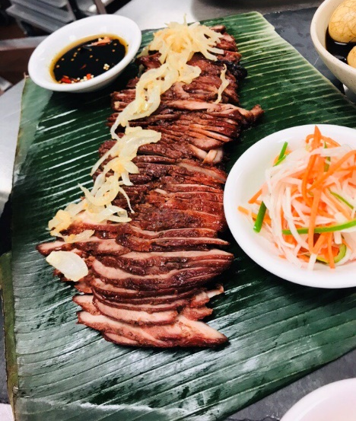

Char Siu served with pickled vegetables

Dish: Char Siu Bau (Steamed Pork Buns)
Cooking techniques:
- Steaming- it is a type of moist heat cooking method where the buns are cooked in the steam. The bottom of the wok was filled with a little bit of water and the bamboo baskets were placed in the wok making sure that the bottom of the basket is not toughing the water level. The heat was on medium to prevent the bun from drying out
Chef facts:
- Char siu- a popular way to flavor and prepare barbequed pork in Cantonese cuisine. It is classified as a type of siu mei, a Cantonese roasted meat
- Oyster sauce- has a sweet and salty taste with some smoky feeling made from oyster extracts, sugar, water, soy sauce, and wheat flour
- Peanut oil- known as ground nut oil or arachis oil, a mild tasting vegetable oil derived from peanuts. It has a strong peanut flavor and aroma
- Sesame oil- amber-colored aromatic oil made from pressed and toasted sesame seeds. Not for use as a cooking. It has an intense flavor and very low smoke point
- Active dry yeast- needs to be dissolved in water before using
- All purpose flour- general use white flour
- Lard- fat from pigs
- Shortening- any fat that is solid at room temperature and used to make crumbly pastry and other food products
- Extra fine granulated sugar- granulated sugar with finer texture
- Dark soy sauce- dark colored soy sauce mainly for adding color and flavor to dishes

Chef’s comment and recommendation:
The buns sticked to the bamboo baskets. The basket should be brush with oil first before placing the buns or placed a banana leaf on it. The buns turn out good and not dried out, but it is doughy, chewy, but flavourful

What I learned:
This dish needs a lot of time for the dough to rest twice unlike other doughs that needs just one resting time. This dish, I learn the muffin method of mixing by combing the dry and wet in separate bowl first then making a well in the center of the dry ingredients and the wet ingredients were placed inside the well then mixing them altogether. What makes this dish unique too is that the baking powder was added lastly after the first resting period. In this bun, we tried making a different shape and placing the stuffing on the sides, which is a more modern way of plate presentation called deconstructed presentation. I learn the different way of presenting these dish on the table.

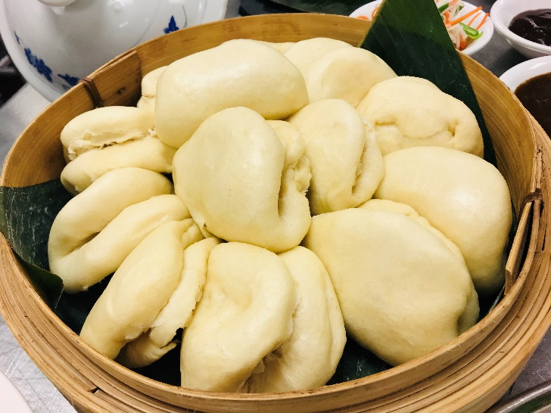

Char Siu Bau (Steamed Pork Buns)

Dish: Stir-fried Squid with Fermented Black Bean Paste
Cooking techniques:
- Stir-frying- the squid and the vegetables were stir fried separately to maintain the right temperature in the wok. Overcrowding the wok will lower the temperature and will lost the smoky flavor of the dish that develops in the wok over high heat and small amount of oil
Chef facts:
- Ginger-the roots of a ginger plant is valued for its clean, sharp flavor, and use to cover up strong fishy odors
- Fermented Black bean paste- a flavoring most popular in the cuisine of China, where they are most widely used for making black bean sauce dishes
- Shaoxing- one of the most famous varieties of Huangjiu, or traditional Chinese wines fermented from rice
- Dry Sherry- a fortified wine with sweet taste and higher alcohol content
- Sesame oil- amber-colored aromatic oil made from pressed and toasted sesame seeds. Not for use as a cooking. It has an intense flavor and very low smoke point
- Tapioca powder- very fine white powder that works well in gluten-free baking. Made from starch extracted from cassava plant, and also use as a thickener
- Cornstarch- starch derived from corn grain. A common food ingredient, used in thickening sauces or soups and in making corn syrup, and other sugars
- Light Soy sauce- a more common type of soy sauce in Chinese cooking. It is thinner and often used as a light seasoning or for dipping sauces
Chef’s comment and recommendation:
Squid is good, flavor is good

What I learned:
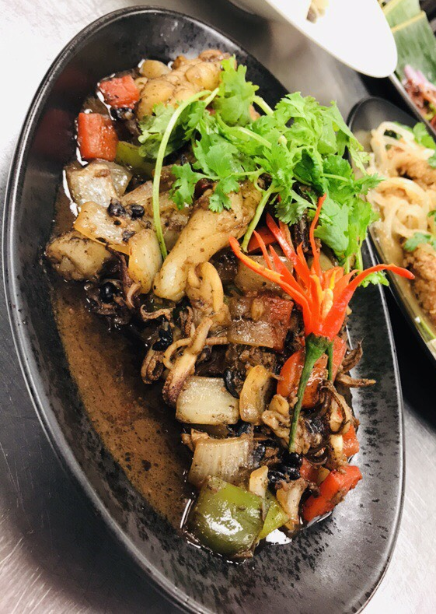
I learn the proper way of scoring the squid and the reason behind the “criss-cross” lines we made when scoring, this absorbs and soaks up the flavor from the sauce.

Stir-fried Squid with Fermented Black Bean Paste Spareribs

The Cuisine of Southern China

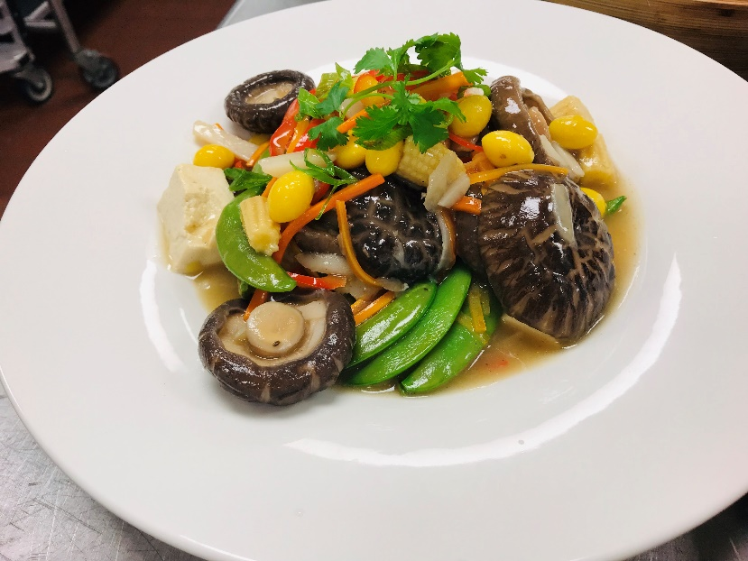
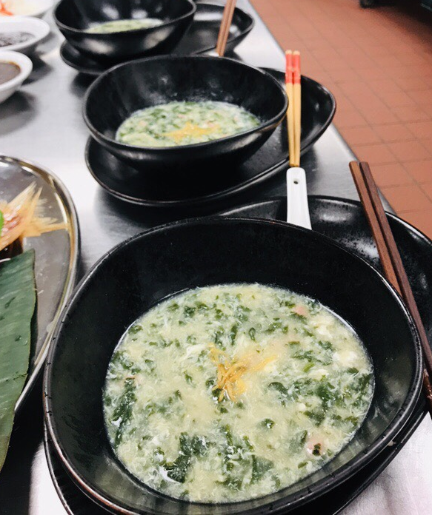

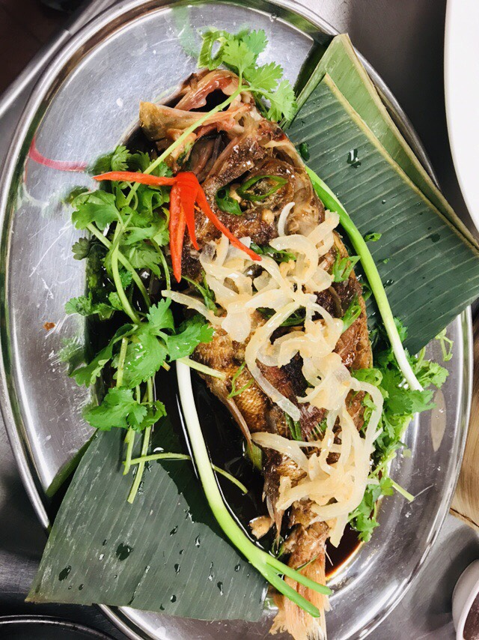
Buddha’s Delight

Spinach Velvet Soup

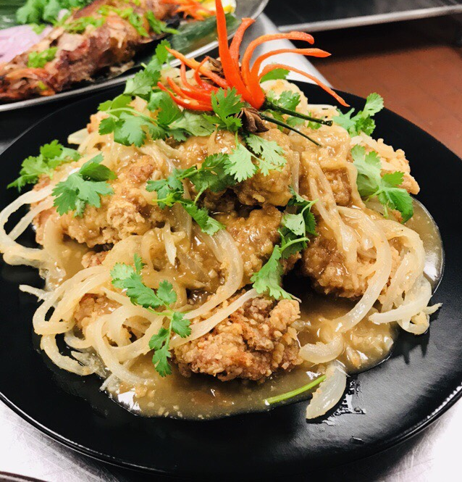

Steamed Whole Fish

Fried Chicken Hong Kong Style

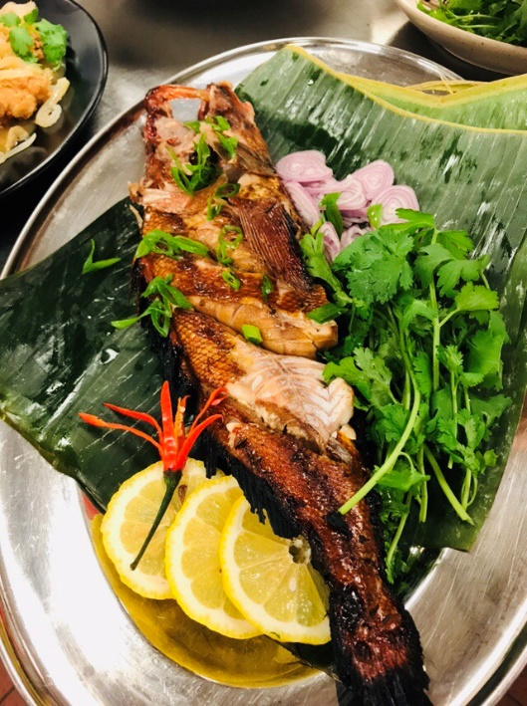
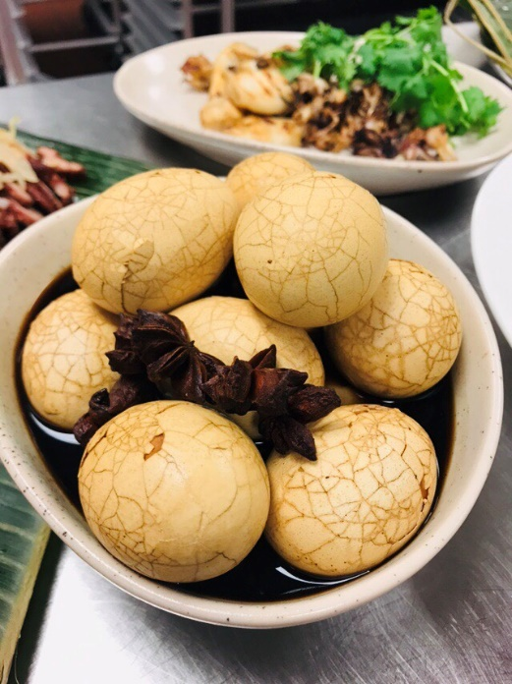
Tea Eggs

Grilled Whole Fish

