Name: The Dat Pham – 1810239
Teacher: Mandy Vial
Class: Intro to Pastry – CUL122
After 10 weeks in this course, here is all the results that I am keeping pictures from.
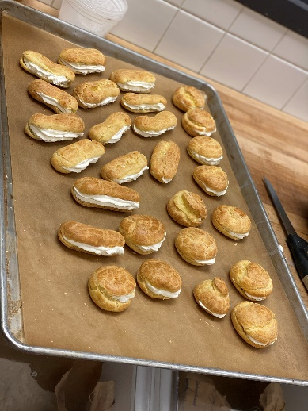
- Choux with Chantilly Cream filling
- Meringue is Choux kind of paste.
- Baked at 400°F for 15 minutes, then 350°F till dry and lightly brown in the bottom.
- Risk of collapse if not baked enough.
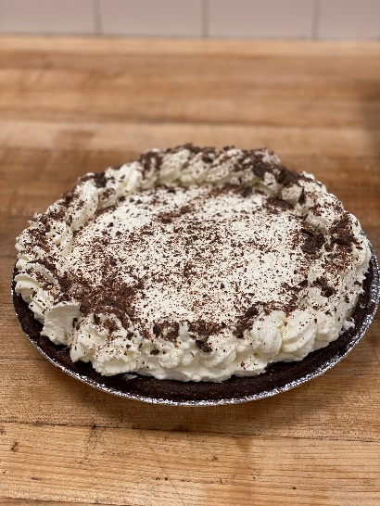
- Peanut Butter Pie
- Method: Cream filling
- Tart: Chocolate.

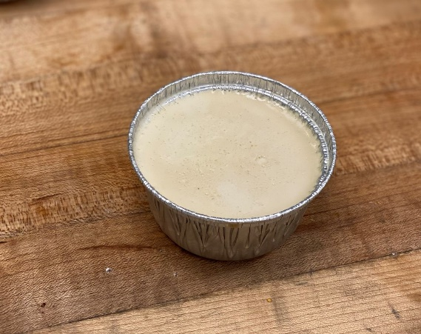
- Panna Cotta
- Method: Cream Custard.

- Toffee Caramel Flan
- Method: Baked Custard.
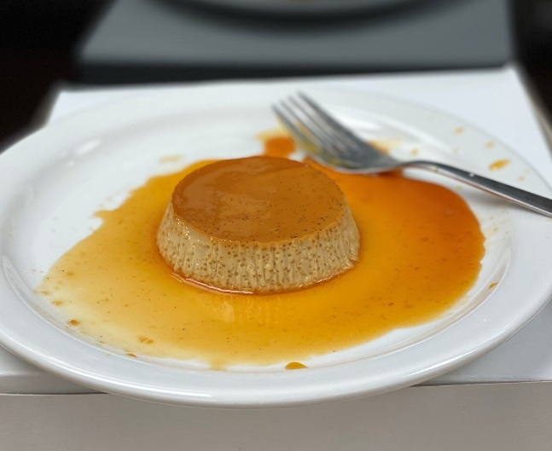

- Choux – Paris Brest
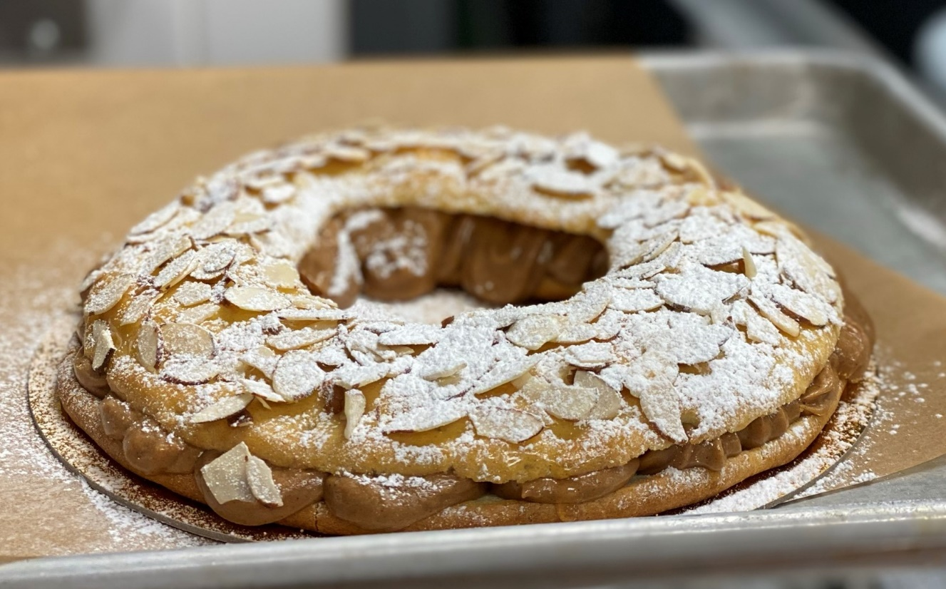

- Lemon Sabayon
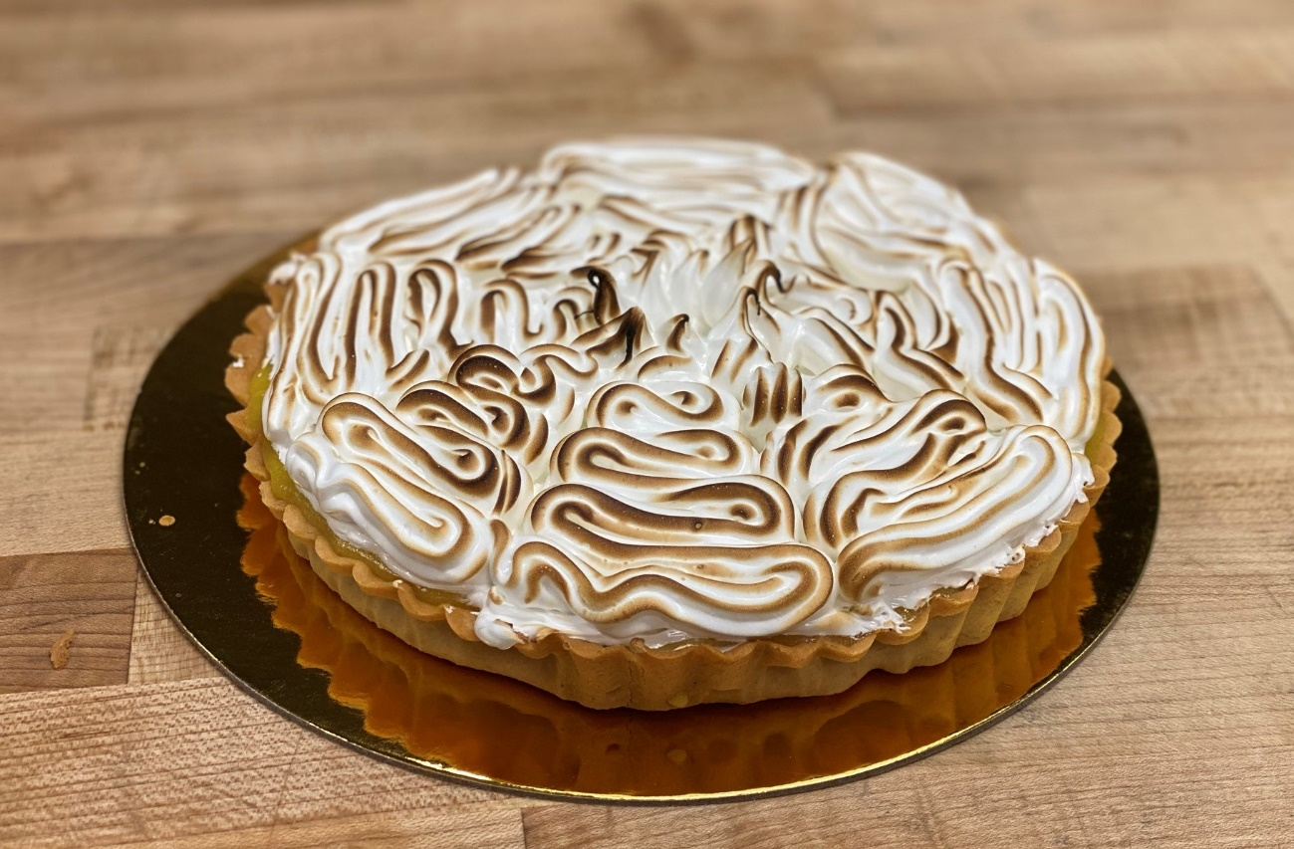

- Chocolate cake
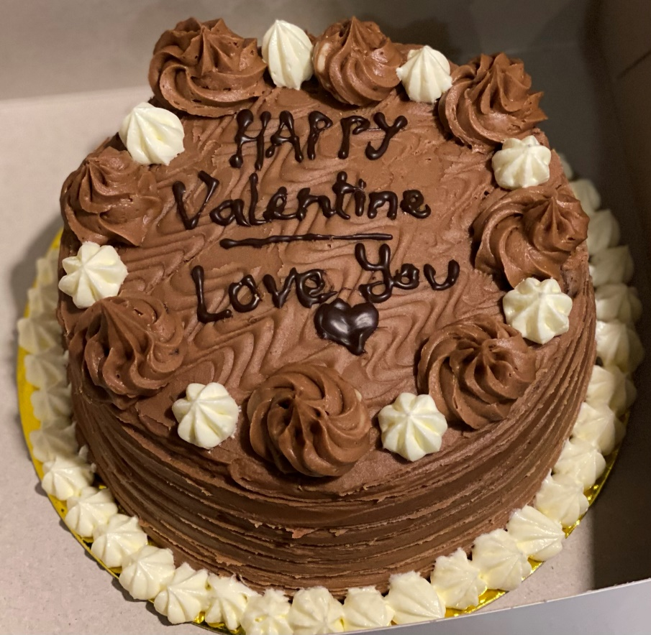
- Chocolate Italian Buttercream.
- Chocolate Genoise.

- Italian Buttercream Cake
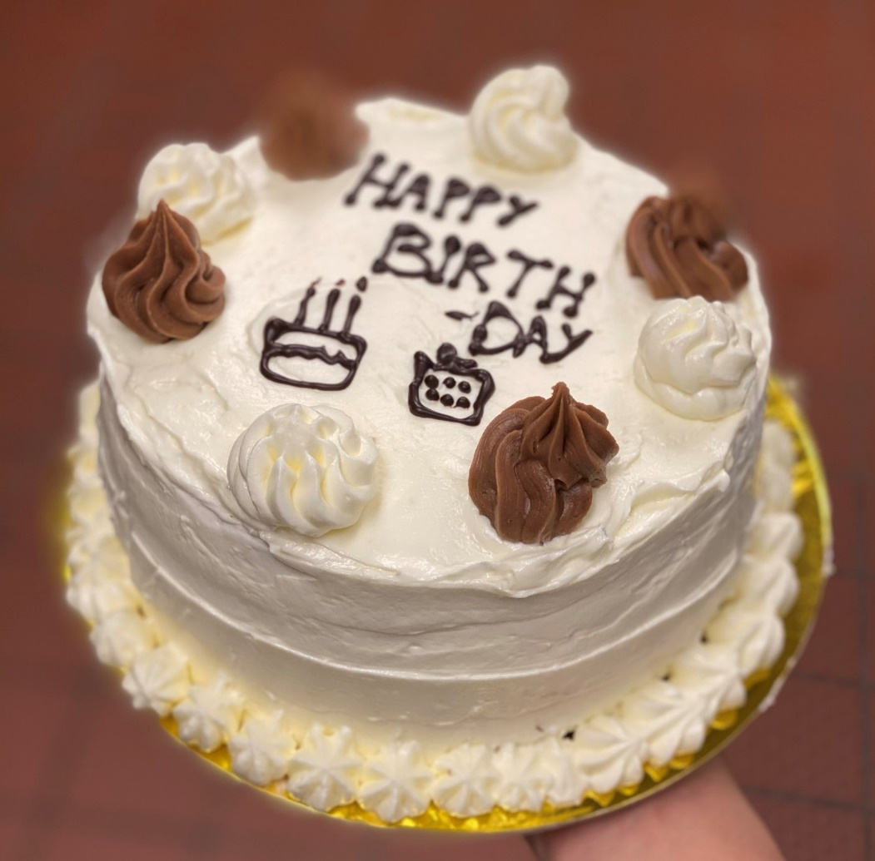

- Danish
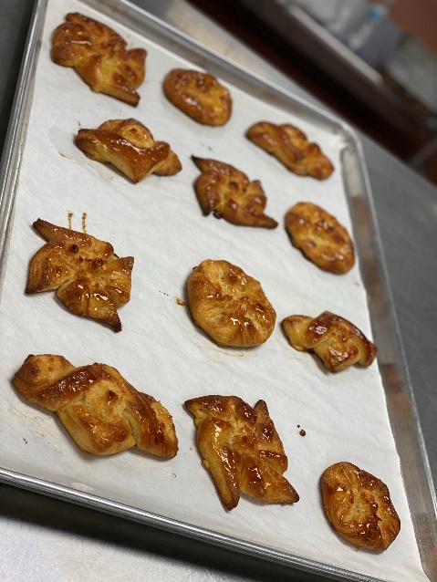
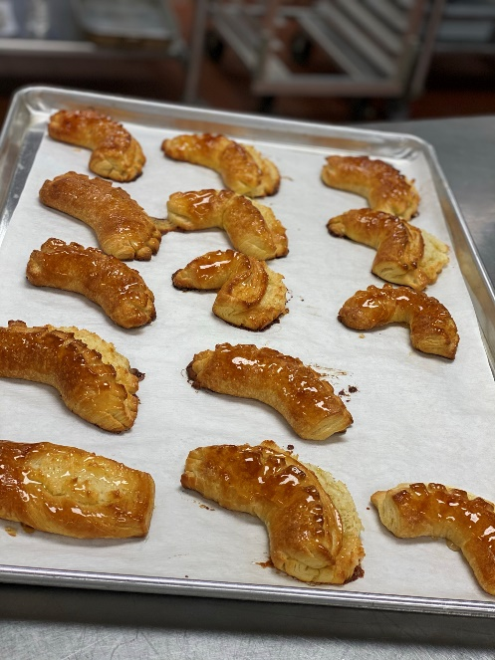

- Croissant
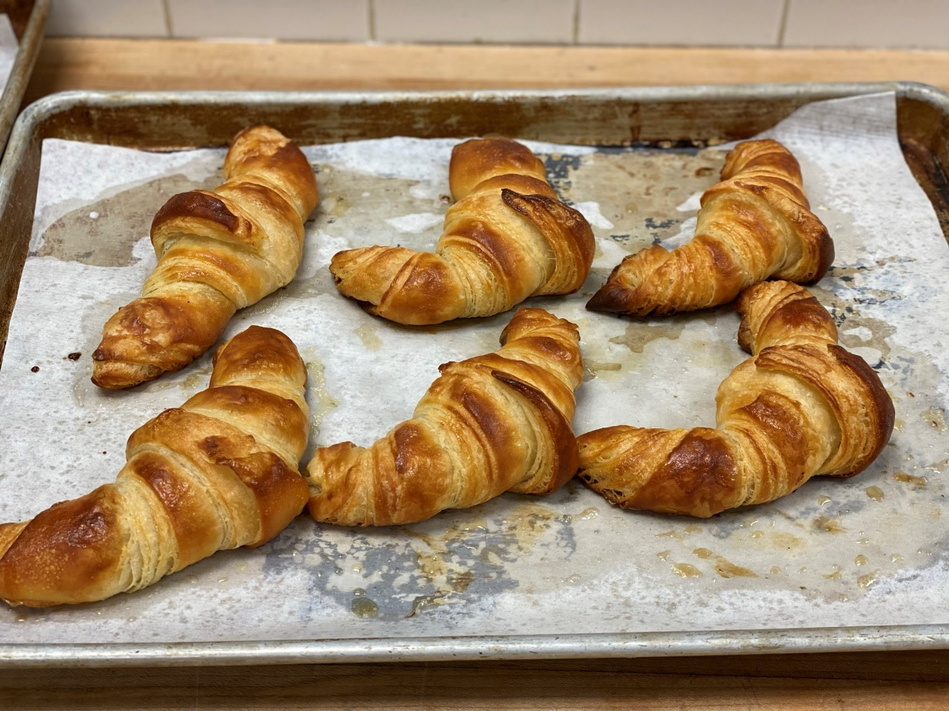

- New York Cheesecake
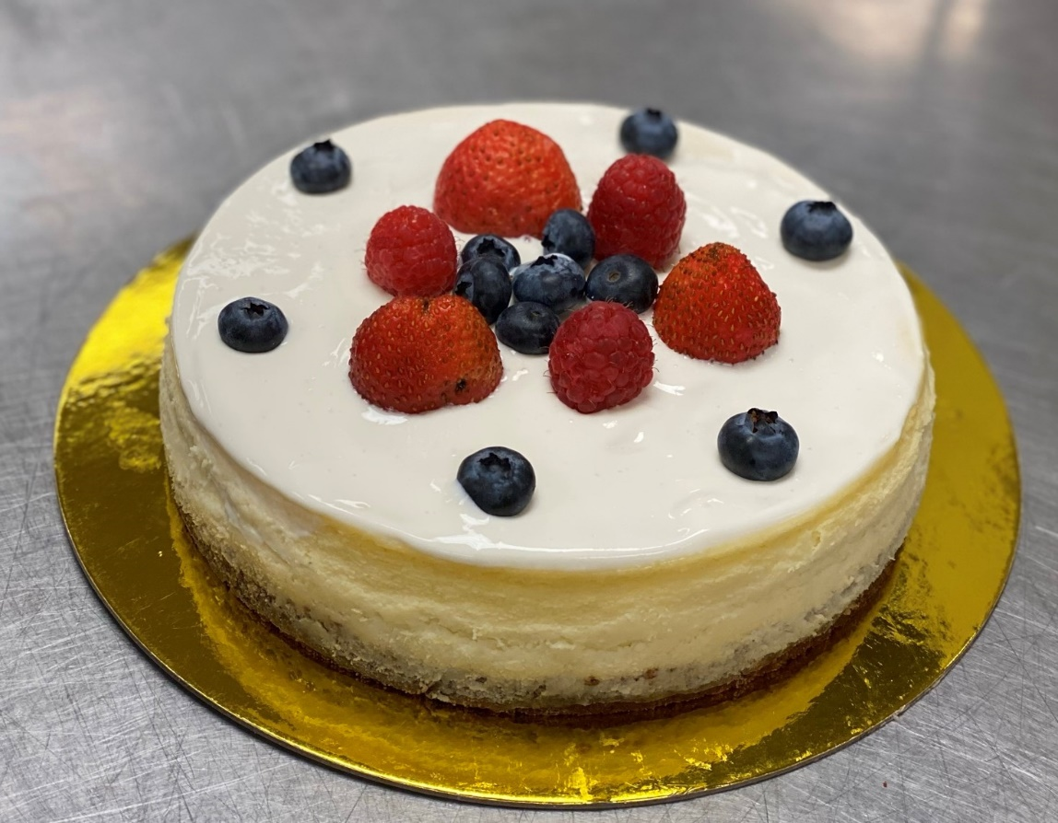
- Raspberry Mousse Cake
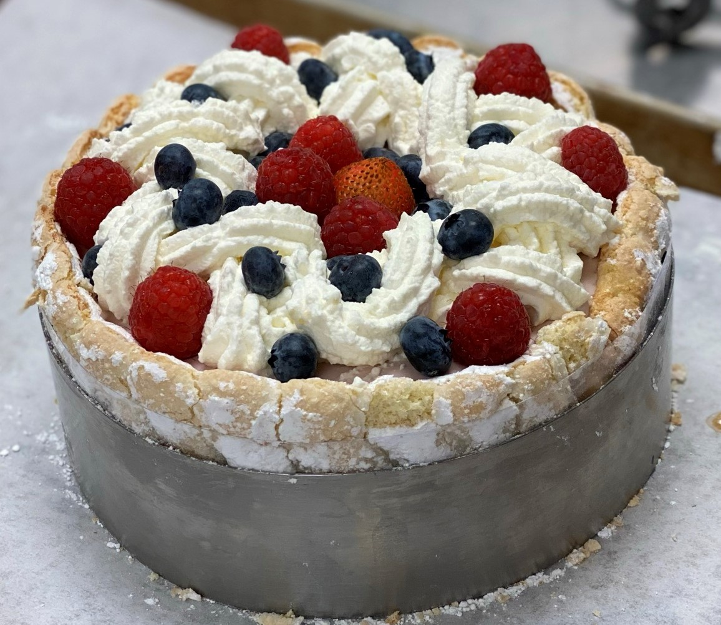

- Tuxedo
Inside was two layers of White Genoise and one layer of Chocolate Genoise in between.
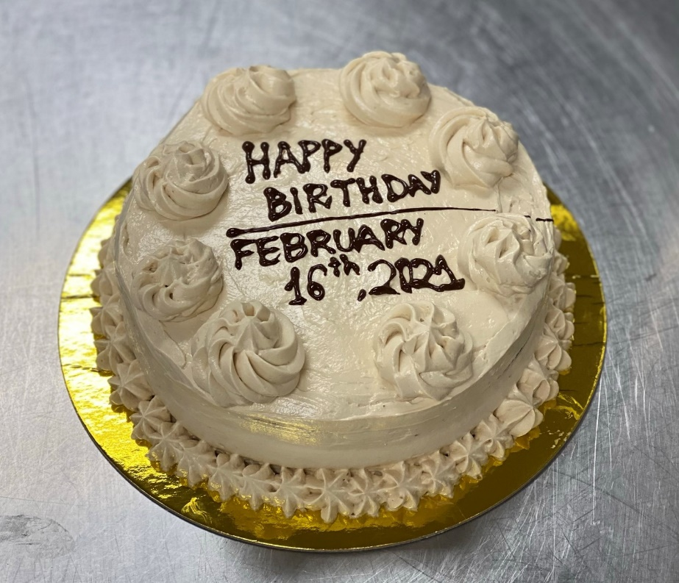

- Black forest
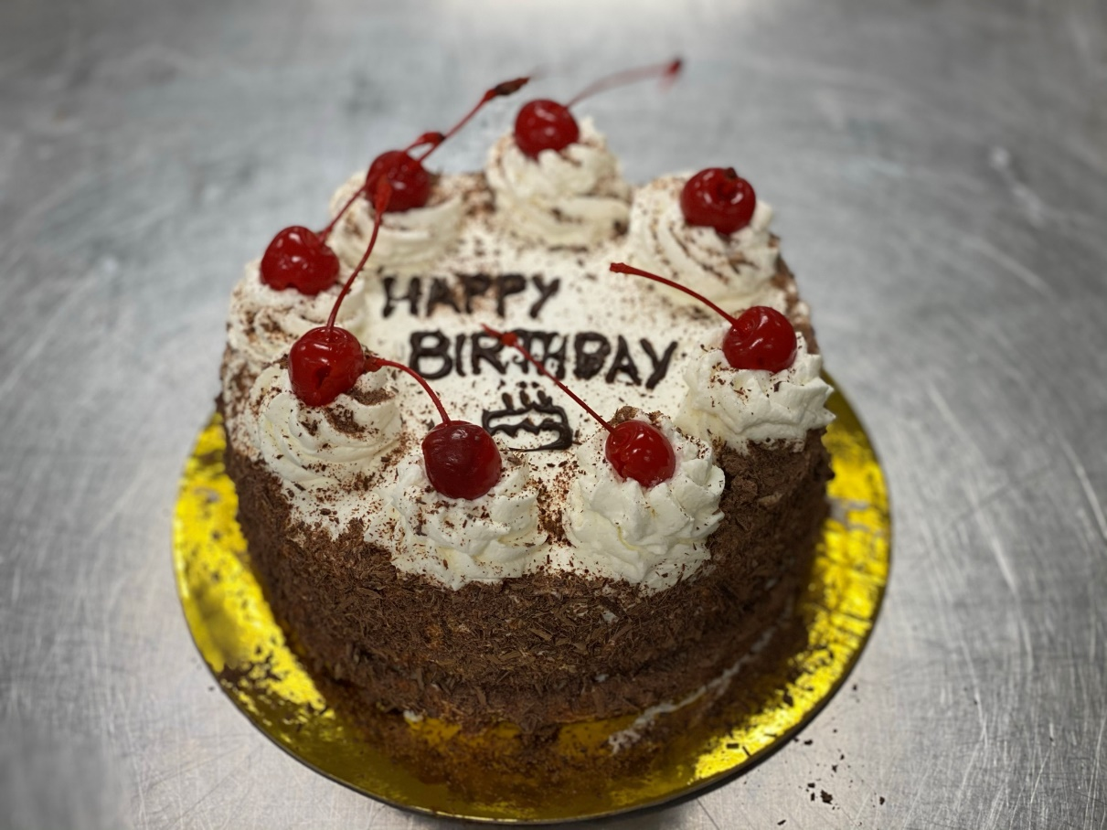

- Chocolate Mousse Cake
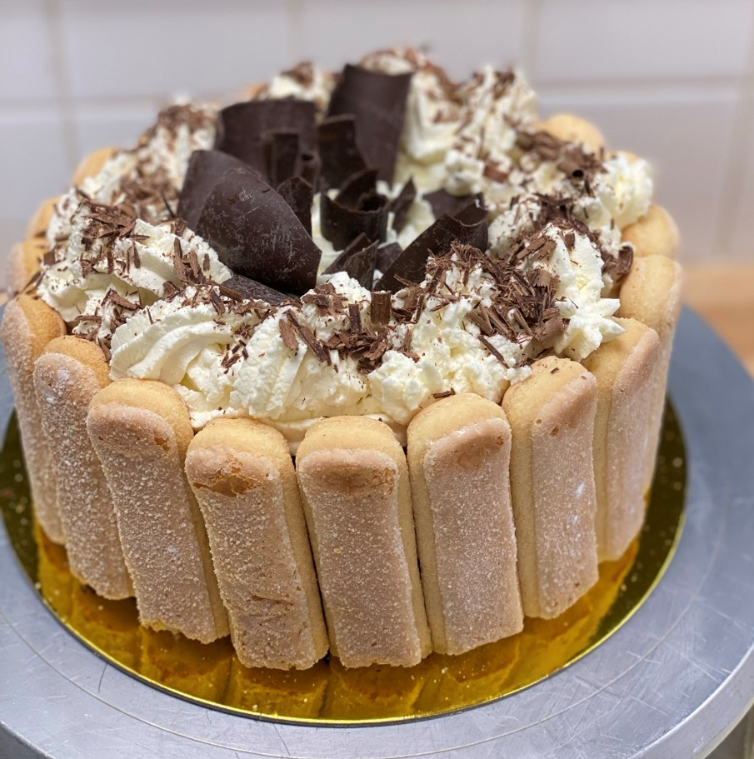
- Perfect Chocolate Cake with Ice cream and Coconut Caramel sauce and Fruit Coulis
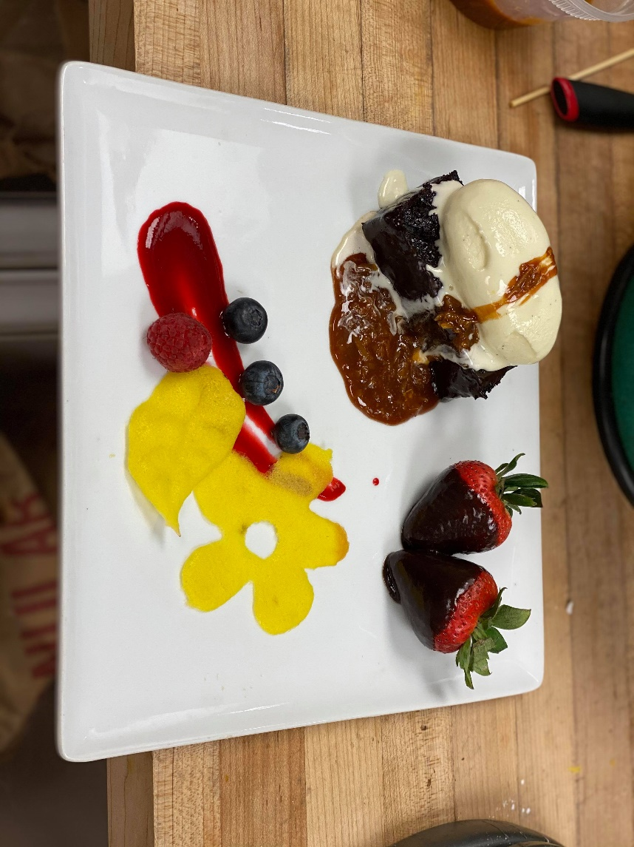

- Mini Ganache with Mango Sorbet
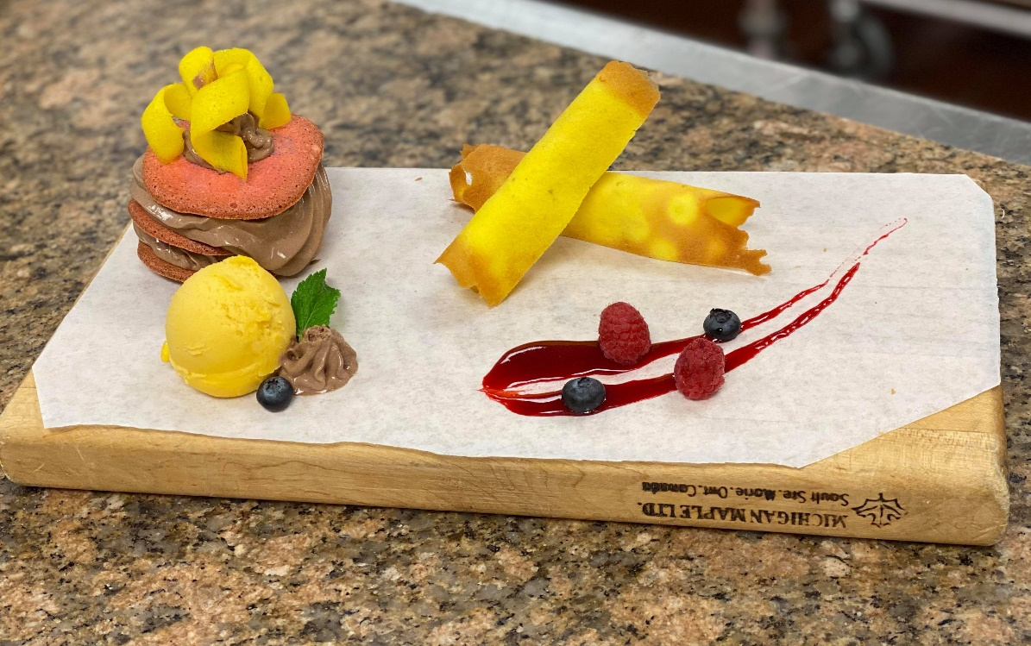

I been through and got a lot of knowledge and experiences from this class which sure will help me so much in the future with my cooking career also with my life.

