Week 7
- Multigrain sourdough
- Pound cake
- Cranberry Orange scone
- Morning glory muffins
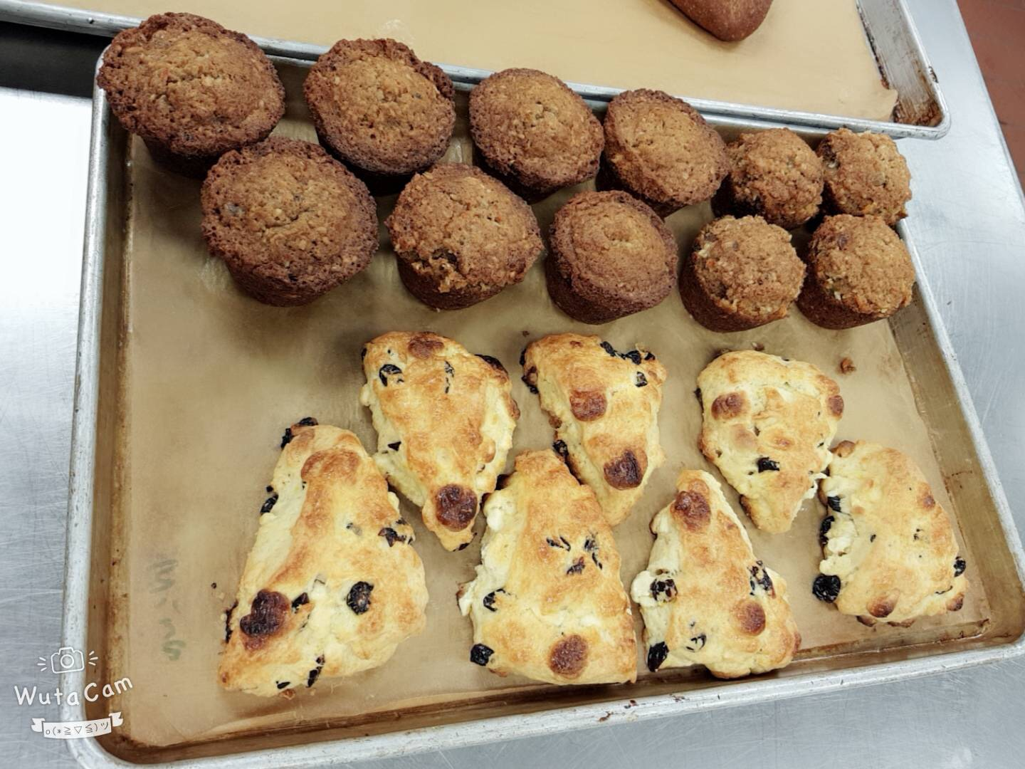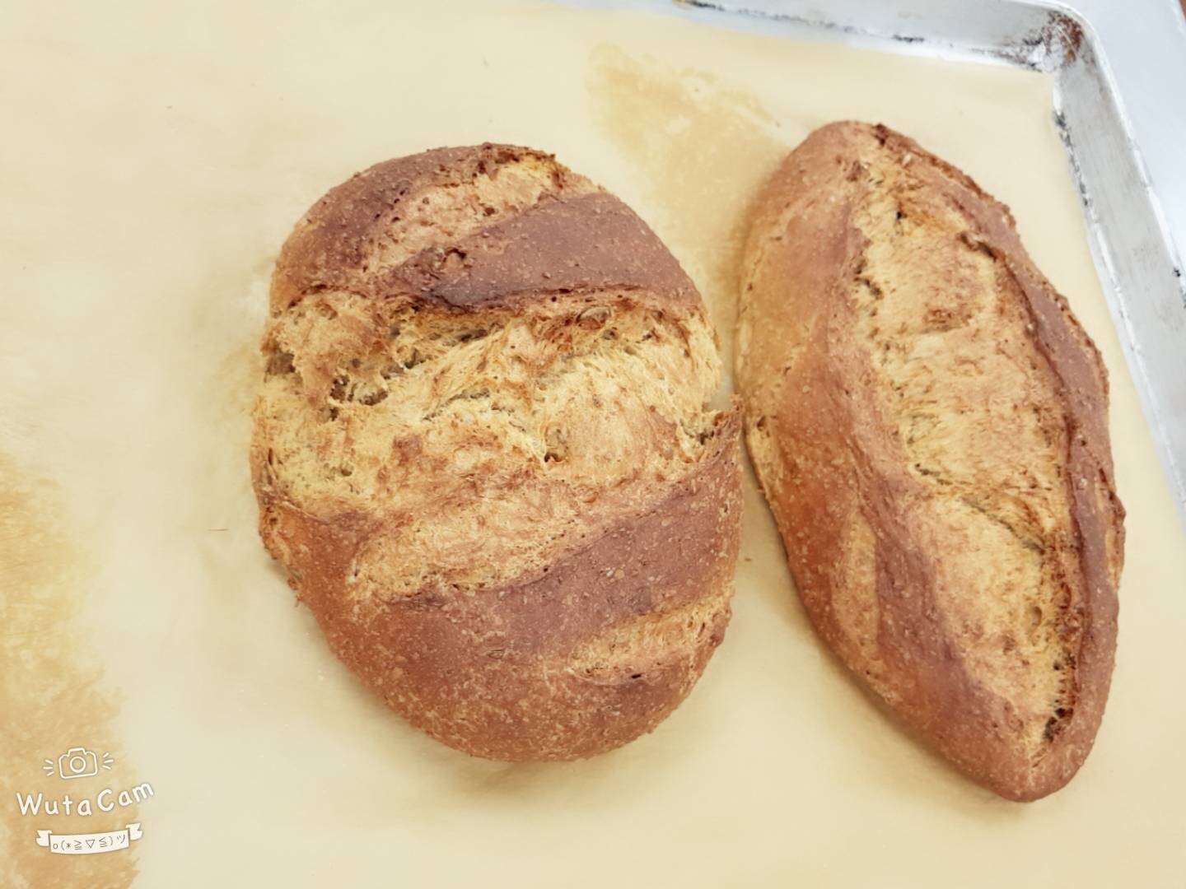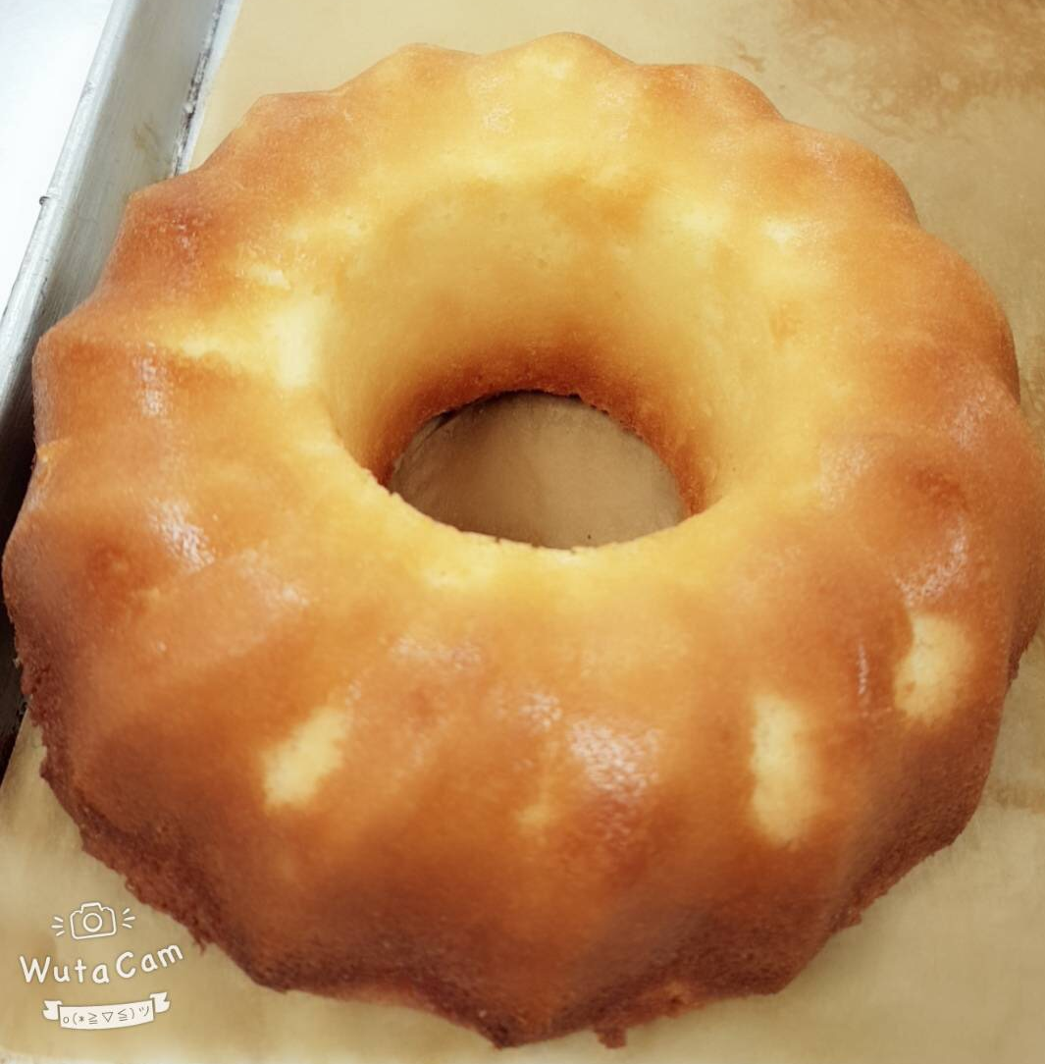

Method: Sourdough & scones
- Sourdough Bread. Making a starter, keeping it alive, and developing rich sourdough flavor. Outcome: everything was done on time.

Time line | 12:30-13:00 | 13:00-13:15 | 13:15-13:30 | 13:30-14:30 | 14:30-15:00 | 15:00-15:30 | 15:30-16:00 | 16:00-16:30 | 16:3-17:00
Multigrain sourdough | Mise en place | Chef demo | Make the dough | Dough take rest until doubled | Divide the dough  Ferment again until doubled | Make the sheap Proof the dough until doubled |  | Bake until golden browned, | Done
Cranberry Orange scone | Mise en place |  |  | Chef demo | Make the dough mix just until dough comes together | Roll into a ½” thick circle and cut 8 wedges.  Egg wash | Bake at 400°F for about 15 – 20 minutes | Done
Morning glory muffins | Mise en place |  |  |  | Chef demo | Mix the dry ingredients with egg-mixture just combine | Portion greased muffin tins | Bake at 350°F for about 15 – 20 minutes | Done
Pound cake | Mise en place |  |  |  |  | Chef demo | Make the batter.  Fold in the dry ingredients alternately with the buttermilk in three additions each | Bake until the centers of the cakes bounce back when lightly pressed, approximately 45 to 55 minutes. | Done

Temperature chart
Multigrain sourdough | 375°F (190°C)
Cranberry Orange scone | 400°F (200°C)
Morning glory muffins | 350°F (180°C)
Pound cake | 400°F (200°C)

Reflections
Everything was well done on time!!
- Multigrain sourdough: it was a little bit over proof, however nice baked.
- Pound cake: the color was great and baked well!
- Cranberry Orange scone: it proof well and nice baked.
- Morning glory muffins: it was not proof well, might because we did not whisk the eggs enough, so we should careful the part next time!
- Recipes

Pound cake [On Baking 3e]Scaled
By: azriel.paz
Adapted from: On Baking 3/e | Chapter 13 (pp 436)
Yield | Serving Size | # of Servings
 | 1/12 loaf
  
  
View Ingredients By
American Metric
Ingredients
flour, cake | 396.9 g | 100%
baking powder | 7 g | 1.8%
butter, unsalted (room temperature) | 283.5 g | 71%
sugar, granulated | 434.7 g | 110%
corn syrup, light (or use additional granulated sugar) | 18.9 g | 4.8%
salt | 7 g | 1.8%
eggs (room temperature) | 302.4 g | 76%
vanilla extract | 4.92 mL
almond extract (optional) | 4.92 mL
Lemon Zest | 0.76 g
Orange Zest | 0.76 g
buttermilk (room temperature) | 157.7 mL
Directions
MISE EN PLACE
► Allow the butter, eggs and buttermilk to come to room temperature.
► Zest the lemon and orange.
► Grease pans.
► Preheat oven to 400°F (200°C).
❶ Sift the flour and baking powder together. Set aside.
❷ Cream the butter until light and lump-free. Add the sugar, corn syrup and salt. Cream on medium speed until light and fluffy. Add the eggs a few at a time, allowing them to be completely incorporated before adding more eggs. Scrape down the bowl after each addition.
❸ Add the vanilla and almond extract (if using) and the lemon and orange zest.
❹ Fold in the dry ingredients alternately with the buttermilk in three additions each.
❺ Divide the batter evenly into three 9-inch × 5-inch (22-centimeter × 12-centimeter) greased loaf pans. Bake at 400°F (200°C) for 15 minutes, then reduce the oven temperature to 350°F (180°C). Bake until the centers of the cakes bounce back when lightly pressed, approximately 45 to 55 minutes. If the cakes begin to darken, cover them loosely with aluminum foil.
❻ Cool the cakes in their pans on a wire rack for 10 minutes. Unmold and cool completely.

Multigrain Sourdough Bread [On Baking 3e]
Source: On Baking 3/e | Chapter 7 (pp 214)
Yield | Serving Size | # of Servings
 | 1/16 loaf
  
View Ingredients By
American Metric
Ingredients
cracked wheat | 127.58 g | 23%
water (warm) | 236.56 mL | 40%
butter (melted) | 56.7 g | 10%
molasses | 42.53 g | 7.5%
honey | 42.53 g | 7.5%
salt | 5.67 g (5.03 mL) | 1%
milk, nonfat dry | 56.7 g | 10%
flax seeds | 56.7 g | 10%
sunflower seeds (roasted) | 56.7 g | 10%
Simple Sourdough Starter [On Baking 3e] | 623.7 g
yeast, dry active | 4.25 g (5.03 mL) | 0.75%
flour, whole wheat | 283.5 g | 50%
flour, bread | 283.5 g | 50%
Egg Wash | as needed
Directions
❶ Combine the cracked wheat and hot water in the bowl of an electric mixer. Add the butter, molasses, honey, salt and milk powder. Set aside to cool.
❷ When the mixture has cooled to lukewarm, stir in the flax seeds, sunflower seeds, starter and yeast. Stir in the whole-wheat flour, then gradually add the bread flour. When the dough begins to stiffen, attach the bowl to a 6 quart (6.5 liter) or larger mixer fitted with a dough hook and continue adding the bread flour. Knead until the dough is smooth and elastic, approximately 5 minutes.
❸ Place the dough in a lightly oiled bowl, cover and ferment until doubled.
❹ Punch down the risen dough, cover and ferment again.
❺ After the second rise, punch down the dough and divide into two equal portions. Place the dough into two well-greased loaf pans, cover and proof the dough until doubled again.
❻ Brush the surface of each loaf with egg wash and make two or three cuts across the top of each loaf. Bake at 375°F (190°C) until done, approximately 30 minutes.

Cranberry White Chocolate Orange Scones (Yield: 8 scones)

Ingredients:

200 g All Purpose Flour
25 g Sugar
1 g Salt
10 g Baking Powder

80 g Cold unsalted Butter

5 g Orange Zest
50 g Dried Cranberries

30 g Eggs
45 g Milk
45 g Cream
150 g White Cho chips
Method: Biscuit

- Sift together dry ingredients.
- Add cold, cubed butter and blend to pea-sized pieces.
- Add dried cranberries and orange zest.
- Combine eggs, milk and cream and add to dry ingredients.
- Mix until dough just comes together.
- Add Cho chips
- Roll or part into a ½“ thick circle and cut 8 wedges.
- Bake at 400°F for 15-20 minutes or until golden and puffed.

Morning Glory Muffins

Ingredients:

200 g All Purpose Flour
40gr whole wheat flour
170 g Granulated Sugar
100gr Brown Sugar
10 g Baking Soda
Pinch Salt
2 g Cinnamon, ground
210 g Carrots, grated
90 g Raisins
60 g Pecan pieces
60 g Coconut, shredded
90 g Apple, grated
150 g Eggs
160 g Canola Oil
10 ml Vanilla Extract

Method: muffin

- Sift the dry ingredients together and set aside.
- Combine the carrots, raisins, pecans, coconut and apple. Mix in with the dry ingredients until each piece is coated with flour evenly.
- Whisk together the eggs, oil and vanilla. Add to the dry ingredients.
- Mix batter until just combined.
- Portion into greased muffin tins and bake at 350°F until done.

Week 8
- Soft Dinner Rolls
- Butter Cookies
- Cinnamon Buns
- Sour Cream Coffee Cake
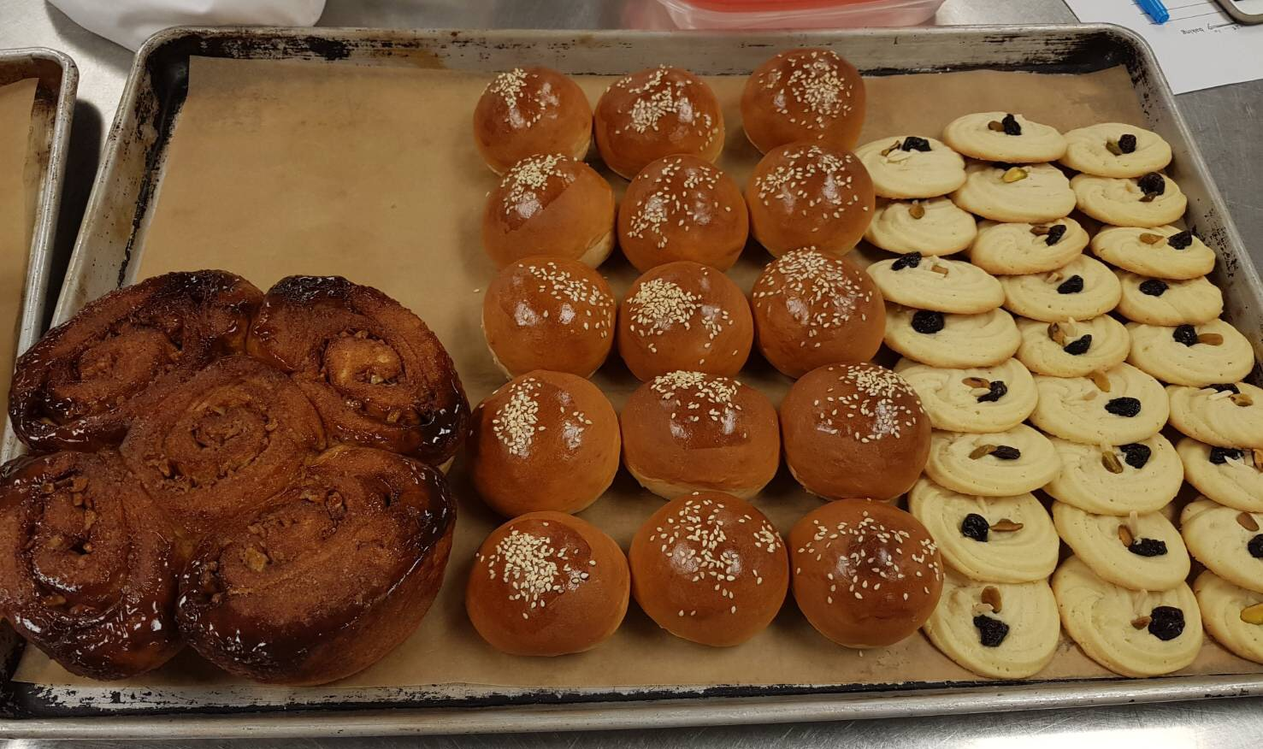
Method: Enriched straight dough, creaming, and yeast dough.
Outcome: everything was done on time, only the coffee cake was not done.
Time line | 12:30-13:00 | 13:00-13:15 | 13:15-13:30 | 13:30-14:30 | 14:30-15:00 | 15:00-15:30 | 15:30-16:00 | 16:00-16:30 | 16:3-17:00
Soft Dinner Rolls | Mise en place | Chef demo | Make the dough | Dough take rest until doubled |  | Divide Proof the dough until doubled |  | Egg wash and sesame seed Bake until golden browned | Done
Cinnamon Buns | Mise en place |  | Chef demo | Make Caramel Glaze | Make the dough and take rest until doubled | Filling the cinnamon sugar and pecan the roll it cut into 6 rolls. | Proof the dough until doubled | Bake at 375°F for about 25 minutes | Done
Butter Cookies | Mise en place |  |  |  | Chef demo | Cream butter and sugar make the batter | Piping and  Place a pistachio, dried cherry and almond on each cookie | Bake at 350°F for about 10 minutes | Done
Sour Cream Coffee Cake | Mise en place |  |  |  | Chef demo | Make the filling | Make the cake batter and fill the filling in the middle and the top of the batter. | Bake at 350°F for approximately 55 minutes. | Done

Temperature chart
Soft Dinner Rolls | 400°F (200°C)
Butter Cookies | 350°F (180°C)
Cinnamon Buns | 375°F (190°C)
Sour Cream Coffee Cake | 350°F (180°C)

Reflections
- Soft Dinner Rolls: we did before so it was have any problem, nice baked!
- Butter Cookies: the cookies baked well and got the light golden color.
- Cinnamon Buns: the glaze was fit on the top, the dough size was a little bit big but was fine.
- Sour Cream Coffee Cake: it was not scales right, so the cake could not bake well. Chef said it might be the baking powder or soda too much.

- Recipes

Soft Yeast Dinner Rolls
Source:
On Baking 3/e | Chapter 7 (pp 190)

Yield | Serving Size | # of Servings
 | 50 g
  
  
Yield: 850.5 g | Serving Size: 35.44 g | # of Servings: 24
View Ingredients By
American Metric
Ingredients
yeast, dry active | 20.25 g | 4.55%
water (temperature controlled) | 243 g | 55%
flour, bread | 445.5 g | 100%
salt | 10.13 g | 2.3%
sugar, granulated | 40.5 g | 9.1%
milk, nonfat dry | 20.25 g | 4.55%
shortening, vegetable | 20.25 g | 4.55%
butter, unsalted (softened) | 20.25 g | 4.55%
eggs | 32.4 g (3/4 ea) | 7.3%
Egg Wash | as needed
Directions
MISE EN PLACE
► Adjust water temperature.
► Soften butter.
► Prepare the egg wash.
► Line sheet pans with parchment while the dough ferments.
❶ Dissolve the yeast in the water in a bowl. Combine the flour, salt, sugar, milk powder, shortening, butter and eggs in the bowl of a mixer fitted with a dough hook.
❷ Add the water-and-yeast mixture to the mixer bowl; stir to combine.
❸ Knead on medium speed 10 minutes or until the dough reaches 77°F (25°C).
❹ Transfer the dough to a lightly greased bowl, cover and place in a warm spot. Ferment until doubled, approximately 1 hour.
❺ Punch down the dough. Let it rest a few minutes to allow the gluten to relax.
❻ Divide the dough into 1 1/4-ounce (38-gram) portions and round. Shape as desired and arrange on paper-lined sheet pans. Proof until doubled in size.
❼ Carefully brush the proofed rolls with egg wash. Bake at 400°F (200°C) until medium brown, approximately 12 to 15 minutes.

Sour Cream Coffeecake [On Baking 3e]Scaled
By: azriel.paz
Adapted from: On Baking 3/e | Chapter 6 (pp 165)
Yield | Serving Size | # of Servings
 | 1/16 ea
  
  
View Ingredients By
American Metric
Ingredients
Filling
flour, all purpose | 11.34 g | 5.4%
cinnamon, ground | 5.67 g | 2.7%
sugar, light brown | 170.1 g | 81%
pecan halves (chopped) | 113.4 g | 54%
butter, unsalted (melted) | 28.35 g | 14%
Cake
butter, unsalted | 113.4 g | 54%
sugar, granulated | 226.8 g | 108%
eggs | 93.56 g | 45%
cream, sour | 226.8 g | 108%
flour, cake (sifted) | 198.45 g | 95%
salt | 1.42 g | 0.7%
baking powder | 3.97 g | 1.9%
baking soda | 3.97 g | 1.9%
vanilla extract | 4.44 mL
Directions
❶ To make the filling, blend all the filling ingredients together in a small bowl. Set aside.
❷ To make the cake batter, cream the butter and sugar. Add the eggs one at a time, beating well after each addition. Add the sour cream. Stir until smooth.
❸ Sift the sifted flour, salt, baking powder and baking soda together twice. Stir into the batter. Stir in the vanilla.
❹ Spoon half of the batter into a greased tube pan. Top with half of the filling. Cover the filling with the remaining batter and top with the remaining filling. Bake at 350°F (180°C) for approximately 35 minutes.

Cinnamon Buns (Yield: 6 buns)
Ingredients:

25 g Brown Sugar
4 g Salt
37 g Shortening
18 g Milk Powder
15 g Egg
175 g Water
16 g Fresh Yeast
282 g Bread Flour
33 g Pastry Flour

Egg Wash
60 g Raisins or Chopped Pecans
Cinnamon Sugar

Method: (Enriched straight dough)

- Place first four ingredients in a bowl and mix with a dough hook until combined.

- Add egg and mix.

- Dissolve yeast in water and add to mix.

- Add flours and mix for 2 minutes or until combined.

- Knead on bench until gluten is fully developed.

- Bench for 20 – 30 minutes @ 29°C dough temperature.

- After benching, roll dough to about a 12” x 10” rectangle. About 1/8” thick.

- Egg wash, sprinkle with cinnamon sugar and raisins or chopped pecans, leaving one long edge free.

- Egg wash bottom and roll into a cylinder.

- Cut into 2” units.

- Place into a greased 8” cake ring prepared with caramel glaze.

- Proof and bake at 375°F

Caramel Glaze
Ingredients:

100 g Brown Sugar
10 g Glucose
15 g Water
25 g Butter
2 g Cinnamon

Method:
- Combine ingredients to make a smooth paste.

- Smear onto bottom of pan.

Butter Cookies (Yield: 2 Dozen Cookies)

Ingredients:

250 g Butter, softened
150 g Icing Sugar
50 g Egg
15 ml Vanilla Extract
5 Drops Orange Extract
5 ml Almond Extract
6 g Salt
330 g Pastry Flour
As Needed Pistachios
As Needed Dried Cherries
As Needed Slivered Almonds

Method:

- Cream butter and sugar. Gradually add the egg, flavourings, and salt.
- Blend in the flour until just combined.
- Using a piping bag and medium star tip, pipe 2” rosettes on parchment-lined sheet pans.
- Place a pistachio, dried cherry and almond on each cookie.
- Bake at 350°F until golden. ~ 10-12 minutes.
- Summary

- What did I learn about baking?
The methods: straight dough, yeast dough, creaming, quick breads, specialty flours, pie dough, tea cakes & cookies…

Yeast Conversion:
Instant *3 = fresh, Dry *2.5= fresh, Instant *1.25= dry

Controlling Dough temperature as it relates to fermentation, benching, retardation & proofing. Dough+ (dough-flour)+ (dough-room)=water temperature

The various moulding, make up and finishing techniques as it relates to yeast-raised dough.

Stages of Baking
1 Fats melt.
2 Gases form.
3 Gases are trapped.
4 Microorganisms are killed.
5 Starches gelatinize.
6 Proteins coagulate.
7 Water evaporates and gases escape.
8 Sugars caramelize
9Carryover baking occurs.
10 Staling begin

PRODUCTION STAGES FOR YEAST BREADS
1 Scaling the ingredients
2 Mixing and kneading the dough
3 Fermenting the dough
4 Punching down the dough
5 Portioning the dough
6 Rounding the portions
7 Make-up: shaping the portions
8 Proofing the products
9 Baking the products
10 Cooling and storing the finished products

Type of flour we have used
Pastry for pie crusts
All – purpose for general baking
Bread for yeast bread
Whole – wheat for bread

- What were some difficulties or challenges?

In my case, I think baking is not like cooking sometimes you have to go fast finish the dish, baking needs time and every steps are very important, you can’t rush the step. For example, if the ingredients scale wrong, the dough might not proof well and the bread will not be good. So the challenges was I have to watch out every steps I did and the skills we use, that was very different between cooking, because if made the mistake you might cannot able to fix it.

- What was the highlight or the most memorable event?

I enjoyed in the classes, every class chef had show the demos and that help me a lot, baking is hard just read the recipes and do it, we have to watch the demos and learn the skills from the chef. Every week I had amazing food, and I always share with my friends, the love my foods from the class!

- What did you take away from the intro to Baking course?

I am a culinary student, before I start I was between pastry and culinary, I like but I love cooking more, it is very nice had the baking class, I think if I want to be a good chef I need to be able to know how to bake not just only cooking.
I have experience of baking; when I was 13 years old I was really interest in baking some cookies or cakes, so I bought a book and baked a lot of cookies. However at that time I did not have a chef teach how to do it, so I had a lot mistakes and I did not know what is was, the baking class let me figure out the problems. I do really learn a lot! In the future I believe it will help my chef or restaurants business career.

