LaSalle College
4/1/2019

Hilarie Djagli Team Leader
Rachel Djagli HR & Operations
Yann Salami Marketing & Sales
Paras Kaushal Finance
Duc Anh Tran I.T. Developer

WeBelong
Business Plan

Submitted to Robert R. Koffler

1. Introduction / Executive Summary (PowerPoint 1) | Mark each 2%
  - Your product & business history

Living and studying in new country can be difficult logically, the aspect of getting support from a social system can relieve the international student from feeling isolated. Many international students face challenges such as adapting and fitting to their new environment. We choose this business because as international students, we also dealt with these struggles when we first arrived in Montréal for our studies. Having said that, we aim to assist fellow international students settle easily from their arrival till the end of their studies.

  - Mission statement
Our mission is to give a feel of a home away from home to all international students starting from Montréal. Provide them with a fun-filled experience throughout their stay.

  - Goals and objectives

- Improving and implement new services:
As the number of subscribers grows, so do their needs. We want to satisfy all customers’ needs as much as we can therefore, our first goal is to continuously evaluate our services in order to improve and add new ones that will keep customers interested.

- Long term relationships with our clients / users:
Connecting with our members and building a lasting relationship is one of our most important customer centricity approach. We personalize our interactions with our members through personal assistance services and social events in which members get to participate in entertaining activities. We follow-up with our members from start to finish and we project to develop more opportunities that will encourage & improve the engagement of our subscribers.

- Maintaining a healthy synergy with our partners and share our vision:
Having multiple partners, it is our goal to maintain healthy and positive relations with them. WeBelong aims to spread our vision and create an incentive to adhere to the needs of international students. We aim to have a system that is beneficial to all the parties involved in achieving our mission.

- GROW nationwide, potentially internationally:
As the world gets globalized each day, people travel out of their countries for studies. Therefore, we desire to grow nationwide and hopefully international to Europe and Asia in the scope of ten years to take away the concept that one must struggle as a new student in a foreign land.

- Maximize the profit margin and maintain debt substantially low:
We aim to maximize profit by reducing cost and increase the number of students that subscribe and use our various services. We forecast a growth of sales each year and especially a boom in the 3rd year as we aspire to set up an office in Toronto which welcomes a relatively huge amount of international student each year.

  - Purpose of the business plan

We are formulating this plan to have an overview of the steps and processes involved in each individual department during the creation of the business. Through this business plan, we can allocate resources accordingly and provide a clear outline of the structure of our company. The completion of this plan also permits us to identify potential risk factors & find solutions. Furthermore, it allows us to develop our services which we provide with more clarity and in a chronological order. Our business plan entails the external & internal resources that are required to make our company a success. This plan also provides a large part of the credibility for our company as it presents a clear identification of whom we are and what we want to achieve. Finally, our business plan is significantly important when it comes to obtaining a loan and working with partners.

  - Short and medium-term sales goals
Our main source of getting international students to be part and benefit our organisation;
Our first 3 months goal is to partner with a minimum of 3 colleges and 2 universities. We also aim to obtain one sponsor to support our activities and events.

In 1 year, our goal is to be well-known for the efficiency of our services, increase members and have the necessary resources needed to serve a larger audience. Improve and implement new services tailored to our members’ needs.

In 3 years, we want to start entering major cities in Canada such us Vancouver, Toronto, Ottawa, and Winnipeg. We also want to develop strong partnership across Canada with businesses in order to increase options in the services we provide in terms of referrals.

  - Location and facilities

We believe that the best location for the business is in downtown, Montreal. We are dealing with students and they don’t necessarily have access to their own means of transportation (car), and we want to make it easy for them to locate us. Therefore, we chose to have our office at 2001 Blvd. Robert Bourassa, H3A 2A6 which is just 2 minutes of walk from the McGill metro station.

2. Human Resources, Team, Staff, Organization & Directors (PowerPoint 1)
2.1 Ownership
WeBelong is founded by five international students. All founders invested $10,000. Therefore, each of us have an equal number of shares which comes with terms and conditions that must be respected in order to keep ownership. In the long term, we could accept other shareholders if a co-founder is willing to sell his/her shares, but if he/she decides to not participate in the establishment of the company, he/she will have no share.

2.2 Management

Djagli, Akoessiwa Hilarie Management

Management is a major role in our business. As a service company that deal with customers on daily basis, there is major decisions to be made and a lot of managing to do. The manager determines the right direction in which to develop the business, work closely with all departments in order to meet deadlines, engage with partners and shareholders. The manager overall helps push the business to new horizons.

Djagli, Akouvi Rachel HR & Operations

The Human resources department has different functions in the company. It is responsible for recruiting, training, developing compensations programs, employee benefits and most importantly dealing with the legal responsibilities of the company.
In our case, the Operations manager ensures that the company runs well and makes sure that every employee is efficient in their job and meets the required expectations of the team and of the members.

Kaushal, Paras Finance

The Finance department is also a crucial role in this company. It manages costs, drafts a budget at the beginning of each year, makes sure that every amount spent is accounted for and keeps shareholders updated on the financial aspects of the organisation with detailed reports and balance sheets.

Tran Duc Anh I.T developer
The I.T. developer plays a vital role in the company as well because WeBelong depends heavily on technology. Our main online platforms are the website and the mobile phone application. The one in charge of this department will be working on fixing any potential security error, continuously improve and implement new functions to the website and mobile application, thus make it more user-friendly and convenient for users.

Salami, Yann Malik Adéwalé Marketing & Sales

Marketing & Sales is an essential part in our company. Through this department, we can understand our target market in greater depth. The marketing & sales department studies the market & competitors through primary and secondary research to optimize the efficiency of the services we provide and cater effectively to the needs/wants of our target audience. By studying & analysing the target audience, competitors and market trends, we are then able to select an appropriate pricing, differentiation & distribution strategies in relation to customer purchase habits.

2.3 Experience and expertise 2.2

We don’t have any experience regarding this project but, by doing the business plan and working on the project, we are obtaining experience and developing a better understanding of each department and their functions along the way.
2.4 Staffing – human resources

Considering that we are a start-up, we want to minimize costs as much as possible. We decide to not hire staff, each shareholder functions as a department in the organisation at the moment. Therefore, the important positions are filled, and other departments will assist if a department needs help. Nonetheless, we are hiring a lawyer who helps in legal affairs as we are dealing with immigrants.

2.5 Strategic alliances
We will cooperate with other firms or businesses …….
We are willing to cooperate with the following;
- Immigration agency
- LaSalle College
- Dawson College
- Georges Vanier College
3. Operations, Products and Services
3.1 Description of services

WeBelong is a One Stop referral service (guichet unique) dedicated to facilitating the integration of international students into our society. We provide information on how to navigate through bureaucracies, where to find convenient housing and how to sign a lease.
As another source of income, we initiate get-togethers supported by sponsors such as cultural events, outings, legal clinics, networking and career guidance. All our activities are devoted to make the foreign student feel that he / she belongs. WeBelong is a home away from home. Our revenue derives from memberships, sponsor contributions, advertisers on our platforms, and diffused sales promotions.

3.2 Key features 3.2-3.3 should be together slide 5-6
The main or outstanding characteristics of our service are ……
- Sense of community
- Develop personal competence
- One stop referral
- Multi-culture
- Close or personal assistance

3.3 Comparative advantage

Why is the quality of our product or service better than others (insert a table to compare)?
We offer a wide range of services that allow every student and new comer to easily integrate in their new environment at a relatively cheaper price. (insert table)

 | Service | Benefits | Price | Features | Location
WeBelong | - Social events  - Legal document  - SIN  - CAQ  - Health Insurance  - Study permit  - Work permit  - Changing status  - Tutorials - “How to”  - Career opportunity  - Referral  - banking  - landlord  - part-time job  file taxes | - Students will be Stress Free using our efficient services.  - Getting acquitted with the city and the important services available.  - By having our services at their disposition, students will Save time.  - Having fun by participating in our organized events.  - Career opportunity through referrals.  Stimulating the mind by keeping them involved and providing them a sense of community | $100/ year as a membership fee | - Sense of community  - Develop personal competence  - One stop referral  - Multi-culture  - Close or personal assistance | Office at 2001 Blvd. Robert Bourassa, H3A 2A6 which is just 2 minutes of walk from the McGill metro station.
ichoosemontreal | - Offer study guide to international students  - Offer guide on how-to live-in Montreal  - Offer Job opportunity to students through develop businesses  - Offer information on how to immigrate in Canada  - Organize events to give more opportunity to students to learn more about education and career paths  Offer contests around Montréal | - Show what is like living in Montréal  - How you can work in Montréal | No membership Fee | - Non-profit organization  - have the government support  - have most university in Montréal as partners? | Do not have a specific location.

3.4 Production of goods and services

we plan to get at least 5% of immigration students that comes to study in Montréal. we will offer our services through sponsorships. details of our services will be provided in the form of a booklet handed out to every newcomer to Montreal. As soon as a student is accepted to enroll in one of our partnering college/university, they will automatically receive an email concerning our services before they travel to Montreal. Students can get membership through our website, mobile application and by calling or sending us an E-mail, our agents will be available to guide them through the process and provide them with all the necessary information. They will also be referred to all the services they need to integrate in the Montréal’s community.

3.5 Adaptation and redesigning

We are dealing with students from different backgrounds; therefore, they have different needs. As our customer-base grows, we will have a clearer picture of who they are, what their needs are and how we can better satisfy them. This being said, we will be designing and adapting our services and platforms as we develop.

3.6 Future services
In the medium term, we are planning to add more services such as giving the chance for newcomers to become tutors, participate in contests and talent shows where awards can be won. We forecast to include travelling where students discover other places in Canada.

4. Marketing, Market Overview
4.1 Market research slide
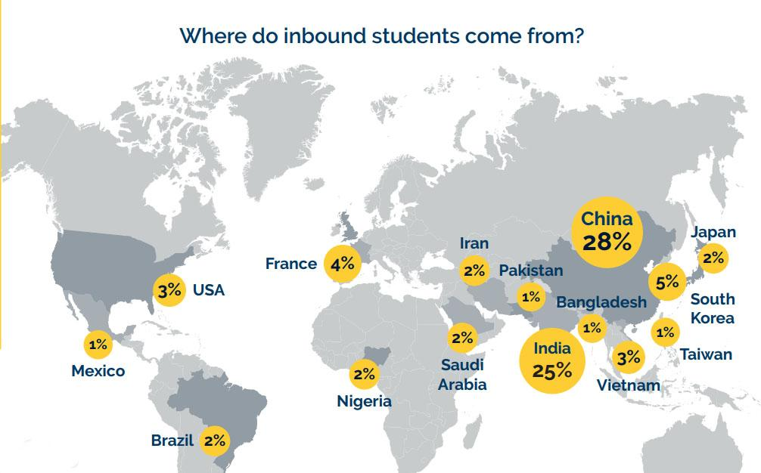

According to Canadian Bureau for International Education (CBIE) research in 2018, 494,525 immigrate as international students in Canada at all levels of study in 2017. The majority of these students are from China with 28%, followed by India with 25%. However, the least number of students come from Mexico, Pakistan, Bangladesh, and Taiwan.
Based on Canada Broadcasting Corporation (CBC) survey. About 70% of university students struggle loneliness and depression during school years.

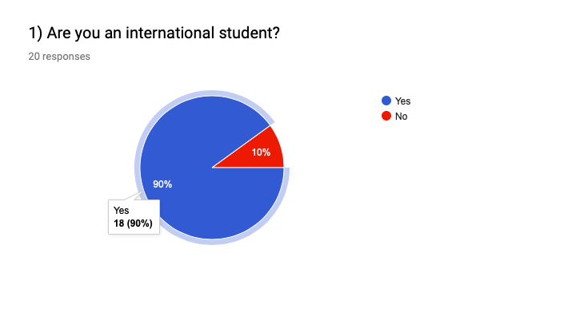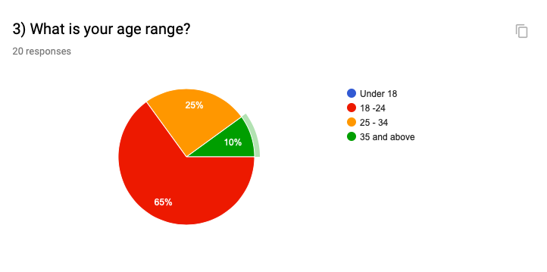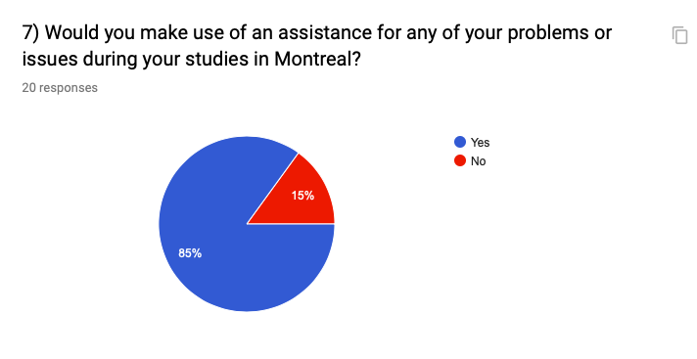
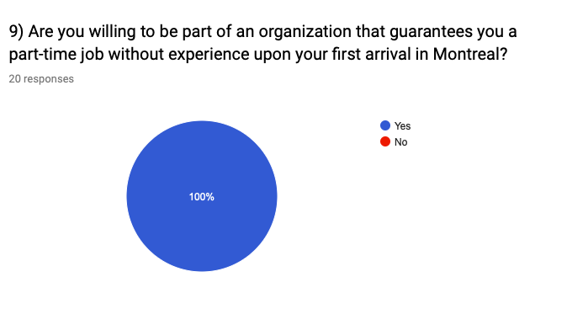

We conducted this survey targeting international students from the regions of South America, Asia, Africa
According to the survey results, we have noticed that most students are from Asia (India primarily). We have also noticed that most student age ranges from 18 to 24. We have also identified that the predominant challenges that people face are feeling homesick, Language barriers and getting a job with the three tallying at the same level (30%).

85% of the population would make use of assistance for any of their issues during their stay in Montreal. The total population would be part of an international students’ organization in which they can participate in entertaining events & contests. This statistic suggests that our target audience matches the lifestyle criteria’ in our segmentation strategies.

Finally, in the question 9) of the survey, 100% of the population would be willing to be part of an organization that guarantees them a part time job without experience upon their first arrival. This suggest that our services may correspond effectively with the needs of our target audience.

4.2 Target market segments, age, location

Our primary target market consists of International students from Africa, South Asia & Southern America. Through our survey, we were able to identify that majority of international students coming from those regions range from 18 to 30 years of age. People in our primary market segment are adventurous and sociable.

4.3 Size of target market

Through our research, according to CTV (Canadian Television Network) News Montreal,
out of the 35,000 of international students enroll to colleges and universities in fall semester, we project to have 5% of its which is 1,750 students that we are targeting in our first year of operation.

4.4 Purchase & buying habit of customers
- Our customers can subscribe through our website
- Subscription can be done with the immigration agency
- Subscription can be done through their colleges and universities.
- subscription can be done in our office, downtown Montreal.

4.5 Market share held by imports
N/A

4.6 Industry trends and other market factors
- WeBelong having a diverse market across the Canadian provinces in 5 year and being well known internationally in 10 years.
- WeBelong to be recognize as a reliable assistance for international students.
- WeBelong depends heavily on Immigration Canada. When Canada open its borders to all students from different countries, our business will flourish but otherwise it will have a huge impact on the percentage of international students that come here each year.
- We plan to give opportunity to students to be tutors.
- This industry is expected to grow yearly as more international students come study in Montréal, however if immigration procedures are to get stricter then the industry will unfortunately narrow.
4.7 Taxes and tariffs

We will pay taxes and other business restriction .
We are taking in account taxes, governmental regulations and restrictions in term of immigration laws.

4.8 Economic environment

The economy will have some effects on our activities as we are targeting international students, our revenue increase will be based on the number of international students the government give access to enter the foreign land. They will be considering tuition fees and costs of living which are dependent on how the economy is functioning at the time.

5. Marketing, Newcomer Entry Strategy
5.1 Description of your competitors

Our major competitor that offer similar service is ichoosemontreal, they help international students who wish to study and stay in Greater Montréal after their studies. ichoosemontreal provide informational assistant to students on immigrating to Quebec and offer career networking events for them to find jobs after completion.

5.2 Analysis of competitive position
Our company compares favorably with the competitors

Political | -Government policies: International students require documents such as; study permits/work permits, CAQ and Visas in order to study in Montréal.  -Tax policies: corporate tax in Quebec is a flat rate of 21%  -Labour laws: every employee that we refer will require a S.I.N
Economical | -Economic growth: dependable on the number of international students coming in Canada yearly.  -Exchange rates: Certain subscription payments made outside of Canada before a student's comes to Montreal may hold a slightly varied value due to exchange rates.  -Inflation rates: Our prices may vary as inflation rates alter.
Social | -Age distribution: International student population changes yearly. We are targeting the ages of 18-30.  -Career attitudes: we are referring international students whom are looking for working experience with no or little prior experience.  -Lifestyle attitudes: we are targeting adventurous & sociable international students.  -Cultural barriers: language barriers, social barriers, financial barriers, culture shocks.
Technological | -Research & development activities: Conducting research to implement new services to our program that target the benefits of international students. creating platforms that are available to our clients.
Ecological | -Weather: Montreal’s seasons will affect our operations.
Legal | -Discrimination laws: Employers to whom we refer International students must respect all laws surrounding discrimination (Charter of Human Rights and Freedoms)  -Employment laws: international student employees will require a work permit.  -Confidentiality: International students are required to sign a confidentiality agreement before joining the WeBelong community. WeBelong needs to respect the privacy of the information that is provided by clients.  -Consumer/client protection laws: Our company must deal honestly in all matters of advertising and fairly in contracts. This refers to ‘Loi sur la protection du consommateur’  -Patents & Copyright laws: WeBelong founders are intellectual property holders.

IchooseMontreal | WeBelong
No real-time assistant. | Real-time assistant in many forms: online chat, email, phone call, face-to-face assistance.
Only have guide in the form of document, online posts. | Guidance in the form of written (posts on WeBelong platforms), video and person-to-person.
Events aim mainly to professional career. | some events are traditional (from other countries) and majority are for leisure.
Referrals to businesses that have experience requirements.  Only provide job-posting websites. | Referrals to businesses that require little to no experience.
IchooseMontreal does not have an app. | WeBelong app is available on many platforms, including but not limited to iOS, Android and Windows 10.
IchooseMontreal does not focus on personalizing their services. | due to the diversity of our services, it creates an ease for innovation and creativity and reinforces the ability to identify new markets and to adapt.
IchooseMontreal does not pertain to culture. | WeBelong is a culture sensitive organization.

5.3 Pricing strategy

WeBelong is using penetration pricing strategy since we are new on the market & dealing with a target audience whom is cautious with money. Thus, we need to provide them with a concrete reason to make use of all our services and give them a return on their investment.
We are charging $100 for the yearly for membership.

5.4 Terms of selling to customers / clients

Our clients who subscribe online can pay with debit, credit and prepaid cards. However, a client subscribing from a third party or directly in our office. They can pay in cash or via any other payment method available that must be accountable for. Clients have 24-hour for a full refund if cancellation is made. After 24-hour refund will not be considered.

5.5 Distribution strategy

Our sales process and quantities are based on organizing boots and contest in schools. We have our call agents that assist clients with any question or issue.
Our mobile application is available on both “Play Store” for Android, “App Store” for iOS systems, and Microsoft Store for Windows 10. Guide on how to reach us and become a member will be available at our partners locations or website as well.

5.6 Description of intermediaries & partners

Our agents & representatives in Canada or abroad are private immigration agencies form Asia, Africa and South America. Our partners in Montréal are colleges and universities, they are our main suppliers. We are also working with Intern-Fox which help students in finding internships.
5.7 Promotion strategy

Through Transgesco we will advertise throughout the metros with posters and flyers.
Online ads: social media & sponsorships
Bus interior display: range from $20 - $50 per ad for a 4-weeks period
Subways (metro interior display vertical format) range from $75 - $150 per ad for 4weeks
Subways interior display 2 sheet: Range from $400 - $950 per ad for a 4weeks period
Flyers: 300 flyers are equal to $150
Social Media (Instagram, Facebook, Snapchat): range from $1000 - $2000 in 4 weeks

6. Purchasing, Suppliers, Regulatory and Logistics Issues
6.1 Main suppliers

Students can become members directly through our website or mobile application. However, we are also partnering with major colleges and Universities that welcome a huge number of international students in Montreal. Our partners are Lasalle College, Dawson College, Vanier College, Guy Concordia University, McGill University and University of Montreal. We are also going to build a partnership with immigration agencies in different countries that help students in applying and getting visa to travel here for their studies. These institutions will help in reaching and acquiring students. Finally, we will be partnering with companies and businesses that wants students for their part-time job positions.

6.2 Terms of purchase from suppliers
In order to make it a win-win situation for the partners and ourselves, we have decided to pay our suppliers based on commission on the number of students they refer to us. The commission will be a percentage of subscription fee paid by every student they refer. Payment will be made through direct deposit into their account (credit, PayPal and debit).

6.3 Regulatory issues, trade documentation

We need to obtain licences, permits, federal and provincial employer ID and request a federal and provincial federal tax form. The students we will be working with must as well have the necessary documents such as a Quebec Acceptance Certificate (CAQ) for studies, valid student permit, and work permit if they come to us for job referral.

6.4 Incoming transport & cargo insurance

We will be working with employers, landlords, Colleges, Universities and some other companies, so we will need liability and workers’ compensation insurance. We are also going to need property insurance because we have an office. Business owner’s policy which every partner will agree upon before any deal agreement.

6.5 Outgoing transport - service providers
N/A
6.6 Intellectual property protection

We will have copyrights over our business idea, logo and company’s name.

7. Risk factors
7.1 Market, marketing and general business risks (text)

WeBelong is not a “For Profit Organization with a Social conscience”. It is established to assist internal students from all over the world to have a smooth beginning in Canada specifically in Montreal. There are some risks that come with starting WeBelong both in long and short terms. One risk that may occur has to do with a shift in the market as the population of international students coming to Montreal may change, therefore affecting our operations either positive, negatively or neutrally. Another risk is in relation to competition, as more businesses may notice opportunities in the market and start to provide similar services for the same target audience as WeBelong’s. Many risks can arise in relation to employees, meaning our HR staff will need to ensure the motivation of the employees and maintain their condition within the workplace. Lastly, risks with clients may occur such as the dissatisfaction of clients in relation to the services which we provide.

Research and Development
Research for customer needs identification and development could come at a high price for the organization. To ensure that we get accurate results, the company must invest efficiently in public relations which might be expensive because we need to gather dater from multiple sources. Due to the fact that we are a start-up company, we may not have enough funds available and this could affect customer satisfaction.

Financing
Pricing strategy is one of the most important components that determine the revenue of an organization. we chose to enter the market with a penetration pricing by setting low prices for students to have access to our services. Therefore, a risk of low revenue income stream could occur leading to financial losses. Overspending might occur especially in events which could cause inability to meet budget, hence affecting other projects.

Legal and compliance
Risk that student will not be compliant with legal requirements, regulations and policies. some students may not have the right to work in Canada but will be willing to work here. This may result in fines, penalties for the organization.

Service delivery and operational
The organization may risk situation where funded and sponsored services will not get completed or delivered in a timely manner as expected. Getting into Debt could follow such act.

Human Resource Management
HR is dealing with employers; we could risk that the employer may not be compliant with labor laws. This might affect the job referring services and the organization if care is not taken.

7.2 Risks (table)

Market, marketing and general business risks | Our research and development processes need to be consistent and effective in order to retain market share. Secondly, we need to ensure that our advertising methods are always efficient & appropriate in relation to the audience which we target. By continuously doing research, we will have an advantage compared to our competitors and it allows us to undertake the right procedures to stay dominant in the industry. By maintaining strong positive relations with our clients, we can then provide more appropriate services by getting feedback from them. Providing training and feedback to our staff will prevent errors and will increase motivation. Lastly, majority of our existing & new service offered, or innovated procedures must be restricted by patents/copyrights to prevent other businesses to make use of them.
Financing Risk | We need to develop a solid plan before targeting conclusions, such as how much capital we will need to invest, proper marketing research should be done before making decisions. In addition, have a source of diversity income. Whenever it is possible for the business to get into new profitable project, ensure that the opportunity is taken.
Service delivery and operational | Define everything before getting into action. make sure each level of activity conduction is well revise before starting it. Time each activity in advance and have days of unfortunate moments in every project plan before announcing the delivery date of a service.  In operations, manage equipment failures in events as quick as possible and follow regulations in the workplace.
Human Resource Management | Obtain liability insurance as we will be dealing with employers and potential employees through referrals. Ensure that the staff is in line with the key performance indicators of the business.

8. Implementation plan
8.1 Key activities and tasks to be done

The Business revision
Review business code (local and provinces)
Update competitive analysis and identify top competitor
Revise strengths and weakness
Revise customer base
Revise types of events and reference services
Meet with a consultant for whole business plan revision

Relationship
Join a bank organisation
Select an insurance company
Getting started
Register business name
Obtain suppliers
Obtain any require licences and permits
Obtain federal employer ID
Obtain province employer ID
Obtain require province and federal tax form
Obtain business insurance
Finance
Establish business checking account
Establish line of credit

8.2 Benchmark evaluation criteria

- By meeting with the consultant, business plan may demand more time for revision.
- Big milestones of legal documents request.
- Waiting for the office design to be completed.

8.3 Time lines of activities & execution
Create a visual GANTT chart with time lines & implementation

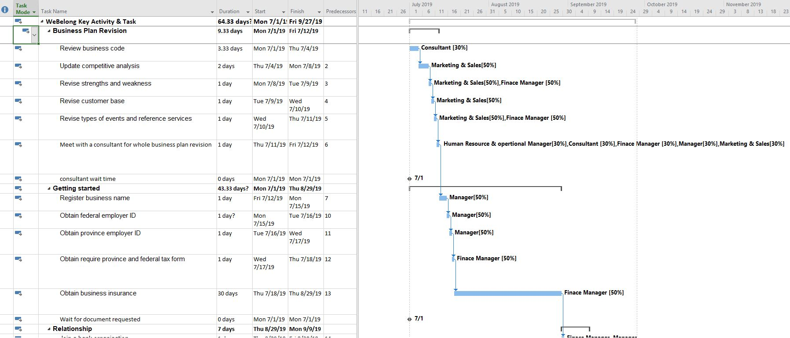

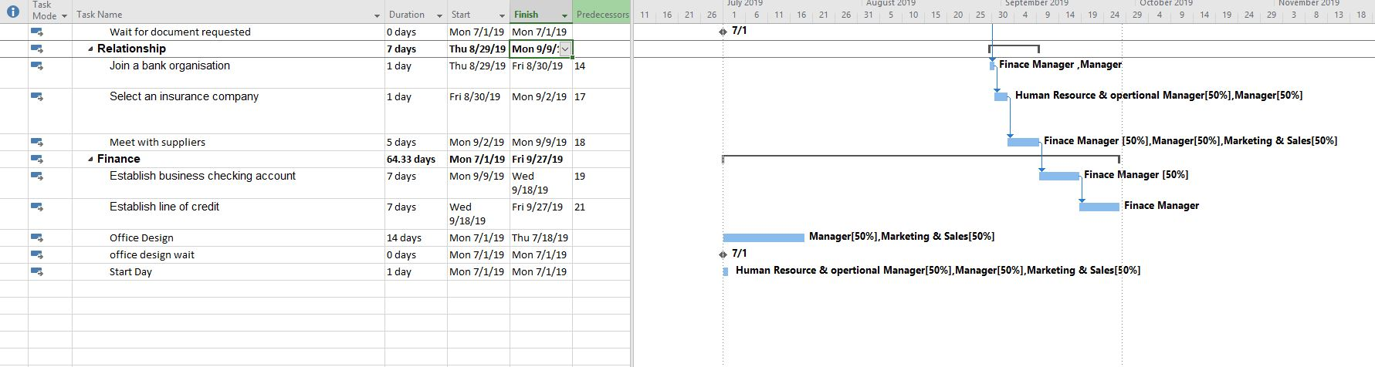
9. Resources
9.1 List all the knowledge sources & resources used

Transgesco
http://www.stm.info/en/about/business-zone/partnerships-and-permissions/use-stm-brand
fyers

Légis Quebec
http://legisquebec.gouv.qc.ca/en/ShowDoc/cs/P-40.1)

droit de la personne
http://www.cdpdj.qc.ca/en/droits-de-la-personne/Pages/default.aspx)

Ichoosemontreal
https://www.ichoosemontreal.com/

Forbes
https://www.forbes.com/sites/thesba/2012/01/19/13-types-of-insurance-a-small-business-owner-should-have/#7476dbbe20d3

https://cbie.ca/infographic/

Marketing research course _ LaSalle College
Statistics course _ LaSalle College
Human Resource Management course _ LaSalle College
Financial analysis course _ LaSalle College
Project Management course _ LaSalle College
Business Management course _ LaSalle College
Marketing strategy course _ LaSalle College
Customer Service _ LaSalle College
Sales Communications _ LaSalle College
10. Finances - First year monthly & Summaries for additional 2 years
10.1 Opening Balance Sheet

Seed Money of $ 50,000 (Members Contribution)

Assets |  | Shareholder’s Equity
Cash on hand | 46,000 | WeBelong, capital | 50,000
Purchase of initial office equipment | 3,000
Prepaid Insurance | 1,000
Total Assets | 50,000 | Total liabilities & Owner’s Equity | 50,000

10.2 Other sources of funding

Financial Assistance of $15,000 grant from PME-MTL Centre Ville, which we are eligible to use for marketing expenses, equipment purchases, and leasehold improvements.
.
10.3 Cost of sales

N/A
10.4 Marketing and promotion expenses
- Social Media
- Banners
- Brochures
- Website
- Billboards

10.5 Other expenses or expenditures

Expenses | Year 1 | Year 2 | Year 3
A) Marketing cost

Advertising | 5,000 | 10,000 | 20,000
B) Overhead Expenses
Rent | 17,000 | 17,000 | 41,000
Incorporate License & Permit | 1,200
Insurance | 1,000 | 1,000 | 2,000
Office Supplies | 3,000 | 2,000 | 5,000
Salaries | 210,000 | 291,000 | 1,146,000
Utilities | 5,000 | 7,000 | 12,000
Miscellaneous | 2,000 | 1,000 | 3,000
Technical Maintenance | 5,000 | 5,000 | 10,000
Total Marketing cost & Overhead Expenses | 249,200 | 334,000 | 1,239,000

10.6 Revenue - Income from Operations Statement – profit & loss

Income & Expenses | Year 1 | Year 2 | Year 3
A) Income from operations (Total)
Sales of services | 318,000 | 449,000 | 1,590,000
Other Sales | 13,000 | 20,000 | 30,000
Total Income | 331,000 | 469,000 | 1,620,000
B) Less Expenses (Total)
Overhead cost | 249,200 | 334,000 | 1,239,000
Total Income Less Total Expenses | 81,800 | 135,000 | 381,000

Membership -
In the first year we are targeting 5% of international students out of 35,000 in Montréal, which is going to be 1,750 international students. Furthermore, the membership fees are $100 yearly; therefore, the revenue earnings from membership is $175,000. In the second year we are targeting 9% out of 35,000, and in the third year we are going to target 13%. Moreover, In the third year we are going to expand in Toronto because in Toronto there are around 168,000 international students, which is the highest in Canada. We are going to target 2% of 168,000, which is 3,360 students.

Housing Assistance -
We are expecting 25% of students out of 1,750 is going to use our service for housing assistance, which means 438 students. Furthermore, each student needs to pay an average amount of 400 dollars to the landlord, which makes the total of $176,000. Therefore, out of $175,200 we are going to take 50% of the amount from the landlords, which makes the earning of $88,000. In the second year and third year we are going with the same 25% of students both in Montréal and Toronto.

Personal Assistance -
We are expecting that 35 students out of 1,750 is going to use our service for personal assistance.

Events -
We are going to organize 24 events yearly in Montréal, and in the first year we are expecting to earn around $54,000. In the second year around $72,000; furthermore, in the third year it is going to increase from $72,000 to $126,000 because we going to organize 12 events in Toronto.

YouTube -
In the first year we are expecting an earning of around $13,000 by posting videos of our events, and about various things to explore in Montréal. In the second year we are expecting $20,000 because of the increase of subscribers on our channel. Furthermore, in the third year we are expecting around 30,000 dollars because we are expanding to Toronto, which is going to help our channel grow faster.

10.7 Cash flow – budget (1+2 years)
Income less expenses & carry forward to next month

