NODE D8
TERN Foldable Bike

ORGANIZATIONAL COMUNNICATION

OSMAN KAPLAN

November 24th, 2015

Students:
- Beatriz Gouveia de Meirelles
- Francisco Antonio Bezerra de Meirelles
- Gavin Christensen Tomlinson

INDEX
Pages

THE PRODUCT 2-3

STRATEGY AND PROMOTION 4

OBJECTIONS 5

EXPENSES 6-7
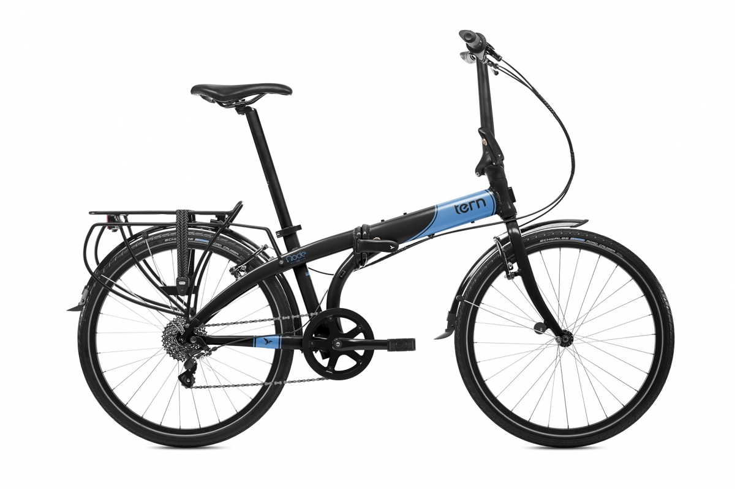

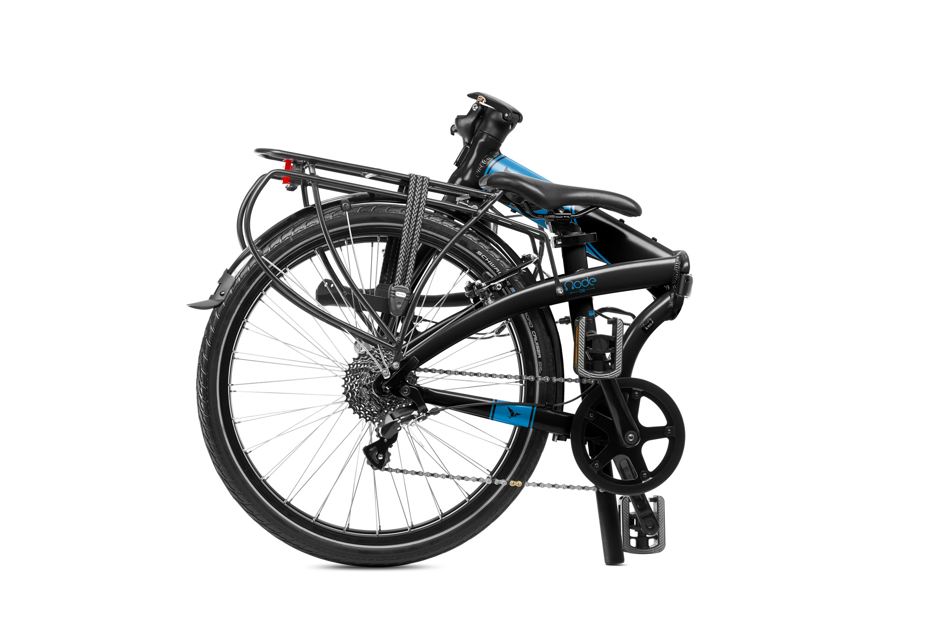

TERN BICYCLE – THE NODE D8
The product we chose to present is called the Node D8. Our main focus is to make the bike transform into a smaller and more transportable object. This allows you to bring the bike inside schools, workplaces, the metro and is why it sets itself apart from any other bike. Have you ever been in a position where you need to bring your bike inside? Well, our bike lets you, by being able to fold into a smaller object. Our bike uses "N" fold technology, which folds in three easy steps at a time of 10 seconds. Our product is made from light weight aluminum metal, and the whole bike only weights 13.3 kg/29.3 lb. It also comes with a bag, which makes it easier to carry anywhere, and in a variety of colours for people who want to stand out and like eye-catching colours. The Node also eliminates leaving your bike out in the rain to rust, as it is very easy to store in your home or basically anywhere. Our bike comes with accessories such as a pack attached to the back of the bike, for people who are on the go storing groceries, school supplies, work supplies etc. These are just a couple of reasons why our bike is revolutionary and very useful in everyday life.

Locks:
A big disadvantage to having a normal bicycle is that you need a lock. The problem with locks is that sometimes they don't work as they were supposed to. The Node eliminates that need by folding into a bag so you can take it with you anywhere. Have you ever been in a situation were the lock for your bike gets stuck or you have lost the lock or the key? This can put you in a situation where you could be late for important appointments. Also, some locks can be easy to break through and allows your bike to be easily stolen. There have been many times when I wanted to go into a store to buy something but I did not have a lock for my bike, our bike eliminates that objection by allowing you to fold the bike and put in a bag so you can carry it around with you while you are shopping.

Time Efficient:

Our product is very easily folded and folds in a matter of seconds. With the Node you eliminate the time for finding a place to lock up your bike, take out your lock, put it together, store your key where you wont forget it etc. Our product also saves time by being allowed inside the metro; most metro systems do not allow taking bikes with you. This is a great tool for getting around because it allows you to bike to the closest metro and be where you need to go much faster.

Unique:

The Node is very unique and one of a kind. There are not a lot of bikes like the Tern Folding Bike. It has a very distinct look and comes in many different colours. The great thing about our bike is that it is very flashy and eye catching and to make it stand out, the Node goes through six trips through the paint line. Every bike looks very similar, but ours stands out because it’s very innovative and has colours that are extremely eye-catching. If you don't want to stand out you could always go with a less flashy colour, which is another option our bikes offer.

Space Efficient:

The folding bike takes less space and gives you more room to store important things. If you live in a small apartment, you know how hard it is to bring your bike in and out or even find a place for it in your home. Our bike fits very well in tight spaces or in a closet and it’s not very hard to find space for it.

Cost Efficient:

Our bike only costs $750 dollars, which is relatively cheap for a bike of its kind. Most bikes can cost a lot and only do one function, but our bike costs less than most and it’s multi functional.

Long Lasting:

Our bike will outlive most bikes for one solid reason: you can store it inside. Most bikes have to be left outside where weather can make them rust and make the chain seize and not work anymore. The Node Bike is easily stored inside, which will ultimately make the bike’s life expectancy much longer and eliminates the chances of getting rusty and unusable. This also means fewer trips to the bike repair shop, which can cost you a lot of money.

Travelling:

The Node is great for someone who travels with constancy, as it is very easy to take it with you anywhere you go. Most metros and subways do not permit bikes inside the cars, but folded they are allowed. If you are travelling to different countries, our product can easily be stored on a plane, and will save you money when it comes to renting transportation.

STRATEGY AND PROMOTION
- Product promotion

To improve the sales of the Tern Bike Node D8 we will use a different marketing strategy based on the main segment that we seek to reach:

Individual Consumers: Marketing for the individual consumers will be done primarily over the Internet, which we believe is the most effective media nowadays. While we will use some magazine advertisement space, the main effort will focus on promoting the website that includes a current catalog of their offerings. This will be the most up-to-date source of product information and availability. The advertisement will also be distributed around the public transport system because they can be seen as complementary means of transportation. The characteristic of being easily carried provides the possibility of taking the foldable bike inside the cars without further issues. All advertising activities and trade show presence will highlight the website as an indispensable source of information.

The electronic advertisements will be done through good positioning on search engines, pay per click advertising, as well as advertising on Twitter, Instagram and other social media networks. Pay per click advertising is a system of advertising that is done through search engines where payment is made to a search engine such as Google whenever the search engine refers a person to our website based on the keyword that they entered into the search engine.

By other side, the paper advertisings, as bicycle magazines, will be advertising in CIBRA Bicycle Retailer (Canadian Independent Bicycle Retailer Asociation), the industry magazine. Ninety-eight percent of the bicycle shops in Canada receive a copy of Bicycle Retailer making the advertising opportunities especially valuable.

OBJECTIONS
Valid Objections: all the truth concerns that the potential client needs to be answered before willing to make the commitment to buy, a few examples of these could be:
1) Is the Node D8 a trustful product?
Tern Foldable Bicycles are made for different weight groups. By increasing the amount of material in key areas, Tern is able to make a bicycle for all weight riders with a huge safety margin. We are aware of the liability risks involved with a product liability suit. Having specific carbon fiber frame tuned for specific riders is a competitive advantage because it provides the rider with the lightest weight bicycles that they can ride safely. It also provides them with the most comfortable riding experience. If a lightweight rider is using a stout bicycle frame it will feel quite stiff and all of the road vibrations will be transferred. Conversely, if a heavy rider is using a bicycle frame that is too light for them, it will not be stiff enough, flexing like a noodle under stress.

2) The bike is quite pricey if compared to other common bikes.
It’s true that our bike costs $750 dollars, but that price is relatively cheap for all the pros that it offers. Most bikes can cost that much and only display one function while the Node bike offers the folding feature in a good quality bicycle. Besides, It costs less than most of the other foldable bikes, putting its price in a really competitive frame.

Invalid Objections: all the defense mechanism used by the interested person to stall, slow down or prevent the sale process from continue, the most of them should be approached in the same way, examples of this could be:
- I’m just looking
- I’ll think it over…
The lack of information or understanding about the Tern Foldable Bicycles could drop into an evasive position from the potential client, especially when the person is attracted just by the curiosity for the company products.
But this is an amazing opportunity to show our product and create a good mouth to mouth advertising, reason the salesperson answer must be “Great, what are you looking for today?” This will throw them off (because you were supposed to say “Ok, let me know if you have any questions.”) and they will blurt out what they are there for. Then simply say “Great! Follow me!” and immediately do an about face and start heading to that item.

EXPENSES
To open a successful bike shop, the first step is the choice of shopping location for the business and it should be easily accessible and with good traffic of people, that can usually be found along major trade centers. As the main product of the store is a folding bike, it is necessary enough space for storage and demonstration. Pictures of the various stages of folding it and a short film showing the practicality that is to have a folding bike in front of the store can be a good trick to attract new customers. The store structure is not very expensive since it is a kind of business that does not require much furniture or special machines. Randy W. Kirk, author of Principles of Bicycle Retailing III, offers his insight about how to open a bike shop. He explains bicycle retailing, choosing which brands to carry, hiring staff, marketing your bike shop, and more. He estimates that the cost to open a store can range from $70,000 up to $100,000 US.

Average expenses for specialty bicycle retailers based on the National Bicycle Dealers Association Cost of Doing Business Survey, expressed as a percentage of gross annual sales:
Payroll Expenses – 20.5%
Occupancy Expenses – 7.7%
Advertising/Promotion – 3.0%
Auto and Delivery – 0.5%
Depreciation – 0.9%
Insurance – 0.8%
Licenses/Other Taxes – 0.5%
Professional Services – 0.5%
Office Supplies/Postage – 1.2%
Telephone – 0.6%
Travel/Entertainment – 0.4%
Other Operating Expenses – 1.3%
Total Operating Expenses – 37.7%
Net Income Before Tax – 4.2%
Gross Margin on Bicycle Sales – 36%
Gross Margin on Clothing Sales – 43%
Gross Margin on Other Equipment – 48.1%

COSTS |  | Estimated
Fixed Costs
 | Advertising for Opening | 1,000
 | Basic Website | 600
 | Brand Development | 400
 | Business Cards/Stationery | 80
 | Business Entity | 150
 | Business Licenses/Permits | 100
 | Computer Hardware/Software | 4,000
 | Internet Setup Deposit | 80
 | Lease Security Deposit
 | Legal/Professional Fees | 100
 | Machines & Equipment | 2,000
 | Office Furniture/Fixtures | 2,000
 | Point of Sale Hardware/Software | 1,400
 | Starting Inventory | 200,000
 | Telephone | 40
 | Tools & Supplies | 5,000
 | Travel | 2,000
 | Truck & Vehicle | 24,000
 | Other 1 (specify)
 | Other 2 (specify)
 | Total Fixed Costs | 242,950
 | Average Monthly Costs
 | Advertising (print, broadcast and Internet) | 1,000
 | Business Vehicle Insurance | 40
 | Employee Salaries and Commissions | 8,000
 | Inventory, raw materials, parts | 20,000
 | Internet Connection | 80
 | Miscellaneous Expenses | 1,000
 | Owner Salary | 8,000
 | Payroll taxes or Self-employment tax | 400
 | Postage/Shipping Costs | 1,000
 | Telephone | 60
 | Travel | 600
 | Website Hosting/Maintenance | 12
 | Total Average Monthly Costs | 40,192
 | x Number of Months | 6
 | Total Monthly Costs | 241,152
 | TOTAL | 484,102

