Antiquity

Mesopotamia  Assyrian (Men) (Right) |  | Egypt (Women) |  | Greece (Men: Charioteers) |  | Rome (Men)
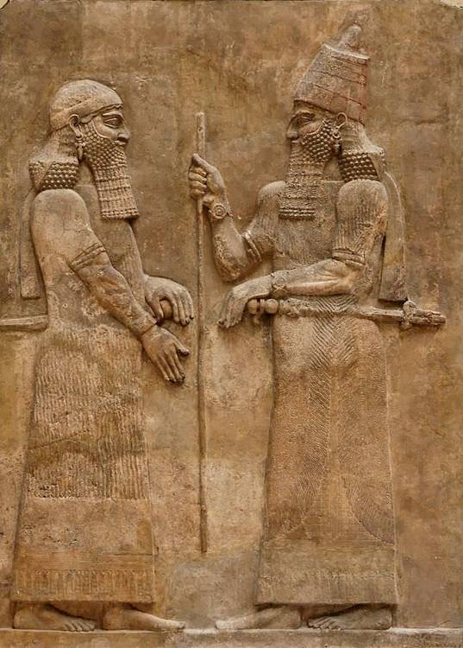 |  | 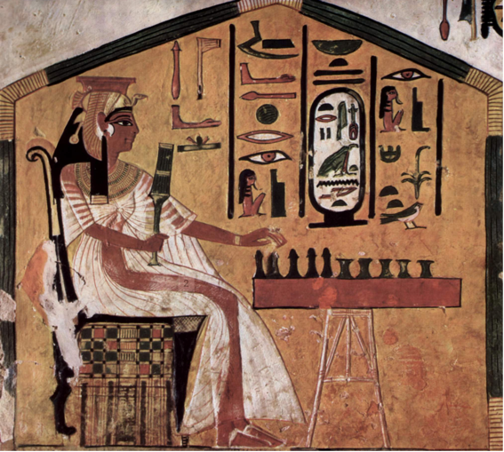 |  | 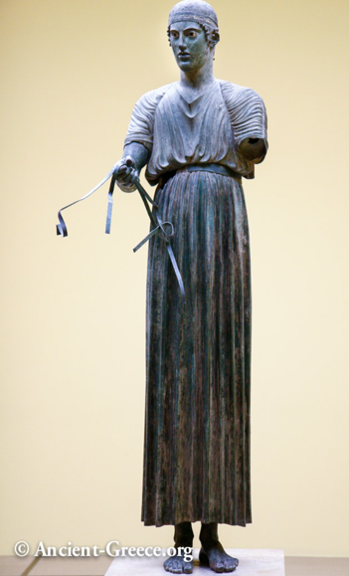 |  | 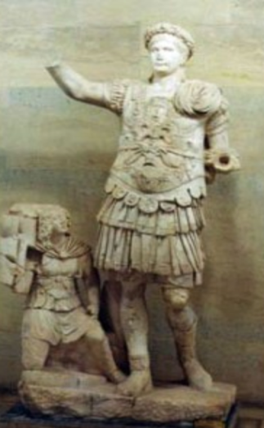
Garments or Accessories | Description | Garments or Accessories | Description | Garments or Accessories | Description | Garments or  Accessories | Description
Shawl | Made of skins then fabric, covering one or both shoulders. Later trimmed with fringes and be attached with a fibula. | Kalasiris | Long full robe, transparent, plated. Full in back, but only waist-length in front.Tied below bust with sash. | Long, vertical lines like architectural columns chiton | Rectangle of dyed wool, later linen, folded around body at left side (open at right side); pinned at shoulders with fibulae. Trimmed at edges | Armor  Detail function: protect them in battle | Corselet/ Cuirass bodices (hinged pieces), tunics of leather, reinforced with metal plates
Candys/ Kandys | Long wool tunic (T-shaped robe) with short sleeves and fringe or tassels at hem. | Wigs  Detail function: women shaved their heads for hygiene, purity and heat | Long and full, with small curls or rows of braids; made of hair, wool or plant fibre. | Ionic chiton | Wide linen or silk fabric, sewn from two pieces, and pinned along arm length to create short sleeves. Excess fabric held in place across bodice with bandolette (straps) | Knee-length pants | Northern campaigns
Beard | Long corkscrew curled beard with square end | Gold collar | Circular shoulder necklace, composed of rows of metal, with counter weight at back | Reins | Offered in victory gesture | Greaves/Shin guard
Hair/Headdress | knotted at back of head | Kohl | Black for eyes and brows | Round leather cap |  | Hairstyles | Short, beards and clean- shaven styles well maintained
Jewelry | Earrings, bracletes | Uraeus | Vulture headdress sits on top of a wigs | Hairstyle | Short crop
Kohl | For eyes | Leather sandals |  | Bare feet
Weaponry | Sword  Staff: Symbol of divinity
Bare feet

Ancient Egypt | Fahion show 2018
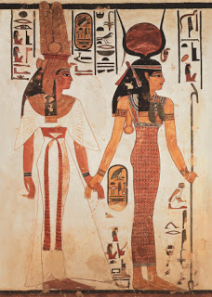 | 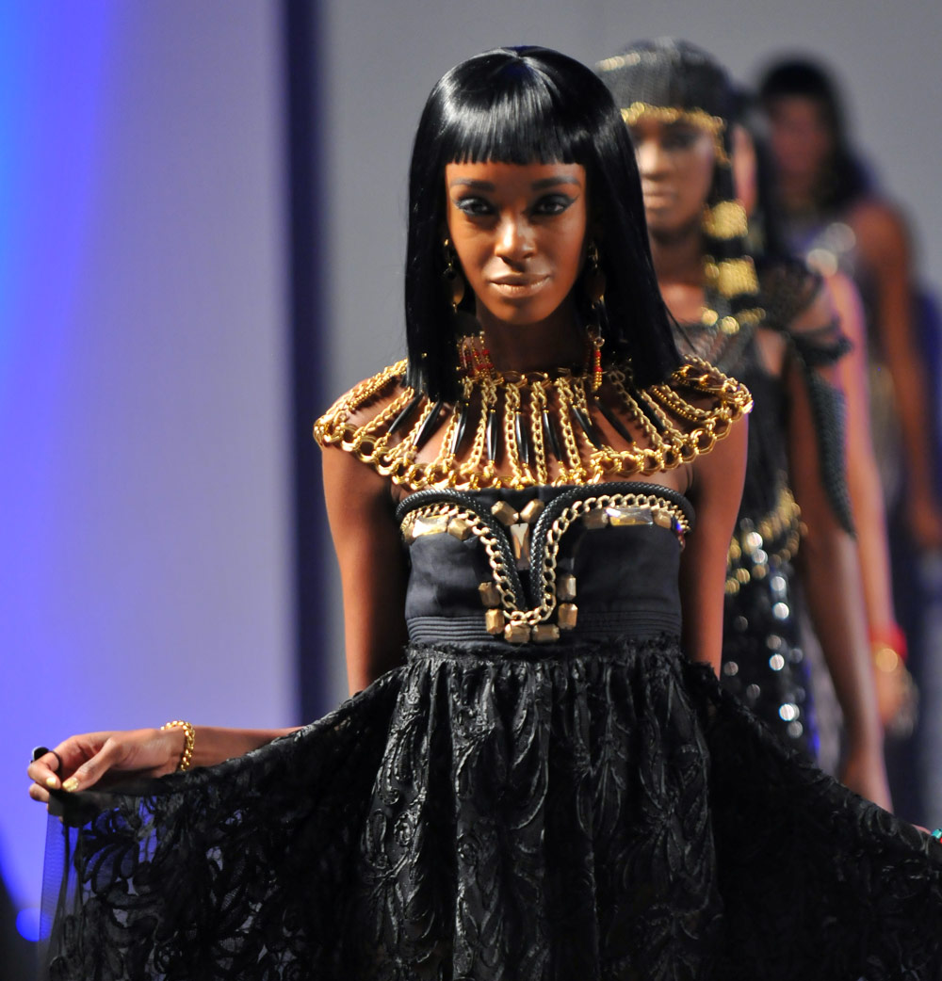
Common Elements:
Wig
Collar -circular, shoulder necklace composed of rows of beads/stones
Jewelry: earrings
Kolh: black for eyes and brows

Sources:
- Mesopotamia Assyrian
https://www.ancient.eu/image/2740/sargon-ii-wall-relief//
- Egypt
https://www.egypttoday.com/Article/4/40805/Ancient-Egyptian-Queens-Nefertari-King-Ramses-II-s-Wife
- Greece
https://ancient-greece.org/art/chiarioteer.html
- Rome
https://www.ancientsculpturegallery.com/marble-statue-of-roman-emperor-trajan-in-cuirass-from-perge.html
- Modern Fashion show
https://wtvox.com/fashion-trends/egyptian-fashion/
- Ancient Egypt
http://www.ancient-egypt.info/2012/02/ancient-egypt-clothingegyptian-wigs.html
- Information: Smithsonian, Fashion The Definitive Of Costume And Style, First American Edition, 345 Hudson Street, DK publishing, October 1st 2012.

