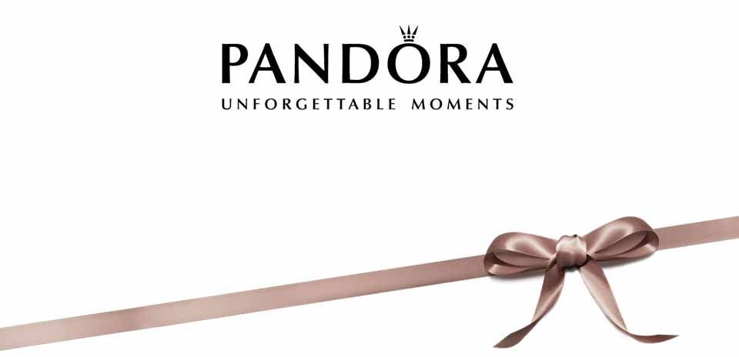

PRESS RELEASE
Launching of a new product line.

For Immediate Release

Opening the Pandora box
A famous market-leader for women’s charm bracelets, Pandora, announces the launch of a men’s bracelet line on a Diner en Blanc.

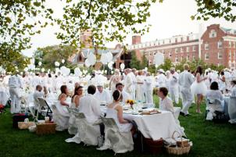
August 14, Vancouver, BC – On Tuesday, August 25th, Pandora is launching their newest collection of men’s bracelets on a highly awaited returning of Dinner en Blanc. Could there be a better match? Featuring the gems of city’s socialites in an endless sea of pure white style and a famous loved-by-many Big Love Ball, it is a truly remarkable sight. Be prepared for the most unforgettable and engaging event of the year.

The story of Pandora started in 1982 with a local Danish jeweler and a small wholesale shop which than grew into a world-leading international jewelry company with sales in more than 70 countries. And now time has come for them to grow even bigger. Pandora’s signature charm bracelets are associated with capturing the most remarkable events in life. It’s like a tiny personal time travel machine right on your wrist, except it looks adorable. Starting August 25^{th,} Pandora women would be sharing this privilege with their significant others. What Pandora prepared for men? A wide variety of leather, wooden and metal beads along with a few signature bracelet bases made either in gold or silver. Milestones made into accessories, that’s what is.
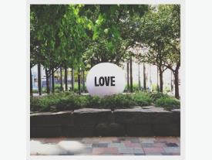
The host of the launch is Diner en Blanc which is returning to Vancouver for their forth edition. The key part of the event which makes anticipation boils even harder is the secrecy of the location – the actual place would be announced at the last minute. Don’t worry all those who eager to participate, you still have time to prepare your best all-white outfit to match that giant Love Ball for your instagram pictures.

Pandora and Diner e n Blanc offer you an opportunity to participate in the unexpected. The most engaging and spectacular event will elegantly announce the end of the summer along with the beginning of a new exciting chapter of collaborating companies. The presence requires registration or a purchase of a VIP ticket along with sponsor’s kit, which includes 50 years old Glenfiddich bottle and an Individually Packed Rocky Patel Royale Sumatra cigar. Location is to be announced.
-30-

For more information, images or to arrange an interview please contact:
Alissa Zadorozhnaya
PR executive for Pandora
604 649 9791
zadorozhnaya.alissa@gmail.com

