WORK TASK MANAGEMENT

571-KX6-AS

section 02042

Mengyang Lyu

201530604

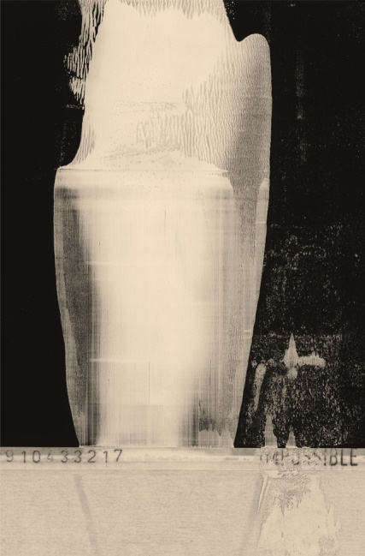
MENGYANG LYU (Tyler)
(514)-963-2182
naoyang123@gmail.com

Languages
Fluent written & spoken Chinese, English
Knowledge of French.

Computer Skills
Microsoft Office **********
Adobe Illustrator and Adobe Photoshop ****************
Painting and sketch *************************
Photography (cartridge and electronic) **********************

Education
Fall 2015-Present Fashion Design, LaSalle College---fashion design
Fall 2014-2015 Parsons the new school of design (New York city)---fashion design

Work Experience
Fall 2008 – winter 2008 Tour guide of Beijing Museum of Natural History
2012- Present artist in MoCA Beijing
2013-2014 Bartender in “School” bar (Beijing)
2015-2016 Delivery guy in Just noodle
Volunteer Work
2008 Tour Guide for Beijing Olympic Game
2014 Translator for exploratory mission from Norway

Interest and Activities
Traveling around the world,
Reading as many books as possible,
Writing poems and philosophy ideas about art
Sewing and designing clothes
Photography

Business card

Fashion company

7
Email：naoyang123@gmail.com
Phone：(+1) 514-9632182
Add：1205 Rue Mackay

Mengyang Lyu
President

vêtements

