Marketing Research 410-DB4-AS

Final Project : The Failure of Google+

Presented to : Jacqueline de Stefano

Gabriel Pires
Victor Tomash
Omar Seifi
Iago Ribeiro

LaSalle College
Fall 2016

INTRODUCTION

The future of social media is hard to predict. Google has been one of the most visited websites, the most used online search engine and it also provides different types of useful tools for its users, such as: Gmail, Google Docs, Google Drive, etc. On an attempt to enter the Social Media segment, Vic Gundotra, the former head of the plan, released Google+, a social media that was supposed to compete against the giant Facebook. However, even though connected to the most used e-mail platform, Google+ has been failing due to the lack of active users.

In this project, we are going to present our methods to understand this fact through the analysis of secondary data, such as web articles, and by a conducted survey to have a primary data for the justification of the failure of Google+.

DEVELOPMENT

Firstly, through our own point of view, Google+ was not very innovative when it released. The problem starts from its beginning due to the fact that the first users could only join the social media when receiving an invitation from someone inside. Even though this fact caused a ‘vip-only’ feeling and greater interest on Google+, the ‘invitation-only’ period took too long. This made users lose interest since there was not much activity due to the low quantity of active people. Thus resulting on the loss of future users since there was already a successful leading-competitor: Facebook.

Even though running so many useful websites, features and apps, Google made the expensive mistake of trying to compete against Facebook on a time when the possibility of overcoming it would be sort of unattainable. Google+ came without much differentiation from what other social medias could do, it was more of the same that the public already had. This resulting on the low or no interest from active users in migrating to other social media to start it all over again. “Everybody is already on Facebook. Why would I move from it when I have so many connections and stories there?” this question sums what could go on the mind of the prospective user, which shows how hard it would be to fight against it and establish a new environment when providing the same tools that we already have. This being the main explanation for the fail of Google+.
For this project, we have been actively using and exploring Google+ within the past days. Its overall performance (Gillette, 2015)leads us to the conclusion that it feels like another social media but missing content. The numbers are really small due to the lack of activity and users, which give us the impression of a desert social media where you will have hard times to find a connection with. The home page is now only based on streams and photos from the Collections, Communities and People that you follow or are friends with, which reminds of Facebook and Instagram: people sharing their thoughts, links and pictures all in one scroll-down page. Thus, again, more of what we already have. In the past picture, there is a post from the Community “Animal Lovers”, which is one of the most popular communities and which appeared as the first suggestion for us. As we can see, the numbers are very small and the content on it is not very relevant or sometimes there is just none. In addition, we performed some researches on well-knowing newspaper’s profiles but even their profile has only old content or no content at all. This demonstrating again the lack of users and interest on Google+, coming even from local information providers as they are broader through other social medias or their own website.

Introducing the secondary data that we explored, we identified different types of explanations for the failure of Google+. In the video “Why Google Plus Failed”, from Echo Gillette, “The reason is because it is visually uncomfortable to work with” (Gillette, 2015), here she justifies one issue with the interface of the social media, referring to the double toolbars that were present at the time but now seem to be removed. Moreover, in addition to design matters, one of the reasons explained on the article “What The Unofficial Death Of Google+ Means For Marketing” is that it “dropped the ball on forcing us to have unwanted usernames. It demanded that you use your real name.” (Wright, 2015) this referring to the fact that users were not able to customize their username and would have to accept the one given.

Furthermore, many articles explore parallel facts, such as the team in charge of the social media. The following extracts from “Why Google+ failed, according to Google insiders” written by Lisa Eadicicco highlight some internal points that reflected on the progress of the social media.

“The main problem with Google+, one former Googler says, is the company tried to make it too much like Facebook. Another former Googler agrees, saying the company was "late to market" and motivated from "a competitive standpoint."”

“Google+ was designed to solve the company's own problems, rather than making a product that made it easy for its users to connect with others.”

“Google+ was a "controversial" product inside Google”

“When Vic Gundotra, who led Google+ and played a big role in creating it, left the company about a year ago, it came as a complete surprise. There was no succession plan…”
(Eadicicco, 2015)

These extracts hint that the failure had also a part from inside the company. The fact that the head of the project, Vic Gundotra, left, shows how the management of a project can turn on to unpredictable situations and how serious and problematic leading a failing social media can be, as he was the one in charge of it.

Proceeding on internal factors, the article “Inside the failure of Google+, a very expensive attempt to unseat Facebook” (Fiergerman, 2015) explores the reasons among the competition with Facebook. Though Google had a larger market share valued at $200 billion compared to Facebook which was valued at $14 billion it was able to withstand and out shine this enormous competitor.

At the time of the launch of Google+, Facebook was stealing many of Google’s employees in order to secure their place as the top social media platform. At first Google+ had confidence that it can compete with Facebook but as time passed that confidence started to shrink. Google+ failed to differentiate themselves from Facebook which also proves that even when a giant company feels insecure with its position and decides to innovate, there is still an evident risk of failure.

Facebook continues to “poach” more and more of Google’s employees and also chip away at their advertising revenue along with Twitter. Facebook has also proved itself superior over Google by acquiring a market share of more than half of Google’s. Currently there are 1.4 billion Facebook users. Google’s previous product manager comments on the Google+ platform adding it to the list of failed Google products and stating “What it could not do is give Google another destination to consume stuff. That's where Facebook continues to win.”

On the other hand, we were able to find on Quora, some articles pro to the use of Google+, as the following answer for the article “Is Google+ a failure? Or does it still remain to be seen?” shows a clear supportive position of the author to the success of the social media with the extracts:
“If you call hitting the 50 million user milemark faster than any other social network a failure, then yes, Google+ has failed.”

“If you view uniting all Google services under a single login as a bad thing, then yes, Google+ has failed.”

“Likewise, if you view instant backups of any photo taken on a mobile phone as something wrong, then Google+ has failed.”

“If you view extremely easy group video chatting being used by musicians, chefs, teachers, businesses, and many others as a failure, then Google+ has failed.”
(Brown, 2013)

These ironically demonstrating some main points that were successful during the history of Google+. However, as the data is 3 years old, the content may not be reliable nowadays, since the social media did not improve much since then.

Furthermore, following the same topic, David Hinckley stated that:

“It still has great features. It's outstanding as a platform, as much as ever. But it's no longer screaming for attention. Today, if you told someone, "believe it or not, I've actually been using Google Plus," it might be met with interest and curiosity. It's perceived to be a ghost town with none of your friends on it, so it's regained a potential for novelty in the discovery of something that everyone else isn't already doing.”
(Hinckley, 2015)
On this extract, he explains clear reactions that people have nowadays when it comes to the use of Google+, he concludes it with the need for something new, reinforcing again that the social media should not give more of the same. Knowing all of that, we proceed to the research of statistics for the social media.

Regarding the numbers for Google+, in the articles “Why You Should Stop Asking Is Google Plus Dead” by Jennifer Beese and “Google Plus Demographics & Statistics” from Statistic Brain, we identified reliable data to the usage of the social media, as following the next citations.

“Google+ has taken a backseat, while other platforms like Facebook and Twitter have continued to dominate the network’s social space. The site has certainly seen its fair share of criticism. The media hasn’t held back either, with some outlets by passing asking is Google Plus dead and outright declaring the network obsolete. Numerous redesigns, shuttered features and the complete removal of popular tools have increased the interest and value in the social network.”
(Beese, 2016)

Based on data analyzed from Statistic Brain report:
· 28% of users are aged between 15-34
· 74.7% of users are male
· 26.3% of users are female
· 55% of users are from US
· 18% of users are from India
· 6% of users are from Brazil
· 5% of users are from the UK
· 4% of users are from Canada

“There is some discrepancy around how many active users are on Google+. Some reports claim the site has upward of 343 million, while more recent studies found just 9% (roughly 198 million) of Google’s 2.2 billion users actually post content on the platform. Other studies claim that only 1% (about 22 million) of that 2.2 billion are active.”
(Beese, 2016)

Based on primary data that our research has collected we can make the following conclusion. Our sample size was divided as follows 58% of people are between age 17-22. 21% of people are between the age of 23-28. 15% of people are between the age of 29-34. 0% are between the age of 35-40. 3% of people are between age 41-46 and 47+

We have surveyed 33 people and 52% of them were males which equal to 17 people and 48% females which equal to 16 people.

We found that 97% (31) of people access their social media profiles through their smartphone 75% (24) prefer laptop 31% (10) prefer tablets 28%(9) PC and 6% (2) other devices. So it means that Google + must work towards maintaining good user interface and all the features for both devices smartphones and computers.

While using smartphones people are divided into two categories. 63% (20) of people are using iOS Apple devices and 38% (12) are using android devices.

Our research shows that most people on average spend between 1-5 hours on their social media. So it shows the great potential of keeping the product on the market. There is also a need to fight for the time they spend on Google+ network.

According to the ranking, people get news from following medias: first place is Facebook; on the second place is Instagram; on the third place is YouTube; on the fourth place is twitter and the last one is Google+.

According to this data, we can see that Google+ is struggling with delivering the right content to people and therefore it loses their attention.

We found that 58% (19) are having active profiles in 1-4 social networks. 36% (12) of people have active profiles in 5-9 social networks. And only 6% (2) of people have more than 10 active profiles. This is very positive information for Company such a Google+ because the majority of people have between 1-4 social networks so it is easier to fight for their attention and find ways to attract customers.

Based on our research, only 39% (13) people use Google+ and 61% (20) do not use it at all.

From those who use Google+, 58% (7) they use it every day, 25% (3) use it once a month and 17% (2) are using it every two days.

We can see that from those who use Google+, the majority is active every day. This shows us that once a person is involved in the media he or she uses it regularly and it is a big advantage for the company.

From those who don't use Google+, 52% (11) reported that it is due to the fact that their friends are not using it, 29% (6) reported that they have never heard about it, 29%(6) said that there is low quantity of users, 24% (5) do not want to try something new, 14% (3) have other reasons and 10% (2) said that it has bad user interface. Those are crucial factors to consider because is is a cause for the failure of Google+. By investing in promotions and commercials, the company can make awareness of the application and raise an amount of users who actually have a friend and it will simply multiply a number of users. The company also need to do the most user-friendly interface possible so people will not be afraid to try it out. These actions will solve the majority of company's problems. And raise attraction.

Based on the collected information we can see that 38% (12) of people want more interactions between users, 34% (11) want more interaction between an app and users, 31% (10) want a friendlier interface, and 22% (7) want interesting news. These are great guidelines from the users that can significantly change the situation for the company. Simply adjusting these four criteria will make great changes and will attract more and more users.

Our research gives hope for Google+. We found that 61% (20) of people is ready to start using the application again in case of Google make improvements and 39% (13) people said that they will not return. 61% of users it is a lot. If this amount of users will return after the improvements, they will have an effect on those who were more pessimistic, and with time, the majority of people tend to attract those who were pessimistic. People usually use the same networks as their peers. So it will increase the number of users.

Those who will not start using the app again reported the following. 64% (9) that is due to the fact that their friends are already on the Facebook, 50% (7) are used to other networks, 36% (5) they are not interested in this social media, and 29% (4) don't want to start over again. Again it turns us back to the fact of collaboration between the Google+ and other medias that already have a lot of users and mainly they need to target Facebook.

Our research show that 97% (32) have active Facebook profiles, 88% (29) have Instagram profiles, 76% (25) have Snapchat profiles, 64% (22) have YouTube profiles, 48% (16) have LinkedIn profiles, 33% (11) have Twitter profile and 30% (10) have Pinterest profile.

We can see here the great potential for Google+ to collaborate and have a partnership with networks like Facebook, Instagram, Snapchat, YouTube, and LinkedIn because they have the most traffic and they can bring an extremely big amount of users to Google+. There are 1.79 billion people that may be exposed to Google+ network just by collaboration between two networks. What we mean is that by creating referrals from Facebook, Instagram, etc, back to Google+ when sharing, posting and creating content, Facebook users will discover Google+. And it is a very big amount of customers.

Conclusion

To conclude, with our exploratory performance through the social media, we are able to state that Google+ could potentially be successful, but is really failing due to simple facts as the “no-need” for it. In addition, the interface was one point that made users lose interest on it as mentioned in our research for secondary data. However, some users do still support Google+, but, nowadays, to be doing such a thing make people curious to know what else there is to do there, even though it is now only a “ghost town”. Furthermore, with the analysis from our survey, we identified that people do prefer other social medias because they do not want to migrate to one that their friends are not in, but they would potentially start using Google+ back if it had improvements. Also, we also identified the need of its connection to other social medias, people are just not really aware of Google+ because there is not much of it elsewhere if not in the social media itself. Therefore, we would recommend implementations on the interface and reinforcement with the connections to other types of social medias in order to enhance its visibility.

Appendices
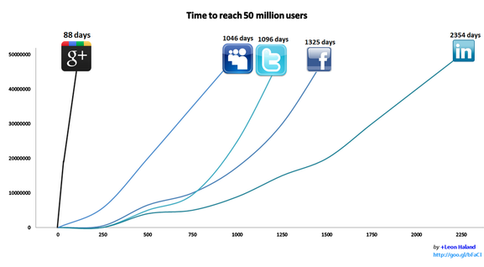
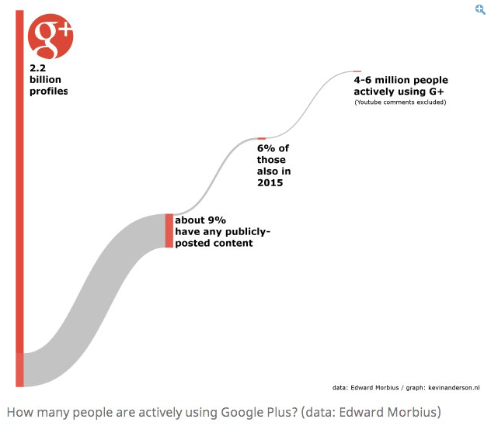

References
Beese, J. (2016, February 16). Why You Should Stop Asking Is Google Plus Dead. Consulted on November 25th, 2016 on sproutsocial: http://sproutsocial.com/insights/is-google-plus-dead/
Brown, A. (2013, March 5). Is Google+ a failure? Or does it still remain to be seen? Consulted on November 25th, 2016 on Quora: https://www.quora.com/Is-Google+-a-failure-Or-does-it-still-remain-to-be-seen
Eadicicco, L. (2015, April 26). Business Insider. Consulted on November 25th, 2016, on Why Google+ failed, according to Google insiders: http://www.businessinsider.com/what-happened-to-google-plus-2015-4

Fiergerman, S. (2015, August 2). Inside the failure of Google+, a very expensive attempt to unseat Facebook. Reviewed on Mashable: http://mashable.com/2015/08/02/google-plus-history/#PcRWc8gIikqJ

Gillette, E. (2015, June 18). Why Google Plus Failed. November 25th, 2016, on Youtube: https://www.youtube.com/watch?v=7UBIcdut1ew

Hinckley, D. (2015, October 15). Is Google+ a failure? Or does it still remain to be seen? Consulted on November 25th, 2016, on Quora: https://www.quora.com/Is-Google+-a-failure-Or-does-it-still-remain-to-be-seen/answer/David-Hinckley

Wright, T. (2015, April 7). What The Unofficial Death of Google+ Means for Marketing. Consulted on November 25th, 2016, on Marketing Land: http://marketingland.com/unofficial-death-google-means-marketing-122696

