|  |
| --- |
| College Lasalle |
| INFRASTRUCTURE PROJECT |
| Building a multi-platform network for Contoso, Ltd. |

|  |
| --- |
| By Iman Vaghefi, Ayman Mohamed and Franz Paulusz |

**Page 1 – Title page and team members**

**Page 2 – Network topology**

**Page 3 – Infrastructure summary and implementation**

**Page 8 – Project notes and conclusion**

**INFRASTRUCTURE DIAGRAM**

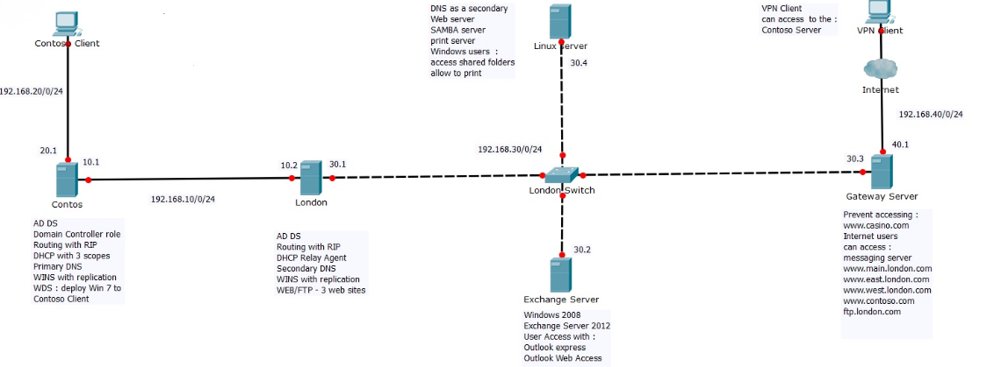

**INFRASTRUCTURE SUMMARY AND IMPLEMENTATION**

Over the past two months we have created a topology that caters to the networking needs of a company called Contoso, Ltd. Using VmWare software and virtual machines, we have been able to put forth an organized system composed of several servers, clients and their respective protocols to ensure a thorough, functional and seamless use of company resources spanning two geographical branches and three segmented networks with a synchronized database of users each with their access needs carefully taken into account. We will now approach, machine by machine, the specific roles, technologies and protocols that have been implemented to meet the specific requirements of the project’s instructions.

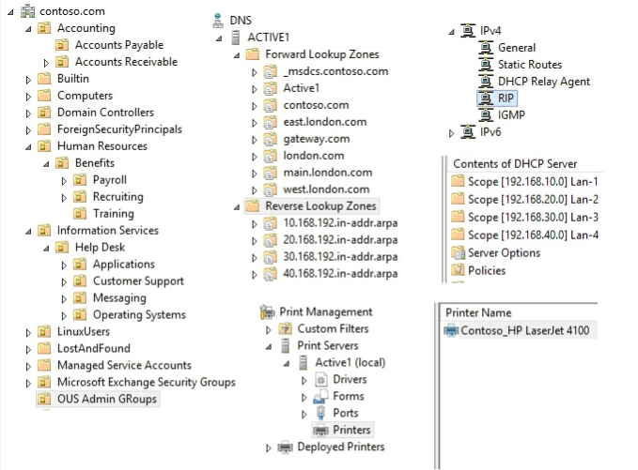

**Contoso.com** will be the first server we present. It hosts the main Active Directory Domain Services and holds the Domain Controller role. The figure above shows the various services present on this machine (note that these are multiple screenshots put together, not one program window). It hosts the primary ACTIVE1 DNS service, a three-scope DHCP role, an HP Laserjet 4100 printer server and has an implemented RIP routing protocol. Contoso.com also features a WINS server as well as a WDS to deploy the Windows 8.1 ISO/OS to Contoso clients, as pictured just below.

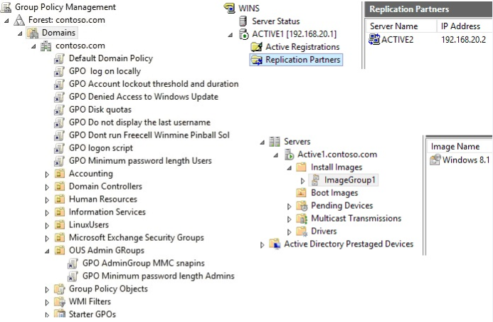

The network also contains another Windows Server 2012 R2 machine with the host name **London.com**. It also has its own DNS and RIP services, but features a relay agent for the DHCP server and a secondary DNS, all of which are displayed below.

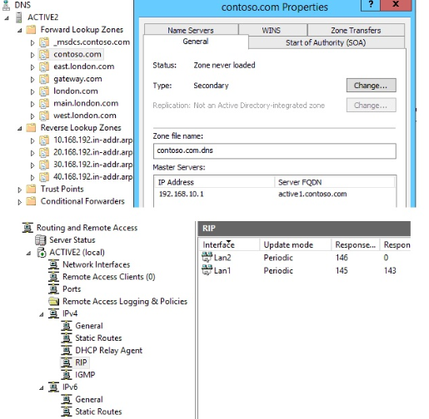

This particular machine also hosts a Web server with three different websites: east.london.com, west.london.com and main.london.com. A CentOS version 6.7 ISO is also included in London.com’s FTP server, ready to deploy the Linux Server included in this project. All of these are pictured below. A WINS service is also installed to map the company’s host names to network addresses.

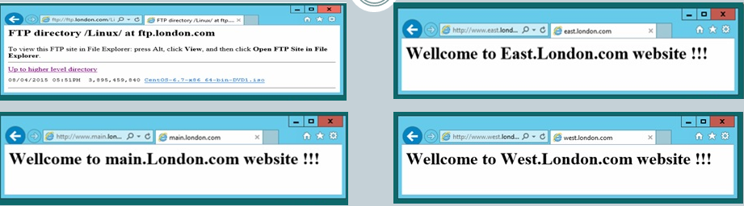

A **Contoso client** has been deployed using the Windows 8.1 ISO mentioned earlier. It was used to test out not only the domains’ websites and FTP files but to gain access to the Linux Server-provided file shares and network printer which will be discussed later. The client’s IP address was provided through the DHCP service, as pictured below.

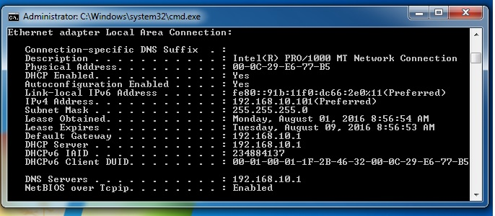

The company also has a **Gateway Server** that acts as the main VPN point of access to the network as well as for the Internet, though it prevents access to certain websites ([www.casino.com](http://www.casino.com)). Internet users can also main.london.com, west.london.com and east.london.com as well as the Messaging Server here, pictured twice below.

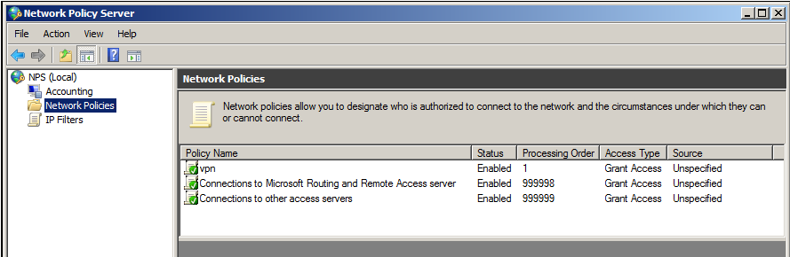

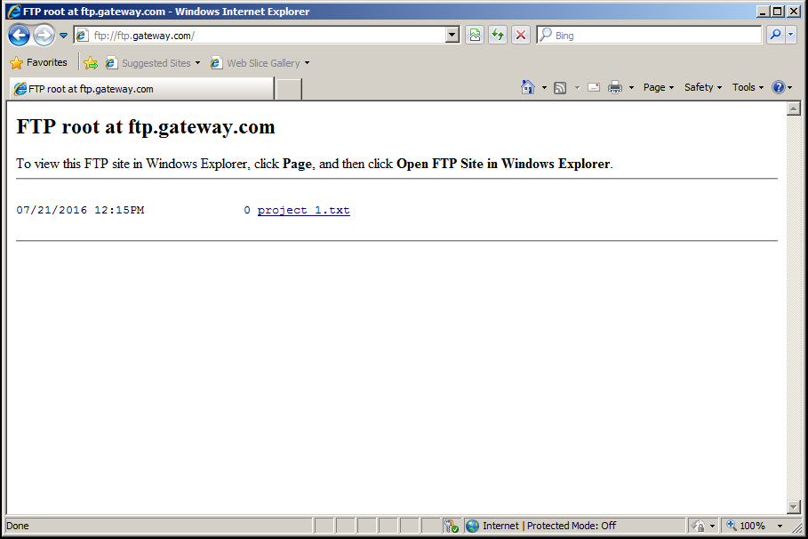

As the name would imply, the **Exchange Server** manages the mailbox server for all of the company’s users on a Windows Server 2008 operating system with Exchange 2010 installed and can send and receive mail from all sites in the entire organization. Outlook Express and WebAccess have been included in the implementation for the staffs’ convenience. Below you may find proof of these services.

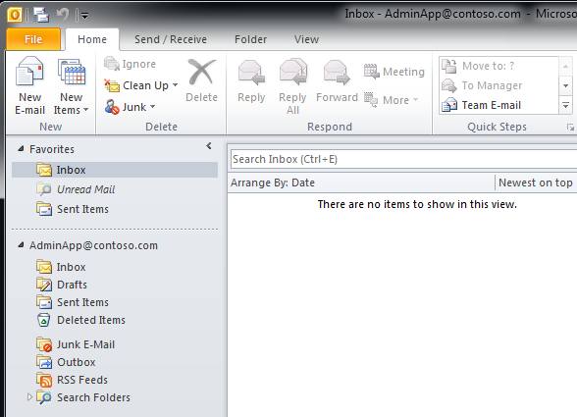

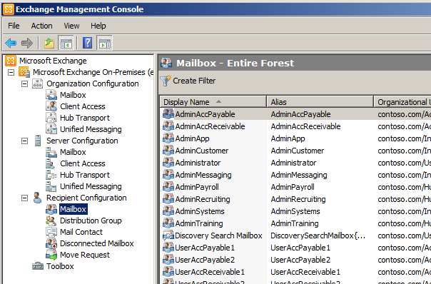

The **Linux Server** provides various services to the organization including an Apache Web Server to access Linux’s own website and FTP folder. It is also used a secondary DNS server for the Contoso domain and as a Samba server, providing clients with network shared folders and a network HP Laserjet 4100 printer for domain users to utilize, managing their print jobs and queues. A Windows 7 client had been put up to test domain users’ access to these Linux-based services, as is shown in the screenshots below.

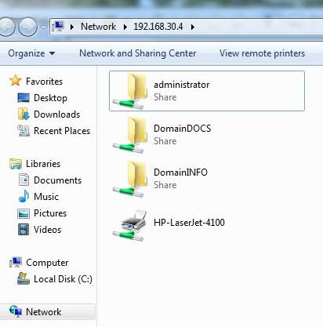

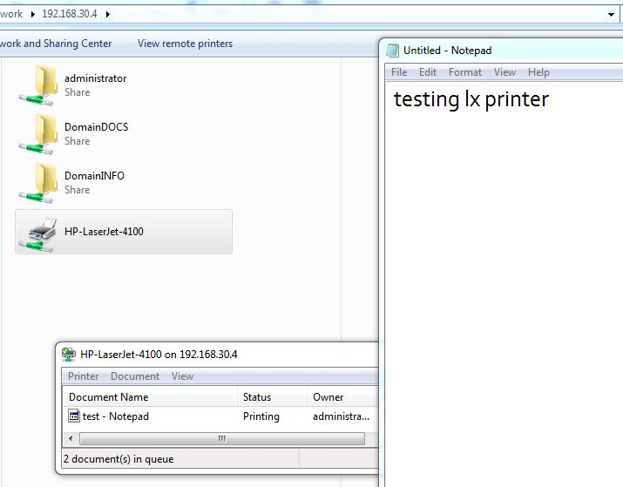

**PROJECT NOTES AND CONCLUSION**

There were occasional complications in building this network, like the time we clean-installed the Linux Server rather than deploy it through Contoso’s FTP ISO for the CentOS version 6.7 distribution, which was due to a misinterpretation of the given instructions. Testing every user in the domain and their permissions and restrictions in the domain, on the clients and on the network resources was quite daunting, as their respective GPOs’ given by their domain controllers sometimes conflicted. The access they had to their network files, provided by the Linux server, was not perfect, as we had missed out on giving each user their own user file on the network share.

We’ve put in countless hours into ensuring that our network functioned perfectly and that all services were up and running. Despite the occasional hiccup we troubleshot and fixed all of our issues thanks to the practice from several of our courses in the past year. Indeed, the Client and Local Network and WAN Implementation, Active Directory, Microsoft Exchange and Linux Network Administration courses have all played an instrumental part in achieving the tasks involved in the infrastructure project. For that we are proud to have taken part in the program and clearly see as well as anticipate the kind of work we will be facing in our professional lives in network administration.

Thank you,

*Iman, Ayman and Franz*