Hilarie Djagli
Sales and Communication
410_DL4_AS gr. 08066

Final Project Report

Presented to Mr. Donald Provençal

LaSalle College
March 20th, 2019
Table des matières
Section I 3
Introduction 3
Section II 4
Functions and Responsibility of WeBelong 4
Management 4
HR & Operations 4
Finance 4
I.T developer 4
Marketing & Sales 5
Section III 5
Manager contribution to everyday sale 5
Planning 5
Decision-making 6
Organising 7
Leading 7
Controlling 7
Section IV 8
Manager role after sales process 8
Quality ISO 9000 8
Consistent action and documentation of a manager role in everyday sales 9
Ensure each stage is self-explanatory and easy to understand. 9
There are identifiable differences between each stage 9
Beware of company risk 10
Section V 10
Dashboard 10
Bibliography 11
Reference documents 11
Websites 11

Section I

Introduction

The level of international students ‘depression is increasing every year. According to Canada Broadcasting Corporation (CBC) survey, about 70% of university student struggle with loneliness and depression during their school year. Living and studying in a new country can be difficult logically, by having a supportive social system nearby relieve international student from feeling isolated. International students face different kinds of challenges on campus. It is not easy to find comfort in a foreign land, you have to get use to the currency, the culture and even change sometimes your way of living, therefore, it is easy to have homesick. You will miss thing you finds comfort in and will be stock with unfamiliar things. Every country is different and each of them comes with their rules and regulation. To do some activities you will need legal documents and sometimes you don’t find your way around to get those documents. As international student of Lasalle College, since we ourselves went through the same struggle, we team of five came up with a cooperation that could solve those problem.

WeBelong is a One Stop referral service (guichet unique) dedicated to facilitating the integration of international students into our society. We provide information on how to navigate through bureaucracies, where to find convenient housing and how to sign a lease. Through celebrations, we implement a divest culture from all other nations into students. Based on canvas business model, our major sources of income are from our subscription fees, referrals, sponsors and business platforms. We are associated with colleges and universities of Montréal, local business to provide jobs for students and insurance company. WeBelong mission is to give each international student a home away from home. By engaging students through events participation and special assistance we eliminate the challenges that students face in a new country and provide a home away from home. In this report, the five functions and responsibility of the team will be described in detail. Explain how a manager could contribute to the sale process of the organization. Describe the duty of a manager after-sale through the seven principles of ISO 9000, the principle that helps businesses to be a success.

Section II

Functions and Responsibility of WeBelong

Management

Management is a major role in our business. As a service company that deals with customers on a daily basis, there is major decisions to be made and a lot of managing to do. The manager determines the right direction in which to develop the business, work closely with all departments in order to meet deadlines, engage with partners and shareholders. The manager overall help push the business to new horizons. Manager creates a better workplace to it, employees, build a culture that employees will feel comfortable spending their time at work. Additionally, a manager job is to keep reminding it team about the mission of the organization. The WHY of the business, company’ culture can be a loss once the Why is forgotten.

HR & Operations

The Human resources department has different functions in the company. It is responsible for recruiting, training, developing compensations programs, employee benefits and most importantly dealing with the legal responsibilities of the company.
In our case, the Operations manager ensures that the company runs well and makes sure that every employee is efficient in their job and meets the required expectations of the team and of the members. In addition, human resource needs to provide feedback to all employees by evaluating their performance, give training regularly, write a good job description and hirer the right employee for the post.

Finance

The Finance department has a crucial role in this company. It manages costs, drafts a budget at the beginning of each year, makes sure that every amount spent is accounted for and keeps shareholders updated on the financial aspects of the organisation with detailed reports and balance sheets. For the company to have a new opportunity, the financial manager needs to be consulted before any decision. The finance manager needs to work closely with the other managers, especially the marketing department and the manager. An advertisement is a big cost on business but a business has to advertise before their message gets to their customers and this is when the marketing manager meet with the finance manager to determine the budget the organization could afford in terms of advertisement.

I.T developer

The I.T. developer plays a vital role in the company. WeBelong depends heavily on technology. Our main online platforms are the website and the mobile phone application. The one in charge of this department will be working on fixing any potential security error, continuously improve and implement new functions on the website and mobile application, making it more user-friendly and convenient for users. WeBelong collects client personal information and the I.T. developer duty is to come up with great software to keep that information confidential.

Marketing & Sales

Marketing & Sales plays an essential part in our company. Through this department, we are able to understand our target market in greater depth. The marketing & sales department studies the market & competitors through primary and secondary research to optimize the efficiency of the services we provide and cater effectively to the needs/wants of our target audience. By studying & analysing the target audience, competition and market, we are then able to select an appropriate pricing strategy, differentiation strategy & distribution strategy in relation to customer purchase habits. Marketing role is understanding the market, the needs of the customers and find a way to communicate those needs to the customers. Moreover, the marketing manager has to work with human resource development in other to agree on the sale pitch that the service representative communicates to customers. The same way if there is any other change in the marketing department has to send it to change to the human resource as quickly as possible.

Section III

Manager contribution to everyday sale

Planning

Planning is one of the primary functions of a manager. Planning is just one of the process to determine the near future activity. When it comes to managing time effectively, writing down your next action determine the kind of result you get for every decision. Planning comes with many role and responsibilities, it is one of the basic activities of each manager. Planning reduces the risk of a start company. As the manager of WeBelong, my role in the sales process is to detail each department reasonability and tasks that they need to fulfil at a specific time. For example, communicate often with the financial manager to decide if the business is ready to take a new opportunity, then have a plan the perfect time to conduct this activity. For example, before WeBelong start operating I plan our daily operation planned accordingly with the milestone. All the permits that we need to apply for and how long it will take before we move to the next task. Each task is detailed.

Fig1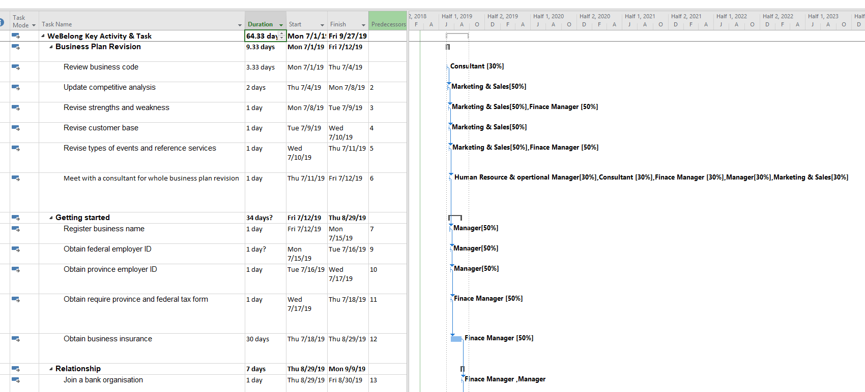

Decision-making

Decisions play an important role in the life of a manager. Decision making is a process of analysis before executing an action. Work with the marketing manager to decide the best sales pitch that could get the attention of customers. Marketing department communicates directly with their customers, they know what is new in the market and the profile of your customers. This department communicates through different aspect such as emotions, psychological and their esteem. Thus, they are the best to formulate the right sales pitch that our sale representative is going to use. Moreover, to establish a new project, I need to consult with the management department because they have a clear idea of the need of the customer. They need to agree if the project corresponds to the brand of the organization, the market of the company, and correspond the profile of customers that the company has.

Fig 2

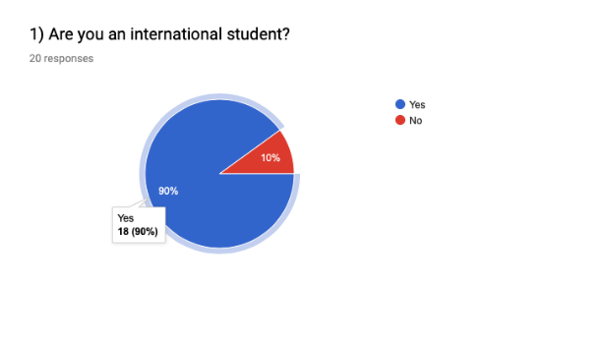

This is a survey that I ask the marketing department to at a booth that LaSalle College organized for business students in their final year to sell their idea of the project to their fellow students. To determine if we need to target LaSalle College as one of our partners, we decide to offer a survey that will determine if it is true whether the college has more international students as we imagine. Out of 20 people that agree to take the survey, 18 respond to be an international student. These figures demonstrate whether we will make a profit by having LaSalle College as our partner.

Organising

Organizing at a level of starting a company involved in developing the organizational structure. There are ways of deciding the best organizational structure for a business. This process includes organizations function and customer relationship. This is a process where you need to decide which department in the firm needs to work together and how the communication needs to flow within the organisation. It is important to strike a balance between the need for each worker, the need of the shareholders and the need of customers. I apply for all this role as manager in my final project in order to design WeBelong structure. A leader must be organized it is the only way your employee will become organized as well.

Leading

Leading is by making appropriates decision and divide appropriates tasks to all your team members. I make sure I put a deadline on each work in order to keep up with the other team. I make sure I fill out all the forms handed by our teacher accordingly and on time. I must balance the team emotion and make a positive decision. Confidence and trust also play a big role in leading my team, by having confidence in oneself the team also feel confident in trusting your decision. It is important to provide information to your team and keep them information about the project and the industry trend. It is important to be persistent in a sale, a manager needs to make sure the organization keeps its sales standard for every month or year. With WeBelong, it is important to set a minimum amount of international student we should have with a supplier at a specific time.

Controlling

Controlling involves ensuring that performance does not deviate from standards. To control the activities in an organization, a manager needs to take necessary actions to ensure if each department is consistency to their work-related and are participating in achieving the organizational goals. To have effective control, a manager needs to have a performance indicator that measures the responsibility of each department and identify where they started deviating from their standards. A manager job is not only to measure and control employee responsibility, but a manager needs to keep track of the customers the organization is gaining each year and how much their losing. It matters to have a detail sales objective that your team need to achieve at a certain time. Make a quick decision whenever there is an opportunity to create a new strategy to manage the team sales and increase it. Key activities and selling objectives are created with rules in place and entered as many data into CRM (Customer Relationship Management).

Section IV

Manager role after sales process

For a business to survive through time, the need to dedicate and have a commitment to their costumers if the need to remain in business. To have a successful business, an organization must apply the principle of ISO 9000

Quality ISO 9000

The quality the service offers to customers determines if your customers trust your company. As an organization dedicated to helping international students, the application of ISO 9000 is fundamental. It is primary that business responds to customers need. The more you focus on your customers the more revenue a company acquire. For example, at WeBelong, our primary activities are with the clients, there are no manufacturing process or product design, we interact with clients on daily basis, therefore, focusing on our clients' needs determine the future of the organization. If we determine the right needs of the target customers of the organization, we will find the right activity and service that will make them happy.

Fig 3
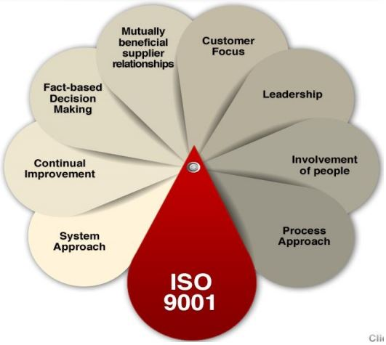

Leadership is crucial in an organization, but good leadership is a necessity for the development of a company. Great leadership make communication between department flow easily. Communication is the key to accomplish a good business relationship. To accomplish a great sale process and after-sale for our customers, our employees need to be happy in the organization, a happy employee gives great service. Our objective is to give a home away from home to all our clients, and if our employee does not feel at home, they cannot offer that home to our client.

Mobilize, motivate and engage of employee prove the involvement of people in an organization. Give a direction to accomplish a good sale for your employee. Motivation is important in achieving a goal, motivate employee by raising their salary, a better way to get a commission.

Engage employee by giving them feedback, show them how well they have to improve and how much they need to improve. In our team, we reward our employees based on customers feedback. We train them how they need to improve and way in with they can keep up with changes in the organization.

Process Approach: this is the process of managing companies’ resources. This means the quality management of resources to reduce cost. At WeBelong we organize events for international students and those events need to be well with quality events products. Events need to be delivered at the right time without delay, and we need to prevent anything that might go wrong on the events. The delay of an event might put us into debt.

The management system is an approach that needs to improve in an organization. Group of managers could come together and sort problems on their own. By improving the management system, customers and suppliers’ approach can be managed effectively. For example, in our company, the human resource manager office is open to every employee whenever there is a problem. The management office is open, and it is never close to every employee starting to the customer service representative to all managers.

We are dedicated to the client’s satisfaction, that is why we will keep improving the service we give to customers. Improving our service is the way we gain loyalty client. We value all customers feedback and if something goes wrong with our service, we try to improve until the client gets satisfaction.

All decisions need to be made on fact in an organization. A business that does not make a logic decision is a business that is built on assumption and hope to succeed. If sales are looking bad it means something is going wrong in the organization sales process or the business structure needs improvement. As WeBelong start operation, every decision the management will be double check and approve on fact research. This contributes to the sale process because once sales start looking down, something must be off the chart it may be an employee bad customer service or the way the management system operates. This will require research and a piece of concrete evidence that decisions will be based on.

Supplier Relationship matters in building a successful business. A good supplier relationship plays a role in the revenue of the company. Without a supplier, a company is unable to run. As we start operating, WeBelong will treat their supplier with respect, not only as a supplier but as a customer.

Consistent action and documentation of a manager role in everyday sales

“The right process” it is important to verify whether the team is in line with the sales process without any deviation. Verifying process of sales gives you the opportunity to see if your team need more insight training or outside knowledge. Next is to verify if your competitors have a new training approach and a new sales strategy.

Ensure each stage is self-explanatory and easy to understand.

Check with new employees the selling objective process of the organization. Make sure you have a clear and understandable approach of which each department will follow. Furthermore, it is important to explain each department sales objective based on their responsibility and title. If each employee doesn’t understand the differences between each stage of the sales process, this could hurt the business in a way that your customers may not understand the concept of your business in a unique way since each sale representative will tell their own understand of the business.

There are identifiable differences between each stage

It a manager duty to identify each department tasks and details the Importance of each stage of accomplishing their duty. A manager should also be logically clear on when to take an opportunity to the next level. For example, if you think your business is ready to take a new opportunity, a manager should know the process before the opportunity and after the opportunity is to establish and have a follow-up. Every stage needs a different approach, in a stage where you need to the hirer, you must analyse what types of employee profile fit with the new opportunity. If any resource needed to accomplish the project, does your team need training, what can of training they need?

Beware of company risk
Companies run into risk at the daily basis of operation, it is impossible to avoid risk. We take a risk every day. A manager needs to calculate and evaluate risk before deciding if it is worth taking. Here is some risk that our organization may consider. One risk that may occur has to do with a shift in the market as the population of international students coming to Montreal may change, therefore affecting our operations either positive, negatively or neutrally this could affect our revenue stream. That is why we must implement another source of income to help the growth of the organization.

Section V

Dashboard
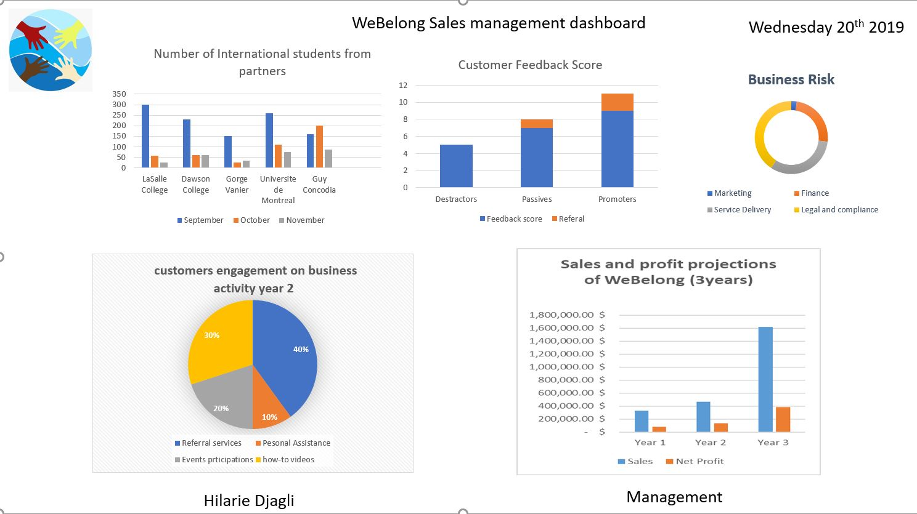

Bibliography

Reference documents

Donald, Provençal lecture LaSalle College Omnivox, Customer Service, Course No: 410-DJ3-AS Class 4

Business Plan of WeBelong_ final project _winter 2019

Websites

ISO 9000 – Quality management
http://www.shahienterprises.com/pages/iso/standards/iso9000.php

Emily Hill _ISO 9001 : 2015-3 tips for choosing KPIs
https://quality.eqms.co.uk/blog/iso-90012015-what-kpis-should-i-track

Canadian Bureau for International Education
https://cbie.ca/media/facts-and-figures/

Prima resource “THE SCIENCE OF SALES” by Frederic Lucas
https://www.primaressource.com/en-ca/blog/roles-of-a-sales-organization

Chron Why is quality important for a business by Sampson Quain
https://smallbusiness.chron.com/quality-important-business-57470.html

