College LaSalle
Project - P55 - Internet Programming I User Manual
Presented to: ………… …………

Author: Eduard Haurylchyk
4/20/2015

Website SLH company.
The SLH company is a transportation company that organizes shipments around the Canada.

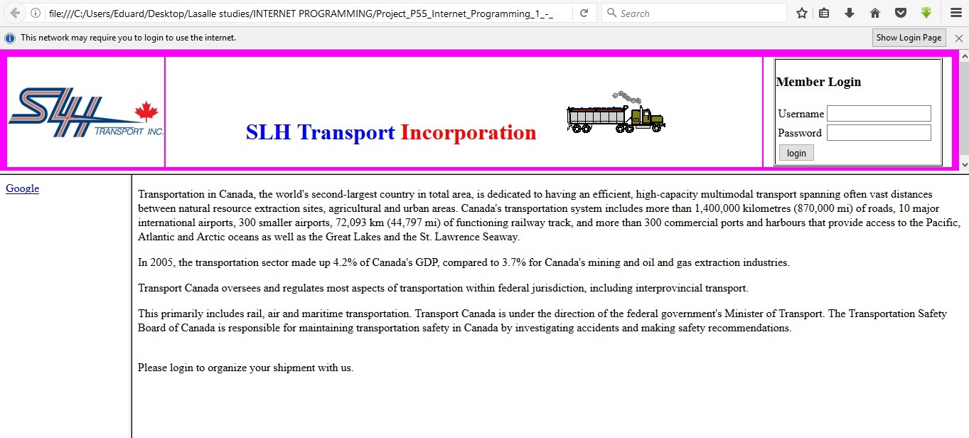

- Enter your Username and Password in order to enter to my web site. (admin, 12345)
If you will enter wrong data, you go to the page where you will be able to create login,or return to the previous menu.

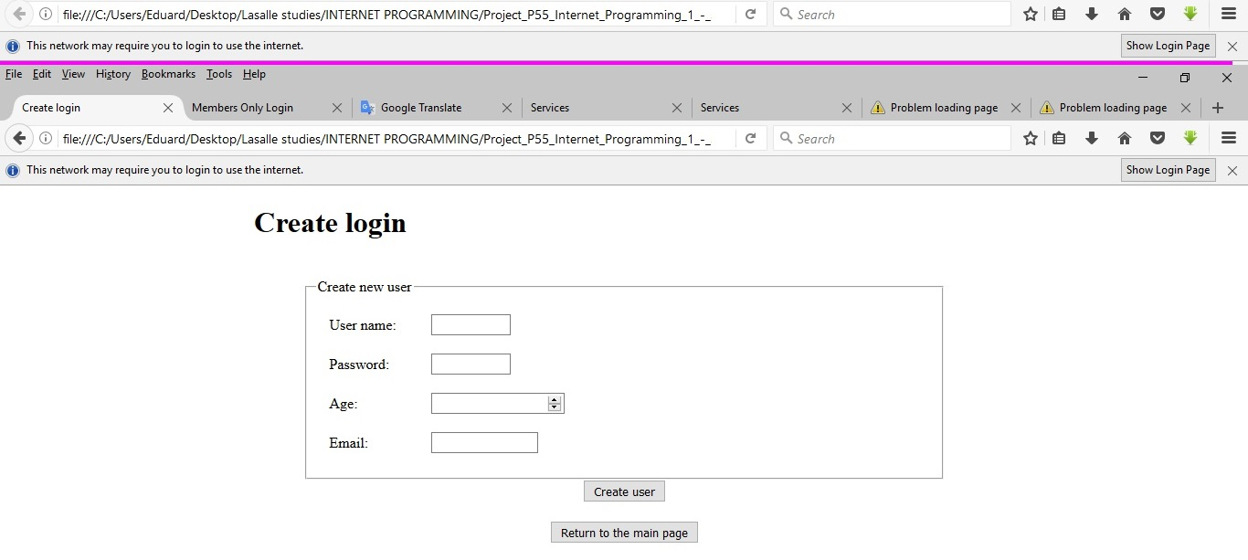

- Then you go to the main page of the logged in user.
Click on one of the links on the wright to have access to different applications.
Page gives description of the main business directions of the company. When you hover, a text box pops up.

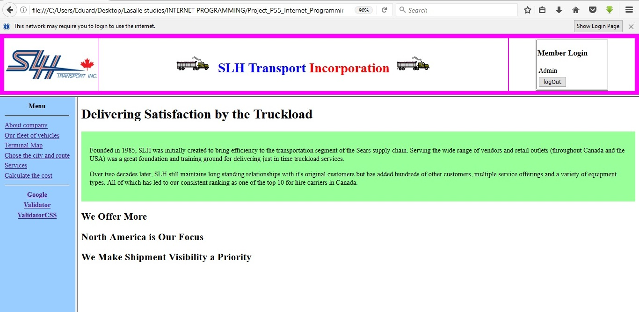

- If you click the link of Google, another web page will open, giving you the possibility to search on the internet.

- To validate web pages like: XHTML or CSS (programmers only), you have to use one of those two buttons under the link Google.

- Page gives the list of all types of vehicles what can be used, according to the type of cargo, which can be chosen.
Allows to select type of transport according to type of cargo.

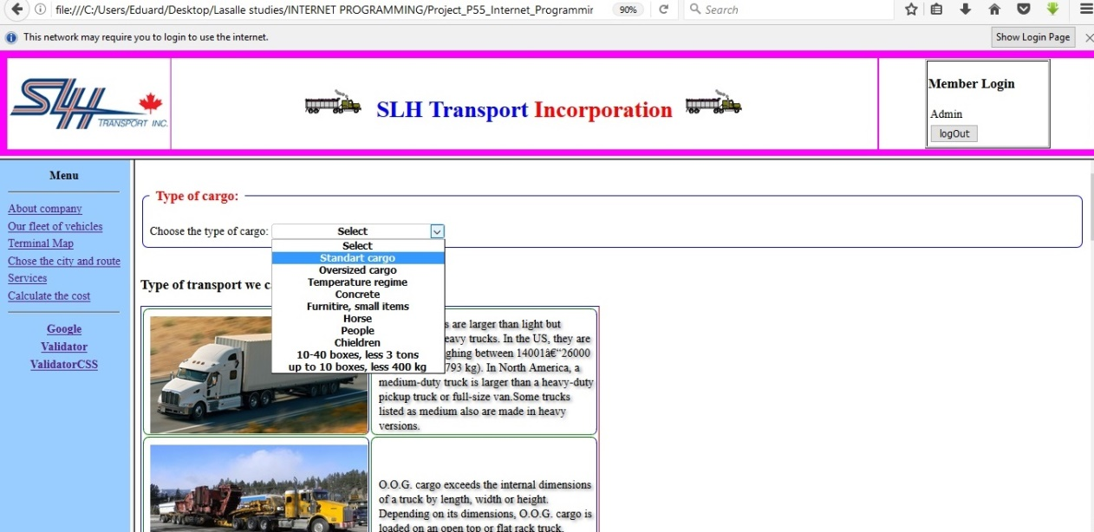

- This page allow to display the contact data and the map of the every terminal and the region.
Used the map of Canada for displaying the terminals in various cities of Canada and the terminals in the selected regions. When clicking on necessary region, the data is displayed with the use of pop-up window.
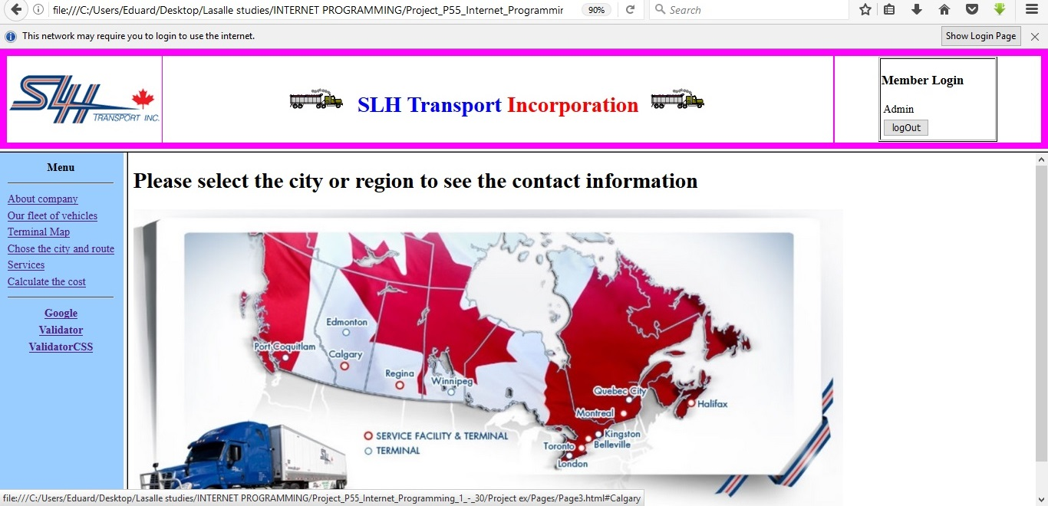

- This page allows to select the necessary type of service: Carriage and Terminal services. When service is selected, the hidden addition data is displayed, that allows to calculate the delivery and terminal zone for different locations.
Depending on the chosen route, or location, the zone type differs.

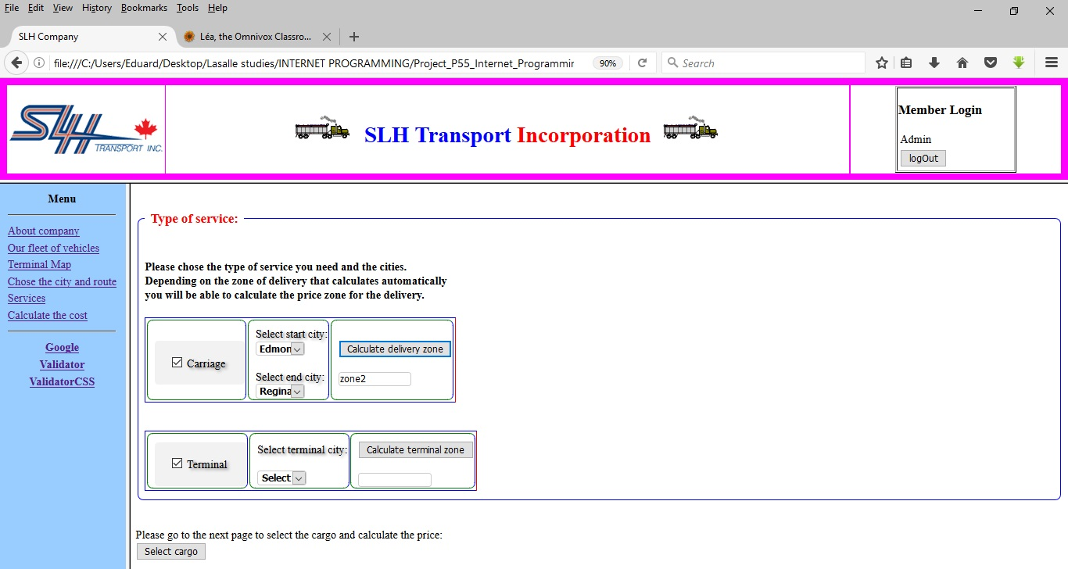

- This page allows user to select the type of cargo, the quantity of trucks, the quantity of days at the warehouse, to calculate the total simm of money.

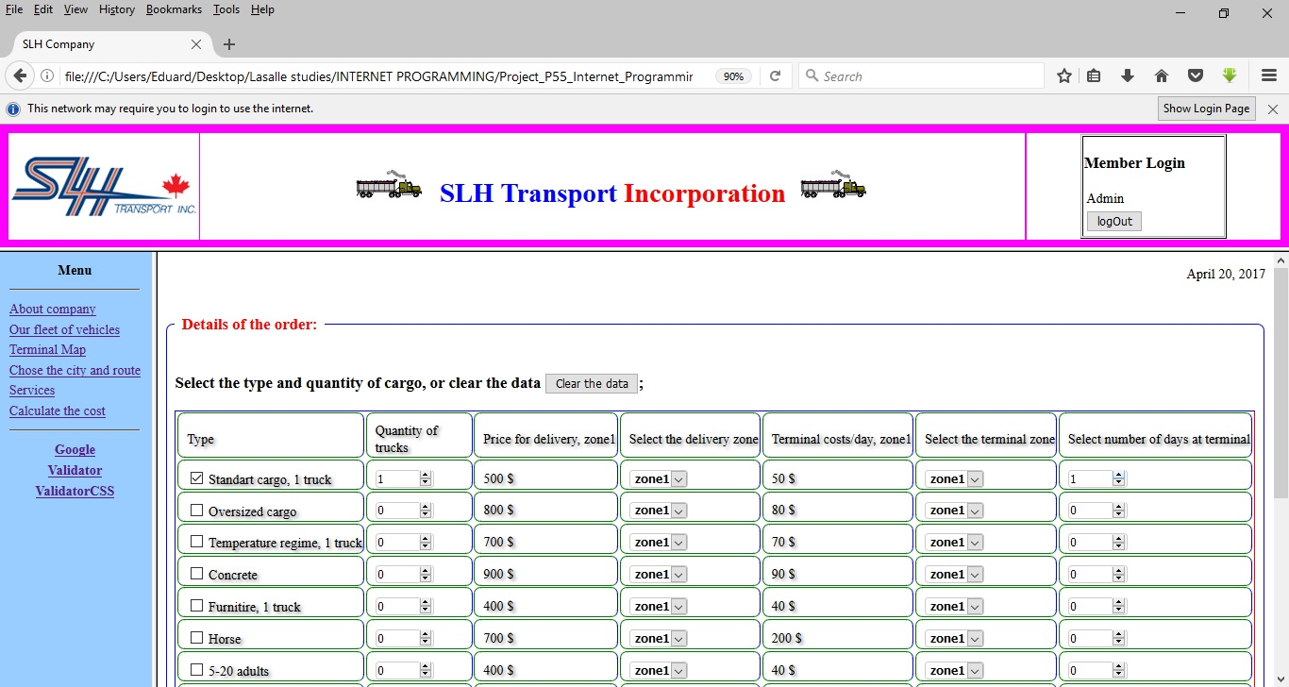

- After calculating the summ and chosing Calculating with taxes you go to the next page, where you can chose the currency USD or CAD.
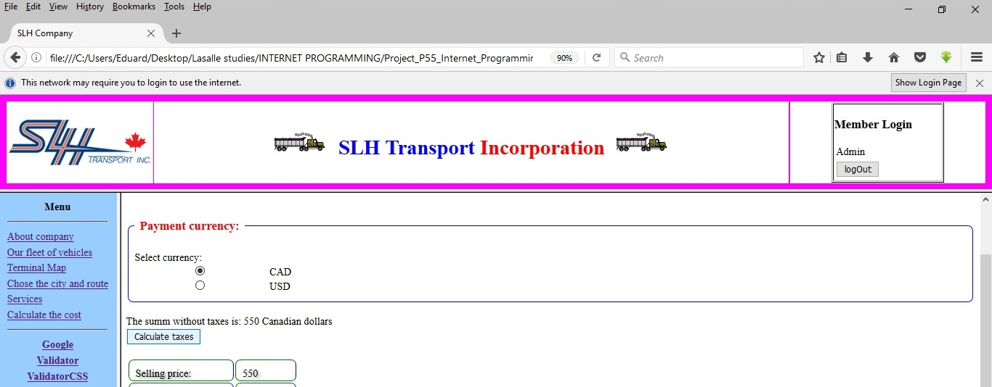

- If you chose the currency like the Canadian dollars, you can get calculation by coins.

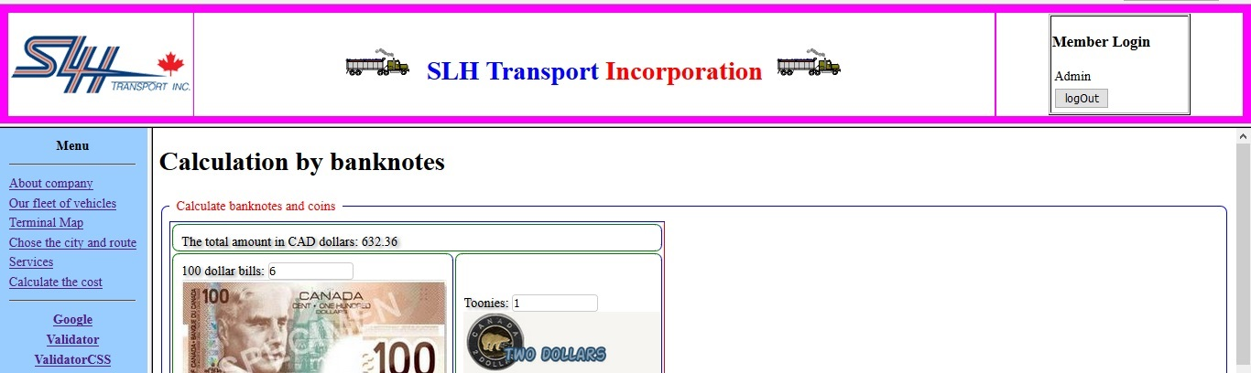

- If you wouild like to proceed with payment, you can enter credit register your credit card on the last page. If the data is incorrect, the message show where you are wrong.
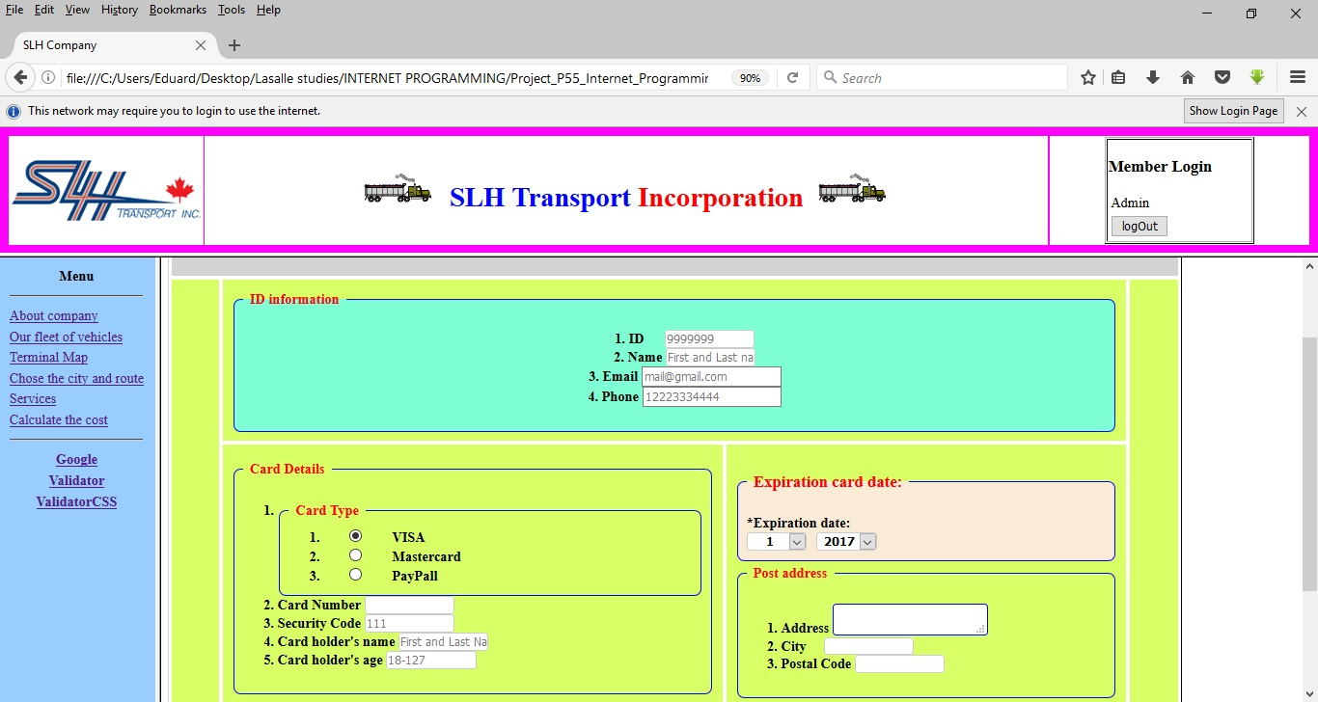

We hope that you our instructions were helpful for you.
If not, you can call to any of our office.

