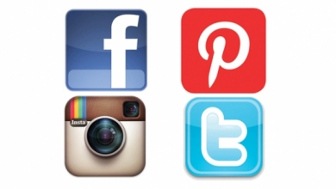 ONLINE

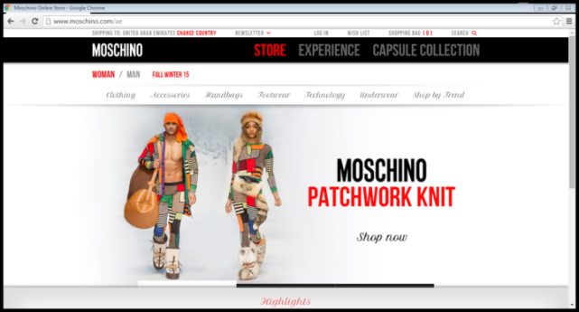
The Moschino webpage offers visitors to shop the new and older collections. As well as shopping, visitors can also view the Moschino fashion shows by selecting the “experience” link. They can also view capsule collections. There is also the opportunity to make a wish list and sign up for the Moschino newsletter. The bottom of the website features new or products that are considered “highlights”.
There are links to all of the Moschino social media platforms that can be accessed by clicking on each one.
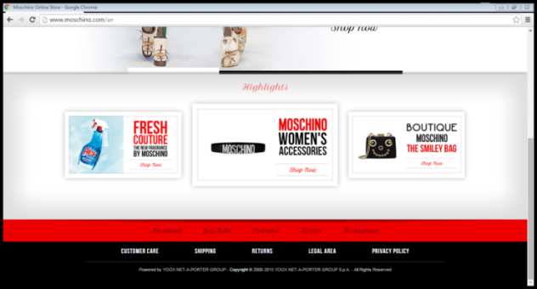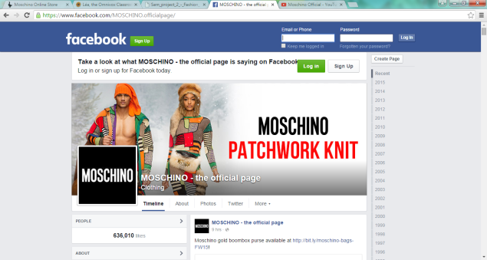
The Moschino Facebook page features up to date advertisements and promotion campaigns featuring models bloggers and other celebrities such as Katy Perry and Madonna. They post content once or twice weekly. These post get between 200-3000 likes and between 11-3000comments depending on the post.
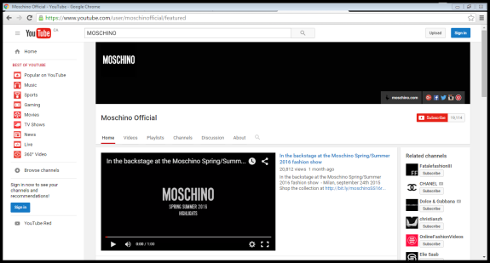
The Moschino Youtube channel features the latest videos from the design labe. The content posted on this channel consists of recent ad campaigns , behind the scenes videos, interviews with celebrities and Jeremy Scott and full fashion shows. The videos attact more viewers depending on the content and who is featured in each one.
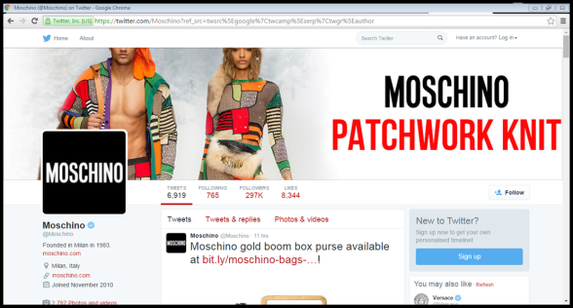
Moschino on Twitter is similar to the Moschino Facebook page. The tweets feature links to new and popular products. Some are retweets from celebrities wearing Moschino apparel. Tweets can also contain links to videos and other advertising and promotional content. Moschino sends an average of three tweets each day . The retweets and favorites vary depending on the content within the tweet.
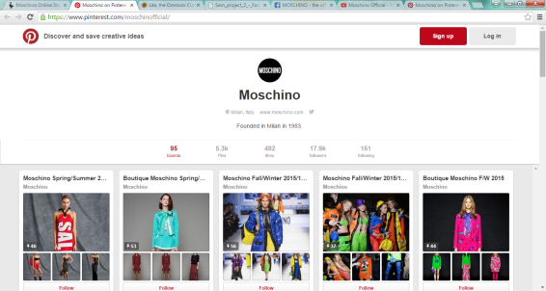
On Pinterest, users can view full Moschino collections, as well as various pictures from the design label. The boards are organized by the season of each collection. Users can pin a picture they would want on their board for inpiration. The Moschino Pinterest account contains 95 boards.
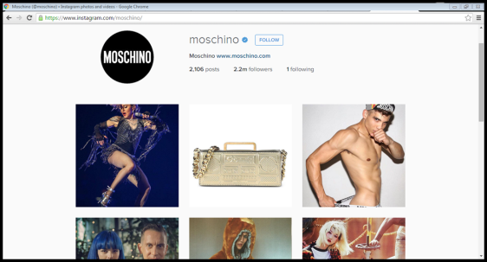
Instagram is the most popular platform for Moschino with 2.2 million followers. The posts are frequently the same as the posts on Facebook and Twitter in addition to reposts from different accounts, without the ability to retweet or share.

