Ziye Meng_____________ 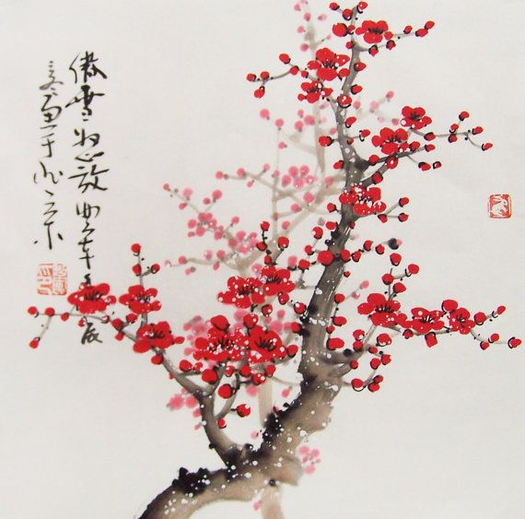
Monday, January 17th, 2018
Jason Wu
240 West 35th Street, 11th Floor (Head Office)
New York, NY 10001
7-1 Qingnian N St, Shenhe, Shenyang, Liaoning, China (Branch)

Dear Ms.Pepe:
Allow me to introduce myself. My name is Ziye Meng and I will be graduating from Lasalle College's Fashion Marketing in Montreal Canada at this upcoming January. I have been pay attention on Jason Wu's collection since the year of 2006. Mr. Jason Wu has always been one of my favourite designers for the luxuary women's wear in US. I am very interested in doing an unpaid 3-week internship with your company to learn about the culture of the company and even-planning as a whole.

As a Fashion Marketing student, I would like to describe the word fashion as a worldwide art. A master piece brand must be known by people from all around the globe. I currently study Fashion Marketing I plan on attending Parsons Fashion & Design College in NewYork to further my study. I have traveled to many different country during my study les. Travelling is my life. I have attended several fashion shows in Beijing, Paris, Toronto, and Tokyo and connected with people who are part of this industry. I also attended Jason Wu's new book singning: < Mom I love You> in Taipei in 2014. I was so inspired by Jason's childhood story and the love for his mother.

I would greatly value the opporunity to do my internship woth you as I am a fast learner and i love working with different people. Thank you for taking time to look at my resume. Please to feel contract me by email: ziyemengsmu2013@gmail.com and call me :XXXXXX It would be a true honor for me to meet you in person. I will be contacting you within next few days.

Sincerely:

Ziye Meng

