Renaissance
Italian (Women) |  | Tudor/ Reform (Men) |  | Spanish/Counter- Reform (Women)
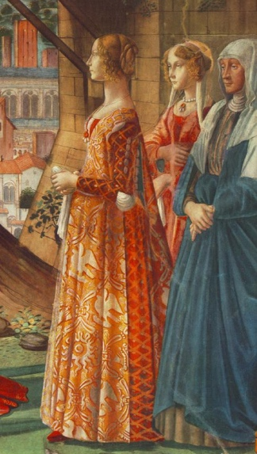 |  | 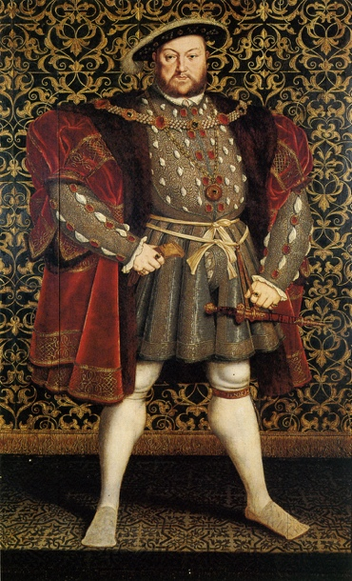 |  | 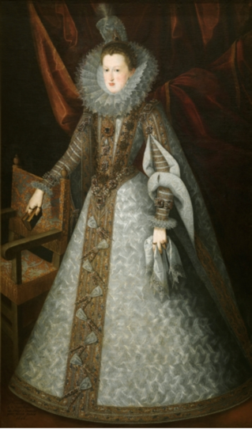
Garments and Accessories | Description | Garments and Accessories | Description | Garments and Accessories | Description
Cotta | long dress, fitted bodice, flare skirt, open neck, sleeves attached to bodice with aiguillettes | Chamarre | Square shaped, knee length jacket, with wide shoulders, fur lined, short sleeves expose doublet’s sleeves | Dress | -Seperate bodice and skirt.  -Shoulders and waist lengthened with tabs  -Whalebone stays – corps piqué – fitted bodice (separate from skirt) with pointed end (front) busc  -Floor-length, pointed sleeves with padded shoulder rolls  -Skirt + underskirt are wide and stiff at bottom, supported by a conical structure: vertugado/ farthingale
Aiguillettes/points  detail function: used for lacing and bouffant | allow to see camicia underneath; soft and colors | Jerkins | slashed, sleeveless vest, worn over, and same length as doublet; sometimes, panels are added below waist, creating a peplum effect
Camicia | Linen chemise worn under dress | Satin doublet | Short, waist length jacket, pleated and/quilted, with aiguillettes/ points at attach hose and codpiece | Hourglass silhouette | Remains but volumes shift  Fabrics are heavily decorated with slashings and jewels
Giornea | long sleeveless dress, open front (and sometimes sides) with lacings, not belted, sumptuous fabrics | Chemise | The smocked edge (ruff) of the chemise is visible around the edge of the doublet’s neck opening, and sleeves | Ruffle and fan collar | Removable collar, starched, with regular round folds create honeycomb effect, it eventually trans
Hair and headdress | soft curls, some frame the face, the rest is loosely pulled up in back in a bun, embellished by braids, pearls, and jewels  hair is lightened to a Redding blond (sun + lemon juice) | Breeches + knitted hose = codpiece  detail function: show off their shapely legs, suggesting athleticism | Breeches are knee length and wide  New knitting loom allows for better adjusted hose; codpiece becomes seduction item, size =virility | Attifet | Curled hair, top of forehead is plucked to get heart shape
Shoes | women wear leather shoe covers with wooden platform heels up to 18”/45cm high, called  chopines | Beret | Wide flat hat made of soft wool or velvet, often decorated with fur or feathers | Jeweled aiglets (ribbon tips) with silk ribbon
jewelry | Gold, silver, precious stones, jeweled headbands worn in headbands | Duck bill or bear paw shoes | Flat leather, with slashings, and wide, square toes

Spainish/Counter – Reform | Modern Fashion
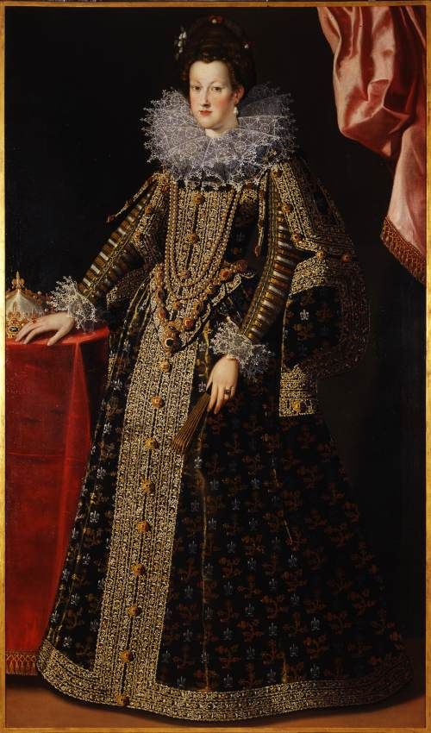 | 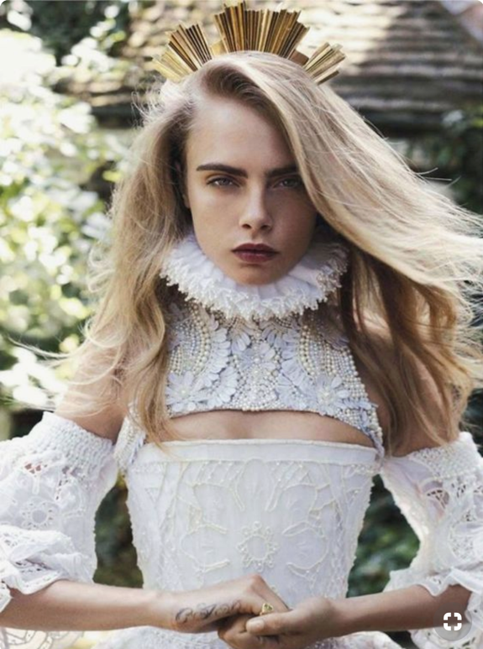
Common elements:
Ruffle and fan collar: Removable collar, starched, with regular round folds create honeycomb effect, it eventually trans

Sources:
- Italian
http://persephonemagazine.com/wp-content/uploads/2011/10/late-15c-fitted.jpg
- Tudor/ Reform
https://www.museodelprado.es/coleccion/obra-de-arte/margarita-de-austria/70ef34ef-320c-475b-9a65-053c43c7322f
- Spanish/Counter- Reform
https://www.museodelprado.es/coleccion/obra-de-arte/margarita-de-austria/70ef34ef-320c-475b-9a65-053c43c7322f
- Modern Fashion
https://www.fashiongonerogue.com/cara-delevingne-channels-royalty-vogue-australia-shoot-benny-horne/
- Spainish/Counter – Reform
http://www.artearti.net/magazine/articolo/C_era_una_volta_le_donne_al_potere/
- Information: Smithsonian, Fashion The Definitive Of Costume And Style, First American Edition, 345 Hudson Street, DK publishing, October 1st 2012.

