Erika Polichronis, Manal Hamida
Job Task Analysis
571-KQD-03 gr.04040

PROFILE PROJECT– “Nancy Richard” – “Nancy Richard Productions”

Nancy Richard (Left), Erika Polichronis (Right), Manal Hamida (absent during interview)

Presented to Mrs. Yolande Nesseth

LaSalle College
April 1th, 2020
Contents

0. Business card---------------------------------------------------3
Introduction:
- Introduction of Nancy Richard------------------------------------- 3 - 4
- Introduction of Nancy Richard Productions -------------------- 4 - 5
Discussion of This Job Function:
- Organizational Chart----------------------------------------------- 5
- Individual’s Positioning-------------------------------------------- 6
- Formal Job Description------------------------------------------- 7
In-depth Profile of Individual Being Interviewed:
- Professional/Educational Background ------------------- 8
- Importance of Technology----------------------------------------- 7
- Professional Accomplishment(s)----------------------------- 8
- Role Model(s)---------------------------------------------------- 8
- Biggest Lesson(s)--------------------------------------------------- 9
- Recommendation(s) & Inspiration---------------------------------------------- 9
- Internship---------------------------------------------------------9
- Thank You Letter ------------------------------------------- 10
Bibliography------------------------------------------------------- 11

- Business Card
Nancy Richard does not have a business card at the moment. She explained how she does not have the time to develop a new one ever since her career change.

Her Contact Information:
Name: Nancy Richard
Company: Nancy Richard Productions
Title: President
Email: Nancyrichard@Live.ca
Tel: 1+ (514.966.4181)

- Introduction

  - Nancy Richard
Nancy Richard, founder and director of “Nancy Richard Productions”, has been involved in the fashion industry since 2004. She has worked with several well-known individuals during her time as both a professional stylist and event coordinator (ex: Jean-Paul Gaultier and Christian Provost). Ms. Richard has always been affiliated with the fashion world. While not wanting to be at the forefront of fashion shows, Ms. Richard has chosen to be in the background, having studied in Fashion Marketing at “Cégep Marie-Victorin”. Ms. Richard did not intend on being a stylist during her studies, but she developed an interest through exposure. She worked as a stylist for fourteen years until late 2019 when she changed career paths.

  - How Contact was made
I was fortunate to have stayed in contact with Ms. Richard. We met a few years ago when she was co-head coordinator/stylist for a fashion show I participated in. At another opportunity, she offered me a brief contract as an assistant and dresser for the “Festival Mode & Design” in Montreal. When the interview assignment was given, I immediately thought of Nancy Richard as the ideal candidate. I was thrilled when she accepted right away, saying that she would love to collaborate on this project with me and Manal.

  - Location
Ms. Richard does not work in an office, preferring to work from home and occasionally at a local café. The interview was conducted February 11th at “Café Neuvé”, a small establishment with three stores in downtown Montreal. Manal had messaged me a day before the interview, saying that she was unable to attend. Despite the unexpected cancellation of my peer, Nancy Richard and I had a pleasant discussion surrounding her overall career in fashion. (Duration: 9 a.m. – 10:15a.m.)

Online site: https://www.cafeneve.com

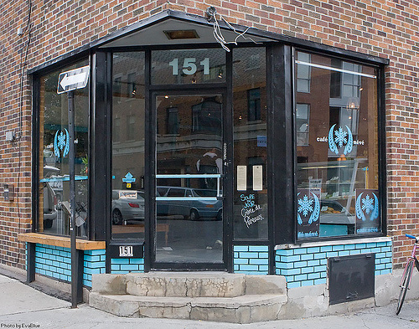
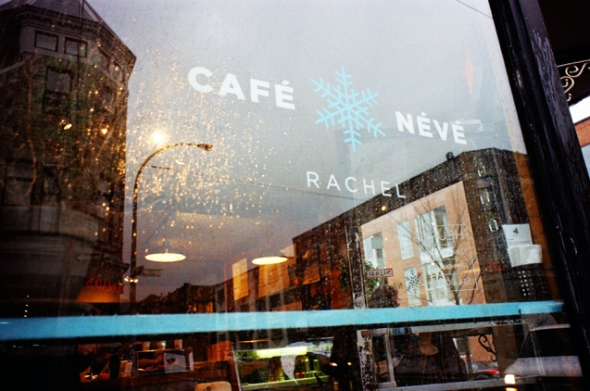

  - Nancy Richard Productions
Created in 2004, Nancy Richard Productions is an event planning company that mostly specialises in the creation and development of fashion shows and various fashion related events). Occasionally, the company partakes in non-profit events, such as “Les Décousus de Certex”
Additionally, at the end of the month (April 30th), the company has organised MuUla’s annual retreat (Nutritionist company). She hires employees under contract for the specific event.

Other than event planning, Nancy Richard takes on small contracts in-between the two big contracts she has with “Groupe Sensation Mode” (February to August) and
“Le Festival Mode & Design” (Yearlong contract). These less time-consuming jobs include: Photoshoots for a fashion magazine (i.e. LOULOU Magazine) or brand (i.e. VINCENT D’AMÉRIQUE) and other non-fashion related events (i.e. MuUla’s annual retreat)

Position in the Channel of Distribution
As an event planning company, Nancy Richard Productions is an “Associated Player” in the Fashion Industry’s channel of distribution.

Physical Setting
As previously stated, Nany Richard works from home or at a nearby café. We met at “Café Neuvé” to conduct the interview.

Mission Statement
The company is currently developing their mission statement.

Target Market
Nancy Richard Production’s target market are primarily fashion organisations and fashion designers.

- Discussion of Job Function

  - Organizational Chart

  - Nancy Richard’s Positioning
Ms. Richard’s role during the annual “Festival Mode & Design” in Montréal is the “Chief of Operations”. She works on the development of the festival as early as February. Her primary tasks include (but not limited to):
- Assists in designing the layout of the venue
- In contact with the board of directors
- Budget management
- Link between artists and the production - marketing – sales teams
- Monitors the execution of each task
- Overseas the development of each mood board (relating to the Fashion Shows and other stands)
- Coordinates the staff and officials
- Assists in hiring lighting and sound crew
- Sits on the judge’s panel during the modelling auditions
- Hires Staff (i.e. dressers, make-up artists, hairdressers, stylists)
- Organizes Photoshoots and Fashion Shows
- Supervision of pre-production of the event as well as during the event
- Backstage during each show, making sure the models are ready to walk on the runway

  - Formal Job Description

FESTIVAL MODE & DESIGN MONTREAL
JOB FUNCTIONS

Office/Division/Department:
Positions Supervised: N/A
Reporting to: Board of directors
Employee Name: Nancy Richard
Position: Chief of Operations
Purpose of Job (Job Scope): Responsible for organizing, mobilizing and,or coordinating the staff, event participants, officials as well as administrators for the success of the annual FMD.

Major Responsibilities and Duties  The responsibilities of this position include, but are not limited to, the following: | % Time
- Management  - Logistical management throughout event: tracking deliverables, liaising with vendors, and service providers  - Assists in searching of the event’s venue  - Budget management  - Supervision of the production process of the event  - Overseas the development of each mood board relating to the different groups participating in the event  - Monitors the progress of the planning and execution of each task  - Hires staff (ex: Dressers)  - Attends the audition & casting of models walking in the event  - Manages post-event evaluations  - Organizes/Overseas photoshoots & fashion shows  - Miscellaneous Management (process, regulations, PO & others) | 70%
- Communications  - Communicate to artists and artisans their schedules & additional information  - Communication link between artist, the production, marketing and sales team | 30%

- In-Depth Profile of Individual being Interviewed

  - Professional & Educational Background
Ms. Richard completed her diploma in fashion marketing at “Cégep Marie-Victorin”. She then went into the job market. In 2004 she founded “Nancy Richard Stylist” (Has since changed to “Nancy Richard Productions”) She was dresser and assistant stylist for many years, eventually she made it big when she under Jean-Paul Gaultier in Paris. From then on, she was offered bigger contracts as a consultant, head stylist and head coordinator.

  - The Importance of Technology
Technology is an essential daily tool for Nancy Richard. She emphasized how it was beneficial when it came to long-distance business meetings (i.e. if ever she does business with a client from
another country, she would be able to contact them through: “Facetime”, “GoToMeetings or “Google Hangouts”). Evidentially, the practicality of email has been useful.

  - Biggest Accomplishment(s)
Ms. Richard hesitated to answer this question, saying that many accomplishments have significant. Nancy Richard revealed that the government of Canada had hired her to spearhead a project relating to Shanghai Fashion Week 2019. She was selected guide six Montreal designers to Shanghai, where she organised a large fashion event promoting Quebec designers. Other notable accomplishments that she mentioned included:

-The creation of “Nancy Richard Productions”
-Being the Program Director for URBANI-T
-Her relationship with the board of FMD

  - Role Model/Mentor Important to the Individual
Ms. Richard has stated she does not have any role model/mentor important to her (no one that comes to mind).

  - Biggest Lesson(s) Learned
Ms. Richard revealed that the biggest lessons she learned in her fifteen years of experience in the industry was to never wait for an opportunity and to stay true to herself. She elaborated by stating that when entering the job market, she did not wait for potential opportunities, she sought to create them, explaining that, had she not had that attitude, she would not be where she is today. She described an experience where she called a potential employer, however the receptionist always said they were busy. One day, she went to the head office and waited until the employer arrived. She then met with him and eventually was hired. During the slower month, being the beginning of July and August, she would call clients herself for any job oppurtunities.

  - Any Recommendations?
Ms. Richard didn’t have any recommendations. However, she stated that she is “inspired” by designers who show diversity in their collections, using Jean-Paul Gaultier (with whom she once collaborated with) and Marc Jacobs as examples. She also expressed that she does not exclusively get inspired by designers but also from diverse experiences and travels to different countries.

  - Internships
Ms. Richard does in fact hire interns. She explains that she is willing to accept internships for event planning (i.e. Fashion shows & events relating to fashion), however she does not take any interns for styling, since she is a full-time event planner/coordinator. Those interested in the possibility of interning for Nancy Richard, may contact her at Nancyrichard@live.ca and include their curriculum vitae.

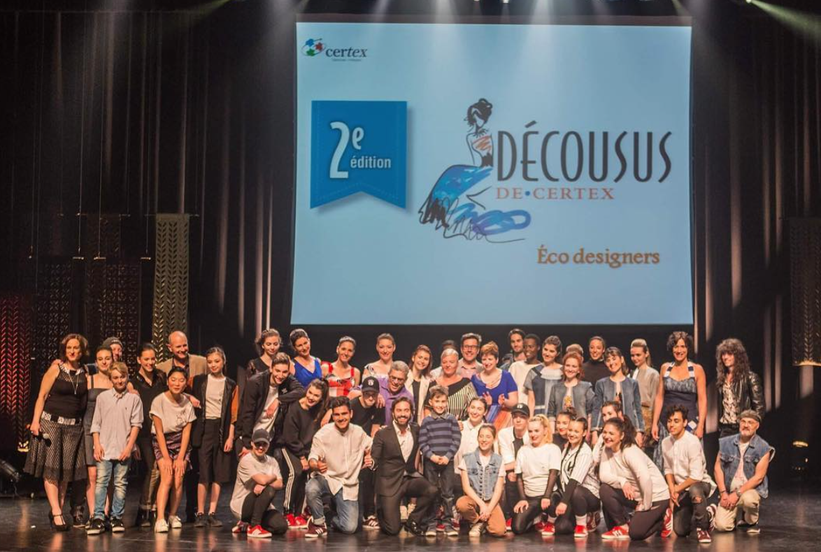
For Fun:
First time working with Nancy at my first “fashion show” in 2016. I am on the left side, looking like Shrek and Nancy is behind the woman in the center of the picture.

- Thank You Letter (Email)

Erika Polichronis
Thu 2020-03-26 08:00
To: nancyrichard@live.ca

Dear Ms. Richard,

I hope you are doing well.

Manal and I would like to thank you for taking the time to work alongside us during these past few months. I had a wonderful time conducting our interview last February. It was great reconnecting with you! Although we had to cancel your presentation in front of our peers, the information that had been already given was plenty.

We are appreciative of your cooperation and understanding throughout this whole process. With your heavy schedule, you still found time for us and answered all of our questions, which was greatly appreciated. I hope we’ll be able to work together once more at the annual “Festival Mode & Design” this up-coming August!

Many Thanks,

Erika Polichronis and Manal Hamida
438.497.3397

Bibliography

Festival Mode & Design
https://festivalmodedesign.com/en/about-us/

Café Neuv
https://www.cafeneve.com

URBANI-T
https://www.urbani-t.com/about-us

MuUla

http://muula.ca/a-propos/

Linkedin

https://www.linkedin.com/in/soukaina-faouzi-478417137/?originalSubdomain=ca

