Profile project-Elizabeth Duguay
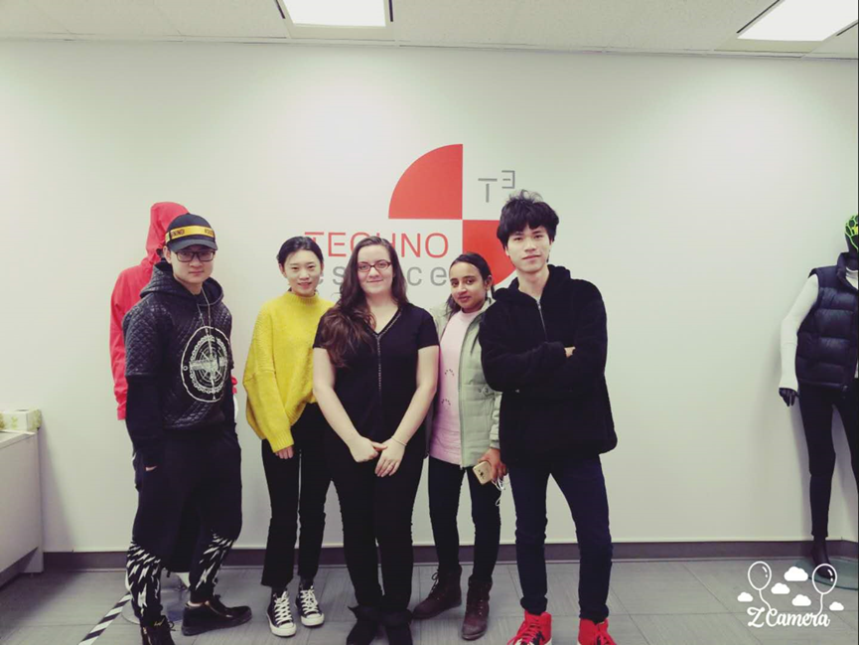

Fashion marketing
Mrs. Nesseth
2018/2/13

Contents
Business card---------------------------------------------------13
Introduction:
- Introduction of Elizabeth Duguay------------------------------------- 3
- Introduction of Techno-Espace (Mission statement, target market) ------------------------------------- 3-5
Discussion of This Job Function:
- Organization Chat----------------------------------------------- 6
- Individuals Positioning-------------------------------------------- 6-7
- Formal Job Description------------------------------------------- 8-9
In-depth Profile of Individual Being Interviewed:
- Professional/Educational Background, and What Leads Her to This Position---------------------------------------------------------- 10
- Importance of her role----------------------------------------- 10
- Professional Accomplishment----------------------------- 10-11
- Role Model---------------------------------------------------- 10
- Biggest Lesson --------------------------------------------------- 11
- Recommendation---------------------------------------------- 11-12
- Intern--------------------------------------------------------- 12
- Thank You Letter/Card------------------------------------------- 13-14
Reference------------------------------------------------------- 15

Introduction:
INTRODUCE INDIVIDUAL:
Ms. Elizabeth Duguay, laboratory technician in College LaSalle. Ms. Duguay Studied at LaSalle college; she finished 3-years program of Fashion Design, 3-years program of Technical design, and 1-year Man’s Wear Design. After that, she went to work in Lillianna Lingerie as a sales person for 5 years. Now, she works for Techno- espace in LaSalle college as a laboratory technician. Before she had a chance to apply for this job, LaSalle college offered her the position.
The way that we made contact with Elizabeth Duguay was by Ms.Nesseth’s recommendation. Because of her recommendation, the interview was easily accomplished, and it took place at Techno-Espace in LaSalle college (2000, rue Sainte-Catherine Ouest (Bureau 6000)）

Introduction of Techno-espace:
Before we introduce the Techno-espace itself, we should know something about Techno-espace’s supporter-LaSalle College.
LaSalle was opened in the late 1950’s, and “LaSalle International’s first educational establishment opened its doors in 1959. It all started with the LaSalle College located in the LaSalle borough of Montreal. Mr. Jean-Paul Morin is the founder of the College. This Canadian entrepreneur's mission is to create job opportunities for the Quebec population by providing education that is in line with job market demands. (Lasalle, )
Techno-espace opened in the late 2010’s. The reason that the program was established is because LaSalle College wants its students to be “instilled with a true understanding of their future professions.” Techno-espace’s mission is to share its expertise and offer courses tailored to provide a new generation of qualified workers in the technical and specialized clothing industry. (Techno,)

MISSION STATEMENT
Techno-espace is a resource center “tailor-made” to meet your needs. Their status as an independent laboratory allows them to be objective and impartial in their research, analyses, and recommendations.

PHYSICAL SETTING
The complexity of the process of designing technical and specialized products requires a multidisciplinary scientific approach. By combining expertise and technology, Techno-espace is able to offer a complete range of RD&D and product V&V (verification and validation) services, in addition to prototype and assembly testing. They also have consulting services which include the drafting of technical specifications and assistance in evaluating responses to calls for tenders in the uniform sector. (Techno-espace)

POSITION IN CHANNEL OF DISTRIBUTION
In Techno-espace, the main distribution channel is the MFR/Designer. Techno-espace are not
raw material suppliers because their materials are bought from other companies. At the same time, they are not distributors because they do not sell products, they only design products with special materials.

Target Market:
The most important thing for the target market is audience determination, and marketing channels. In Techno-espace there are two target markets. The first target market is concentrated on students; it is a non-profit business which is to educate student and try to give students an environment that they can learn how does Technical Design works. The second target market is for profit, and it is mainly for the people or cooperative that has need for their products. For example, they have designed waterproof jackets，heated jackets and they have also worked with the military and the police.

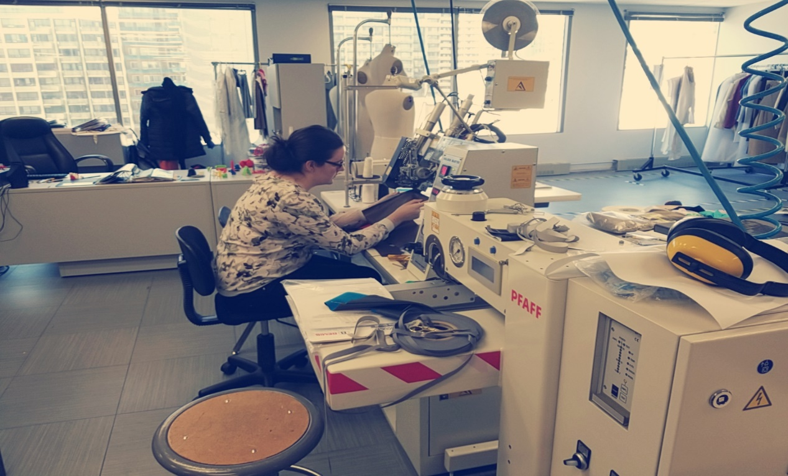

Discussion of This Job function:
Organization Chart:

For Mrs. Elizabeth’s group, the Organization Chart for Techno-Espace is down below:

President of international group: Jacque Marchand

Fashion school director: Francois Bousquet

Product developer: Nicole Voyeur

Laboratory technician: Elizabeth Duguay

As a Laboratory technician, Ms. Duguay has to keep contact with the Fashion school director and her boss. She usually must report to them once a month. The report is usually about: how the contract was going, which equipment was used ( and how often) and if there is any equipment broken.

Individual’s positioning:
Basically, what Elizabeth Duguay does as a Laboratory technician in Techno-Espace is to take care of different equipment and make sure all the equipment works well. Also, she and her group research how to “increase product functionality and optimize product performance.” Which means they must develop the product for different functions. Another task is to write a report for the Techno-espace for different situations. Also, she has the responsibility to show visitors (not only students in LaSalle College) how to work with different equipment. Furthermore, she helps student’s in Fashion classes to provide the information they need. For example, she provides material information for students in their 4th year of the fashion course’s projects. Moreover, Elizabeth’s group frequently make a contract with some of their cooperation partners and design for them. For example, they have cooperated with the army and designed their uniforms in 2016. The pattern of the uniform and its function had already been decided. What they needed to do was to use specific materials and equipment to make sure the function of the uniform worked as to what the army wanted.

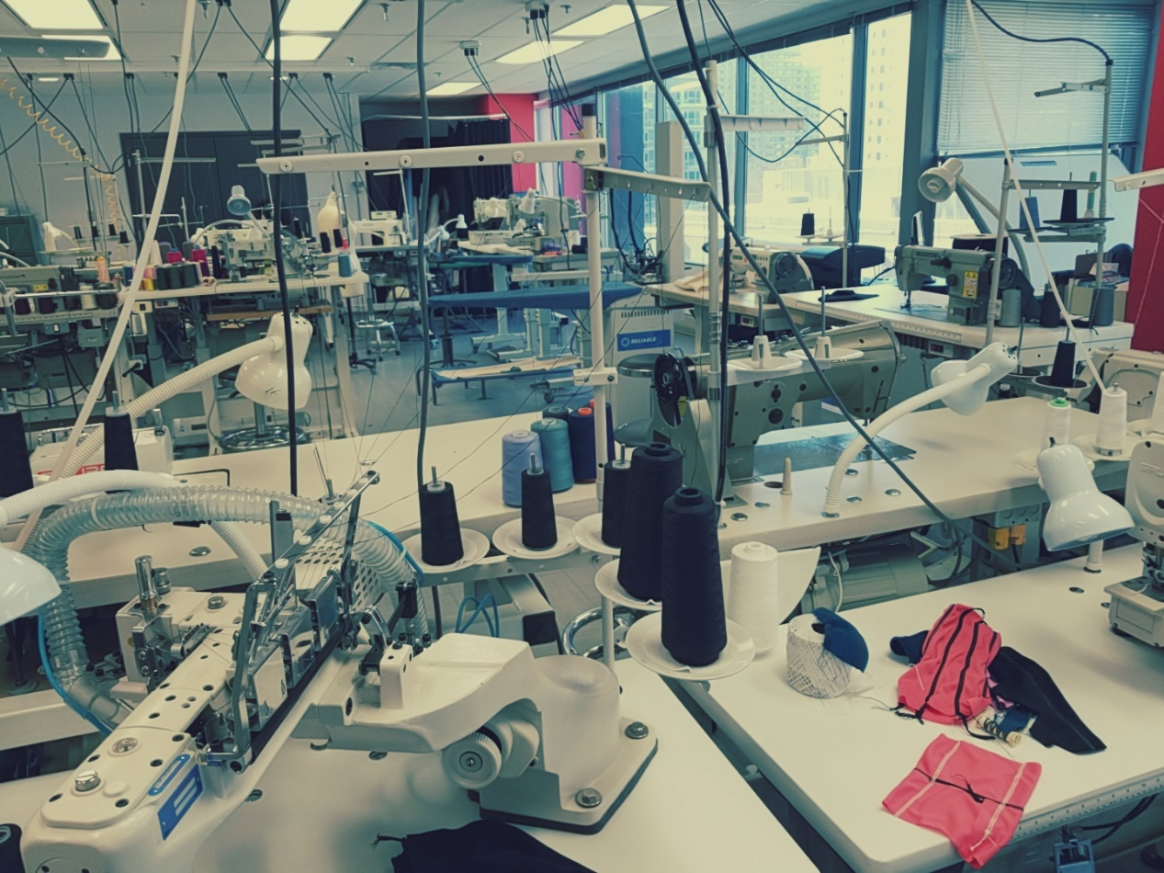

Format job Description:
Techno-Espace
Laboratory technician
Office/Division/Department:
Employee Name: Elizabeth Duguay
Positions Supervised: None
Reporting to: Product developer
Position: Laboratory technician
Purpose of Job: The Laboratory technician is responsible for Manage equipment, and help student in Fashion classes (Especially for the students in Technical Clothing Designer).
% Time

50%

15%

Major Responsibility and Duties
The responsibilities of this position include, but are not limited to, the following:
1. Management:
- Equipment and technology (needs assessment, evaluation of new technologies, testing and capacity of laboratory equipment, information retrieval, training on new equipment at the facility for Techno-Espace and LaSalle College)
- Maintenance management (logistics, planning, repair, monitoring, contractual agreement, cleanliness and security of premises, cleanliness and safety of equipment, etc.)
- Management of student appointments.
- Management of unfulfilled appointments.
- Report writing (Techno-Espace and LaSalle College)
- Meetings (Techno-Space and LaSalle College (teachers, Rémi, François)
- Project Plan (Techno-Space and LaSalle College)
- Miscellaneous Management (processes, regulations, PO, others)
2. Pedagogic:
- Development of educational activities (eg tuque, modular, etc.)
- Educational activities (Laboratory visit, demonstration of machines, training on equipment or others, etc.)
- Use of machines (Student / Teacher)
- Consulting for expertise (eg Manual for Enterprise, etc.)
- Student Special Project (eg Student in fashion marketing)

Time%

15%

20%

Major Responsibilities and Duties
The responsibilities of this position include, but are not limited to the following:
3. CL and Te maintenance:
- Inventory of equipment (LaSalle College and Techno-Space)
- Inventory of Techno-Space Supplies
- Classroom LaSalle College (cleaning, layout, seating plan, various improvement)
- Moving Equipment LaSalle College (mannequins, machines, ect)
- Repair / Identification of equipment breakage (LaSalle College and Techno-Space)
- CSST (compliance with standards, regulations, monitoring, maintenance, inspection, etc.)
- Cleaning and periodic maintenance:
- Techno-Space (the printer, conveyor, specialized sewing machines)
- Purging kettles
- Ironing boards and covers (pattern, sewing, change of cover, etc.)
- Oil change (Techno-Espace and LaSalle College)

4.Other:
- Realization of sample book
- Realization of prototypes
- Realization of patterns
- Events (Fashion Week, Signature, Business, Fashion and Design Festival)
- Promotional activities for LaSalle College (laboratory visit for LaSalle College guests, foreign students, open doors, day students for École de Mode, etc.)
- Techno-Espace and LaSalle College equipment user manual
commissions
- Others (hodgepodge and lost time here and there)

These document is provided by official of LaSalle College in French version.

In-Depth Profile of the Individual Being Interviewed:

Professional and educational background:
For Ms. Duguay’s educational background, she has finished a 3-year program in Fashion Design and Technical Design. Also, she has finished Men’s Wear Design in LaSalle college. Because she has the experience of studying in two different projects, she has a clear understanding of the difference between Fashion Design and Technical Design. Before being hired by LaSalle College, Ms. Duguay was definite that she wanted to pursue the job of laboratory technician, and she really has discovered her niche working in a laboratory and teaching students.
Importance of technology:
Ms. Duguay plays a really important role in her company. Basically, as a laboratory technician, she needs to test the laboratory equipment works well, and she needs to have the professional technology to understand how does each equipment works. Moreover, she has the responsibility to hand in the report about her laboratory. Also, she must present students the information that they need, which means she must have the skills of: manage the appointment, presentation skills, coordination skills, and professional knowledge. For example, she must check if the 3D printer be able to functionate, and she has the responsibility to fix it if it doesn’t work. Anyways, Ms. Duguay have a really important position in her entire company.
Professional accomplishment:
Elizabeth’s professional accomplishment are twofold: She has worked with the army and police in 2016 and in 2012-she even designed an army uniform with her group. She is dedicated; she has helped many students with their projects, using her considerable knowledge of the fashion industry.
Role model:
Elizabeth’s role model is Manual Duran, her former boss. Manual Duran really influenced her, because he is knowledgeable and taught her the concept that everything is functional, and everything has its own reason to exist in this world.

Biggest lesson:
When we asked her what is the biggest lesson in her career as a Laboratory technician, she told us that Her biggest lesson is：“It takes a long time to develop a proper technical product.” Which means we need to be patient with any product development. After we really tried to understand what she told us, we completely agree with her point. Similar to the fashion industry, every qualified product in the fashion industry needs a long development, and those products need their designer to be patient.

Book recommendation:
The book that Ms. Duguay recommends is National Geographic Magazine.
Why does she recommend this book? Because she gets inspiration from extreme environments, helping her to develop new products.
For example，in the desert climate there is less rain, plants find it difficult to survive, plant species and the number of them is extremely scarce，the surface is bare, the air is dry, with little water. Therefore，people in Saudi Arabia choose robes as their main dress to adapt to the year-round hot and humid desert environment. For their robes, they choose those fabrics that are hygroscopic and sporadic, such as linen, silk, cotton, etc. Most of the robe's colors are light colors, mostly white, light blue and light green, to minimize heat absorption in style design, the collar and sleeve opening part of the robes are relatively large, for good ventilation inside and outside the outfit.
A loose robe, can play a role in accelerated air convection, and then at other times, play the role of "chimney" to promote the ventilation inside the robe. human skin is like a large robe cover, blocking the direct sunlight on the body surface, making people feel cool and comfortable. （BaiDu, 2017）
Finally, Duguay said that: In addition to the inspiration she got from National Geographic Magazine, her inspiration also comes from the experience of life, her living environment and her travels.

Interns：
For the internship in Techno-espace, we asked Mrs. Elizabeth:” Is your company interested in giving us some intern opportunities in the future?”. She replied that” It wasn’t planned before”. Honestly, for techno-espace, it is too hard to find someone who has the professional knowledge to help them with their work. In conclusion, there are no internships that Ms. Duguay can provide for us.

Business card:
For Ms. Duguay, she doesn’t have a business card provide to us, and the reason is simple: “It’s wasting paper”. However, we put her basic information down below:
Name: Elizabeth Duguay
Title: Laboratory technician
Company: Techno-Espace Collège LaSalle
Address: 2000, rue Sainte-Catherine Ouest (Bureau 6000) | Montréal (Québec) Canada | H3H 2T2 poste 4224
Phone/E-mail:514 939 4443/Elizabeth.duguay@collegelasalle.com
Website: http://www.lasallecollege.com/about-us/facilities/techno-espace

Thank you letter:
We have written a thank you card and bought a nice gift for Elizabeth, and
The picture is down below.

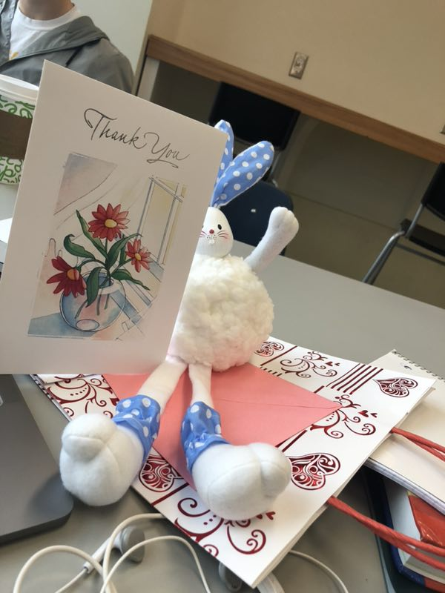

Here is the text copy of our thank you letter:

Montreal，February 09，2018
Fashion marketing class
3530 Notre Dame West ， Montreal，Quebec， Canada
H4C 1P4

Dear Mrs. Elizabeth
We are honored to be able to interview you，and thank you for all the help you have given to us.
We especially appreciate the information and advice about Techno-espace you have provided, and thanks for the special experience you have shared with us. Your assistance has been invaluable to us during this process.

Hopefully, the three times we visited, didn’t bother you. Thank you again for your valuable information.

Sincerely,
Binsi、Hong jin、Shyna、Rifka

Reference:
Here are the websites that we have used:
http://www.lasallecollege.com/about-us/history
https://zhidao.baidu.com/question/78631200.html
http://www.lasallecollege.com/sitecore/content/home/new-montreal/home/techno-espace

