Ryan Bains 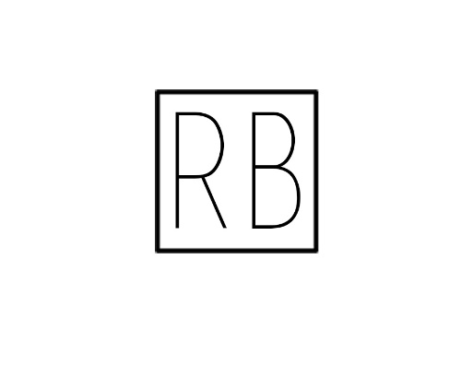

VFX Compositor

Vancouver, BC

Cell Phone: (778)-989-7926
Email: ryanbains23@hotmail.com
Linkedin: https://www.linkedin.com/in/ryan-bains/
Website: https://ryanbains23.wixsite.com/vfxcompositor/about

Education

Jan 2016 - March 2018

VFX Diploma – LaSalle College Vancouver, B.C
Educational Interest
- Compositing
- Green Screen Keying
- CG Integration
- Camera Tracking

Software
- The Foundry Nuke | - Adobe Photoshop
- Autodesk Maya | - Adobe Premiere
- Pixar Renderman | - HitFilm Pro
- Arnold | - Adobe After Effects

Work Experiences

July 2011 - August 2014

Lot Attendant – Richmond Honda
- Detail New/Used Vehicles

Feb 2016 - Jan 2017

Dispatcher – Kee West Auto Carrier
- Work in office Answering calls

